A
Project Report on
AI-Powered Mental Health Monitoring System (RoboMH)
Developed By
Km Meenu Tomar [2305102120008]
developed at
Acciojob Pvt. Ltd
as
Partial Fulfillment of IVth Semester of
Master of Science Information Technology
For A.Y. 2024 – 2025
Under The Guidance of
Dr. Hina Chokshi
Submitted To
Department of M.sc-IT
Faculty of IT & Computer Science PARUL University




CERTIFICATE

This is to certify that Ms. Km Meenu Tomar, Enrollment no. 2305102120008 student of Master of Science Information Technology have satisfactorily completed the Major Project on “AI Powered Mental Health Monitoring System” at AccioJob Pvt. Ltd. as fulfillment of MSc (IT) Semester IV.

Seat No. Date of Submission:

Internal Guide Project Coordinator Director - MCA

Department of MCA
Faculty of IT & Computer Science
PARUL University,
Vadodara


Preface

Mental health is a vital aspect of overall well-being, yet millions worldwide face significant challenges in accessing timely diagnosis, support, and intervention. Recognizing the urgent need for accessible and proactive mental health solutions, this project, "AI-Powered Mental Health Monitoring System (RoboMH)," was developed. RoboMH aims to bridge the gap between technology and mental healthcare by offering a sophisticated yet user-friendly platform that leverages the latest advancements in artificial intelligence and machine learning.

The project integrates cutting-edge technologies, including natural language processing (NLP), to deliver comprehensive and real-time mental health assessments. Utilizing robust frameworks such as Streamlit, FastAPI, and advanced AI models like Gemini AI, the system provides precise, actionable insights into users' emotional and psychological states. Furthermore, secure storage solutions through Supabase and stringent privacy measures ensure user data integrity and confidentiality.

This documentation details the systematic journey of project development, from initial requirement analysis and feasibility studies to design, implementation, rigorous testing, and potential future enhancements. Each phase is clearly outlined to facilitate a thorough understanding of the system’s architecture, functionalities, and technical underpinnings. Emphasis has been placed on clarity and comprehensiveness, ensuring that stakeholders, developers, and researchers alike can navigate and leverage the documentation effectively.

Through RoboMH, this project demonstrates how integrating AI-driven analytics with practical software solutions can significantly enhance mental health monitoring and intervention capabilities. It represents not only an academic milestone but also a practical contribution to the growing field of digital health technologies. We encourage readers, researchers, and practitioners to utilize this documentation to further explore, refine, and expand upon these methodologies to continually advance the intersection of artificial intelligence and mental healthcare.

Acknowledgement
I would like to express our sincere gratitude to everyone who contributed to the development of this project work. This project would not have been possible without the support, guidance, and cooperation of numerous individuals and organizations.
First and foremost, I extend our heartfelt thanks to our esteemed faculty members, our Dean Dr. Priya Swaminarayan ma’am, our HOD Prof. Vivek Dave sir, my project guide Dr. Hina Chokshi Ma’am for their invaluable insights and mentorship throughout the project. Their continuous encouragement and constructive feedback significantly shaped the direction of my work.
I am also indebted to my peers and friends who provided valuable suggestions and feedback during various stages of development. Their input helped us refine the features and functionalities of the system, making it more user-friendly and effective.
Last but not least, I want to express my gratitude to my families for their unwavering support and understanding during the challenging times of project development. Their encouragement and patience were instrumental in helping me navigate through the complexities of this endeavor.
In conclusion, i would like to thank everyone who played a role, whether big or small, in the successful completion of this project. Your contributions have made this project a reality, and I am truly grateful for your support.

Sincerely,
Km Meenu Tomar
MSc-IT, Parul Institute of Engineering and Technology
Parul University

INDEX
No. | Description | Page No.
1. | About Department of MCA | 1
2. | Company Profile | 2
3. | Project Profile  - Project Definition  - Project Description  - Existing System / Work Environment  - Problem Statements  - Need for New System  - Proposed System & Features  - Scope  - Outcomes  - Tools & Technology used  - Project Plan | 3
4. | Requirement Analysis  - Feasibility Study  - Users of the System  - Modules  - Process Model  - Hardware & Software Requirements  - Use Cases | 6
5. | Design  - Use Case Diagram  - Entity Relationship Diagram  - Data Flow Diagrams  - Data Dictionary | 12
6. | Implementation  - Form Layouts  - Report Layouts  - Coding Convention | 20
7. | Testing  - Test Strategy  - Test Cases | 33
8. | Future Enhancement | 38
9. | Bibliography | 39

About Department 2024-2025
About Department of M.Sc. IT

PARUL University
Parul University is a legitimate university established under Gujarat Private University Act 2009, after legislation passed by the Government of Gujarat on 26th March 2015 giving University status to Parul Group of Institutes functioning under the aegis of Parul Arogya Seva Mandal Trust.

Faculty of IT & Computer Science
Faculty of IT and Computer Science, Parul University has materialized as one of the prime IT education providers at global level. Various departments under Faculty of IT and Computer Science strive in preparing IT-industry ready professionals by means of various skill development courses, vocational courses, co-curricular & extra-curricular activities, industry visits and expert lectures.

M.sc IT Department
The Department Master of Science in Information Technology at Parul University emphasizes on building professionals in the domain of computer applications by providing necessary environment by means of facilitating suitable blend of technical and non-technical learning experience. The department cultivates students in various curricular, co-curricular and extra-curricular activities in order to produce future system analysts, system designers, system programmers, application programmers, testing professionals, system managers, project managers, researchers and other leading positions in systems/IT department.

The departments offer various subjects from diversified technical/non-technical areas such as – core IT domain, management, communication skills, mathematics & logic building and rich pool of elective subjects.

The department of MCA and M.Sc. (IT) focuses on project-based learning, and hence students are motivated to work on tiny hands-on projects in practical oriented subjects to get better exposure. Moreover, throughout their MCA studies, students are required to work on around 3 mini/major projects in individual/team to get enough confidence on software-development and thereby become industry-read.

Company profile 2024-2025
Company Profile

Company Logo : | 
Company Name : | Acciojob Pvt.Ltd.
Company CEO Name: | Yashwardhan Burad
Address: | UNIT NO-437 -b 4th Floor,Spaze|Techpark, Tower-a Sec-49 ,Sohna Road Haryana.
City: | Delhi
URL: | https://acciojob.com/
Contact No. (M): | +91 8882439836
Email Address (O): | contactus@acciojob.com
Company Profile: | Edtech,IT Software & Solutions

Project Profile

Project Definition
AI – Powered Mental Health Monitoring System

Project Description
The AI-Powered Mental Health Monitoring System is designed to assess individuals' mental health conditions through facial expressions, speech tone, and textual sentiment analysis. The system provides real-time feedback and assists users and therapists in identifying signs of depression, anxiety, and stress using AI-driven models.

Problem Statements

Mental health is a crucial aspect of well-being, yet many individuals struggle to access timely diagnosis and support. AI-driven mental health analysis offers an automated, objective, and accessible solution.
This project integrates computer vision, speech processing, and NLP models to create a multimodal system that can detect emotional distress and support early mental health intervention.
Mental health disorders, including depression, anxiety, and stress-related conditions, affect nearly 1 billion people globally (WHO, 2023). Despite the increasing awareness of mental health issues, timely diagnosis and intervention remain a major challenge, especially in underserved areas. Traditional mental health assessments rely heavily on self-reporting, clinical observations, and therapist availability, leading to delays in diagnosis and a lack of accessibility for many individuals.
India faces significant mental health challenges, with approximately 197.3 million individuals affected by mental disorders as of 2017, including 45.7 million experiencing depressive disorders and with anxiety disorders. The treatment gap is substantial, with over 75% of affected individuals not receiving adequate care.
To address these issues, the Indian government launched the Tele Mental Health Assistance and Networking Across States (Tele-MANAS) initiative in October 2022, providing 24/7 remote access to mental health services. Tele-MANAS has established 51 cells and has received nearly 400,000 calls to date, demonstrating its reach and utility.
In the private sector, Fortis Healthcare introduced an AI-powered mental health service featuring self-assessment tools and round-the-clock virtual assistance, aiming to enhance accessibility and support for mental health care. citeturn0search16
Additionally, AI-driven platforms like InfiHeal offer digital services, including meditation audios and mood trackers, to support mental well-being.
These initiatives reflect a growing recognition in India of the potential for AI to bridge gaps in mental health care by providing scalable, accessible, and personalized support.

Need for New System
The requirement from a new system rose from the following points:
The current mental health assessment approaches face several key challenges:
- Limited Access to Mental Health Professionals – There is a global shortage of mental health professionals, with less than 1 psychiatrist per 100,000 people in many countries.
- Subjectivity in Diagnosis – Mental health assessments rely on self-reported symptoms, which can be influenced by social stigma, personal bias, or underreporting of distress.
- Delayed Interventions – Many individuals do not seek professional help until their condition has worsened, leading to higher suicide rates and mental health crises.
- Scalability Issues – Traditional therapy and counseling services are not scalable to address the rising number of cases, making mental health care inaccessible to many.

User-Friendly Interface

Existing mental health monitoring applications often have a steep learning curve, discouraging new and potential users. Our system, built with Streamlit, provides an intuitive and easy-to-use chat-based interface, making mental health assessment more accessible.

Simplified Workflow & Seamless Integration

The system ensures a smooth user experience by offering a simple sign-up process and a real-time chat feature. It integrates seamlessly with Supabase for data storage and NLP models for sentiment analysis, ensuring efficient and accurate mental health insights.

Proposed System & Features
The proposed system is an application, with following features:
    - Beginner friendly UI/UX
    - Optimized for individual Use and Therapists
    - Secure Chat & Sentiment Analysis
    - Privacy & Data Security

Scope
The main scope of this project is to provide individual users with an easy-to-use AI-powered mental health monitoring system. By analyzing text-based conversations, the system offers real-time sentiment insights to help users better understand their mental well-being.
In future versions, the system could expand its scope to therapists, mental health professionals, or organizations, integrating additional features like facial expression analysis (FER2013), advanced AI models, and real-time alerts for at-risk individuals.

Outcomes
A user-friendly platform that allows individuals to monitor their mental health through text-based conversations.
Real-time sentiment analysis using NLP models trained on the Dizvik dataset for accurate mental state assessment.
Secure storage of chat history with Supabase, ensuring privacy and data integrity.
Potential for future enhancements, including integration with healthcare services, mobile apps, and AI-driven mental health insights.

Tools & Technology used

- Python
- Streamlit
- Natural Language Processing (NLP)
- Supabase
- FastAPI
- Gemini AI
- Firebase Authentication
- PostgreSQL
- HTML, CSS & JavaScript

Project Plans

This project is currently in the final phase of development and will soon be ready for deployment after thorough testing. Based on user feedback and reviews, I plan to make further improvements in the coming months. Positive feedback will help identify the features that enhance the user experience and differentiate this system from existing mental health applications. Constructive feedback will highlight areas that require refinement or replacement with better implementations. Future enhancements may include integrating facial emotion recognition (FER2013, Dizvik) for a more comprehensive analysis, improving AI models like Gemini AI for more accurate sentiment detection, and optimizing FastAPI and Supabase for better performance and scalability. The project will continue to evolve to ensure data security, user engagement, and effective AI-driven mental health insights.

Requirement Analysis

Feasibility Study

A feasibility study is conducted to assess the practicality and viability of the AI-powered Mental Health Monitoring System. This evaluation ensures that the system is technically, operationally, economically, and market-wise feasible, while also determining if it can be completed within the desired timeframe.

Technical Feasibility
The system leverages FastAPI, Streamlit, and Supabase, which are well-suited for building a scalable and efficient application. Gemini AI and NLP models trained on the Dizvik dataset provide advanced text-based sentiment analysis, ensuring reliable mental health monitoring. The cloud-based infrastructure of Supabase allows for secure storage of user interactions, making the system technically feasible. Additionally, the application is designed to handle multiple users simultaneously without performance degradation.

Operational Feasibility
The system seamlessly integrates into existing mental health support frameworks, providing users with a chat-based AI assistant for emotional assessment. The user-friendly UI ensures accessibility for individuals with little to no technical expertise. Given the increasing awareness of mental health and AI-driven solutions, users are more likely to adopt the system for self-monitoring and emotional well-being tracking.

Economic Feasibility
The project’s development cost is optimized using open-source technologies such as FastAPI, Streamlit, and Supabase, reducing infrastructure expenses. Future monetization strategies may include premium AI-driven insights, partnerships with mental health professionals, or subscription-based services. Given the rising demand for AI-driven mental health applications, the potential benefits and impact outweigh the costs in the long run.

Schedule Feasibility
Description: Access whether the project can be completed within the desired timeframe. Considerations:
What is the estimated development timeline, including design, coding, testing, and deployment?
Are there any critical deadlines or time-sensitive factors that could affect the project's success?

Market Feasibility
There is a growing demand for AI-driven mental health applications, with an increasing number of users seeking personalized emotional well-being tools. While existing applications provide general therapy support, this project differentiates itself by focusing on NLP-based sentiment analysis and secure user record tracking. The use of Gemini AI and the Dizvik dataset enhances the system’s ability to provide personalized and precise insights, making it stand out in the market.

Conclusion

Based on the feasibility study, the AI-powered Mental Health Monitoring System demonstrates strong potential for success.
From a technical perspective, the required technologies, including FastAPI, Streamlit, Gemini AI, and Supabase, are readily available and well-suited for the project’s needs. The system is capable of handling real-time sentiment analysis using NLP models trained on the Dizvik dataset, ensuring accurate emotional assessments.
Operationally, the system seamlessly integrates into mental health monitoring processes, providing an intuitive and user-friendly chat-based interface. The use of AI for emotional state analysis enhances efficiency in mental health tracking, making the system accessible to individuals seeking self-monitoring tools.
From an economic standpoint, the adoption of open-source technologies minimizes development and maintenance costs. Additionally, the potential for subscription-based models, AI-driven insights, and partnerships with mental health professionals presents a promising return on investment.
The project is on track for completion within a reasonable timeline, with a structured development plan ensuring timely deployment. The increasing demand for AI-driven mental health applications indicates a favorable market feasibility, positioning the system as a valuable tool for individuals looking for personalized mental health support.

Users of the System
- Administrator: Administrators will have full control over the workflow of the application as well as other users. They may monitor and should be liable to take necessary action as per requirement.
- Users: Core users who will use the application for mental health monitoring, accessing insights, and receiving personalized recommendations.

Administration
This module handles user registration, login, and account management. Features might include user profiles, password reset, and user roles.
Role-based access control to ensure appropriate access levels for different users.

User Management
This module manages user information, including demographics, mental health history, and assessment results. Users can update their personal details and track their mental health progress over time and addresses.

Data Collection & Analysis
This module is responsible for collecting, processing, and analyzing multimodal data—facial expressions, voice tone, and textual inputs—to assess an individual’s mental state. AI models deployed in this phase extract meaningful patterns and generate insights for early mental health detection and intervention.

1. Facial Expression Analysis (Computer Vision - OpenCV, FER2013)
- Technology Used: OpenCV, Deep Learning-based Emotion Detection Models (VGGFace, ResNet, FER2013 dataset from Kaggle).
- Process:
  - Captures real-time facial expressions using webcams or smartphone cameras.
  - Analyzes microexpressions like frowning, raised eyebrows, downcast gaze, which may indicate stress or emotional distress.
  - FER2013 dataset is used to train deep learning models for detecting emotions such as sadness, anger, happiness, and fear.
- Example Insight:
  - A user exhibiting prolonged sadness (detected via facial cues) is flagged for potential depressive symptoms.
  - AI recommends self-help exercises or a virtual mental health check-up if distress patterns persist.

2. Voice Tone Analysis (Speech Processing - Librosa, OpenSMILE, Dizvik)
- Technology Used: Librosa (feature extraction), OpenSMILE (speech emotion recognition), Dizvik’s voice datasets.
- Process:
  - Extracts speech features such as pitch, tone, and speech rate.
  - Recognizes speech patterns linked to anxiety, stress, or depression (e.g., monotone voice, slow speech, long pauses).
  - Compares real-time speech samples against Dizvik’s annotated emotional speech datasets.
- Example Insight:
  - A monotone voice with long hesitations may indicate depressive tendencies.
  - AI suggests self-assessment tools or therapist recommendations based on speech analysis.

3. Textual Sentiment & NLP Analysis (BERT, GPT, Gemini AI, Kaggle Datasets)
- Technology Used: NLP models (BERT, GPT, Gemini AI), sentiment analysis libraries (VADER, TextBlob), Kaggle’s depression text datasets.
- Process:
  - Analyzes user text from chats, journals, or voice-to-text transcriptions.
  - Detects negative sentiment, suicidal ideation, and cognitive distortions in language use.
  - Uses Kaggle’s annotated depression datasets to train models in recognizing distress-related language.
- Example Insight:
  - A user typing "I feel empty" or "I have no motivation" frequently may show early signs of depression.
  - AI flags high-risk phrases and suggests self-help interventions or urgent mental health support.

Key Benefits of This Approach
✔ Objective Analysis – Reduces reliance on self-reported data, minimizing bias.
✔ Early Detection – Identifies subtle signs of mental distress before symptoms worsen.
✔ Multimodal Insights – Combines facial, vocal, and textual data for a comprehensive assessment.
This AI-driven module enables real-time, scalable, and data-backed mental health monitoring, making early intervention more accessible.

Reports Generation
Generates personalized mental health reports based on user data, displaying trends, risk assessments, and actionable insights. Users can download and share reports with mental health professionals.

Therapy & Support Recommendations

The system provides users with personalized self-care strategies, therapy recommendations, and access to mental health resources based on their analyzed facial expressions, voice tone, and text inputs. It integrates with therapists or AI-powered chatbots to offer real-time support, helping users manage their mental well-being effectively.
This module handles the creation and management of users and their mental health records, along with unique ID generation for tracking assessments. It includes user details such as name, profile picture, contact information, and medical history.
For generating unique assessment IDs, the system utilizes prefix, suffix, padding, and model-based sequencing, ensuring structured and consistent tracking of mental health evaluations.

Process Model

Rapid Application Development model
As the project is defined with the basic idea of application and have small team, it’s suitable to develop a prototype and reiterate it to achieve the planned goal. Various modules were divided to each member and been merged for testing and next iteration.

Hardware & Software Requirements

Hardware requirement
Computer | 1.7 GHz CPU
Processor | Intel Core i5 or higher (or equivalent AMD processor)
RAM | At least 8 GB, Preferred 16 GB
Storage | SSD with at least 256GB of storage space
Network | Network Interface Card (NIC) for network connectivity

Network Infrastructure:
- Router or Switch for network connectivity
- Ethernet cables or Wi-Fi access points for connecting devices

Software requirements
Operating System | Windows 10/11, WSL (Ubuntu)
Web Server | Nginx
Frontend | Python, Streamlit, HTML, CSS, JavaScript
Backend | Python, FASTAPI, REST
Database | Supabase-PostgreSQL, Supabase-Object Bucket
Artificial Intelligence & Machine Learning | TensorFlow, Keras, OpenCV, Gemini-Fast, Librosa, Hugging Face Transformers
Dependency Management | Pip
Version Control | Git
Code Repository | GitHub
IDE | Visual Studio Code, Jupyter Notebook
Cloud Infra | Supabase
IAM | Supabase-Auth, Streamlit-Supabase-Auth

Use Cases
The AI-driven mental health monitoring system is designed for various real-world applications. Some key use cases include:
- Users: Individuals seeking self-assessment and emotional support.
- Functionality: The chatbot interacts with users, analyzing their facial expressions, voice tone, and text inputs to provide mental health insights and coping strategies.
- Example: A person experiencing stress at work can interact with the chatbot, which detects signs of anxiety and suggests breathing exercises or professional counseling.

Design

Use Case Diagrams

A Use Case Diagram is a visual representation of the interactions between users (actors) and a system, showing how they engage with the system to achieve specific goals. It is a part of Unified Modeling Language (UML) and is used during the design phase of software development.
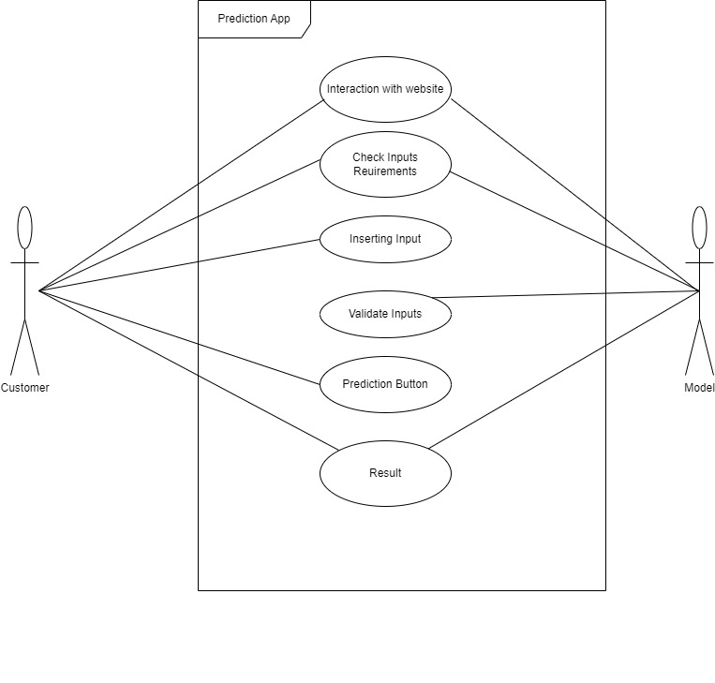
Figure 1Use case diagram

System Design
Frontend using Streamlit, REST APIs using FASTAPI, Supabase Cloud Managed.
- Identity and Access Management
- Database
- Security Policy
- Email Service
Gemini LLM for Text Generation

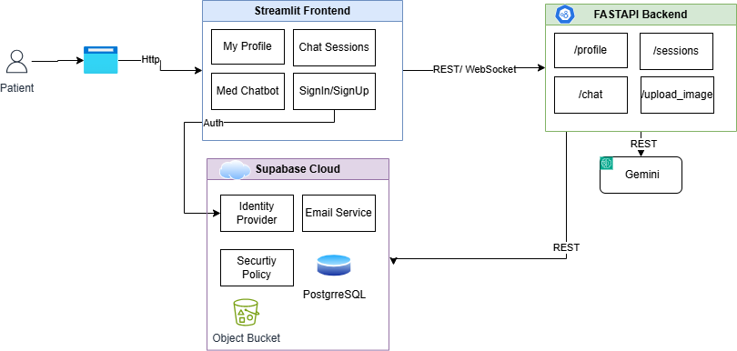

Figure 2 System Design

Data Flow Diagrams

Zero level DFD
A Zero Level Data Flow Diagram (DFD), also known as Context Level DFD, is the highest-level diagram that provides an overview of an entire system or process. It is the most abstract representation of the system.
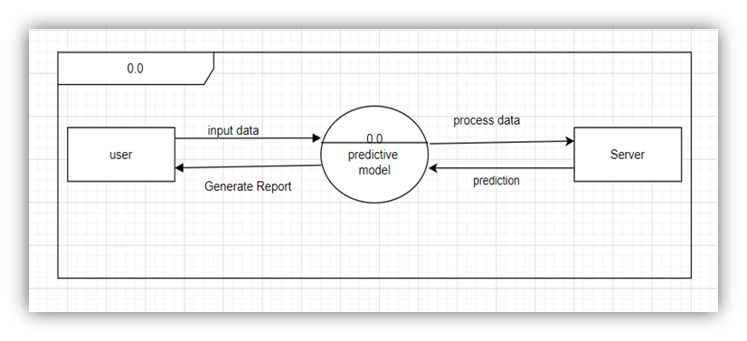 Figure 3 Zero level DFD

Process Diagram
A Process Diagram for a AI-Powered Mental Health Monitoring System visually represents how data flows through the system, showing different processes, users, and how they interact.
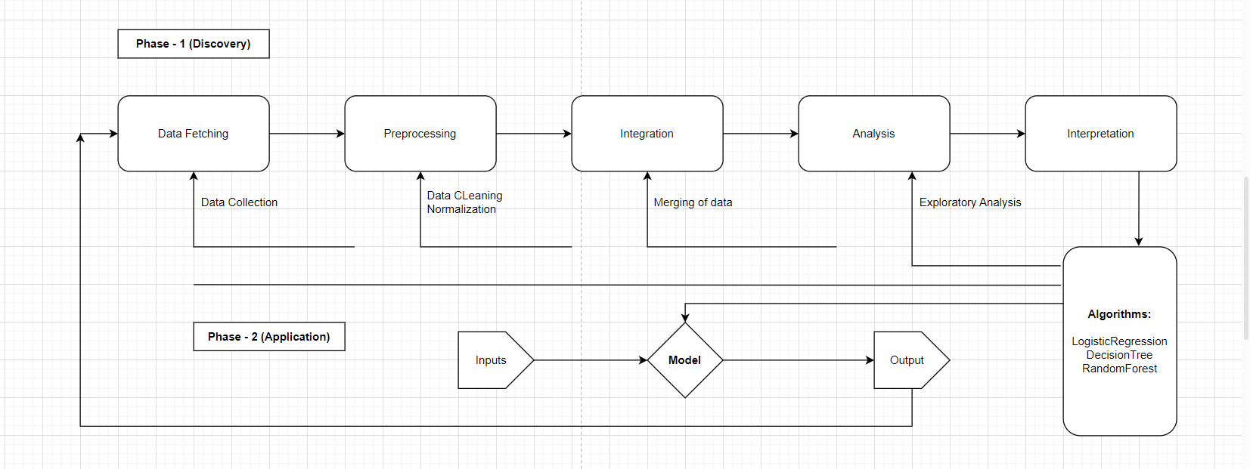
Figure 4 Process Diagram

Activity Diagram
An Activity Diagram for AI-driven Mental Health Monitoring System is a type of UML (Unified Modeling Language) diagram that visually represents the flow of activities in the system. It shows how different actions and decisions are performed within the system, typically from the user's perspective.
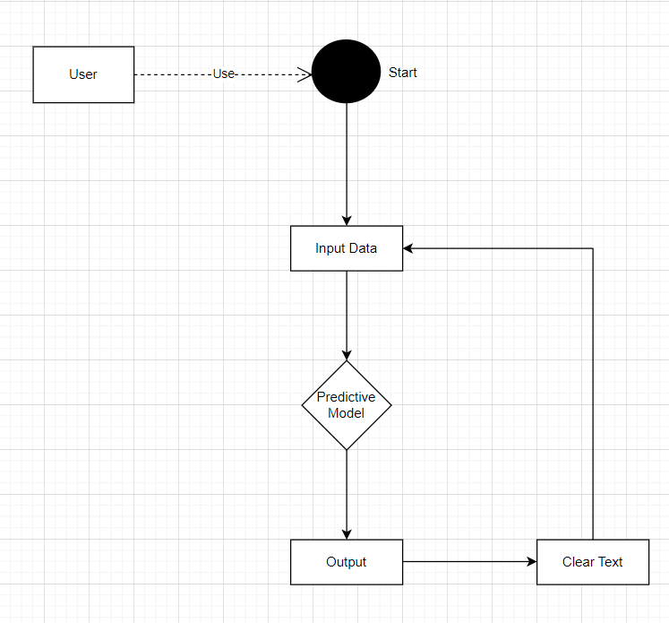

Data dictionary

Table - User Profile
Stores user profile information.
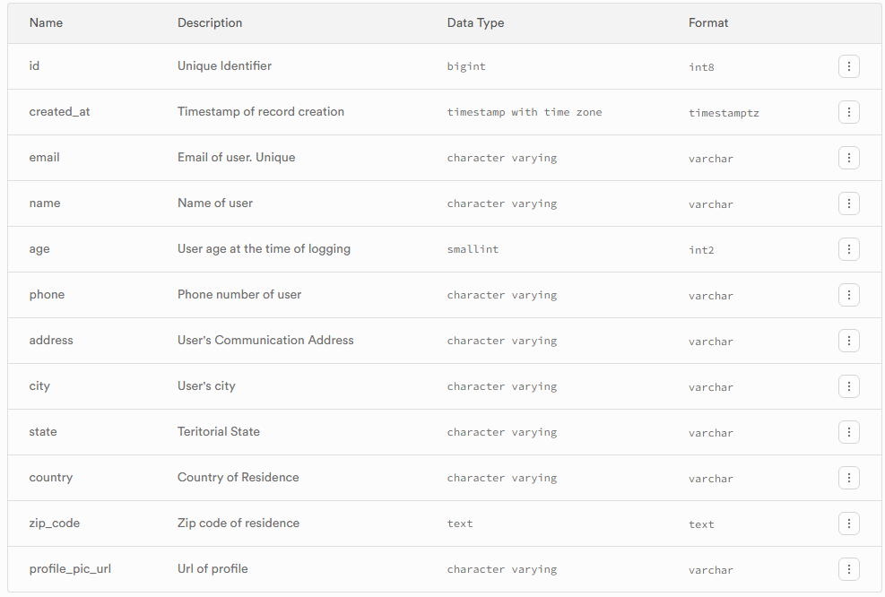
- Stores user profile information like name, age, address, etc.

Table 1 User Profile

Table - Chat_Session
Stores chat session with med-bot RoboMH.
- Records user’s chat session details.
- Contains history of users all chat sessions.

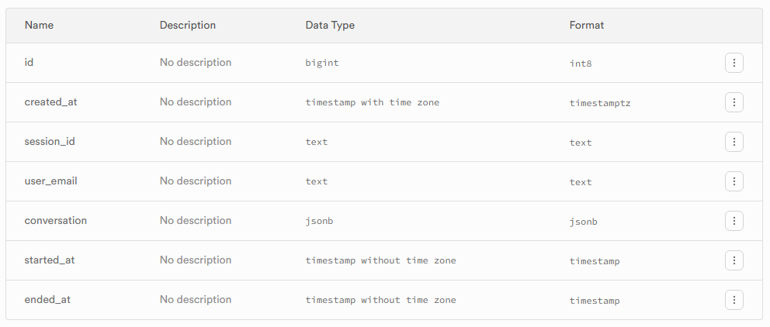
Table 2: Table Chat_Session

Table - Session_Analysis
Stores analysis of each saved chat conducted my ML model.
- Contains analytical information about chat conducted
- Record gets updated with the latest score after comparison with previous scores and insights.

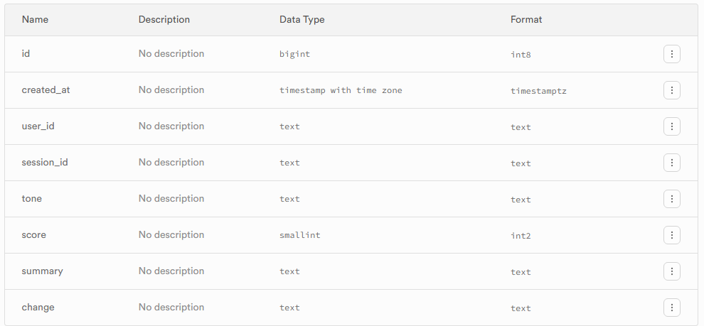

ER Diagram
An Entity-Relationship (ER) Diagram is a visual representation of the database structure used to model the relationships between different entities in a system. It is commonly used in database design.
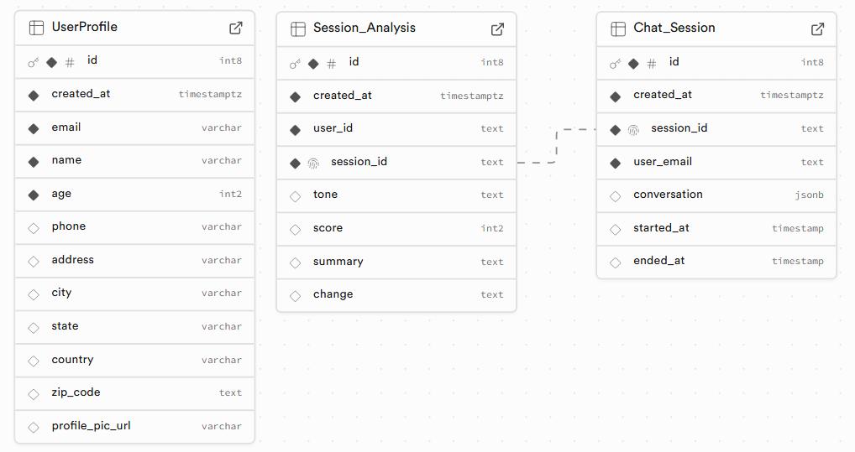

Implementation

Form Layout

Landing Page
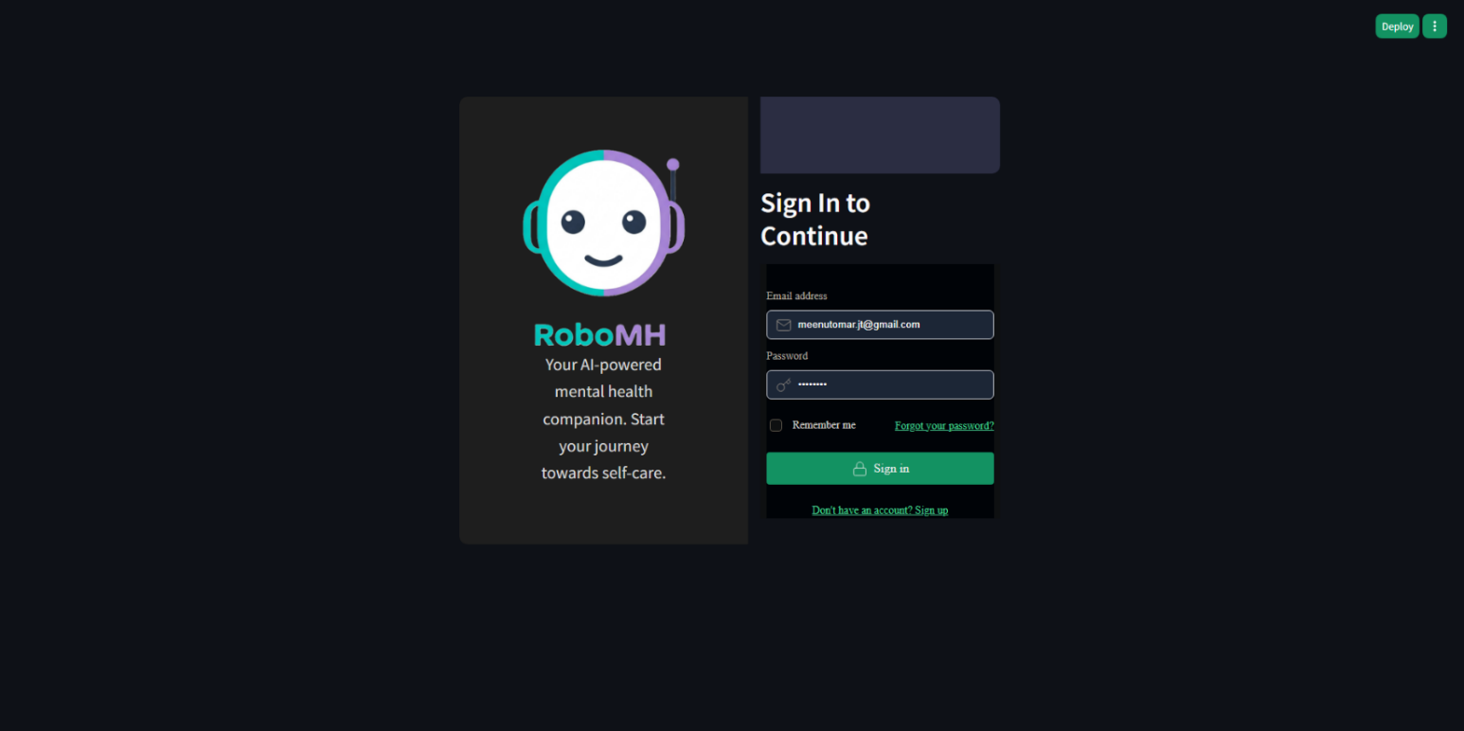
Landing page of the application. Allows users to login and sign-up into the application. User need to follow the process of registration before exploring the application.
Figure landing page-1

Chat Session View
Home page of the application. Default view of the application after successful login. Real-time chat session with medical chat bot.
Bot detects emotion in real-time and respond back to the user by understanding sentiment.
Save and End session will save the session for reference and initiates analytics on real-time
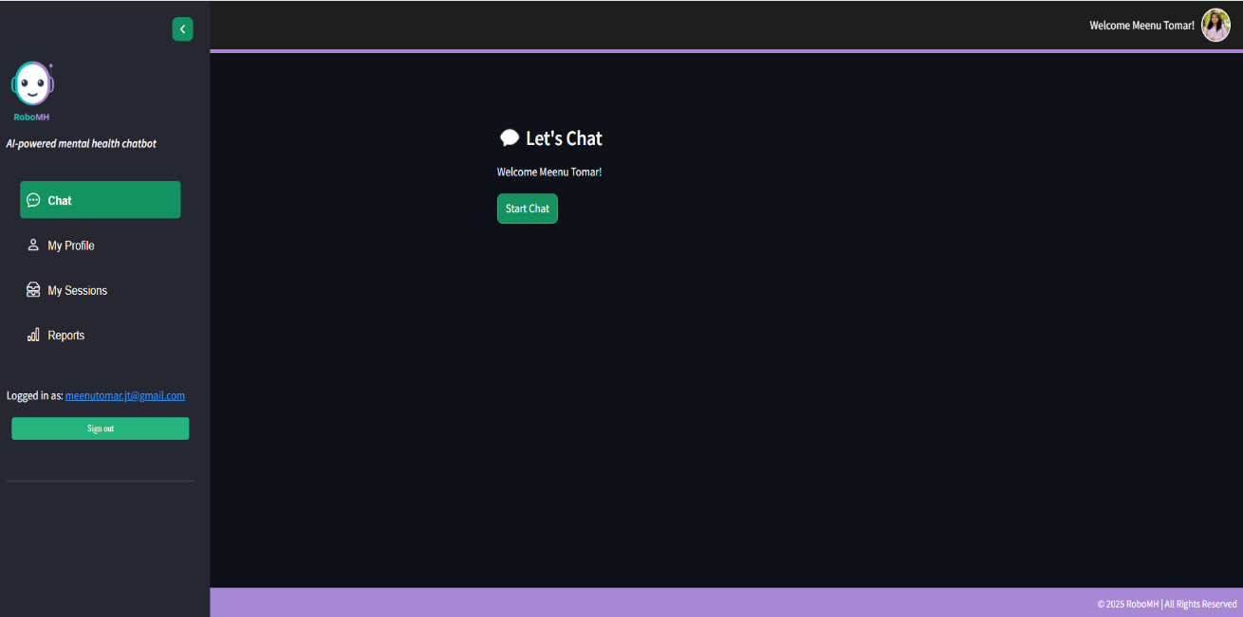
Figure-2 Start Chats

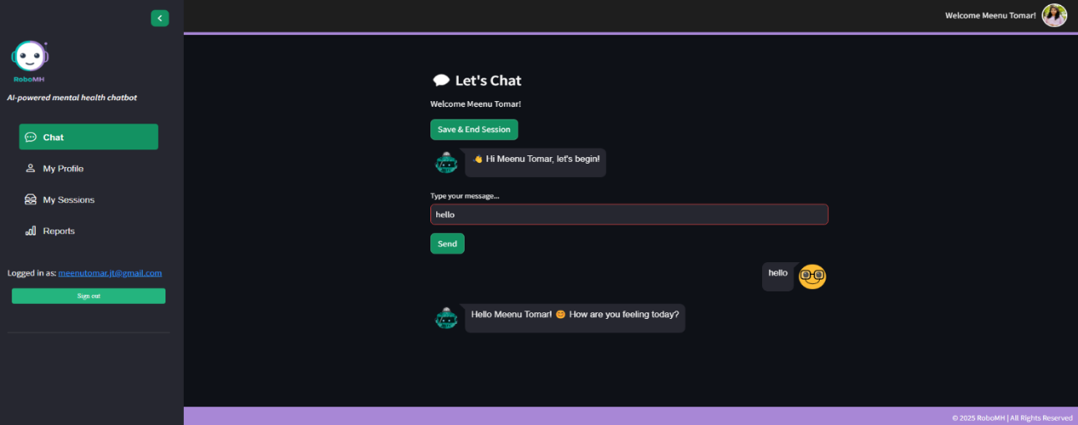
Figure-3 Chat Session view

My Profile View
Users can view and edit his/her profile.
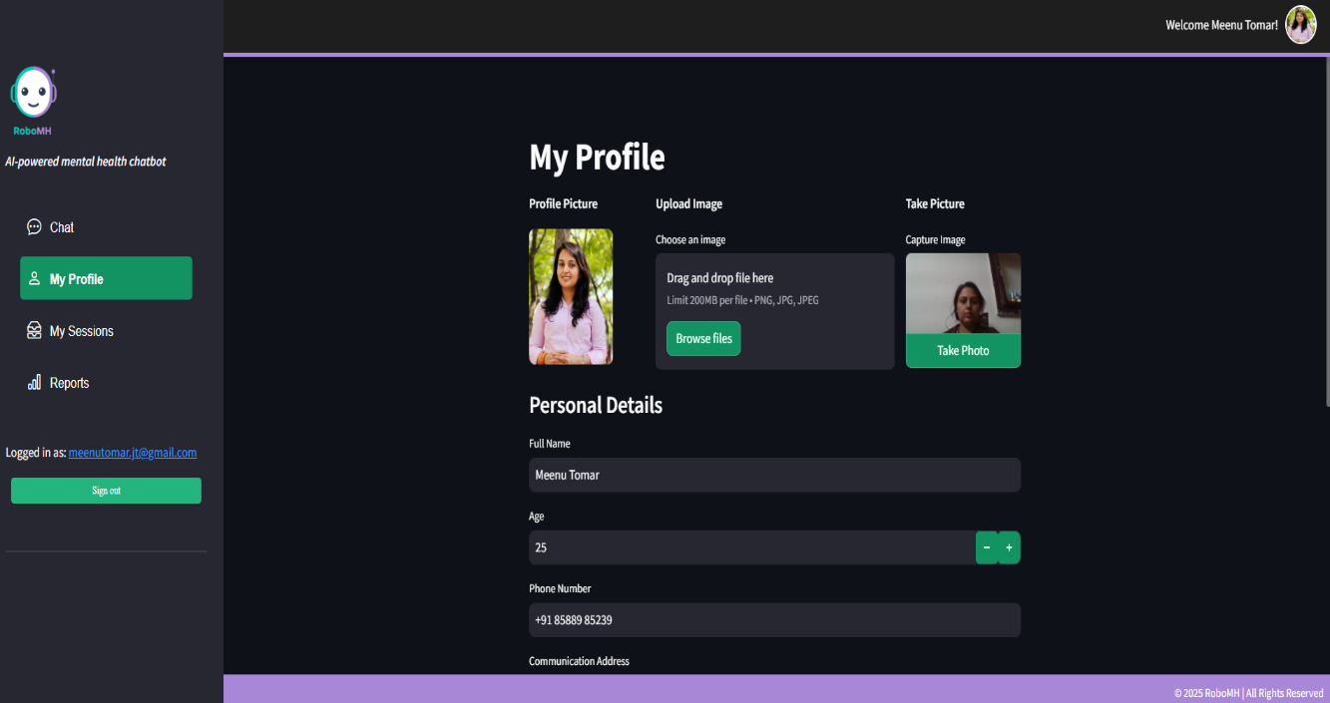
Figure-4 profile view
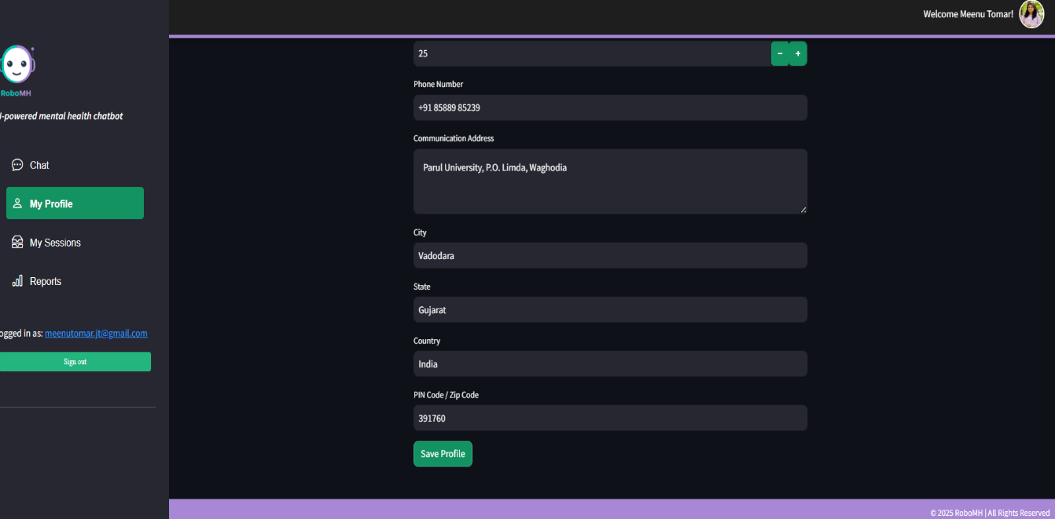

Figure-4.1 Profile view

Sessions View
Displays all users saved sessions conducted with chatbot RoboMH on Chat option. Provides features:
- Default current date view sessions
- Change date range to view sessions of a particular date range
- Search using Text.
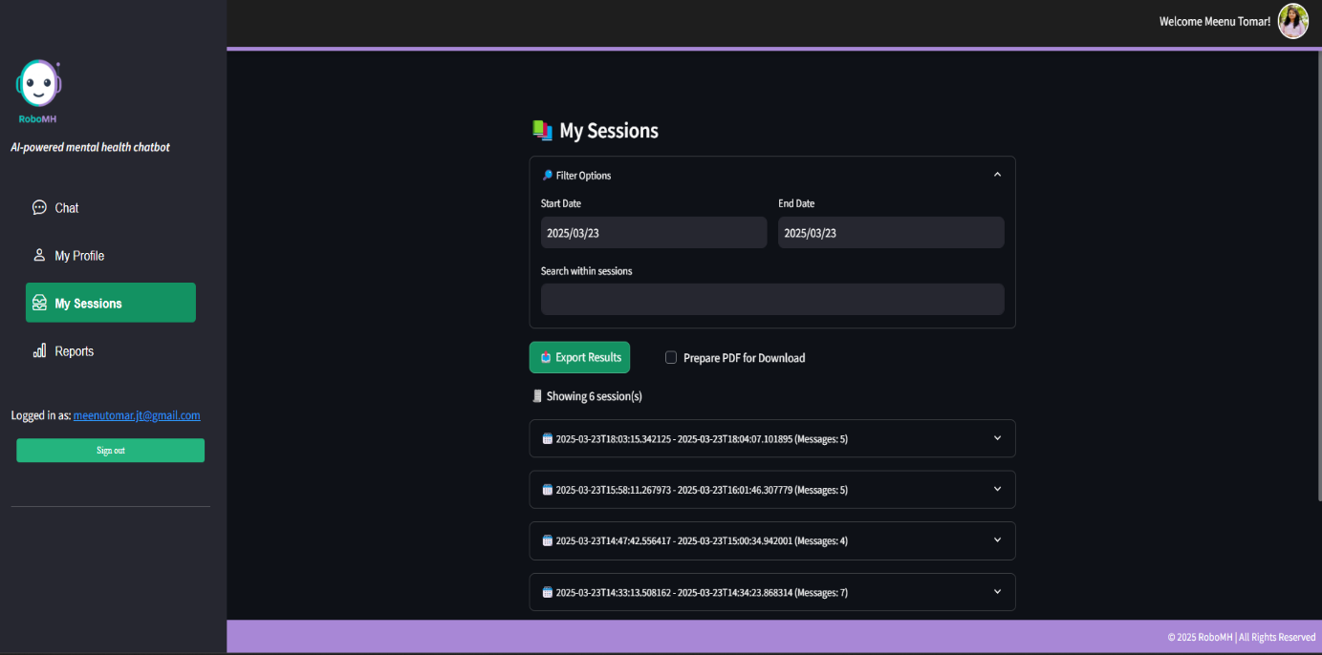
- Displays all medical chat session history.

Figure-1 Session view – All
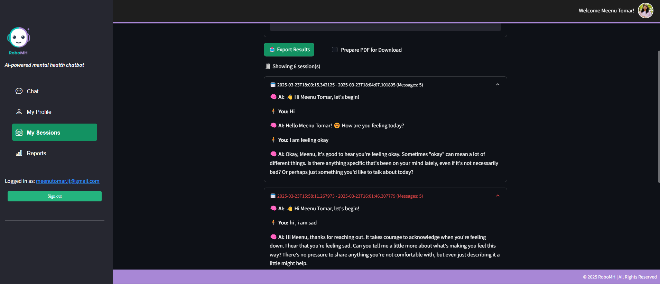
Figure-5.1 Session view - Single

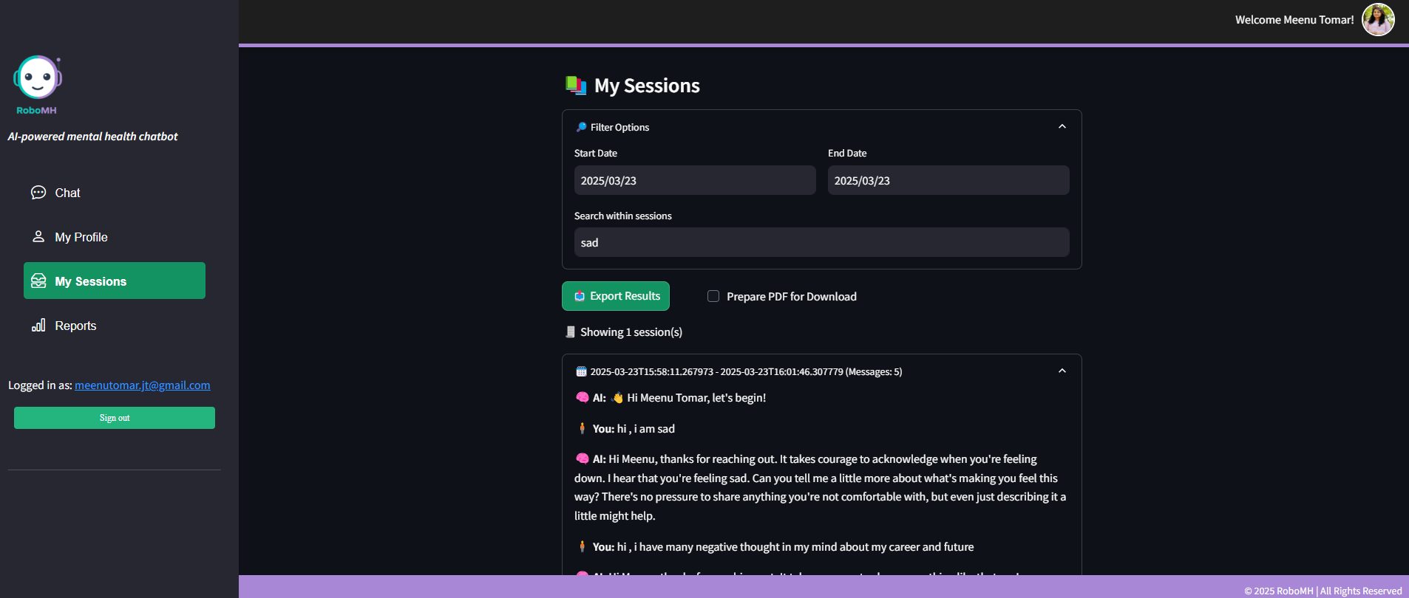
Figure-5.2 Session with filter

Analytical Reports
Displays analytical report of user.
- Shows recovery over period-of-time.
- Provide insights of conversation from beginning till date
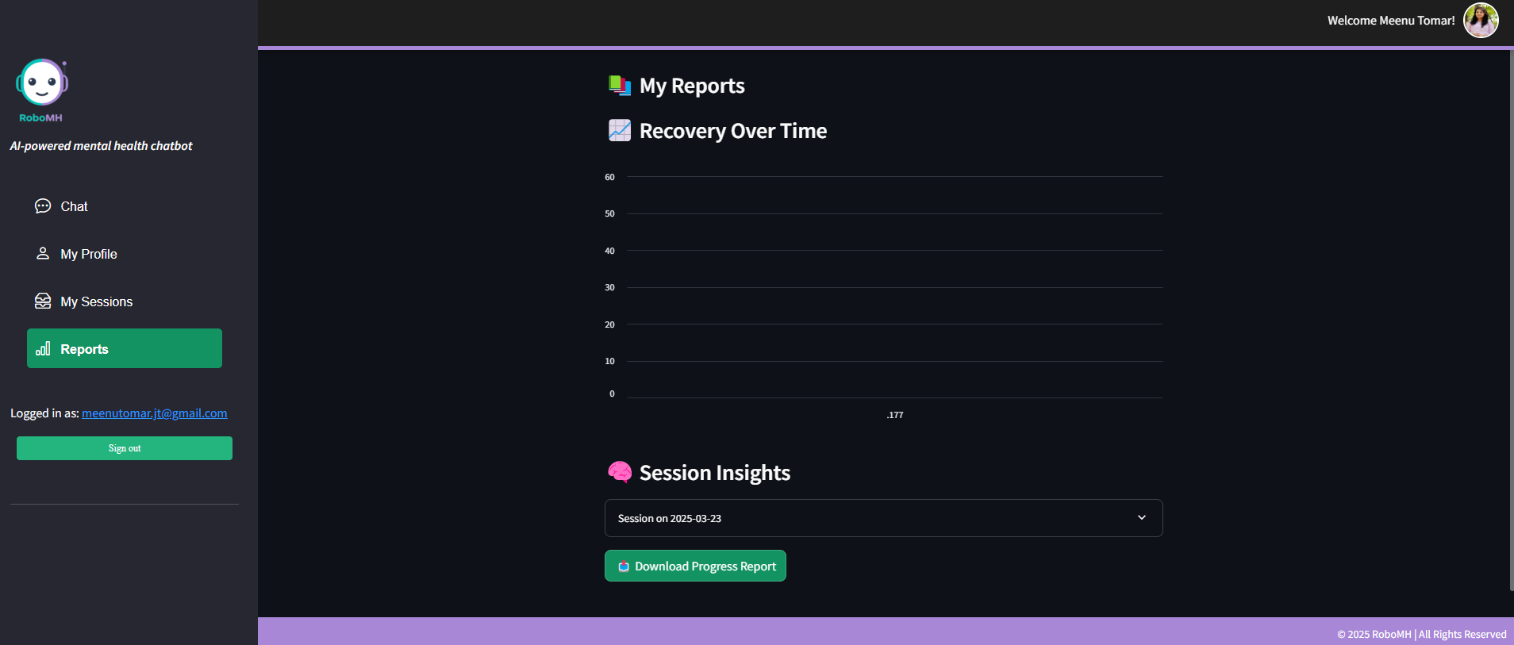
Figure-6 report graph view
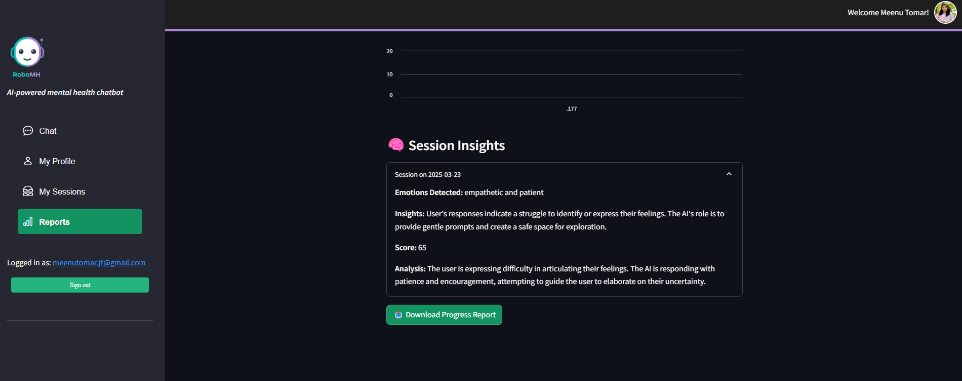
Figure-6.1 report view

Sign-out page
Page after successful sign-out from the application.
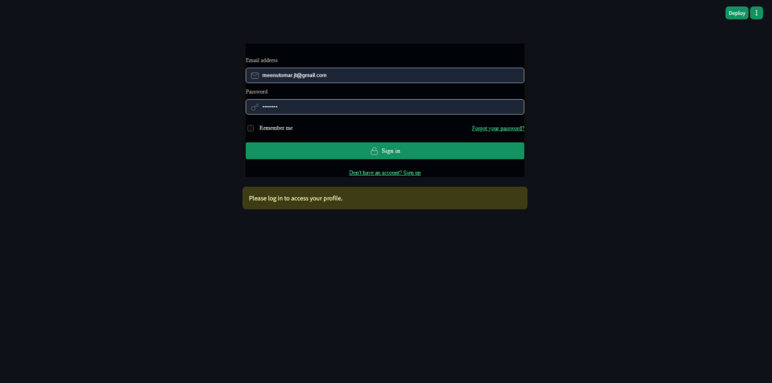
Figure -7 Sign in/up-view

Generated Reports

Mental health progress report – generated from My Sessions Analytical view
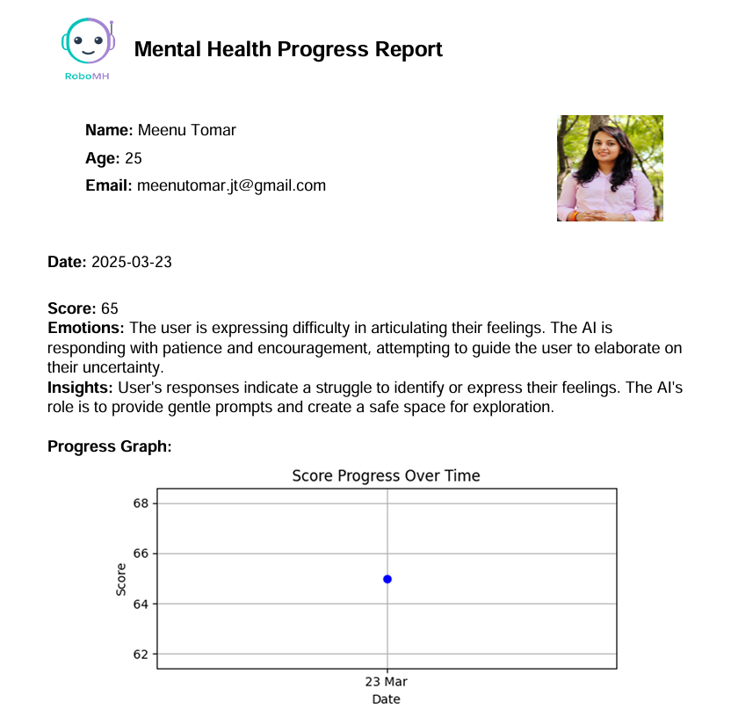
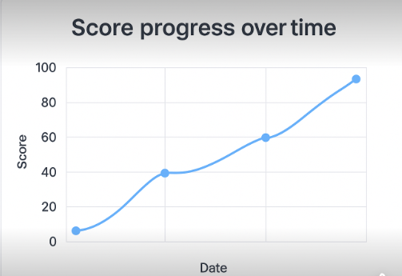

Session Conversation Report
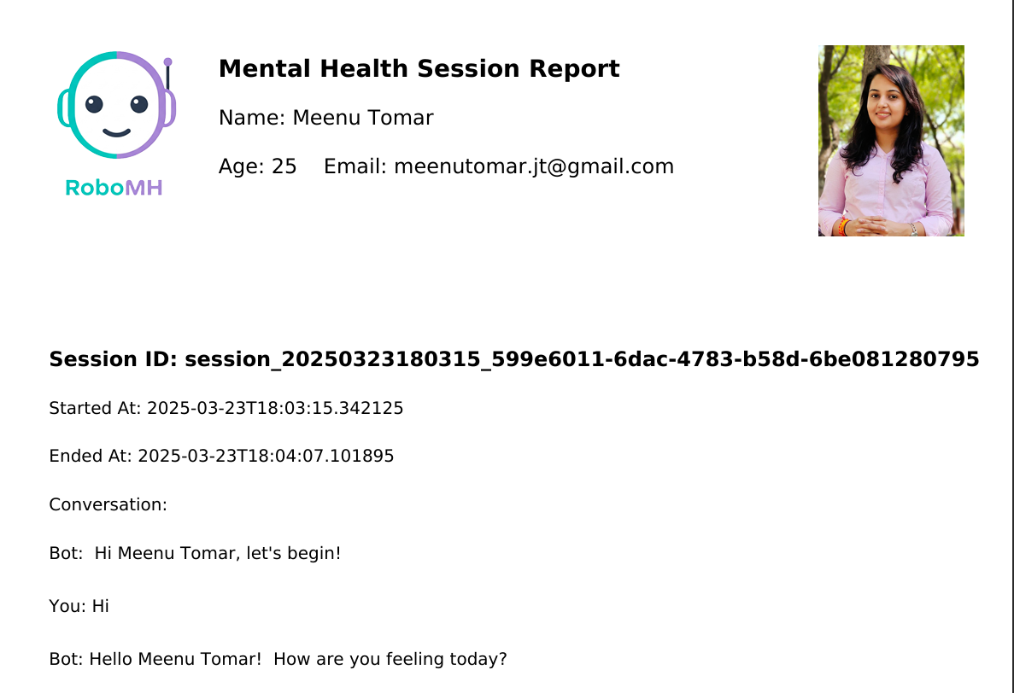
Multi-page session history report of all the conducted sessions.

Coding Convention:
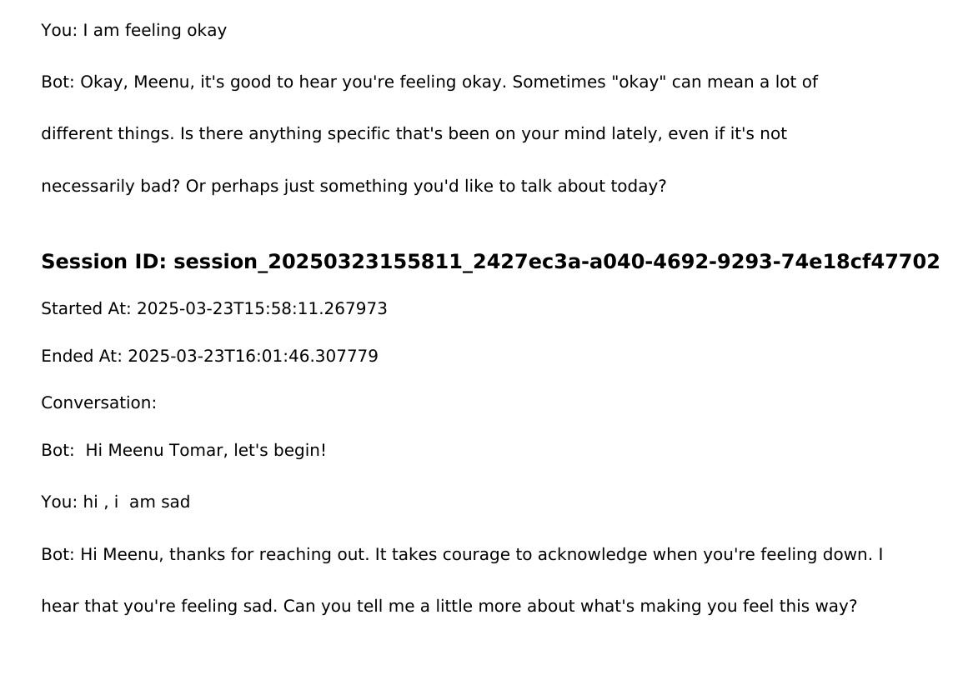
To ensure code readability, maintainability, and efficiency, the AI-powered mental health monitoring system follows well-defined coding conventions. These conventions help in maintaining consistency across the codebase, making it easier for developers to collaborate and debug.

Naming Conventions
- Variables and function names follow the snake_case convention (e.g., process_text_input).
- Class names use the PascalCase convention (e.g., TextAnalyzer).
- Constants are written in uppercase with underscores (e.g., MAX_TEXT_LENGTH).

Code Structure
- The code is modularized into separate files for text processing, API communication, and UI handling.
- Each module is responsible for a specific task, ensuring a clean and structured codebase.

Documentation and Comments
- Every function and class is documented using docstrings to explain functionality.
- Inline comments are used for complex logic to ensure better code understanding.
- Example:
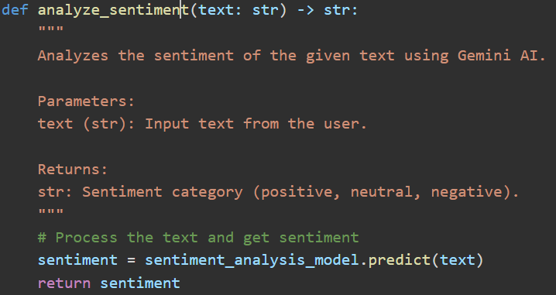

Error Handling
- Exception handling is implemented using try-except blocks to prevent system crashes.
- Errors are logged using the logging module for debugging and issue tracking.
- Example:
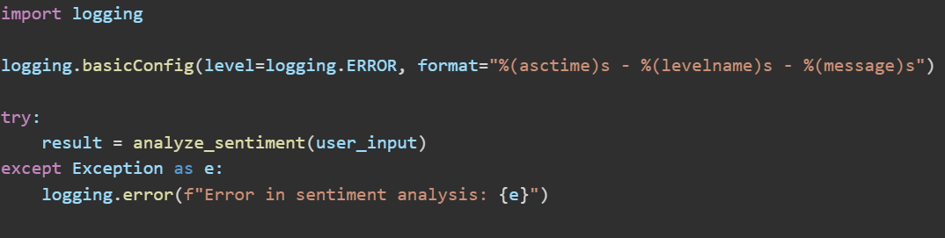

API and Data Handling
- The system follows RESTful API design principles using FastAPI.
- API responses are structured in JSON format for easy integration.
- Supabase authentication is implemented for secure user management.
- Example API response:
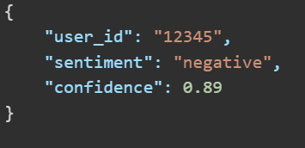

Code Optimization
- Unused variables and redundant computations are removed to improve performance.
- Caching mechanisms are implemented where applicable to reduce API call latency.
- List comprehensions and optimized loops are used for efficiency.
- Example:
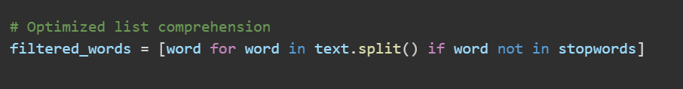

Testing Standards
- Unit tests are written using pytest to validate individual functions.
- Integration tests ensure proper communication between Gemini AI, FastAPI, and Streamlit.
- Example unit test:
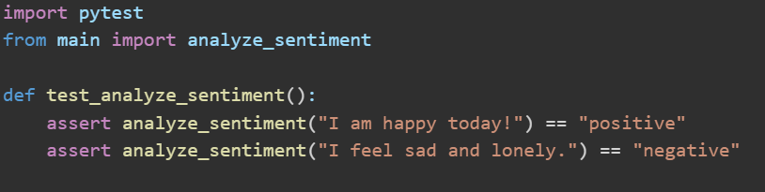

By following these coding conventions, the AI-powered mental health monitoring system ensures a scalable, maintainable, and efficient codebase.

Version Control
- Git is used for version control with meaningful commit messages.
- Branching strategies are followed to manage feature development and bug fixes.

Security Measures
- User inputs are sanitized to prevent injection attacks.
- API keys and sensitive data are stored in environment variables.

Testing

Test Strategy
The primary objective of testing is to identify errors and ensure that the AI-powered text-based mental health monitoring system provides accurate and meaningful insights. The system processes live text input and uses Gemini AI for sentiment and emotion analysis.
Since this system is text-driven, manual testing plays a crucial role in verifying user experience, input validation, and text-processing accuracy. Automated testing is used for AI model evaluation and API performance validation.
Here for this application manual testing can be used. It has many benefits as mentioned below:
Manual testing is very easy to understand.

Human brain is irreplaceable. Only humans can create valid test design foresee defects and execute designs to get the expected result. Human testers will quickly detect when something looks “Off” and can anticipate other failures that sometimes go unnoticed during automation testing. There is no replacement for the human eye.
It is not possible to do the UX/UI testing through automation. A manual tester can spot contextual, functional, visual, and usability bugs that automation scripts may not identify.
There are still some domains that prefer Manual testing over Automation testing for most of the system functionality.
Several times, situations arise when there are runtime variations in the functionality of some components either as an enhancement or behavioral change. In this case, the time and knowledge of functionality play a major role.
To optimize the price and time needed to test any software, testers cannot entirely rely upon the automation testing approach. Testers need the right combination of manual testing and automatic testing to get error-free software.
Field validation: Application has field validation to check whether input is valid or not. So, at every field, validation is given by the developer using regular expression.

UI/UX testing
UI/UX is a very important part of testing so this testing is also performed by the developer and some candidates for testing purpose.
Streamlit-based interface is tested for usability and real-time responsiveness.
Ensures that feedback from Gemini AI is clear and actionable.

Range validation
Range validation can give more support to restrict invalid input, so it is also done in this application.
Required field validation: Without filling all fields, it is not possible submission of form so required field validation provides a feature that application must have to take all required data. The system prevents submission of empty or invalid text inputs. It ensures that users receive meaningful feedback from the AI model.

Code coverage validation
In code coverage validation, we have tested all statement, branch and loop part of code. Because it is very important that if we have written anything then it must have some work. Useless code can give load to our system only. Ensures all backend API endpoints (FastAPI) function correctly. Tests different text processing scenarios to cover all possible user inputs.

Unit testing
At the completion of every module development developer had checked all possibilities of errors. So unit testing is also done by me.
• Each component, including text preprocessing, API calls to Gemini AI, and sentiment analysis, is tested separately.
• Ensures proper error handling for invalid inputs.

Integration testing
After unit testing one by one tester has taken all modules and done integration testing.

System testing
At the end of development fully system is tested by developer and some selected testers. In system testing all the validation and other features have been checked by testers and working perfectly as per requirement.

Beta testing
For beta testing with the help of some selected people application has been checked.
- Conducted with a selected group of users to test real-time text analysis and assess system reliability.
- User feedback is gathered to improve sentiment accuracy and UI interactions

Alpha testing
Developer has checked all features of the system for alpha testing and it is working very well.
- Internal testing by developers to verify system stability, text classification accuracy, and API performance.
- Ensures compliance with predefined mental health evaluation criteria.

Test Scenarios

If user is not providing the correct details for login, then it is restricted by the system. User is not permitted to access the application without providing the correct login credentials.

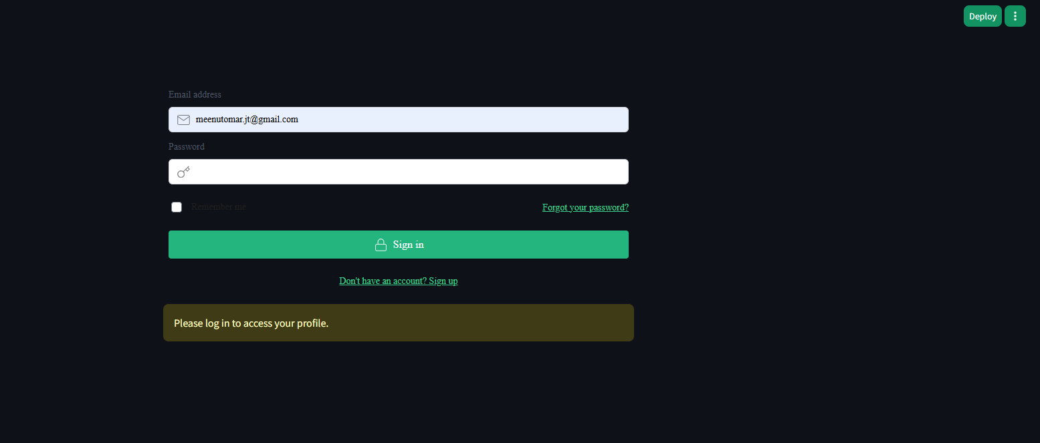

User who wants to explore the application, should go through the registration process, then user will be able to access the application.

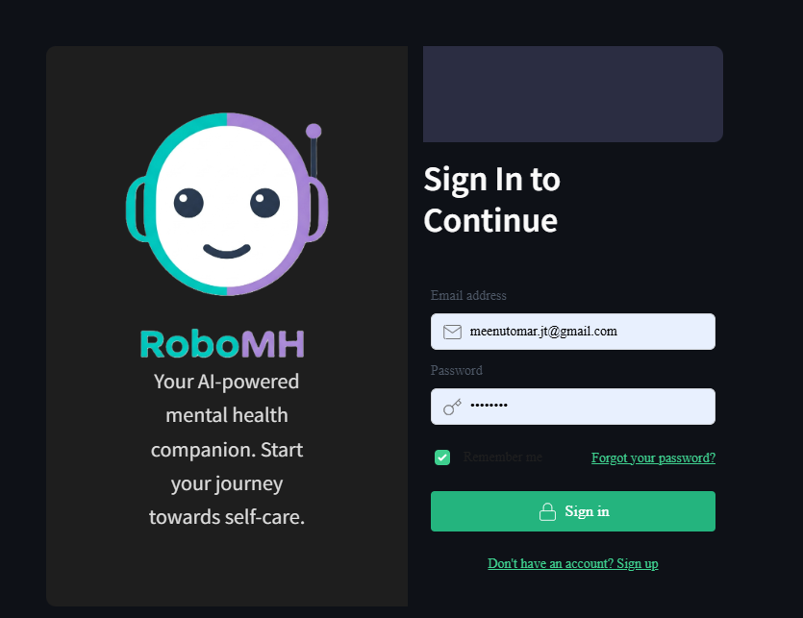

Test Cases
`The following test cases ensure the robustness and reliability of the mental health chatbot system:
Test Case ID | Test Scenario | Input | Expected Output | Status
TC_01 | Validate user login | Correct email & password | Successful login | Pass
TC_02 | Validate incorrect login | Wrong email/password | Error message displayed | Pass
TC_03 | Check response generation | "I feel sad" | Supportive chatbot response | Pass
TC_04 | Analyze chatbot's NLP response | "I am happy" | Positive sentiment detected | Pass
TC_05 | UI field validation | Empty login form | Required field error displayed | Pass
TC_06 | System response time | Text input in chatbot | Response within 2 seconds | Pass
TC_07 | Report export function | Click on "Export PDF" | PDF file generated | Pass
TC_08 | Session storage check | Multiple chat inputs | Data stored in database | Pass
TC_09 | Audio/video input testing | Speak or upload video | System processes correctly | Pass
TC_10 | AI model accuracy | "I feel anxious" | Correct sentiment analysis | Pass

These test cases cover functional validation, UI testing, NLP processing, and security measures to ensure seamless user experience.

Future Enhancements

7.1 Advanced Report Generation
The system will be further developed to generate detailed mental health reports based on live text, audio, and video analysis. These reports will summarize emotional patterns over time, providing valuable insights for users and mental health professionals.

7.2 Automated Report Sharing
The system will be enhanced with an automated email feature to send mental health assessment reports to users. This will enable users to track their emotional well-being and share reports with therapists or caregivers if needed.

7.3 Multi-Session Data Analysis
The system will be upgraded to analyze multiple user sessions and track emotional trends over time. This enhancement will allow users to review long-term patterns in their mental health and receive personalized recommendations.

7.4 Integration with Audio and Video Analysis
Future enhancements will include audio and video-based emotion recognition to improve assessment accuracy. Speech tone, facial expressions, and body language will be analyzed alongside text inputs to provide a more comprehensive mental health evaluation.

7.5 Integration with Wearable Devices
Future versions of the system may include integration with wearable devices to collect physiological data, such as heart rate and stress levels. This multimodal approach will improve the accuracy of mental health assessments.

7.6 Multi-Language Support
To reach a wider audience, the system will be developed to support multiple languages, allowing users to interact with the AI in their preferred language for better accessibility.

Bibliography
All the research, training, and support for this project were based on various technical resources and datasets related to AI-driven mental health assessment.
- Gemini AI Documentation: https://ai.google.com/gemini
- FastAPI Documentation: https://fastapi.tiangolo.com/
- Streamlit Documentation: https://docs.streamlit.io/
- Supabase Authentication & Security Guidelines: https://supabase.com/docs
- Sentiment Analysis Dataset (Sentiment140): https://www.kaggle.com/datasets/kazanova/sentiment140
- Audio Emotion Dataset (RAVDESS):https://zenodo.org/record/1188976
- Facial Emotion Recognition Dataset (FER2013): https://www.kaggle.com/datasets/msambare/fer2013
- Dizvik Dataset for Mental Health Analysis: https://dcapswoz.ict.usc.edu/wwwdaicwoz/
- Research Papers on AI in Mental Health: Various sources were referenced for understanding the latest advancements in AI-driven mental health analysis.
- https://www.who.int/news/item/28-06-2021-who-issues-first-global-report-on-ai-in-health-and-six-guiding-principles-for-its-design-and-use

Books:
- R. Narasimha Rao
Machine Learning and Artificial Intelligence: Applications in Healthcare, Tata McGraw Hill, 2020
https://www.mheducation.co.in/machine-learning-and-artificial-intelligence-applications-in-healthcare-9789389811202-india
- Rajiv Chopra
Artificial Intelligence and Machine Learning for Healthcare, Pearson India, 2021
https://www.pearsonindia.com/artificial-intelligence-and-machine-learning-for-healthcare.html
- Dinesh Kumar
Data Science and Analytics for Healthcare, Wiley India, 2019 https://www.wileyindia.com/data-science-and-analytics-in-healthcare.html
- World Health Organization (WHO)
Cardiovascular Diseases (CVDs) Fact Sheet, 2023
https://www.who.int/health-topics/cardiovascular-diseases

