Employee Handbook

Last Modified: December 15, 2023



Table of Contents

Disclaimer 2

Introduction 3

About the Practice 4

Chief Medical Officer 5

Organization Chart 6

Employee Records 7

General Office Policies 8

Hours & Wages 10

Attendance & Breaks 12

Employee Benefits 13

Terminations & Resignations 14

# Disclaimer

______________________________________________

THIS EMPLOYEE HANDBOOK (“HANDBOOK”) IS NOT INTENDED TO CREATE, NOR IS IT TO BE CONSTRUED AS, AN EXPRESS OR IMPLIED CONTRACT OF EMPLOYMENT OR AGREEMENT OF ANY TYPE WITH HEALTH & PSYCHIATRY AND SHOULD NOT BE CONSTRUED AS A GUARANTEE OF CONTINUED EMPLOYMENT. RECEIPT OF THE HANDBOOK DOES NOT GRANT A LEGAL RIGHT OR PRIVILEGE OF ANY TYPE TO EMPLOYEES. THE EMPLOYMENT RELATIONSHIP BETWEEN HEALTH & PSYCHIATRY AND ITS EMPLOYEES IS "AT-WILL." THIS MEANS THAT REGARDLESS OF ANY PROVISION IN THIS EMPLOYEE HANDBOOK, EITHER YOU OR THE COMPANY MAY TERMINATE THE EMPLOYMENT RELATIONSHIP AT ANY TIME, FOR ANY REASON, WITH OR WITHOUT CAUSE OR NOTICE.

POSSESSION OF THIS HANDBOOK IS NOT NECESSARILY AN INDICATION THAT YOU ARE ELIGIBLE FOR THE VARIOUS BENEFITS DESCRIBED HEREIN; YOU MAY BE REQUIRED TO SATISFY CERTAIN ELIGIBILITY REQUIREMENTS BEFORE OBTAINING COVERAGE. IN SOME INSTANCES, STATE OR FEDERAL LAWS OR THE POLICIES OF OUR CLIENTS MAY IMPOSE REQUIREMENTS IN ADDITION TO THE STATED PRACTICE POLICY. FURTHER, IN ANY SITUATION WHERE INSURANCE OR OTHER BENEFITS PLANS ARE CONCERNED, THE TERMS OF THE POLICY OR PLAN PREVAIL OVER THE STATEMENTS IN THIS HANDBOOK. ANY AGREEMENT OR PROMISE ALTERING THE TERMS AND PROVISIONS OF THIS HANDBOOK MUST BE IN WRITING AND SIGNED BY THE CEO OF HEALTH & PSYCHIATRY.

WHILE HEALTH & PSYCHIATRY EXPECTS TO CONTINUE ITS POLICIES, PROCEDURES AND BENEFITS, IT RESERVES THE UNCONDITIONAL RIGHT TO MODIFY, REVOKE, SUSPEND, TERMINATE OR CHANGE ANY OR ALL SUCH POLICIES, PROCEDURES AND BENEFITS AT ANY TIME AND WITHOUT NOTICE. OUR COMPANY IS AN AT-WILL EMPLOYER.

HEALTH AND PSYCHIATRY RESERVES THE RIGHT TO REFRAIN FROM HIRING ANY PERSONS WHO HAVE PREVIOUSLY BEEN A PATIENT OF THE PRACTICE AT ANY AND ALL LOCATIONS.

We expect each employee to read this Handbook carefully, as it is a valuable reference for understanding your job and the company. The policies outlined in this Employee Handbook should be regarded as management guidelines only, which in a developing business will require changes from time to time. The company retains the right to make decisions involving employment as needed to conduct its work in a manner that is beneficial to the employees and the company. This Employee Handbook supersedes and replaces all prior Employee Handbooks and any inconsistent verbal or written policy statements.

The company complies with federal and state law and this handbook generally reflects those laws. The company also complies with any applicable local laws, even though there may not be an express written policy contained in the handbook.

Except for the policy of at-will employment, the company reserves the right to revise, delete and add to the provisions of this Handbook at any time without further notice. All such revisions, deletions or additions to the Handbook must be in writing and must be signed by the president of the company. No oral statements or representations can change the provisions of this Employee Handbook.

# Introduction

______________________________________________

Welcome to Health and Psychiatry!

This Handbook will provide you with an overview of our vision, mission, values, policies, procedures and benefits of working at our Healthcare practice. You have been specially selected because of your talent, your passion and your potential. At this practice we recognize and reward high performance; encourage open and honest communication and promote individual empowerment.

What can you expect from Health & Psychiatry?

1. A workplace that is comfortable, orderly and safe.
2. An exciting, challenging and rewarding working experience.
3. Opportunities to contribute directly to the success of our Practice
4. Regular reviews of wages and working conditions with the objective of being competitive
5. Health and welfare benefits, Paid Time Off (PTO) and holidays for eligible employees.
6. Open opportunities to discuss any issue or problem with management.
7. Prompt responses to complaints brought to the attention of management.
8. Respect for individual rights and the treatment of all employees with dignity and respect.

What Health & Psychiatry expects from you?

1. Make each working day as satisfying and rewarding as possible.
2. Know your own duties and how to do them promptly and correctly.
3. Uphold our core values and make them your own; show mutual respect to coworkers
4. Cooperate with management and maintain a good team environment.
5. Perform every task to the very best of your ability.
6. Contribute your suggestions to improve the quality of Health & Psychiatry.
7. Grasp the opportunities for personal development that will be offered to you.
8. Think holistically about the success of your team, your patients and the Practice.

It is highly recommended that you go through this handbook during your orientation and keep it handy throughout your employment with us!

# About the Practice

______________________________________________

**COMPANY PROFILE**

Health & Psychiatrist Consultants was founded in 2009 by Mr. Usman Ezad as a mechanism to create better service options for patients and provide innovative solutions in a traditional market. Since our establishment, we have treated over 20,000 patients and opened a number of remote clinics under phase one which are managed by 61 employees at our HQ, a 12,000 sq. ft with a lot size of 3.3 acre on the main Tampa Road valued at $4 million. .  **VISION**

**Affordable, Accessible & Reliable.**

Our Vision is to provide an Innovative Telehealth approach fully integrated for efficient delivery of high value, patient-centered care. We offer world class Multidisciplinary Healthcare services to improve quality and delivery of care while bringing patients and clinicians together.

**MISSION**  
To offer **compassionate** healthcare experience with deep sense of hope, health and harmony through customized behavioral healthcare, professional medical services and state of the art cosmetic therapies.

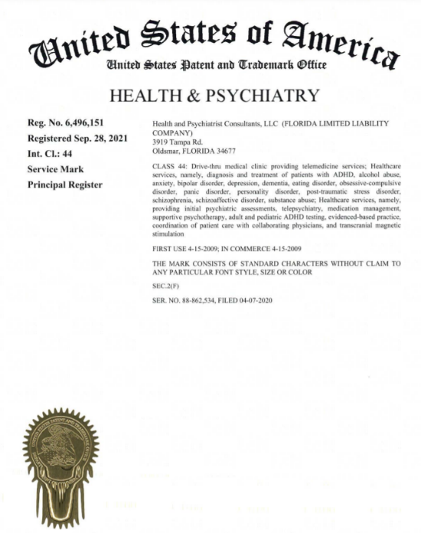

# Chief Medical Officer

______________________________________________

Dinar Sajan, MD

Dr. Sajan completed her training in Adult Psychiatry at Northwestern Memorial Hospital, Chicago.

She has been awarded “Top Psychiatrist in Clearwater” and was included in The Marquis’s Who’s Who Publications for her outstanding achievement.

At Health & Psychiatry, Dr. Sajan focuses on providing individualized treatment plans and her philosophy is clearly articulated within her practice; all clients are treated with compassion & thorough care.

# Organization Chart

______________________________________________

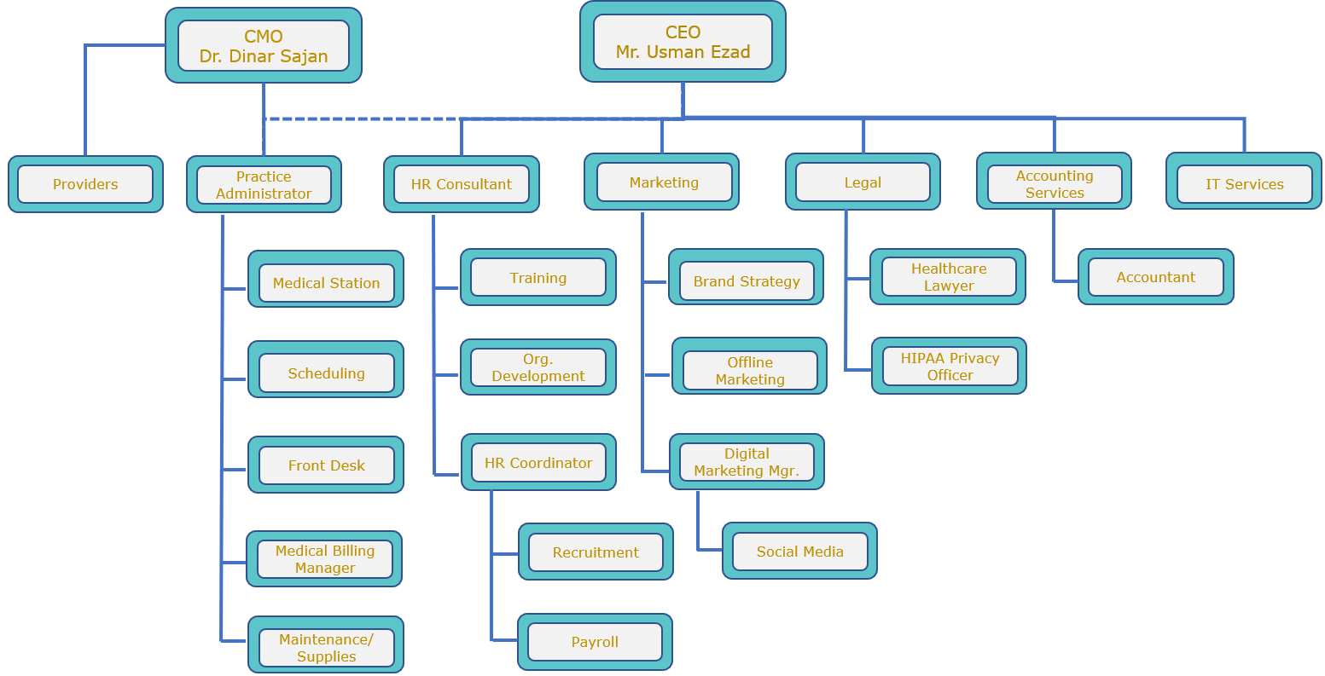

# Employee Records

______________________________________________

It is important for us to keep your personal information current. Please be sure to inform management if any of the below information about you changes during the course of your employment with our Practice:

* Legal name
* Home address
* Home telephone number
* Person to contact in case of emergency
* Marital Status, Disability Status or Veteran Status
* Dependent Information
* Change of beneficiary/Social Security number
* Driving record or status of driver’s license, if driving privileges are a part of your job duties
* Exemptions on your W-4 tax form.
* Training certificates or licenses maintained

# General Office Policies

______________________________________________

**Conduct:** Health & Psychiatry counts on its employees to behave in a manner that displays professionalism, integrity, a pursuit of excellence, good judgment, and common sense at all times. These qualities are essential to Health & Psychiatry’s ability to meet the needs of our patients in the most positive environment possible. As such, conduct that is dishonest, dangerous to others (including violence or threats of violence), embarrassing to our business, illegal, or abusive will not be tolerated. Violations of this or any Health & Psychiatry policy may be grounds for disciplinary action, up to and including termination of employment. The Company prohibits discrimination and harassment. Please refer to the Anti-Harassment and Discrimination Policy, which was provided to you and is integrated herein.

**MATTERS PERTAINING TO THE PRACTICE, ITS OPERATIONS, STAFF OR PATIENTS CANNOT BE DISCUSSED OUTSIDE THE OFFICE SETTING OR WITH OUTSIDE PARTIES (ex. friends/family/former employees/**

**competitors)**

**Dress Code:** As a general rule, employees should dress in a professional manner, taking care to ensure that they are clean and groomed in a manner consistent with generally accepted health standards, and that their clothing is appropriate workplace attire. Furthermore, Health & Psychiatry asks that employees consider the possibility that others around them may be fragrance sensitive, and avoid heavy use of perfumes and colognes, or other strongly scented products.

**Personal Calls:** Hourly employees are NOT permitted to use their telephone or any other personal device during paid work time. Likewise, they are not permitted to use any computer or device for personal communications during paid work time. If such an employee has an emergency that requires them to make a personal call or send any personal message during scheduled work time, to the extent possible, the Employee should first notify their manager that they need a break from work time in order to resolve the emergency. Failure to abide by this policy is a serious violation and may result in disciplinary action up to and including termination of employment.

Salaried employees may use their personal telephone or device for short, non-disruptive personal communication during working hours. But this communication must be kept to the shortest duration possible. Salaried employees with performance or efficiency problems may be prohibited from using personal phones or any device for personal communications during the workday. Any salaried employee who is engaged in personal communication that is disruptive, disrespectful, or decreases their ability to complete work in a timely manner, may be disciplined up to and including termination.

No employees, regardless of hourly/salaried, are ever permitted to make international personal telephone calls from office telephones or use office hotlines for personal calls.

You may provide the following work number to your family/school etc. to reach you in case of emergencies: (813) 733 6111

**PERSONAL CELL PHONE USE IS STRICTLY FORBIDDEN INSIDE THE PREMISES.**

General Office Policies (cont’d...)

______________________________________________

**Parking:** Please reserve the front of the building parking spots for the patients. Employees can park along the sides or to the rear of the building.

**Lockers:** A locker will be provided to you along with a lock to keep your personal belongings. Please write down your code in safe place once you are trained on your lock. We ask that you leave this unlocked on your last day of employment with us, otherwise a $50 locksmith charge will be deducted from your final paycheck. Employees are responsible for the safety of the contents in their lockers.

**Workplace Security:** To have a safe workplace and prevent workplace violence, each employee must be familiar with their work environment and observant of their surroundings. For example, all entrances and exits to the office area must be kept secured at all times so that no one may enter the premises without first being authorized to do so. Doors that are intended to be locked must be kept locked and not left partially open for any reason. Propping a door open, even for a good reason, is a violation of this policy.

Employees are expected to assist Health & Psychiatry in this safety precaution by informing visitors of this policy and by questioning any strangers as to their purpose in the office area. If an employee notices anyone who appears to be out of place or in a location where they should not be, an employee should immediately notify their supervisor or Talent Management or building security.

If an employee notices behavior in a patient, visitor or co-worker and believes that the individual is in need of assistance or is a threat to others, the employee should notify their Supervisor/Management immediately. It is not the employee’s responsibility to approach the individual to try to "fix" the problem or reach a conclusion as to whether or not a real problem exists. Rather, the employee’s responsibility is merely to observe the individual's behavior and immediately report what they heard or saw to a Supervisor/Management. All reports will be kept confidential to the maximum extent possible.

**Disciplinary Actions:** Discipline for violation of Practice policy will be determined on a case-by-case basis, based upon the totality of the circumstances. As a reminder, Health & Psychiatry employees are employed at will, and can be terminated or resign at any time for any lawful reason, including but not limited to economic or business reasons, unacceptable conduct or performance, or violation of the general rules of conduct.

I HAVE READ THE ABOVE CAREFULLY AND HAVE AGREED TO THE ABOVE:

____________________________ ____________________

PRINT NAME AND SIGN DATE SIGNED

# Hours & Wages

______________________________________________

**Pay Transparency Nondiscrimination Provision:**

Health & Psychiatry will not discharge or in any other manner discriminate against employees or applicants because they have inquired about, discussed, or disclosed their own pay or the pay of another employee or applicant. However, employees who have access to the compensation information of other employees or applicants as a part of their essential job functions cannot disclose the pay of other employees or applicants to individuals who do not otherwise have access to compensation information, unless the disclosure is (a) in response to a formal complaint or charge, (b) in furtherance of an investigation, proceeding, hearing, or action, including an investigation conducted by the employer, or (c) consistent with the Practice’s legal duty to furnish information.

**Policy on Salary-based Pay:**

In accordance with the federal Fair Labor Standards Act and applicable state wage and hour laws, employees are designated as either “exempt” or “non-exempt.” Generally, exempt employees are paid on a “salary basis,” which means that each work week the Employee must receive a predetermined amount of compensation, which may not be reduced because of variations in the quality or quantity of the employee’s work, subject to limited permissible deductions provided by law. Such employees are not subject to deductions for variations in the quantity or quality of the work performed. Salaried employees are paid every other week.

**Policy on Hourly Pay:**

Non-Exempt employees’ wages will be paid at an hourly rate that is agreed upon and signed by you and the manager in your compensation form. Health & Psychiatry always pays its employees compensation that meets or exceeds required wage levels under law. Standby time does not count towards hours worked. Hourly employees are paid every other week.

**Policy on Overtime:**

Overtime is to be avoided. Anything over 40 hours per week is considered overtime in Florida. It is the responsibility of the employee to check their own hours and follow the policy. Managers may exceptionally schedule overtime or extra shifts however employees are not permitted to work overtime without the prior written approval of the practice administrator; this includes starting work early and skipping designated meal breaks. Excessive warnings may lead to termination.

**Deductions:**

The company is required by law to make certain deductions from your paycheck each pay period. Such deductions typically include federal and state taxes and Social Security (FICA) taxes. Depending on the state in which you are employed and the benefits you choose, there may be additional deductions. All deductions and the amount of the deductions are listed on your pay stub. These deductions are totaled each year for you on your Form W-2, Wage and Tax Statement.

It is the policy of the company that exempt employees' pay will not be “docked,” or subject to deductions, in violation of salary pay rules issued by the United States Department of Labor and any corresponding rules issued by the state government, as applicable. However, the company may make deductions from employees' salaries in a way that is permitted under federal and state wage and hour rules. Employees will be reimbursed in full for any isolated, inadvertent, or improper deductions, as defined by law.

**Garnishment/Child Support:**

When an employee's wages are garnished by a court order, our company is legally bound to withhold the amount indicated in the garnishment order from the employee's paycheck. Our company will, however, honor applicable federal and state guidelines that protect a certain amount of an employee's income from being subject to garnishment.

**Pay Raises:**

Depending upon your performance and our company's profitability, adjustments in your pay may be made when there has been an improvement in or sustainment of an already good performance during the review period.

**Pay Advances:**

Pay advances will not be granted to employees.

# Attendance & Breaks

______________________________________________

**Attendance:** It is crucial to be at work 10 minutes prior to your scheduled start time to ensure that your station is ready for the day. There is a 90-day probationary period at the onset of your employment. We allow 3 missed days during this time. Please contact the practice administrator (or CEO) to report your absence.

**1 missed day: Note in personnel file  
2 missed days: verbal warning issued  
3 missed days: written warning issued  
4 missed days: automatic termination**

**Notice of Lateness or Unscheduled Absence:** An employee who cannot report to work on time as scheduled is required to notify the practice administrator at least 2 hours prior to the scheduled start of the employee’s regular workday on the first day of the absence and each day thereafter that they are unable to report to work. If the Practice administrator is unavailable, the employee should leave a voice mail message. An employee must give the reason for their lateness or absence, when the employee expects to arrive to work next, and how the practice administrator can contact them if needed. It is the employee’s responsibility to ensure that proper notification is given. Notification received from another employee, friend, or relative is not considered proper unless there is a bonafide emergency.

**Failure to Provide Notice of Unscheduled Absence:** An employee who fails to provide the required notice of an absence or who cannot demonstrate a bona fide emergency that prevented prompt notice will not be excused for the absence, unless required by law. An employee who does not report to work at all without any notice will be considered no call no show and subject to disciplinary action, up to and including termination. Any no call/no show lasting 3 days is considered job abandonment and will result in immediate voluntary termination of employment, absent emergency circumstances.

**Break Time:** An employee’s break time is scheduled by their supervisor, in compliance with all applicable law. Employees are to take their scheduled meal breaks away from the work area and separate from work activities. Hourly Employees are required to return from scheduled breaks promptly. Failure to do so may result in disciplinary action, up to and including termination. Salaried employees are expected to use break time (including lunch or meal breaks) judiciously, and to return promptly. Salaried employees who use break time in a manner that is excessive, unprofessional or interferes with their ability to perform their job up to our expected level of performance will be subject to disciplinary action up to and including termination.

**Smoke Breaks:** There are no designated smoke breaks. If you need them, we ask that you keep them under 3 minutes once or twice a day. Areas by the downstairs lockers or top of stairs at back are permitted smoking zones.

# Employee Benefits

______________________________________________

**Health Insurance:** Employees are eligible to opt for our Health Insurance benefits only after completing 90 days of employment with the Practice. After 90 days, if the employee chooses to enroll in our plan, Health and Psychiatry will pay 50% of the premium. The remaining 50% premium cost to be borne by the employee. Employees pay for their portion of the health insurance premium through payroll deductions. Employees should contact the Practice Administrator for further details.

**Paid Time off:** To be eligible to receive paid time off, an hourly employee must complete 6 months of employment with the Practice. Requests for PTO must be submitted at least a week in advance of the 1st date of expected absence. PTO will be offered based on employment tenure. For salaried employees, 5 major holidays and an additional 5 PTO days will be given at the start of employment, unless otherwise noted. The 5 major US holidays recognized by Health and Psychiatry are *New* *Years’ Day, Labor Day, Independence Day, Thanksgiving Day and Christmas Day.*

# Terminations & Resignations

______________________________________________

**Termination of Employment:**

THE EMPLOYMENT RELATIONSHIP BETWEEN AN EMPLOYEE AND HEALTH & PSYCHIATRY IS "AT-WILL.” THIS MEANS THAT REGARDLESS OF ANY PROVISION IN THIS EMPLOYEE HANDBOOK, EITHER YOU OR THE COMPANY MAY TERMINATE THE EMPLOYMENT RELATIONSHIP AT ANY TIME, FOR ANY REASON, WITH OR WITHOUT CAUSE OR NOTICE.

All terminated employees will be paid in accordance with state and federal laws. Earned but unused Vacation Time will be paid in accordance with Health & Psychiatry’s policy and applicable state law.

**Resignation Policy:**

Although we hope your employment with Health & Psychiatry will be a mutually rewarding experience, we understand that varying circumstances do cause employees to voluntarily resign employment. Should this time come, you are asked to follow the guidelines below regarding notice and exit procedures.

Employees are encouraged to provide two weeks’ notice to facilitate a smooth transition out of the organization. During this notice period, the employee is not permitted to use vacation days without managerial permission. All resignations should be submitted by informing the Supervisor/Practice Manager. If an employee provides more notice than requested, Health & Psychiatry will evaluate whether the additional notice period is necessary for effective business operations and will notify the employee to confirm the final date of employment.