Meer murtaza (p18-0145)

task 1 basic commonds of ubuntu:

1:ls with 3 flags:

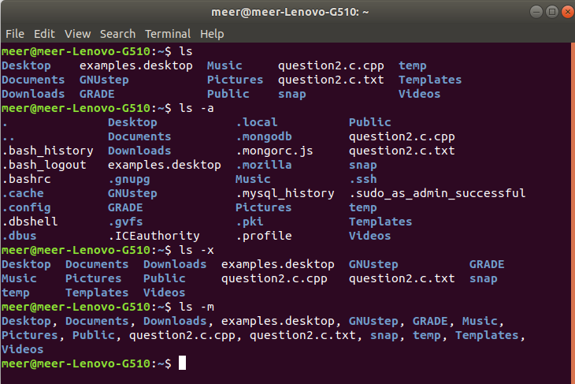

2:man for details of any commond:
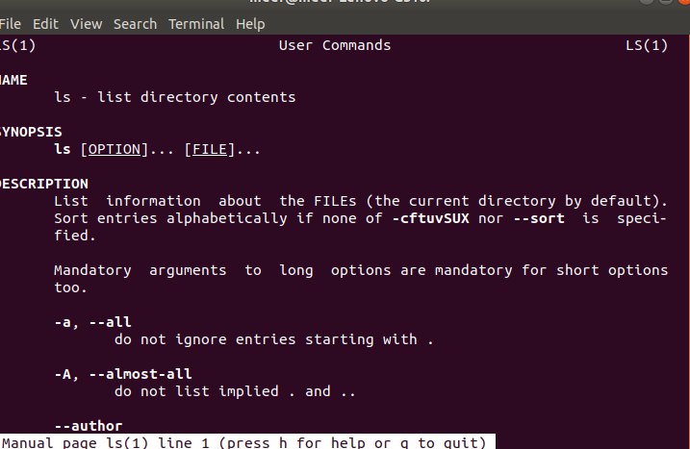

3:pwd for absolute path:

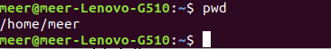

4:The less command is a Linux terminal pager that shows a file's contents one screen at a time.

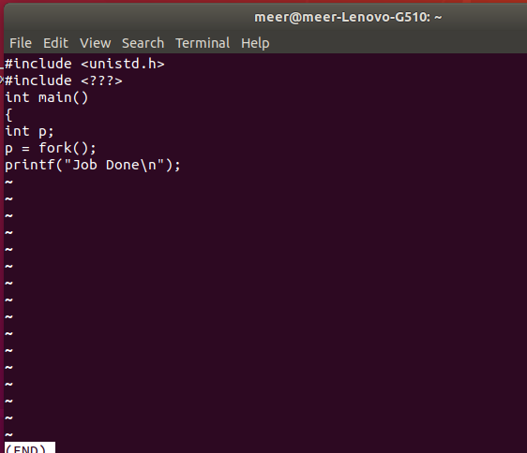

5:uname(with all flags):
The uname command writes to standard output the name of the operating system that you are using.

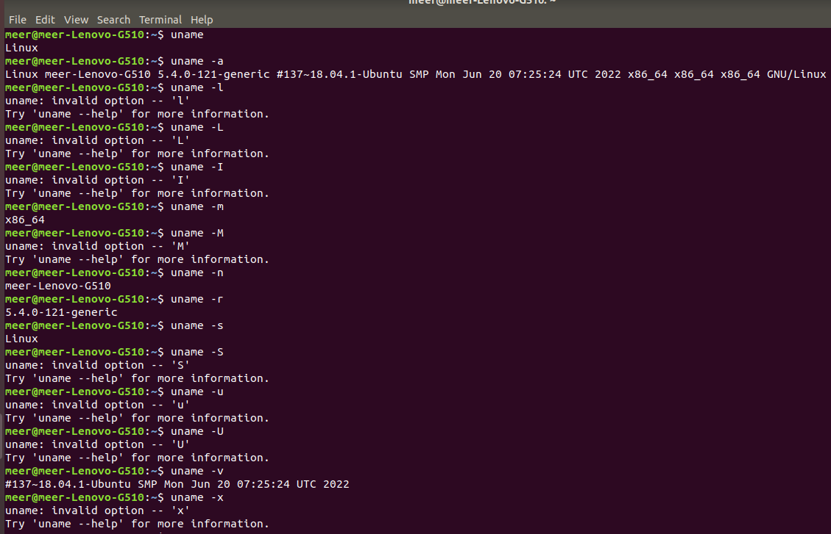

6:hostname: display the name of current host system:

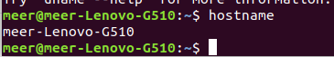

7💿:cd this commond use to change current directory:

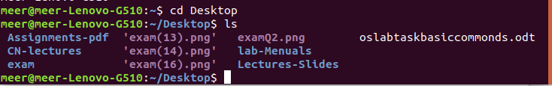

8:mkdir: for making new directory:

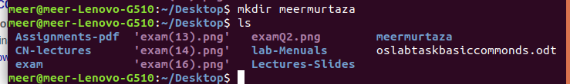

9:rmdir for remove directory:
;
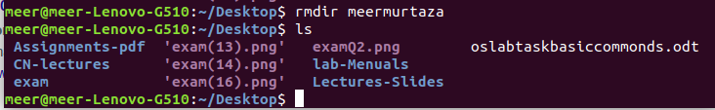

10:touch:The touch command creates a file only if the file doesn't already exist.

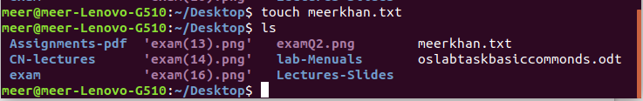

11:grep:The grep command searches through the file, looking for matches to the pattern specified.

12:cat :cat command allows us to create single or multiple files, view content of a file, concatenate files and redirect output in terminal or files.

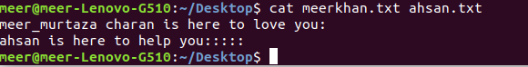

13:SORT command is used to sort a file, arranging the records in a particular order. By default, the sort command sorts file assuming the contents:
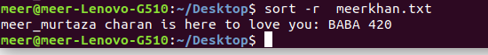

14:head & tail: head output first part of file and tail output the last part of file:

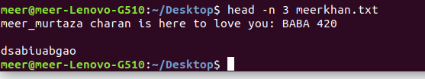

15:stat The stat is a command which gives information about the file and filesystem. Stat command gives information such as the size of the file.

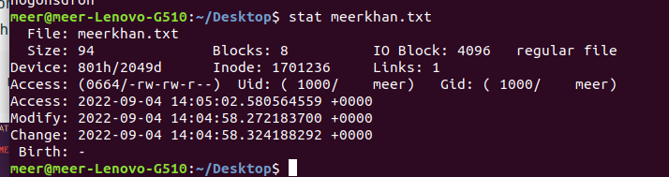

16:free: The Linux free command outputs a summary of RAM usage, including total, used, free, shared, and available memory and swap space.
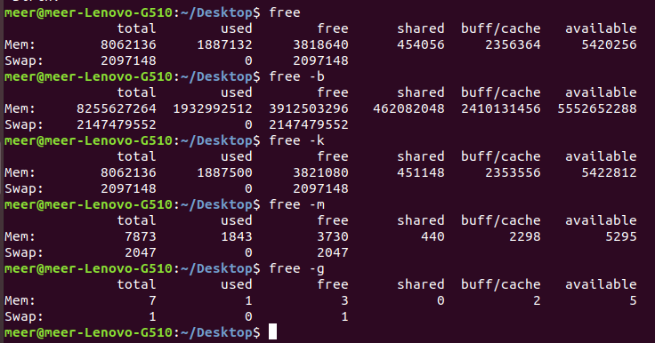

17:uptime: Uptime is a command that returns information about how long your system has been running together with the current time

18:top: top command is used to show the Linux processes.

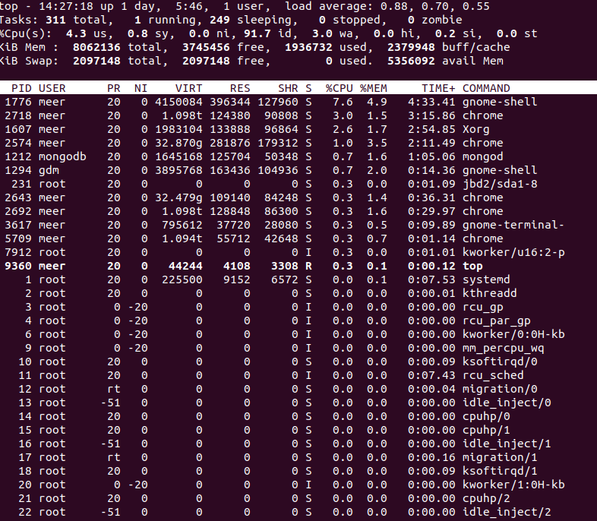

19:ifconfig: use for network details:

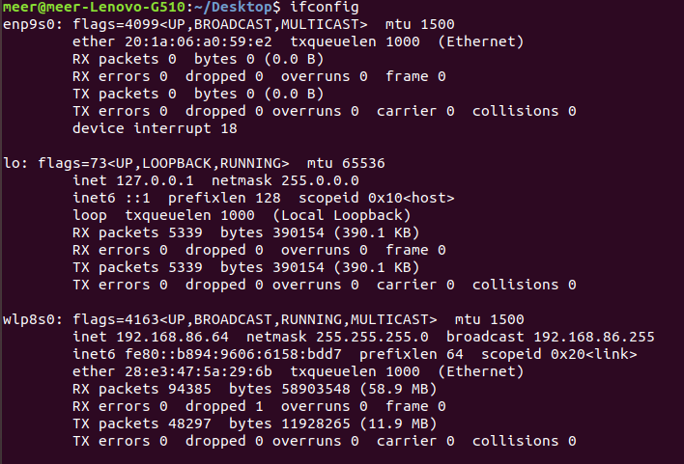

20:gzip: use to zip the file:

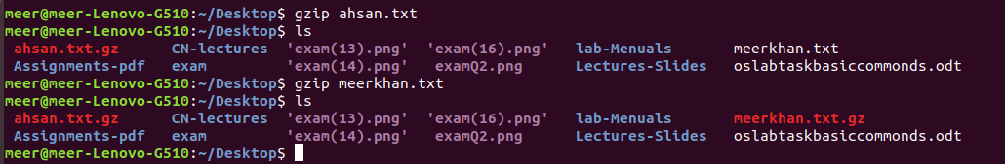

21:gunzip use to unzip a file:
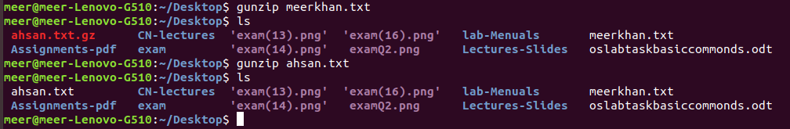

22:ping ping commond use to check the destination is live or not

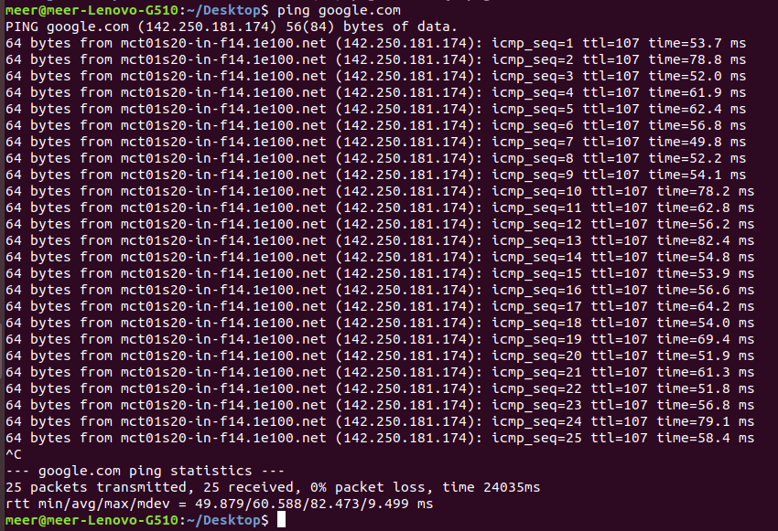

23:netset: Netstat is a command line utility to display all the network connections on a system. It displays all the tcp, udp and unix socket connections. Apart from connected sockets it also displays listening sockets that are waiting for incoming connections.

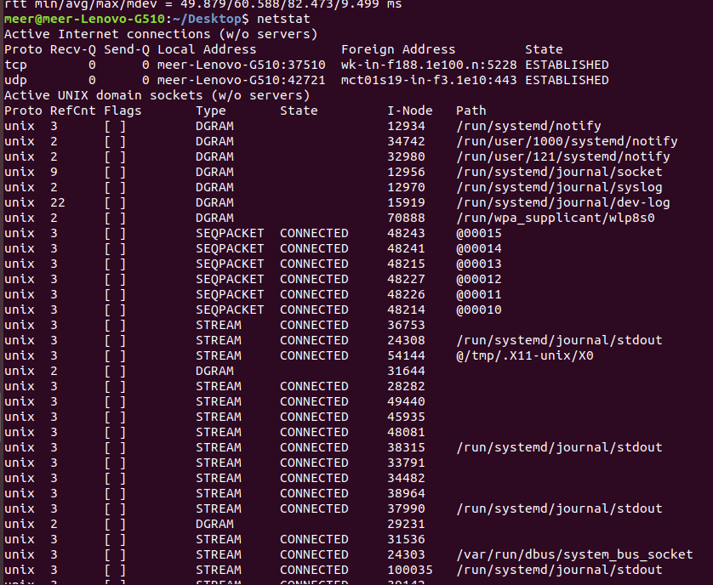

24:nslookup: is a useful command for getting information from the DNS server.

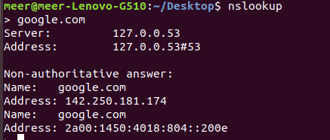

25:ps: ps for viewing information related with the processes on a system which stands as abbreviation for “Process Status”. ps command is used to list the currently running processes and their PIDs along with some other information depends on different options. It reads the process information from the virtual files in /proc file-system. /proc contains virtual files, this is the reason it’s referred as a virtual file system.
