INSTITUTIONAL ENGINEERING & ACADEMIC SCHEDULING
Software Requirements Specification (SRS)
Smart Classroom & Timetable Scheduler (TS-SC)
Document Version: | Version 2.0 (High-Level Architecture & Implementation Baseline)
Compliance Standard: | IEEE Std 830-1998 / ISO/IEC/IEEE 29148 / SEPM Standards
Target System: | Higher Education Institutional Timetabling & Dynamic Substitution
Lifecycle Status: | Approved Baseline — Implemented & Production Tested
Publication Date: | November 2026

1. Introduction
1.1 Purpose
This Software Requirements Specification (SRS) document details the high-level functional, non-functional, interface, and behavioral requirements for the Smart Classroom & Timetable Scheduler (TS-SC) platform. It reflects the production architecture following iterative development cycles, documenting both initial design requirements and the subsequent architectural shifts (pivots) implemented to enhance privacy, performance, deployment consolidation, and security.
1.2 Scope
TS-SC is an automated institutional timetable generation, resource allocation, and dynamic faculty substitution engine designed for higher education institutions (specifically modeled on university departments such as SVVV Indore). The system:
- Automated Timetable Generation: Constraint programming (Google OR-Tools CP-SAT) formulates decision variables to generate complete, conflict-free academic schedules across faculty, sections, and physical rooms.
- Infeasibility Explainability: When an academic configuration cannot be scheduled due to physical or load limitations, iterative constraint relaxation pinpoints the exact structural cause of failure instead of failing silently.
- Dynamic Faculty Substitution: Same-day substitution requests trigger candidate identification, multi-attribute compatibility scoring (P1 > P2 > P3), load balancing, and timeout handling.
- Zero-Account Student Privacy: Students access schedules using Section Codes and Coordinator Passkeys via an encapsulated PostgreSQL RPC, ensuring zero personally identifiable data is stored.
- Role-Hardened Security: Faculty sign-in and administrative tools are secured with strict Row-Level Security policies and discrete, obscured login discovery.
1.3 Definitions, Acronyms, and Abbreviations
Term / Acronym | Definition
CP-SAT | Constraint Programming - Boolean Satisfiability Solver (Google OR-Tools).
RLS | Row-Level Security in PostgreSQL, enforcing authorization policies at the database engine level.
RPC | Remote Procedure Call (SECURITY DEFINER stored functions executing with elevated database privileges).
BaaS | Backend-as-a-Service (Supabase: PostgreSQL, Auth, Storage, Realtime).
SEPM | Software Engineering and Project Management.
Passkey | Cryptographically distinct, human-readable section credential (e.g., H-7216) distributed offline.
Priority Tiers | Ranking for faculty substitution: P1 (Same section & free), P2 (Same course qualification & free), P3 (Free faculty in department).
Temporal Rule | Constraint permitting substitution requests exclusively on the day of the lecture, prior to the lecture start time.
2. Overall Description & Architectural Evolution
2.1 Architectural Pivot Log
During system development and deployment testing, critical operational, infrastructural, and privacy constraints prompted key architectural revisions away from the legacy specification:
Feature / Subsystem | Legacy SRS Design (v1.0) | Revised Production Architecture (v2.0)
Student Account Model | Individual Supabase Auth accounts (email/password), profiles table with student role. | Zero-Account Passkey Access: Students store no PII. Access via Section Code + Passkey RPC.
Administrative Login Discovery | Prominent Admin tab on public login landing page. | Security by Obscurity: Public login shows Student & Faculty. Admin gated in muted footer trigger to block probes.
Microservice Hosting & Solver Gateway | External PaaS (Render / Fly.io) subject to cold starts (1-2m) and distributed domains. | Vercel Multi-Service: Vite + FastAPI Gateway + internal CP-SAT Solver via private IPC service bindings.
Timetable Color Model for Substitutions | Binary scheduled/free lecture state. | Real-Time Trinary Color States: Yellow (pending), Green (assigned), Red (expired/unfilled).
Substitution Timing Constraints | Arbitrary advance scheduling permitted. | Strict Day-Of Temporal Guard: Requests valid only on lecture day before lecture starts.
2.2 User Classes & Personas
- System Administrator: Academic Registrar / Timetable Coordinator. Configures academic resources (rooms, programs, courses, faculty), executes the CP-SAT solver, reviews soft-constraint conflicts, manages section passkeys, and publishes official versions.
- Faculty Member: Authenticated faculty profile. Views weekly timetable, initiates same-day substitution requests, accepts/declines incoming substitution requests, and monitors personal workload.
- Student / Class Coordinator: Unauthenticated student or coordinator. Views live published section schedules via Section Code and Passkey, toggles laboratory batch filters (Batch 1 / Batch 2), and tracks real-time substitution highlights.
- Internal Microservices (Solver & API Gateway): Automated worker services executing mathematical optimization, candidate scoring, and proxy routing.
3. System Features & Functional Requirements
3.1 Module 1: Institutional Resource Management
- F-REQ-1.1 (Room Management): The system shall allow administrators to manage rooms with physical capacities and room types (classroom, lab, seminar_hall).
- F-REQ-1.2 (Course Catalogs): The system shall maintain course catalogs specifying credits, weekly session frequency, continuous session duration, and laboratory prerequisites.
- F-REQ-1.3 (Faculty Qualifications): The system shall enforce faculty-course qualification mappings, preventing faculty from being scheduled for unqualified subjects.
- F-REQ-1.4 (Section & Batch Partitioning): The system shall support section partitioning into multiple lab batches (Batch 1 and Batch 2) for concurrent laboratory scheduling.
- F-REQ-1.5 (Elective Slot Blocks): The system shall allow definition of exclusive elective slot-blocks where core courses cannot be scheduled.
3.2 Module 2: Automated Timetable Generation & CP-SAT Engine
- F-REQ-2.1 (Hard Constraint - Resource Singularity): No room, faculty member, or student section shall be assigned to more than one session in any given time slot.
- F-REQ-2.2 (Hard Constraint - Capacity & Type Match): Laboratory courses must be assigned to laboratory rooms; room capacity must be >= section strength (or batch strength for practicals).
- F-REQ-2.3 (Hard Constraint - Workload Limit): Weekly scheduled hours for each faculty member shall not exceed their configured maximum weekly load.
- F-REQ-2.4 (Soft Constraint - Gap Minimization): The optimization model shall penalize single-period idle gaps in student daily schedules.
- F-REQ-2.5 (Soft Constraint - Daily Spread): Sessions of the same multi-credit course shall be evenly distributed across distinct days of the academic week.
- F-REQ-2.6 (Infeasibility Diagnostics): When constraints are mathematically irreconcilable, the solver shall execute iterative constraint relaxation (loads, rooms, qualifications, electives) and output the exact structural cause of failure.
3.3 Module 3: Dynamic Same-Day Faculty Substitution Engine
- F-REQ-3.1 (Temporal Enforcement): Faculty can request substitutions only on the same calendar day as the scheduled lecture and prior to the slot's start time.
- F-REQ-3.2 (Algorithmic Priority Ranking): When a request is created, candidate faculty are ranked by Priority 1 (teaching same section), Priority 2 (qualified for course), and Priority 3 (department free faculty), tie-broken by lowest weekly load and earliest response.
- F-REQ-3.3 (State Transitions & Timeout): The request transitions across Open, Assigned, or Expired (if unfulfilled 10 minutes post lecture start, marking lecture free).
- F-REQ-3.4 (Penalty Tracking): Declining or failing to respond to a substitution request shall log an administrative penalty record.
3.4 Module 4: Zero-Account Student Passkey Access
- F-REQ-4.1 (Privacy Preservation): The system shall strictly prohibit storing student identities, names, or email accounts in the database.
- F-REQ-4.2 (Cryptographic RPC Verification): Timetable data for students shall only be accessible through the PostgreSQL SECURITY DEFINER function get_section_timetable(p_code, p_passkey).
- F-REQ-4.3 (Live Slot Highlighting): The student timetable grid shall visually indicate substitutions: Yellow for pending, Green for assigned substitute, and Red for expired/free period.
- F-REQ-4.4 (Batch Filtering): Students shall be able to filter practical lab sessions by Batch 1, Batch 2, or All Batches directly in the user interface.
3.5 Module 5: Secure Authentication & Discovery Boundary
- F-REQ-5.1 (Public Login Boundary): Default authentication route (/login) shall display only Student Passkey Access and Faculty Sign-In.
- F-REQ-5.2 (Obfuscated Admin Entry): Administrative login credentials and input forms shall remain hidden behind a discrete, unstyled trigger to minimize exposure to automated vulnerability crawlers.
4. External Interface & Architectural Requirements
The TS-SC platform is deployed as a consolidated Vercel Project containing three distinct services interacting via internal service bindings:
- Service 'frontend' (Vite + React + TypeScript): Single-Page Application deployed on Vercel's Edge CDN, routing all public UI traffic from /(.*). Communicates directly with Supabase via Supabase JS SDK.
- Service 'api' (FastAPI Public Gateway): FastAPI public reverse proxy exposed at /api/(.*), forwarding requests securely to the solver.
- Service 'solver' (Internal Optimization Worker): FastAPI microservice executing Google OR-Tools CP-SAT algorithms, kept completely internal without direct public internet exposure. Receives requests via Vercel service binding SOLVER_URL.
- Database & BaaS Tier (Supabase Cloud): PostgreSQL 15 database hosted on Supabase Cloud, utilizing Row-Level Security (RLS) for faculty data isolation and stored procedure RPCs for student access.
[ARCHITECTURE NOTE] Vercel service bindings resolve dynamically in serverless functions at runtime without exposing the internal solver service to the public internet.

5. Conceptual Models & UML Diagrams (SEPM Standards)
This section contains standard UML 2.5 conceptual models representing the system boundary, domain entity relationships, dynamic interactions, behavioral state machines, and deployment layout.
5.1 UML Use Case Diagram
Defines the interactions between human/automated actors and core system use cases within the institutional scheduling boundary.
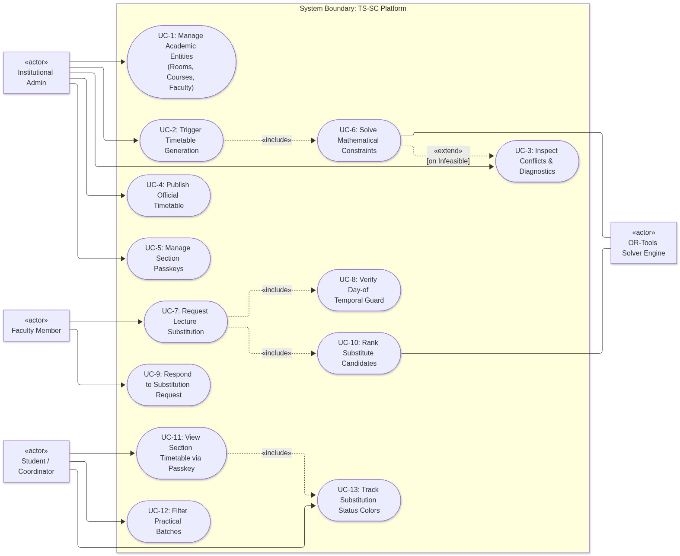
Figure 1: UML Use Case Diagram — Actors, Use Cases, «include» & «extend» Dependencies
5.2 UML Class Diagram
Models domain entities, structural properties, visibility, data types, operations, and multiplicity associations.
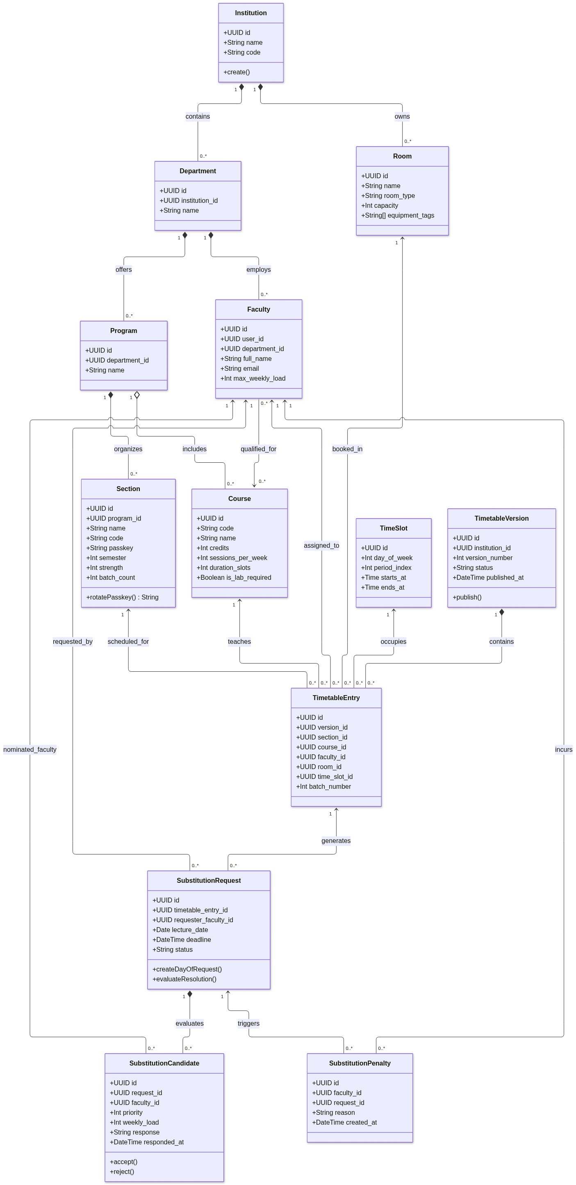
Figure 2: UML Class Diagram — Institutional Entities, Scheduling Relations, and Cardinality

5.3 UML Sequence Diagram: Timetable Generation & Infeasibility Analysis
Details the dynamic message interchange during mathematical optimization, including conflict relaxation diagnostics.
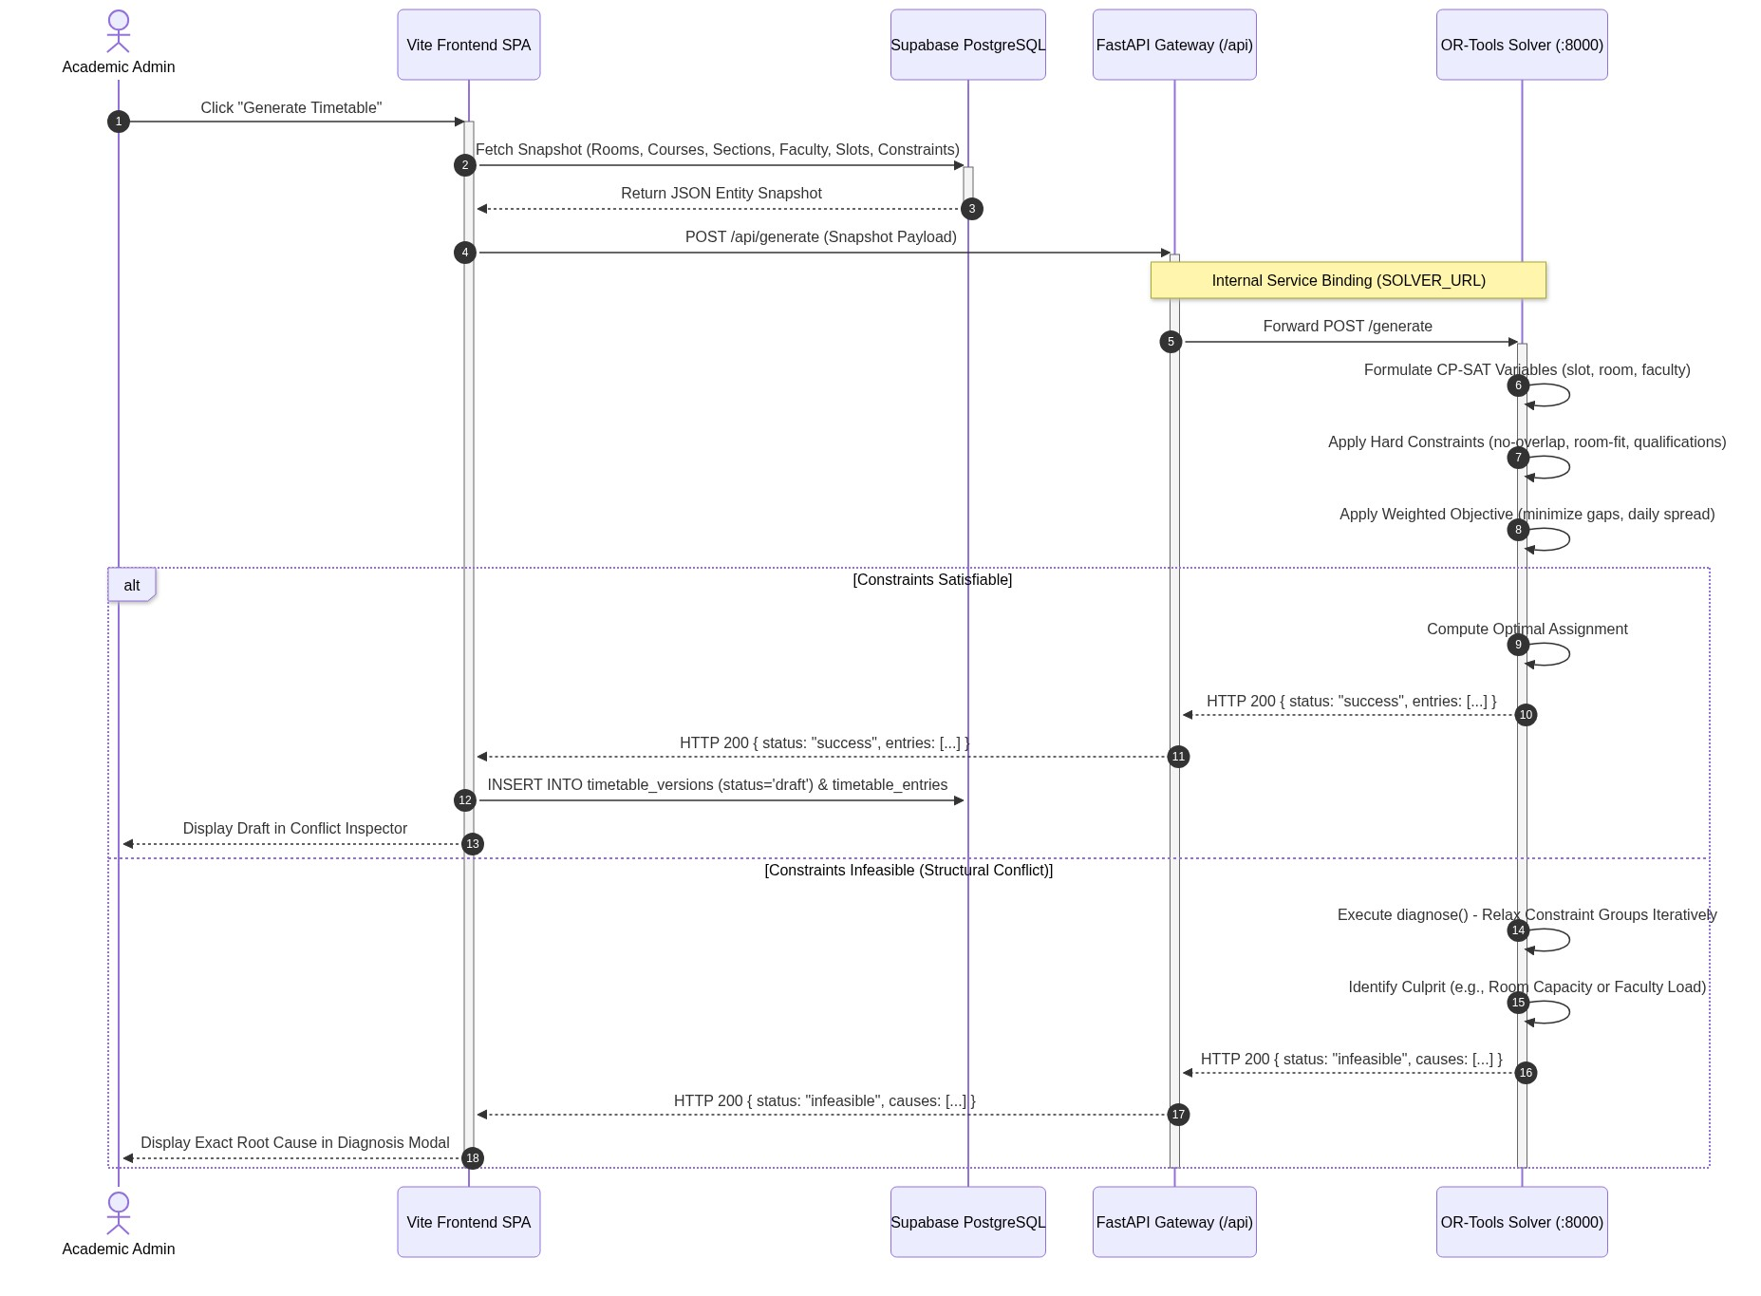
Figure 3: UML Sequence Diagram — Automated Generation & Constraint Relaxation Diagnostics
5.4 UML Sequence Diagram: Priority-Based Faculty Substitution Lifecycle
Captures the same-day request submission, temporal validation, candidate ranking, and state resolution sequence.
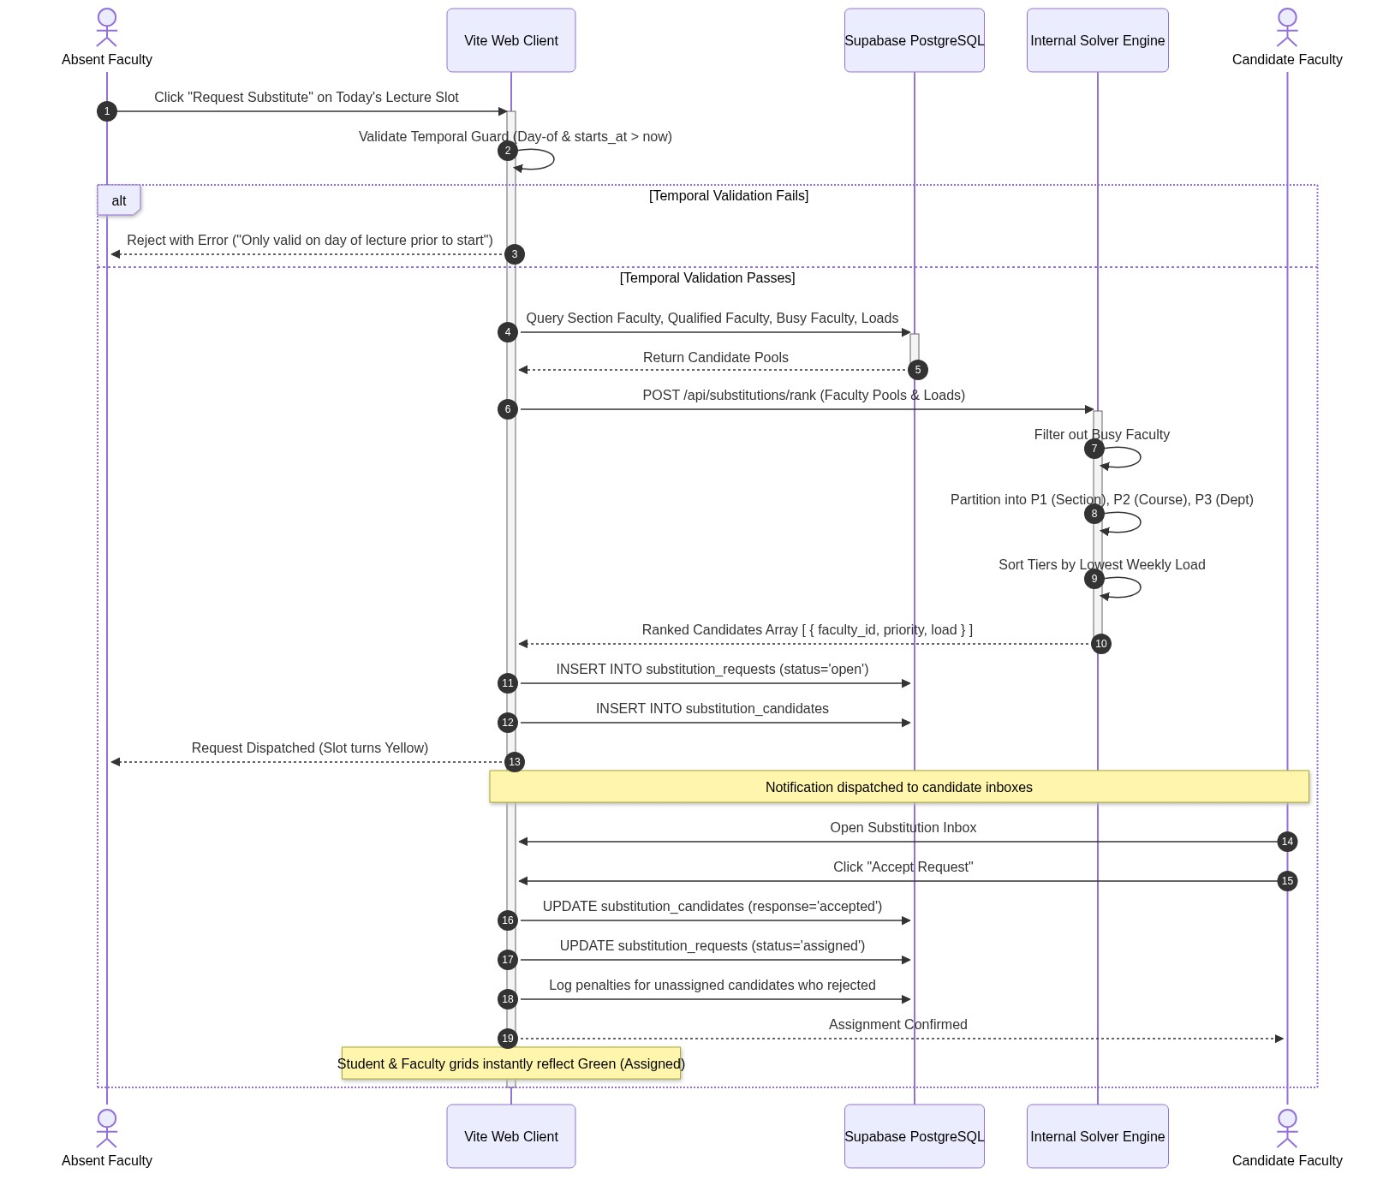
Figure 4: UML Sequence Diagram — Substitution Ranking Engine & State Confirmation

5.5 UML Activity Diagram: Substitution Request Evaluation Workflow
Illustrates control flow, decision branches, timeout guards, and UI color transformations.
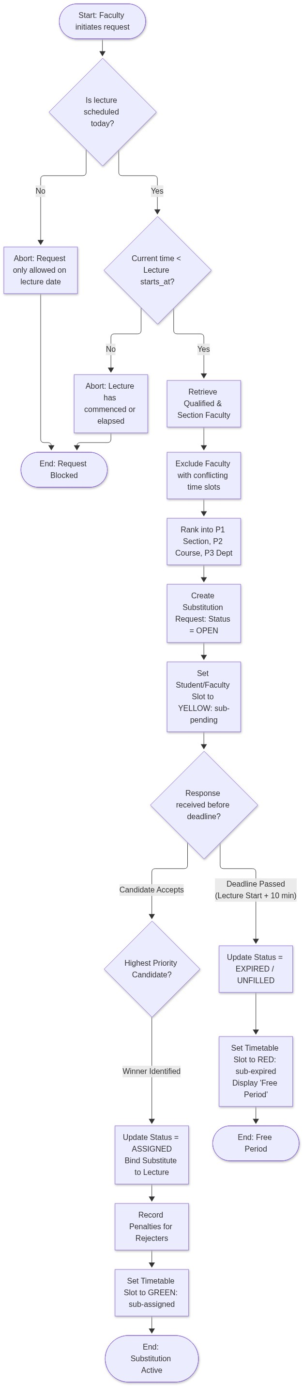
Figure 5: UML Activity Diagram — Decision Logic, Deadlines, and Visual Slot Updates
5.6 UML State Machine Diagram: Substitution Entity Lifecycle
Specifies entity states and trigger transitions for SubstitutionRequest entities from creation through terminal resolution.
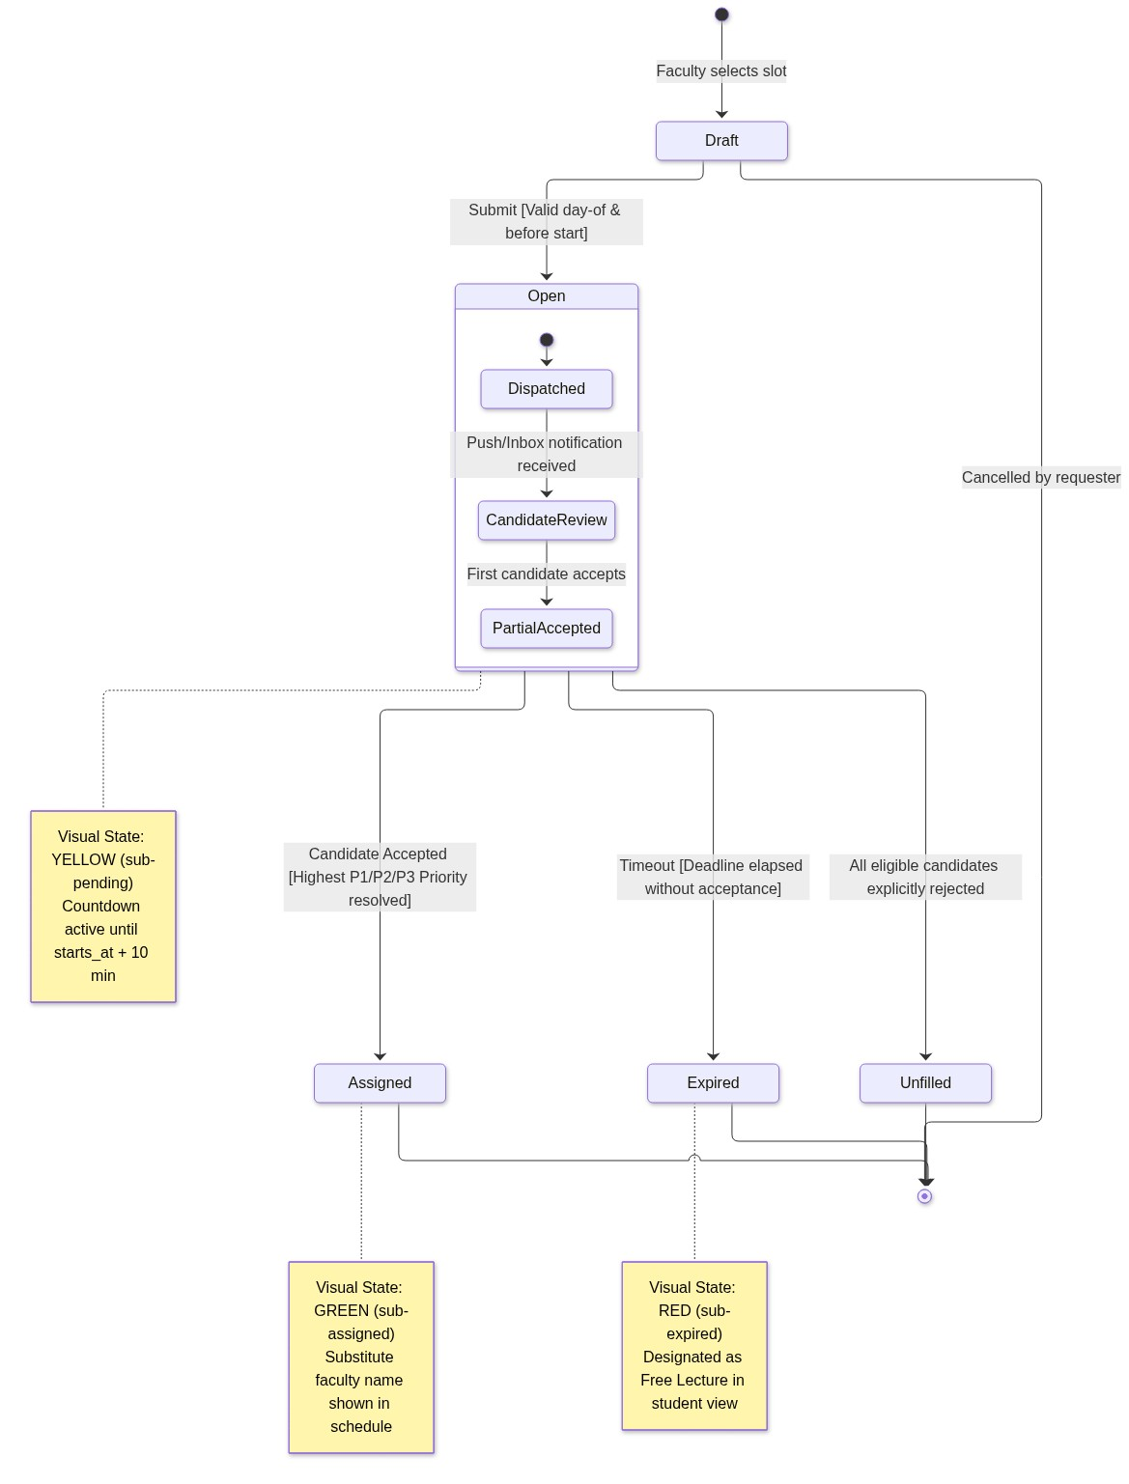
Figure 6: UML State Machine Diagram — Substitution Request Lifecycle & Trinary UI Colors

5.7 UML Deployment Diagram: Consolidated Vercel Multi-Service Architecture
Maps physical and virtual execution containers, internal service bindings, and external BaaS infrastructure.
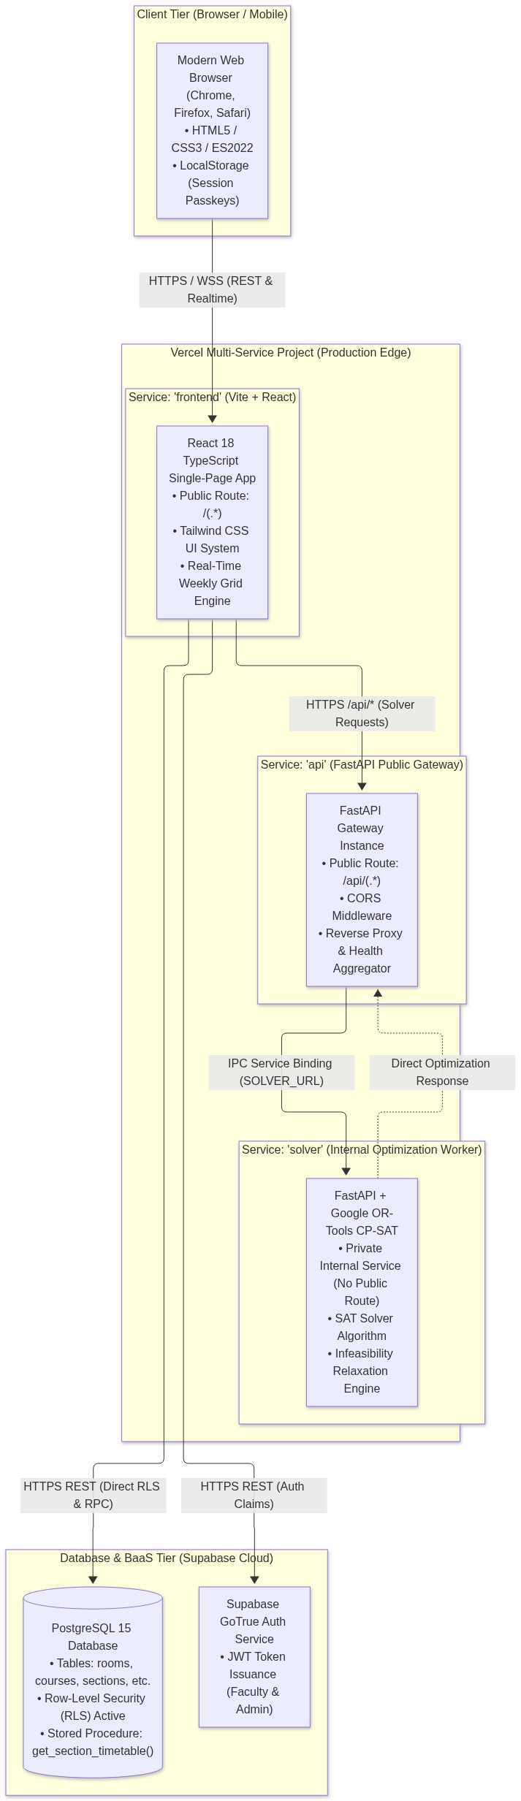
Figure 7: UML Deployment Diagram — Multi-Service Topography & Supabase Cloud
6. Non-Functional Requirements (NFR)
- NFR-P1 (Timetable Solving Latency): The CP-SAT engine shall solve standard department workloads (<= 60 sections, <= 500 weekly course sessions) within 120 seconds.
- NFR-P2 (RPC Query Latency): Student section timetable queries via the get_section_timetable RPC shall return within 300 milliseconds under standard network conditions.
- NFR-P3 (Vite Cold Build Time): Incremental production build duration for the frontend on Vercel shall not exceed 15 seconds.
- NFR-S1 (Zero-Trust Student Privacy): No personal identifiable information (PII) such as student enrollment IDs, names, or contact data shall be stored in any database table.
- NFR-S2 (RPC Encapsulation): Student schedule retrieval must execute under a SECURITY DEFINER stored function that isolates access solely to verified section codes and matching passkeys.
- NFR-S3 (Admin Route Obfuscation): The administrative authentication mechanism must remain unindexed and hidden behind an opaque trigger to eliminate automated dictionary attack vectors.
- NFR-R1 (Zero Cold Starts): Deployment on Vercel services with multi-service binding shall eliminate the 1-2 minute inactive spin-up latency characteristic of legacy free-tier PaaS providers.
- NFR-R2 (Explainable Infeasibility): The timetable solver shall never fail silently; when an infeasible state occurs, a diagnostic relaxation breakdown shall identify the violating constraint group.
7. Requirements Traceability Matrix (RTM)
The Requirements Traceability Matrix correlates functional requirements, components, UML models, verification methods, and implementation status:
Requirement ID | Module / Component | UML Artifact Reference | Verification Method | Status
F-REQ-1.1 – 1.5 | Resource Management | Figure 2 (Class Diagram) | Integration Test | Implemented
F-REQ-2.1 – 2.3 | CP-SAT Hard Constraints | Figure 2 & 3 (Sequence Diagram) | Solver Unit Test | Implemented
F-REQ-2.4 – 2.5 | Soft Optimization (Gaps/Spread) | Figure 3 (Sequence Diagram) | Benchmarking Suite | Implemented
F-REQ-2.6 | Infeasibility Diagnostics | Figure 3 (Sequence Diagram) | Diagnostic Test | Implemented
F-REQ-3.1 | Day-Of Temporal Guard | Figure 4 & 5 (Activity Diagram) | Unit Test (getLectureTemporalStatus) | Implemented
F-REQ-3.2 | Algorithmic P1/P2/P3 Ranking | Figure 2 & 5 (Activity Diagram) | Ranking Test Suite | Implemented
F-REQ-3.3 | Real-Time Substitution States | Figure 5 & 6 (State Machine) | UI Integration Test | Implemented
F-REQ-4.1 – 4.2 | Zero-Account Passkey Access | Figure 1 (Use Case) & Figure 7 | Security Penetration Audit | Implemented
F-REQ-4.3 | Color-Coded Timetable Grid | Figure 6 (State Machine) | UI Snapshot Test | Implemented
F-REQ-5.1 – 5.2 | Obfuscated Administrative Login | Figure 1 (Use Case) & Figure 7 | Vulnerability Scan | Implemented
NFR-R1 | Vercel Multi-Service Binding | Figure 7 (Deployment Diagram) | End-to-End Latency Probe | Implemented

