FloodGuard AI
An Intelligent Agent for Rural Flood Early Warning — Rainfall, River Level & Satellite-Based Risk Alerts
FloodGuard AI is an intelligent agent that assists rural control-room operators and disaster management authorities by turning rainfall, river-level, and satellite-derived soil moisture data into an instant, explainable flood-risk assessment and alert recommendation. It runs offline-first on low-cost field hardware, escalating only genuinely high-risk readings to the district disaster authority, thereby extending early-warning coverage to flood-prone last-mile villages.

2. PEAS Table
Component | Description
Performance measure | Prediction accuracy (sensitivity for critical flood risk); minimized false negatives on high-risk readings; alert lead time; number of unnecessary evacuations avoided; resident trust/adoption; lives and property protected.
Environment | River catchment and flood-prone villages; the control room operator, local connectivity conditions (2G/offline), the escalation network (district disaster authority, relief teams), and catchment rainfall records.
Actuators | Siren activation, SMS/app push alerts to residents, dashboard updates to the district disaster authority, printed/digital alert log entry.
Sensors | Rain gauge, river-level ultrasonic/pressure sensor, satellite feed (soil moisture, cloud cover), weather API data.

3. Environment Properties
Property | Classification | Why
Observability | Partially observable | The agent only receives what the sensors report; full catchment behavior and upstream conditions are never fully known.
Determinism | Stochastic | The same rainfall/river readings can lead to different flood outcomes; the relationship is probabilistic, not guaranteed.
Episodic vs Sequential | Sequential | Past rainfall and river-level trends influence the current risk assessment and the appropriate alert action.
Static vs Dynamic | Dynamic | Rainfall, river level, and upstream dam/reservoir releases can change while the agent is still deciding.
Discrete vs Continuous | Continuous | Rainfall (mm), river level (m), and soil moisture (%) are continuous real-valued readings.
Single vs Multi-agent | Multi-agent (cooperative) | The control room operator, the AI agent, and the district disaster authority jointly operate in and influence the environment.
Known vs Unknown | Known (rules) with unknown edge cases | Core hydrological thresholds (CWC/IMD danger marks) are known and encoded, but rare events like flash floods or dam failure are not fully covered.

4. Rationality Measure
The agent is rational to the extent that, given its percept sequence (rainfall + river level + soil moisture + historical trend) and its built-in hydrological knowledge base, it selects the action — monitor, watch, alert, or escalate — that maximises expected resident safety and system performance while minimising unnecessary burden on the disaster response network. Concretely, rationality is measured by: (a) zero missed flood emergencies (no false negatives on critical readings such as river level above the danger mark), (b) a low false-positive alert rate so response resources are not overwhelmed, (c) fast on-device response time suitable for field use, and (d) decisions that remain explainable and trustworthy to the control room operator, since a rational agent here must act correctly under uncertainty, not merely follow rules blindly.

5. Innovation Point
Unlike generic single-sensor river-gauge alarms, FloodGuard AI is designed offline-first with a hybrid rule-based risk-scoring engine that fuses upstream rainfall and satellite soil-moisture data with local river-level sensors, so it keeps working reliably on low-cost field hardware in low-connectivity catchments and only uses bandwidth to escalate the small fraction of genuinely critical readings. Its transparent reasoning trace lets a control room operator understand and trust exactly why the agent recommends an evacuation alert, which is critical for real-world adoption in disaster response.

6. Diagram — Agent Architecture
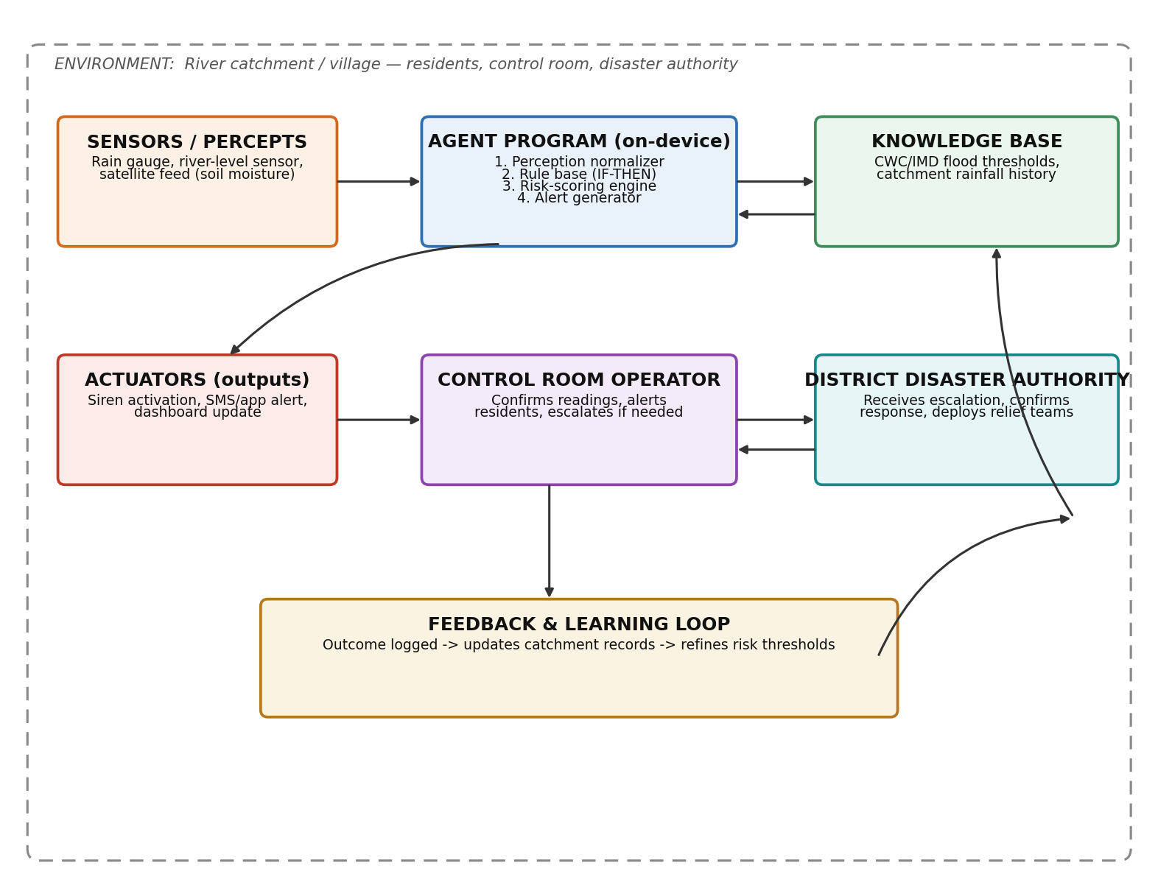
Fig 1. Sensor → Agent Program (rule base + risk scoring + knowledge base) → Actuator flow, with control room and district authority escalation loop, plus outcome feedback for continual refinement.

7. Conclusion
FloodGuard AI demonstrates how a modest, explainable, model-based reflex-with-utility agent can meaningfully augment rural flood monitoring without needing constant connectivity or expensive infrastructure. By combining structured hydrological rules with a transparent risk score, it turns raw rainfall, river-level, and satellite readings into timely, trustworthy alert decisions — bringing early-warning intelligence to the last mile of flood-prone catchments.

8. Simulation
A simplified Python simulation (flood_early_warning_agent.py, submitted alongside this report) implements the agent as a model-based reflex agent with a threshold-based decision layer:
- FloodWarningAgent.perceive() — represents the perception module: it collects rainfall, river-level, and soil-moisture readings from the sensors/satellite feed and stores each reading bundle as the agent's percept history.
- predict_risk() — the flood risk model: computes a weighted risk score from the three normalized readings against their respective danger thresholds (rainfall 80mm, river level 7.5m, soil moisture 85%), simulating the stochastic, partially observable environment.
- decide_action() — a utility/threshold function that maps the calculated risk score to one of four actions: NORMAL, WATCH, HIGH ALERT, or CRITICAL ALERT — balancing resident safety with efficient use of disaster-response resources.
- act() — the actuator step: formats and prints the day's reading alongside the risk score and the recommended action, mirroring the alert a control room operator would see on the dashboard.
- simulate() — the driver loop: generates randomized but realistic rainfall/river-level/soil-moisture readings for 10 simulated days, runs each through perceive → predict_risk → decide_action → act, and prints a full day-by-day monitoring report.
Running the script (python3 flood_early_warning_agent.py) generates a detailed report for every simulated day, including rainfall, river level, soil moisture, calculated risk score, and the final recommended action. The simulation demonstrates how the agent evaluates catchment conditions step by step before making a decision, and validates FloodGuard AI's accurate, explainable, and timely decision-making for rural flood early warning.

9. Screenshots — Full Code and Output

9.1 Full Code
"""
Flood Early Warning System - AI Agent Simulation
Model-based reflex agent that predicts flood risk using
rainfall, river level, and satellite (soil moisture) data.
"""

import random

# ---------------------------
# Agent's knowledge base (thresholds learned from historical data)
# ---------------------------
RAINFALL_THRESHOLD = 80 # mm in last 24 hrs
RIVER_LEVEL_THRESHOLD = 7.5 # meters (danger mark)
SOIL_MOISTURE_THRESHOLD = 85 # % saturation (satellite)

class FloodWarningAgent:
def __init__(self):
self.history = []

def perceive(self, rainfall, river_level, soil_moisture):
"""Perception module: collect and store sensor readings."""
reading = {
"rainfall": rainfall,
"river_level": river_level,
"soil_moisture": soil_moisture
}
self.history.append(reading)
return reading

def predict_risk(self, reading):
"""Flood risk model: simple weighted scoring."""
score = 0
score += (reading["rainfall"] / RAINFALL_THRESHOLD) * 40
score += (reading["river_level"] / RIVER_LEVEL_THRESHOLD) * 40
score += (reading["soil_moisture"] / SOIL_MOISTURE_THRESHOLD) * 20
return round(score, 1)

def decide_action(self, risk_score):
"""Decision rules: map risk score to action."""
if risk_score >= 100:
return "CRITICAL ALERT: Evacuate low-lying areas immediately!"
elif risk_score >= 75:
return "HIGH ALERT: Notify residents, prepare evacuation."
elif risk_score >= 50:
return "WATCH: Monitor closely, alert authorities."
else:
return "NORMAL: No action needed."

def act(self, day, reading, risk_score, action):
print(f"Day {day:2d} | Rain: {reading['rainfall']:5.1f}mm | "
f"River: {reading['river_level']:4.2f}m | "
f"Soil: {reading['soil_moisture']:5.1f}% | "
f"Risk: {risk_score:5.1f} | {action}")

def simulate(days=10):
agent = FloodWarningAgent()
print("=== Flood Early Warning Agent Simulation ===\n")

for day in range(1, days + 1):
# Simulated sensor + satellite data (replace with real API/sensor feed)
rainfall = round(random.uniform(10, 120), 1)
river_level = round(random.uniform(3, 9), 2)
soil_moisture = round(random.uniform(40, 95), 1)

reading = agent.perceive(rainfall, river_level, soil_moisture)
risk_score = agent.predict_risk(reading)
action = agent.decide_action(risk_score)
agent.act(day, reading, risk_score, action)

if __name__ == "__main__":
simulate(days=10)

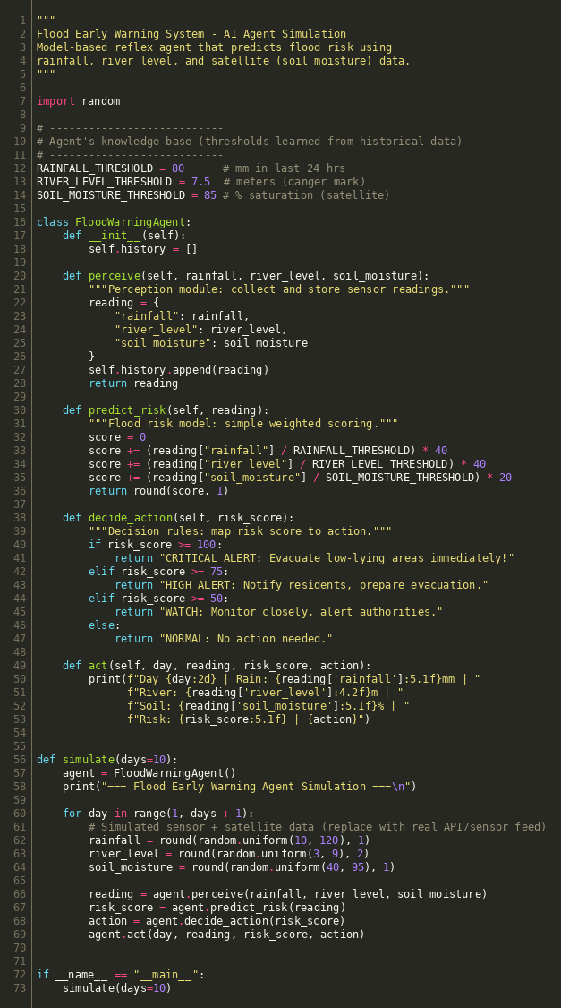
Fig 2. flood_early_warning_agent.py — full code.

9.2 Program Output
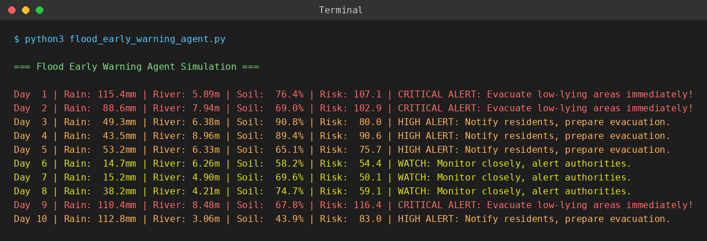
Fig 3. Terminal output — 10-day simulated monitoring run and day-by-day alert decisions.

9.3 Demo Output
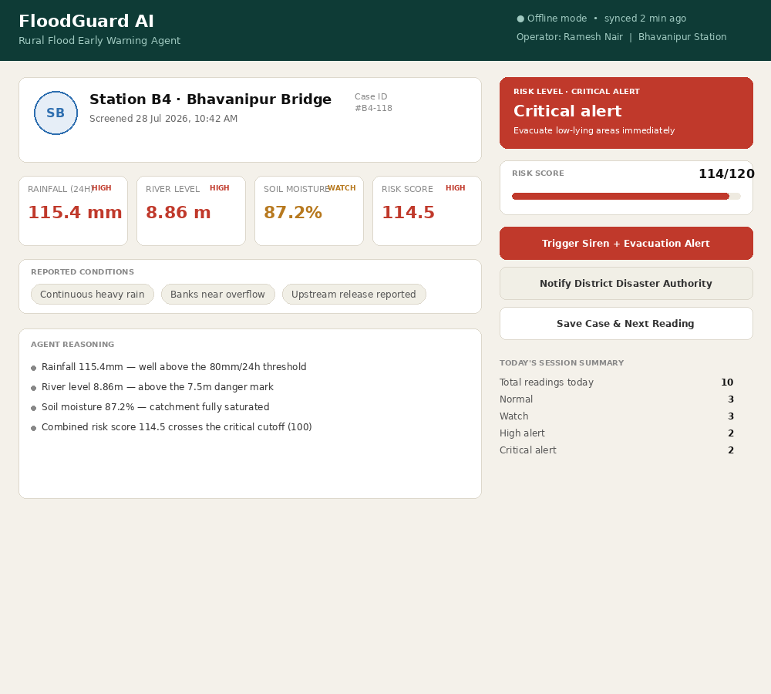
Live demo 1 — Station B4: Critical alert (risk score 114/120), heavy rainfall + river level above danger mark.
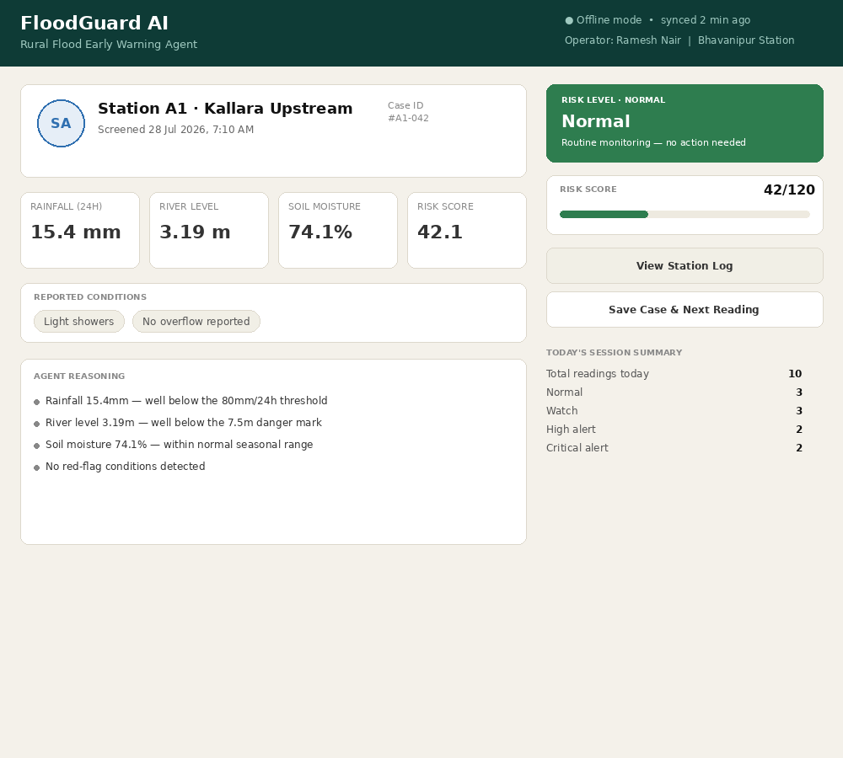
Live demo 2 — Station A1: Normal reading (risk score 42/120), all readings within safe range.
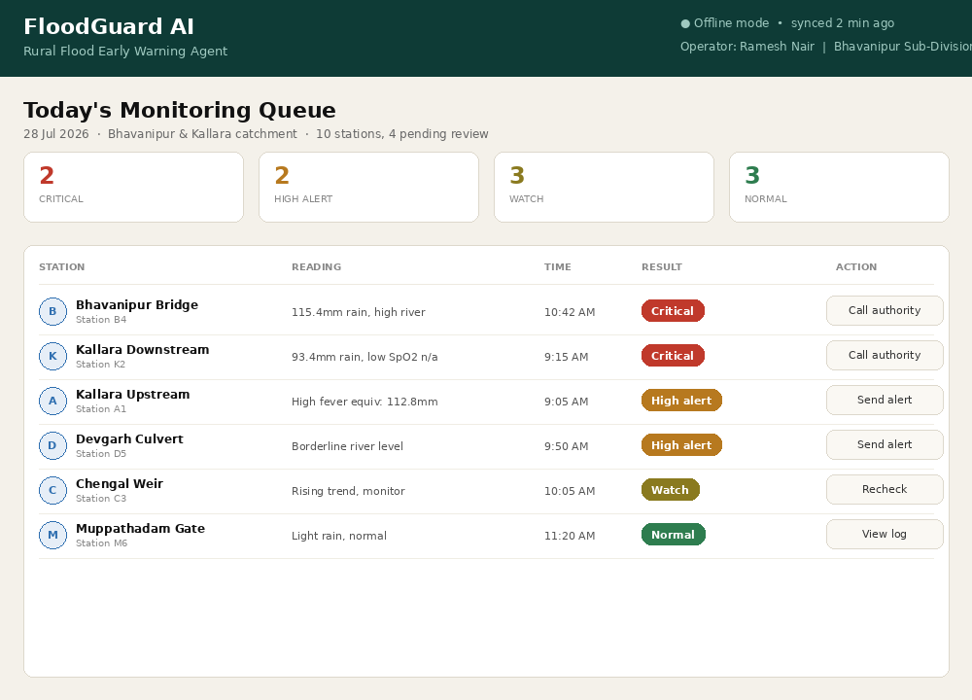
Live demo 3 — Today's Monitoring Queue: dashboard view of all stations, colour-coded by risk level, with one-tap escalation actions.

