

**Company analysis report**

**Retail Industry**

**Tesco Plc and J Sainsbury Plc**

**Title: Valuation conclusions and recommendations**

**Module Name: Project -Finance and Investment**

Abstract:-

Assessing the market positioning and development possibilities of Tesco PLC and J Sainsbury PLC, two significant UK retail corporations, this paper provides a thorough financial analysis of each. The intrinsic values of both businesses are established by applying valuation techniques including Price Multiple Analysis, Dividend Discount Model (DDM), and Free Cash Flow (FCF) model. With a strategy focus on cost control, sustainability, and digital transformation, Tesco PLC has a high chance of expanding and maintaining its market leadership. These three areas also contribute to steady revenue growth. Because of its reliance on the UK market, J Sainsbury PLC's growth is consistent but its prospects are more moderate. However, the company's diverse business strategy and sustainability initiatives are in line with changing customer tastes. The study places a strong emphasis on the contributions that digital innovation, operational efficiency, and strategic investments make to maintaining competitiveness. Both businesses exhibit resiliency, but Sainsbury's perspective is still more conservative while Tesco's development trajectory is more dynamic, preparing it for long-term success.

Contents

1 **Tesco PLC**

1.1 Tesco Tearsheet 4

1.2 Tesco Business Description 5

1.3 Tesco Business Strategy/Model 5

1.4 Tesco's Swot Analysis 6

1.4.1 Strength 6

1.4.2 Weakness 6

1.4.3 Opportunity 7

1.4.4 Threat 7

1.5 Valuation 8

**2 J Sainsbury PLC**

2.1 J Sainsbury’s Tearsheet 11

2.2 Sainsbury Business Description 12

2.3 Sainsbury Business Strategy/Model 13

2.4 Sainsbury's Swot Analysis 13

2.4.1 Strength 14

2.4.2 Weakness 14

2.4.3 Opportunity 15

2.4.4 Threat 16

2.5 Valuation 16

3 Conclusion 19

4 **References**  20

5 **Appendix** 22

1.1Tear Sheet Tesco

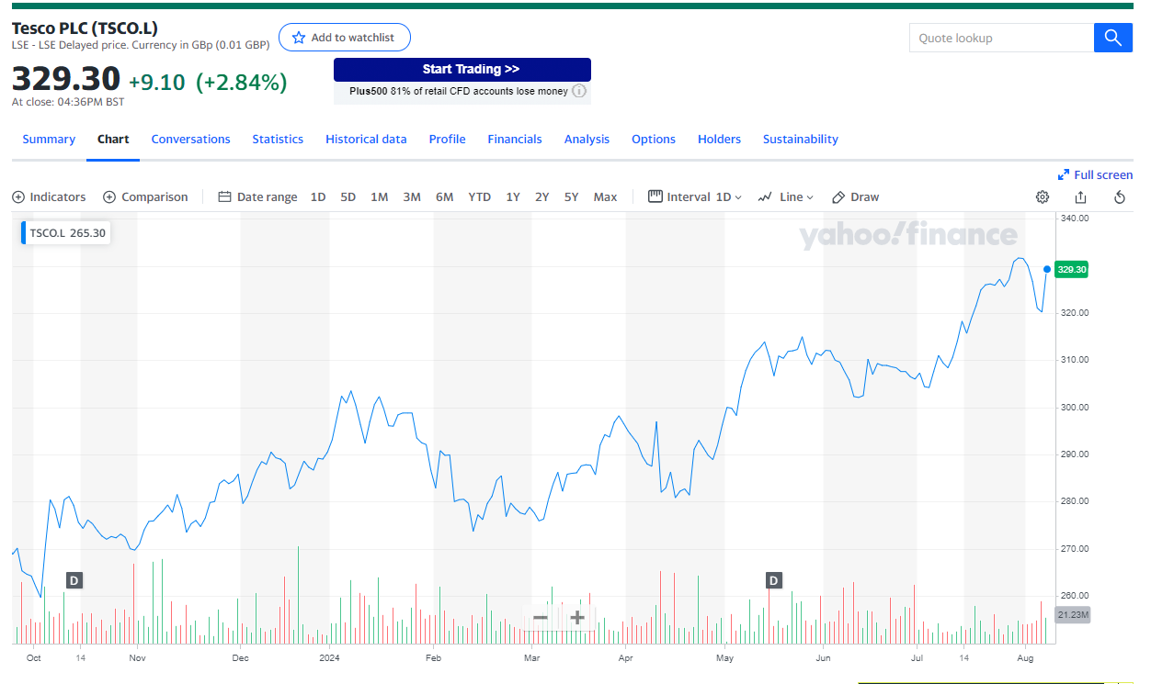Source: Yahoo Finance

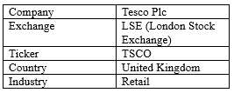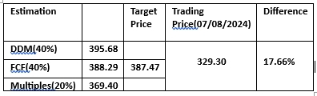

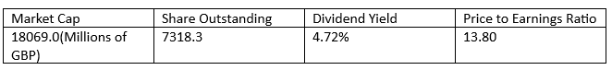

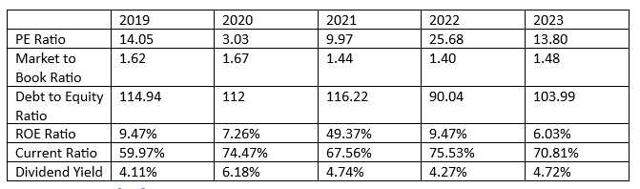(Source: Bloomberg)

**Recommendation: - STRONG BUY**

Strength:-

Improving competitive position:-

Tesco committed to implementing certain strategies in order to become more competitive. These strategies have resulted in: (1) stronger customer relationships through the digitalisation of the Clubcard; (2) more convenience stores to serve a larger customer base; (3) an increase in customer satisfaction; and (4) the ability to offer products at a significantly lower price by combining "Low Everyday Prices2," "Aldi Price Match1," and Clubcard prices3.

Associated Risk/ Weakness:-

Operating in a non-cyclical industry with intense competition, Tesco is exposed to many hazards. Regulatory and legal risks stemming from the need to comply with intricate laws across different regions; supply chain disruptions and climate change are examples of operational risks; inflation and demand fluctuations are economic risks; financial risks are associated with interest rates and liquidity; and pandemic risks have the potential to disrupt operations, as demonstrated by the COVID-19 pandemic. Please view my entire financial analysis report for more information.

**1.2 Business Description:-**

Jack Cohen founded Tesco in 1919 as a collection of market stalls, and it has since expanded to become one of the biggest retailers in the world. It runs 4,270 stores in different forms all throughout Central Europe, the UK, and Ireland (Bedford, 2024a). Tesco positions itself as a one-stop shop with a wide range of products, including groceries, clothing, electronics, and financial services. With a substantial market share in the UK grocery industry, the company has become a market leader due to its dedication to quality, price, and customer service.

**1.3 Business Model and Strategy of Tesco PLC:-**

Tesco PLC has created a strong and diverse business strategy to support millions of customers each week and keep a competitive advantage in the global retail sector. The four primary pillars of the company's strategy are: providing customers with compelling value; leveraging digital and loyalty networks; maximizing convenience; and optimizing operational efficiency.

Tesco combines price, quality, and sustainability to provide customers attractive value. Price-conscious shoppers in the UK are the target of initiatives like Aldi Price Match, which matches prices on over 600 products (Harris, 2020). To increase consumer loyalty and sales, Tesco also provides Low Everyday Prices and Clubcard Prices (Bayford, 2023).

Tesco's strategy heavily relies on its robust digital and loyalty ecosystem. Tesco is able to customise customer interactions and improve the shopping experience thanks to the Clubcard program, which has a 79% penetration rate in the UK, 77% in the Republic of Ireland, and 83% in Central Europe (Financial Times, 2023). In addition, Tesco's collaboration with Dunnhumby to create the Media and Insight platform helps businesses create new revenue streams and helps brands increase the effectiveness of their marketing.

Tesco's multi-format retail strategy, which consists of supermarkets, hypermarkets, convenience stores, and a full online grocery business, maximizes accessibility. Having more than 4,859 sites worldwide, including the 2,000th UK Express store, Tesco makes sure to satisfy customers everywhere. Convenience is further enhanced by innovations like the 1,000-location Whoosh rapid delivery service.

Last but not least, Tesco's "Save to Invest" campaign seeks to cut expenses and increase productivity. By February 2024, the effort hopes to have saved £1 billion overall. These savings are put back into the company to expand its client base and foster growth. Tesco is also dedicated to sustainability; by 2050, it wants to have 100% renewable electricity and an electrified delivery fleet, and it has already significantly reduced its emissions (Tesco Annual Report, 2023).

**1.4 SWOT Analysis of Tesco PLC:-**

**1.4.1 Strengths**

Tesco PLC, the leading retail giant in the UK, has a number of advantages that help it dominate the industry. Its broad market presence is one of its main advantages. As of 2023, Tesco is the rival with the most share of the UK grocery market, at 27.5%, ahead by Sainsbury's at 15.8% and Asda at 13.6%(Kantar,2023). Tesco can take advantage of economies of scale, which lower costs and increase profitability, thanks to its large market share. Tesco recorded total group sales of £65.7 billion for the fiscal year that ended in 2023, up 5.3% from £62.4 billion in 2022. Tesco's robust brand image and devoted client base are also essential advantages; the company can keep a significant number of clients through loyalty programs, as evidenced by the 19 million active Clubcard members. Another important asset of Tesco is its extensive online presence, particularly in the wake of the pandemic. the company's online sales reached £6.3 billion in 2023, a 15% rise from the previous year. This indicates the company's ability to effectively cater to consumers' changing needs and preferences by offering click-and-collect and home delivery alternatives (Tesco Annual Report, 2023).

––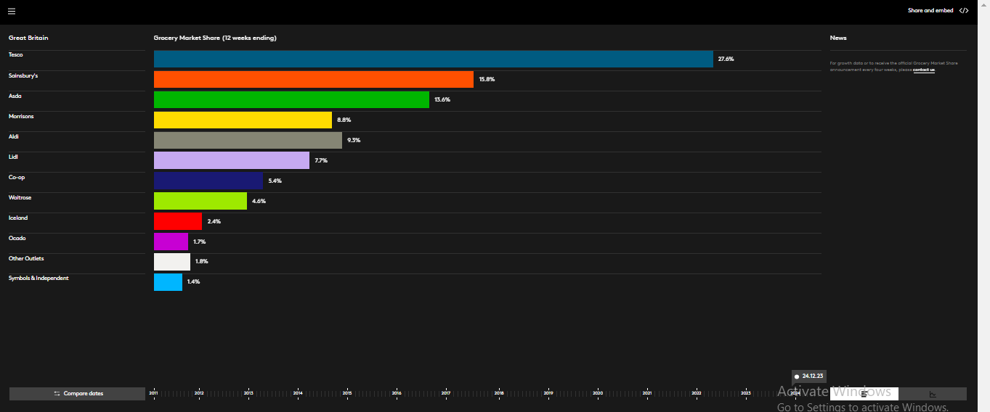

Figure 1: - Grocery Market Share

Source: - Kantar

Available From: - <https://www.kantar.com/uki/campaigns/grocery-market-share>

**1.4.2 Weaknesses**

Tesco's performance suffers by a number of internal issues, despite its advantages. company over reliance on the UK market, which generates about 75% of company revenue, is a serious problem. Tesco is sensitive to regional economic changes and uncertainties as a result of its significant reliance on the UK market. Maintaining a large retail network comes at a substantial expense in terms of labour, supplies, and transportation. Tesco's statutory operating profit decreased by 40.4% in 2023 as a result of these costs, from £2,560 million to £1,525 million. This decrease was due to difficulties in successfully managing costs (Singsit, 2023). Tesco’s reputation has been damaged by criticism and legal troubles it encountered in the past in its pricing policies and accounting procedures. Challenges in upholding corporate governance norms were brought to light in 2017 when Tesco was fined £129 million for accounting breaches (BBC News, 2017). Tesco's operating profit margin in 2023 was 3.8%, down from 4.3% in 2022. This suggests that the company is facing difficulty in sustaining high efficiency and higher operational costs. This constitutes another weakness. Moreover, Tesco's wide selection of products might cause complications in inventory management and inefficiencies in the supply chain, which puts additional pressure on working expenses.

**1.4.3 Opportunities**

Tesco can improve its market presence and growth in a number of ways. Increasing its online presence and e-commerce skills is a major opportunity. It is anticipated that the UK's online grocery business would expand at a rate of 16% per year between 2023 and 2028, when it is estimated to reach a valuation of £27.1 billion (Statista, 2023). Tesco has a great chance to take advantage of this and invest more in its online platform and digital services. Tesco offers an additional advantage: the company is dedicated to sustainability and plans to achieve net zero carbon emissions throughout its value chain by 2050 and in its operations by 2035. By comparison, it has already cut emissions in its activities by 55% from the baseline set in 2015. Tesco attracts environmentally concerned customers and improves its brand name by investing in electric delivery vans and renewable energy. International growth prospects can also be obtained by entering emerging markets. Tesco may broaden its portfolio and lessen its reliance on the UK market given that emerging regions like India is expected to grow at a rate of 6-7% yearly (IMF, 2024, p.12). Tesco’s background in managing expansive retail stores may also be used in this growth to break into new market niches.

**1.4.4 Threats**

Tesco is vulnerable to many external challenges that could affect its performance in the future. A major threat still comes from fierce rivalry from other giants of retail like Sainsbury's, Asda, and bargain retailers like Aldi and Lidl. As seen in figure 1, Aldi and Lidl's combined market share increased from 13% in 2020 to over 15% in 2023, indicating a shift in customer preference towards cheap retailers. Tesco's profit margins and pricing policies are under pressure as a result of the growing competition. Additionally, Tesco's operations are seriously threatened by the economic instability in the UK brought on by variables like Brexit, inflation, and volatile exchange rates.  the Bank of England reported that inflation rates in 2023 were between 6 and 7%, Significantly higher than the historical norm. This can lower consumer spending and raise operating costs (Bank of England, 2023). Tesco may face operational costs and operational efficiency issues as a result of regulatory constraints, particularly those pertaining to labour regulations, food safety, and environmental requirements. Tesco's profitability may be affected by the adoption of extra regulatory measures, as the UK's 2022 Plastic Packaging Tax has resulted in higher costs for retailers (GOV.UK, 2021). The COVID-19 pandemic, Brexit, and geopolitical tensions are among of the issues that are putting pressure on the global supply chain (McGillivray, 2021). Tesco is susceptible to disruptions due to its reliance on this network, which can result in product shortages, higher expenses, and delays. Sustaining a robust supply chain is imperative for Tesco's image and client contentment.

**1.5 Valuation:-**

**Free Cash Flow Model:**

**Assumption**

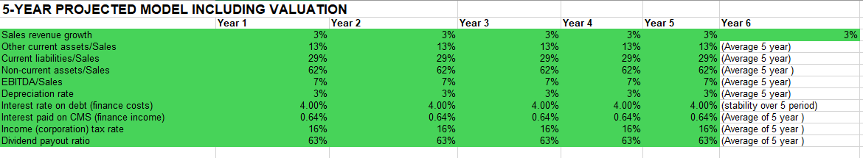(source: Bloomberg)

**Sales Revenue Growth:** The model projects a consistent 3% average annual growth rate in sales revenue, demonstrating Tesco's commitment to maintaining stable performance in the face of economic uncertainty. This cautious approach to market conditions is reflected in the conservative growth assumption, which prioritises stability and predictability above rapid expansion. To prioritise customer loyalty and stable growth, Tesco is reportedly focussing on enhancing digital capabilities and service quality.



**Tax Rate**: Using the average of the effective tax rates over the previous five years, I calculated the tax rate in my model. The following formula serves as the basis for this computation:



**Depreciation Rate:** I sought to eliminate any year-to-year variations and offer a more consistent and accurate representation of the long-term effects of depreciation on Tesco's sales by averaging this rate across a five-year period. The approach is a strategy meant to enhance the company's overall financial sustainability and health by striking a balance between the cost of updating and maintaining assets and the requirement to keep operating expenses under control.

$$\frac{depreciation}{sales }$$

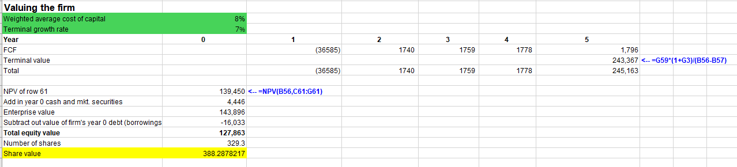

**Bloomberge gave me a terminal growth rate of 7%. Tesco has a significant potential for long-term growth, which is bolstered by its extensive retail network, strong brand loyalty, and tactical positioning in the rapidly changing online and convenience industries. This growth rate is indicative of this. Tesco can also respond to changes in the economy and seize expansion opportunities thanks to its emphasis on cost control and operational efficiency, which improves the company's long-term earnings trajectory.**

**DDM:-**

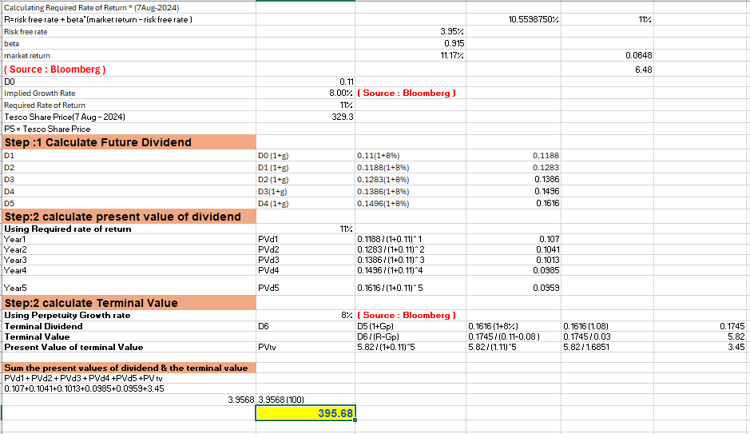

After a careful analysis of the company's strategic aims and operational enhancements, Tesco decided to raise its terminal growth rate from 7% (source Bloomberg) to 8%. Tesco has pledged to cut costs by £1 billion over the next three years through increased productivity and operational efficiency, which will bolster its prospects for growth. Tesco is also well-positioned for faster-than-anticipated growth thanks to its emphasis on growing its convenience store and online channels and its capacity to provide personalised customer experiences (Bloomberge). These variables, which demonstrate confidence in Tesco's capacity to surpass market projections and provide steady value to shareholders, justify the move to an 8% terminal growth rate.

**Price multiple model:-**

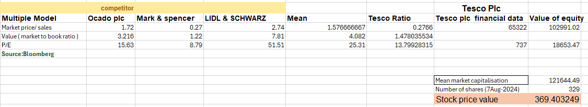

With Tesco Plc trading at 329.30 and an expected share price of 369.40, my price multiples model indicates that the company has great growth potential. This shows Tesco is a good buy at the current market price, suggesting it is undervalued. Tesco is beating its rivals, according to the model, which is indicative of strong investor confidence and promising growth prospects.

**Recommandation:-**

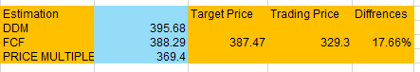

The analysis indicates that Sainsbury's shares are undervalued since the predicted target price is continuously greater than the current trading price, according to a comparison of the valuation methods—Dividend Discount Model (DDM), Free Cash Flow (FCF), and Price Multiple. It is advised to issue a "Buy" recommendation with a potential upside of 17.66% because the stock is anticipated to meet its target price. This demonstrates a potent investment opportunity backed by sound foundations and promising future growth.

2.1 Tear Sheet J Sainsbury Plc

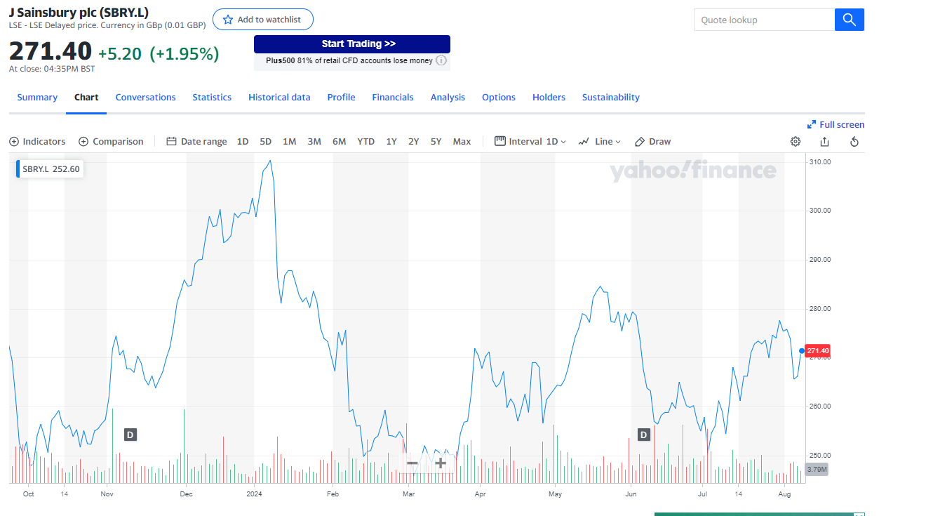

Source: Yahoo Finance

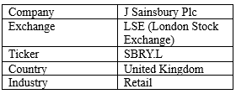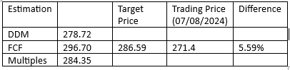

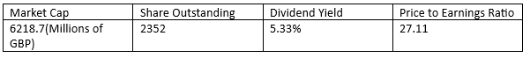

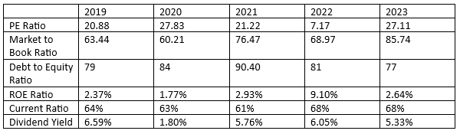(source: Bloomberg)

**Recommendation: - HOLD**

Strength:

**Diversification and Digital Focus:**

Sainsbury Plc has put strategies into place to keep itself competitive and expand its market footprint. Among these are: (1) increasing the number of customers it can serve with its online shopping capabilities; (2) diversifying its business by offering financial services through Sainsbury's Bank; (3) enhancing customer loyalty with the Nectar program, which has proven essential in keeping customers; and (4) launching high-quality in-house brands like TU clothing, which offers customers high-quality alternatives at affordable prices.

Associated Risk/Weakness:

In addition to facing obstacles that could impede its long-term growth, Sainsbury Plc operates in a highly competitive sector. Regulatory and legal risks resulting from shifting compliance requirements; (2) high operational costs from inflationary pressures and rising labour costs, which may negatively impact the company's cost structure and profit margins; (3) fierce competition from low-cost retailers like Aldi and Lidl, which could lead to price cuts and margin compression; and (4) the impact of economic volatility, which could reduce consumer spending, particularly on non-essential items like clothing and financial services.

**2.2 Business Description: -**

J Sainsbury PLC, or Sainsbury's, is a major participant in the UK retail industry. With more than 597 supermarkets and about 834 convenience outlets (AS shown in figure 2), it began as a small store in London and has expanded into a comprehensive retail company to become the second-largest supermarket chain in the UK. A vast array of goods is available at Sainsbury's, such as food, clothing, home furnishings, and financial services. In addition, the business owns a number of well-known companies that help to diversify its product offerings and sources of income, including Sainsbury's Bank, Tu, Argos, Habitat, and Nectar. Sainsbury's maintains a solid position in the competitive UK retail industry by focussing on customer satisfaction and sustainability, while being committed to providing high-quality items at low rates.

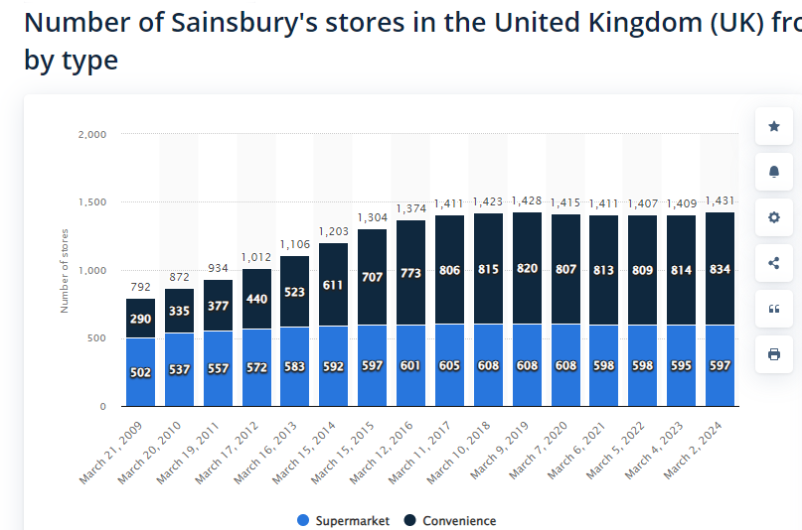

Figure 2:- Number of Sainsbury Stores By type

Source:- Statista

Available from:- <https://www.statista.com/statistics/386475/sainsburys-store-numbers-by-convenience-and-supermarket-united-kingdom-uk/>

**2.3 Business Model/Strategy:-**

One of the top grocery chains in the UK, Sainsbury Plc, has developed a thorough business plan that is based on digital transformation, diversification, multi-channel retailing, and sustainability. This strategy seeks to improve growth and competitiveness while satisfying a variety of customer needs.

Sainsbury's multi-channel retail strategy combines strong internet platforms with physical locations in an efficient manner. The corporation served numerous customers at about 1,400 locations in the UK as of 2024, including supermarkets, convenience stores, and hypermarkets (Sainsbury's Annual Report, 2024). Sainsbury's online sales have increased from 17% of total income last year to 20% this year, demonstrating strong development in e-commerce, to go along with their extensive physical presence. With over 20 million online orders fulfilled in 2023, the UK online grocery market is expected to increase at a compound annual growth rate (CAGR) of 5.6% from 2024 to 2028, presenting Sainsbury's with a sizable opportunity.

Sainsbury’s business plan is based on diversification, which goes beyond food and involves financial services, general retail, and apparel. By 2023, the company's non-food division will have grown by over £4 billion in sales and its client base would have grown thanks to the acquisition of Argos in 2016. The efficacy of Sainsbury's diversification plan was demonstrated in the same year by the 5.0% increase in general retail sales and the 3.4% increase in sales of the clothing brand TU.

In line with consumer demands for environmental responsibility, sustainability is also a key component of Sainsbury's business strategy. By 2035, the company wants to have net-zero carbon emissions, and in the last ten years, it has cut its carbon footprint by 30%. By2025, it wants to reduce plastic packaging by50%, and in 2023, it intended to invest £100 million in solar and wind energy initiatives.

Sainsbury's strategy heavily relies on digital transformation. The corporation has invested heavily in improving its digital capabilities, which include growing its distribution network and improving its websites and mobile apps. Customer satisfaction and delivery efficiency have grown as a result of a logistical cooperation with Ocado (The Guardian, 2024). By 2023, the average value of online orders will have increased by 8% due to the use of advanced data analytics to get insights into customer behaviour, enhance inventory management, and personalise marketing.

**2.4 Swot Analysis:-**

**2.4.1 Strengths**

The second-biggest grocery chain in the United Kingdom, Sainsbury Plc, was established in 1869 and has a number of advantages that help it compete in the market. Figure 1 illustrates Sainsbury's market share in the UK grocery industry as of 2024, which is 15.8%, indicating the company's significant market share and customer base. Supermarkets, convenience shops, digital retail (Argos), apparel (Tu), home furnishings (Habitat), and financial services (Sainsbury's Bank) are all part of the company's diversified business model, which lessens reliance on a single revenue source and increases cross-selling opportunities. Sainsbury's leads in digital retail thanks to its strong omnichannel and digital capabilities, which include integrating Groceries Online and Argos. In FY 2021/22, digital sales increased to 39%. Its 'Save to Invest' campaign successfully brought down retail operational expenses, enabling reinvestment in its food sector to improve value and keep prices competitive. In keeping with consumer demand for environmentally friendly practices, Sainsbury's strong commitment to sustainability is evidenced by a 20% decrease in greenhouse gas emissions from the 2018/19 baseline and a target of achieving Net Zero emissions by 2035 (Mitchell, 2023).

**2.4.2 Weaknesses**

Due to its heavy reliance on the UK market for income(around 95 % of total revenue come from uk market)(annual report,2021), Sainsbury's is particularly sensitive to economic risks like inflation, Brexit, and changes in consumer behaviour. As a result, the company confronts a number of difficulties. The COVID-19 pandemic resulted in a pre-tax loss of £261 million in 2021, which brought attention to this risk. This is in stark contrast to prior years, when earnings were frequently over £400 million (Figure 3). While the company's grocery sales are still strong, its non-food divisions, such as general items and clothes, have grown more slowly. For instance, Argos' sales fell by 12.5% in FY 2021/22 as a result of fewer discounts and supply chain interruptions. Additionally, combining businesses like Argos and Sainsbury's Bank involves a number of difficult tasks, including as closing stores and consolidating operations, which need a large financial outlay and might result in operational inefficiencies if handled improperly. Apart from that, compared to competitors with a greater worldwide presence, Sainsbury's small foreign presence limits the company's capacity to take advantage of growth prospects in emerging areas and increases its susceptibility to domestic economic fluctuations.

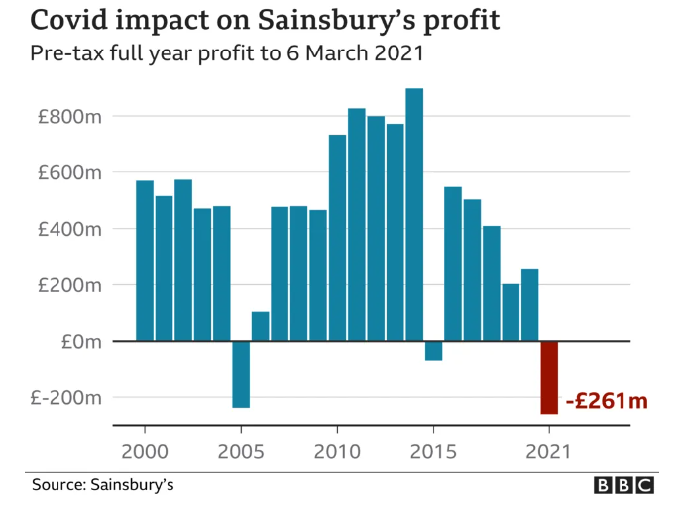

Figure 3: - Covid 19 Impact on Sainsbury

Available From: - <https://www.bbc.co.uk/news/business-56912064>

**2.4.3 Opportunities**

Sainsbury's has multiple external avenues for enhancing its market standing and propelling its future expansion. An important possibility is the increase in online buying that coincided with the COVID-19 outbreak. Online grocery sales at Sainsbury's increased by more than 120% in 2021 and now make up over 20% of the company's overall grocery sales (Sainsbury's Annual Report 2021). By 2025, online grocery shopping is predicted to account for 23% of the UK food market. Sainsbury's may improve its e-commerce platform by increasing delivery times and providing a greater selection of products. Additionally, Sainsbury's stands to benefit from the expanding market for wellness and health items. Under its "Plant Pioneers" brand, Sainsbury's has already launched over 300 new plant-based items, contributing to the 12.6% growth in the UK organic food market in 2021 (Actual, 2021). Targeting health-conscious customers and broadening this offering offers a significant development potential. Moreover, Sainsbury's dedication to sustainability presents opportunities for expansion. The corporation has made a commitment to become carbon neutral by 2050 and has cut 4,500 tonnes of plastic waste since 2019(Sainsbury’s Sustainability Report,2021). Increasing these initiatives will strengthen its attractiveness to customers who care about the environment. Lastly, forming new alliances offers still another tactical growth path. This is exemplified by the merger of Argos, which was effective and increased non-food sales by 8.3% in 2022.

**2.4.4 Threats**

In the fiercely competitive UK food industry, where Tesco, Aldi, Lidl, and Asda are fighting fierce price wars, Sainsbury's faces a number of major challenges. Sainsbury's must find a balance between providing high-quality products at competitive prices and risking profitability as cheap merchants rise in order to keep its market position. Another significant hazard is that of macroeconomic issues like inflation. Early in 2024, inflation reached a peak of 6.5%. This could reduce consumer spending and raise operating expenses, which would hurt Sainsbury's bottom line (Bank of England, 2024). Furthermore, supply chain interruptions, especially those made worse by political instability and trade laws following Brexit, might harm Sainsbury's capacity to keep inventory levels stable and control costs. Sainsbury's is further threatened by economic instability, which includes inflation, growing interest rates, and a problem related to the cost of living. Customers may turn for Discount Retailers, which would lower sales and profit margins. Furthermore, to maintain compliance with labour, environmental, and food safety regulations, regulatory and environmental concerns require ongoing investment and adaptation. Lastly, the growth of Sainsbury's online footprint increases the risks associated with cybersecurity and data privacy, where a significant breach could lead to financial losses, damage consumer confidence, and result in GDPR fines.

**2.5 Valuation:-**

**Free Cash Flow Model:**

**Assumption**

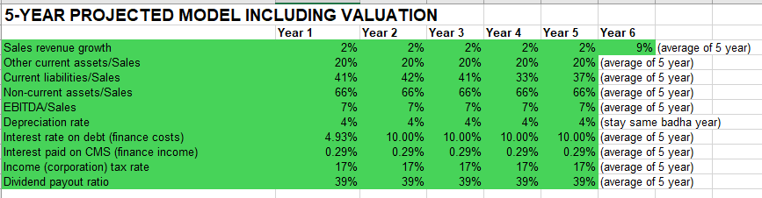

**Sales Revenue Growth**: For the first five years, the model predicts a steady 2% annual growth rate in sales revenue. In Year 6, there will be a notable 9% increase, nevertheless. This cautious approach is suggested by the first few years' cautious growth rate, which is probably the result of issues with the supply chain and other economic variables like inflation. Year 6's noteworthy gain suggests that a recovery is anticipated and that strategic efforts like market adaption and digital development are starting to pay off.



**Tax Rate**: The average tax rate for the entire six-year period has been calculated at 17%. The consistent rate indicates that Sainsbury's expects stable financial conditions and uniform tax laws in the areas where it conducts business.



**Depreciation Rate**:

The conservative approach to capital management and sustainable asset depreciation adopted by Sainsbury is reflected in the model's assumption of an average yearly depreciation rate of 4%. A concentration on long-term financial stability and operational effectiveness is suggested by this consistent rate. The company presents a cautious yet optimistic picture of its future development and wealth generation, which is highlighted by the balanced outlook with consistent growth rates and financial ratios.



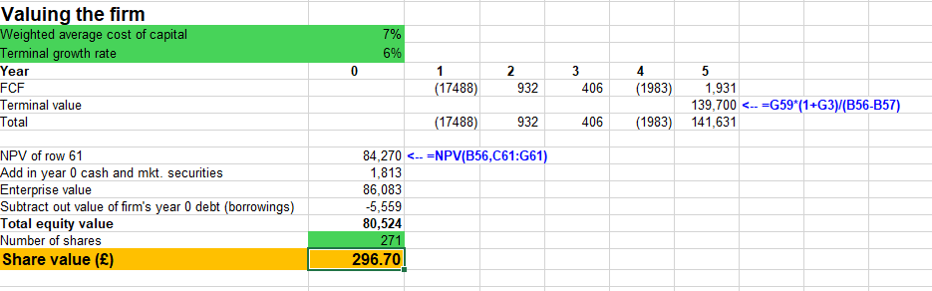

Instead of going with Bloomberg's suggested growth rate of 8%, I chooses a 5.5% growth rate, which is a calculated move based on market realities. Due to increased rivalry, margin pressure, and cost challenges, Sainsbury competes in a mature retail market with limited room for development. A more cautious assessment is supported by the supermarket industry's moderate growth and Sainsbury's significant investment in lower-margin e-commerce. By striking a balance between Sainsbury's consistent success and the long-term economic circumstances in the UK, the 5.5% rate ensures a more accurate and sustainable value while reducing the possibility of overestimation that a higher growth rate could bring about.

**Dividend Discount Model:-**

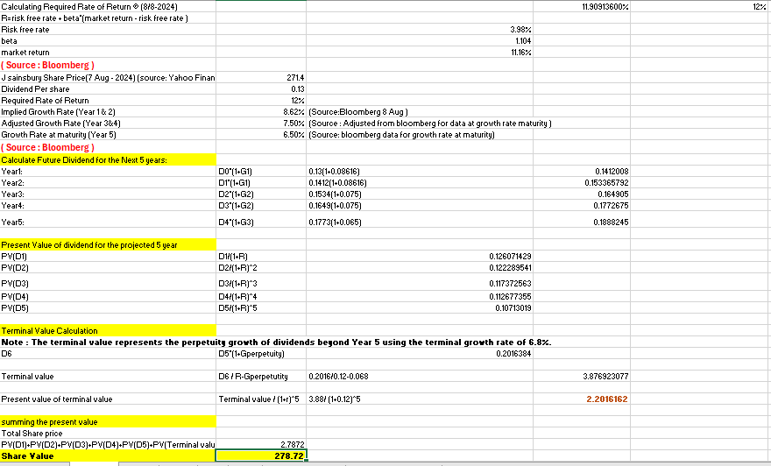

Based on Bloomberg's assumed growth data, I applied a growth rate of 8.624% for the first two years, reflecting Sainsbury's significant investments in digital transformation and market development. Significant short-term growth is anticipated as a result of these strategic objectives, which also include growing digital platforms and increasing operational efficiency. Since these initiatives are starting to mature and growth is gradually tapering, I changed the growth rates for years 3-5 to 7.5% and 6.5%. With a minor adjustment from Bloomberg's 6.552%, the terminal growth rate of 6.8% represents Sainsbury's strong market position and continuous cost reductions. A balanced forecast of Sainsbury's dividend growth over time is ensured by this trend.

**Price Multiple Model:-**

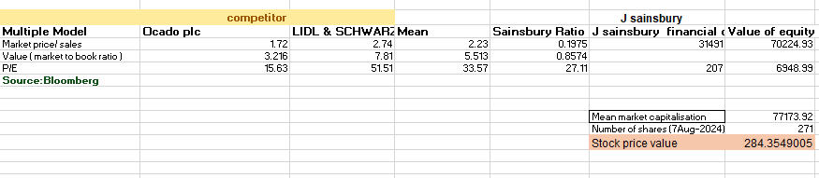

In my price multiple model for J Sainsbury, I calculated a forecast stock price of 284.35, which is higher than the current market price of 271. This model uses valuation multiples such as the Market Price to Sales ratio, Market to Book ratio, and Price to Earnings (P/E) ratio and is based on competitors like Ocado plc and Lidl & Schwarz. I used Sainsbury's financial data to compute the equity worth of the company, which led to the predicted stock price, by averaging these ratios.

Given the higher expected price, Sainsbury's might be undervalued by the market. Supporting this evaluation are the company's robust financial performance, as highlighted in its annual reports for 2022 and 2023. By 2022, Sainsbury's showed tenacity and effective cost control techniques with a 104% rise in underlying profit before taxes and strong growth in retail sales (annual report, 2022). Sainsbury's emphasis on improving operating efficiency, reducing debt, and increasing shareholder returns through dividend payments supports the notion that the current market price may not fairly reflect the company's intrinsic value and development potential. The price multiple model therefore indicates a potential investment opportunity given Sainsbury's solid financial situation and strategic aspirations.

**Recommendation: -**

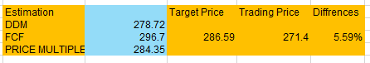

Based on the study of three different valuation methods (Price Multiple, FCF, and DDM, the target price is just 5.59 percent higher than the current trading price. This suggests a small amount of upside potential. A "Hold" recommendation is made in light of the moderate valuation gap since, while the stock may not offer substantial short-term gains, it still has steady fundamentals that may provide value in the long run.

Conclusion

Different growth paths are revealed by the analysis of Tesco Plc and J Sainsbury Plc, which are fuelled by their approaches to operational effectiveness, diversification, and digital transformation. Tesco is positioned as a great buy due to its strong market position and cost-cutting measures, which show dynamic development potential. On the other hand, a more cautious perspective is suggested by Sainsbury's moderate growth, which is a result of its reliance on the UK market and greater competition, which supports a Hold recommendation. Both businesses exhibit tenacity, but Tesco has greater long-term promise.

**Reference: -**

Actual, B.E. (2021) *UK Organic Market Continues to Grow - 2021 Soil Association Report* *Bio Eco Actual*. 15 February 2021 [online]. Available from: https://www.bioecoactual.com/en/2021/02/15/2021-soil-association-organic-market-report-uk-organic-market-grow/#:~:text=Soil%20Association%202021%20Organic%20Market%20Report [Accessed 18 September 2024].

Bank of England (2024) *Monetary Policy Report* [online]. Available from: https://www.bankofengland.co.uk/-/media/boe/files/monetary-policy-report/2024/august/monetary-policy-report-august-2024.pdf.

Bank of England (2023) *Monetary Policy Report - November 2023* *Bank of England*. November 2023 [online]. Available from: https://www.bankofengland.co.uk/monetary-policy-report/2023/november-2023 [Accessed 25 August 2024].

Bedford, E. (2024a) *Tesco PLC* *Statista*. 14 June 2024 [online]. Available from: https://www.statista.com/topics/3807/tesco-plc/#topicOverview [Accessed 2 September 2024].

Bayford, K. (2023) *Supermarket loyalty: is Tesco Clubcard Prices model the ‘new normal’?* *Grocery Gazette*. 28 April 2023 [online]. Available from: https://www.grocerygazette.co.uk/2023/04/28/supermarket-loyalty-tesco/ [Accessed 25 July 2024].

BBC (28th March 2017) Tesco fined £129m for overstating profits *BBC News* [online]. Available from: https://www.bbc.co.uk/news/business-39415681.

Financial Times (2023) *Tesco PLC Preliminary Results – Company Announcement - FT.com* *markets.ft.com*. 2023 [online]. Available from: https://markets.ft.com/data/announce/detail?dockey=1323-15913793-3KJQS4SG9NL6MDET3KAGE565OE [Accessed 26 July 2024].

GOV.UK (2021) *Introduction of Plastic Packaging Tax from April 2022* *GOV.UK*. 20 July 2021 [online]. Available from: https://www.gov.uk/government/publications/introduction-of-plastic-packaging-tax-from-april-2022/introduction-of-plastic-packaging-tax-2021.

Harris, S. (2020) *Tesco price match Aldi on hundreds of items - Tesco shoppers could cut their grocery bill* *Express.co.uk*. 29 September 2020 [online]. Available from: https://www.express.co.uk/life-style/life/1341232/supermarket-tesco-aldi-price-match [Accessed 27 July 2024].

IMF (2024) *World economic outlook (International Monetary Fund)* [online]. International Monetary Fund, p. 12. Available from: https://www.imf.org/en/Publications/WEO/Issues/2024/04/16/world-economic-outlook-april-2024 [Accessed 28 August 2024].

Kantar (2023) *Grocery Market Share* *www.kantar.com*. 2023 [online]. Available from: https://www.kantar.com/uki/campaigns/grocery-market-share.

McGillivray, G. (2021) *An expert explains: How COVID-19 exposed the fragility of global supply chains* *World Economic Forum*. 30 July 2021 [online]. Available from: https://www.weforum.org/agenda/2021/07/covid-19-pandemic-global-supply-chains/ [Accessed 1 August 2024].

Mitchell, D. (2023) *M A Y 2 0 2 3 CIRCULARITY, NET ZERO AND PLASTIC FUTURE OF PACKAGING ANNUAL REPORT 2023* [online]. p. 22. Available from: https://www.leedsbeckett.ac.uk/-/media/files/business-services/the-retail-institute/circularity-net-zero-and-plastic.pdf [Accessed 25 August 2024].

‘Sainsbury (J) PLC Final Results 2021 April 28, 2021’ (2021) *James Sharp & Co.* 28 April 2021 [online]. Available from: https://www.jamessharp.co.uk/market-news/sainsbury-j-plc-final-results-2021/ [Accessed 2 July 2024].

Singsit, J. (2023) *Tesco’s adjusted operating profit declined by 6.9% in fiscal 22/23* *Retail Insight Network*. 14 April 2023 [online]. Available from: https://www.retail-insight-network.com/news/tesco-2022-23-result-uk/?cf-view [Accessed 26 July 2024].

Excell Links :-

Tesco Excel File Link :- [TESCO_EXCEL_FILE_23069530.xlsx](https://uweacuk-my.sharepoint.com/:x:/g/personal/meeraben2_vaja_live_uwe_ac_uk/EaVA7BgTMHRDvgirVuScDRwBi6zsOTNEKEuA5uHMVadO3A?e=YA0me0)

J Sainsbury’s Excel File Link :- [JSAINSBURY_EXCEL_FILE_23069530.xlsx](https://uweacuk-my.sharepoint.com/:x:/g/personal/meeraben2_vaja_live_uwe_ac_uk/EYN4E2P945BHv_wbnUAIzVkBH4jFcXgjN7c1iP-oYu_qUg?e=aTsUv9)

**Appendix: -(source of all calculation : Bloomberg)**

**Tesco**

**FCF:**

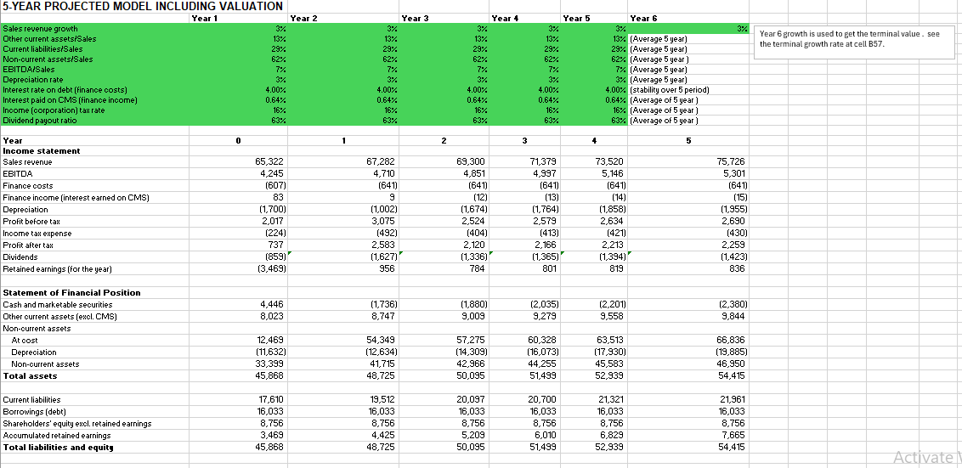

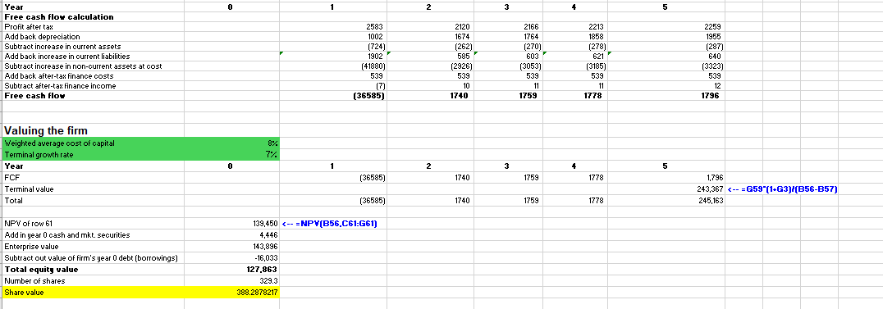

**DDM: -**

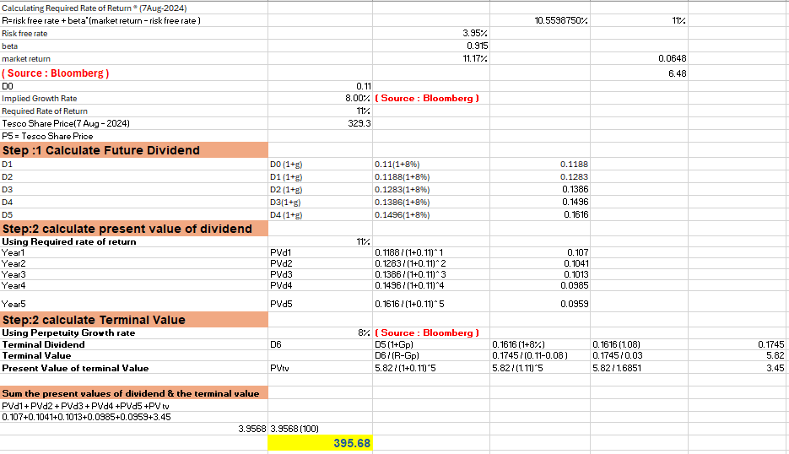

**PM:-**

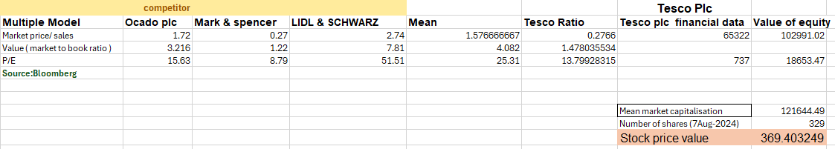

**J Sainsbury:**

**FCF**

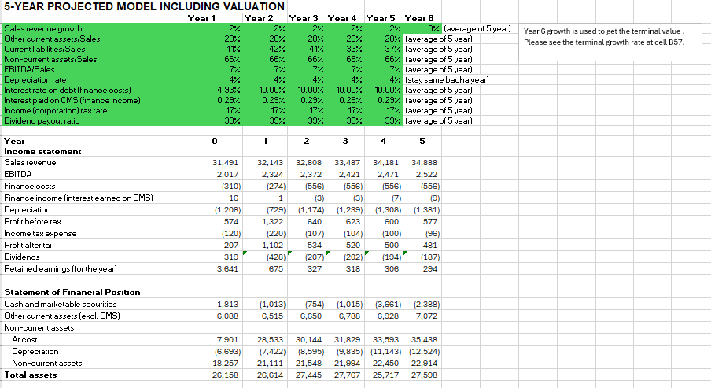

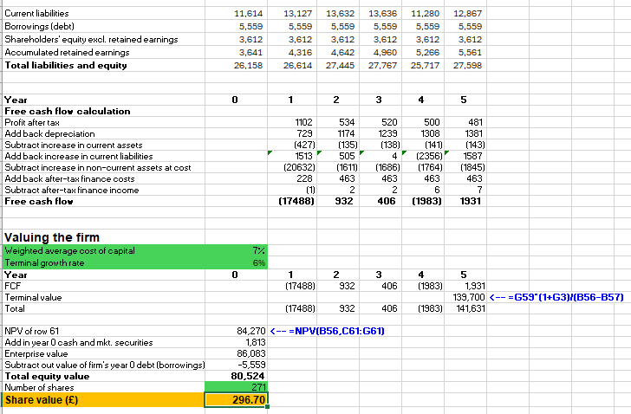

**DDM:-**

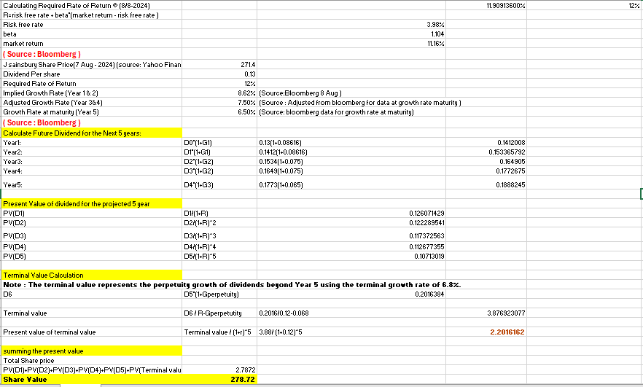

**PM:-**

