

**Company name: Tata Consultancy Services Ltd**

**Assessment title: Equity Analyst Report**

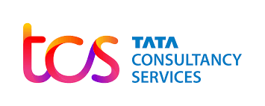

Tear Sheet

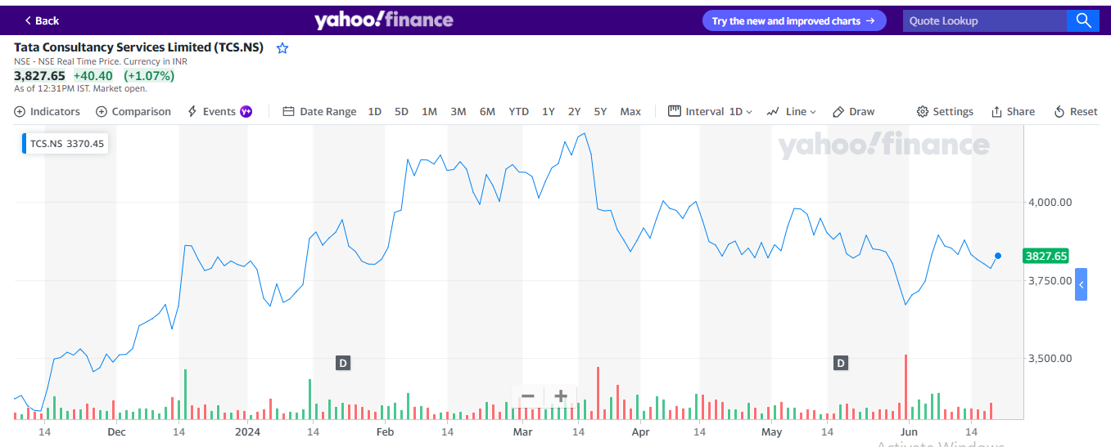

Source: Yahoo Finance

|  |  |
| --- | --- |
| Company | Tata Consultancy Services Ltd |
| Exchange | NSE India |
| Ticker | TCS |
| Country | India |
| Industry | Consultancy |

|  |  |  |  |  |
| --- | --- | --- | --- | --- |
| Estimation |  | Target Price | Trading Price  21/6/2024 | Difference |
| DDM | 4007.84 |  | 3827.65 | 6% |
| FCF | 4053.23 | 4057.79 |
| Multiples | 4112.30 |  |

Bearish: -

An investor who is bearish is one who is certain that the stock price will fall. Would therefore use strategies to profit from declining prices or engage in short selling.

Neutral: -A neutral position usually means that there are no particular thoughts about how well a stock will perform. Neutral investors hope for stable prices typically because those prices are often made under circumstances that are unclear.

Bullish: -Being bullish reflects hope for rising prices, most times. Bullish investors look for good returns from equities during upward trends.

Recommendation: - It is advised to ‘**’HOLD’**’ TCS stock. Significant risks exist despite the fact that the current trading price is below the target price because of concern about the rising cost of capital brought on by higher Treasury bond yields, rising inflationary pressures, and probable economic downturns in important markets like the U.S. and Europe. A hold position would be wiser given the potential impact these issues could have on TCS's profit margins and future revenue growth.

Market cap : 11,730,552.80(Millions of inr)

Share outstanding : 3659.1

Dividend Yield : 3.59%

Price to Earning ratio : 27.83

**Company Profile: -**

Tata Consultancy Services Ltd. (TCS) is an Indian multinational consulting and IT services provider. Founded in 1968, TCS is one of the biggest IT companies in the world, offering services ranging from IT consulting to software development and business process outsourcing. TCS, a company dedicated to innovation, uses cutting-edge technology to deliver solutions that help companies across a range of industries. One of the major players influencing the digital landscape is TCS, which is renowned for emphasizing quality and client happiness. It also continues to be a dependable partner for businesses searching for game-changing technological solutions (Jana, 2022).

**Company History: -**

From a punched card company when it was first founded in 1968, Tata Consultancy Services (TCS) has become one of the largest names in IT globally. Since the 2000s, J R D Tata's company, TCS, has made $1 billion annually by creating revolutionary solutions and reshaping the digital landscape.

**Segment and Revenue: -**

* **Manufacturing:** TCS provides IT services and solutions to the manufacturing industry, allowing companies to integrate digital technology and improve processes inside their supply chain systems to boost productivity and creativity (Emrouznejad, 2023).
* **Banking, Financial Services, and Insurance (BFSI):** TCS is interested in this market since it provides financial institutions with a variety of services, including core banking solutions, risk management, digital transformation, and improvements to the client experience.
* **Communication, Media, and Technology:** TCS works with companies in the media, technology, and communication industries to develop digital transformation solutions for content distribution, provide data analytics services, and provide advisory support for information technology-related issues.
* **Retail and Consumer Business:** TCS helps the retail and consumer employment sectors become more competitive by assisting with e-commerce, improving logistics management, resolving customer service concerns, and digital marketing.
* **Other Industries:** TCS's overall revenue may also come from a variety of clients in different industries (Kolte, 2022). Among other things, this could include travel, energy, or healthcare.

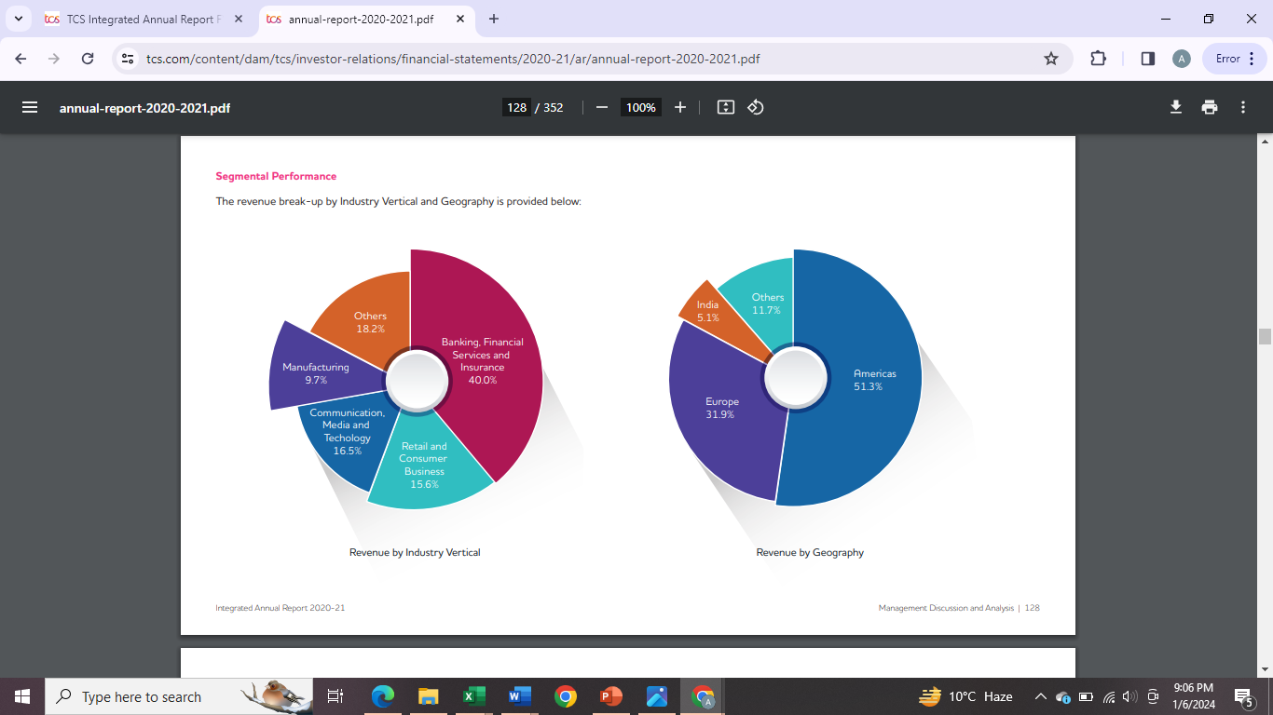

**Figure: Segment revenue analysis of TCS for the year 2023 (Annual report, 2021)**

**Macro-Economic Analysis**

## 

## **Tata Consultancy Services (TCS) PEST Analysis: Navigating External Business Factors**

**Political:**

* Trade Policies and Brexit: TCS and other multinational IT companies have to adapt to shifting trade regulations. For example, its operations in the UK and EU are impacted by post-Brexit legislation. The business needs plans in place to handle any tariffs and limits on cross-border data movement that might have an effect on its services.
* Local Regulations: Data localization will be more important in 2023 in nations like the US and India, which will have an impact on how organizations like TCS handle data internationally. In reaction to these kinds of regulatory changes, operational strategies and compliance expenses are constantly modified.

**Economic:**

* Revenue and Market Fluctuations: TCS recorded revenue of ₹225,458 crores (about $27.9 billion) for the fiscal year that concluded in March 2023, indicating a growth rate of 17.6% in spite of uncertainty surrounding the state of the world economy. However, future income streams may be impacted by market volatility and economic downturns in important markets like the U.S. and Europe.
* Exchange Rate Impact: A major amount of TCS's revenue comes from revenues repatriated from international markets, and in 2023, the Indian Rupee saw considerable fluctuations versus the US Dollar.
* Inflationary Pressures: Operating costs, particularly salaries in the IT sector in nations like India, have experienced an increase in 2023 due to an increase in global inflation rates, which has an effect on profit margins.

**Social:**

* Workforce Demographics: TCS employs more than 614,000 people worldwide as of 2023. Women make up 35.7% of the organization's workforce (Fortuneindia.com, 2023), demonstrating its commitment to gender diversity. The company has been concentrating on increasing diversity.
* Aging Workforce: The aging population in major countries like Europe and Japan offers opportunities and problems for workforce management, particularly when it comes to tailoring IT solutions for older populations.
* Corporate Social Responsibility (CSR): TCS's CSR programs, which prioritize community welfare, health, and education, improved over 4.5 million lives worldwide in FY 2023 (Annual report 2022-23). This greatly improved the company's reputation and increased stakeholder participation.

**Technological:**

* Innovation Investment: To keep a competitive advantage, TCS invested in establishing 5 Pace Ports (innovation hubs) worldwide by 2023. These hubs will promote innovation in digital technology and artificial intelligence (‘Pace PortTM Amsterdam’, n.d.)
* Cybersecurity Investments: TCS has increased its investment in cybersecurity solutions to protect its extensive data management activities, in line with industry demands. The global cybersecurity market is anticipated to develop significantly.
* Digital Transformation Services: TCS's digital revenue division had significant growth, accounting for around 35% of its total revenue in 2023, as more companies moved to digital platforms. As businesses increase their investments in automation technologies and cloud solutions, this industry is expected to expand.

## **Porter’s Five Forces Analysis for Tata Consultancy Services (TCS) Globalization of IT Services: Navigating Industry Dynamics**

**Threat of New Entrants(Low)**: -

Due to its well-established brand and substantial operations—TCS employs over 614,000 consultants across 55 countries—it enjoys a considerable competitive advantage. For newcomers without comparable resources, a global presence, and a solid reputation, this raises a significant hurdle. Over its 55 years existence, TCS has developed the trained labor, technology, and brand building that the IT industry demands, along with significant initial expenditures. New businesses find it difficult to get into the market and grow rapidly because of this.

**Bargaining Power of Suppliers (Low)**: -

TCS enhances its service capabilities by partnerships with multiple international technology providers, but it also depends on these vendors. But TCS's size and established connections allow it to bargain for advantageous terms (Isabelle et al., 2020), which lessens the overall influence of the suppliers. TCS is a market leader, therefore its selection of technological platforms and tools may have an impact on market trends and, in turn, supplier dynamics.

**Bargaining Power of Buyers (HIGH)**:

Customers, especially the major clients who make up a significant portion of TCS's revenue, have a great degree of bargaining leverage because of the importance of large agreements and long-term contracts. TCS continuously invests in customer connections to improve client retention and satisfaction (annual report 2022-2023). TCS's emphasis on industry-specific solutions and capacity to provide end-to-end services enable them to become more deeply integrated into their clients' processes, which over time may lessen customers' negotiating strength by raising switching costs.

**Threat of Substitute Products or Services (MEDIUM)**:

As alternatives to traditional IT services, rapid technology breakthroughs like automation, AI, and machine learning pose serious risks. To counter these challenges, TCS makes investments in state-of-the-art technologies and modifies its service portfolio accordingly. The business's proactive approach in fields like cloud services and digital transformation enables it to successfully compete with alternatives and hold onto its market relevance.

**Rivalry Among Existing Competitors (HIGH)**:

With big players like Infosys, Wipro, IBM, and Accenture, the global industry for IT services is fiercely competitive. TCS's ongoing investment in workforce training and the development of proprietary platforms like TCS BaNCSTM and TCS MasterCraftTM strengthens its market position and competitive edge, despite the intense competition in the industry. TCS distinguishes itself with an extensive service portfolio, a strong global delivery model, and a focus on high-quality and innovative solutions. By always innovating and offering creative services, TCS can maintain its competitive edge (Subramanian, 2022).

**Corporate Strategy Evaluation: -**

TCS has a broad corporate strategy with an emphasis on innovation, digital transformation, market expansion, sustainability, and personnel management. With a robust global footprint spanning 55 countries, TCS is able to reduce market volatility risks and take advantage of notable revenue growth in a number of different geographic areas. This suggests effective market penetration and growth.

As a leader in the IT services sector, TCS is able to maintain its position because to its ongoing investments in innovative technologies such as artificial intelligence (AI) and cloud computing. TCS's dedication to promoting innovation is demonstrated by the creation of Pace Ports and its emphasis on research & development.

TCS's approach to digital transformation is to leverage the worldwide trend towards cloud computing. Their method assists customers in navigating their cloud journeys, strengthening TCS's value proposition and meeting market expectations at the same time. Furthermore, TCS's involvement with cutting-edge technologies like generative AI highlights its preparedness to take advantage of fresh chances and provide cutting-edge solutions.

In terms of sustainability, TCS adheres to international environmental sustainability trends by lowering its carbon footprint and utilizing more renewable energy sources. Through its social efforts, it improves business goodwill and advances societal welfare (Business today, 2022) (ANI Press Release, 2021).

In order to maintain a talented and competitive workforce, TCS employs tactics for diversity promotion and talent development. By preparing the company for upcoming difficulties and assisting TCS in adapting successfully to market changes, this strategic strategy promotes long-term growth and the creation of value for stakeholders.

Ratio Analysis: -

**Profitability Ratio:**

**Return on equity:**

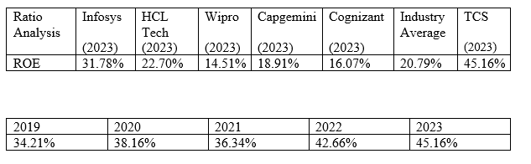

**(Source: Bloomberg)**

With yearly rises from 34.21% in 2019 to 45.16% in 2023, Tata Consultancy Services (TCS) has shown a spectacular rising trend in Return on Equity (ROE) during the last five years. During this time, TCS has not only consistently outperformed the industry average ROE, but it has also demonstrated consistent year-over-year growth. A number of strategic efforts are responsible for this outstanding performance. Even in times of economic volatility, TCS has highlighted innovation, adaptability, and resilience as key components propelling their success. Modern technologies including cloud computing, machine learning (ML), and artificial intelligence (AI) have been used by the corporation to improve client offerings and operational efficiency.

In conclusion, TCS has maintained a ROE growth rate considerably above the industry average by utilizing cutting-edge technologies, strong talent management, and ongoing innovation. These programs improve TCS's financial performance indicators and put the business in a strong position for long-term, sustainable growth.

**Net Profit Margin:**

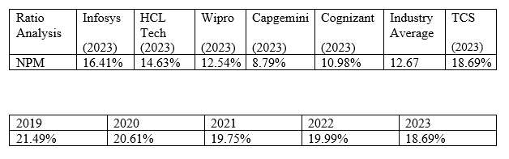

**(Source: Bloomberg)**

Despite a steady decline in Net Profit Margin (NPM) from 21.49% in 2019 to 18.69% in 2023, Tata Consultancy Services (TCS) has continuously maintained an NPM above the industry average. TCS outperforms the industry average of 12.67% for 2023 by a substantial amount. This is indicative of TCS's effective pricing tactics and operational efficiency, which allow it to outperform its competitors in terms of profitability.

Numerous reasons have contributed to the NPM's fall throughout time. Geopolitical concerns, growing inflation, and fluctuating commodity prices were some of the problems presented by the global environment in FY 2023, and they all put pressure on industry profitability. Nonetheless, TCS has been able to sustain profitability above the industry average thanks to its strategic objectives and emphasis on innovation, particularly in digital transformation and cloud services.

**EBIT Margin:**

|  |  |  |  |  |  |  |  |
| --- | --- | --- | --- | --- | --- | --- | --- |
| Ratio Analysis | Infosys  (2023) | HCL Tech (2023) | Wipro  (2023) | Capgemini  (2023) | Cognizant  (2023) | Industry Average | TCS  (2023) |
| EBIT | 22.70% | 19.20% | 16.31% | 10.23% | 14.40% | 16.57% | 25.24% |

|  |  |  |  |  |
| --- | --- | --- | --- | --- |
| 2019 | 2020 | 2021 | 2022 | 2023 |
| 28.38% | 26.92% | 26.65% | 26.95% | 25.24% |

**(Source: Bloomberg)**

Top of Form

Bottom of Form

Over the course of the five-year period from 2019 to 2023, TCS's EBIT margin performance was consistently strong.TCS's EBIT margin in 2023 was 25.24%, which was lower than its prior year performance but still higher than the 16.57% industry average. relative to its peers.With the exception of Infosys, TCS outperformed most of its rivals in terms of EBIT margin.

TCS has a solid market position and efficient operations, as seen by its EBIT margin trend and comparisons with the industry and its competitors. Increased investments in innovation and technology, which are essential for long-term success in the quickly changing IT services sector, may be the cause of the minor decline in EBIT margin in 2023 when compared to prior years. A strategic focus on maintaining profitability while positioning the business for future technology-driven opportunities is evident in the company's aggressive effort to implementing new technologies and growing its service offerings.

**Investor relation:**

**Dividend Yield:**

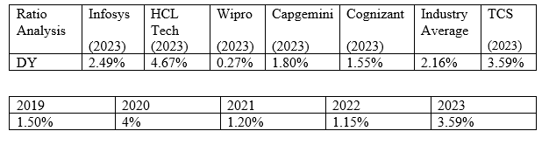

TCS's dividend yield had a variable but usually increasing trend between 2019 and 2023.TCS's dividend yield in 2023 is 3.59%, higher than the 2.16% average for the industry. In comparison to its rivals: TCS has a greater dividend yield than the most of its significant rivals, with the exception of HCL Tech.

TCS has demonstrated its commitment to shareholder returns through its dividend policy, which is in line with its financial performance and strategic choices. Strong financial health and a shareholder-friendly strategy are indicated by the dividend yield increase in 2023, despite the larger concerns. Its yield, which is greater than that of the majority of its rivals and the industry average, further demonstrates TCS's durability and strategic capital management vision in the fast-paced IT services sector, making it an appealing option for dividend investors.

**Price to Earnings ratio:**

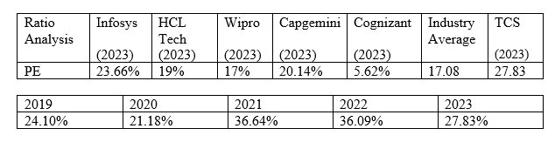

**(Source: Bloomberg)**

The P/E ratio of TCS has seen significant fluctuations over the five-year period. The ratio increased from 24.10% in 2019 to a high of 36.64% in 2021, indicating heightened investor expectations during that year it slightly decreased to 36.09% in 2022 and adjusted further to 27.83% in 2023. In 2023, TCS’s P/E ratio of 27.83 is higher than the industry average of 17.08%, reflecting a premium that investors are willing to pay for TCS shares relative to the industry. Their quick rise to a powerful value of (Liao, 2022) is notably abnormal compared to industry standards.TCS has a higher P/E ratio than most of its key competitors, except for Capgemini which is relatively close. This suggests that investors have higher growth expectations from TCS, perhaps due to its market position, global reach, or perceived strategic advantages.

The P/E ratio analysis over the years and in comparison, with industry and competitors underscores TCS as a favoured entity among investors, likely due to its robust business strategies, consistent performance, and ability to navigate complex digital transformation landscapes effectively. While the ratio has seen a decline in 2023, it remains relatively high, suggesting continued investor trust in TCS’s capability to generate value and leverage opportunities in the rapidly evolving tech sector.

**Liquidity Ratio:**

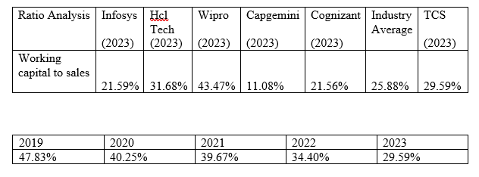

**(Source: Bloomberg)**

From 2019 to 2023, TCS's working capital to sales ratio clearly displays a downward tendency. The ratio peaked in 2019 at 47.83% and began to gradually decline each year, reaching 29.59% in 2023. This decrease points to a better working capital management efficiency in relation to sales, which may be the result of tighter controls over inventory and receivables or better terms with suppliers. Higher ratios may be an indication of less effective working capital use or of greater capital committed to operations—neither of which are ideal in weaker economic times. Over time, TCS's working capital to sales ratio has decreased, which raises the possibility that the company is carefully allocating its resources to growth efforts rather than locking them up in working capital. This aligns with its initiatives in worldwide expansion and digital transformation solutions.

**Debtor Days:**

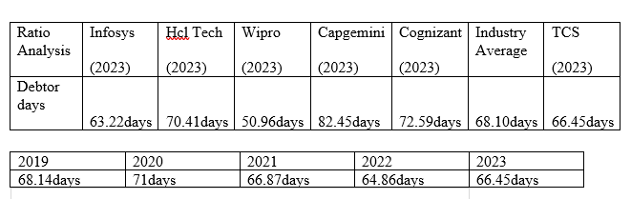

**(Source: Bloomberg)**

TCS's debtor days from 2019 to 2023 showed fluctuations, peaking at 71 days in 2020 and reaching a low of 64.86 days in 2022, settling at 66.45 in 2023. This indicates effective management of receivables within competitive ranges compared to the industry average of 68.10 days and peers like Infosys, HCL Tech, and Wipro. The slight variations year-on-year reflect the dynamic nature of project-based business and client-specific payment terms. TCS has excellent working capital strategies, as seen by their exceptional management of debts and payables (Romero-Lara, 2023). TCS’s stable management of receivables is crucial for maintaining liquidity and funding ongoing operations and investments. This efficiency is a positive sign for investors, indicating disciplined cash flow management and operational efficiency.

**The Main Efficiency Ratio:**

**Fixed Asset Turnover:**

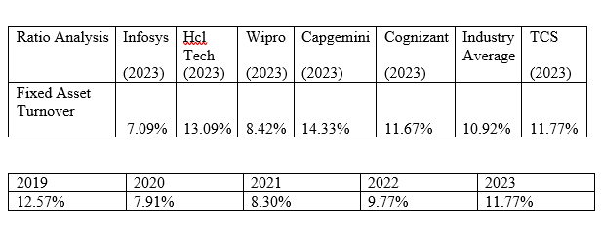 **(Source: Bloomberg)**

TCS's fixed asset turnover ratio exhibits a declining tendency, peaking at 12.57% in 2019 and then dropping to 8.30% in 2021 before increasing to 11.77% in 2023. TCS is more efficient than the industry average, with a fixed asset turnover rate of 11.77% in 2023 versus the industry average of 10.92%. In terms of efficiency, TCS performs better than Infosys, Wipro, and Cognizant, but slightly worse than Capgemini and HCL Tech.

TCS is now ahead of many of its competitors and the industry average in terms of asset utilisation thanks to an impressive comeback. This shows that the company has recovered from the early pandemic years and that it has an asset management plan that works well and is in line with its larger operational objectives and the state of the market. This strengthens its position as a leader in the technology services industry.

Gearing Ratio:

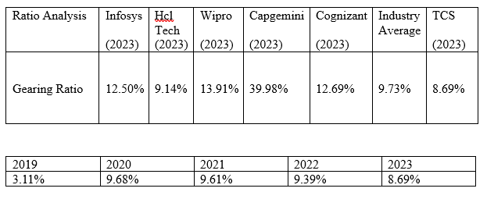

**(Source: Bloomberg)**

The five-year period has seen fluctuations in TCS's gearing ratio, which gauges financial leverage. Notably, it increased from a low of 3.11% in 2019 to 8.69% in 2023. A more cautious leverage posture is shown by TCS's 2023 gearing ratio of 8.69%, which is lower than that of the industry average and most of its competitors with the exception of HCL Tech. This lower gearing ratio is a result of TCS's smart use of debt to support development prospects while preserving financial stability.

In comparison to its competitors, TCS has remained relatively conservative with its financial leverage, which may help explain its strong financial standing and resilience to market swings. Its long-term objective of sustainable growth through prudent financial management, strategic investments in technology, and market expansions is in line with this approach.

Valuation:

**Free Cash Flow Model:**

**Assumption**

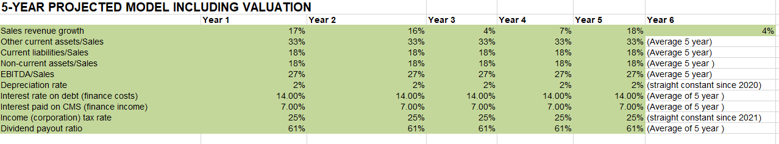(Source: Bloomberg)

**Sales Revenue Growth:**

TCS's investments in digital transformation services are supporting the strategic deployment of new technologies and market expansion, as indicated by the notable growth rates in Years 1, 2, and 5. The macroeconomic study highlights the instability of global markets and economic pressures, which may indicate market saturation or macroeconomic downturns, which could account for the lower growth rates in Years 3 and 6. These elements, which include Brexit and trade policies, directly affect market potential and operating costs.

**Depredation rate:**

Using the depreciation and amortization and PP&E, the depreciation rate was computed. To obtain more accurate data, we considered averages of a 5-year period (2019–2023). (continuously steady since 2020)

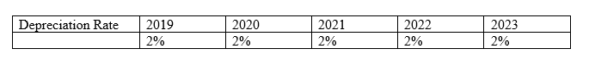

A consistent approach to asset management and capital expenditure is indicated by the steady depreciation rate. This low rate may be the result of TCS using its technology resources well and/or a reduced asset turnover rate, which fits with the industry's shift away from physical assets and toward more cloud-based digital solutions. This tactic is consistent with a larger industry trend away from physical infrastructure investments and toward digital transformation.

**Tax rate:**

I calculated Tax rate through, dividing the Income tax expense to EBIT. (Straight constant since 2021)



Stable fiscal policies on company taxation in the regions where TCS operates are probably reflected in the uniform tax rate. Talks about cross-border data mobility and data localization are still ongoing, though, and they could have an impact on future tax laws and compliance expenses. As stated in the analysis, these regulatory considerations may have an impact on operational strategies and raise compliance costs that influence net profitability even though they are not immediately apparent in tax rates.

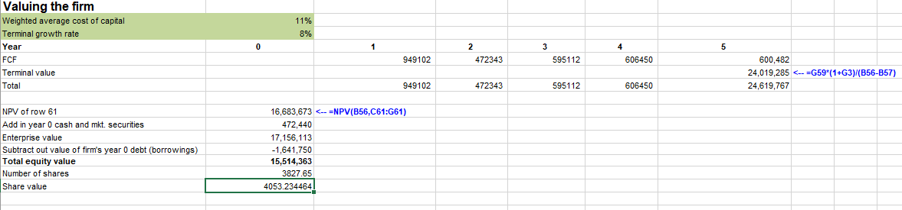**(Source: Bloomberg)**

I think an 8% terminal growth rate is both acceptable and well-justified, given TCS's past performance, favourable sector trends, and optimistic economic outlook. TCS's high growth trajectory, which is fuelled by its technology leadership, strategic initiatives, and market expansion efforts, is reflected in this rate. By using a data-driven methodology to calculate this growth rate, I can make sure that the value model is reasonable and in line with TCS's long-term growth potential as well as industry expectations.

**Dividend Discount Model:**

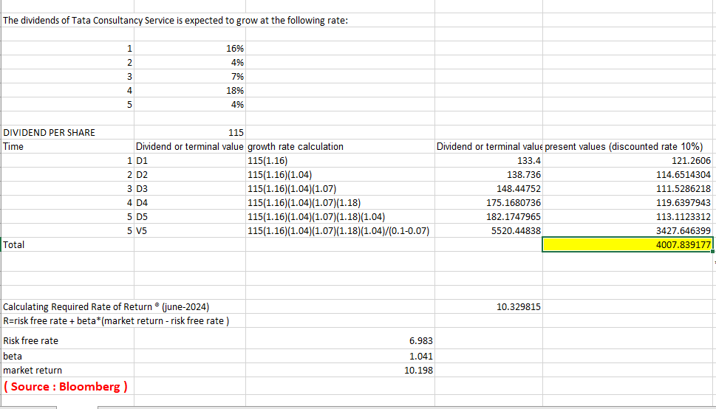

TCS's robust financial performance and steady revenue growth—which was 17.6% for the fiscal year that ended in March 2023—are the reasons for the first year's notable 16% rise. TCS's investments in state-of-the-art technologies, efficient operational management, and tactical market positioning are the main causes of this remarkable increase.

The second year's 4% decline may have been brought on by market volatility and economic uncertainty in important areas such as the U.S. and Europe. Even though TCS had a great first year, inflationary pressures and volatile currency rates could pose problems, resulting in more cautious growth estimates.

In the third year, the growth rate increases to 7%, pointing to a recovery and adjustment to earlier economic difficulties. TCS is starting to see favourable returns on its continuous investments in innovation and digital transformation, which are increasing its revenue streams and profitability.

The significant rise to 18% in the fourth year probably indicates that TCS's strategic initiatives—such as growing its digital services, utilising cloud and AI technology, and keeping a strong worldwide presence—are fully paying off. These initiatives greatly improve TCS's financial results and ability to increase dividend payments.

In the fifth year, the growth rate returns to 4%, presumably as a result of market saturation and the normalcy of periods of exceptional growth. Even though TCS is still doing well, the growth rate shows that dividends are increasing in a more sustainable and stable manner when taking into account possible economic headwinds and established market conditions.

For TCS's DDM valuation, I selected a growth rate of 7% on the basis of the company's track record of reliable dividend growth, which is in line with peer performance and industry projections. This score is a reflection of TCS's solid financial performance, sector growth prospects, analyst consensus, and tactical posture within the IT services industry.

We think the outcomes are less than the FCF and price multiples model because of a performance deviation for the 2022 fiscal year, based on the DDM price of INR 4007.84. However, the DDM results support our "HOLD" stance and are consistent with our previous analyses.

**Price Multiples Model:**

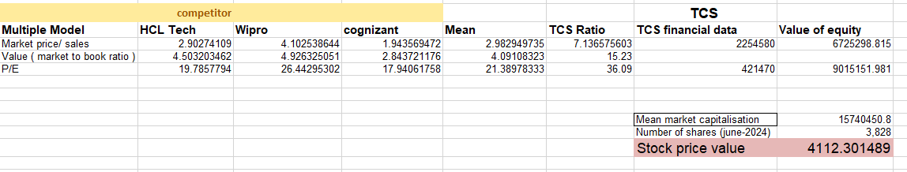**(Source: Bloomberg)**

It is outperforming rivals with high multiples according to price multiple analysis, which suggests great investor confidence and high growth expectations. TCS looks cheap at its present price of INR 3827.65 compared to a price multiple projected at INR 4112.30. Despite, TCS's strong position and bright future in the digital services sector, we recommend a possible holding option because there are some concern in economic market.

Conclusion and Recommendation:

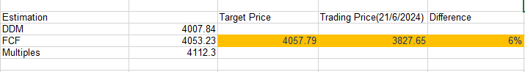

We advise holding TCS stock in light of the competitive challenges, economic uncertainty, and moderate upside potential. The company's long-term prospects are reinforced by its sound financial standing, steady dividend yield, and wise investments. By holding, investors can minimise short-term market and economic risks while potentially benefiting from future growth.

# **References:**

Annual report 2022-23 (no date) *Tata Consultancy Services Annual report 2022-23* [online]. pp. 136–144. Available from: <https://www.tcs.com/content/dam/tcs/investor-relations/financial-statements/2022-23/ar/annual-report-2022-2023.pdf>.

annual report 2022-23 (no date) *Tata Consultancy Services Annual report 2022-23* [online]. Available from: https://www.tcs.com/content/dam/tcs/investor-relations/financial-statements/2022-23/ar/annual-report-2022-2023.pdf.

ANI Press Release (2021) *TCS targets net zero emissions by 2030* *@bsindia*. 3 June 2021 [online]. Available from: https://www.business-standard.com/content/press-releases-ani/tcs-targets-net-zero-emissions-by-2030-121060301131_1.html [Accessed 5 July 2024].

Business today (2022) *TCS launches energy solutions to help businesses achieve sustainability goals* *Business Today*. 10 February 2022 [online]. Available from: https://www.businesstoday.in/latest/corporate/story/tcs-launches-energy-solutions-to-help-businesses-achieve-sustainability-goals-322102-2022-02-10 [Accessed 5 July 2024].

Emrouznejad, A., Abbasi, S. and Sıcakyüz, Ç. (2023b) Supply chain risk management: A content analysis-based review of existing and emerging topics. *Supply Chain Analytics* [online]. 3, p. 100031. Available from: https://doi.org/10.1016/j.sca.2023.100031 [Accessed 2 July 2024].

Fortuneindia.com (2023) *Women attrition rate outpaces that of men in TCS as work from home ends* *www.fortuneindia.com*. 8 June 2023 [online]. Available from: https://www.fortuneindia.com/enterprise/women-attrition-rate-outpaces-that-of-men-in-tcs-as-work-from-home-ends/112965.

Isabelle, D., Horak, K., McKinnon, S. and Palumbo, C. (2020) Is Porter’s Five Forces Framework Still Relevant? A study of the capital/labour intensity continuum via mining and IT industries. *Technology Innovation Management Review* [online]. 10 (6). Available from: https://www.timreview.ca/article/1366 [Accessed 27 June 2024].

Jana, R.N. and Yadav, S.K., (2022). Financial Performance Analysis of Selected IT Companies in India: Special Reference with Tata Consultancy Services. Amity Business Review, 23(2).

Kolte, A., Pawar, A., Rossi, M. and Rasal, D. (2022) Analysing the financial state of selected Indian information technology companies: the assessment towards foreseeing the future of industry. *International Journal of Intellectual Property Management* [online]. 12 (3), p. 281. Available from: https://www.inderscienceonline.com/doi/abs/10.1504/IJIPM.2022.124631#:~:text=https%3A//doi.org/10.1504/IJIPM.2022.124631 [Accessed 2 July 2024].

Liao, H., Peng, Y., Wang, F.-Z. and Zhang, T. (2022) Understanding energy use growth: The role of investment-GDP ratio. *Structural Change and Economic Dynamics* [online]. 63, pp. 15–24. Available from: https://doi.org/10.1016/j.strueco.2022.08.007 [Accessed 2 July 2024].

María Jesús Romero-Lara, Comino, F. and Ruiz, M. (2023) Seasonal energy efficiency ratio of regenerative indirect evaporative coolers—Simplified calculation method. *Applied thermal engineering* [online]. 220, pp. 119710–119710. Available from: https://doi.org/10.1016/j.applthermaleng.2022.119710 [Accessed 3 July 2024].

‘Pace PortTM Amsterdam’ (no date) *www.tcs.com* [online]. Available from: https://www.tcs.com/what-we-do/pace-innovation/pace-port/pace-port-accelerating-digital-transformation [Accessed 4 July 2024].

Subramanian, A. and Felman, J., (2022). India's Stalled Rise: How the State Has Stifled Growth. Foreign Aff., 101, p.139.