DSA Project:
Group Members:
- Meerab Aijaz Khan - 01-135232-043
- Sarah Naseer - 01-135232-088
- Wasla Abbasi - 01-135212-100

Introduction
The provided code implements a basic Library Management System in C++. It allows for managing books in a library using binary search trees (BST) and a queue data structure for breadth-first search (BFS) traversal. The system supports operations such as adding, deleting, searching for books, displaying books in both in-order and BFS traversal, and saving book data to a file. The implementation includes:

Book Data Structure: Representing books using a structure with attributes such as ISBN, title, and author.
Binary Search Tree (BST): A tree data structure used for storing books based on ISBN for efficient searching, insertion, and deletion.
Queue for BFS: A queue is used to implement the breadth-first traversal of the books.
File I/O: Loading and saving book information from/to a text file.
Code:
#include <iostream>
#include <fstream>
#include <sstream>
#include <string>
using namespace std;

struct Book {
int isbn;
string title;
string author;
Book* left;
Book* right;

Book(int bookIsbn, string bookTitle, string bookAuthor) {
isbn = bookIsbn;
title = bookTitle;
author = bookAuthor;
left = nullptr;
right = nullptr;
}
};

struct QueueNode {
Book* data;
QueueNode* next;

QueueNode(Book* book) {
data = book;
next = nullptr;
}
};

class Queue {
private:
QueueNode* front;
QueueNode* rear;

public:
Queue() {
front = nullptr;
rear = nullptr;

}

~Queue() {
while (!empty()) {
pop();
}
}

void push(Book* book) {
QueueNode* newNode = new QueueNode(book);
if (rear == nullptr) {
front = rear = newNode;
}
else {
rear->next = newNode;
rear = newNode;
}
}

Book* pop() {
if (empty()) return nullptr;
QueueNode* temp = front;
Book* book = temp->data;
front = front->next;
if (front == nullptr) {
rear = nullptr;
}
delete temp;
return book;
}

bool empty() const {
return front == nullptr;
}
};

class LibrarySystem {
private:
Book* root;

Book* insertRec(Book* node, int isbn, const string& title, const string& author) {
if (node == nullptr) {
return new Book(isbn, title, author);
}
if (isbn < node->isbn) {
node->left = insertRec(node->left, isbn, title, author);
}
else if (isbn > node->isbn) {
node->right = insertRec(node->right, isbn, title, author);
}
return node;
}

void inorderRec(Book* node) const {
if (node == nullptr) {
return;
}
inorderRec(node->left);
cout << "ISBN: " << node->isbn << endl;
cout << "Title: " << node->title << endl;
cout << "Author: " << node->author << endl;
inorderRec(node->right);
}

void bfsRec() const {
if (root == nullptr) {
cout << "No books in the library." << endl;
return;
}

Queue q;
q.push(root);

cout << "Books in Library (BFS Traversal):" << endl;
while (!q.empty()) {
Book* current = q.pop();
cout << "ISBN: " << current->isbn << endl;
cout << "Title: " << current->title << endl;
cout << "Author: " << current->author << endl;

if (current->left != nullptr) {
q.push(current->left);
}
if (current->right != nullptr) {
q.push(current->right);
}
}
}

Book* searchRec(Book* node, int isbn) const {
if (node == nullptr || node->isbn == isbn) {
return node;
}
if (isbn < node->isbn) {
return searchRec(node->left, isbn);
}
return searchRec(node->right, isbn);
}

Book* deleteRec(Book* node, int isbn) {
if (node == nullptr) {
return node;
}
if (isbn < node->isbn) {
node->left = deleteRec(node->left, isbn);
}
else if (isbn > node->isbn) {
node->right = deleteRec(node->right, isbn);
}
else {
if (node->left == nullptr) {
Book* temp = node->right;
delete node;
return temp;
}
else if (node->right == nullptr) {
Book* temp = node->left;
delete node;
return temp;
}
Book* temp = minValueNode(node->right);
node->isbn = temp->isbn;
node->title = temp->title;
node->author = temp->author;
node->right = deleteRec(node->right, temp->isbn);
}
return node;
}

Book* minValueNode(Book* node) {
Book* current = node;
while (current && current->left != nullptr) {
current = current->left;
}
return current;
}

void loadBooksFromFile() {
ifstream file("books.txt");
if (!file.is_open()) {
cout << "Could not open the file!" << endl;
return;
}

string line;
while (getline(file, line)) {
stringstream ss(line);
int isbn;
string title, author;

if (ss >> isbn) {
ss.ignore();
getline(ss, title, ',');
getline(ss, author);

if (!title.empty() && !author.empty()) {
root = insertRec(root, isbn, title, author);
}
else {
cout << "Invalid data format in line: " << line << endl;
}
}
else {
cout << "Error parsing ISBN in line: " << line << endl;
}
}
file.close();
}

void saveBookToFile(int isbn, const string& title, const string& author) {
ofstream file("books.txt", ios::app);
if (file.is_open()) {
file << isbn << "," << title << "," << author << endl;
file.close();
}
else {
cout << "Could not open the file for writing!" << endl;
}
}

void saveAllBooksToFile(Book* node) {
if (node == nullptr) return;
saveAllBooksToFile(node->left);
saveBookToFile(node->isbn, node->title, node->author);
saveAllBooksToFile(node->right);
}

public:
LibrarySystem() {
root = nullptr;
cout << "Books Saved:" << endl;
addBook(123, "The Great Gatsby", "F. Scott Fitzgerald");
addBook(456, "1984", "George Orwell");
addBook(789, "To Kill a Mockingbird", "Harper Lee");
addBook(101, "Moby Dick", "Herman Melville");
loadBooksFromFile();
}

~LibrarySystem() {
saveAllBooksToFile(root);
}

void addBook(int isbn, const string& title, const string& author) {
root = insertRec(root, isbn, title, author);
saveBookToFile(isbn, title, author);
cout << "Book Details: " << endl;
cout << "ISBN: " << isbn << endl;
cout << "Title : " << title << endl;
cout << "Author : " << author << endl;
}

void displayBooks() const {
cout << "Books in Library (In-order Traversal):" << endl;
inorderRec(root);
}

void displayBooksBFS() const {
bfsRec();
}

void searchBook(int isbn) const {
Book* book = searchRec(root, isbn);
if (book) {
cout << "Book found: ISBN: " << book->isbn << endl;
cout << "Title: " << book->title << endl;
cout << "Author: " << book->author << endl;
}
else {
cout << "Book with ISBN " << isbn << " not found." << endl;
}
}

void deleteBook(int isbn) {
root = deleteRec(root, isbn);
cout << "Book with ISBN " << isbn << " deleted (if it existed)." << endl;
}
};

int main() {
LibrarySystem library;
int choice, isbn;
string title, author;

while (true) {
cout << endl;
cout << "Library System Menu:" << endl;
cout << "1. Add Book " << endl;
cout << "2. Display All Books (In-order Traversal)" << endl;
cout << "3. Display All Books (BFS Traversal)" << endl;
cout << "4. Search Book" << endl;
cout << "5. Delete Book" << endl;
cout << "Enter your choice: ";
cin >> choice;

if (cin.fail()) {
cin.clear();
cin.ignore(1000, '\n');
cout << "Invalid input. Please enter a number." << endl;
continue;
}

switch (choice) {
case 1:
cout << "Enter ISBN: ";
cin >> isbn;
cin.ignore();
cout << "Enter Title: ";
getline(cin, title);
cout << "Enter Author: ";
getline(cin, author);
library.addBook(isbn, title, author);
break;
case 2:
library.displayBooks();
break;
case 3:
library.displayBooksBFS();
break;
case 4:
cout << "Enter ISBN to search: ";
cin >> isbn;
library.searchBook(isbn);
break;
case 5:
cout << "Enter ISBN to delete: ";
cin >> isbn;
library.deleteBook(isbn);
break;

default:
cout << "Invalid choice. Please try again." << endl;
}

cout << "Do you want to make another choice? (yes/no): ";
string anotherChoice;
cin >> anotherChoice;
if (anotherChoice == "no" || anotherChoice == "No") {
cout << "Exiting..." << endl;
return 0;
}
else {
cout << "Displaying menu..." << endl;
}
}

return 0;
}
Output: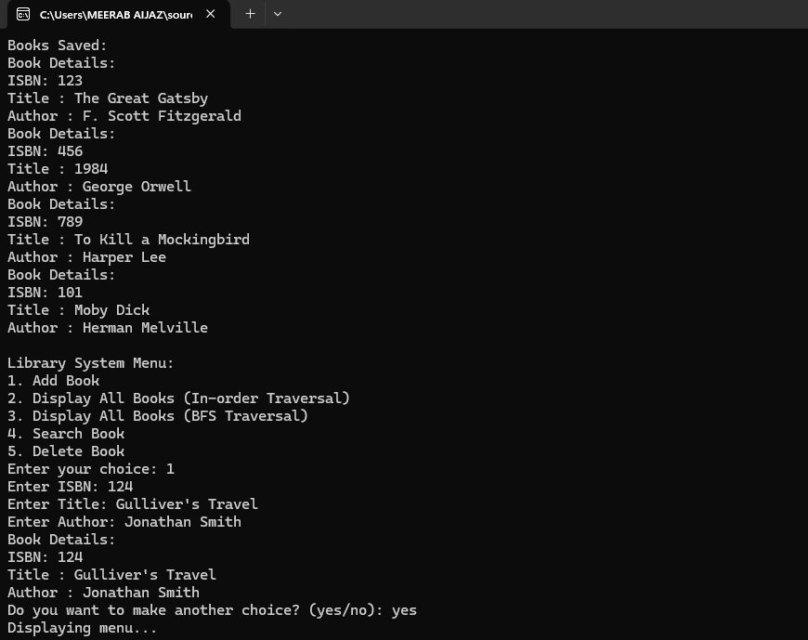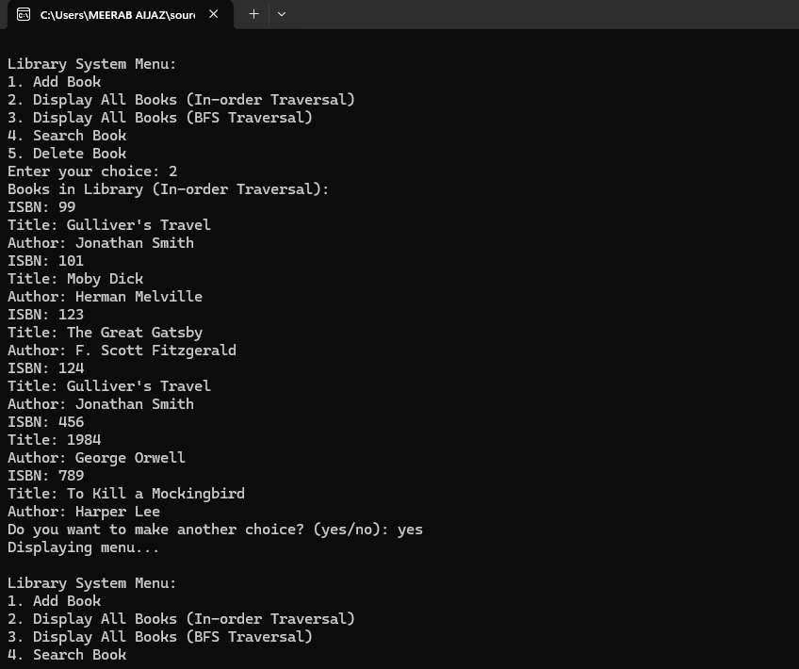
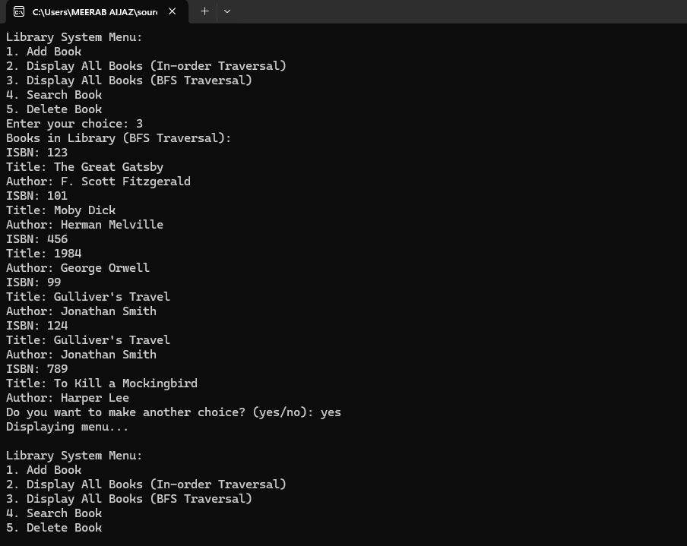
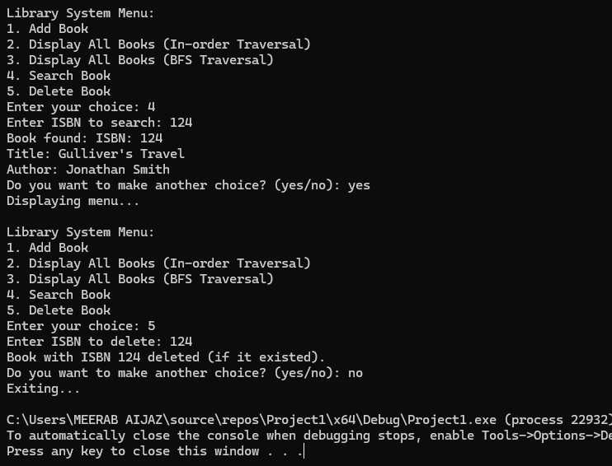
Text File:
