**NAME: MEERAB AMIR STUDENT ID: FA17-BECE-0017**

**LAB 10**

**EXERCISE 1:**

**1.**

x=(0:pi/50:2*pi);

y1=sin(x);

y2=cos(x);

plot(x,y1 ,x,y2);

title("Waves");

grid on

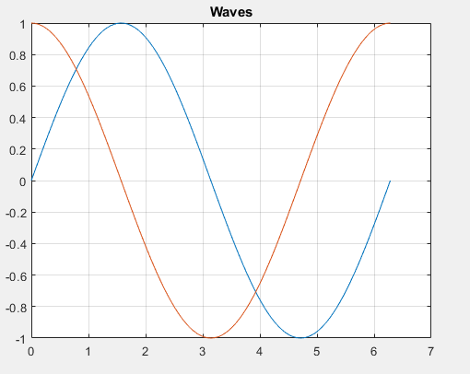

**2.**

x=(0:pi/50:2*pi);

y1=sin(x);

y2=cos(x);

plot(x,y1,'--',x,y2,':');

title("Waves");

grid on

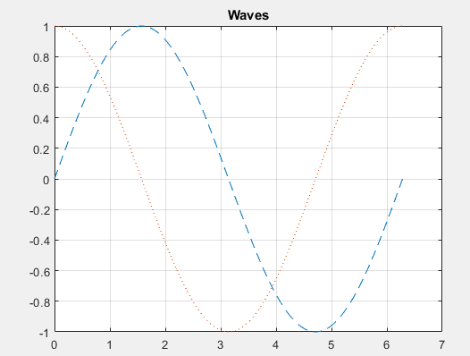

**3.**

x=(0:pi/50:2*pi);

y1=sin(x);

y2=cos(x);

subplot(2,1,1)

plot(x,y1,'--g')

subplot(2,1,2)

plot(x,y2,':r');

title("Waves");

grid on

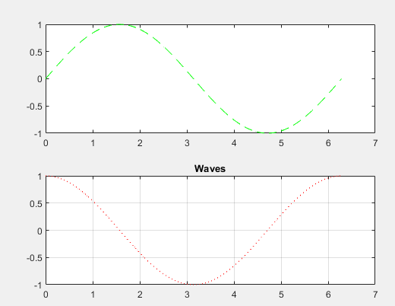

**EXERCISE 2:**

x=[0:0.01:4*pi];

y=sin(x);

subplot(1,1,1)

plot(x,y)

title("Plot of a Sine Wave")

ylabel("y values")

xlabel("x values")

grid on

figure(gcf)

