NAME:MEERAB AMIR STD. ID:FA17-BECE-0017
LAB O9
#include <stdio.h>
#include <stdlib.h>
#include <pthread.h>
#include <semaphore.h>
#include <unistd.h>

sem_t s;

void* thread (void* arg)
{
sem_wait(&s);
printf("\nENTERED \n ");

sleep(4);

printf("\nJUST EXITING\n");
sem_post(&s);
}
int main()
{
sem_init(&s,0,1);
//sem_init(&s,0,5);
pthread_t t1,t2,t3;
pthread_create(&t1,NULL,thread,NULL);
sleep(2);
pthread_create(&t2,NULL,thread,NULL);
pthread_create(&t3,NULL,thread,NULL);
pthread_join(t1,NULL);
pthread_join(t2,NULL);
pthread_join(t3,NULL);
sem_destroy(&s);
return 0;
}

S=1

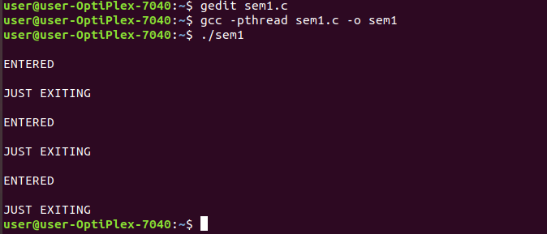
S=5

