OS LAB 14
MEERAB AMIR FA17-BECE-0017

TASK 1:

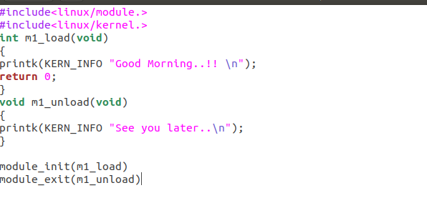

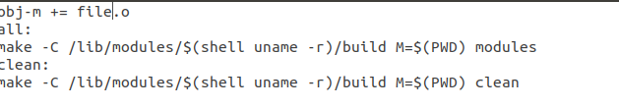
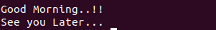

TASK 2:

