Lab Evaluation -1
Full Stack Framework

RollNo : CB.SC.U4CSE23663
Name : Meera J Vaishnav

- About the use case :
This application is designed as a Visual Schedule Trainer for children with autism. It helps them manage daily routines, tasks, and activities in a structured, engaging, and interactive way. Using colorful visuals, icons, and rewards, the app encourages children to complete tasks while keeping them motivated. The interface is simple and intuitive, reducing stress and confusion for autistic children by providing a predictable daily workflow. Features like check-off tasks and visual rewards are included to make daily activities more fun and engaging.

- Purpose:
The primary purpose of this application is to improve daily routine management for autistic children. It provides comfort and support by:
    - Helping children understand and follow their schedule independently.
    - Reducing anxiety by providing a predictable and consistent routine.
    - Using visual cues, colors, and animations to make tasks clear and enjoyable.
    - Offering a reward system (stars, badges) to encourage motivation and positive reinforcement.

    - Enabling parents or caregivers to monitor and adjust tasks easily.

- List of similar applications
  - Choiceworks App
  - AutiPlan
  - First Then Visual Schedule
  - Endless Alphabet / ABCMouse

- Technology stack:
Frontend:
    - ReactJS – for building the user interface
    - HTML5 – structure of the web pages
    - CSS3 – styling, animations, and layout
    - Axios – for making HTTP requests to the backend
    - React Router DOM – for page navigation (Profile, Dashboard, Rewards, Routine)
Backend:
    - Node.js – runtime environment
    - Express.js – server framework to build APIs
    - MongoDB — Database

- Responsiveness of the application:
The application is responsive in the following ways using ReactJS and CSS:
  - Component-based UI: Each screen (Login, Dashboard, Profile, Rewards, Routine) is built as a reusable React component.
  - Flexible layout using CSS Flexbox:
      - Tasks are displayed in columns that adjust to screen size.
      - Navigation bar adapts to smaller widths.
  - Mobile friendly inputs and buttons:
    - Large clickable buttons.
    - Simple forms for children to use.
  - Adaptive UI:
    - Tasks move smoothly between “To Do” and “Done”.
    - Rewards update dynamically without page refresh.
  - Real-time updates:
    - When a task is completed, stars increase instantly.
    - Profile updates reflect immediately.

6. Workflow of the application:
  - User opens the app
  - Login/Profile Page appears
  - Child enters:
    - Name,
    - Age,
    - Favorite color,
    - Favorite cartoon
  - Data is saved to backend using Axios to MongoDB
  - User is redirected to Dashboard
  - Dashboard:
    - Shows daily routine tasks
    - User can add tasks
    - Mark tasks as completed
    - Delete tasks
  - When a task is completed:
    - Star count increases
    - Bronze, Silver and Gold badges are achieved based on the number of stars
    - The child gets a congratulations message from their favourite cartoon character
  - User can navigate:
    - Profile → Edit profile
    - Rewards → See rewards based on stars
    - Routine → Full task list
  - Data is continuously saved to backend
  - User can log out and log back in later

7. Screenshots:

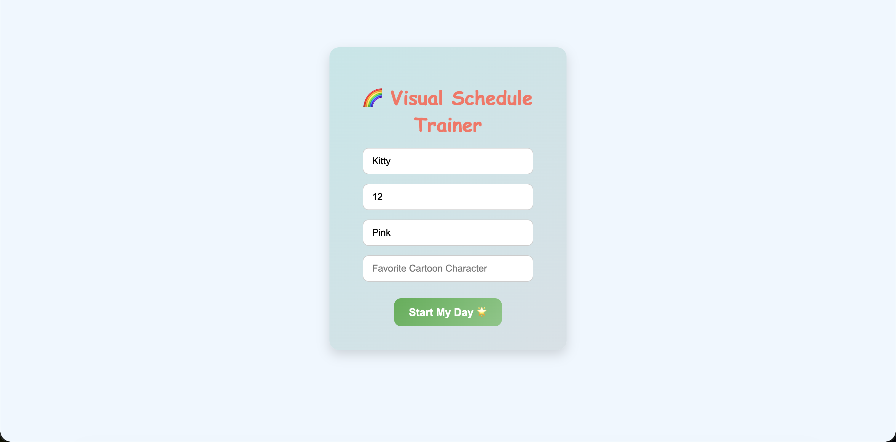
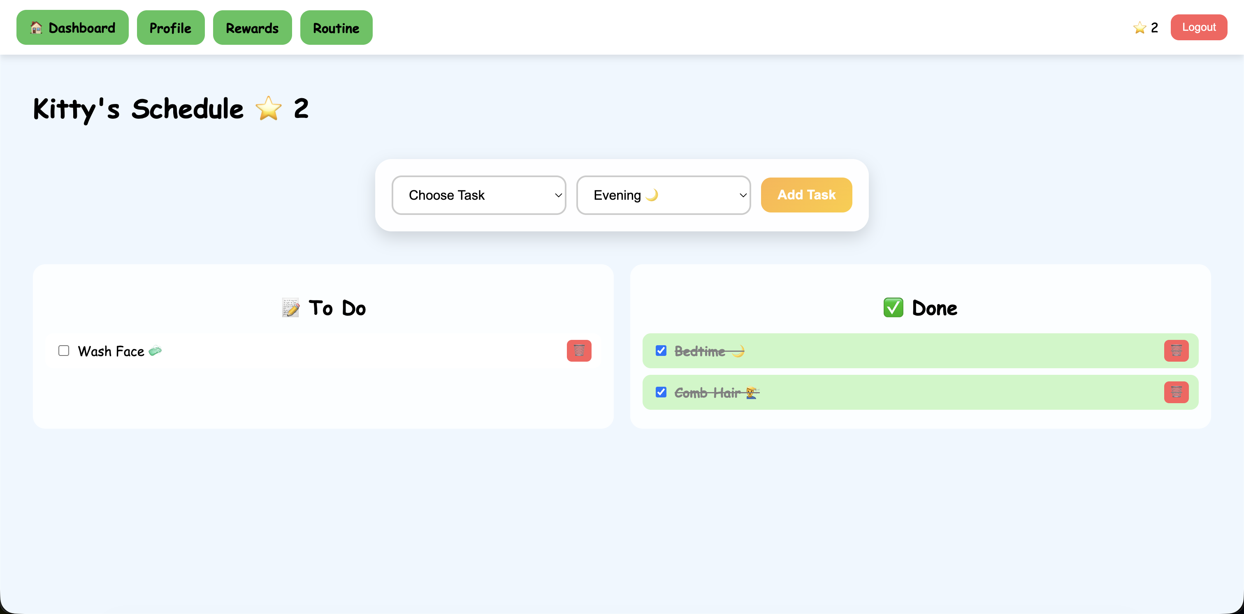
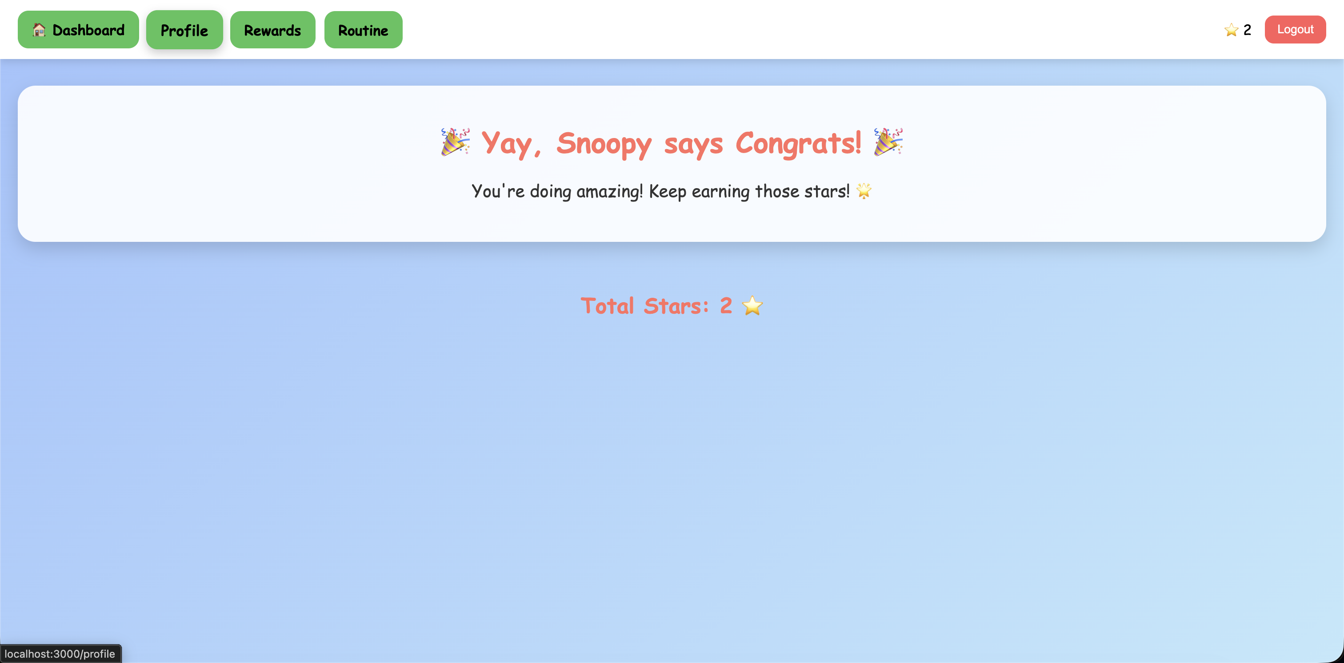
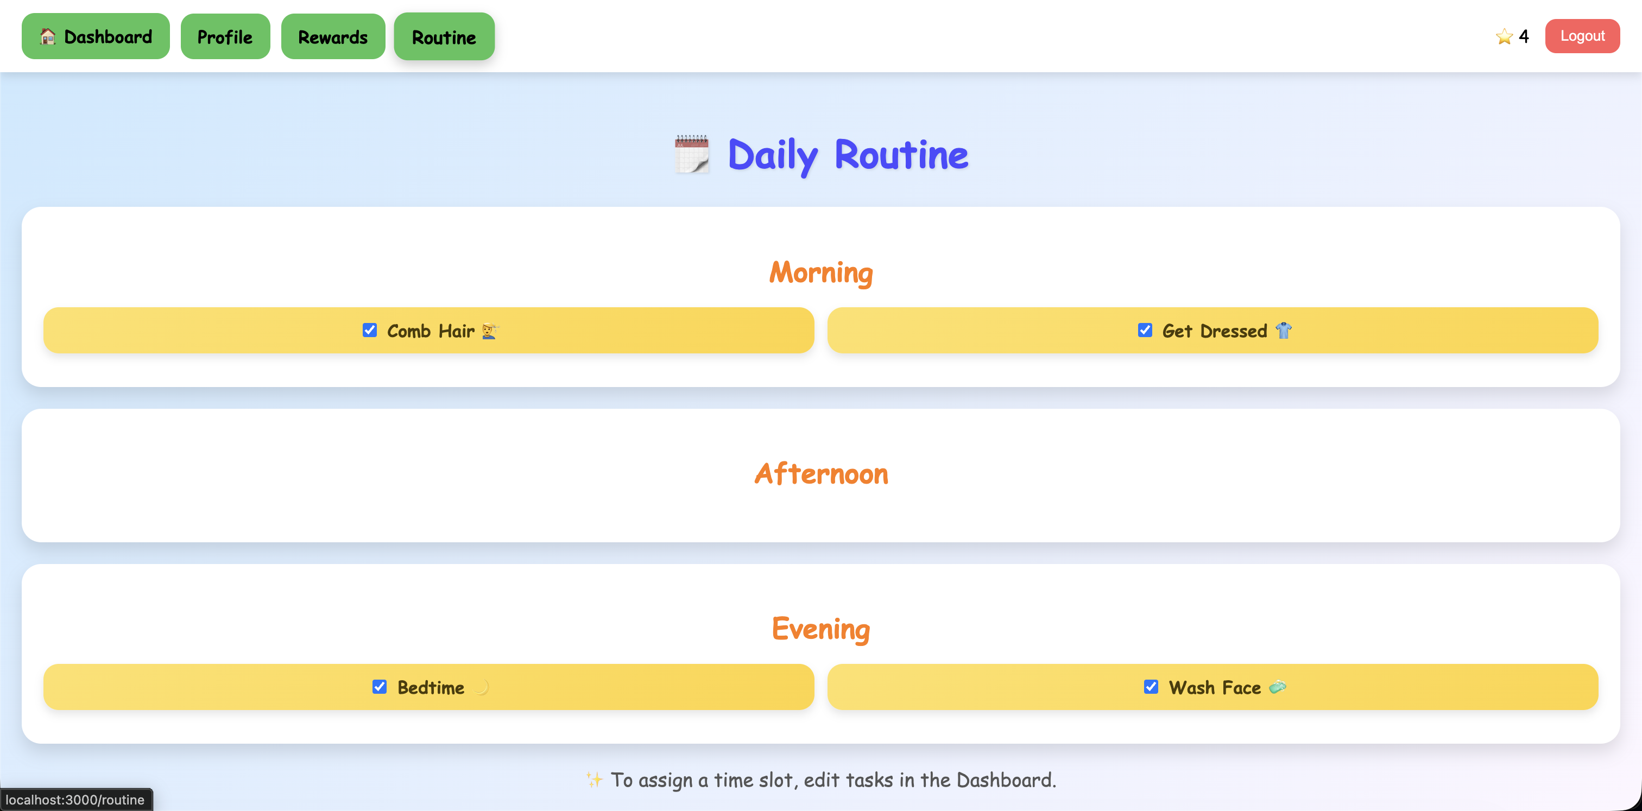

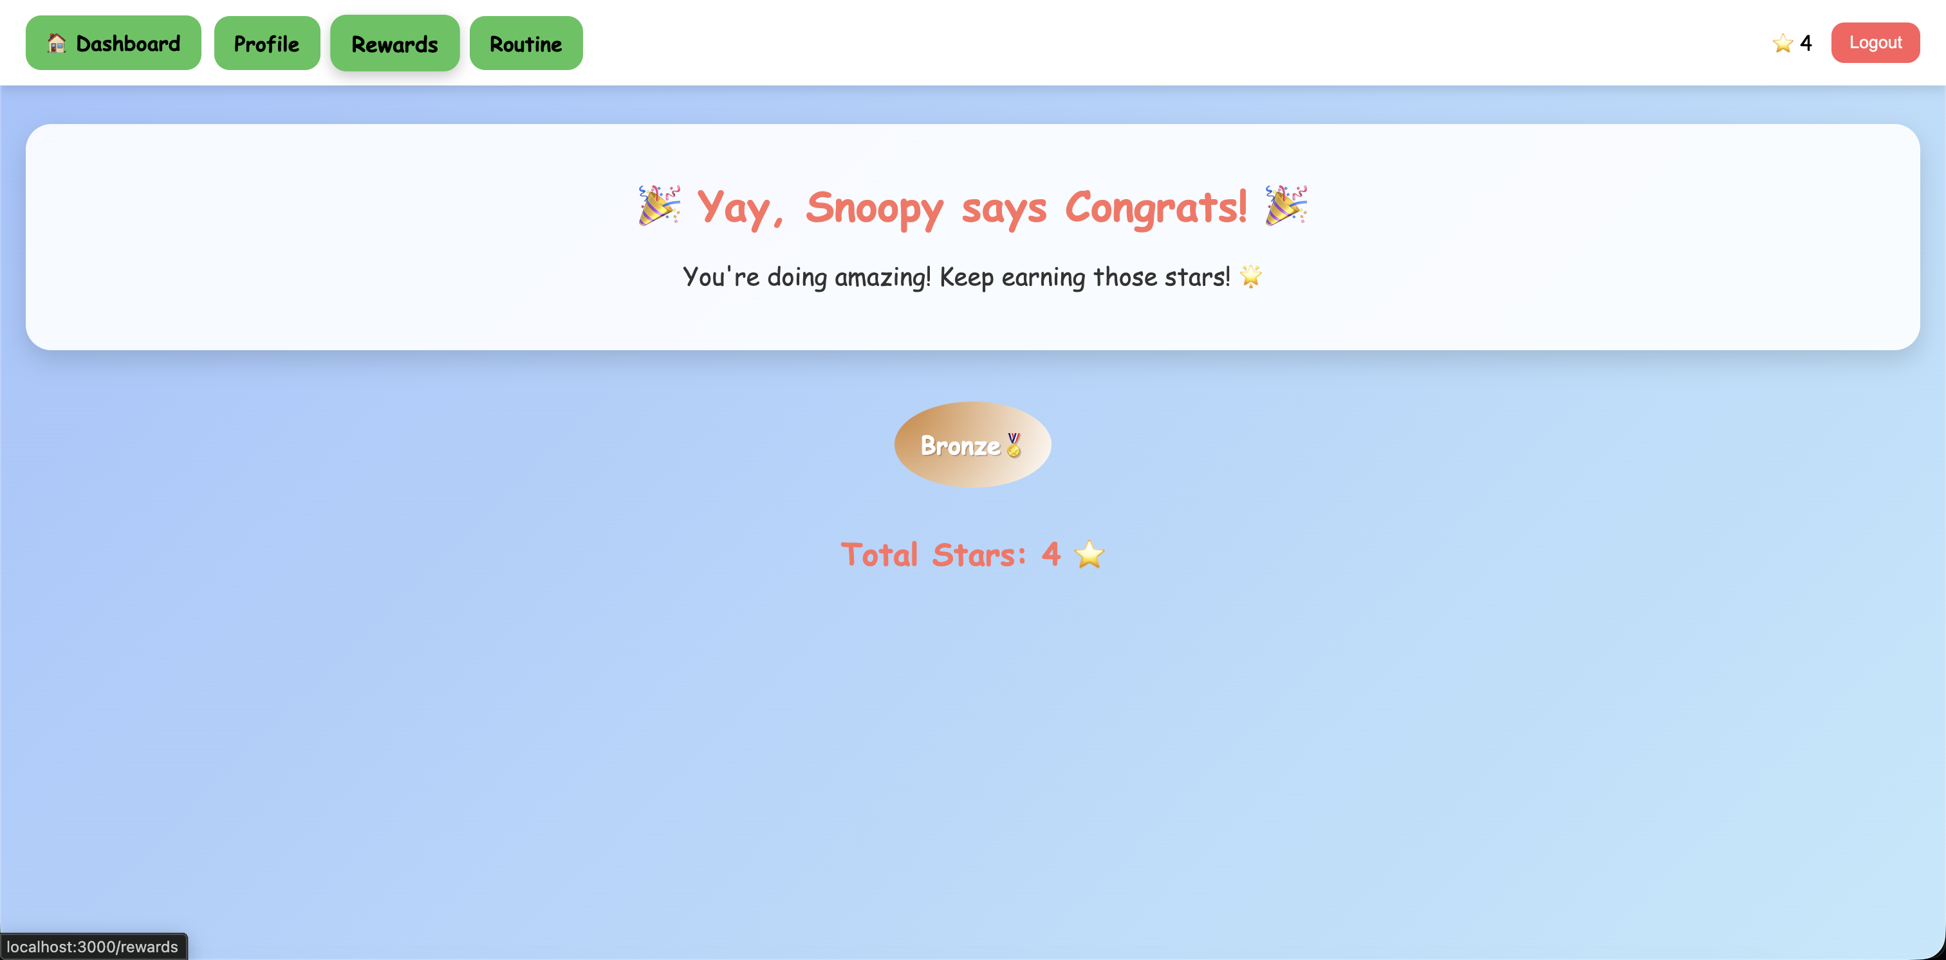
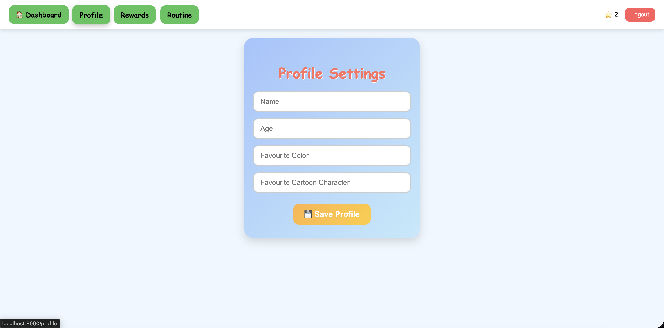
8. List of files with its purpose?
App.js | Main React component that controls routing, login, dashboard, task logic and API calls
server.js | Backend server using Express. Handles APIs for the profile and tasks
ProfilePage.js | Displays and updates the Childs’s profile information
RewardsPage.js | Shows rewards based on number of stars earned, shows bronze, silver and gold badges, also shows their favourite cartoon character saying congratulations
RoutinePage.js | Displays full routine schedule and allows task management
index.js | Entry point of the React application
Apps.css | Contains all styling, animations and layout design
index.html | Main HTML code where React mounts the app

