**SUMMARY**

## USC ID/s: 8203536510

## Datapoints

|  |  |  |  |  |
| --- | --- | --- | --- | --- |
| M+N | Time in MS (Basic) | Time in MS (Efficient) | Memory in KB (Basic) | Memory in KB (Efficient) |
| 16 | 0 | 0 | 1.25 | 1.3 |
| 64 | 4 | 5 | 42.41 | 42.46 |
| 128 | 24.76 | 20.02 | 169.4 | 55.84 |
| 256 | 72.39 | 87.23 | 661.05 | 125.79 |
| 384 | 164.21 | 227.7 | 1473.49 | 92.2 |
| 512 | 317.53 | 398.03 | 2600.36 | 106.78 |
| 768 | 920.5 | 1062.01 | 5822.59 | 88.49 |
| 1024 | 1882.42 | 1901.91 | 10322.3 | 144.22 |
| 1280 | 3431.12 | 3366.83 | 16111.47 | 151.39 |
| 1536 | 4611.38 | 5465.55 | 23172.88 | 230.43 |
| 2048 | 9125 | 8785.78 | 41135.65 | 228.03 |
| 2560 | 14660.34 | 14401.04 | 64225.53 | 256.9 |
| 3072 | 21152.95 | 21002.39 | 92435.54 | 303.8 |
| 3584 | 30193.51 | 27977.83 | 125739.4 | 341.59 |
| 3968 | 35180.08 | 36145.8 | 154098.54 | 386.55 |

## Insights

### Graph1 – Memory vs Problem Size (M+N)

#### Nature of the Graph (Logarithmic/ Linear/ Polynomial/ Exponential)

Basic: Polynomial

Efficient: Linear

#### Explanation: The points represent the peak memory usage (worst-case) of both algorithms as the input increases. From the graph we can see that the basic algorithm’s memory consumption grows polynomially as the input size increases in contrast to the efficient algorithm that grows linearly and maintains a straight line. In the basic implementation we build a dp-table of size (x+1) * (y+1) so the memory usage grow quadratically O(n^2) whiles the efficient implementation only stores two rows of y+1 length and a recursion stack which is typically O(logx) which amounts to a usage of O(n) space.

### Graph2 – Time vs Problem Size (M+N)

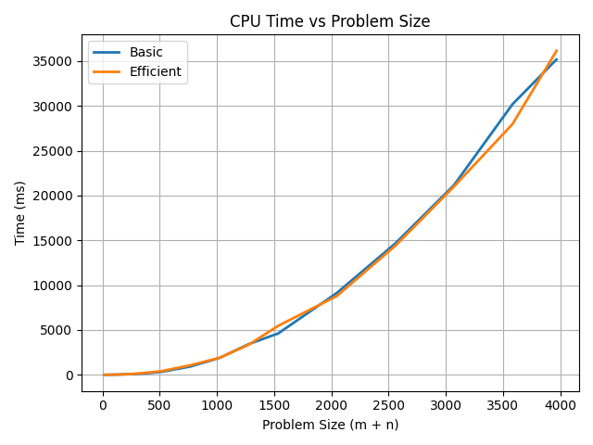

#### Nature of the Graph (Logarithmic/ Linear/ Polynomial/ Exponential)

Basic: Polynomial

Efficient: Polynomial

#### Explanation: The points represent the total runtime of both algorithms as the input increases. From the graph we can see that the basic and efficient algorithm’s runtime grows polynomially as the input size increases, this is due to both implementations computing the dp-table of (x+1)*(y+1) length, however the efficient is a bit slower due to working one row at a time rather than a double loop and the recursion plus swapping overhead.

## Contribution

<USC ID/s>: 8203536510 <Equal Contribution>* I worked on this project by myself.