CUZZY CREW
MERCH PLATFORM

Functional Specification & Product Plan
Version 1.0 • February 2026

Flutter Web + Node.js + Firebase
Guest-First Checkout • Stripe Payments • Responsive Design

Table of Contents
Table of Contents 2
1. Executive Summary 4
1.1 What This Document Covers 4
1.2 Scope Boundaries 4
In Scope (MVP) 4
Out of Scope (Post-MVP) 4
2. System Architecture 6
2.1 Architectural Overview 6
2.2 API Design Principles 6
3. Brand, Theme & Visual Direction 7
3.1 Brand Personality 7
3.2 Theme Tokens 7
3.3 Typography Hierarchy 7
3.4 Visual Rules 7
4. Responsive Experience Strategy 9
4.1 Breakpoint System 9
4.2 Core Requirements 9
5. Frontend UX Plan (Screen-by-Screen) 10
5.1 Home 10
5.2 Shop / Catalog 11
5.3 Product Details 14
5.4 Cart 14
5.5 Checkout (Guest-First) 16
5.6 Order Success & Tracking 16
5.7 Help & Policies 16
6. UI Component System 18
7. Backend API Specification 19
7.1 API Domains 19
Catalog APIs 19
Cart APIs (Guest-First) 19
Checkout & Order APIs 19
Payment APIs 20
Address APIs 20
Authentication APIs 20
Review APIs 21
7.2 Admin APIs (Restricted) 21
7.3 Error Handling Standards 21
8. Authentication & User Management 23
8.1 Guest-First Model 23
8.2 Registration 23
8.3 Login 23
8.4 Token Lifecycle 23
8.5 Theme Management 23
9. Database Design 25
9.1 Stack 25
9.2 Entity Definitions 25
9.3 Data Integrity Safeguards 26
10. Admin Panel 27
10.1 Dashboard 27
10.2 Product Management 27
10.3 Order Management 27
10.4 Coupon Management 27
10.5 Audit Trail 27
11. Checkout, Payment & Order Reliability 28
11.1 Customer Journey Reliability 28
11.2 Payment Flow 28
11.3 Failure Handling 28
12. Performance, Quality & Accessibility 29
12.1 Frontend Targets 29
12.2 Backend Targets 29
12.3 Accessibility 29
13. Delivery Roadmap 30

1. Executive Summary
This document presents the complete product plan for the Cuzzy Crew Merch Platform: a premium, web-first ecommerce experience designed to match the Cuzzy Crew brand identity and convert influencer traffic into repeat customers.

The platform is purpose-built for creator-led commerce, where a single influencer brand sells directly to their community. Every design decision, from the guest-first checkout flow to the streetwear-premium visual language, is optimized for this use case.

1.1 What This Document Covers
- System architecture and technology stack
- Brand identity, theme system, and visual direction
- Responsive experience strategy across all breakpoints
- Screen-by-screen frontend UX plan with design mockups
- Reusable UI component inventory
- Backend API scope, endpoints, and behavior contracts
- Guest-first checkout and payment integration (Stripe)
- Database schema and data integrity safeguards
- Admin panel functionality
- Performance, quality, and accessibility targets
- Delivery roadmap and execution sequence

1.2 Scope Boundaries

In Scope (MVP)
- Landing page and home merchandising sections
- Shop/catalog browsing with filtering, sorting, and pagination
- Product detail pages with variants (size/color), gallery, and recommendations
- Cart with quantity management, promo codes, and upsell strips
- Guest-first multi-step checkout (Address → Shipping → Payment → Review)
- Order confirmation, tracking timeline, and guest order lookup
- Help and policy pages (shipping, returns, contact, FAQ)
- Light mode (default) and dark mode theme toggle
- Admin dashboard with product, order, and inventory management
- Stripe payment integration with webhook verification

Out of Scope (Post-MVP)
- Multi-vendor marketplace behavior
- Full custom CMS builder
- Loyalty/gamification engine
- Social login (Google/Apple) — planned for Phase 2
- Push notification system
- Wishlist sharing and social features

2. System Architecture

2.1 Architectural Overview
The system follows a layered architecture with clear separation of concerns, designed for scalability, security, and maintainability:

Layer | Technologies
Frontend | Flutter Web (Dart)
State Management | valuenotifier (production-grade reactive state)
Routing | GoRouter (Flutter-recommended declarative routing)
HTTP Client | Dio (interceptors, retry, token refresh)
Local Storage | Hive (session tokens, theme preference, guest cart)
Backend | Node.js + Express.js
Database | Firebase
Cache | Redis (cart sessions, high-read query acceleration)
Image Storage | Cloudflare R2 / AWS S3
Payments | Stripe (Payment Intents + Webhooks)
Authentication | JWT (access + refresh token pattern)

2.2 API Design Principles
- Versioned API structure (/api/v1/...)
- JSON-first request and response format
- Consistent success/error response envelope
- Guest cart continuity support via session tokens
- Idempotent order and payment operations (Idempotency-Key header) to prevent duplicate purchases
- Rate limiting on authentication and checkout endpoints
- Structured, readable error payloads with validation vs. business rule distinction

3. Brand, Theme & Visual Direction

3.1 Brand Personality
- Creator-led and community-first
- Bold but minimal — streetwear premium aesthetic
- Confident tone with clean editorial structure
- Conversion-first layout choices: important actions visible early

3.2 Theme Tokens
The platform ships with a dual-theme system. Light mode is the default; dark mode is user-toggled and persisted locally.

Token | Light Mode (Default) | Dark Mode
Primary Accent | #E39C3A | #E39C3A
Secondary Accent | #A16E29 | #A16E29
Background | #F0F0F0 | #0D0D0D
Surface | #FFFFFF | #141414
Surface Alternate | #E4E4E4 | #1E1E1E
Border | #CCCCCC | #2A2A2A
Main Text | #1A1A1A | #E8E8E8
Muted Text | #666666 | #666666

3.3 Typography Hierarchy
Role | Font Family | Usage
Display / Hero | Bebas Neue | Page titles, hero headlines, section headers
Body / UI | Syne | Body copy, navigation, buttons, form labels
Labels / Metadata | DM Mono | Prices, SKUs, timestamps, badges

3.4 Visual Rules
- Accent color is used strategically: CTAs, key highlights, status emphasis, active states
- Strong spacing rhythm and controlled white/negative space
- Thin borders, clean surfaces, minimal visual noise
- Manual contrast validation for WCAG AA accessibility compliance
- No horizontal scrolling at any breakpoint

4. Responsive Experience Strategy

4.1 Breakpoint System
Breakpoint | Width | Layout Behavior
Mobile | < 640px | Stacked flows, drawer navigation, persistent key action buttons, single-column grids
Tablet | 640–1023px | Compact top header, drawer-based navigation, adaptive 2-column grids
Desktop | ≥ 1024px | Fixed brand-first top navigation, wider 3-column product grids, sticky utility areas

4.2 Core Requirements
- No horizontal scrolling at any breakpoint
- Consistent usability via mouse, keyboard, and touch
- Accessible touch targets (minimum 44px) and visible focus states
- Smooth theme switching without visual flicker
- Fast first render on cached scenarios

5. Frontend UX Plan (Screen-by-Screen)
The following section details every screen in the application, its purpose, key components, and user flows. Design mockups are provided for both light and dark themes.

5.1 Home
Purpose: High-conversion discovery and brand storytelling

- Ecommerce top navigation: Home, Shop, Categories, Track Order, theme toggle, cart icon
- Hero split section with creator-brand headline, brand stats row (followers, reach, drops), and primary CTA
- Accent divider + animated ticker strip for drop messaging and promotional urgency
- Featured categories grid: Hoodies, Tees, Caps, Accessories
- New arrivals product grid with “View Collection” link
- Drop-focused promotional strip for limited editions
- Editorial brand story section (“The Soul of the Crew”)
- Footer with navigation columns (Explore, Support), social links, and newsletter signup

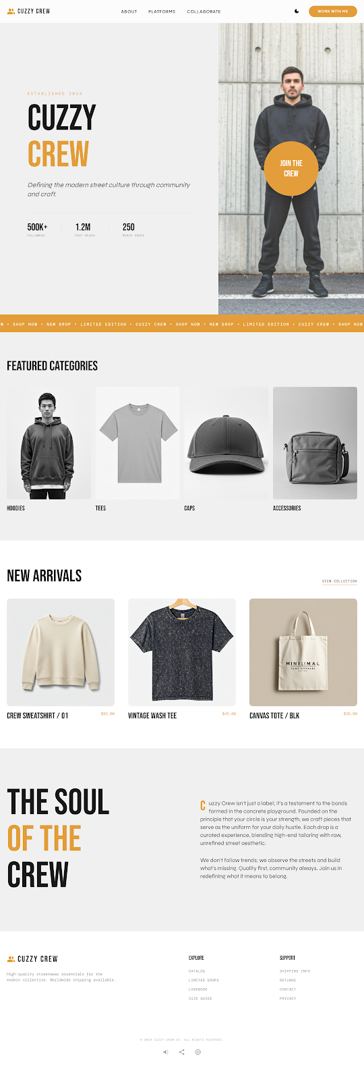  Fig. 5.1a — Home (Light Mode) |   Fig. 5.1b — Home (Dark Mode)

5.2 Shop / Catalog
Purpose: Fast product finding with rich filtering

- Collection header with page title, item count, and sort controls
- Filter sidebar: category, size, colorway, price range slider, availability
- Sort options: Newest Arrivals, Price Low→High, Price High→Low, Featured/Trending
- Product card badges: NEW (accent), LIMITED (accent outline), SOLD OUT (muted overlay)
- Quick Add reveal on hover for desktop conversion speed
- Product cards show: image, name, price, material/color subtitle, sale strikethrough where applicable
- Pagination with numbered pages and item count indicator

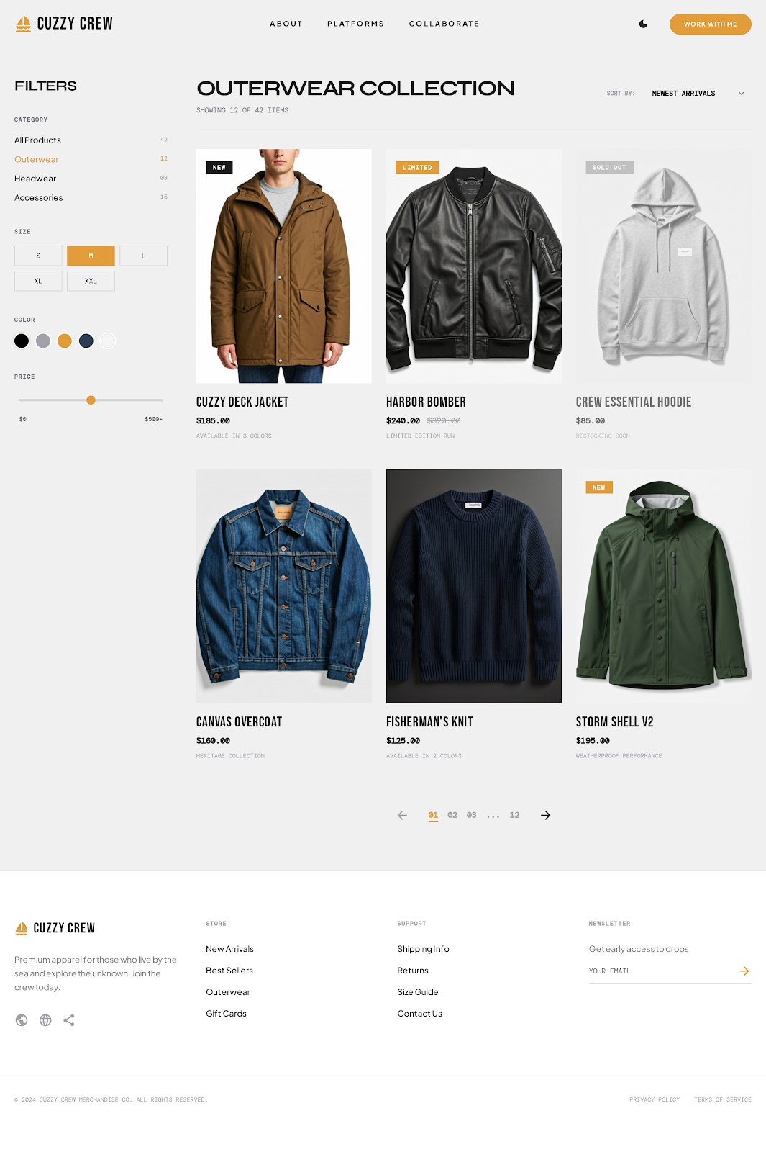
Fig. 5.2a — Shop / Catalog (Light Mode)
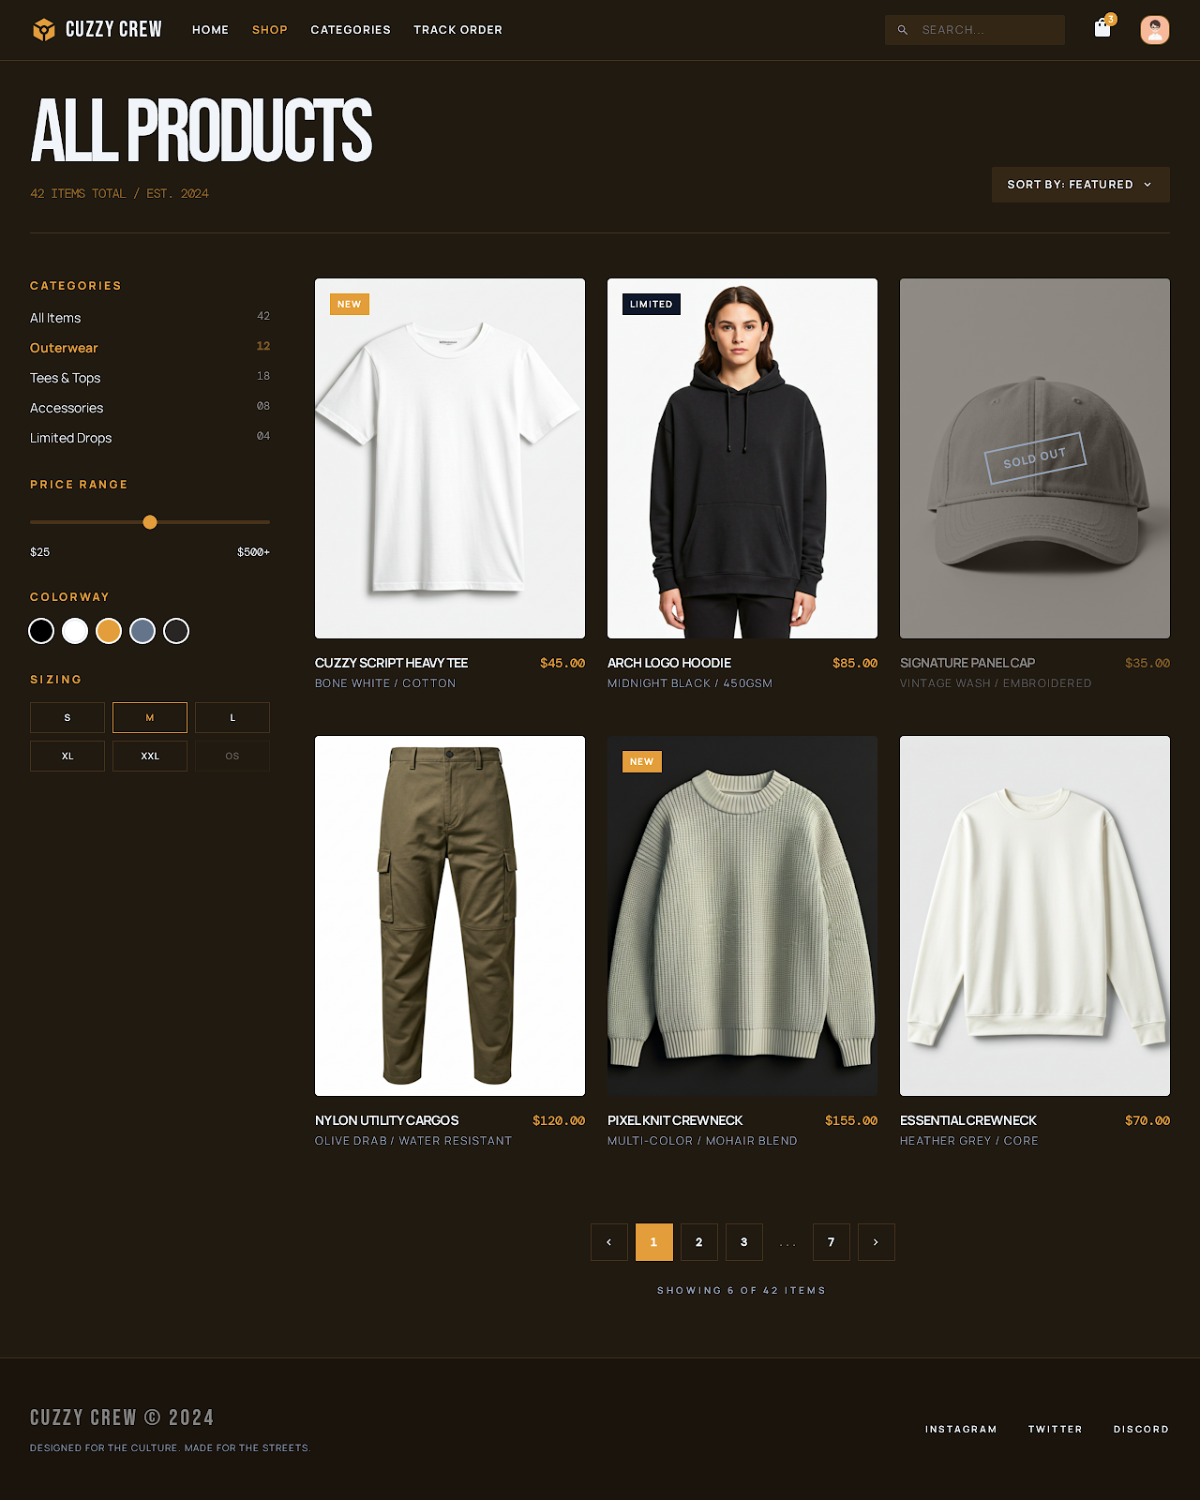
Fig. 5.2b — Shop / Catalog (Dark Mode)

5.3 Product Details
Purpose: Maximize add-to-cart conversion rate

- Breadcrumb navigation (Home > Category > Product)
- Image gallery: large hero image with zoom, vertical thumbnail strip
- Product title in display typography with star rating and review count
- Price display with comparison strikethrough and “SAVE X%” badge for sale items
- Color selector chips with active color name label
- Size selector chips with size guide link; unavailable sizes shown as disabled/greyed
- Primary CTA: “ADD TO CART” (accent fill) + secondary: “WISH LIST” or “BUY NOW”
- Accordion sections: Description, Shipping & Delivery, Returns
- “Pair It With” recommendations rail (4 products)
- Sticky add-to-cart bar on mobile (appears on scroll past main CTA)

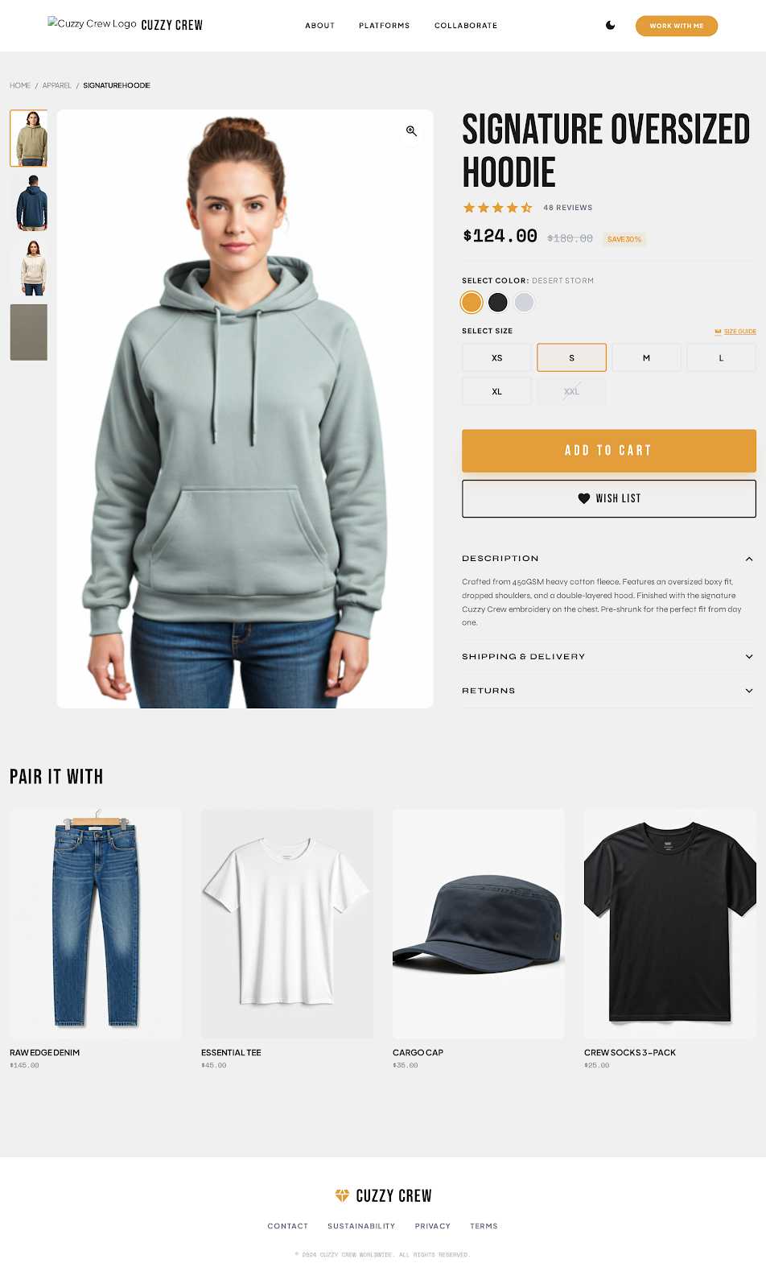  Fig. 5.3a — Product Details (Light) | 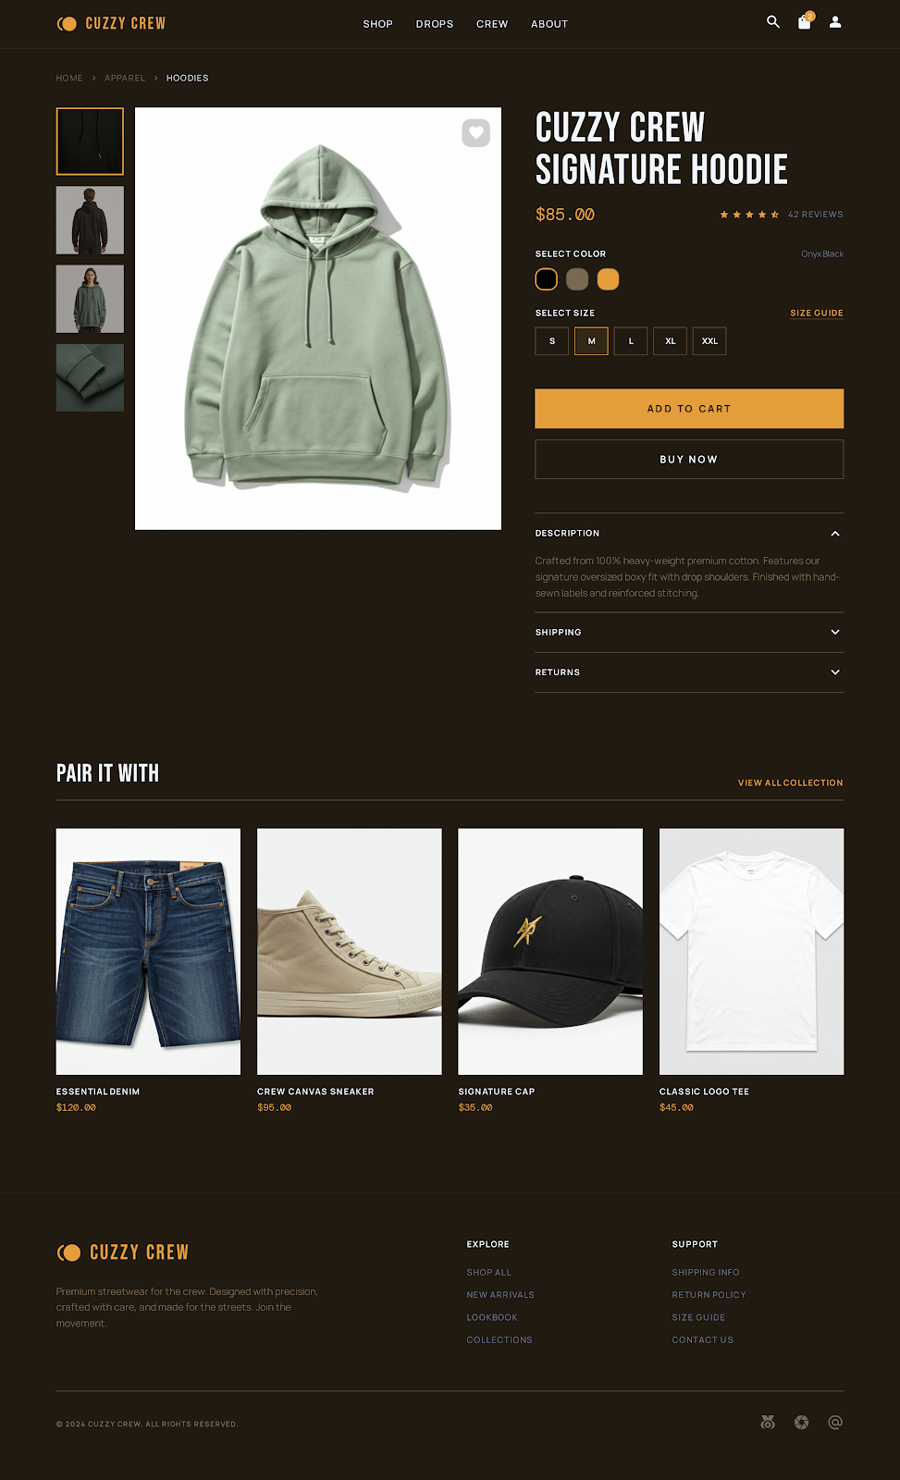  Fig. 5.3b — Product Details (Dark)

5.4 Cart
Purpose: Reduce abandonment and drive upsells

- Cart item list: product thumbnail, name, selected variant (size/color), quantity stepper (−/+), line price, remove button
- Order summary panel (sticky on desktop): subtotal, shipping estimate, discount code input with “APPLY”, total
- “PROCEED TO CHECKOUT” CTA in accent with accepted payment method icons
- Taxes calculated at checkout notice
- “Don’t Miss Out” / related products upsell strip below cart
- Empty cart state with “Continue Shopping” CTA
- Real-time stock validation: items removed or flagged if stock changes

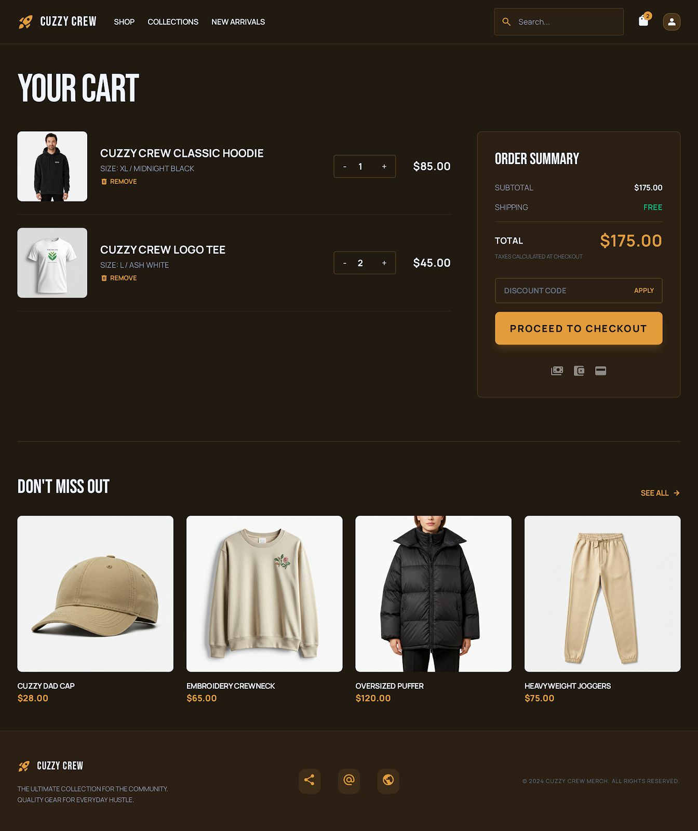
Fig. 5.4 — Cart Page (Dark Mode)

5.5 Checkout (Guest-First)
Purpose: Complete purchase in one guided flow without a login gate

The checkout uses a multi-step linear flow. No account creation is required to complete a purchase. Optional account creation is offered post-purchase on the confirmation screen.

Step | Content | Validation
1. Address | Full name, email, phone, street address, city, state/province, postal code, country | All required fields validated inline. Email format check. Phone format check.
2. Shipping | Shipping method selection with estimated delivery dates and costs | At least one method must be selected before proceeding.
3. Payment | Stripe Elements embedded card form. Promo/discount code input if not already applied. | Card validation via Stripe. Payment Intent created server-side.
4. Review | Full order summary: items, address, shipping method, payment method, totals with discount breakdown. | Final stock check before order placement. Idempotency-Key prevents double orders.

- Desktop: persistent order summary panel alongside step content
- Mobile: collapsible summary at top, step content below, progress indicator
- Clear inline validation with error messaging at field level

5.6 Order Success & Tracking
Purpose: Build trust and confidence after purchase

- Confirmation page with order number, items purchased, shipping address, and estimated delivery
- Optional “Create Account” prompt to save order history for future purchases
- Email confirmation sent automatically
- Order tracking page with visual progress timeline: Confirmed → Processing → Shipped → Delivered
- Guest order lookup via order number + email

5.7 Help & Policies
Purpose: Reduce purchase friction and support post-order trust

- Shipping Policy: delivery regions, timeframes, costs, tracking info
- Return Policy: eligibility window, process, refund timeline
- Contact/Support: email form, expected response time
- FAQ: common questions with accordion expandable answers
- Size Guide: measurement tables per product category

6. UI Component System
A shared component library ensures visual consistency and accelerates screen delivery. All components are theme-aware and respond to the active light/dark mode.

Component | Description
AppShell | Top navigation + footer wrapper with responsive drawer behavior
CTA Buttons | Primary (accent fill), Secondary (outline), Ghost (text-only) variants
ProductCard | Default and compact variants with badge support, hover Quick Add
PriceDisplay | Current price + comparison strikethrough + save percentage
VariantChips | Size chips (selectable, disabled) and color swatches
StatusBadge | NEW, LIMITED, SOLD OUT with appropriate color coding
SectionHeader | Display-font title + optional “View All” link
ProductRail | Horizontal scrollable product strip for recommendations and upsells
FilterRail/Drawer | Sidebar on desktop, bottom sheet/drawer on mobile
CartItemCard | Thumbnail + details + quantity stepper + price + remove
OrderSummary | Subtotal, shipping, discount, total with promo code input
OrderTimeline | Visual step progress for order tracking
SkeletonLoader | Shimmer placeholder for all async-loading content areas
EmptyState | Illustrated message + CTA for empty cart, no results, no orders
ThemeToggle | Sun/moon icon toggle, persisted to Hive, applied on app load
InlineAlert | Success, warning, error notification banners

7. Backend API Specification

7.1 API Domains
All endpoints are versioned under /api/v1/ and return consistent JSON envelopes. Authentication uses Bearer JWT tokens. Guest operations use session-based cart tokens.

Catalog APIs
Method | Endpoint | Request | Description
GET | /api/v1/products | — | Paginated product list with filtering (category, color, size, price) and sorting
GET | /api/v1/products/:slug | — | Full product detail by slug: variants, images, stock, description
GET | /api/v1/categories | — | All active categories with product counts
GET | /api/v1/products/:id/recommendations | — | Related product suggestions for “Pair It With” rail

Cart APIs (Guest-First)
Method | Endpoint | Request | Description
GET | /api/v1/cart | — | Retrieve current cart (guest via session token, auth via JWT)
POST | /api/v1/cart/items | { variantId, qty } | Add variant to cart with stock validation
PATCH | /api/v1/cart/items/:itemId | { quantity } | Update item quantity; validates against available stock
DELETE | /api/v1/cart/items/:itemId | — | Remove item from cart
POST | /api/v1/cart/apply-coupon | { code } | Validate and apply coupon; returns updated totals
DELETE | /api/v1/cart/coupon | — | Remove applied coupon from cart

Checkout & Order APIs
Method | Endpoint | Request | Description
POST | /api/v1/checkout/quote | { addressId, shippingMethod } | Calculate final pricing: subtotal, shipping, tax, discount, total
POST | /api/v1/orders | { cartId, addressId, ... } | Place order (requires Idempotency-Key header). Final stock check + payment capture.
GET | /api/v1/orders | — | List user’s orders with status and pagination
GET | /api/v1/orders/:orderId | — | Full order detail: items, address, payment, status timeline
POST | /api/v1/orders/:orderId/cancel | — | Request cancellation if order is still in PENDING/PROCESSING

Payment APIs
Method | Endpoint | Request | Description
POST | /api/v1/payments/intent | { orderId, amount } | Create Stripe PaymentIntent; returns client secret
POST | /api/v1/payments/webhook | Stripe event | Handle Stripe webhook events (payment_intent.succeeded, failed, etc.)
GET | /api/v1/payments/:orderId/status | — | Poll payment status for a given order

Address APIs
Method | Endpoint | Request | Description
GET | /api/v1/addresses | — | List saved shipping addresses for authenticated user
POST | /api/v1/addresses | { address fields } | Create new address
PATCH | /api/v1/addresses/:id | { fields } | Update existing address
DELETE | /api/v1/addresses/:id | — | Remove saved address

Authentication APIs
Method | Endpoint | Request | Description
POST | /api/v1/auth/register | { name, email, password } | Register new user; password hashed with Bcrypt; returns JWT pair
POST | /api/v1/auth/login | { email, password } | Authenticate user; returns access + refresh JWT tokens. Rate limited.
POST | /api/v1/auth/refresh | { refreshToken } | Refresh access token before expiry

Review APIs
Method | Endpoint | Request | Description
POST | /api/v1/reviews | { productId, rating, comment } | Submit product review (authenticated users, post-purchase only)
GET | /api/v1/reviews/:productId | — | Fetch paginated reviews for a product

7.2 Admin APIs (Restricted)
All admin endpoints require JWT authentication with ADMIN role. Actions are logged to the AuditLog table.

Method | Endpoint | Request | Description
POST | /api/v1/admin/products | { product data } | Create new product with variants and images
PATCH | /api/v1/admin/products/:id | { fields } | Update product details, description, status
DELETE | /api/v1/admin/products/:id | — | Soft-delete product (hides from catalog)
PATCH | /api/v1/admin/variants/:id/stock | { stock } | Update variant stock level
GET | /api/v1/admin/orders | ?status&date | List all orders with filtering by status and date range
PATCH | /api/v1/admin/orders/:id/status | { status } | Update order status (PENDING→PROCESSING→SHIPPED→DELIVERED)
POST | /api/v1/admin/coupons | { coupon data } | Create discount coupon with validity rules
GET | /api/v1/admin/dashboard | — | Dashboard metrics: revenue, order count, pending orders, low stock

7.3 Error Handling Standards
All API errors return a consistent envelope for predictable client handling:

- 400 Bad Request: validation failures with per-field error details
- 401 Unauthorized: missing or expired authentication token
- 403 Forbidden: insufficient role permissions
- 404 Not Found: resource does not exist
- 409 Conflict: duplicate order (idempotency violation), stock conflict
- 422 Unprocessable Entity: business rule violations (e.g., coupon expired, item out of stock)
- 429 Too Many Requests: rate limit exceeded
- 500 Internal Server Error: unexpected failures with request correlation ID

8. Authentication & User Management

8.1 Guest-First Model
The platform prioritizes frictionless purchasing. No account is required to browse, add to cart, or complete a purchase. Guest users receive a session token (stored in Hive) that maintains cart continuity across sessions.

Authenticated features (order history, saved addresses, wishlists, reviews) are available to users who choose to register. Account creation is offered as an optional step on the order confirmation page.

8.2 Registration
- User provides name, email, and password
- Email uniqueness enforced at database level
- Password constraints: minimum 8 characters, at least one letter and one number
- Password hashed using Bcrypt (cost factor 12) before storage
- JWT access token (short-lived) + refresh token (long-lived) issued on success
- Tokens stored securely on device via Hive
- Structured error responses for invalid input or existing email

8.3 Login
- User provides email and password
- Credentials validated via hashed password comparison
- JWT token pair issued with configurable expiration
- Rate limiting applied: max 5 attempts per 15-minute window
- Guest cart merged with authenticated cart on login
- Clear error messages for invalid credentials

8.4 Token Lifecycle
- Access token: 15-minute expiry, sent as Bearer header
- Refresh token: 7-day expiry, used to obtain new access token
- Dio interceptor automatically refreshes expired access tokens
- On refresh failure: user redirected to login screen

8.5 Theme Management
- Default: light mode
- Toggle via sun/moon icon in navigation bar
- Preference persisted in Hive; applied immediately on app load
- Purely client-side; no backend involvement

9. Database Design

9.1 Stack
- PostgreSQL as the source of truth for all transactional commerce data
- Redis for short-lived cache and session acceleration (guest cart tokens, high-read catalog queries)
- Supabase-hosted PostgreSQL for managed infrastructure

9.2 Entity Definitions
All primary keys use UUID v4. Timestamps use ISO 8601 with timezone. Foreign key constraints enforce referential integrity.

Entity | Fields
User | id (UUID), name, email (unique), passwordHash, role (USER/ADMIN), createdAt, updatedAt
Product | id (UUID), name, slug (unique), description, basePrice, status (ACTIVE/DRAFT/ARCHIVED), categoryId (FK), createdAt, updatedAt
ProductVariant | id (UUID), productId (FK), sku (unique), price, stock, color, size, createdAt, updatedAt
ProductMedia | id (UUID), productId (FK), url, altText, displayOrder, type (IMAGE/VIDEO)
Category | id (UUID), name, slug (unique), description, displayOrder
Tag | id (UUID), name (unique)
ProductTag | productId (FK), tagId (FK) — many-to-many join table
Cart | id (UUID), userId (FK, nullable), sessionToken (unique, for guests), status (ACTIVE/MERGED/COMPLETED), createdAt, updatedAt
CartItem | id (UUID), cartId (FK), variantId (FK), quantity, unitPriceSnapshot
Order | id (UUID), orderNumber (unique, human-readable), userId (FK, nullable), email, totalAmount, discountAmount, shippingAmount, taxAmount, couponId (FK, nullable), status (PENDING/PROCESSING/SHIPPED/DELIVERED/CANCELLED), idempotencyKey (unique), createdAt, updatedAt
OrderItem | id (UUID), orderId (FK), variantId (FK), productName, variantLabel, quantity, unitPrice — immutable snapshot at time of purchase
Payment | id (UUID), orderId (FK), amount, provider (STRIPE), status (PENDING/SUCCESS/FAILED/REFUNDED), stripePaymentIntentId (unique), createdAt, updatedAt
ShippingAddress | id (UUID), userId (FK, nullable), orderId (FK, nullable), fullName, addressLine1, addressLine2, city, state, postalCode, country, phone
Coupon | id (UUID), code (unique), discountType (PERCENT/FIXED), discountValue, minOrderAmount, maxUses, currentUses, validFrom, validTo
Review | id (UUID), userId (FK), productId (FK), rating (1–5), comment, createdAt
AuditLog | id (UUID), adminId (FK), action, entity, entityId, details (JSON), createdAt

9.3 Data Integrity Safeguards
- Variant-level stock checks within a database transaction before order creation
- Idempotent order placement via unique idempotencyKey to prevent duplicate orders on retries
- Immutable OrderItem snapshots: product name, variant label, and unit price are frozen at purchase time
- Timestamped status transitions for order and payment audit trails
- Soft-delete strategy for products and coupons (status flag, never hard-deleted)
- Bcrypt password hashing with cost factor 12
- Database-level unique constraints on email, slug, sku, code, orderNumber

10. Admin Panel

10.1 Dashboard
- Total revenue (all time + period selectors)
- Order count and pending orders
- Low stock alerts with direct link to variant stock editor
- Top-selling products by quantity and revenue
- Sales trend chart (daily/weekly/monthly)

10.2 Product Management
- Create new products with name, slug (auto-generated), description, base price, category assignment
- Add/edit variants: size, color, SKU, individual pricing, stock levels
- Upload and reorder product images via Cloudflare R2
- Set product status: Active, Draft, Archived
- Bulk stock update capability

10.3 Order Management
- View all orders with filters: status, date range, customer email
- Update order status through the fulfillment pipeline: PENDING → PROCESSING → SHIPPED → DELIVERED
- Cancel orders (triggers refund flow if payment was captured)
- View order details: items, customer info, payment status, shipping address
- Export order data as CSV for external analytics

10.4 Coupon Management
- Create coupons: code, discount type (percent/fixed), discount value, validity dates, usage limits, minimum order amount
- View active/expired coupons with usage stats
- Deactivate coupons before expiry if needed

10.5 Audit Trail
- All admin actions logged: product CRUD, order status changes, coupon creation
- Logs include admin user, action type, target entity, timestamp, and change details (JSON)

11. Checkout, Payment & Order Reliability

11.1 Customer Journey Reliability
- Stable cart continuity for guest users across sessions via persistent session tokens
- Duplicate-order prevention on retries via Idempotency-Key enforcement
- Accurate pricing summaries before order placement (checkout/quote endpoint)
- Timely payment/order state synchronization via Stripe webhooks
- Clear order status visibility post-purchase through tracking timeline

11.2 Payment Flow
The payment integration uses Stripe Payment Intents for secure, PCI-compliant card processing:

- Step 1: Client requests a PaymentIntent from the backend (POST /payments/intent)
- Step 2: Backend creates Stripe PaymentIntent and returns the client_secret
- Step 3: Client uses Stripe Elements to confirm payment with the client_secret
- Step 4: Stripe sends webhook event (payment_intent.succeeded or payment_intent.payment_failed)
- Step 5: Backend webhook handler updates order and payment status atomically
- Step 6: Client polls or receives real-time confirmation and shows success/failure screen

11.3 Failure Handling
- Network timeout during payment: client retries with same Idempotency-Key; server returns existing result
- Payment declined: clear error message with option to retry or use different payment method
- Webhook delivery failure: Stripe retries automatically; backend handles idempotent status updates
- Stock depleted between cart and order: order creation fails with clear “item unavailable” message, cart updated

12. Performance, Quality & Accessibility

12.1 Frontend Targets
- Fast first render on cached scenarios (service worker for static assets)
- Smooth theme switching without visual flicker (theme applied before first paint)
- Accessible touch targets: minimum 44px on all interactive elements
- Visible focus states for keyboard navigation (WCAG AA)
- No layout breaks at any breakpoint; no horizontal scrolling
- Skeleton loading states for all async content to prevent layout shift
- Image lazy loading with placeholder blur-up effect

12.2 Backend Targets
- Catalog reads: < 200ms p95 response time (Redis-cached popular queries)
- Checkout operations: < 500ms p95 for quote and order creation
- Predictable behavior under retry and network instability (idempotent operations)
- Structured logging with request correlation IDs for observability
- Database connection pooling via Prisma for concurrent request handling

12.3 Accessibility
- Semantic HTML structure for screen reader compatibility
- Alt text on all product images (from ProductMedia.altText)
- Color contrast ratios validated against WCAG AA standards for both themes
- Form labels and ARIA attributes on all interactive elements
- Keyboard-navigable checkout flow

13. Delivery Roadmap
Development follows a sequential build order, with each phase building on the deliverables of the previous one:

Phase | Deliverables | Key Outcomes
1 | Catalog service, cart service, database schema, seed data | Backend API functional; database populated with test products
2 | App shell, home page, shop/catalog page, theme system | Browsable storefront with filtering, sorting, responsive layout
3 | Product detail page, cart page, variant selection, recommendations | Complete browse-to-cart flow with upsell behavior
4 | Guest checkout, Stripe payment integration, order creation | End-to-end purchase flow; real payments processing
5 | Order confirmation, guest tracking, email notifications | Post-purchase trust and visibility
6 | Admin dashboard, product/order management, coupon system | Operational control panel for store management
7 | Auth system, user profiles, order history, reviews, wishlists | Returning customer features and social proof
8 | Search tuning, recommendation optimization, UX polish, QA | Production-ready quality and performance

END OF DOCUMENT
Cuzzy Crew Merch Platform — Functional Specification v1.0

