Gameco

Team 04: Marcus Lorenzana, Marvin Lopez, Marcos Gonzales, Desiree Johnson

Contents

Description of Organization: 2

Conceptual Design: 3

Conceptual Database Schema: 5

Relational Database Schema 6

Database Iplementation………………………………………………………………………………………………………………………………….7

Application Implementation……………………………………………………………………………………………………………………………8

Milestones………………………………………………………………………………………………………………………………………………………9

Collaboration Distribution……………………………………………………………………………………………………………………………..16

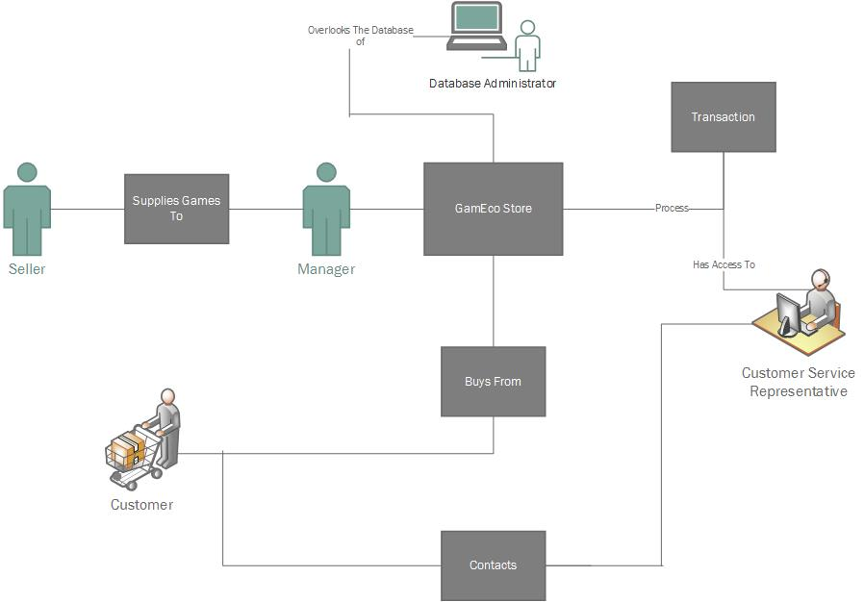

# Description of Organization:

The company will sell products, specifically games that are strictly digital codes. The customer uses the webpage to enter their details in order to place an order for an item, and receiving the order should be relatively instantaneous. Once the customer submits an order as soon as the order is processed and verified, an email will be sent to the user within about an hour containing the redeemable code for the product that will be activated on the platform of their choice (PC, Xbox, PlayStation, Nintendo). Since the store will operate with digital items only, there will be no need for a warehouse nor will there be any shipping data. The customer should be able to access their codes at any time through the website if they accidently lose their code.

There are three main category of users: The customers, suppliers, and employees. The customers will buy from the store which contains a catalog of video games on different platforms. There will be multiple suppliers that will supply games to our company and they will receive royalty on the items that sell. The manager (an employee) will be the one that contacts the supplier and orders games for our digital inventory. There will also be customer support representatives, who will have access to basic customer information and past transactions. There is also a database administrator who will deal with security updates and changes to the database (if necessary).

Some examples of this eCommerce setup is the digital section of Amazon.com, Greenmangaming.com, or any website that sells products that can be redeemed through online game codes.

# Conceptual Design:

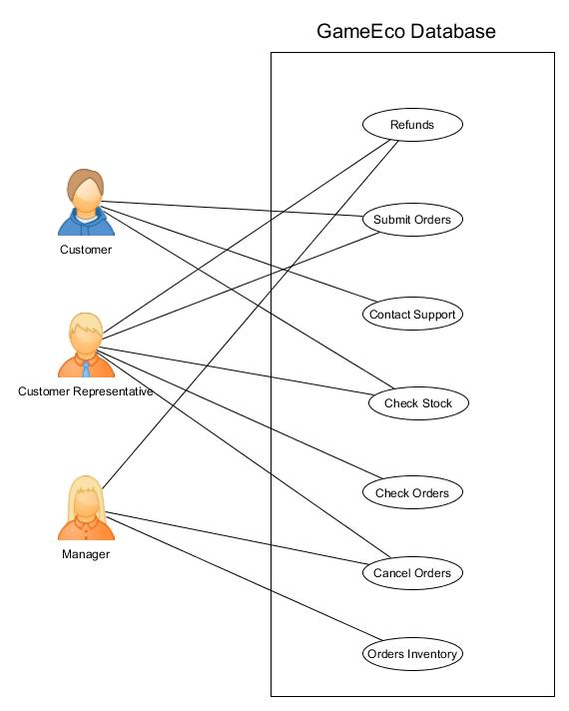

**Person**: This is the primary entity that gives personal information about Employees and Customers. This entity will hold attributes such as FName, LName, State, Zip, Address, Phone#, Status, DOB, and a primary key “ID”.

**Customer**: The customer will be able to buy products from the online store and will interact only with the front end website and customer support. They will be able to create/edit their personal information and send these queries to the database without really knowing what's happening in the back-end. Customer would have an age greater than 18 to place orders and as such will sign a policy agreement upon registering. Customer has an indirect relationship with the supplier and a direct relationship with our company via the products from the website. He/she will “Buy” 1 or more products (games) from the site store if the item is stock. The customer should be able to delete their account but will keep transaction details.

**Supplier**: The suppliers supply our online games. The supplier has a direct relationship with the manager, as the manager will place 1 or more orders for new games from the supplier or to restock current inventory. The supplier will be its own entity, not inheriting any of the attributes from Person. Its attributes will be the company name it represents, personal information, and its own unique supplier ID, SID.

**Database Administrator**: Handles the security and upgrades to the MySQL database. Has access of the database itself and is able to make changes to the tables, etc. The DBA will need to give (or remove) permissions to employees and trouble shoot problems dealing with the database.

**Customer Service Rep**: Will be able to access customer information and game information. The customer will contact the support for help with their product through a submission form on the website. They will also be able to submit trouble ticket to DBA and Manager (for issues with dealing with supplier if necessary). If the key does not work they will contact customer support by sending in a support ticket. The customer support will determine whether or not they will get a refund.

**Manager**: This is a subclass of Employee and inherits person attributes. The manager will place orders from the supplier for more game keys. Will utilize the action entity “Order” to place 1 or more orders for game codes to hold in the digital inventory. Manager will also receive trouble tickets or alerts from the system to indicate low inventory.

**Game**: Will hold all the details about the game and its availability such as Title, Date released, Developer, Publisher, Genre, and price.

**Transactions**: This entity holds information about all transactions involving the sellers, customers, and the manager. Each transaction has its own unique transaction ID which will aid in the lookup of specific transactions and help the customer support representative as well to review mistakes on orders when contacted on such an issue.

# Conceptual Database Schema:

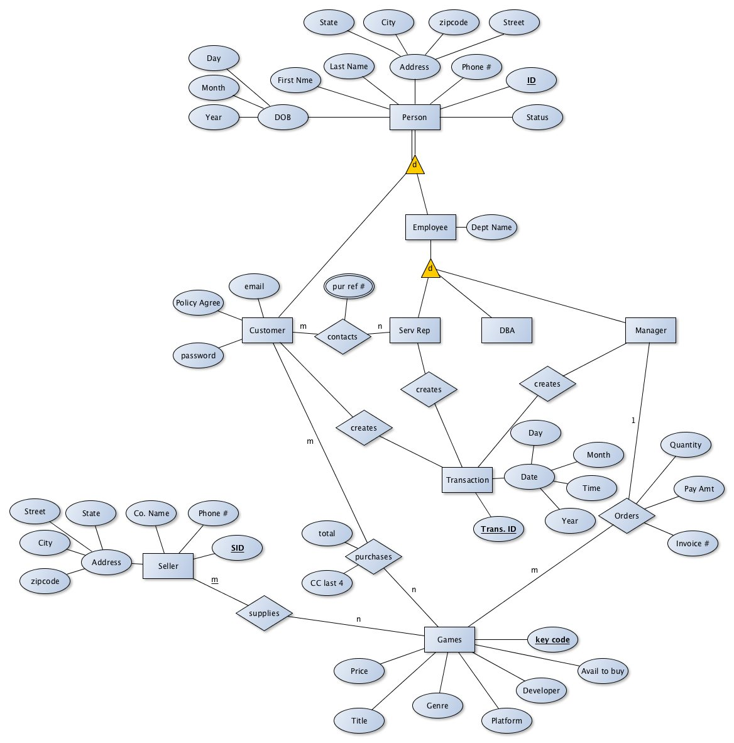

# C:\Users\Marcus\Desktop\fd1.pngRelational Database Schema

# C:\Users\Marcus\Desktop\fd1.png

# 

# Database Implementation

For the project we used many SQL queries to create, update, insert and alter the tables and columns.

We also implemented some triggers, an example of the trigger is in the inventory table when the games has run out of game codes. The table would report to the webpage that it is out of stock and the manager would have to order some more codes or remove the game.

The lessons we learned was that it was difficult to translate the projects E/R scheme to a proper database. So the group created new tables, delete redundant ones, change the BCF forms, and primary keys. The experienced we gained was how to implement Efficient SQL Coding.

We created the database with a SQL script “Mydb6.sql ” in MySQL database an example SQL command we

Implemented is

CREATE TABLE IF NOT EXISTS `gameK` (

`item_ids` int(10) unsigned NOT NULL,

`gameKey` varchar(30) NOT NULL

)

This would create the table “gameK” that would hold the id of the items and game’s keys. The way we populated the tables was using SQL insert.

INSERT INTO `gameK` (`item_ids`, `gameKey`) VALUES

(7, 'n1');

The tables “order”, “order_contents”, “shop”,”users” are created and populated the same way.

A query’s we used was to see if the tables populated.

SELECT * FROM `gamek`;

We also had to alter some tables so we used

ALTER TABLE `shop`

MODIFY `item_id` int(10) unsigned NOT NULL AUTO_INCREMENT,AUTO_INCREMENT=9;

For instance the query alters the table “shop” and changes the column “item_id”.

# Application Implementation

For the implementation of the database we created a local server and created a website “Gameco” , using html, and PHP code. Some of the key functions we used was sort the games we have, create a cart of games you have selected, register user’s to the database, checking if the customer or manager are users in the database, for the manager adding games to inventory, and show users transaction history . Some of the functions we didn’t implement was having the customer contact “Gameco” If a problem would arise.

# Demo

For the front page we have a selection page. You could either select if you are a manager or a customer. Once the option has been selected

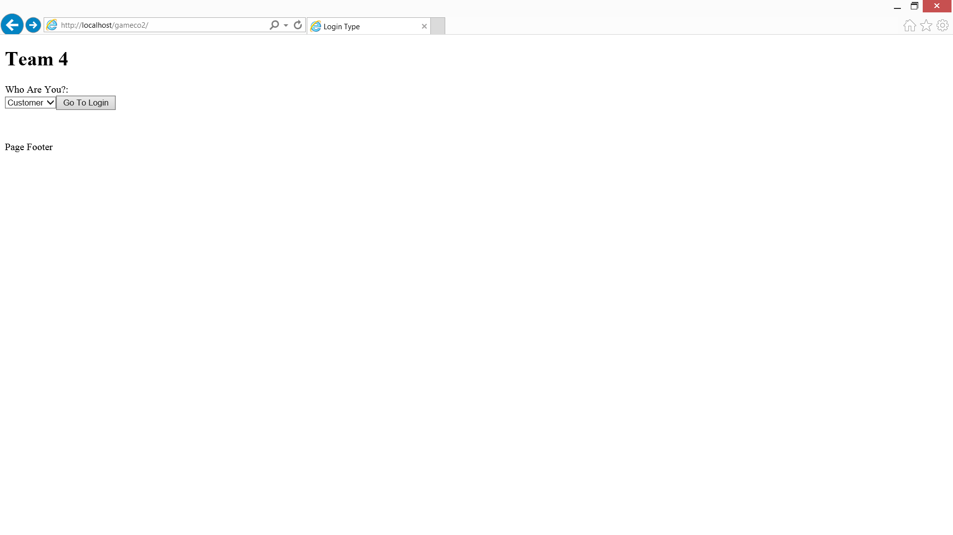

The next page the user would see depending of the selection is the logon page, for the customer they would also see the register button.

Manager Login

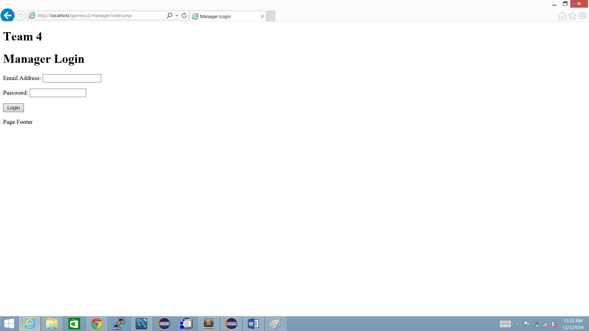

Customer Login

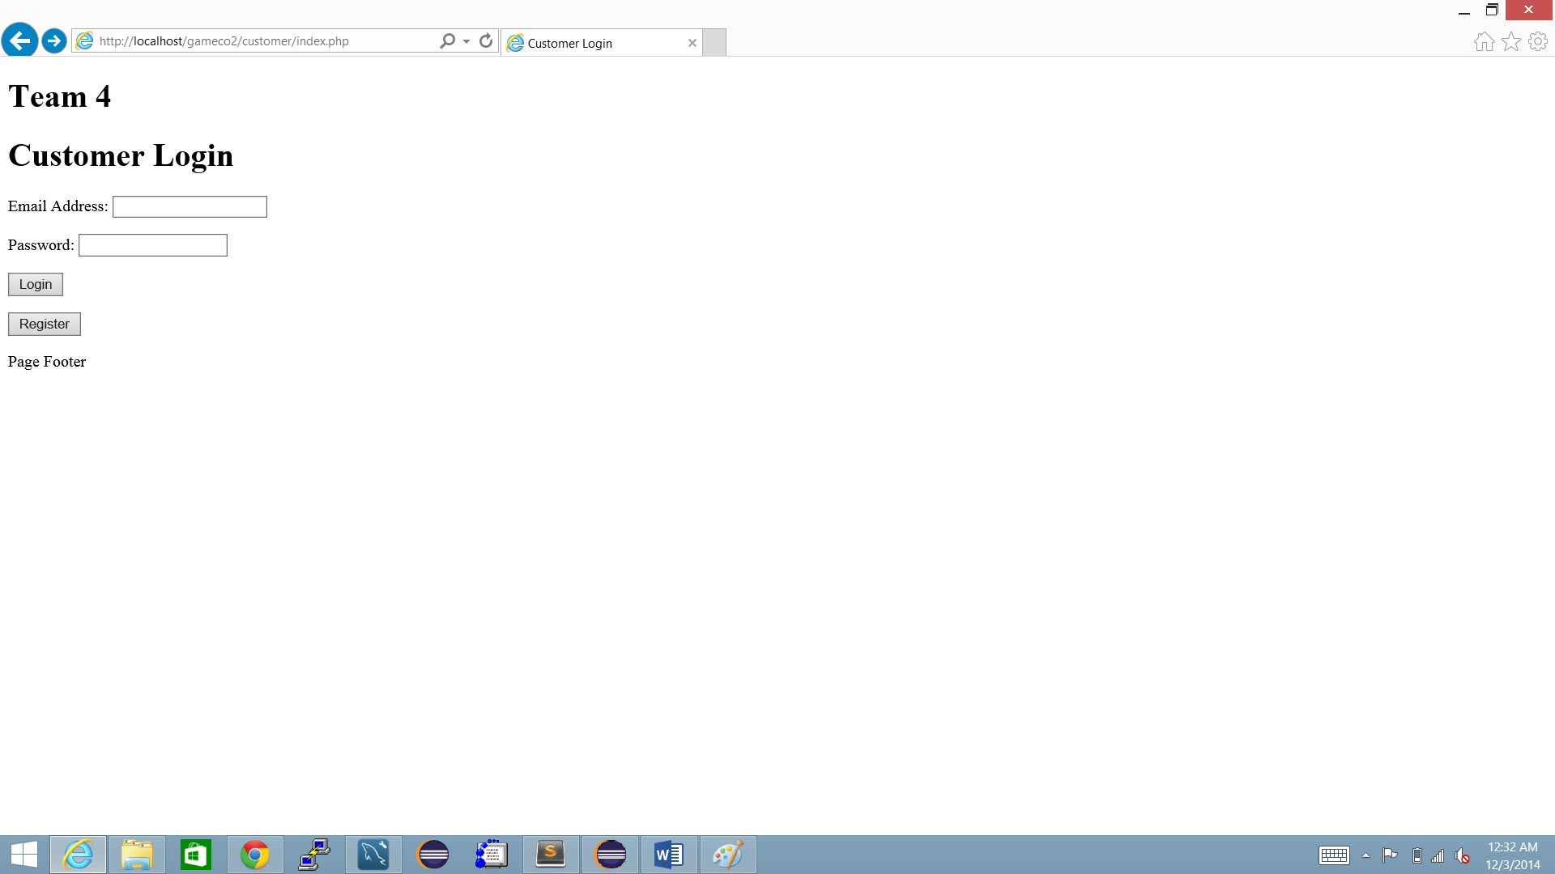

If the registration button is pressed you be taken to the page where you would see the form to fill out to be added the database.

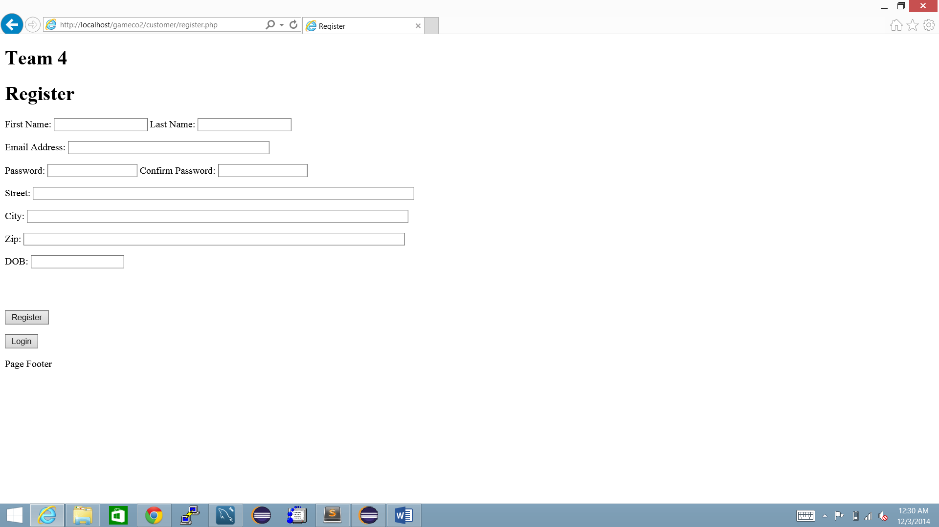

Once you have logged in you would see the home page the options you have are to home, shop Transaction history, and logout.

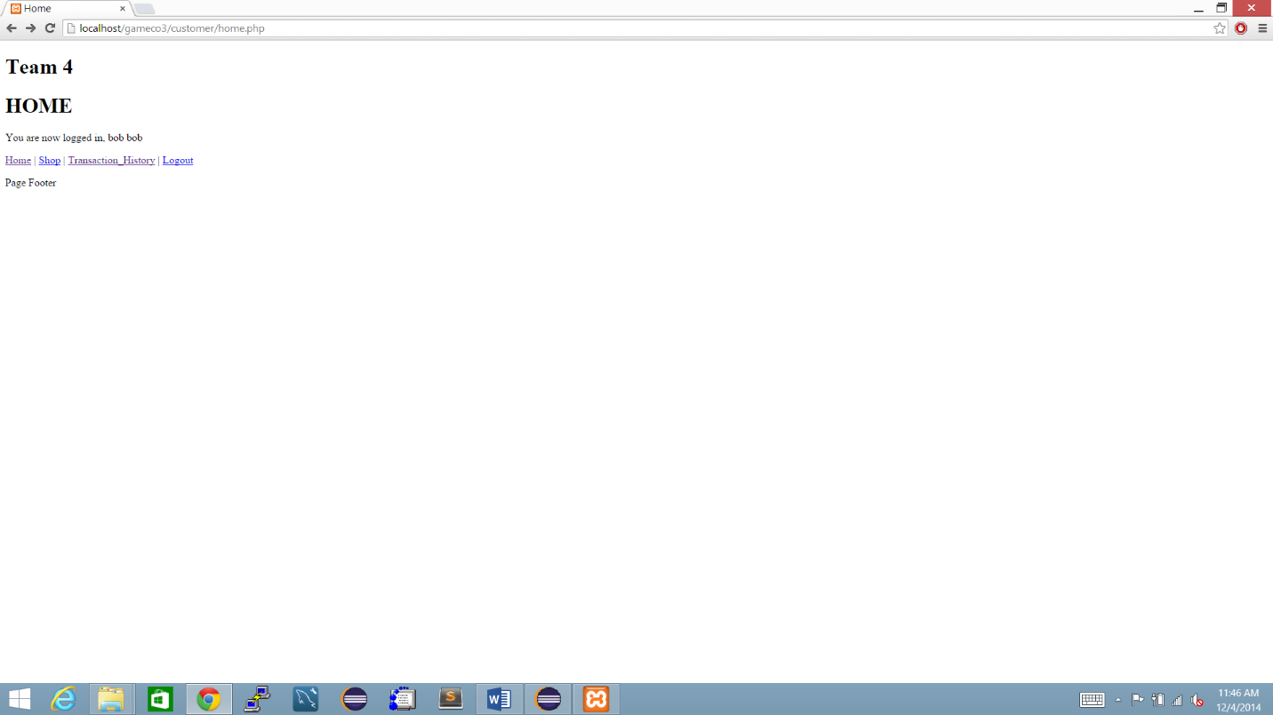

If you select shop it would take you to the page where you can buy the game keys

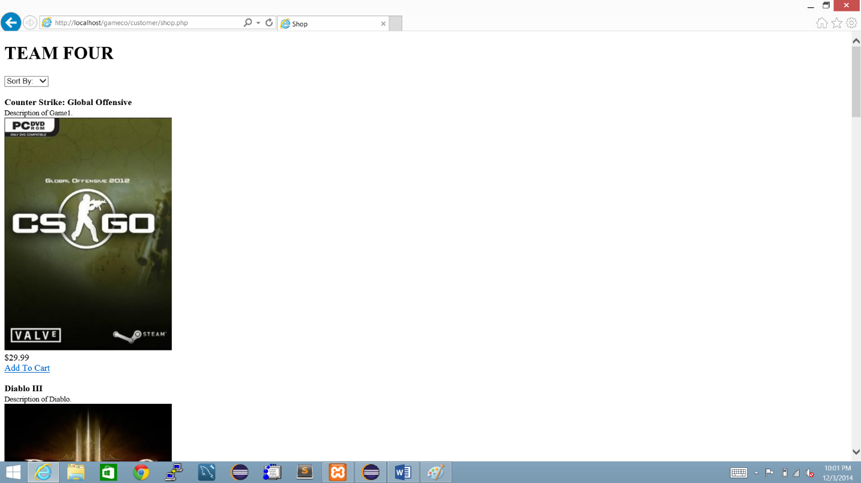

In this page you can sort the games by platform (e.g. PlayStation), name or price. Once you select the games you want to buy you can go to the cart and checkout. In the checkout section you can see the games you have selected and how many you want to buy.

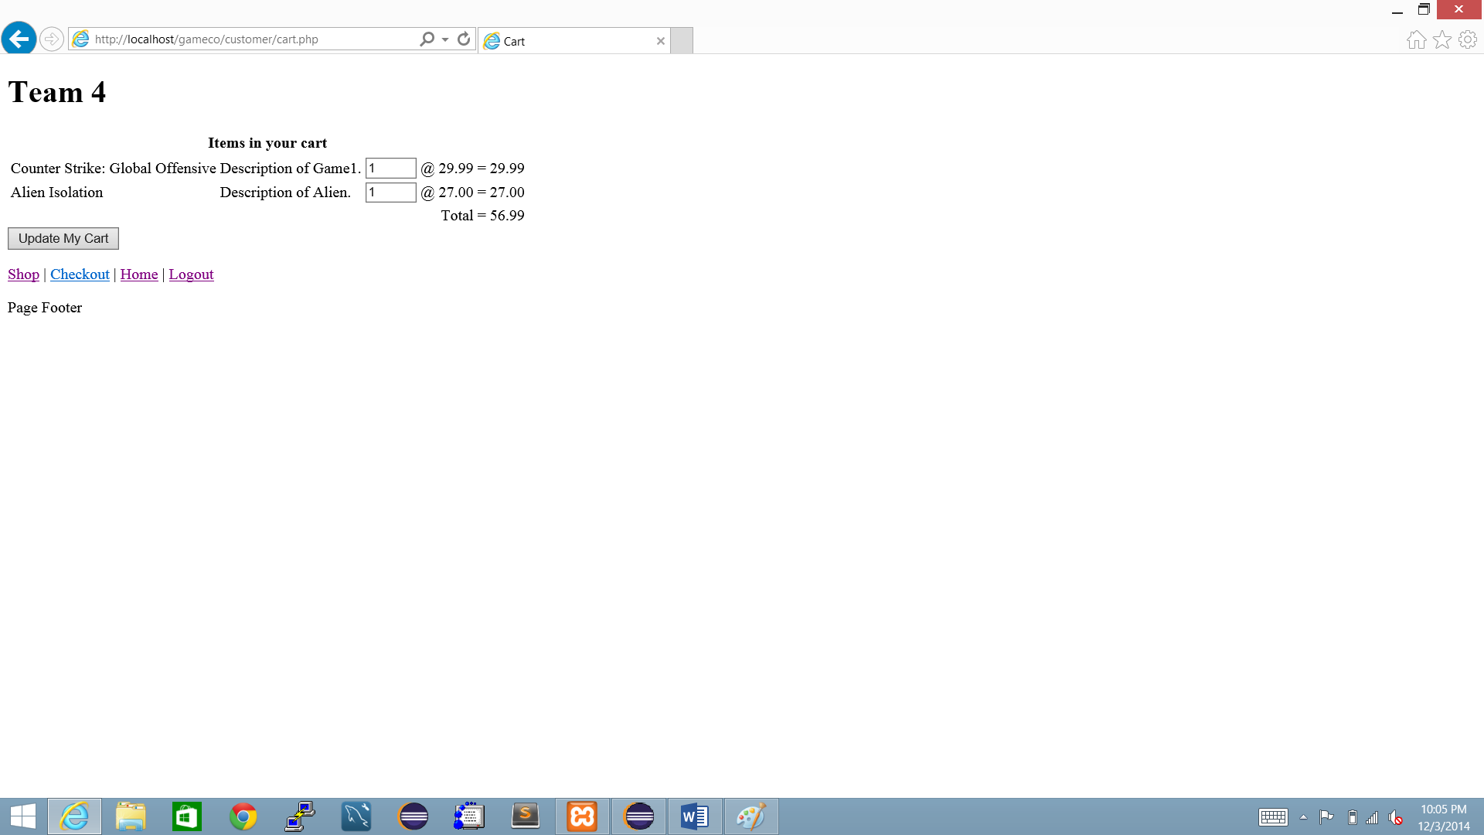

Since you selected the games and how many keys you want to buy the website would tell if you are successful.

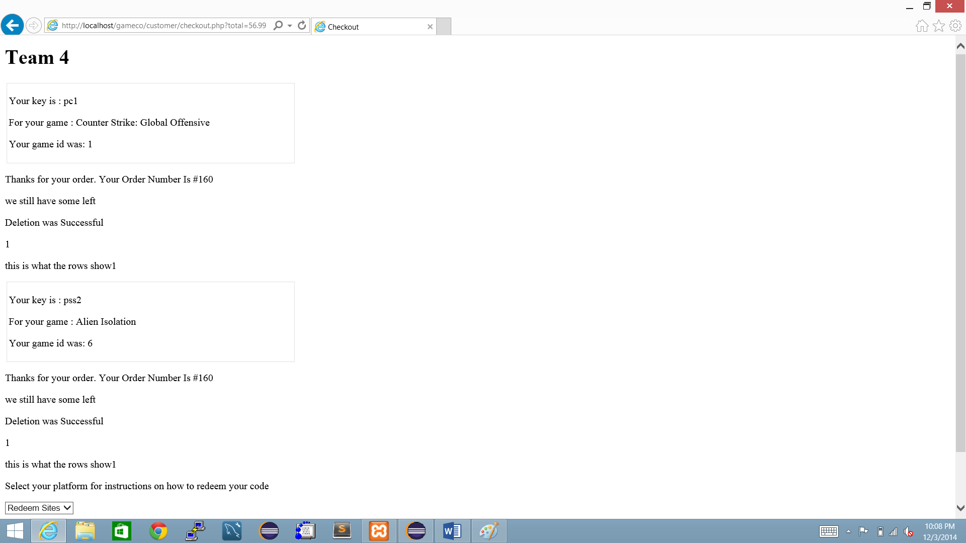

If the inventory unavailable you would see that the inventory is unavailable. If unavailable you would see that it is “OUT OF STOCK” in the shopping page.

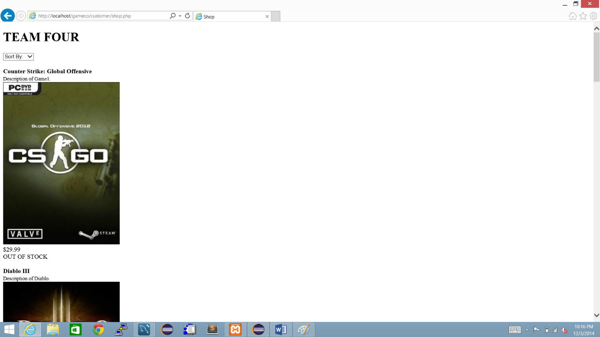

If you log in the managers page and you go to the shop page, you would see the extra option of “CONTATACTING THE SELLER”

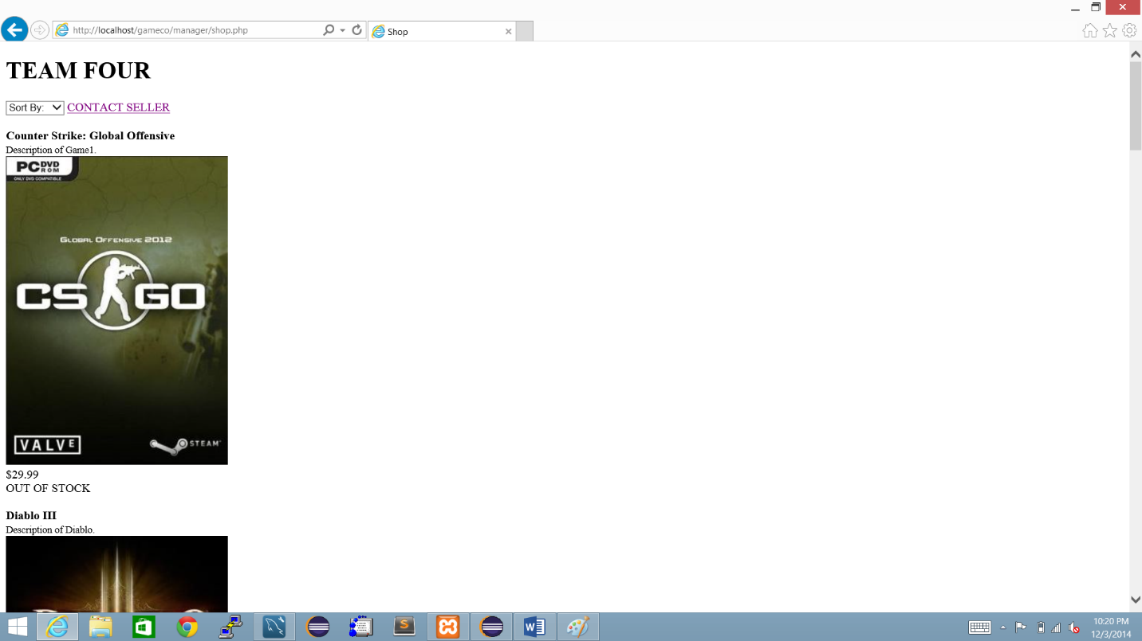

With this option you can add inventory to the database by making an order form the seller.

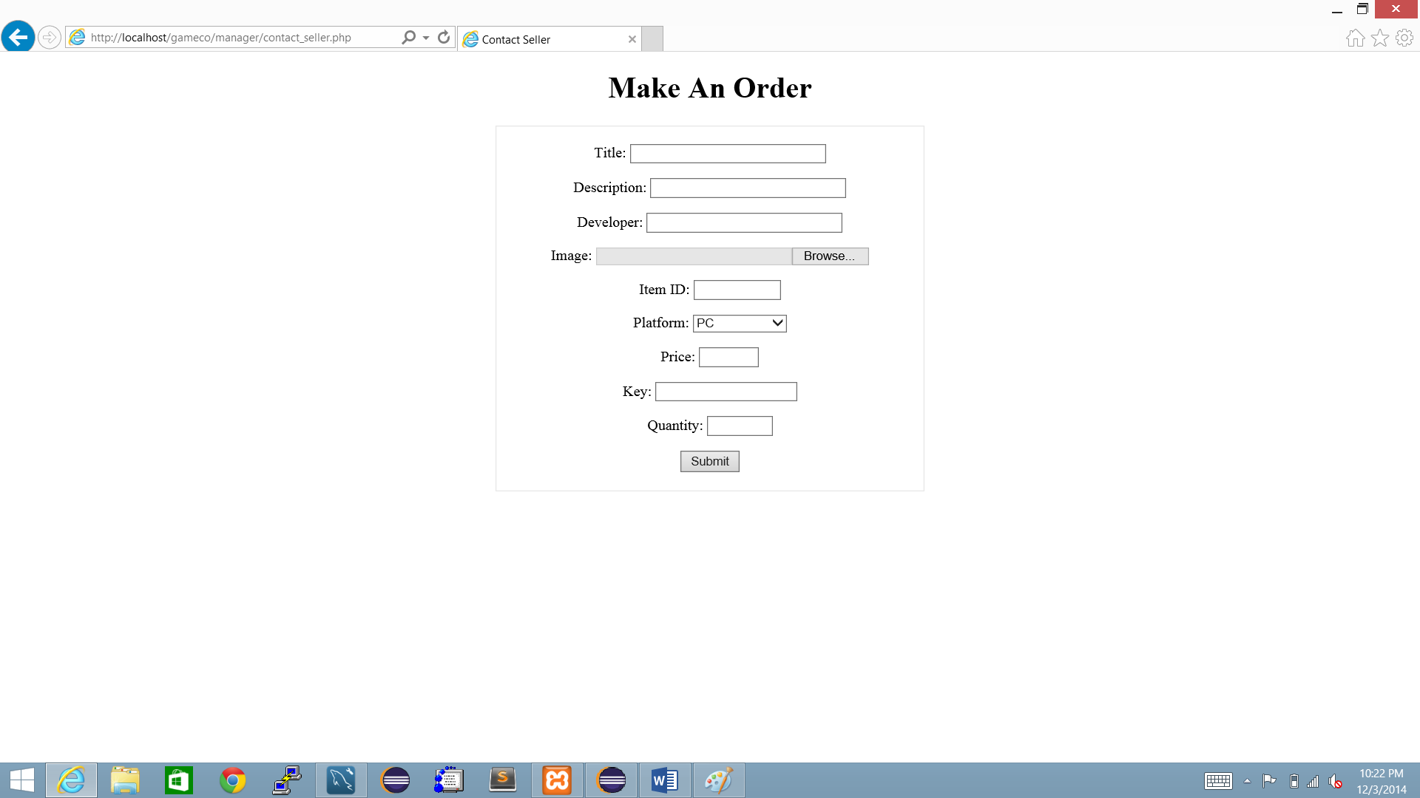

Once you make an order the shop page is updated with the latest order. This is the basic implementation of the video game shopping website.

The way we tried to communicate and share data was through GitHub and eclipse, with some people it was easier than others.

As you can tell we didn’t achieve all that we originally planned to but we did program a basic working website, if the team had more time the website would look more elegant and refined.

# Milestones

For the milestones we did achieve the easy milestones, and most of the hard milestones with the exception of the club membership idea.

Easy milestone: implementing the conceptual database into MySQL and designing the front end website.

Hard milestone: Figuring out PHP and connecting the website with the MySQL database. We would also like to implement a club membership if time permits. The idea is that a customer could sign up for a premium membership for a monthly fee and have access to discounts and other worthwhile features.

# Collaboration Distribution:

Marcus Lorenzana:

- First draft of ER diagram on paper.

- Midpoint report and midpoint presentation slides.

- Company snapshot.

- Initial front end implementation using bootstrap (inside the backups/bootstrap directory).

- PHP registration, customer support, and game search forms for the initial front end bootstrap website.

- Rough draft of EER diagram used mainly for understanding how to setup our MySQL database.

- On the final application, created separate pages for manager and customer.

- Implemented the retrieval of the customer’s redeemable keys at checkout with the help of Desiree. Also added external website navigation to redeem their keys for whichever platform they bought for.

- Implemented seller requests on the manager’s login to add more games to the database/website.

- Minor changes to physical database and edits to the database building script.

- Various front end additions such as dropdowns, etc.

Marcos Gonzales:

-Created the relational database schema

-Created the final physical MySQL database

-Provided the foundation of the final website application which handles add to cart functionality, login, registration, and displaying the products on the page.

-Added functionality for sorting the games based on price, platform, etc.

-Added functionality for retrieving transaction history for customer and transaction history lookup for manager.

Desiree Johnson:

-Polished ER diagram and changed the relations of transactions.

-Created the functional dependencies with the relational database schema and normal forms.

-Helped with midpoint presentation slides and did the final presentation slides.

-Helped implement retrieval of keys at checkout.

Marvin Lopez:

-Implemented the ER diagram in yED and made various changes and fixes to it.

-Created the Use Cases diagram to help convey the actions of different users.

-Created the final report.

A significant portion of the time was spent implementing the physical database and creating the PHP scripts along with the HTML to get the web application working properly. We initially attempted to create a responsive and well-designed website using bootstrap as a framework but found that the code made things complicated and we decided on a simple looking but more functional website application that allowed us to communicate easier with the database and make changes to the website where necessary. Given more time, we would have probably implemented what we have in our web application now with the bootstrap website.