Gameco

Team 04: Marcus Lorenzana, Marvin Lopez, Marcos Gonzales, Desiree Johnson

Contents

Description of Organization: 2

Conceptual Design: 3

Conceptual Database Schema: 5

Relational Database Schema 6

Milestones 7

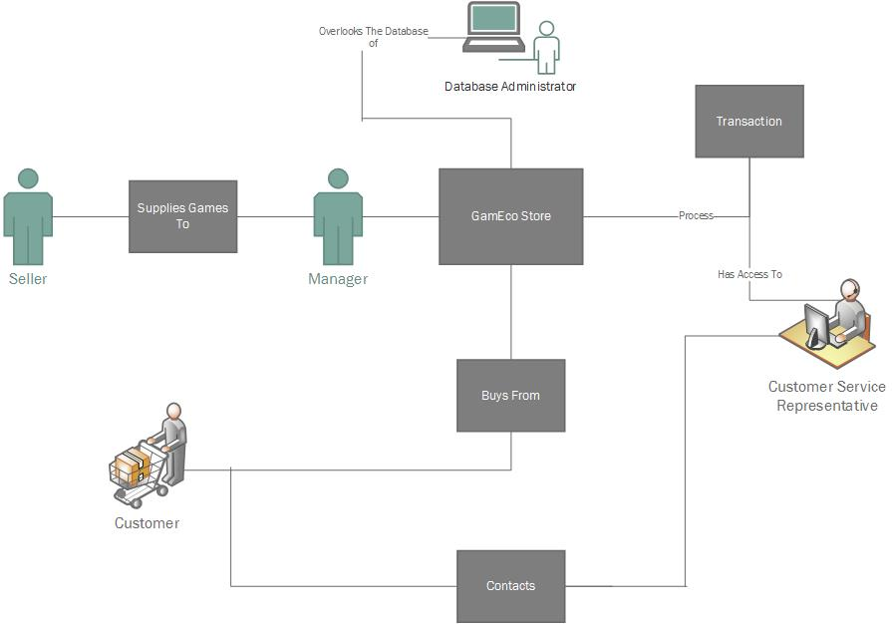

# Description of Organization:

The company will sell products, specifically games that are strictly digital codes. The customer uses the webpage to enter their details in order to place an order for an item, and receiving the order should be relatively instantaneous. Once the customer submits an order as soon as the order is processed and verified, an email will be sent to the user within about an hour containing the redeemable code for the product that will be activated on the platform of their choice (PC, Xbox, PlayStation, Nintendo). Since the store will operate with digital items only, there will be no need for a warehouse nor will there be any shipping data. The customer should be able to access their codes at any time through the website if they accidently lose their code.

There are three main category of users: The customers, suppliers, and employees. The customers will buy from the store which contains a catalog of video games on different platforms. There will be multiple suppliers that will supply games to our company and they will receive royalty on the items that sell. The manager (an employee) will be the one that contacts the supplier and orders games for our digital inventory. There will also be customer support representatives, who will have access to basic customer information and past transactions. There is also a database administrator who will deal with security updates and changes to the database (if necessary).

Some examples of this eCommerce setup is the digital section of Amazon.com, Greenmangaming.com, or any website that sells products that can be redeemed through online game codes.

# Conceptual Design:

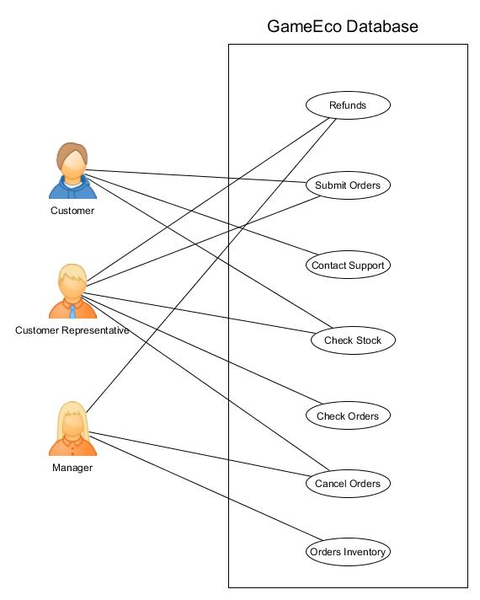

**Person**: This is the primary entity that gives personal information about Employees and Customers. This entity will hold attributes such as FName, LName, State, Zip, Address, Phone#, Status, DOB, and a primary key “ID”.

**Customer**: The customer will be able to buy products from the online store and will interact only with the front end website and customer support. They will be able to create/edit their personal information and send these queries to the database without really knowing what's happening in the back-end. Customer would have an age greater than 18 to place orders and as such will sign a policy agreement upon registering. Customer has an indirect relationship with the supplier and a direct relationship with our company via the products from the website. He/she will “Buy” 1 or more products (games) from the site store if the item is stock. The customer should be able to delete their account but will keep transaction details.

**Supplier**: The suppliers supply our online games. The supplier has a direct relationship with the manager, as the manager will place 1 or more orders for new games from the supplier or to restock current inventory. The supplier will be its own entity, not inheriting any of the attributes from Person. Its attributes will be the company name it represents, personal information, and its own unique supplier ID, SID.

**Database Administrator**: Handles the security and upgrades to the MySQL database. Has access of the database itself and is able to make changes to the tables, etc. The DBA will need to give (or remove) permissions to employees and trouble shoot problems dealing with the database.

**Customer Service Rep**: Will be able to access customer information and game information. The customer will contact the support for help with their product through a submission form on the website. They will also be able to submit trouble ticket to DBA and Manager (for issues with dealing with supplier if necessary). If the key does not work they will contact customer support by sending in a support ticket. The customer support will determine whether or not they will get a refund.

**Manager**: This is a subclass of Employee and inherits person attributes. The manager will place orders from the supplier for more game keys. Will utilize the action entity “Order” to place 1 or more orders for game codes to hold in the digital inventory. Manager will also receive trouble tickets or alerts from the system to indicate low inventory.

**Game**: Will hold all the details about the game and its availability such as Title, Date released, Developer, Publisher, Genre, and price.

**Transactions**: This entity holds information about all transactions involving the sellers, customers, and the manager. Each transaction has its own unique transaction ID which will aid in the lookup of specific transactions and help the customer support representative as well to review mistakes on orders when contacted on such an issue.

# Conceptual Database Schema:

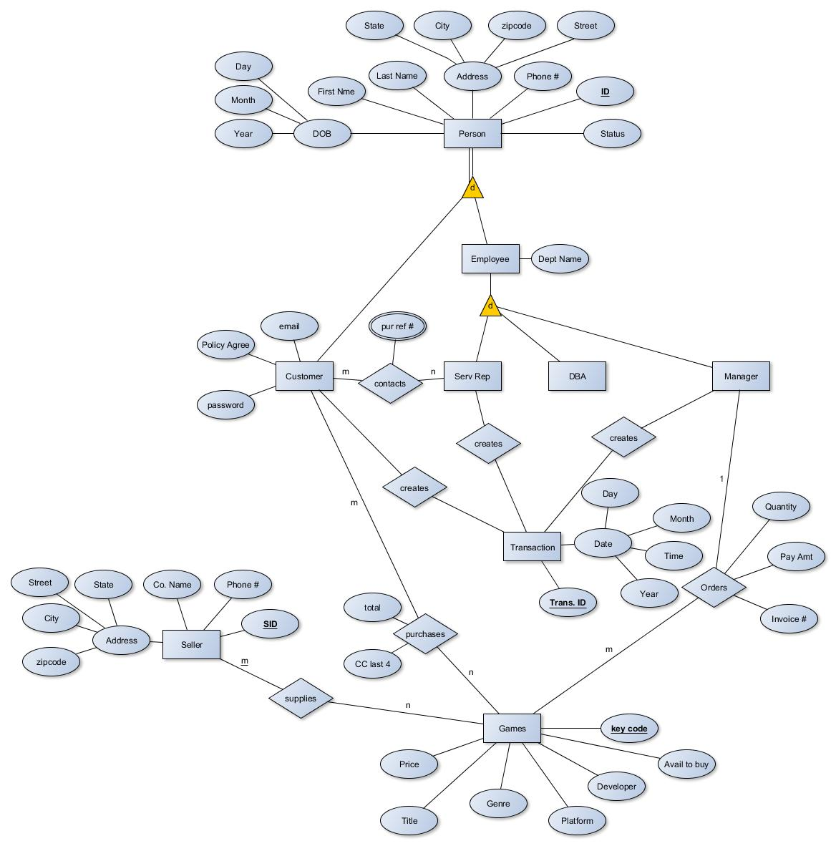

# C:\Users\Marcus\Desktop\fd1.pngRelational Database Schema

# C:\Users\Marcus\Desktop\fd1.png

# Milestones

Easy milestone: implementing the conceptual database into MySQL and designing the front end website.

Hard milestone: Figuring out PHP and connecting the website with the MySQL database. We would also like to implement a club membership if time permits. The idea is that a customer could sign up for a premium membership for a monthly fee and have access to discounts and other worthwhile features.