Git Assignment 1

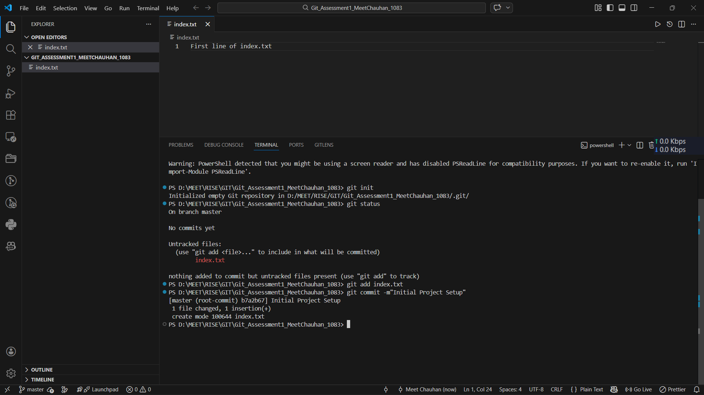
TASK 1: Repository Setup

TASK 2: Branch Creation & Work
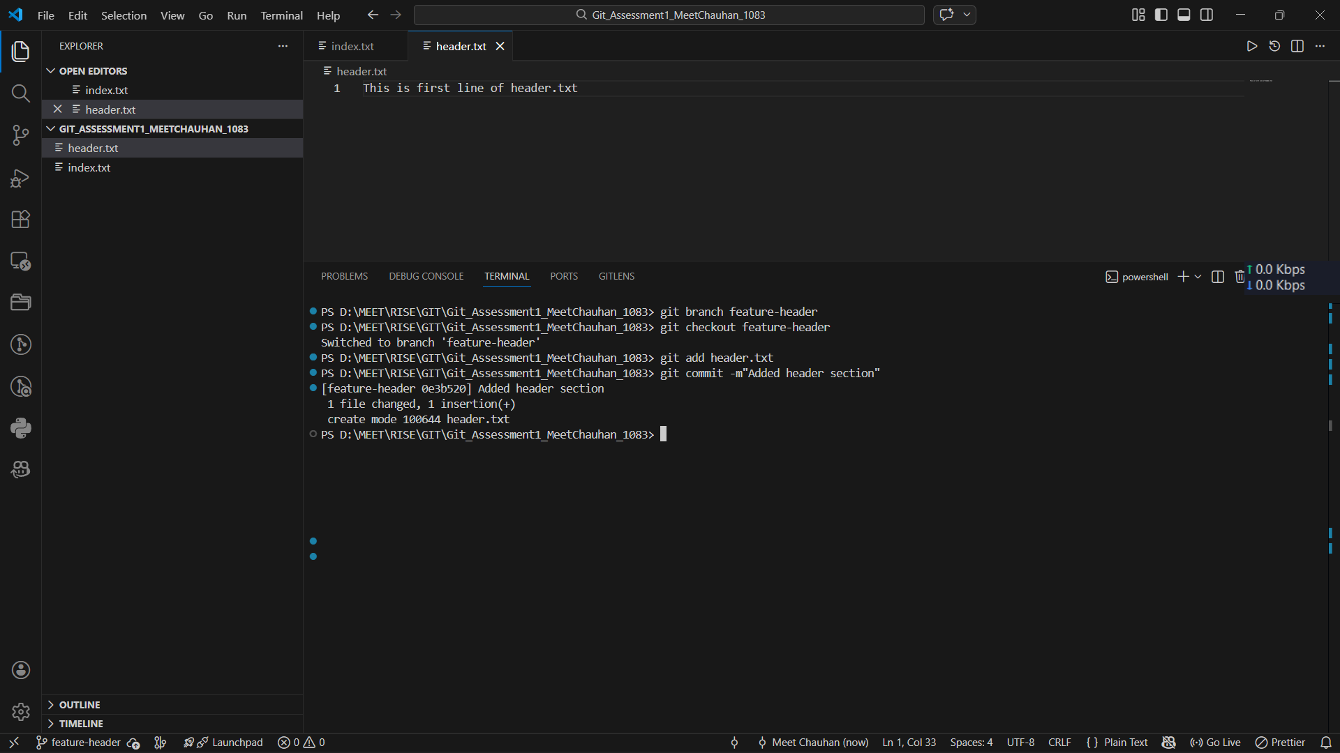

Task 3: Branch Switch Observation
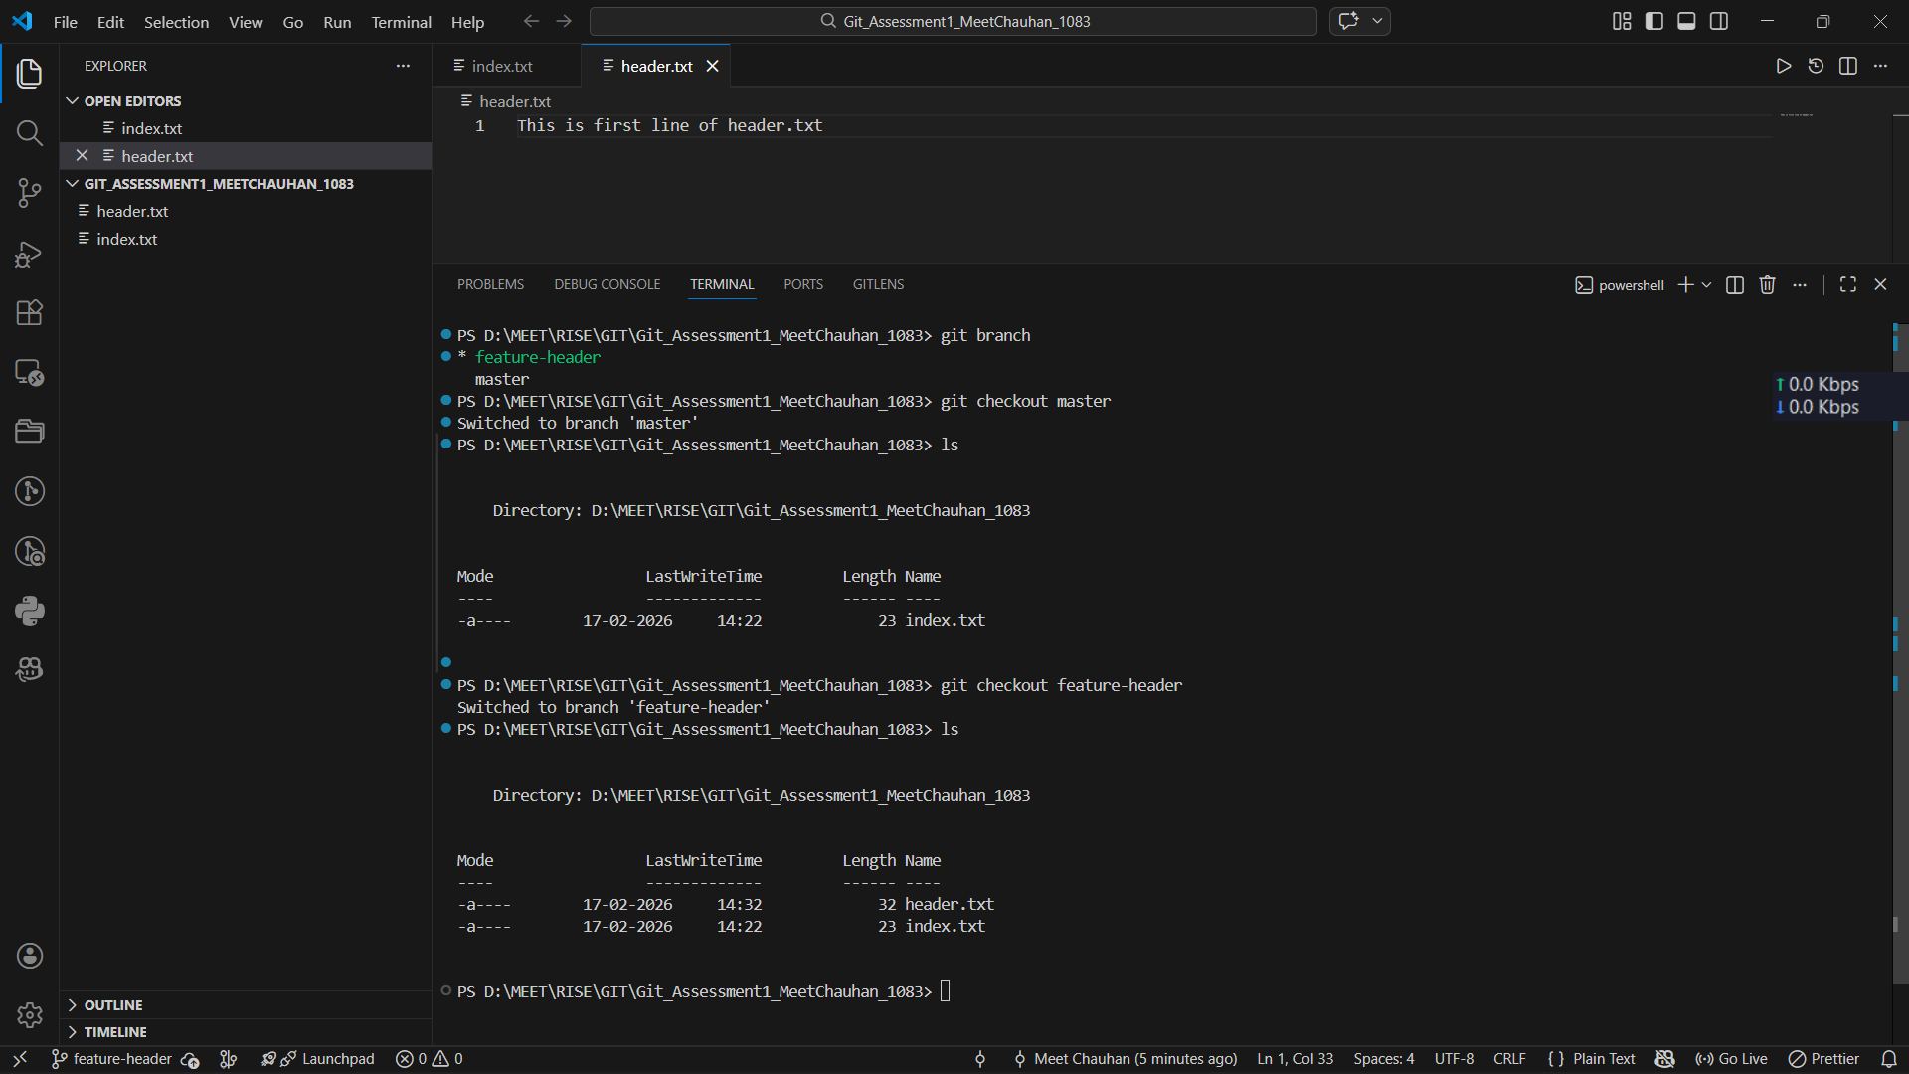

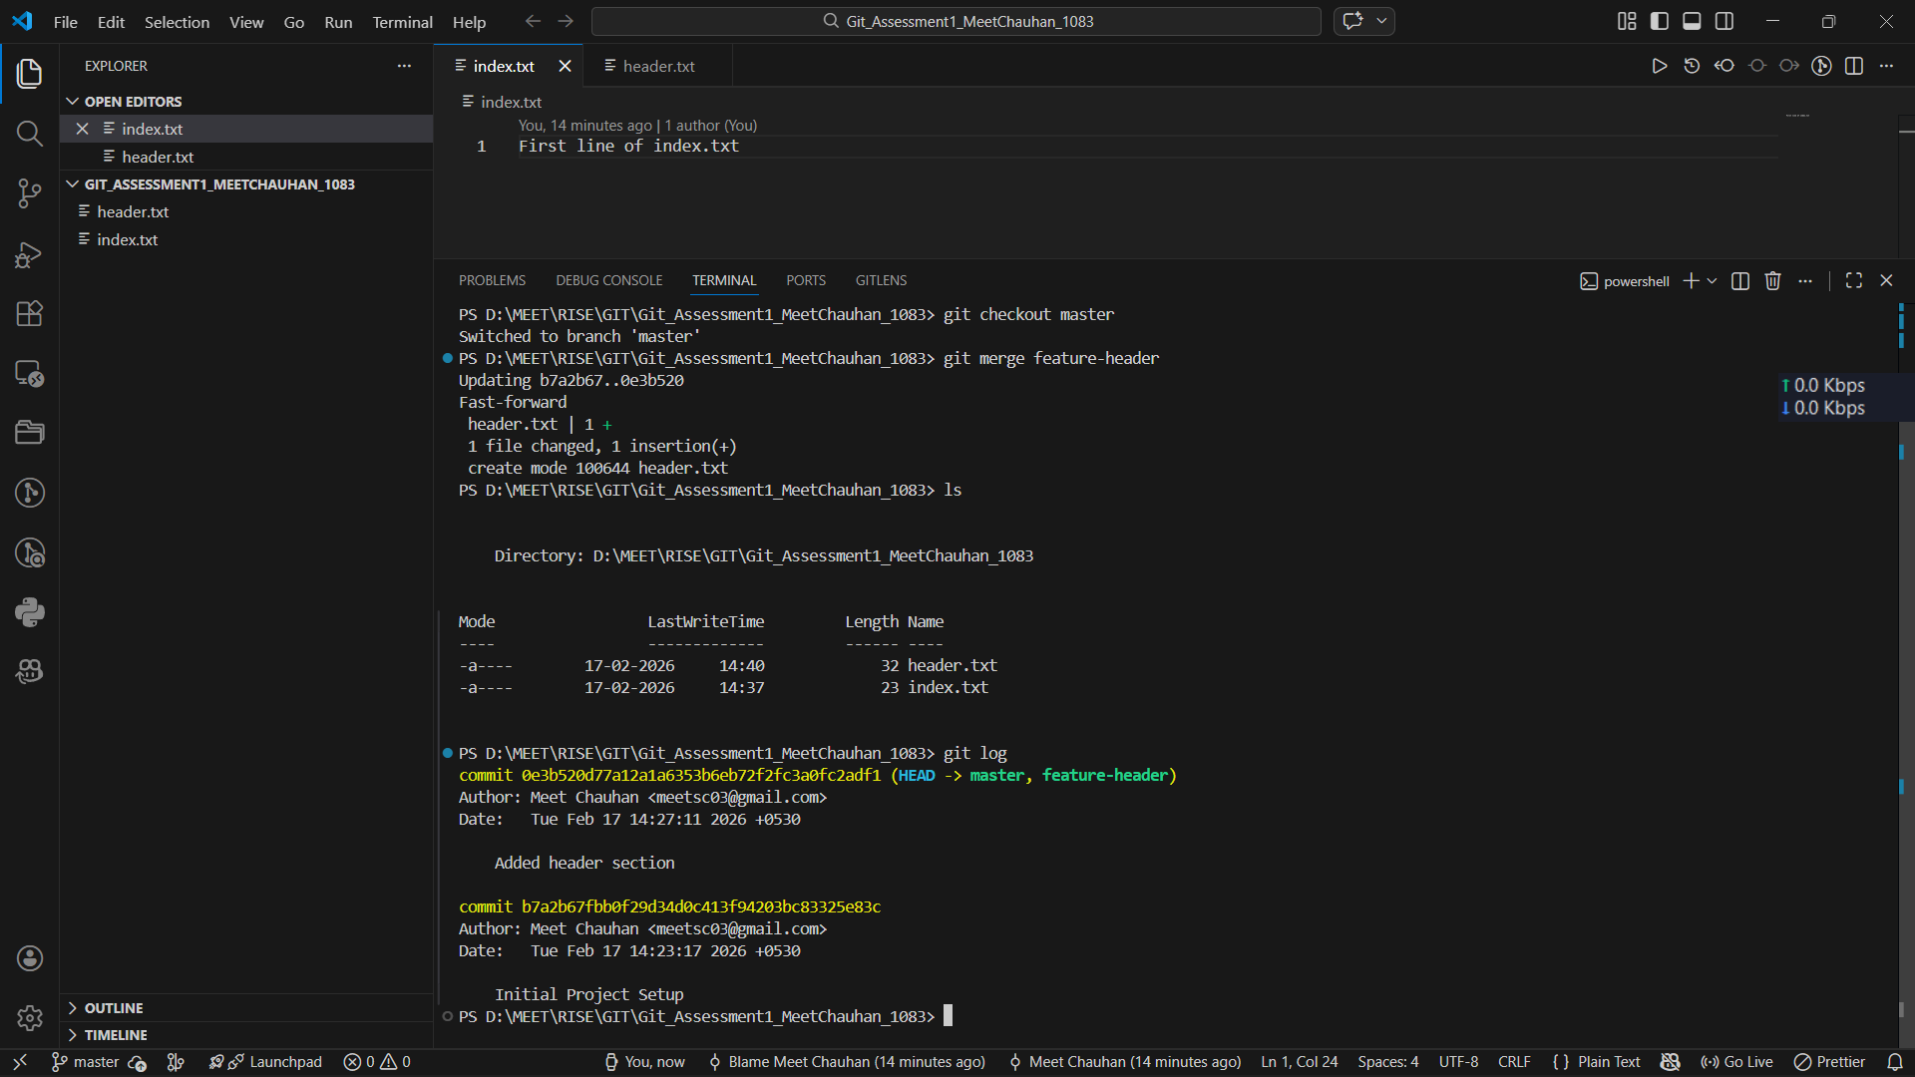
Task 4: Undo a Mistake

Task 5: Merge Feature Branch

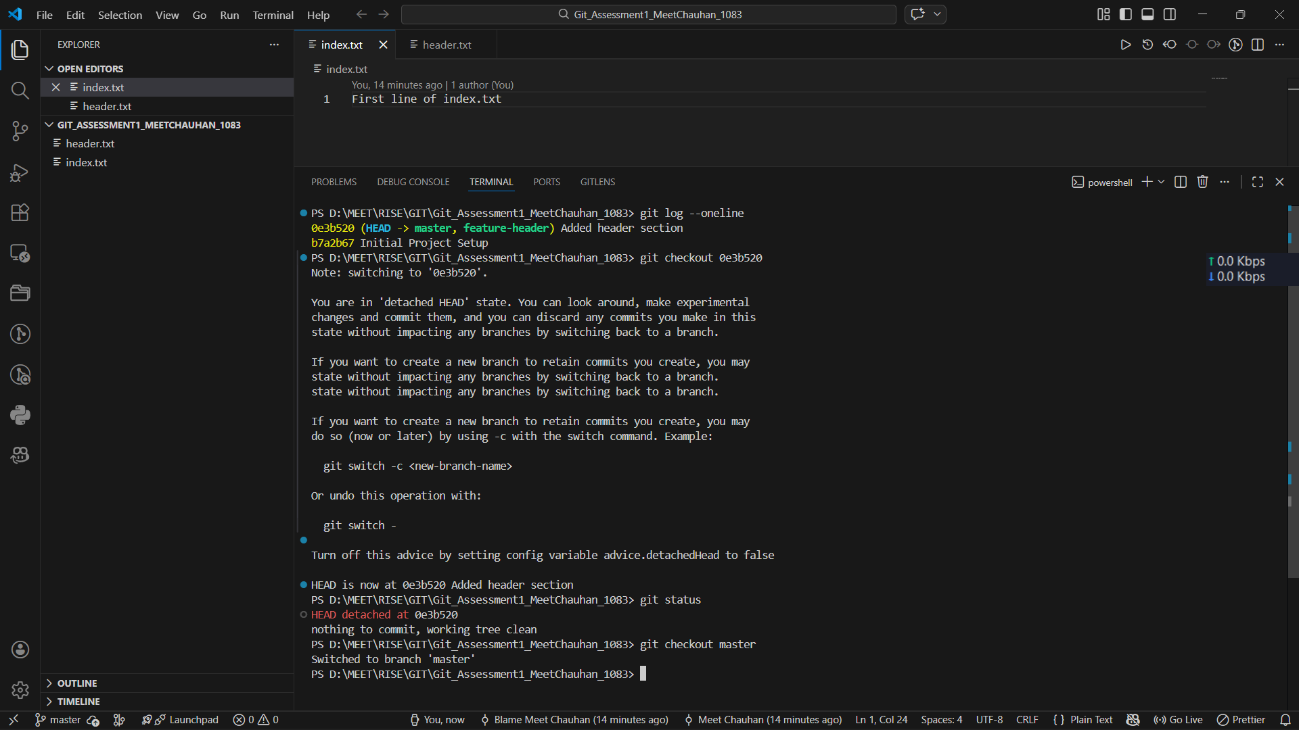
Task 6: Checkout a Commit (Detached Head)

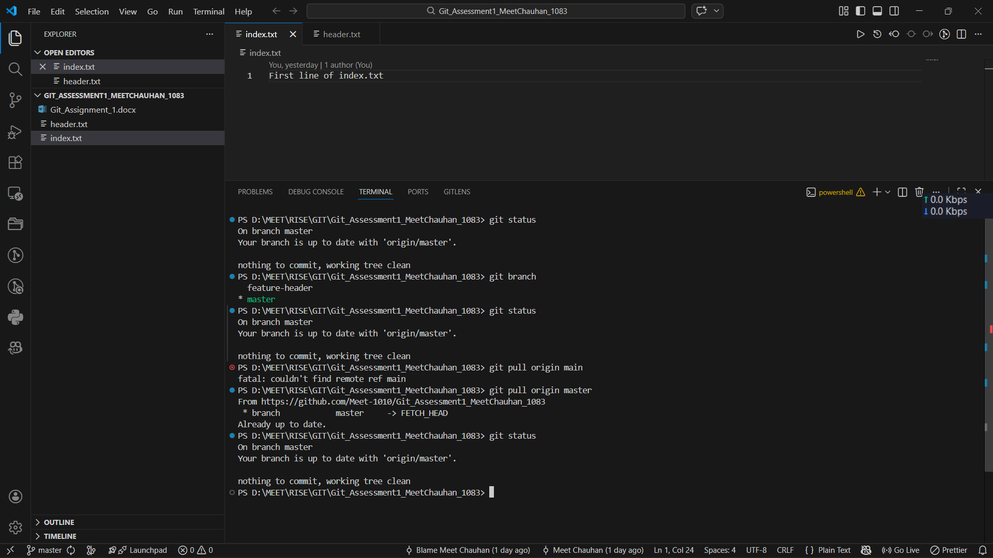
Task 7 & 8: Simple Pull

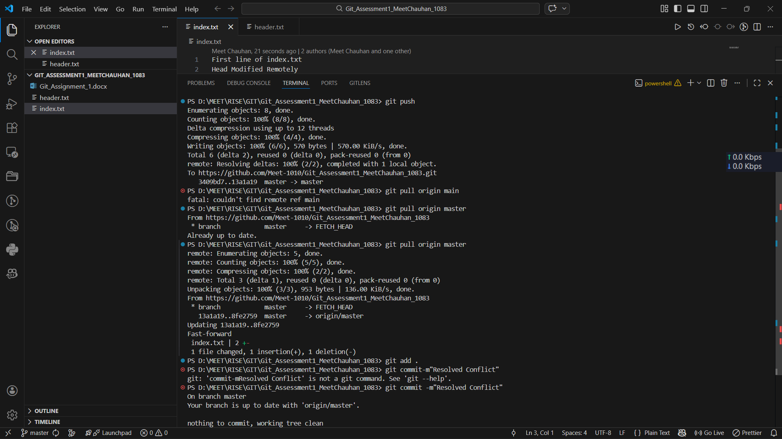
Task 9: Push and Pull with conflict resolution

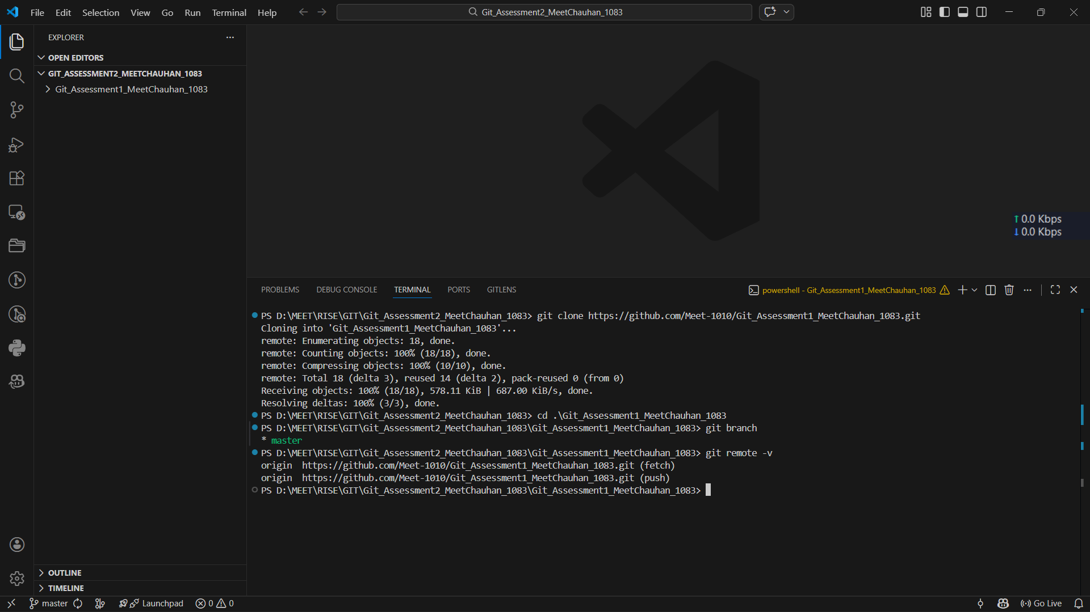
Task 10 : Clone an Existing Repository

