ZD Backup Automation
Note: This document provides a step-by-step guide for automating Ruckus ZoneDirector configuration backups using PowerShell. The sanitized PowerShell script is available separately in the Automation/PowerShell folder. All controller names, IP addresses, usernames, paths, and screenshots shown in this guide are dummy examples.
- Create a user name like (zdbkup/automation) in ZD with the available minimum rights such as only back
- Set the strong password for the newly created user
- Open windows power shell with administrator rights
- In power shell Check the connectivity for the current system where we access the and place the backup files with the following command.

- Test-NetConnection 192.168.100.100 -Port 443

- 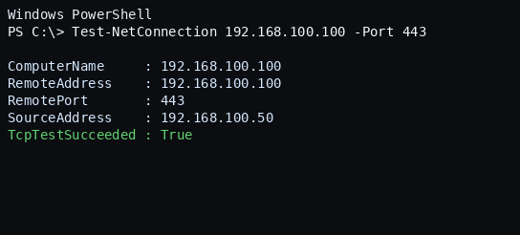

- If the result are True then go forward but if the test false then check the connectivity again between backup system and ZD.

- Once the verification is true then open the ZD in browser and login with the newly created user and test the backup activity manually to verify the backup is downloaded. (This is for to check the user rights for backup)

- Open power shell with admin rights and write the below command for creating the folder in the local system drive d: (You can also change as per your requirement)
$NewZDBase = "D:\Automation\ZoneDirectorBackup\Sample-Site"
- After creating the folders and path just enter the below commands in the same time.
New-Item -ItemType Directory -Path "$NewZDBase\Config" -Force | Out-Null
New-Item -ItemType Directory -Path "$NewZDBase\Backups" -Force | Out-Null
New-Item -ItemType Directory -Path "$NewZDBase\Logs" -Force | Out-Null
Get-Credential | Export-Clixml "$NewZDBase\Config\ZD_Credential.xml"
- The moment above command applies in the Power shell the below windows will popup for the ZD username and password.
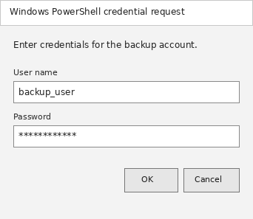
Enter the same user name and password that is created for the backup.
- Once the user name and password entered it will save auto and create a file in you above mentioned path with .xml extension.
- After this verification you can also test via power shell with the following command

Get-Credential | Export-Clixml "D:\Automation\ZoneDirectorBackup\Config\ZoneController-01_Credential.xml"
- This command will show the result as below with the true value as we can see in below picture.
- After this the below script need to edit just enter the dummy controller name and IP address then it will be the final step just copy the below script in the same folder and run in the power shell for test it.

Just open note pad save this code after change in yellow highlighted and save as file with extension .ps1 in the saved location that you already have created.
For example we have created this file name as ZoneDirector-Backup.ps1
For testing copy the code in power shell.
Note: (PowerShell Script: The backup script is available in the repository under:
Automation/PowerShell/ZoneDirector_Backup.ps1)
powershell.exe -NoProfile -ExecutionPolicy Bypass -File "D:\Automation\ ZoneDirector-Backup.ps1"
- The below result is expected in ideal completed setup.
- You can also check the backup folder that is already in placed the located location. There should be a backup in that folder.

