Trader Performance vs. Market Sentiment
An Analysis of Hyperliquid Trading Data and the Bitcoin Fear & Greed Index

1. Overview
This analysis merges 29,979 trades from 8 accounts on Hyperliquid (Jan 2024 – May 2025) with the daily Bitcoin Fear & Greed Index. The goal is to test whether market sentiment is associated with trader profitability, position sizing, and behavior, and to surface insights that could inform trading strategy. 99.98% of trades matched to a sentiment reading for their trade date.

2. Performance by Sentiment Regime
Restricting to trades with a non-zero closed PnL (actual realized closes, n = 13,245):
Sentiment | Trades | Win Rate | Avg PnL (USD) | Total PnL (USD)
Extreme Fear | 571 | 71.8% | $565 | $322,691
Fear | 4,495 | 87.4% | $360 | $1,619,931
Neutral | 2,858 | 94.9% | $217 | $619,980
Greed | 3,569 | 92.7% | $248 | $885,961
Extreme Greed | 1,752 | 84.1% | $147 | $257,486

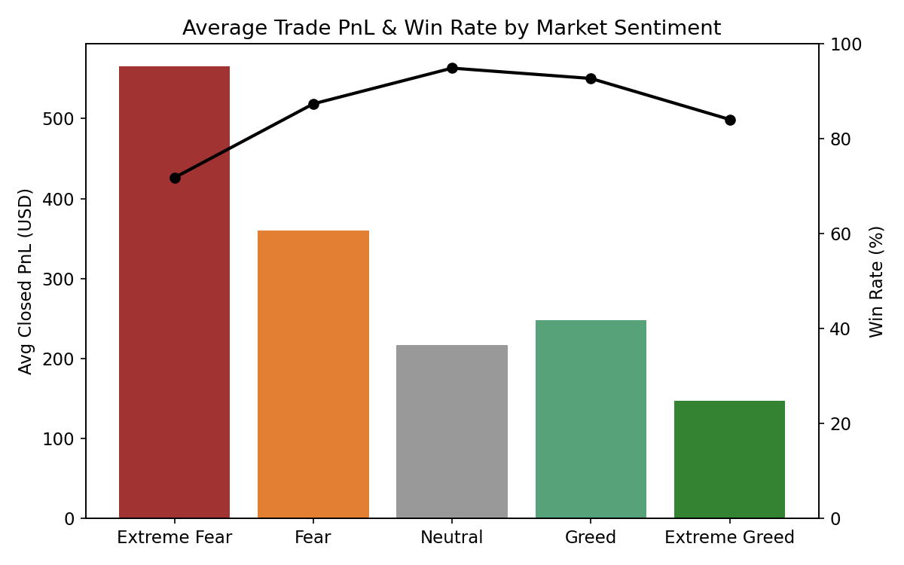

3. Key Finding: Traders Perform Best During Fear, Not Greed
The data shows a counter-intuitive but consistent pattern: both win rate and average PnL per trade are highest during Fear and Extreme Fear, not during Greed or Extreme Greed. Average PnL per trade during Extreme Fear ($565) is nearly 4x the average during Extreme Greed ($147).
This aligns with the classic contrarian principle of 'being greedy when others are fearful' — on this dataset, traders who are active and closing positions during fear periods are realizing meaningfully larger gains per trade than those trading during euphoric greed periods, when crowded positioning and mean-reversion risk are typically higher.

4. Position Sizing Behavior
Traders also size up meaningfully during Fear regimes — average trade size during Fear ($28,164) is more than double the average size during Extreme Fear or Extreme Greed (~$12,700-13,000):
Sentiment | Avg Position Size | Buy Trades | Sell Trades
Extreme Fear | $12,670 | 736 | 510
Fear | $28,164 | 5,184 | 4,577
Neutral | $18,184 | 2,917 | 2,930
Greed | $21,022 | 4,080 | 4,344
Extreme Greed | $12,983 | 2,411 | 2,284
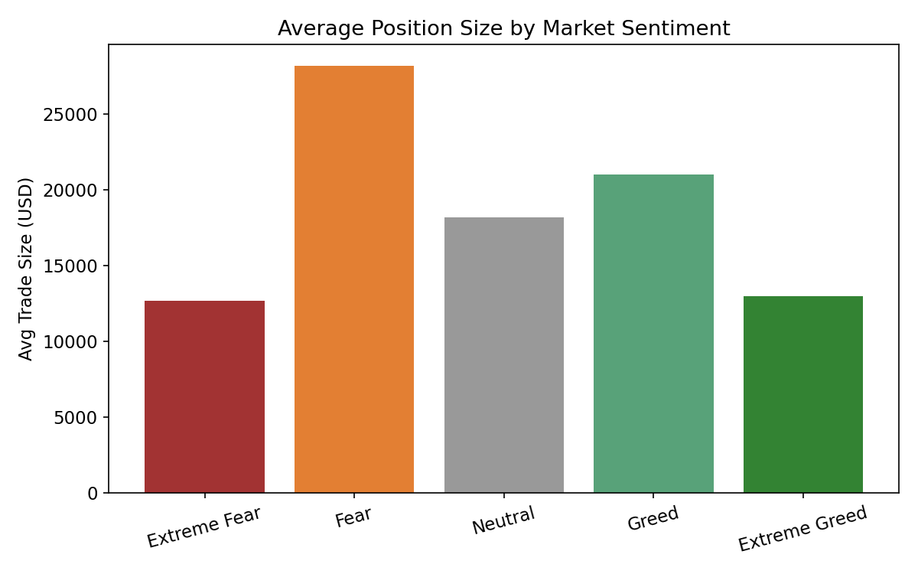
This suggests traders on this platform are adding risk (moving larger notional) specifically during the Fear regime — the same regime where they see their highest profitability. Buy/Sell splits stay fairly balanced across all regimes (no strong directional bias by sentiment), suggesting the edge comes more from sizing and selection than from simple long/short bias.

5. Sentiment-PnL Correlation
At the daily level, plotting the raw Fear & Greed Index value (0 = Extreme Fear, 100 = Extreme Greed) against average daily closed PnL shows a weak negative correlation (r = -0.16) — i.e., as the index value rises toward 'Greed,' average trader profitability tends to drift slightly lower.
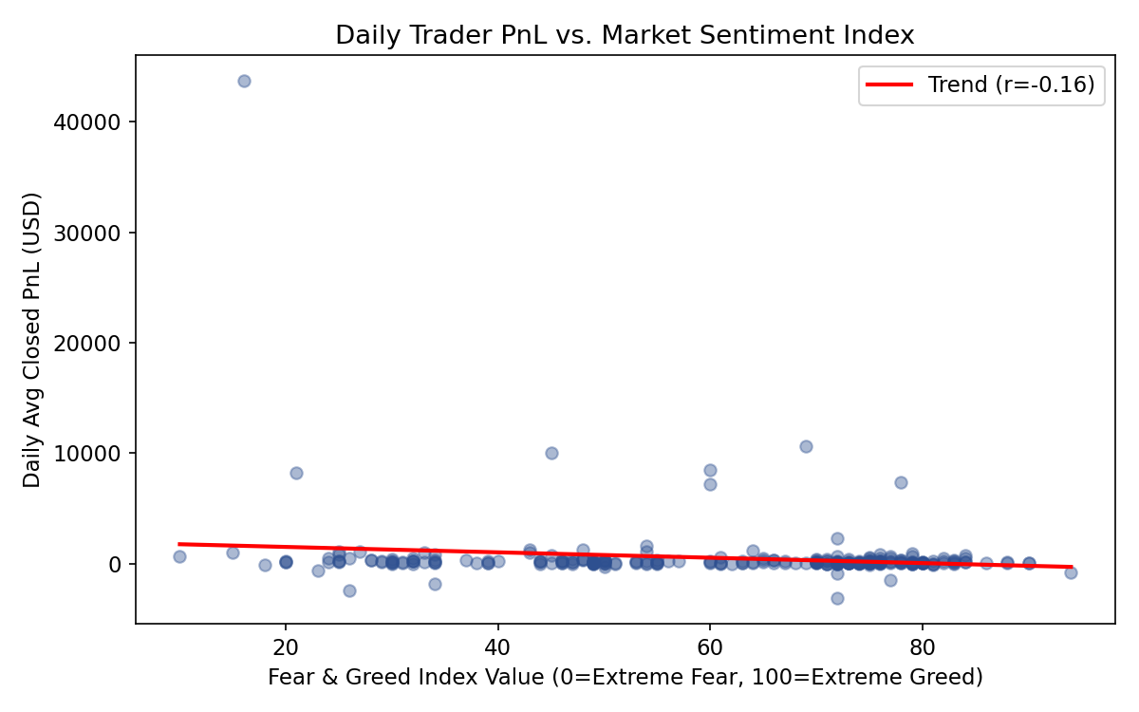
The correlation is weak, meaning sentiment alone explains only a small part of daily PnL variance — but the direction is consistent with the regime-level finding above, and notably runs opposite to a naive 'ride the trend/greed' assumption.

6. Trader-Level Variation
Individual accounts do not respond to sentiment uniformly. Among the three most active accounts, one showed its best average PnL during Neutral conditions, another peaked during Extreme Fear, and a third performed best during Greed but had a losing average in Extreme Greed. This indicates sentiment-performance relationships are trader/strategy-specific, not universal — any sentiment-based strategy should be validated per trading style rather than applied as a blanket rule.
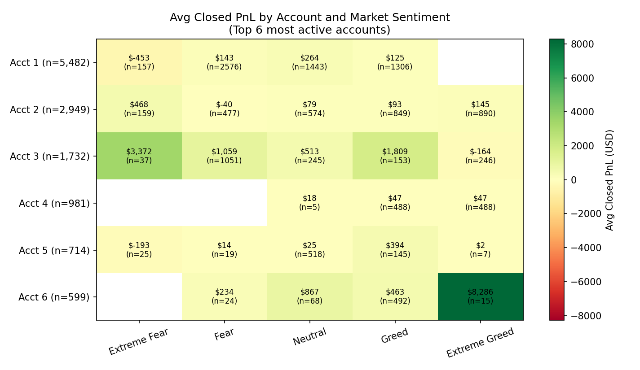
The heatmap above quantifies this: among the six most active accounts, average closed PnL per trade by regime ranges from a loss of roughly -$453 (Account 1, Extreme Fear) to a gain of roughly $8,286 (Account 6, Extreme Greed, on a small n=15 sample) and $3,372 (Account 3, Extreme Fear). No two accounts share the same "best regime," and several accounts turn unprofitable in exactly the regime where another account peaks. This confirms that the aggregate Fear-outperforms-Greed pattern in Section 3 is a population-level average, not a rule that holds account-by-account — a sentiment-based sizing rule would help some accounts and hurt others if applied uniformly. Cells with small sample sizes (n) should be read with proportionally less confidence.

7. Data Notes & Limitations
- The 'leverage' field mentioned in the assignment brief was not present in the raw file; position sizing (Size USD) was used as the closest available proxy.
- Analysis covers 8 accounts only — this is a small, non-random sample of Hyperliquid users, so findings should not be generalized to the broader market.
- Correlation does not imply causation — sentiment may be a lagging co-indicator of the same volatility/liquidity conditions that drive PnL, rather than a direct cause.

8. Strategic Takeaways
- Consider selectively increasing position sizing during confirmed Fear/Extreme Fear regimes, where historical win rate and average PnL were highest in this dataset.
- Be cautious about scaling up during Extreme Greed — this regime showed the lowest average PnL per trade and a below-average win rate.
- Sentiment should be one input among several (volatility, liquidity, trader-specific edge) rather than a standalone signal, given the weak overall correlation and high trader-level variance.
- Backtest any sentiment-conditioned rule per-strategy before deployment, since the aggregate pattern did not hold uniformly across individual accounts.

