Internship Report
At
Goldenmace It Solution

Internship Duration: 22-12-2025 to 31-1-2026

Submitted in partial Fulfilment of the requirement for the Degree of
BACHELOR OF COMPUTER APPLICATION
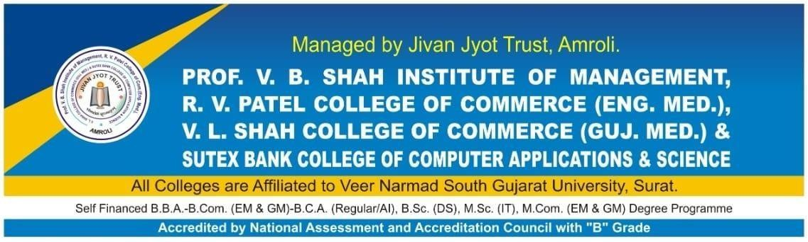

SUBMITTED BY:

Name of Student | TYBCA  Sem. | Roll No. | Seat No. | SPID
Meet Chauhan | 6 | 431 | 6077 | 23410258

UNDER THE GUIDANCE OF

Industry Guide: Madhuri Patil
Faculty Guide: Jigisha Patel

Certificate

- Company Certificate

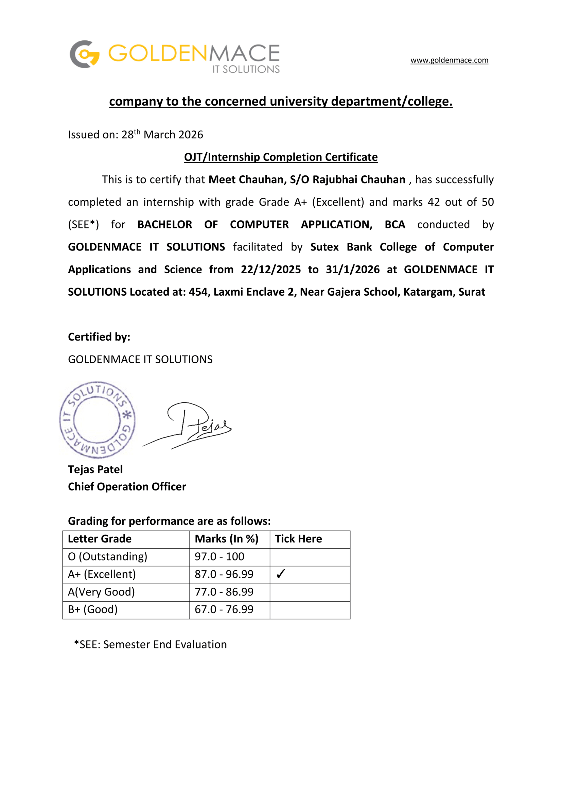

- Collage Certificate

Acknowledgment

I would like to express my sincere gratitude to everyone who supported and
guided me during my internship in the field of MERN Stack Development at Goldenmace IT Solution.

This internship provided me with a valuable opportunity to gain practical knowledge and enhance my technical skills in modern web development technologies.

I would like to extend my heartfelt thanks to my faculty guide, Prof. Madhuri
Patil, for her valuable guidance, continuous support, and encouragement throughout the internship period. Her kind and supportive nature helped me
to overcome challenges and gain confidence during my learning journey.

I am also sincerely thankful to my organization, Goldenmace IT Solution, for
giving me the opportunity to work in a professional environment. The
experience I gained during this internship helped me understand real-world application development using the MERN stack (MongoDB, Express.js, React.js,
and Node.js).

This internship significantly improved my understanding of full-stack
development, strengthened my coding skills, and gave me exposure to building scalable and user-friendly web applications.

Finally, I would like to thank everyone who directly or indirectly contributed to making this internship a valuable and successful learning experience.

Declaration

I hereby declare that this internship report on “MERN Stack Development” is my original work carried out during my internship period. It is submitted as a part of the academic requirement for TYBCA (Semester-6).

The work included in this report is based on my practical learning at Goldenmace IT Solution under the guidance of my faculty guide, Prof. Madhuri Patil.

I confirm that this report has not been submitted anywhere else for any degree or certification. I take full responsibility for the authenticity of the content.

Student Name | Chauhan Meet Rajubhai
Course | TYBCA (Sem-6)
Roll No. | 431
Institute | Sutex Bank College of Computer Applications & Science, Amroli, Surat
Student Signature
Date

Index

Sr. No. | Contents | Page No.
1 | Internship Details | 7
2 | Objectives of the Internship | 8
3 | Description of Work Done | 9
4 | Learning Outcomes | 11
5 | Challenges and Solutions | 12
6 | Weekly Work Summary | 13
7 | Conclusion | 14
8 | References | 15
9 | 9.1 annexure (Week 1–12)  - annexure (Logbook) | 16

Internship Details

Particular | Details
Organization Name | Goldenmace It Solution
Address | 454, Laxmi Enclave-2, Near Gajera School, Katargam, Surat
Internship Role | MERN Stack Developer
Duration | 22-12-2025  to  31-1-2026
Working Hours | 120
Supervisor, Mentor | Madhuri Patil
Department | Information Technology
Technology Used | Mern Stack: React.js , Node.js, Express.js, MongoDB
Tools Used | Vs Code, Postman, Git & Github  Ai tools, Browser Dev Tools.
Project Type

2. Objectives of Internship

- To Gain Real-World Industry Exposure:
To understand the professional working environment of an IT company and
learn how real-world web development projects are managed.

- To Apply Academic Knowledge Practically:
To bridge the gap between theoretical knowledge gained during the BCA
program and its practical implementation in real-world projects.

- To Enhance Technical Skills:
To develop and improve skills in MERN stack technologies such as MongoDB, Express.js, React.js, and Node.js.

- To Develop Problem-Solving Ability:
To learn how to identify, analyze, and solve technical problems during
development.

- To Improve Productivity Using Modern Tools:
To explore and use modern tools and technologies to increase efficiency and productivity in development work.

3. Description of Work Done

- Roles and Responsibilities::
During my internship at Goldenmace IT Solution, I was actively involved in developing web applications using MERN stack technologies. I got the opportunity to understand how real-time projects are executed in a professional IT environment. My responsibilities included both frontend and backend development tasks, along with learning best coding practices.

- Website Development:
Developed and structured web pages using HTML, CSS, and JavaScript to create interactive and user-friendly interfaces.

- Frontend Design and Layout:
Designed responsive layouts and improved the visual appearance of web pages to ensure better usability and user experience.

- Backend Development:
Worked on creating REST APIs, handling server-side logic, and managing routes using Node.js and Express.js.

- Database Management:
Used MongoDB to store and manage application data efficiently.

- Testing and Debugging:
Tested applications, identified bugs, and fixed issues to improve performance and functionality.

- Description of Technologies, Tools Used:

- MERN Stack (MongoDB, Express.js, React.js, Node.js):
Used for full-stack web application development.

- Visual Studio Code (VS Code):
Used as the main development environment for writing, editing, and testing the source code.

- Browser Developer Tools:
Used for debugging, inspecting elements, and improving the layout and performance of web pages.

- Postman:
Used for testing APIs and verifying backend functionality.

- Project Implementation:
Worked on implementing complete features including UI design, API development, and database connectivity.

- AI Tools (Google Gemini, ChatGPT):
Used for generating ideas, solving coding issues, and improving productivity during development tasks.

- Web Development Projects:
Screenshots of website interfaces, forms, and web pages developed during the internship period.

4. Learning Outcomes

During my internship at Goldenmace IT Solution, I gained valuable industry exposure and enhanced both my technical knowledge and professional skills related to the IT field.

Technical & Software Skills Developed:

- Web Development Skills:
Improved practical knowledge of web development by working with technologies such as React.js, Node.js, Express.js and MongoDB to design and develop responsive webpages.

- Frontend Design and User Interface Development:
Learned how to design clean and responsive website layouts, focusing on improving the user interface and user experience.

- Debugging and Testing:
Developed the ability to identify errors in code and resolve them effectively while testing web pages and application features.

- Development Tools Usage:
Gained hands-on experience using development tools such as Visual Studio Code and browser developer tools for writing, editing, and debugging code.

Professional Skills & Industry Exposure Gained:

- Understanding of IT Industry Workflow:
Learned how real-world IT projects are planned, developed, and maintained within a professional development environment.

- Problem-Solving Ability:
Improved logical thinking and problem-solving skills while handling coding challenges and fixing technical issues.

5. Challenges and Solutions

- Challenge 1: Debugging Errors in Web Development

Problem: While developing web pages using react.js and components, I encountered several coding errors that caused layout issues and improper functioning of certain elements such as forms and navigation components. Identifying the exact source of these errors was challenging in the beginning.

Solution: I carefully analysed the code using browser developer tools and debugging techniques. I also referred to online documentation and AI tools such as Google Gemini and ChatGPT to understand the error and find appropriate solutions. This helped me improve my debugging skills and resolve the issues effectively.

- Challenge 2: Creating Responsive Web Layouts

Problem: While designing website interfaces, ensuring that the layout worked properly on different screen sizes such as mobile, tablet, and desktop devices was initially difficult. Some sections were not adjusting correctly across various screen resolutions.

Solution: I studied responsive design techniques and used Tailwind CSS utility classes to create flexible layouts. By testing the website on multiple screen sizes and making necessary adjustments, I was able to develop a fully responsive and user-friendly interface

6. Weekly Summary

Week | Date | Technologies Used | Learning Outcome
Week 1 | 22-12-2025 to  27-12-2025 | HTML,  CSS, Bootstrap  JavaScript | Understood basics of web development, created simple web pages, and learned structure, styling, and basic interactivity.
Week 2 | 29-12-2025 to  03-01-2026 | React.js, JSX,  TypeScript,  Tailwind CSS | Learned React fundamentals, component-based architecture, and created basic UI components.
Week 3 | 05-01-2026 to  10-01-2026 | Node.js,  Express.js | Understood backend development,  created basic server, handled routing  and built simple APIs.
Week 4 | 12-01-2026 to  17-01-2026 | MongoDB,  Mongoose | Learned database integration,  performed CRUD operations, and  managed data using MongoDB.
Week 5 | 19-01-2026  to  24-01-2026 | JWT, Auth Security  API Integration (Axios) | Implemented authentication system, connected frontend with backend, and handled secure data exchange.
Week 6 | 26-01-2026  to  31-01-2026 | Git, GitHub,  Debugging Tools | Learned version control, project  management, debugging techniques  and improved overall application performance.

7. Conclusion

- My internship at Goldenmace IT Solution has been a valuable and enriching experience. It helped me move beyond theoretical knowledge and gain practical exposure to real-world software development.

- During this internship, I improved my technical skills in MERN stack technologies and gained hands-on experience in building web applications, developing APIs, and managing databases. I also learned how real projects are planned and executed in a professional environment.

- Apart from technical knowledge, I developed important skills such as problem-solving, time management, and teamwork. Working under guidance helped me gain confidence and understand industry expectations.

- Overall, this internship played a significant role in enhancing my
practical knowledge and preparing me for future career
opportunities in the IT field.

8. References

- MDN Web Docs (Mozilla Developer Network): Referenced for understanding web development concepts including HTML, CSS, and JavaScript.

- W3Schools: Used as a learning resource for practicing web development techniques and understanding coding examples.

- Tailwind CSS Documentation: Referenced for designing responsive layouts and implementing modern UI components using Tailwind CSS.

- Visual Studio Code Documentation: Used to understand development tools, extensions, and coding practices during the project development process.

- Google Gemini, ChatGPT: Utilized as an AI-based resource for solving coding problems, generating ideas, and improving development efficiency.

- YouTube Educational Content: Referred to various web development tutorials for learning practical implementation of frontend development techniques.

9. Annexure

9.1 Annexure (Week 1–12)
(Diary Internship Report pages)

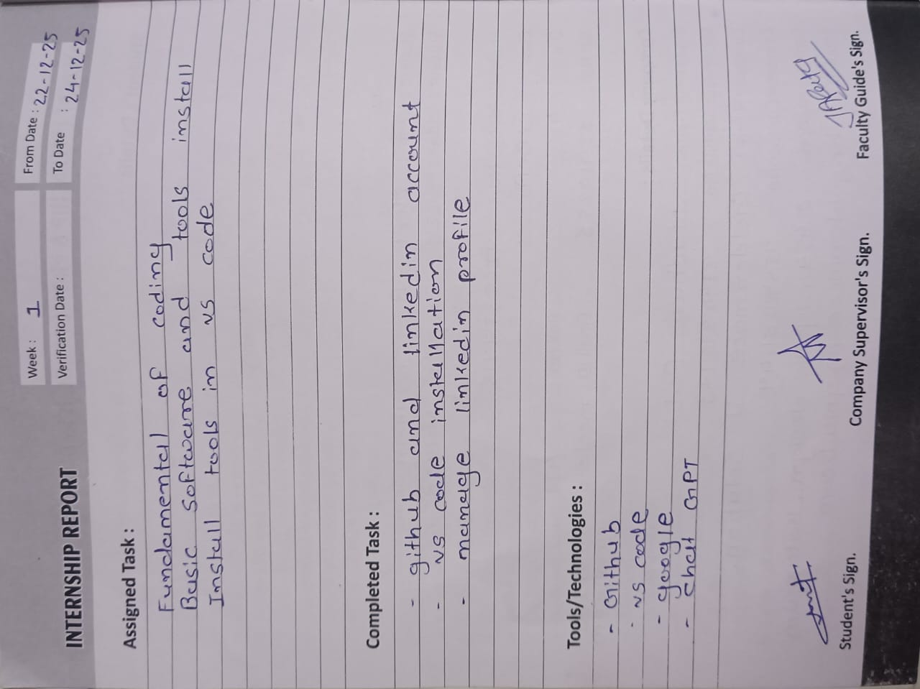
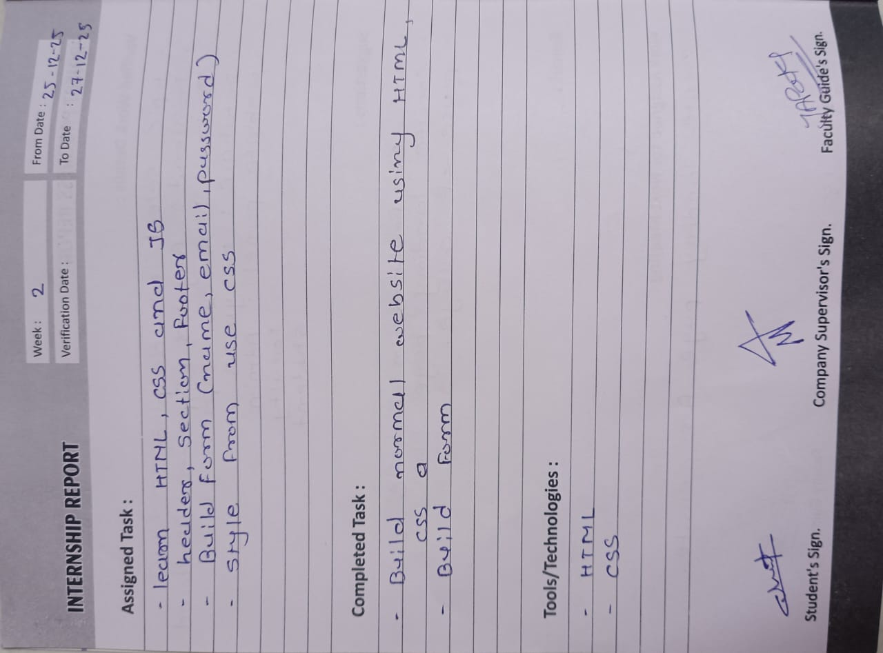

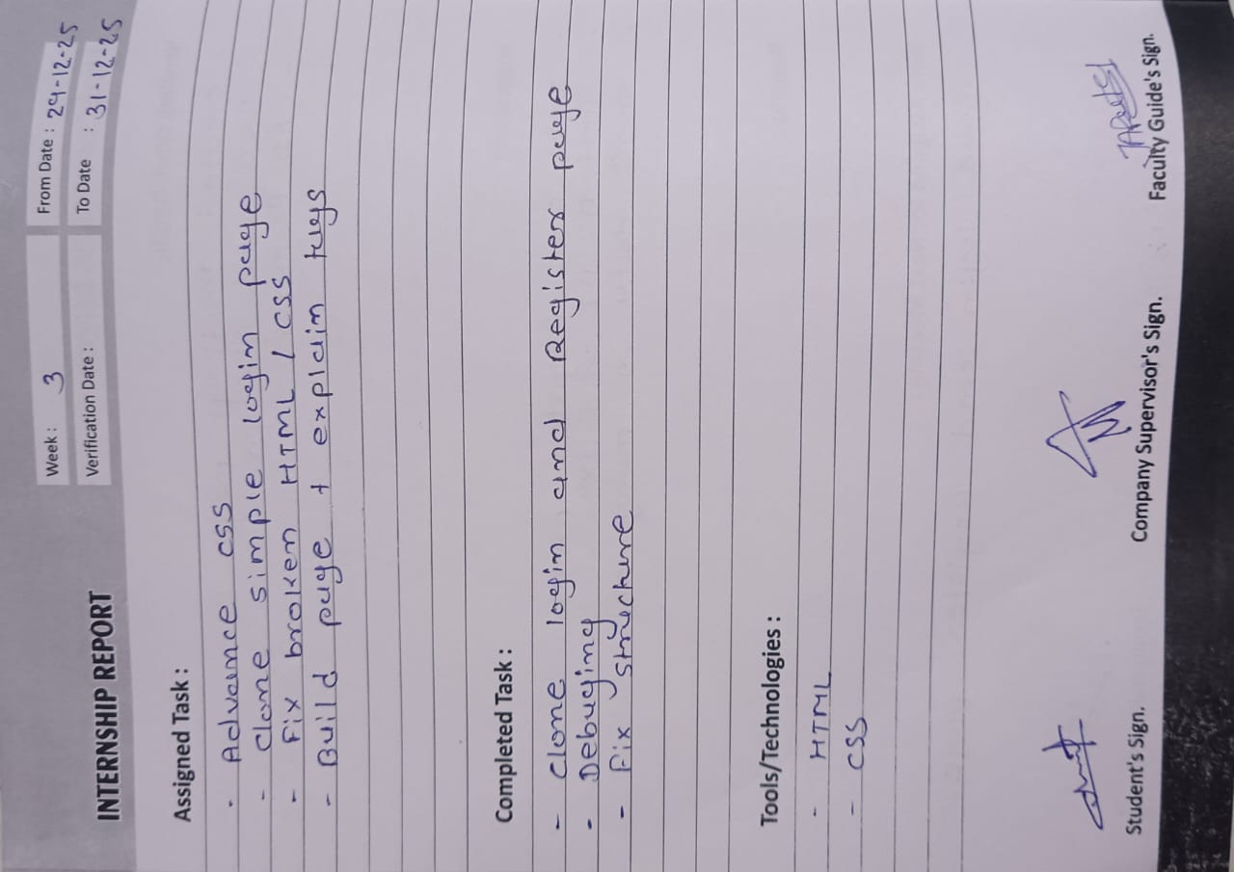

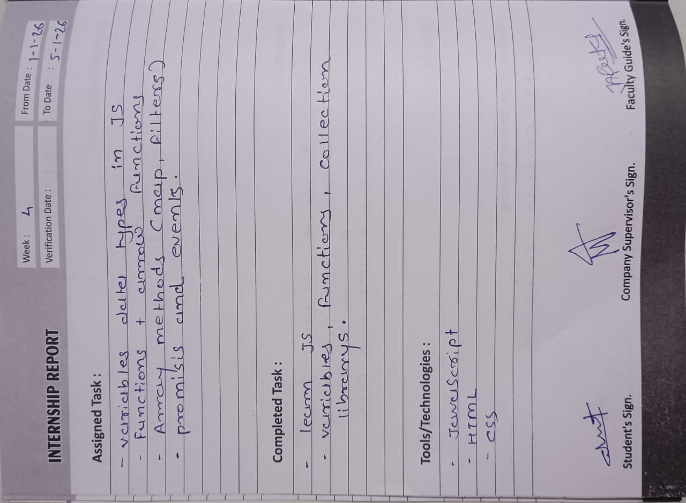

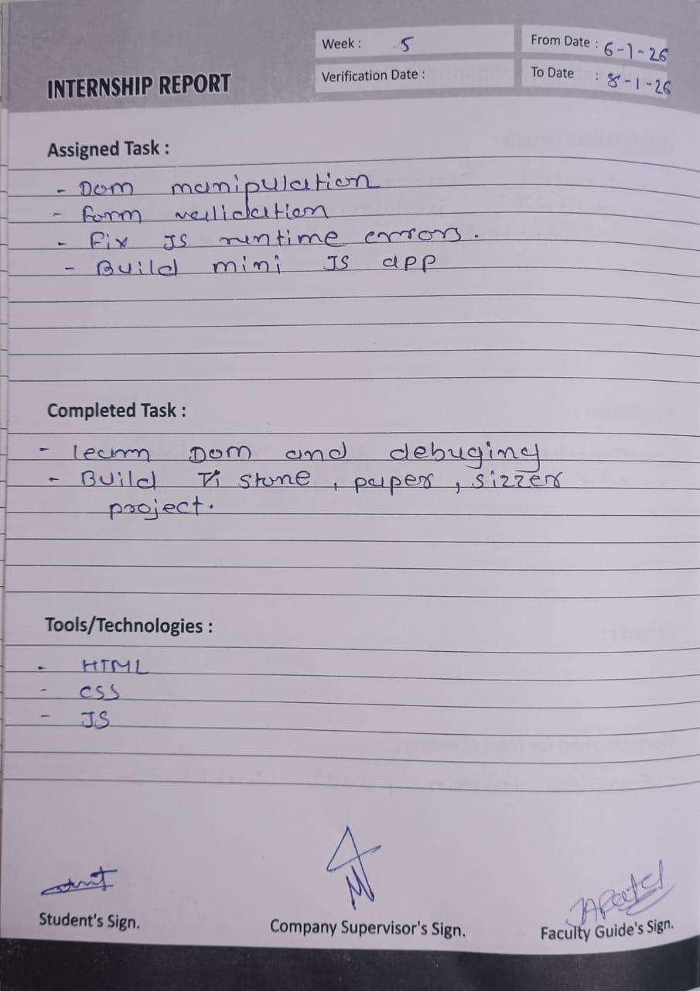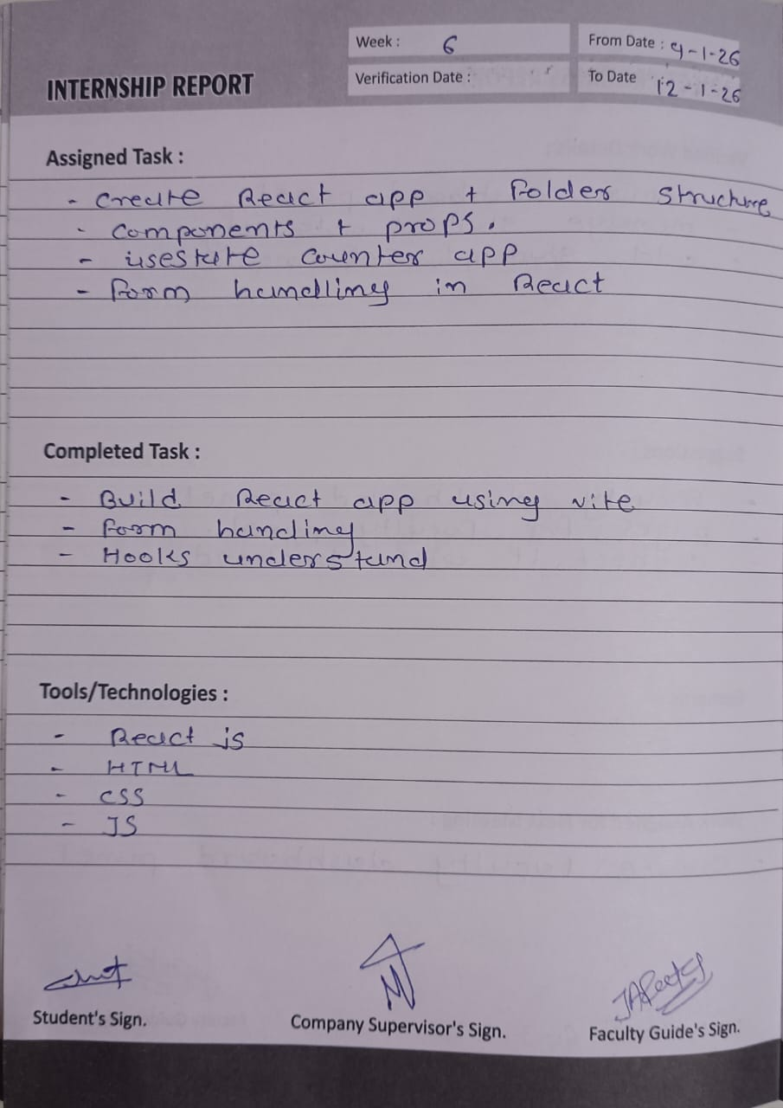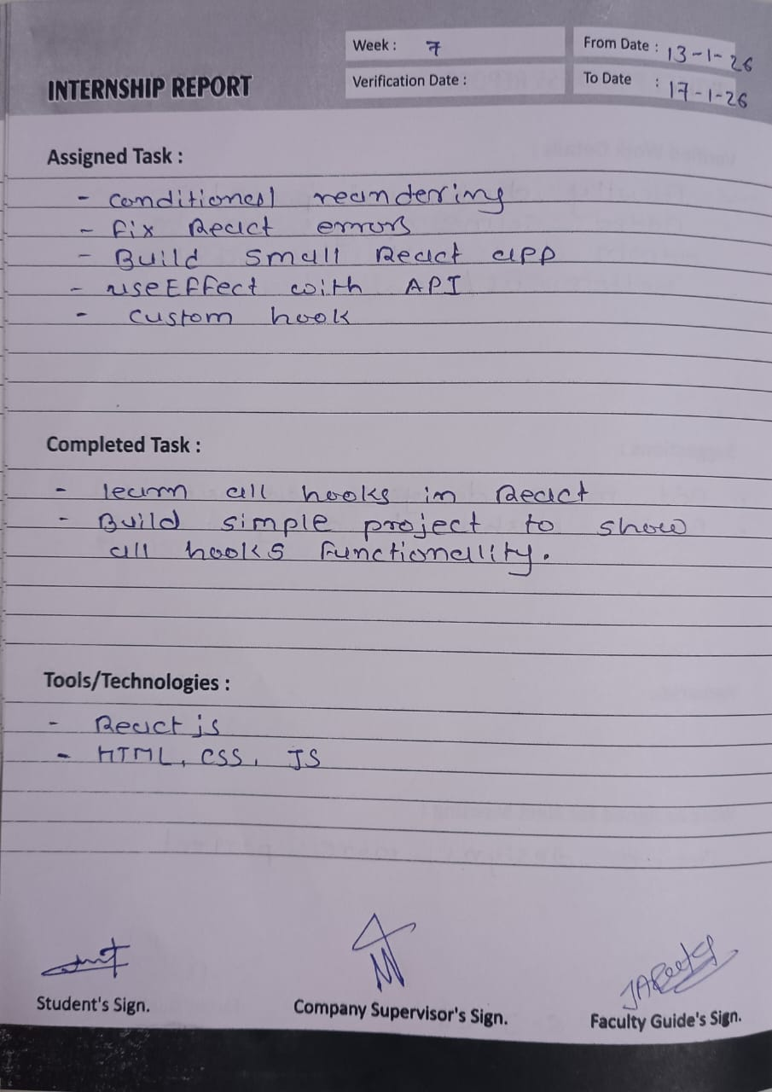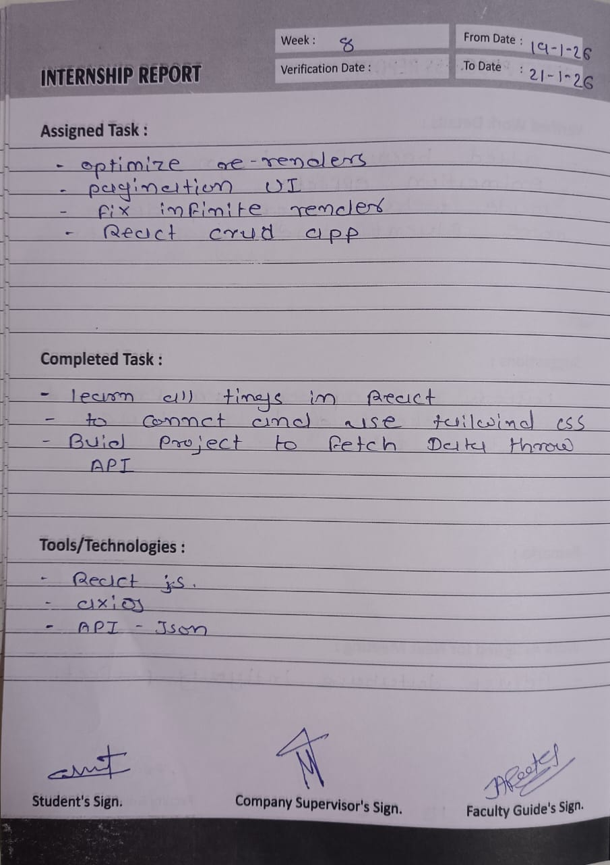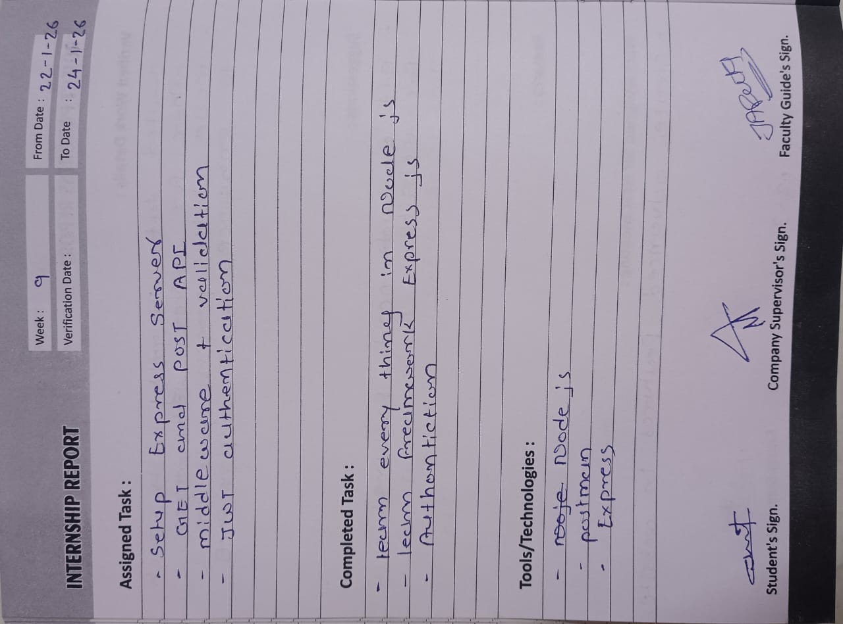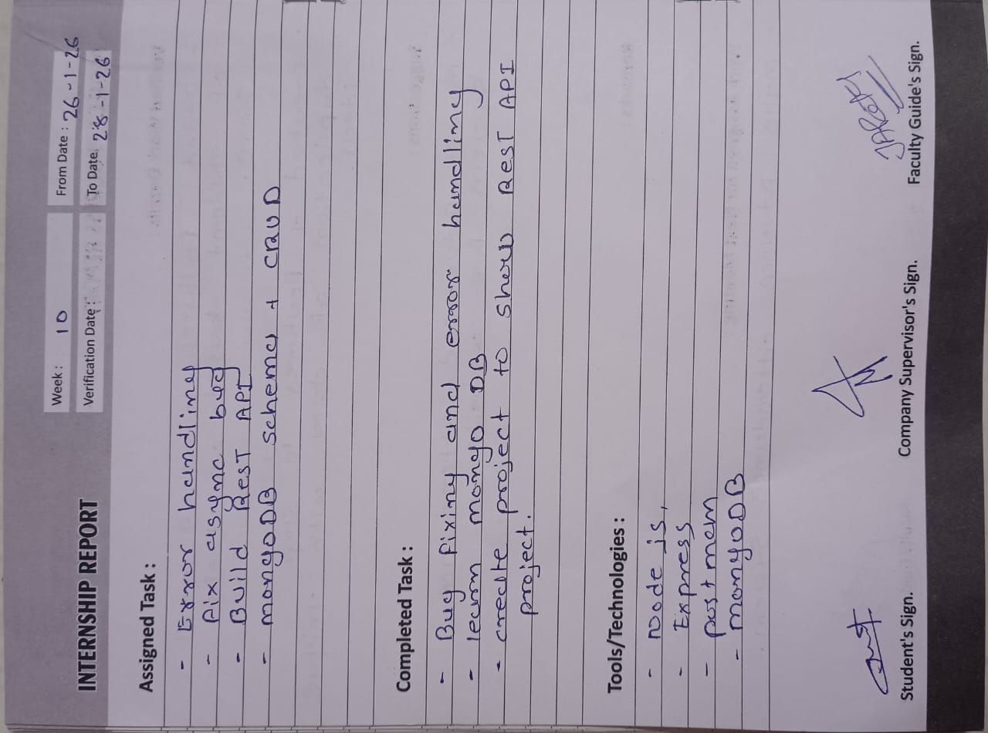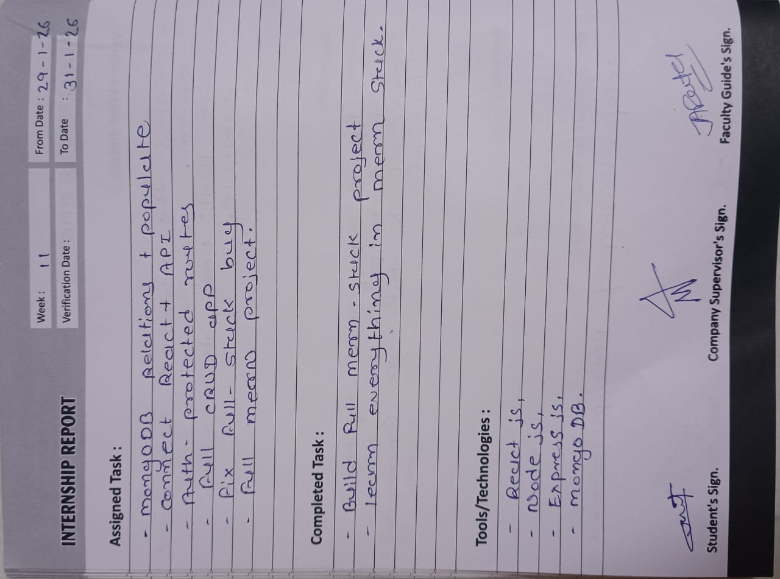

9.2 Annexure (Logbook):

(Diary Last Logbook Pages)

