**LAB 5: DATABASE PROGRAMMING**

Name: Meet Patel ID: 500509440 Section:02

**Instructions to Run the Program:** The program for lab5 was made using NETBEANS IDE 8.0.2. Click on the project called library open the project program using NETBEANS and then go the package where it says library click on it the drop down menu should come up for source packages then another drop down menu for library and finally click on the main class which is called library.java and run the main class. From that point on all instructions should appear in the terminal. *(No Bugs or Errors were found when creating this).*

**DUMP of DATABASE PROGRAM**

PRAGMA foreign_keys=ON;

BEGIN TRANSACTION;

CREATE TABLE Author(

AuthorId INTEGER PRIMARY KEY AUTOINCREMENT,

AuthorName VARCHAR(50) NOT NULL,

Website VARCHAR(50) NOT NULL,

PhoneNo VARCHAR(50) NOT NULL

);

INSERT INTO Author VALUES(1,'ramesh','www.ramesbooks.com',6476486980);

INSERT INTO Author VALUES(2,'james','www.jamesstories.com',4476456980);

INSERT INTO Author VALUES(3,'mathew','www.mathewstories.com',947645698);

INSERT INTO Author VALUES(4,'alex','www.alextories.com',847645698);

INSERT INTO Author VALUES(5,'priya','www.priyafables.com',623345898);

INSERT INTO Author VALUES(6,'omar','www.omarfables.com',619345895);

INSERT INTO Author VALUES(7,'jonathan','www.jonathanfables.com',619845895);

INSERT INTO Author VALUES(8,'lisa','www.lisashortstories.com',646845295);

INSERT INTO Author VALUES(9,'lavanya','www.lovestories.com',646945293);

INSERT INTO Author VALUES(10,'geet','www.geetstories.com',846943293);

CREATE TABLE CustomerBook(

CustomerId INT NOT NULL,

BookId INT NOT NULL,

CONSTRAINT PK_CustomerBook PRIMARY KEY

(

CustomerId,

BookId

),

FOREIGN KEY (CustomerId) REFERENCES Customer(CustomerId),

FOREIGN KEY (BookId) REFERENCES BOOK (BookId)

);

INSERT INTO CustomerBook VALUES(1,12);

INSERT INTO CustomerBook VALUES(2,13);

INSERT INTO CustomerBook VALUES(3,15);

INSERT INTO CustomerBook VALUES(4,19);

INSERT INTO CustomerBook VALUES(5,20);

INSERT INTO CustomerBook VALUES(6,11);

INSERT INTO CustomerBook VALUES(7,16);

INSERT INTO CustomerBook VALUES(8,17);

INSERT INTO CustomerBook VALUES(9,7);

INSERT INTO CustomerBook VALUES(10,2);

INSERT INTO CustomerBook VALUES(1,19);

INSERT INTO CustomerBook VALUES(3,17);

INSERT INTO CustomerBook VALUES(5,14);

INSERT INTO CustomerBook VALUES(7,10);

INSERT INTO CustomerBook VALUES(9,2);

INSERT INTO CustomerBook VALUES(10,5);

CREATE TABLE BookAuthor(

AuthorId INT NOT NULL,

BookId INT NOT NULL,

CONSTRAINT PK_BookAuthor PRIMARY KEY

(

AuthorId,

BookId

),

FOREIGN KEY (AuthorId) REFERENCES Author(AuthorId),

FOREIGN KEY (BookId) REFERENCES BOOK (BookId)

);

INSERT INTO BookAuthor VALUES(3,9);

INSERT INTO BookAuthor VALUES(2,19);

INSERT INTO BookAuthor VALUES(1,10);

INSERT INTO BookAuthor VALUES(4,13);

INSERT INTO BookAuthor VALUES(5,17);

INSERT INTO BookAuthor VALUES(8,20);

INSERT INTO BookAuthor VALUES(6,13);

INSERT INTO BookAuthor VALUES(7,14);

INSERT INTO BookAuthor VALUES(9,7);

INSERT INTO BookAuthor VALUES(10,15);

INSERT INTO BookAuthor VALUES(3,12);

INSERT INTO BookAuthor VALUES(5,10);

INSERT INTO BookAuthor VALUES(7,9);

INSERT INTO BookAuthor VALUES(9,13);

CREATE TABLE IF NOT EXISTS "Customer" ("CustomerId" INTEGER PRIMARY KEY ,"CustomerName" VARCHAR(50) NOT NULL ,"Address" VARCHAR(50) NOT NULL DEFAULT (null) ,"PhoneNo" VARCHAR(50));

INSERT INTO Customer VALUES(1,'james','6649 N Blue Gum St,London','504-621-8927');

INSERT INTO Customer VALUES(2,'Art','8 W Cerritos Ave #54,Paris','907-385-4412');

INSERT INTO Customer VALUES(3,'Donette','3 Mcauley Dr,NewYork','419-503-2484');

INSERT INTO Customer VALUES(4,'Mitsue','7 Eads St,LosAngeles','773-573-6914');

INSERT INTO Customer VALUES(5,'Leota','7 W Jackson Blvd,NewJersey','408-752-3500');

INSERT INTO Customer VALUES(7,'Kris','228 Runamuck Pl #2808,Toronto','410-655-8723');

INSERT INTO Customer VALUES(8,'Minna','2371 Jerrold Ave,London','215-874-1229');

INSERT INTO Customer VALUES(9,'Abel','37275 St Rt 17m M,Paris','631-677-3675');

INSERT INTO Customer VALUES(10,'Kiley','25 E 75th St #69,NewYork','431-677-3695');

CREATE TABLE IF NOT EXISTS "Warehouse" ("WarehouseId" INTEGER PRIMARY KEY ,"Location" VARCHAR(50) DEFAULT (null) ,"PhoneNo" VARCHAR(50));

INSERT INTO Warehouse VALUES(1,'Los Angeles','310-498-5651');

INSERT INTO Warehouse VALUES(2,'NewYork','440-780-8425');

INSERT INTO Warehouse VALUES(3,'Toronto','956-537-6195');

INSERT INTO Warehouse VALUES(4,'Newjersey','456-537-6195');

INSERT INTO Warehouse VALUES(5,'London','366-537-6125');

INSERT INTO Warehouse VALUES(6,'Paris','856-537-6125');

INSERT INTO Warehouse VALUES(7,'London','602-277-4385');

INSERT INTO Warehouse VALUES(8,'NewYork','802-477-5385');

INSERT INTO Warehouse VALUES(9,'NewYork','202-477-5387');

INSERT INTO Warehouse VALUES(10,'LosAngeles','802-477-5383');

CREATE TABLE IF NOT EXISTS "FedEx" ("FedExId" INTEGER PRIMARY KEY ,"Location" VARCHAR(50) DEFAULT (null) ,"PhoneNo" VARCHAR(50));

INSERT INTO FedEx VALUES(1,'Toronto','410-655-8723');

INSERT INTO FedEx VALUES(2,'Paris','810-455-923');

INSERT INTO FedEx VALUES(3,'NewYork','789-345-324');

INSERT INTO FedEx VALUES(4,'LosAngeles','215-874-1229');

INSERT INTO FedEx VALUES(5,'NewJersey','515-874-1229');

INSERT INTO FedEx VALUES(6,'London','615-474-1232');

INSERT INTO FedEx VALUES(7,'NewYork','515-474-1298');

INSERT INTO FedEx VALUES(8,'Toronto','815-344-1226');

INSERT INTO FedEx VALUES(9,'LosAngeles','310-498-5651');

INSERT INTO FedEx VALUES(10,'NewJersey','931-313-9635');

CREATE TABLE IF NOT EXISTS "Publisher" ("PublisherId" INTEGER PRIMARY KEY ,"Website" VARCHAR(50));

INSERT INTO Publisher VALUES(1,'www.createbooks.com');

INSERT INTO Publisher VALUES(2,'www.harpercollins.com');

INSERT INTO Publisher VALUES(3,'www.tlac.com');

INSERT INTO Publisher VALUES(4,'www.mandagroup.com');

INSERT INTO Publisher VALUES(5,'www.dundrunpress.com');

INSERT INTO Publisher VALUES(6,'www.betweenthelines.com');

INSERT INTO Publisher VALUES(7,'www.wemakebooks.com');

INSERT INTO Publisher VALUES(8,'www.secondstorypress.com');

INSERT INTO Publisher VALUES(9,'www.coachhousebooks.com');

INSERT INTO Publisher VALUES(10,'www.nationalbooknetwork.com');

CREATE TABLE IF NOT EXISTS "BOOK" ("BookId" INTEGER PRIMARY KEY ,"BookName" VARCHAR(50) NOT NULL ,"Price" INT NOT NULL ,"ISBN" INT,"Language" VARCHAR(50),"PublicationDate" Int DEFAULT (null) ,"AmazonRating" INT,"Genre" Char(10),"" );

INSERT INTO BOOK VALUES(1,'Harry Potter and the Cursed Child',30,1338099132,' English',20160731,4,'Fiction',NULL);

INSERT INTO BOOK VALUES(2,'The Guide: A Novel',22,143039644,' English',20060806,4.5,'Fiction',NULL);

INSERT INTO BOOK VALUES(3,'The High Mountains of Portugal: A Novel ',34.799999999999997157,345809432,'English',20160202,4,'Fiction',NULL);

INSERT INTO BOOK VALUES(4,'The Unconquered',28,'030746296X','ENGLISH',20111118,3.5,'NonFiction',NULL);

INSERT INTO BOOK VALUES(5,'Adrift: Seventy-six Days Lost at Sea',22,618257322,'ENGLISH',20100919,4.7000000000000001776,'NonFiction',NULL);

INSERT INTO BOOK VALUES(6,'Long Walk: The True Story Of A Trek To Freedom ',40,1592289444,'ENGLISH',20060401,4.2999999999999998223,'NonFiction',NULL);

INSERT INTO BOOK VALUES(7,'HomeAlone',20,4534746036,' English',20110806,3.2999999999999998223,'Fiction',NULL);

INSERT INTO BOOK VALUES(8, 'Brief History of Time Stephen Hawking',3,0553380163,' English','1998-09-01',4.5,'Fiction',NULL);

INSERT INTO BOOK VALUES(9,'Asylum ',40,62220977,' English',20141106,3.2999999999999998223,'Fiction',NULL);

INSERT INTO BOOK VALUES(10,'Gandhi: An Autobiography, The Story of My Experiments with Truth',12,1554551838,' English',20090303,3.8999999999999999111,'Fiction',NULL);

INSERT INTO BOOK VALUES(11,'The 120 Days of Simon',4.9500000000000001776,'978-1-60309-050-6','ENGLISH',20120303,4.2999999999999998223,'Fiction',NULL);

INSERT INTO "BOOK" VALUES(12,'The Snowden Files: The Inside Story of the Worlds Most Wanted Man',12.58,'978-0804173520','ENGLISH','2014-02-07',4.3,'NonFiction',NULL);

INSERT INTO "BOOK" VALUES(13,'The Pretender: My Life Undercover for the FBI',30,'978-1250068637','ENGLISH','2017-06-06',3.7,'Fiction',NULL);

INSERT INTO BOOK VALUES(14,'The World As I See It ',32.5,806527900,'ENGLISH',20090809,4.2000000000000001776,'NonFiction',NULL);

INSERT INTO "BOOK" VALUES(16,'Outliers: The Story of Success',23,1451639619,'ENGLISH','2011-06-07',4.5,'NonFiction',NULL);

INSERT INTO "BOOK" VALUES(20,'Tripe Cross: How Bin Ladens Master Spy Penetrated the CIA the Green Berets and the FBI',9,0061189418,'English','2009-06-16',4.4,'NonFiction',NULL);

DELETE FROM sqlite_sequence;

INSERT INTO sqlite_sequence VALUES('Author',10);

COMMIT;

**SCREENSHOTS OF PROGRAM COMPILATION**

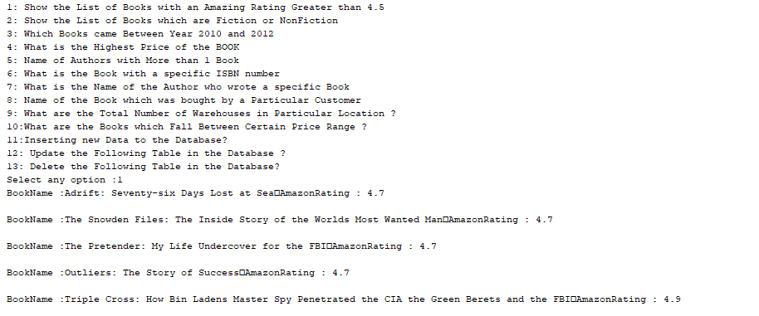**Case 1:**

**Figure 1: Case 1 Result**

**Case 2:** 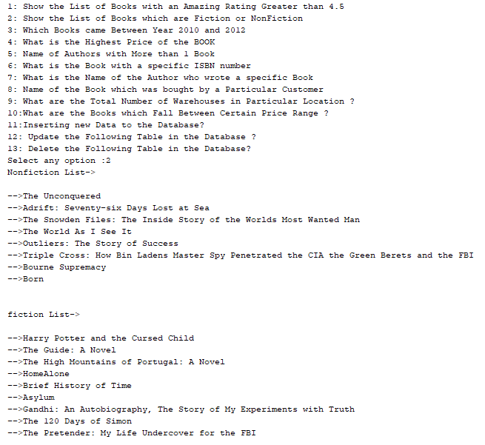

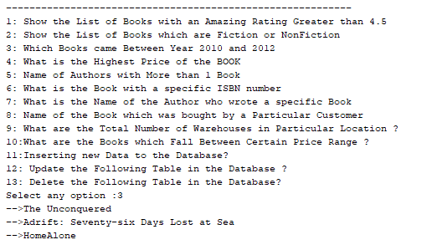**Figure 2: Case 2 Result**

**Figure 3: Case 3 Result**

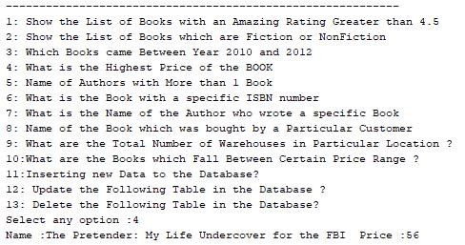

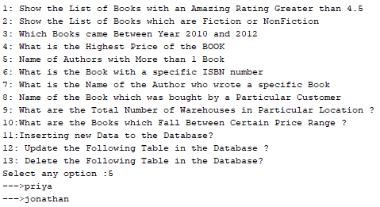**Figure 4: Case 4 Result 4**

**Figure 5: Case 5 Result 5**

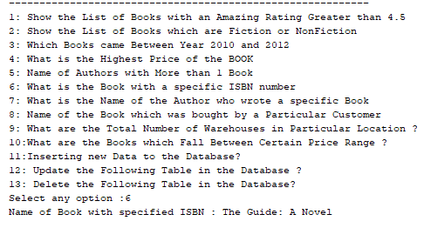

**Figure 6: Case 6 Result 6**

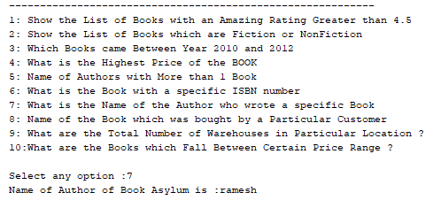

**Figure 7: Case 7 Result 7**

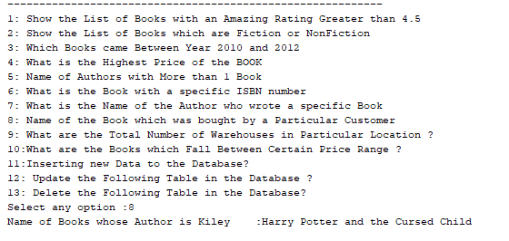

**Figure 8: Case 8 Result 8**

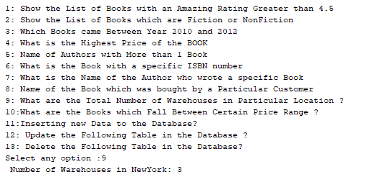

**Figure 9: Case 9 Result 9**

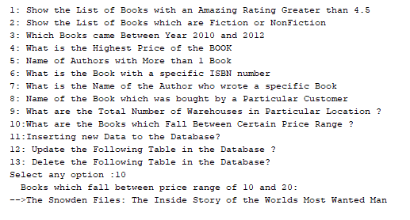

**Figure 10: Case 10 Result 10**

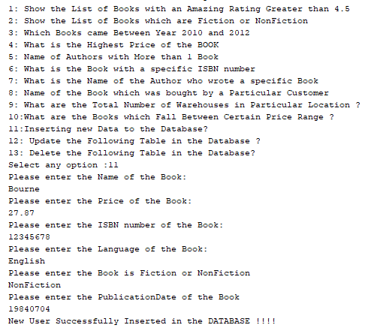**INSERTING(USER MANUALLY ENTERS) NEW DATA INTO DATABASE**

**Figure 11: Case 11 Result 11**

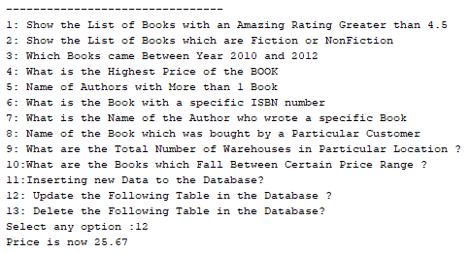**UPDATING THE TABLE IN THE DATABASE**

**Figure 12: Case 12 Result 12**

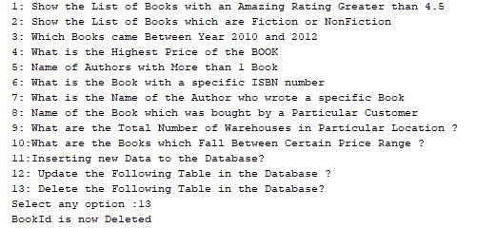**DELETING THE TABLE IN THE DATABASE**

**Figure 13: Case 13 Result 13**