**Index**

Table of Contents

1. Introduction 7

1.1 Existing System 8

1.2 Need for the new system 8

1.3 Objectives of new system 9

1.4 Problem Definition 9

1.5 Core components 10

1.6 Project Profile 11

1.7 Assumption and Constraints 12

1.8 Advantages and Limitations Of Proposed System 14

1.9 Proposed Time Line Chart ………………………………………………………………………………………………………………..15

2. Requirement Determination & Analysis 16

2.1 Requirement Determination 16

2.2 Targeted Users 17

3. System Design 18

3.1 Use Case Diagram 18

3.2 Class Diagram 19

3.3 Interaction Diagram 20

3.4 Activity Diagram 21

3.5 Data Dictionary 23

4. Development 28

4.1 Coding Standards 29

5. Agile Documentation 30

5.1 Agile Project Charter : 30

5.2 Agile Project Roadmap/Schedule : 31

5.3 Agile Project Plan : 32

5.4 Agile User Story : 33

5.5 Agile Release Plan : 34

5.6 Agile Sprint Backlog : 35

5.7 Agile Test Plan : 36

5.8 Earned-Value and Burn Chart : 37

6. Proposed Enhancements 38

7. Conclusion 39

8. Bibliography 40

Car Vengers

**1. Introduction**

• In the modern world, there is a rising population of car enthusiasts.

• This trend has sparked an increased demand for luxury and sports cars among the new generation.

• The market segment for luxury and sports cars is projected to expand significantly in the coming years, driven by the preferences of this new generation.

• Recognizing this demand, we have established Car Mania, a platform offering premium car accessories and services to cater to the needs of enthusiasts seeking luxury and sports cars.

**1.1. Existing System**

• Traditional car accessory and service sellers often prioritize volume sales over meeting customer needs.

• Consumers seeking premium car accessories face limited options, primarily from Big Brand Tire (BBT) and some reseller garages.

• The lack of an effective online platform hampers the reach and accessibility of premium car accessories and services to a broader audience, hindering potential sales growth.

• For example, BBT serves as a notable illustration of this challenge.

**1.2. Need for the New System**

• As technology evolves and user expectations shift, there's a need for a new system designed to offer a more intuitive, user-friendly interface, ensuring a seamless and enjoyable experience for both buyers and sellers of car accessories and services. This system can incorporate enhanced navigation, responsive design, and interactive features to enhance the overall user experience.

• There's a growing demand for a centralized platform exclusively featuring premium car accessories and services, catering to the needs of discerning consumers.

• The new system aims to bridge the gap between sellers and consumers in the car accessories and service industry, facilitating smoother transactions and fostering stronger connections between the two parties.

• The development of a new system can focus on streamlining processes, reducing complexities, and optimizing workflows for both sellers and buyers of car accessories and services. This may involve improvements in the listing process for sellers, implementing a more efficient search and filter mechanism for buyers, and ensuring a faster and smoother transaction process, including services for electric cars.

**1.3. Objective of the New System**

• Connectivity: Establish a seamless connection between consumers seeking high-quality car accessories and services and vendors specializing in such offerings.

• Empowerment: Provide vendors with a platform to showcase their unique car accessories and services, contributing to a vibrant car enthusiast community.

• Convenience: Offer an intuitive and user-friendly platform that streamlines the shopping experience for discerning consumers seeking car accessories and services.

• Simplify: Develop an intuitive and user-friendly platform that improves the shopping experience for conscious consumers seeking car accessories and services.

**1.4. Problem Definition**

* In the dynamic landscape of online car accessories and service sales, [Car Vengers] has identified several challenges that currently hinder the optimal user experience for both buyers and sellers. These challenges necessitate a comprehensive problem definition to guide the development of effective solutions. This website aims to bridge the gap between customers seeking car accessories and services and the availability of trustworthy, helpful, and convenient online shopping options.
* Problem: Users encounter difficulties in establishing trust and confidence in online car accessories and service transactions due to concerns about the authenticity of listings, seller credibility, and overall transparency.
* Impact: This lack of trust may discourage potential buyers from exploring the platform and hinder sellers from effectively showcasing their products and services..

**1.5. Core Components**

**1. User**

* Registration: - User can Register.
* Login: - User can Login.
* Buy Cars: - User can buy the Products.
* Sharing Products Review: - user can share the Products review to other people’s
* Logout: - User can Logout.

**2. Admin**

* + Admin Registration: - Admin can Register.
  + Admin Login: Admin can login.
  + Manage Category: - Admin can Manage Categories of Accessories .
  + Manage Items: - Admin can Manage Particular Accessories.
  + Manage Orders: - Admin can Manage Orders.
  + Manage Report: - Admin can Manage Report of items.
  + View Confirmation: - Admin can view the Confirmation of the customer for Online Payments.
  + View Reviews: Admin can view the user review for providing better products and services.

**1.6. Project Profile**

|  |  |
| --- | --- |
| Project Title | Car Vengers |
| Components/Module | Admin  User |
| Institute Name | LJ Institute of Computer Application |
| Duration | 4 Months |
| Project Internal Guide | Prof Jayshree dasa |
| Front End | Laravel |
| Back End | PHP |
| Operating System | Windows 11 |
| Team Member | IMS-18Urmil Patel  IET-16 Neel Gorana  ICA-B-27 Meet Soni |

**1.7. Assumptions and Constraints**

**Assumptions:**

**• User Demand for Online Car Accessories and Service Transactions: It is assumed that there is a significant and sustained demand for purchasing car accessories and booking car services through online platforms. Users prefer the convenience and accessibility offered by digital channels for their automotive accessory purchases and service bookings.**

**• User Internet Access: Users have access to stable internet connections and devices capable of browsing the website for car accessories and service bookings.**

**• User Trust: It is assumed that users are willing to engage in online transactions for car accessories and services if the platform ensures robust security measures. Trust in the form of secure payments, data protection, and transparent communication is considered crucial.**

**• Secure Transactions: Users assume that their personal and financial information will be handled securely during the checkout process for car accessories and service bookings.**

**Constraints:**

**• Technological Limitations: The functionality and features of the website for car accessories and service bookings are constrained by the technologies used in its development. This might limit the user experience, speed, and responsiveness of the platform.**

**• Data Accuracy: The accuracy of product information for car accessories and service offerings depends on the quality of data provided by suppliers, which might not always be up-to-date or reliable.**

**• Mobile Responsiveness: The website needs to be optimized for mobile devices, given that a significant portion of users might access it through smartphones and tablets for browsing car accessories and booking services.**

**• Site Performance: The website needs to maintain good performance even during periods of high traffic to prevent slow loading times and crashes, ensuring a smooth browsing and booking experience for users.**

**• User Experience: The design and navigation of the website should be user-friendly and intuitive, catering to users with varying levels of technical expertise who are browsing for car accessories and booking services.**

**1.8. Advantages and Limitations of the Proposed System**

**Advantages:**

**• User Experience: The proposed system aims to offer an intuitive and user-friendly interface, enhancing the overall user experience for both buyers and sellers in the car accessories and service industry. Advanced search options, real-time communication tools, and innovative features contribute to a more engaging platform.**

**• Trust and transparency: By addressing concerns related to authenticity of products, seller credibility, and transparency in service provision, the proposed system fosters trust among users. Clear and detailed listings of car accessories, coupled with transparent service offerings and secure transactions, contribute to a more trustworthy online environment.**

**• Feedback and Reviews: Customers can provide feedback and leave reviews about car accessories and service providers, aiding others in making informed decisions and providing valuable insights to the business.**

**Limitations:**

**• Security Concerns: The platform requires robust security measures to safeguard user data and financial information from cyber threats, particularly important in the car accessories and service sector.**

**• Dependence on Internet: The system relies on stable internet connectivity, and any disruptions could hinder the browsing and purchasing experience for users seeking car accessories or services.**

**• Product Authenticity: Ensuring the authenticity and quality of car accessories, as well as the reliability of service providers, may pose challenges, especially if the business relies on third-party suppliers for its offerings.**

**1.9. Proposed Time Line Chart**

|  |  |  |  |  |  |  |  |  |  |  |  |  |  |  |  |  |
| --- | --- | --- | --- | --- | --- | --- | --- | --- | --- | --- | --- | --- | --- | --- | --- | --- |
| **Task** | **Weekly**  **January(2024) February(2024) March(2024) April (2024)** | | | | | | | | | | | | | | | |
|  | **1** | **2** | **3** | **4** | **5** | **6** | **7** | **8** | **9** | **10** | **11** | **12** | **13** | **14** | **15** | **16** |
| **Introduction** |  |  |  |  |  |  |  |  |  |  |  |  |  |  |  |  |
| **Problem Definition** |  |  |  |  |  |  |  |  |  |  |  |  |  |  |  |  |
| **Objective Of the New System** |  |  |  |  |  |  |  |  |  |  |  |  |  |  |  |  |
| **Core Components** |  |  |  |  |  |  |  |  |  |  |  |  |  |  |  |  |
| **Project Profile** |  |  |  |  |  |  |  |  |  |  |  |  |  |  |  |  |
| **Advantages And Limitation** |  |  |  |  |  |  |  |  |  |  |  |  |  |  |  |  |
| **Time Line Chart** |  |  |  |  |  |  |  |  |  |  |  |  |  |  |  |  |
| **Requirement Determination** |  |  |  |  |  |  |  |  |  |  |  |  |  |  |  |  |
| **Requirement Specification** |  |  |  |  |  |  |  |  |  |  |  |  |  |  |  |  |
| **Use Case Diagram** |  |  |  |  |  |  |  |  |  |  |  |  |  |  |  |  |
| **Class Diagram** |  |  |  |  |  |  |  |  |  |  |  |  |  |  |  |  |
| **Activity Diagram** |  |  |  |  |  |  |  |  |  |  |  |  |  |  |  |  |
| **Data Dictionary** |  |  |  |  |  |  |  |  |  |  |  |  |  |  |  |  |
| **User Interface Design** |  |  |  |  |  |  |  |  |  |  |  |  |  |  |  |  |
| **Coding Standards** |  |  |  |  |  |  |  |  |  |  |  |  |  |  |  |  |
| **Test Case** |  |  |  |  |  |  |  |  |  |  |  |  |  |  |  |  |
| **Proposed Enhancements** |  |  |  |  |  |  |  |  |  |  |  |  |  |  |  |  |
| **Conclusion** |  |  |  |  |  |  |  |  |  |  |  |  |  |  |  |  |
| **Bibliography** |  |  |  |  |  |  |  |  |  |  |  |  |  |  |  |  |
| **Project Coding** |  |  |  |  |  |  |  |  |  |  |  |  |  |  |  |  |

**2.Requirement Determination & Analysis**

**2.1. Requirement Determination**

* **Hardware Requirement**
  + **Client-Sonie Tools**
    - Processor: Intel ®i5 (Minimum)
    - RAM: 8GB
    - Hard Disk: 512 GB
  + **Server-Sonie Tools**
    - Processor: Intel ®i5 (minimum)
    - RAM: 8GB
    - Hard Disk: 1 TB Hard disk space (minimum)
* **Software Requirement**
* Operating System: Windows
* Back-end: Xampp
* Database-Technology: SQL[PHP My Admin]

**2.2. Targeted Users**

* **Our Targeted Audience are**:

- Individuals in need of car accessories for personal vehicles.

- Tourists seeking car service during their stay.

- Businesses requiring car service for their employees or clients.

**3.System Design**

**3.1 Use Case Diagram**

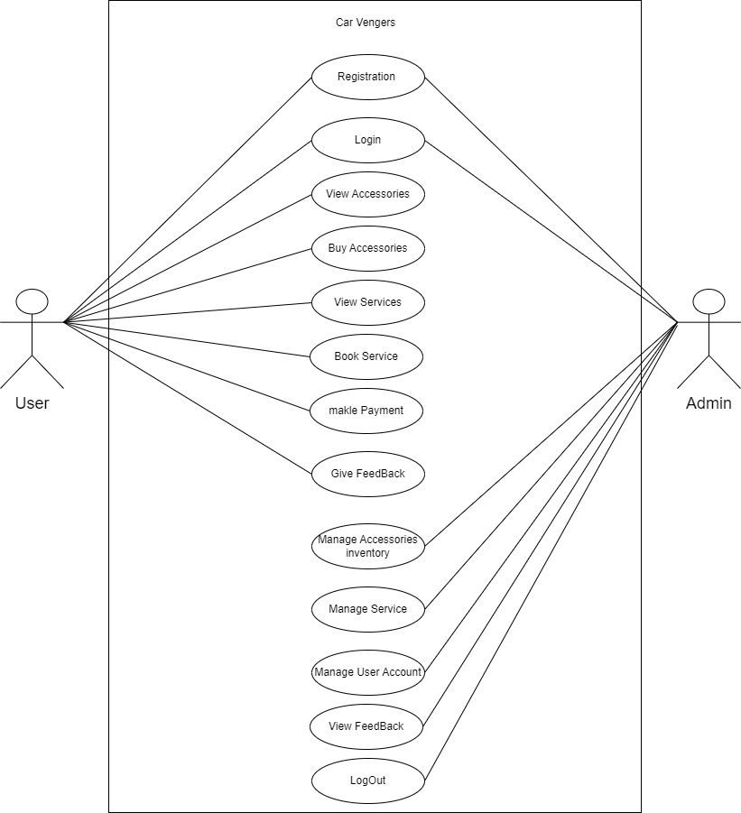

**3.2 Class Diagram**

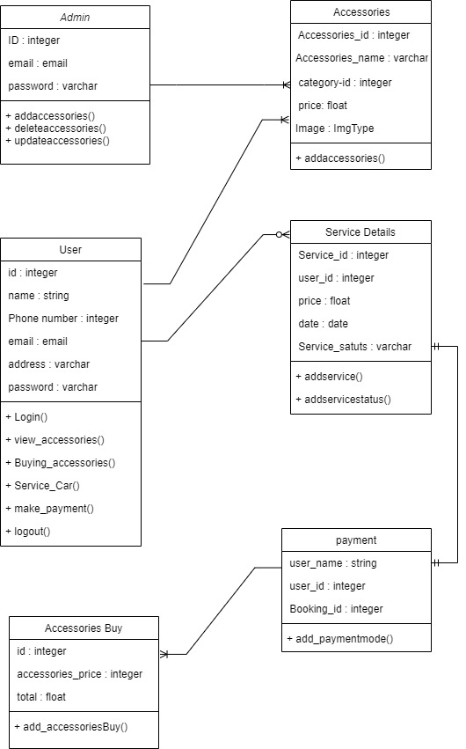

**3.3 Sequence Diagram**

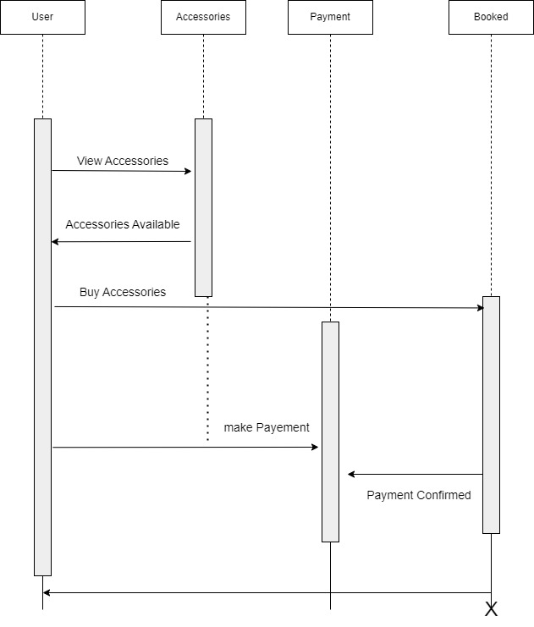

**3.4 Admin Activity**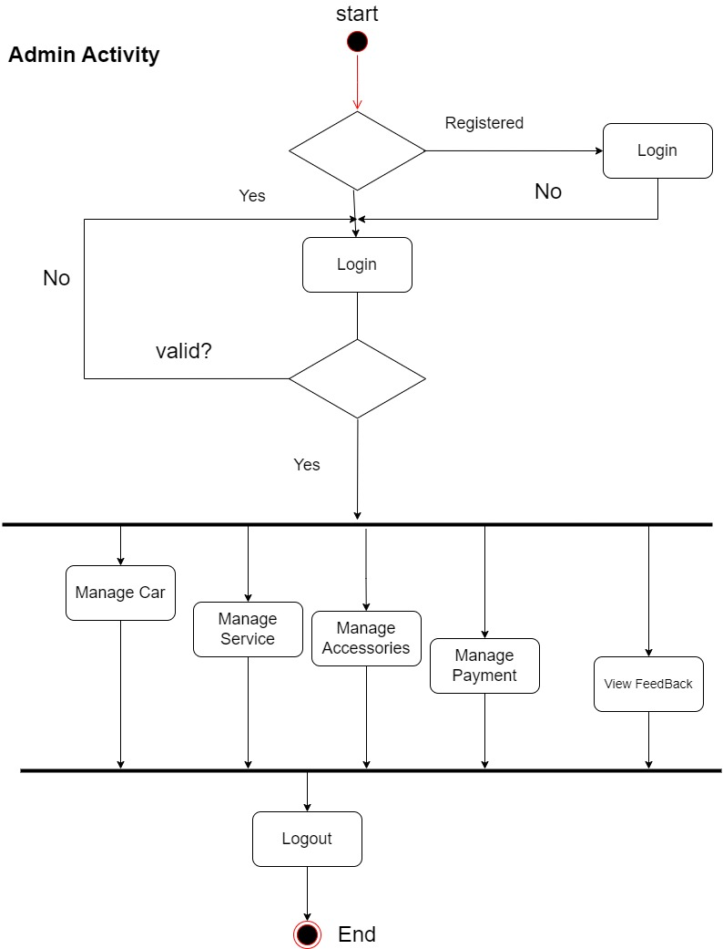

**3.4.2 User Activity**

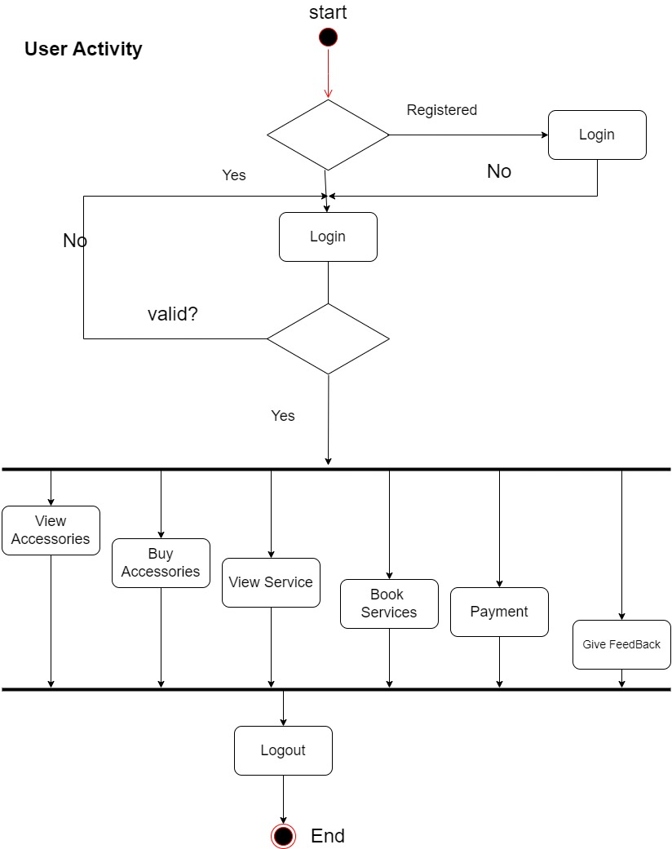

**3.5 Data Dictonanry**

**User Table**

|  |  |  |  |  |
| --- | --- | --- | --- | --- |
| Sr. no | Name | DataType | Constraint | Description |
| 1 | User_id | integer(10) | Primary key | To store the user id |
| 2 | User_name | Varchar(10) | Not null | To store the user name |
| 3 | Email | Varchar(50) | Not null | To store the user email |
| 4 | Phone | bigInteger(10) | Not null | To store the Contact |
| 4 | Password | varchar(10) | Not null | To store the password |

**Admin Table**

|  |  |  |  |  |
| --- | --- | --- | --- | --- |
| Sr. no | Name | DataType | Constraint | Description |
| 1 | Admin_id | integer(10) | Primary key | To store the admin id |
| 2 | Admin _name | Varchar(10) | Not null | To store the admin name |
| 3 | Email | Varchar(10) | Not null | To store the email |
| 4 | Password | varchar(10) | Not null | To store the password |

**Accessories Table**

|  |  |  |  |  |
| --- | --- | --- | --- | --- |
| Sr. no | Name | DataType | Constraint | Description |
| 1 | Accessories_ id | integer | Primary key | To store the Accessories id |
| 2 | Accessories Name | Varchar(30) | Not null | To store the Accessories Name |
| 3 | image | Image | Not null | To store the Accessories image |
| 4 | Price | Integer (20) | Not null | To store the Price name |
| 5 | Type | varchar(10) | Not null | To store the type |
| 6 | Year | integer(20) | Not null | To store the year of Accessories |

**Contact_Us Table**

|  |  |  |  |  |
| --- | --- | --- | --- | --- |
| Sr. no | Name | DataType | Constraint | Description |
| 1 | id | integer | Primary key | To store the Resort id |
| 2 | Name | Varchar(30) | Not null | To store the Name |
| 3 | Email | nvarchar(15) | Not null | To store the Email |
| 4 | Subject | Varchar(20) | Not null | To store the Subject |
| 5 | Message | Varchar(20) | Not null | To store the Message |

**Checkout_Page Table**

|  |  |  |  |  |
| --- | --- | --- | --- | --- |
| Sr. no | Name | DataType | Constraint | Description |
| 1 | id | Integer | Primary key | To store the Booking id |
| 2 | Yourname | varchar (10) | Not null | To store the name |
| 3 | Phone | Integer(10) | Not null | To store the phone |
| 4 | Email | Varchar(50) | Not null | To store the Email |
| 5 | Area | varchar (20) | Not null | To store area |
| 6 | City | Varchar(20) | Not null | City |
| 7 | State | Varchar(20) | Not null | State |
| 8 | Zip | Varchar(20) | Not Null | zip code |
| 9 | Name | Varchar(20) | Not Null | Name |
| 10 | Quantity | Integer(10) | Not Null | Quantity |
| 11 | Price | bigInteger(20) | Not Null | Price |
| 12 | Total | bigInteger(20) | Not Null | Total |

**Service Table**

|  |  |  |  |  |
| --- | --- | --- | --- | --- |
| Sr. no | Field Name | DataType | Constraint | Description |
| 1 | id | Integer | Primary Key | To store the id |
| 2 | Fname | Varchar(50) | Not null | To store Firstname |
| 3 | Lname | Varchar(50) | Not null | To store Lastname |
| 4 | Email | Varchar(50) | Not null | To store the email |
| 5 | Number | Varchar(50) | Not null | To store number |
| 6 | Model | Varchar(20) | Not null | Model of car |
| 7 | Company | Varchar(20) | Not null | Company of car |
| 8 | Pdate | Date | Not null | Pickup date |
| 9 | Ptime | Date | Not null | Pickup time |
| 10 | Service_Pkg | Varchar(20) | Not null | Service package |

**4.Development**

**­**

**4.1 Coding Standards**

● **Use a consistent coding style**: This will make your code easier to read and maintain. Choose a coding style that is clear and easy to understand, and stick to it throughout your codebase. ­-

● **Keep your code modular**: Break your code into smaller, reusable modules that can be easily tested and maintained. This will make it easier to add new features and fix bugs.

● **Use meaningful variable and function names**: Choose descriptive names for your variables and functions that clearly indicate their purpose. This will make your code more readable and easier to understand.

● **Use comments**: Use comments to explain what your code does and why it does it. This will make it easier for other developers to understand your code and make changes to it.

● **Follow best practices for security**: Make sure you follow best practices for security, such as sanitizing user input to prevent SQL injection attacks and using HTTPS to protect user data.

● **Optimize your code for performance**: Make sure your code is optimized for performance, especially for pages that will be accessed frequently. This can include techniques such as caching, minifying CSS and JavaScript, and reducing HTTP requests.

● **Test your code thoroughly**: Test your code thoroughly to ensure it works as expected and that there are no bugs. This can include unit tests, integration tests, and user acceptance testing.

**5.Agile Documentation**

**5.1 Agile Project Charter :**

|  |  |
| --- | --- |
| General Project Information | |
| Project Name | Car Mania |
| Project Champion | Urmil Kachhadiya,Meet Soni,Neel Gorana |
| Project Sponsor | LJ Institute of Computer Application |
| Project Manager | Prof. Jayshree dasa |
| Stakeholders | Admin,User |
| Expected Start Date | 25/01/2024 |
| Expected Completion Date | 20/04/2024 |

|  |  |
| --- | --- |
| Project Details | |
| Mission | We continuously innovate to be the best Car mania for our admin and user. |
| Vision* | Our vision is to create a comprehensive and integrated school management system that empowers educators to deliver high-quality education and fosters a culture of learning among students. We aim to provide a platform that streamlines administrative tasks, enhances communication and collaboration between teachers, students, and parents, and enables data-driven decision-making to support student success. Our goal is to become the go-to solution for schools seeking to leverage technology to enhance teaching and learning outcomes, and to create a positive impact on education at a global scale. |
| Scope* | The scope of a school management system refers to the specific features, functions, and capabilities that the system will include to fulfill its intended purpose. The scope defines the boundaries of the system and outlines what it will and will not do. |
| Date | 25/01/2024 |

**5.2 Agile Project Roadmap/Schedule :**

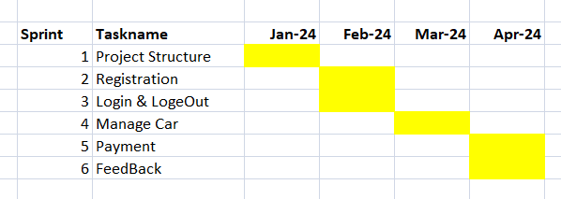

**5.3 Agile Project Plan:**

|  |  |  |  |  |
| --- | --- | --- | --- | --- |
| **Task Name** | **Duration** | **Start** | **Finish** | **Status** |
| **Sprint#1 : Project Structure** | 9d | 25/01/2024 | 02/02/2024 | Completed |
| UI Designing | 4d | 25/01/2024 | 28/01/2024 | Completed |
| Database Management | 5d | 29/01/2024 | 04/02/2024 | Completed |
| **Sprint#2 : Registration** | 5d | 02/02/2024 | 08/02/2024 | Completed |
| Admin Registration  User Registration | 5d | 02/02/2024 | 08/02/2024 | Completed |
| **Sprint#3 : Login and Logout** | 2d | 04/03/2024 | 07/03/2024 | Completed |
| Admin Login  User Login | 2d | 05/03/2024 | 07/03/2024 | Completed |
| **Sprint#4 : Forget Password** | 2d | 07/03/2024 | 08/03/2024 | Completed |
| Admin changes Password  User change Password | 2d | 07/03/2024 | 08/03/2024 | Completed |
| **Sprint#5:Manage(Admin)** | 9d | 09/03/2024 | 17/03/2024 | Completed |
| Add, Update, View, Delete | 9d | 09/03/2024 | 17/03/2024 | Completed |
| **Sprint#6 : Manage(User)** | 5d | 21/03/2024 | 25/03/2024 | Completed |
| View Accessories | 2d | 21/03/2024 | 22/03/2024 | Completed |
| View Accessories Details | 3d | 23/03/2024 | 25/03/2024 | Completed |
| **Sprint#7 : Profile** | 6d | 05/03/2024 | 10/03/2024 | Completed |
| Admin Profile | 2d | 05/03/2024 | 07/03/2024 | Completed |
| User Profile | 4d | 05/03/2024 | 09/03/2024 | Completed |
| **Sprint#8 : Payment** | 1d | 13/03/2024 | 14/03/2024 | Completed |
| View Payment | 1d | 13/03/2024 | 14/03/2024 | Completed |

**5.4 Agile Project Plan:**

|  |  |  |  |
| --- | --- | --- | --- |
| **1** | Admin | Manage Login Module | Ensure that validate user can join |
| **2** | Admin | Manage Accessories | Insert, Update Delete and View the accessories |

**5.5 Agile Release Plan:**

|  |  |  |  |  |
| --- | --- | --- | --- | --- |
| Task Name | **Duration** | **Start** | **Finish** | **Release Date** |
| **Sprint#1: Project Structure** | 9d | 25/01/2024 | 02/02/2024 | 01/02/2024 |
| UI Designing | 4d | 29/01/2024 | 01/02/2024 | 04/02/2024 |
| Database Management | 3d | 02/01/2024 | 04/02/2024 | 04/02/2024 |
| **Sprint#2 : Registration** | 5d | 10/01/2024 | 28/01/2024 | 28/02/2024 |
| Admin Registration  User Registration | 5d | 24/02/2024 | 28/02/2024 | 28/02/2024 |
| **Sprint#3 : Login and Logout** | 4d | 04/02/2024 | 07/02/2024 | 07/03/2024 |
| Admin Login  User Login | 2d | 04/02/2024 | 05/02/2024 | 07/03/2024 |
| Admin Login | 3d | 05/02/2024 | 07/02/2024 | 07/03/2024 |
| **Sprint#4: Manage accessories** | 9d | 09/02/2024 | 17/02/2024 | 17/03/2024 |
| Add, Update, View and Delete | 9d | 09/02/2024 | 17/02/2024 | 17/03/2024 |
| **Sprint#5 : Profile** | 5d | 21/03/2024 | 25/03/2024 | 25/03/2024 |
| View Admin profile | 2d | 21/03/2024 | 22/03/2024 | 25/03/2024 |
| **Sprint#6: Payment** | 6d | 25/03/2024 | 27/03/2024 | 28/03/2024 |
| View Payment | 2d | 25/03/2024 | 26/03/2024 | 28/03/2024 |

**5.6 Agile Sprint Backlog:**

|  |  |  |  |  |  |
| --- | --- | --- | --- | --- | --- |
| **Task Name** | **Story** | **Sprint Ready** | **Priority** | **Status** | **Story Point** |
| **Sprint#1: Project Structure** | Yes | Yes | High | Completed | 3 |
| UL Designing | Yes | Yes | High | Completed | 2 |
| Database Management | Yes | Yes | High | Completed | 2 |
| **Sprint#2 : Registration** | Yes | Yes | High | Completed | 2 |
| User Registration  Admin Registration | Yes | Yes | High | Completed | 1 |
| **Sprint#3 : Login & Logout** | Yes | Yes | High | Completed | 4 |
| User Login | Yes | Yes | High | Completed | 4 |
| Admin Login | Yes | Yes | High | Completed | 4 |
| **Sprint#4 : Manage accessories** | Yes | Yes | High | Completed | 4 |
| Add, Update, View and Delete | Yes | Yes | High | Completed | 4 |

|  |  |  |  |  |  |
| --- | --- | --- | --- | --- | --- |
| **Sprint#5: profile** | Yes | Yes | Medium | Completed | 4 |
| View Admin and User profile | Yes | Yes | High | Completed | 4 |
| Add and Delete from cart | Yes | Yes | Medium | Completed | 2 |
| **Sprint#6 : Contacts** | Yes | Yes | Low | Completed | 1 |
| Contact to admin | Yes | Yes | Low | Completed | 1 |

**5.7 Agile Test Plan:**

|  |  |  |  |  |  |
| --- | --- | --- | --- | --- | --- |
| **Test Case ID : 1** | | | **Test Case Name : User Login** | | |
| **Designed by** :Neel Gorana | | | **Design Date :- 02/02/2024** | | |
| **Module Name : User Login** | | | **Sub Module Name : Login** | | |
| **Executed by : Neel Gorana** | | | **Execution Date : 25/03/2024** | | |
| **Brief Description : User Login**  **email: neel @gmail.com** | | | **Test Priority (Low/Medium/High) : High** | | |
| **Pre-Conditions: User Must Registered** | | | **Correct Username & Password.** | | |
| **Dependencies :** | | | None | | |
| **Test Case ID : 2** | | | **Test Case Name : Admin Login** | | |
| **Designed by** :Neel Gorana | | | **Design Date :- 12/02/2024** | | |
| **Module Name :admin Login** | | | **Sub Module Name : Login** | | |
| **Executed by : Neel Gorana** | | | **Execution Date : 25/03/2024** | | |
| **Brief Description : Admin Login**  **email: meet@gmail.com** | | | **Test Priority (Low/Medium/High) : High** | | |
| **Pre-Conditions: Admin Must Registered** | | | **Correct Username & Password.** | | |
| **Dependencies :** | | | None | | |
| **Test Case ID : 3** | | | **Test Case Name : Accessories** | | |
| **Designed by** :Neel Gorana | | | **Design Date :- 22/02/2024** | | |
| **Module Name : Accessories added** | | | **Sub Module Name : Accessories** | | |
| **Executed by : Urmil Patel** | | | **Execution Date : 25/03/2024** | | |
| **Brief Description : Accessories added to admin Side and User side** | | | **Test Priority (Low/Medium/High) : High** | | |
| **Pre-Conditions: Admin Must Registered** | | | **Correct Username & Password.** | | |
| **Dependencies :** | | | None | | |
| **Test Case ID : 4** | | | **Test Case Name : Checkout Page** | | |
| **Designed by** :Neel Gorana | | | **Design Date :- 02/03/2024** | | |
| **Module Name : Checkout Page** | | | **Sub Module Name : Checkout** | | |
| **Executed by : Neel Gorana** | | | **Execution Date : 25/03/2024** | | |
| **Brief Description : Checkout Page Details** | | | **Test Priority (Low/Medium/High) : High** | | |
| **Pre-Conditions: User Must Registered** | | | **Correct Username & Password.** | | |
| **Dependencies :** | | | None | | |

**5.8 Earned-Value and Burn Chart:**

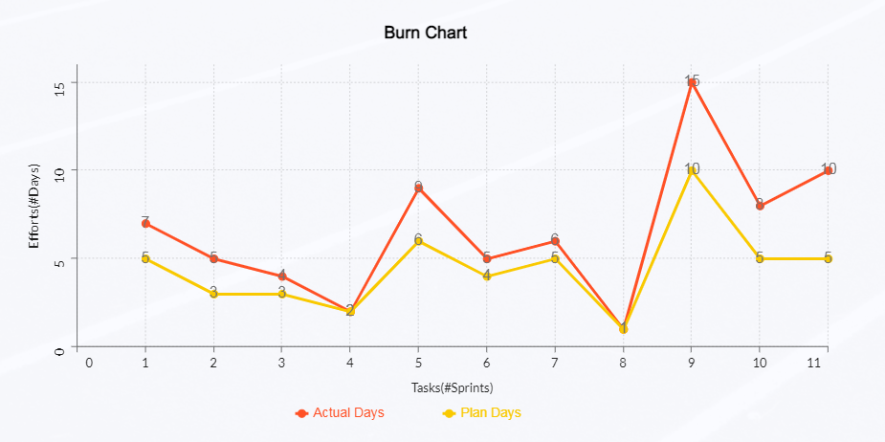

**6.Proposed Enhancements**

Proposed enhancements for Car Venger’s include for personalized product recommendations, enhancing seller verification processes to bolster trust, implementing real-time chat support for instant assistance, and introducing interactive for immersive product experiences. Additionally, incorporating admin-generated content features like photo galleries and reviews can enrich the platform's engagement. These enhancements aim to solidify Car Venger’s position as the go-to destination for luxury car enthusiasts, driving sustained growth and satisfaction.

**7.Conclusion**

In conclusion, Car Venger’s aims to revolutionize the car accessory and service industry by addressing existing challenges and meeting the evolving needs of car enthusiasts. Through a user-centric approach and innovative technology, the platform strives to enhance connectivity between buyers and sellers, empower vendors, and provide unparalleled convenience for consumers. By prioritizing trust, transparency, and user experience, Car Venger’s seeks to establish itself as the premier destination for premium car accessories and services, ensuring a seamless and enjoyable experience for all stakeholders in the automotive community.

**8.Bibliography**

* [**https://AutoFurnish.com**](https://AutoFurnish.com)
* [**https://CarHatke.com**](https://CarHatke.com)