**Infrastructure**

Our plant is one of the largest peanut processing plant in Saurashtra Region. With a daily production capacity of over 50 Metric Tonne, it covers an area of 4500 Sq. meter.

The raw material that comes in is firstly cleaned and then sorted and graded as per requirements. We have fully automatic production machines as well as skilled manpower to enhance the production. Our company complies with stringent food safety regulations and holds ISO 22000:2018 certification. The key features of our infrastructure that ensure the delivery of fresh, high-quality products include:

* Cutting-edge technology to guarantee top quality
* Rigorous hygiene standards maintained
* Efficient coordination of all processes

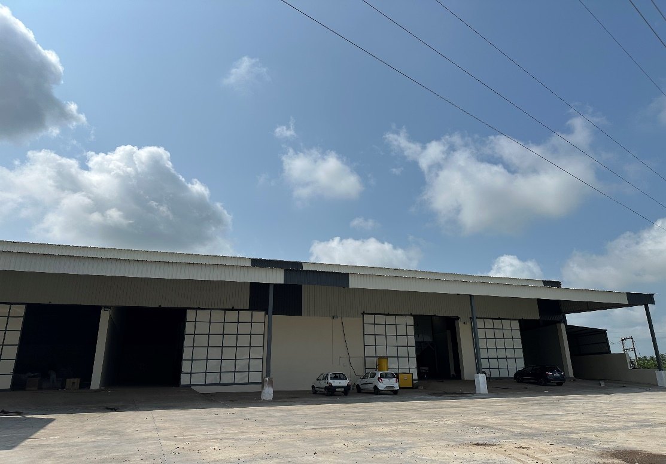

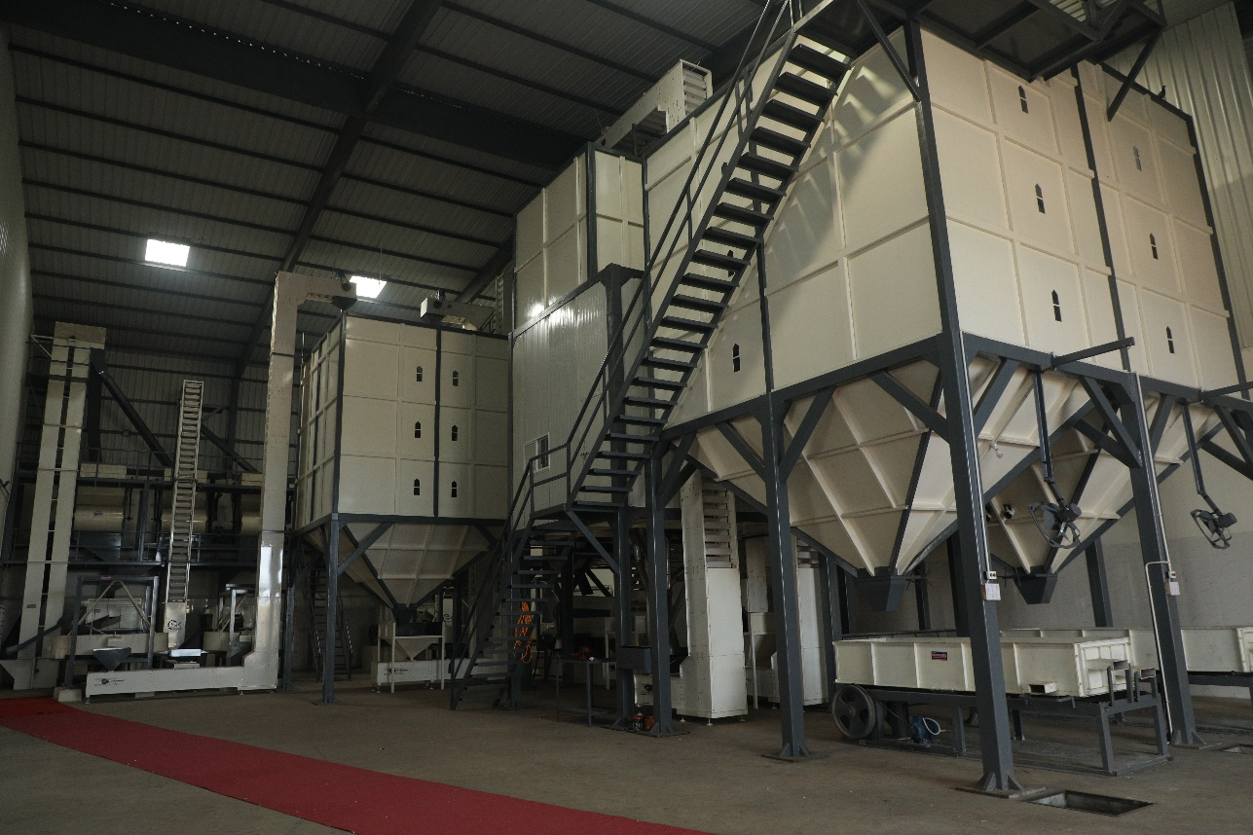

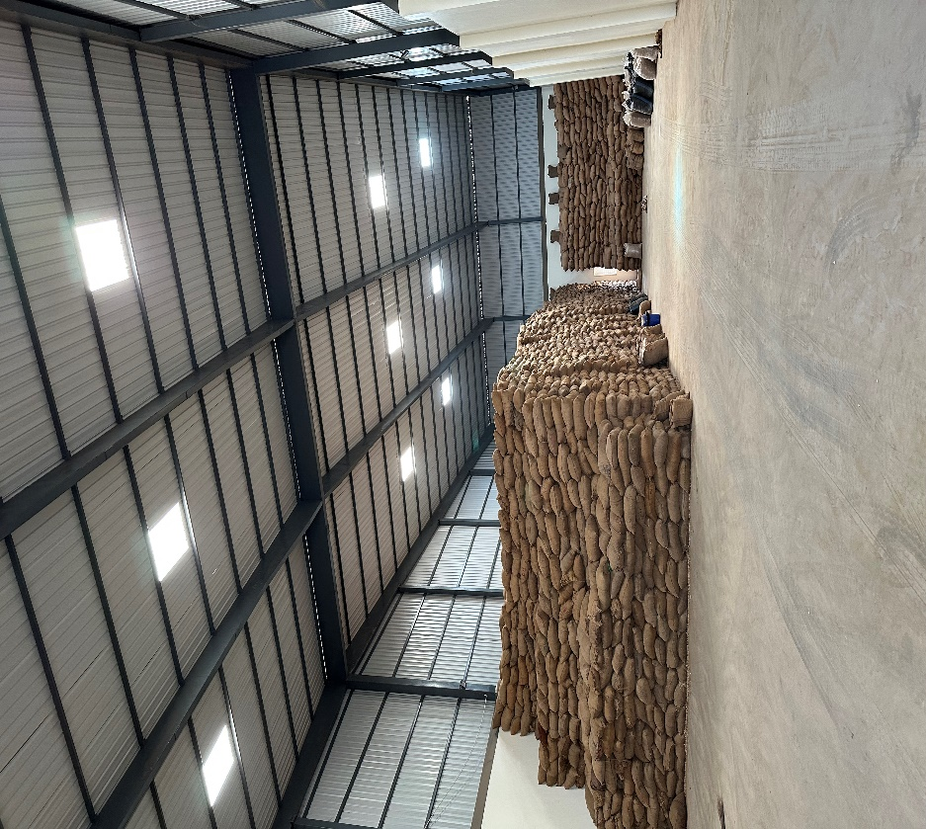

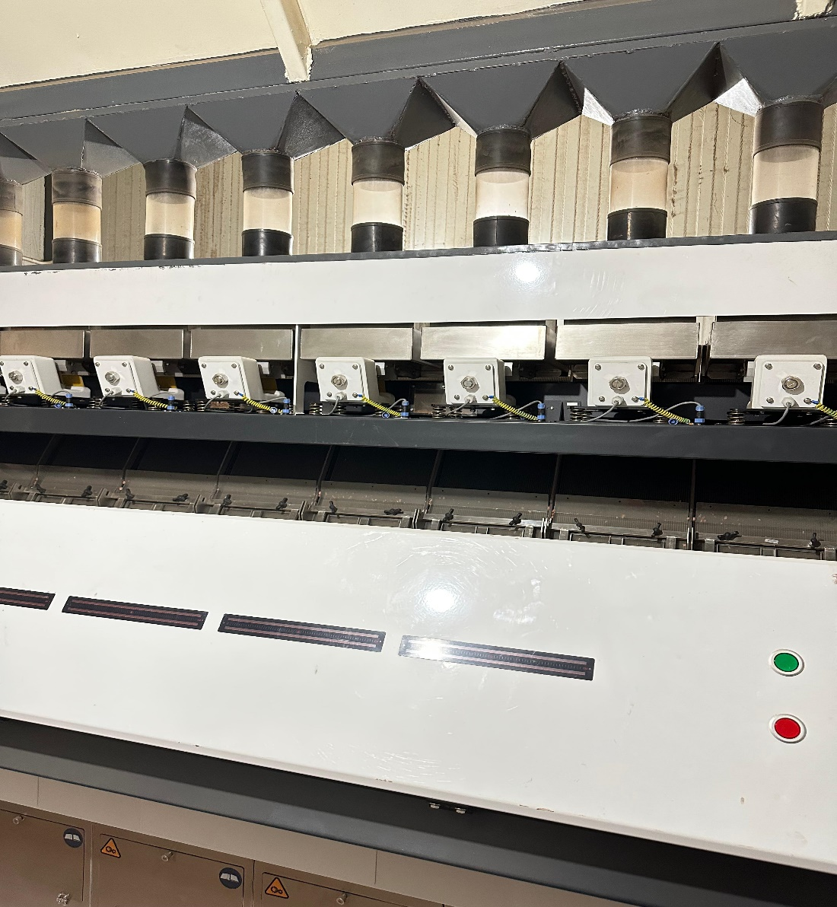

**Products**

1) Peanuts

* Java Peanuts

Counts per Ounce – 50/60 60/70 70/80 80/90 120/140 140/160

Moisture – 8% max

Foreign matter – 0.5% max

Packaging – Jute bag, PP bag (As per Customer Requirement)

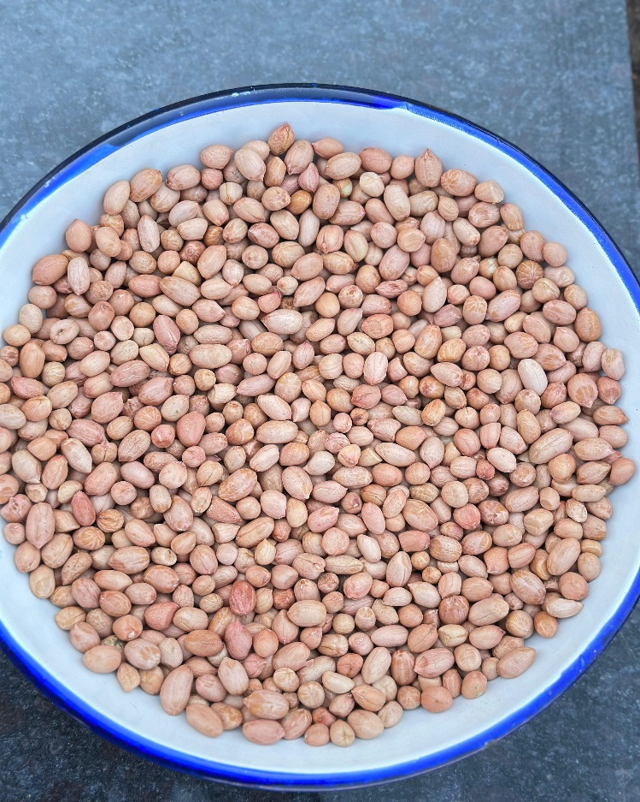

* TJ PEANUTS

Counts per Ounce – 50/60 60/70 70/80 80/90 90/100

Moisture – 8% max

Foreign matter – 0.5% max

Packaging – Jute bag, PP bags (as per customer requirement)

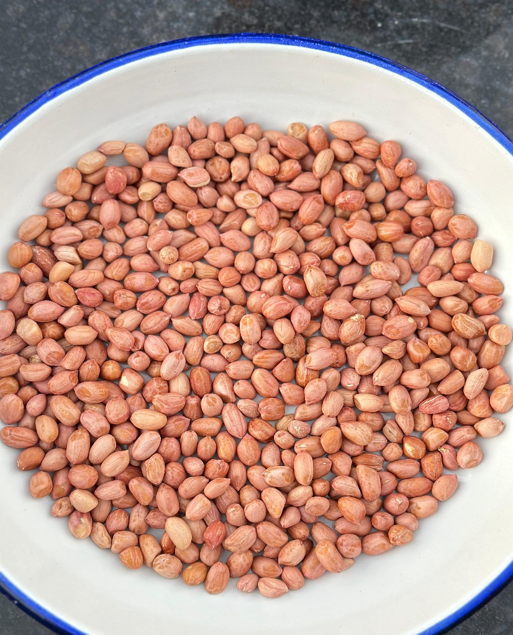

Bold Peanuts

Counts per Ounce – 38/42 40/50 50/60 60/70

Moisture – 8% max

Foreign matter – 0.5% max

Packaging – Jute bag, PP bags (as per customer requirement)

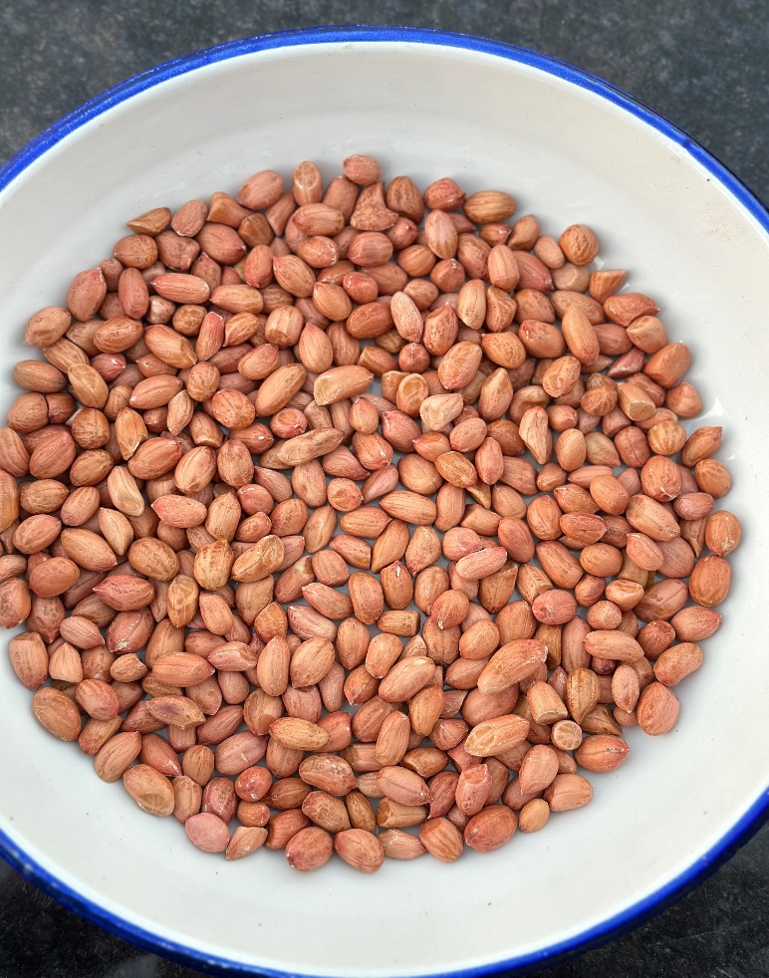

2) Sesame Seeds

Natural Sesame seeds

|  |
| --- |
| Oil Percentage – 40 to 50% |
| Physical Purity - Up to 99.99%  Moisture – 5% max  Packaging – Multi layer PP bag (as per customer Requirement) |  |  |

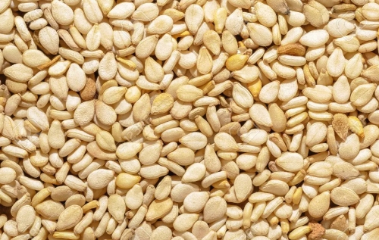

|  |
| --- |
| Black Sesame Seeds |
|  |
| Oil Content – 40 to 50% |
|  |  |  |
| Physical Purity - Up to 99.99%  Moisture – 5% max  Packaging – Multi layer PP bag (as per customer Requirement) |  |  |

Hulled Sesame Seeds

Oil content – 48 to 52%

Physical Purity - Up to 99.99%

Moisture – 5% max

Packaging – Multi layer PP bag (as per customer requirement)

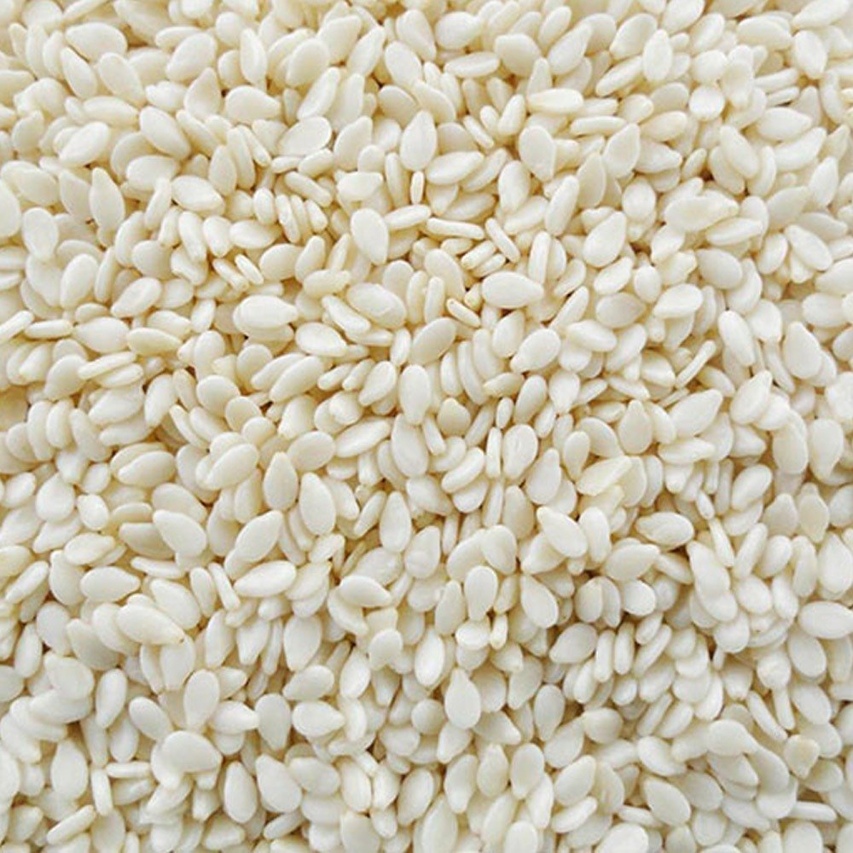

Brown Chickpeas

Origin - India

Impurity – 1% max

Packaging – 25 & 50 Kgs PP bag

Type – Machine cleaned

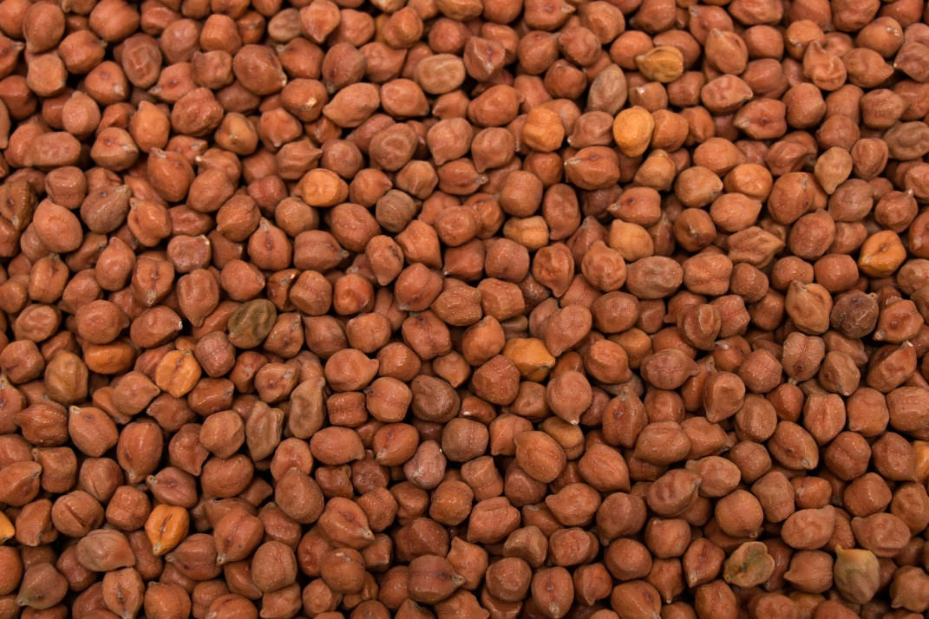

Roasted grams

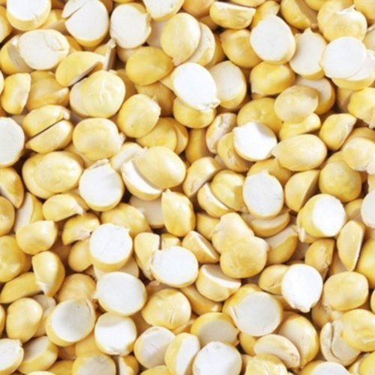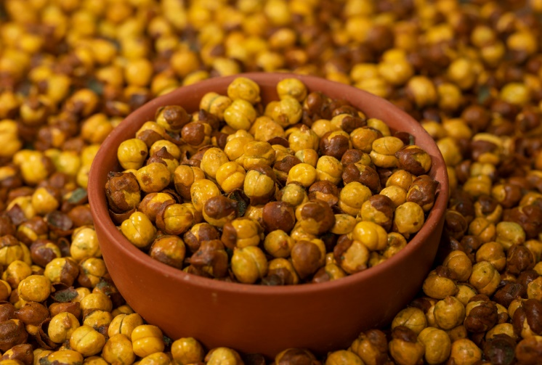

Quality – With skin & Without Skin

Type –Whole and Split

Packaging – 20,30 KGS PP BAG (As per customer requirement)

About Us

A ONE INDUSTRIES was established in the year 1998 with aim to deliver best quality products to its customers.

CERTIFICATES





CONTACT US

Mr. Deep Gor – 9408736514

Email id – aoneind1248@gmail.com