Azure ict – solution **OrderItem**

Publishing a .NET Core Microservice in Kubernetes using Azure

1. Create a ASP.NET Core Web API Project in VS 2019

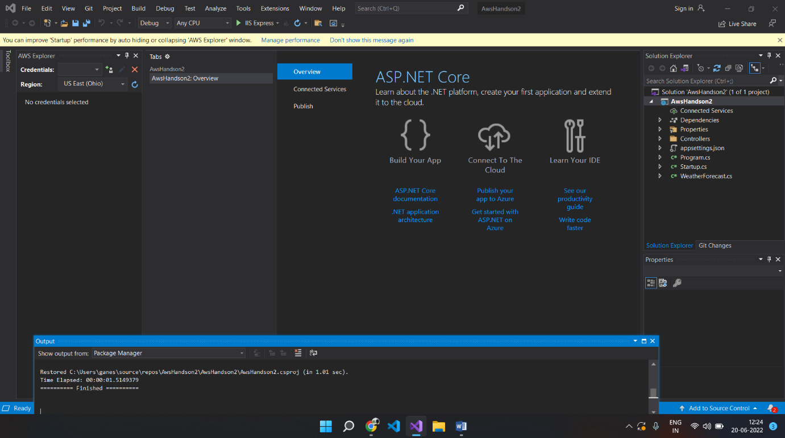

1. Add a new controller in the solution explorer named “ValuesController” and create a HTTPGET method which will return list of string.

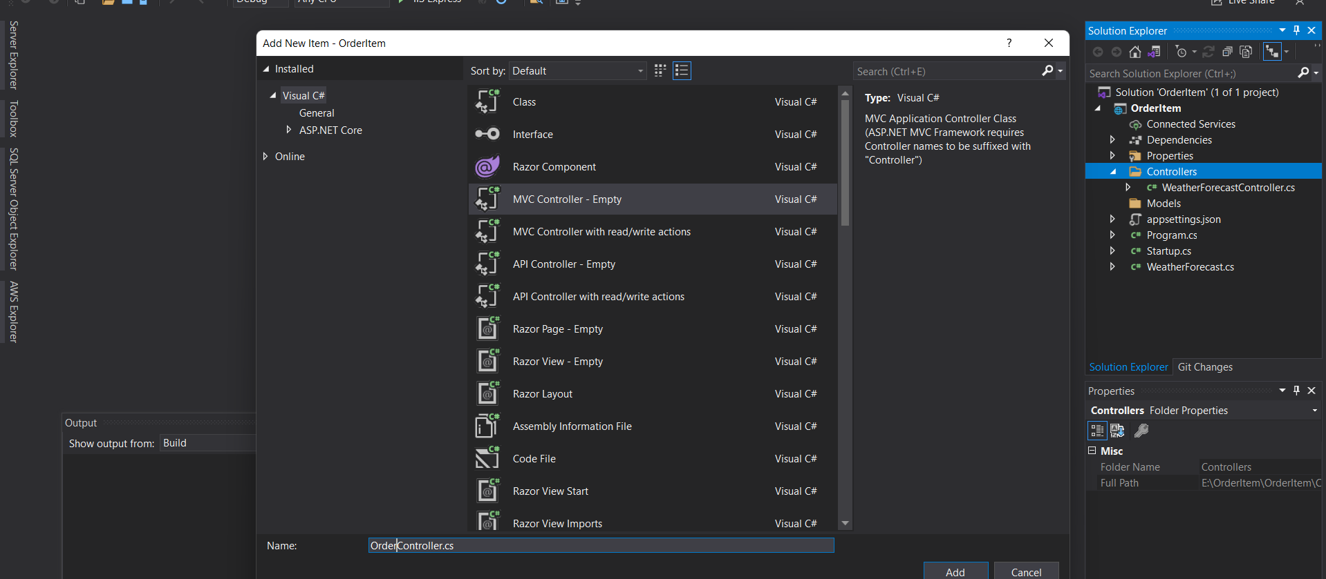

1. Create container registry in Azure

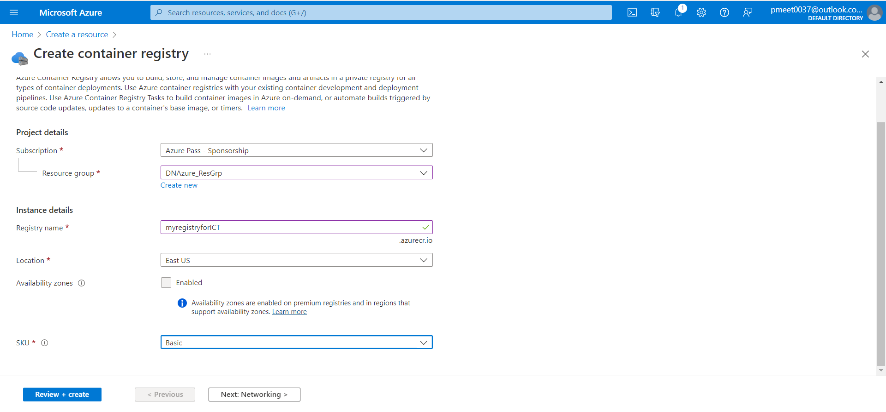

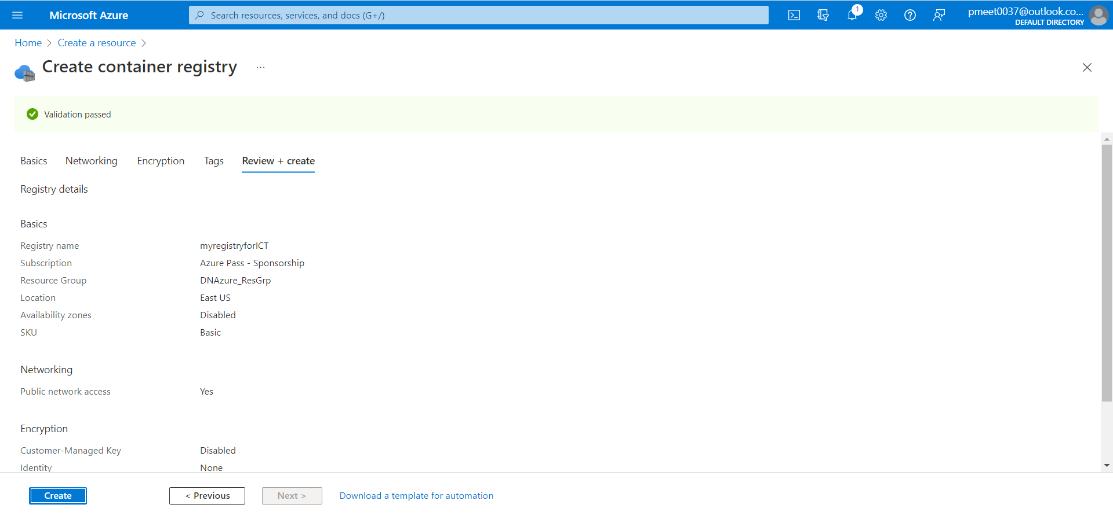

1. Deployed container registry in Azure Successfully

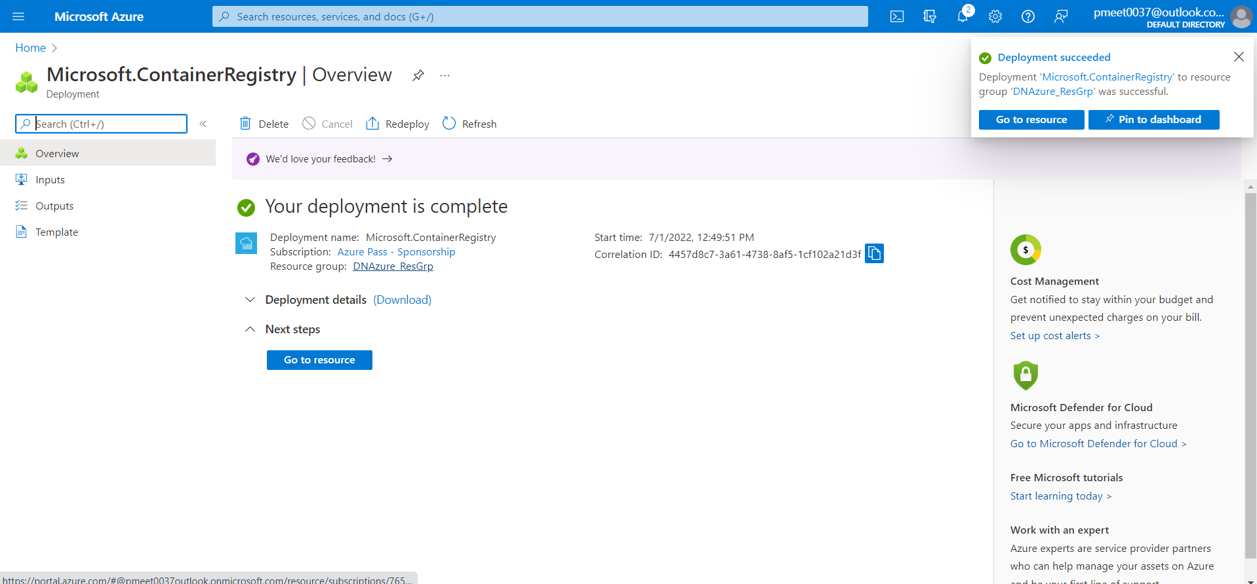

1. Create Kubernetes cluster in Azure

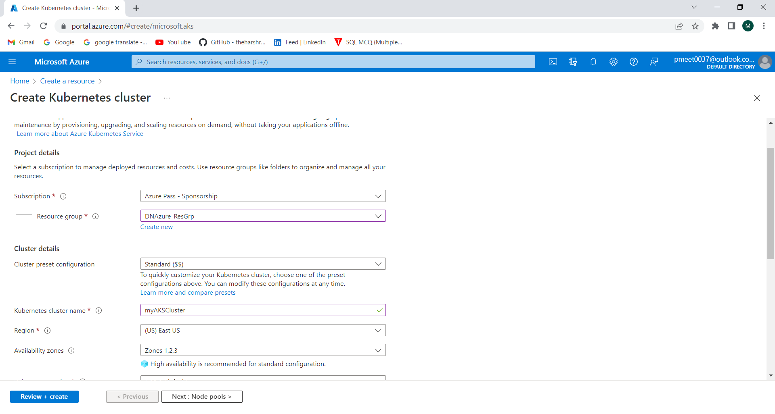

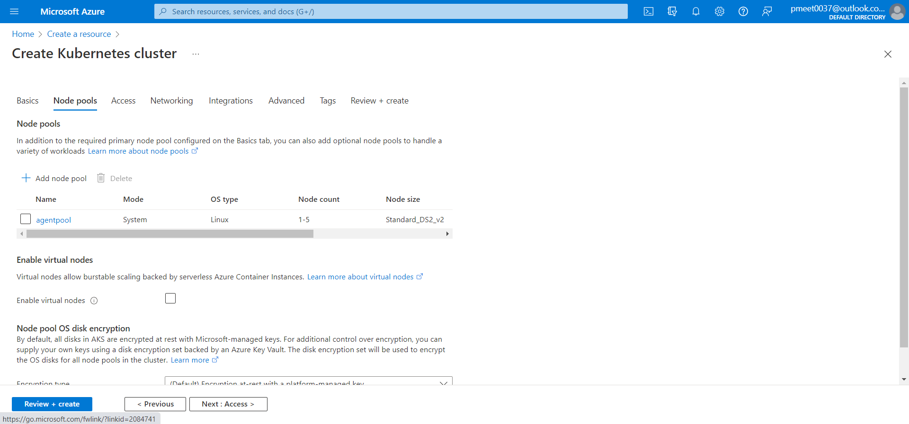

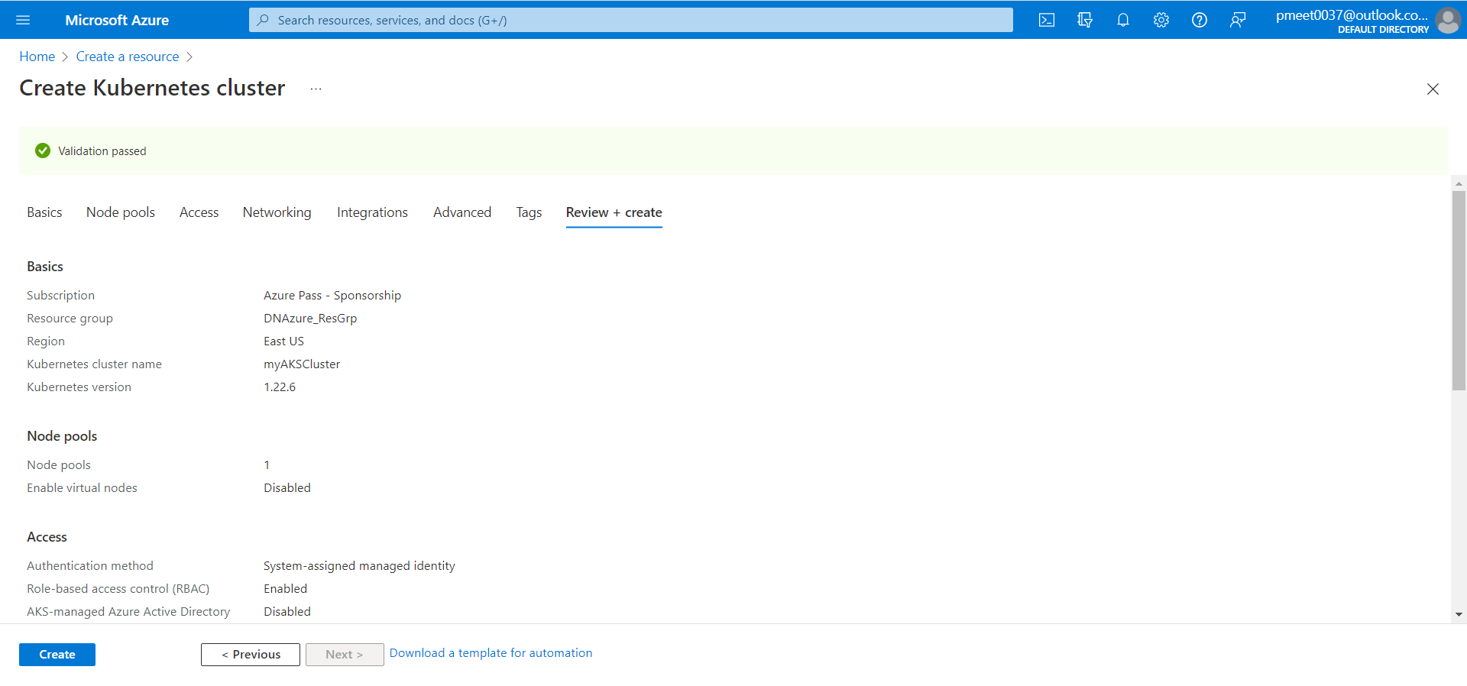

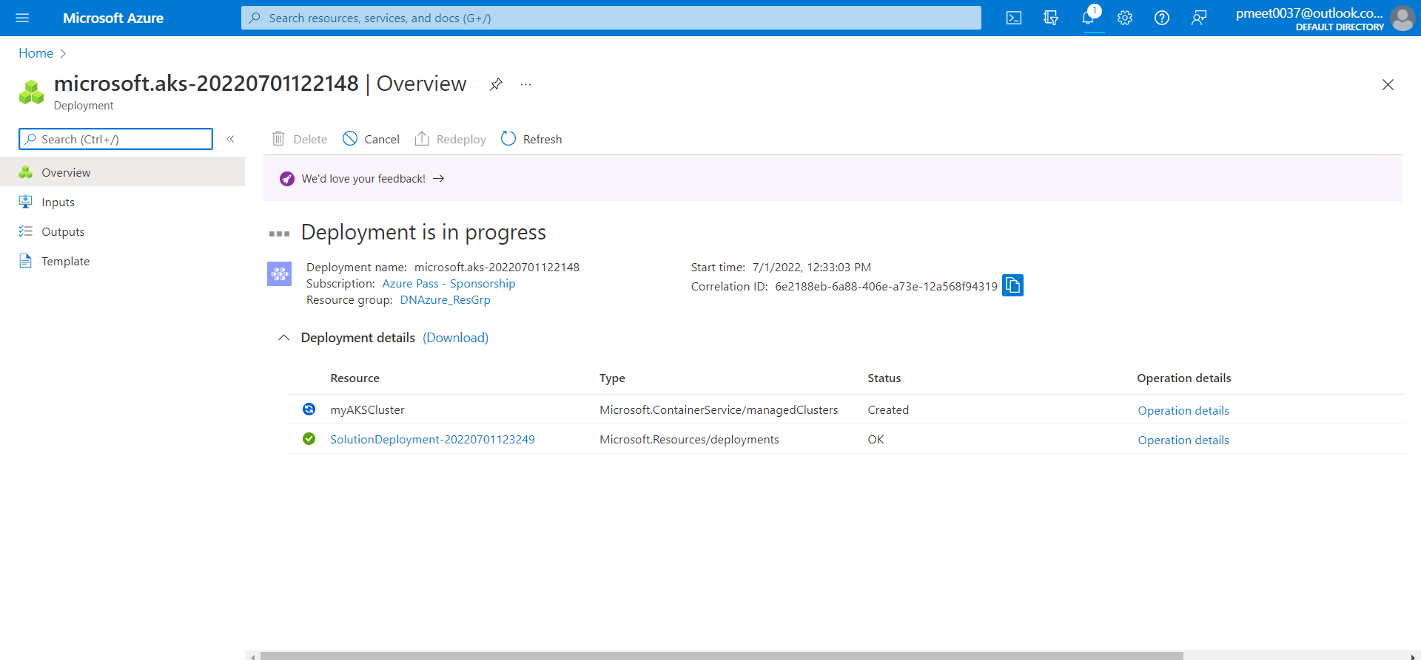

6. Kubernetes cluster deployed successfully in Azure

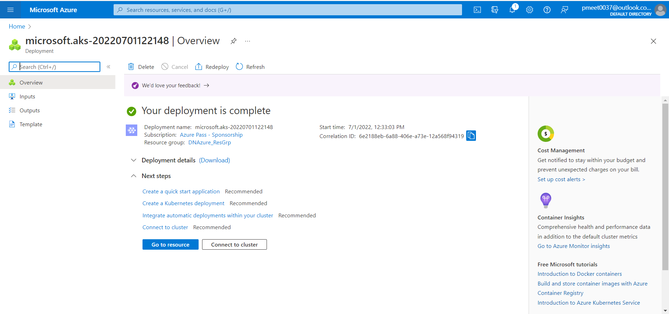

7. Publish MenuItem project in container registry

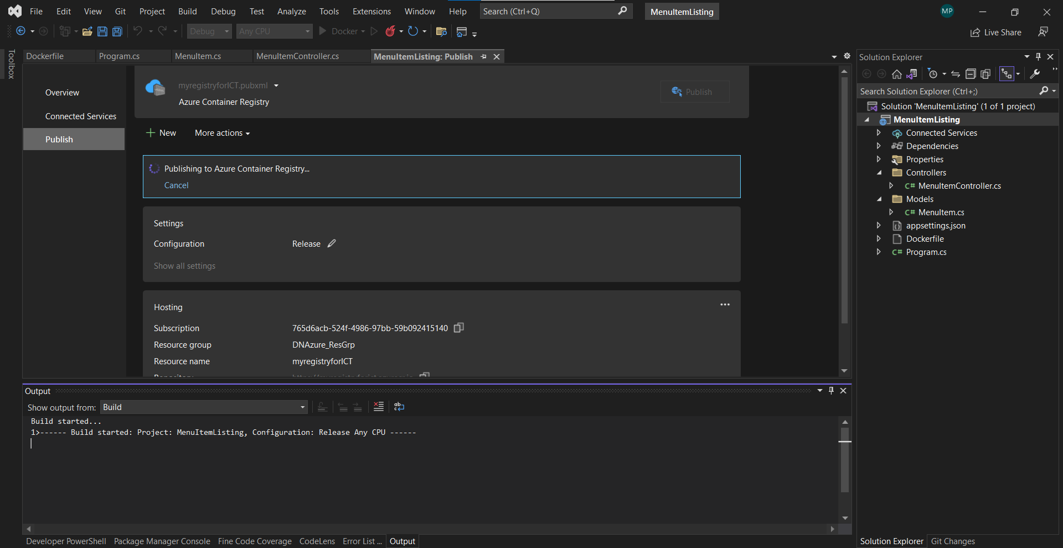

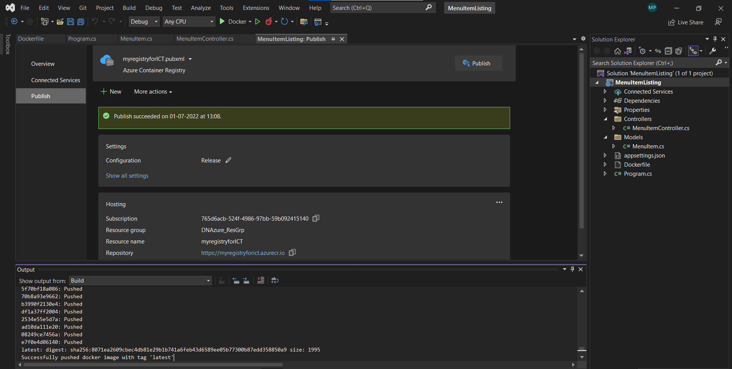

1. Docker image stored successfully in container registry using Azure

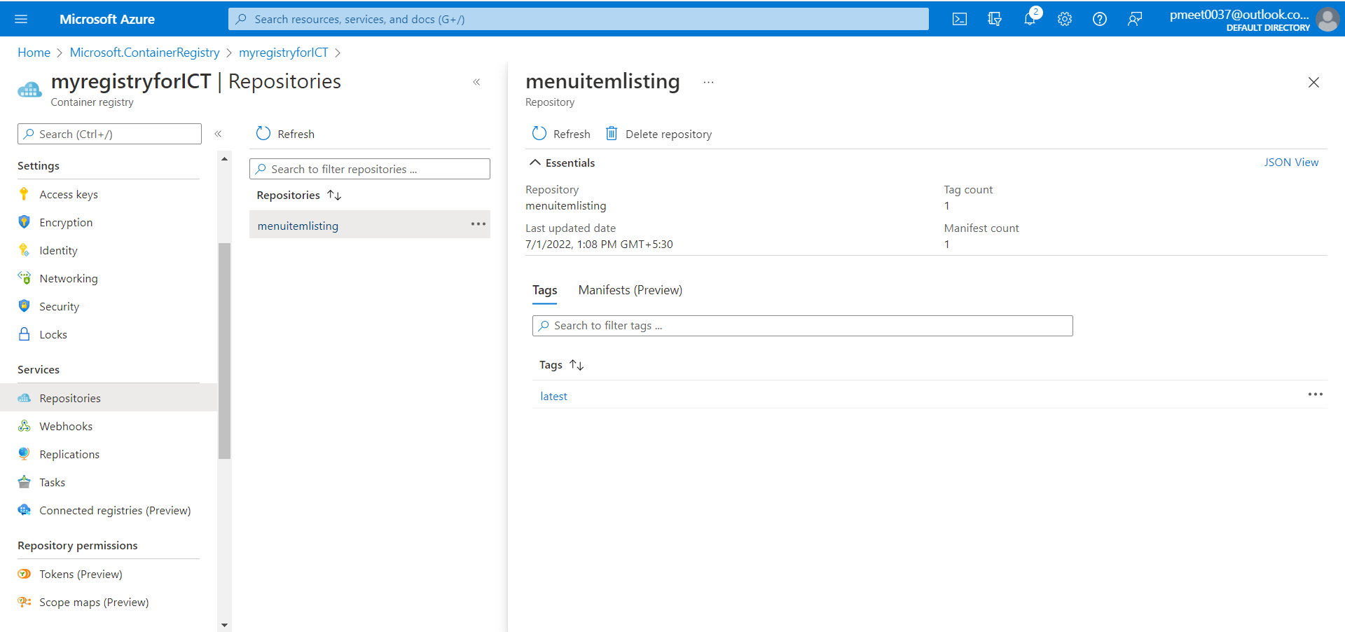

1. Click on the URL and browse for the end point (/api/Order/1) and the following screen will appear

