**BACKEND TASK**

**Following are the APIs created:-**

1. Create Survey
2. Take A Survey
3. Getting Results of a particular Survey
4. Getting Results of all created Surveys (Extra API)

* **Code has been written in Java with Spring Boot.**
* For running the Code, I would suggest to run it on Eclipse because it has better support than other IDE for Maven projects.

**Steps To Run The Code in Eclipse-**

* Following is the link of git <https://github.com/Meet03/Backend-Task.git>
* I am attaching the same zip file in email.
* After downloading the zip file, extract it in some folder.
* Open Eclipse
* Click on File🡪Import🡪Maven🡪Existing Maven Projects.
* Then select the location of the extracted folder
* Now you will be able to see the Project ‘backendTask’ on project Explorer panel on left side.
* Right click that folder and then select Run As🡪 Maven Build
* Now in ‘Goals’ field enter “clean install” and then click on run.
* Automatically Console of Eclipse will open and then after successful build this screen at the end of build will appear.

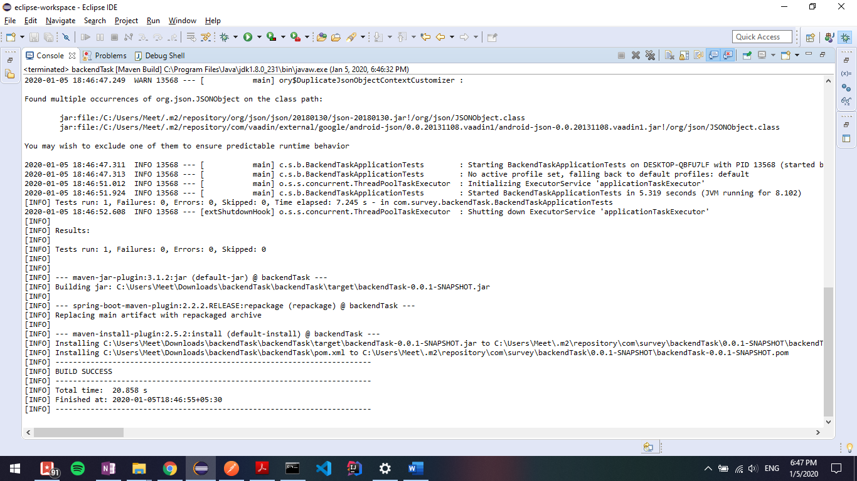

* Now after this, go to backendTask🡪src/main/java 🡪com.survey.backendTask
* Now you can see a java file named ‘BackendTaskApplication.java’, right click that file and go to Run As 🡪java Application
* Now after that console will automatically appear and you will be able to see following screen.

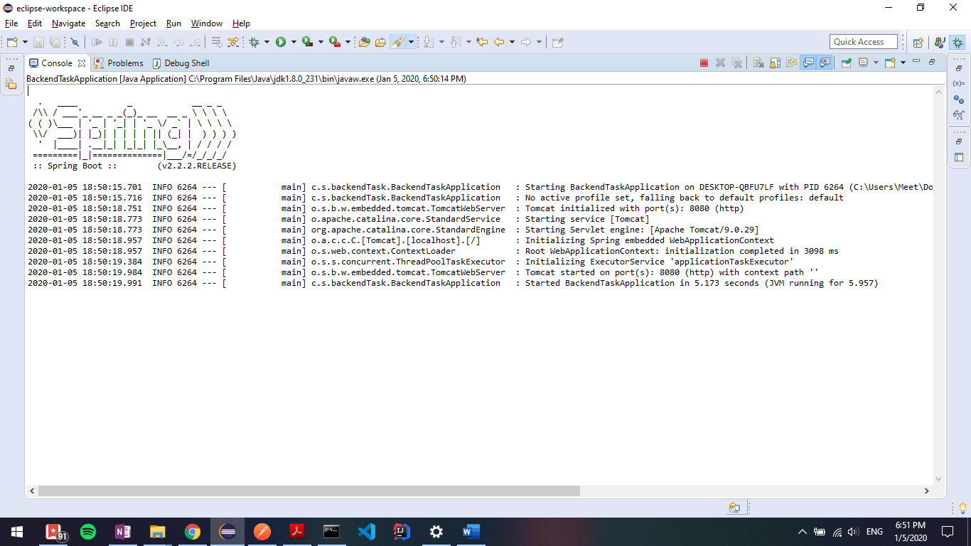

* It means your application is successfully running on Tomcat server with localhost and port number 8080.
* Now to hit the API, you may use Postman.

1. **Create A Survey**
   1. Following is the screen of API endpoint and its request body parameters.

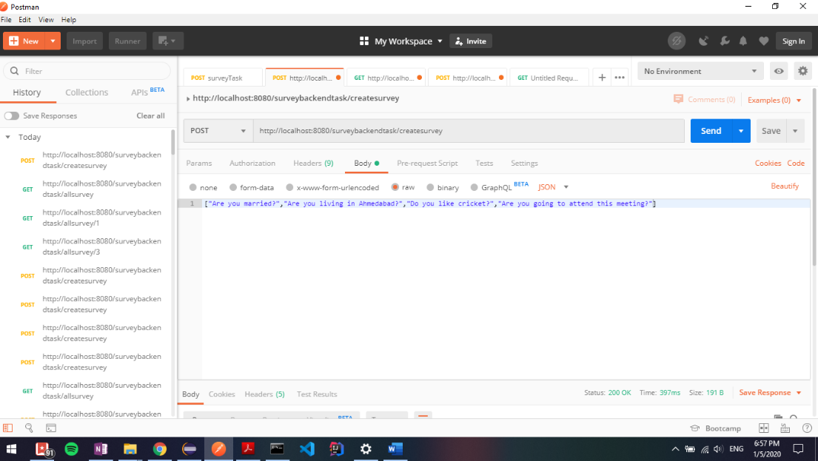

b) Endpoint is <http://localhost:8080/surveybackendtask/createsurvey> and in the body you can enter any number of questions you want.

c) Body part:- “["Are you married?","Are you living in Ahmedabad?","Do you like cricket?","Are you going to attend this meeting?"]” in JSON format

d) After running the API, following message will appear as response.

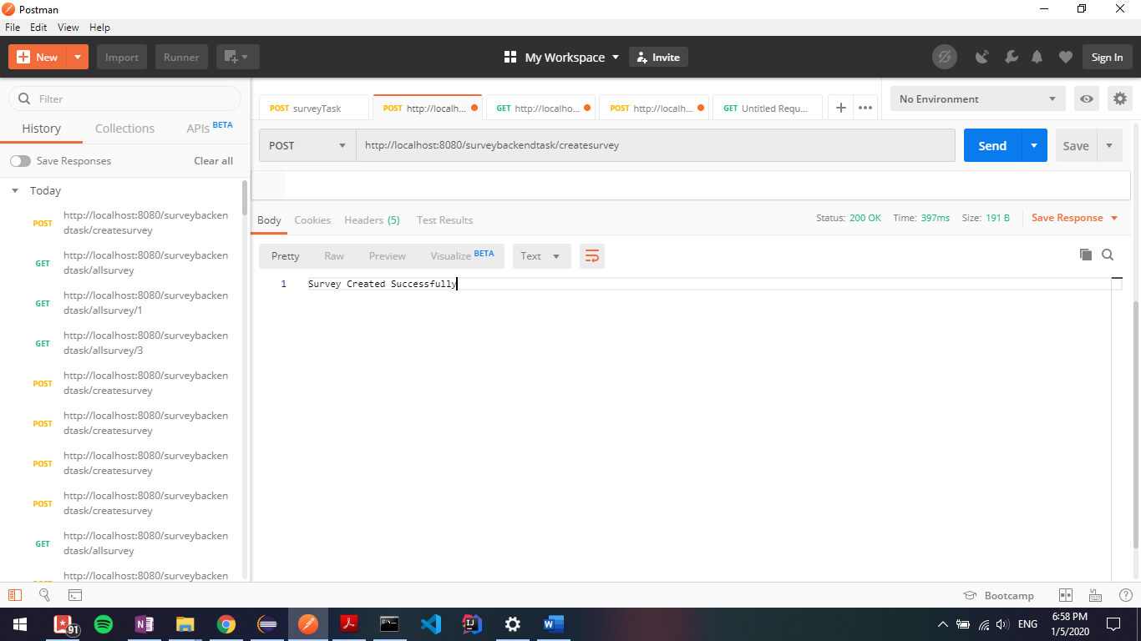

e) A survey Object will be created in the backend with SurveyId starting with 1 and so on and be added into an ArrayList containing all the created Surveys.

2) **Take A Survey:-**

a)This API will allow user to enter the SurveyId and the answers he want to add to those questions of chosen surveyId.

b)Following is the end point for the API <http://localhost:8080/surveybackendtask/takeasurvey> and in body you have enter JSON in the following format

{

"surveyId":"2",

"Questions":["Are you married?","Are you living in Ahmedabad?","Do you like cricket?"],

"Answers":["yes","no","yes"]

}

c) Following is the screen of postman for the given API

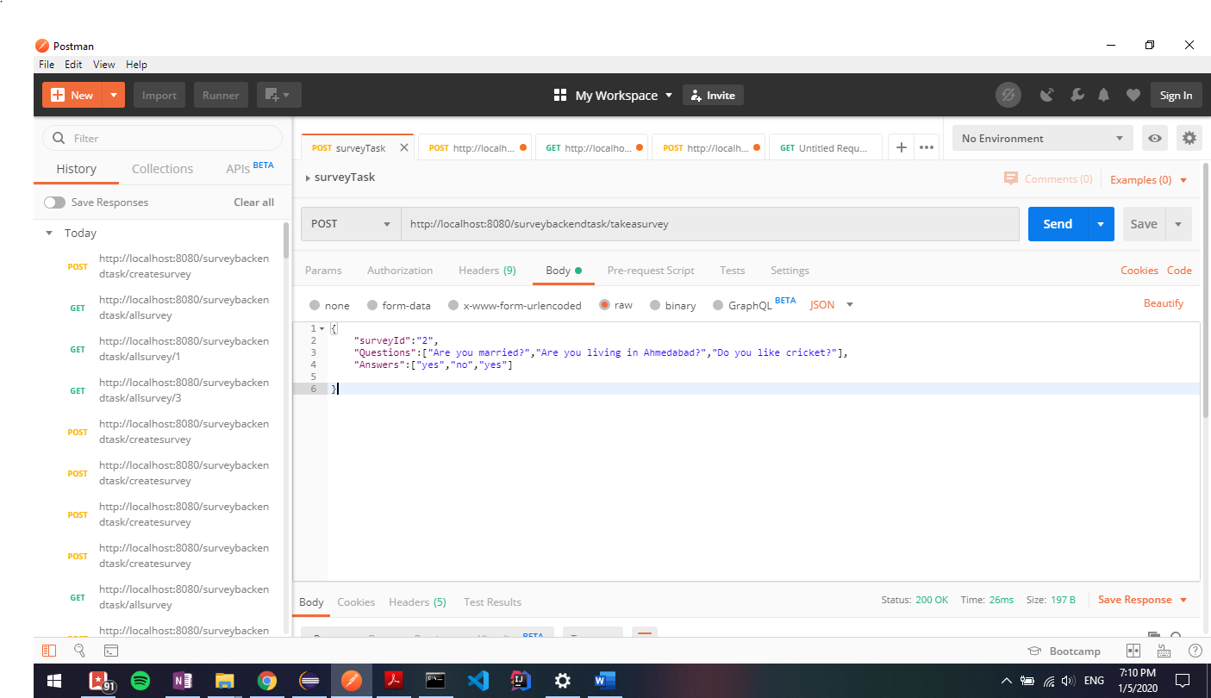

d) Following response will appear after running the API.

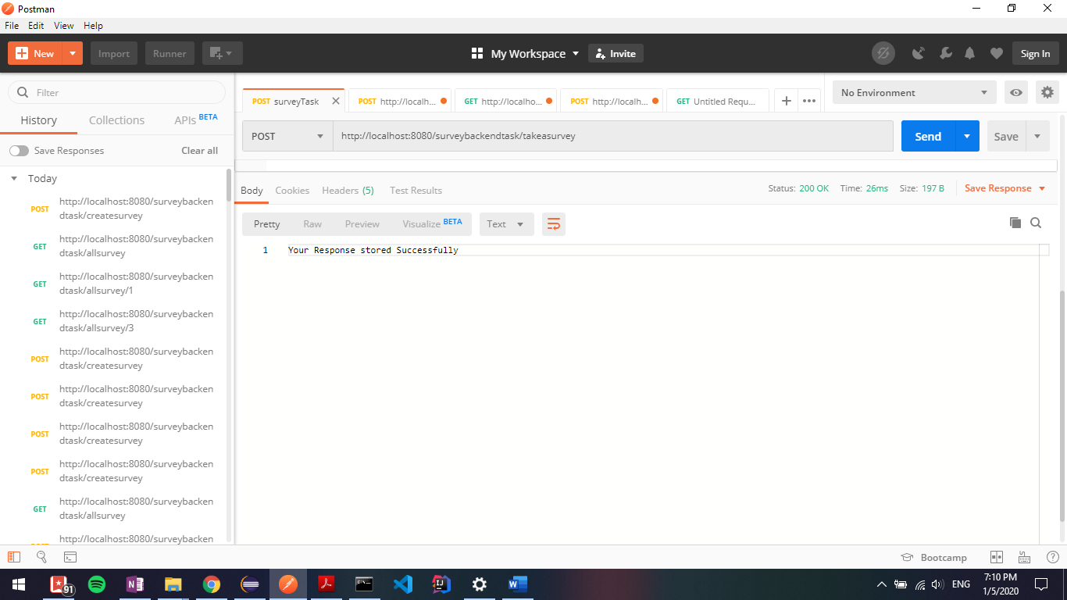

e) In the backend the answers get stored with the corresponding questions, as many times you hit the API, the count of ‘yes’ and ‘no’ gets on increasing.

1. **Get Result of a Particular survey**
2. Following is the end point of given API <http://localhost:8080/surveybackendtask/allsurvey/1>
3. Given screen will appear after running the API

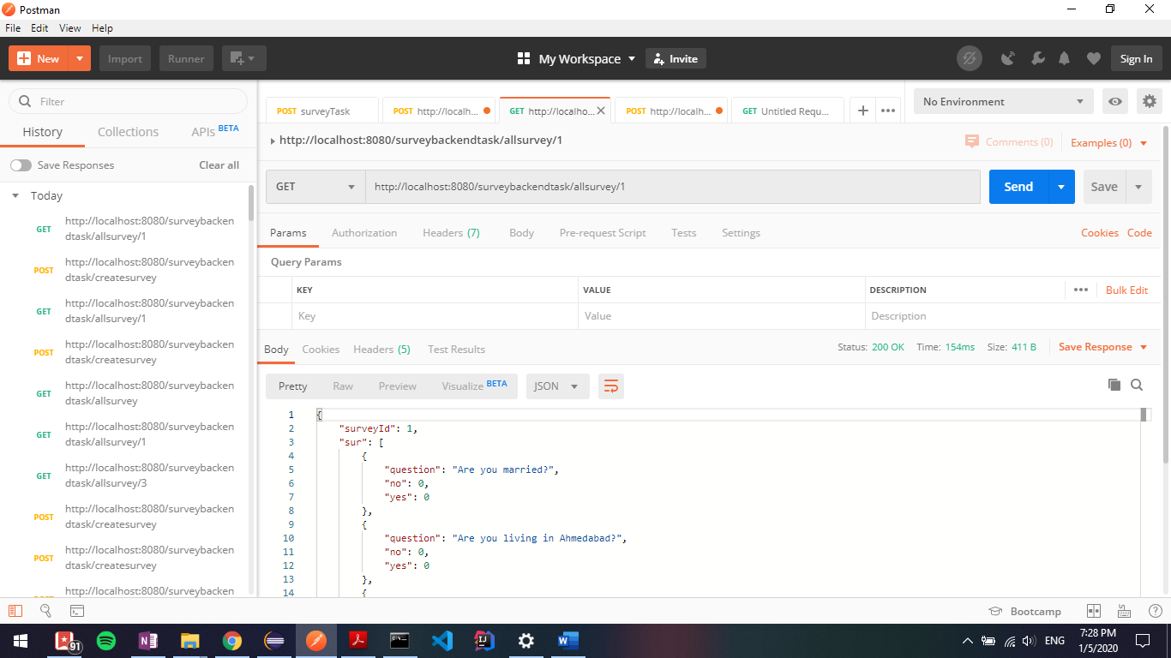

1. This is a Get method so required SurveyId will be passed in the link itself and in Response the survey with its result and count of yes and no of individual question will appear on screen.
2. **Getting results of all created Surveys (EXTRA).**
3. Following is the end point of given API <http://localhost:8080/surveybackendtask/allsurvey>
4. After running the API in response all the created survey will appear.

* I tried to Deploy this application to Heroku but I could not found out that why it was not running, Following screen appeared in the logs of Heroku.
* My Application even run for a while and then it got stoped.

