**CRYPTOGRAPHY IN PYTHON**

**Class:** ___20 IS+BD___ **Group No.:** _____3______

**Group Members Details**

|  |  |  |
| --- | --- | --- |
| **S. No.** | **Name** | **UID** |
|  | AKASH | 20BCS4388 |
|  | HARSH BABU | 20BCS4412 |
|  | BHARTI MALIK | 20BCS4384 |
|  | PARMEET SINGH | 20BCS4415 |
|  | ASHISH KUMAR | 20BCS4409 |

**Problem Statement**

In our day-to-day lives, the use of cryptography is everywhere. Let us suppose, if all of the secrecy creator engines/functions stopped working for a day, modern life as we know it would stop. Bank transactions wouldn’t go through, internet traffic would come to a halt, and cell phones would no longer function. At this point, all of our important information would be exposed, and it then could be exploited to do unimaginable harm to us all.

Cryptography is an essential way of preventing that from happening. It secures information and communications using a set of rules that allows only those intended—and no one else—to receive the information to access and process it.

**Key Features/Benefits**

* *This program encodes the message into ciphertext in several level of secrecy.*

1. *First it checks the length of statement If it is even then read adds no characters and if it is odd then it adds 1 later to make it even length statement*
2. *Replace the even position letters with odd position letters.*
3. *it reverses the whole message*
4. *by using a library to make it in cipher text.*
5. *Also, whole message is encrypted with OTP.*

**List of Software Used**

* *Visual Studio Code IDE*
* *Python 3.7.0 (x64)*
* *Python packages*
* *Internet connection (to install libraries)*
* *Command prompt*

**Deliverables**

* [*https://www.geeksforgeeks.org/cryptography-gui-using-python/*](https://www.geeksforgeeks.org/cryptography-gui-using-python/)
* [*https://www.tutorialspoint.com/cryptography_with_python/index.htm*](https://www.tutorialspoint.com/cryptography_with_python/index.htm)
* [*https://inventwithpython.com/hacking/chapter22.html*](https://inventwithpython.com/hacking/chapter22.html)
* <https://www.geeksforgeeks.org/python-program-to-generate-one-time-password-otp/#:~:text=They%20are%20generally%20combination%20of,to%20generate%20OTP%20using%20Python>.
* <https://www.youtube.com/watch?v=50XM-h3h6Fw>
* <https://www.youtube.com/watch?v=5jpgMXt1Z9Y>
* <https://pypi.org/>
* <https://github.com/>
* <https://stackoverflow.com/>
* <https://www.geeksforgeeks.org/>

**(*Kindly provide the link where all deliverables are uploaded*)**

**Workflow**

**Step – 1: *Installation of libraries through COMMAND PROMPT***

***LIBRARY REQUIRED --- 1. numpy***

***2. string (python basic lib, included with python)***

***3. random (python basic lib, included with python)***

***4. onetimepad***

***5. pyotp***

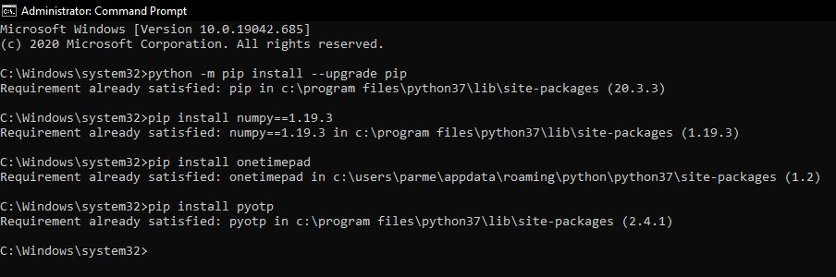

**Step – 2: *Writing of code***

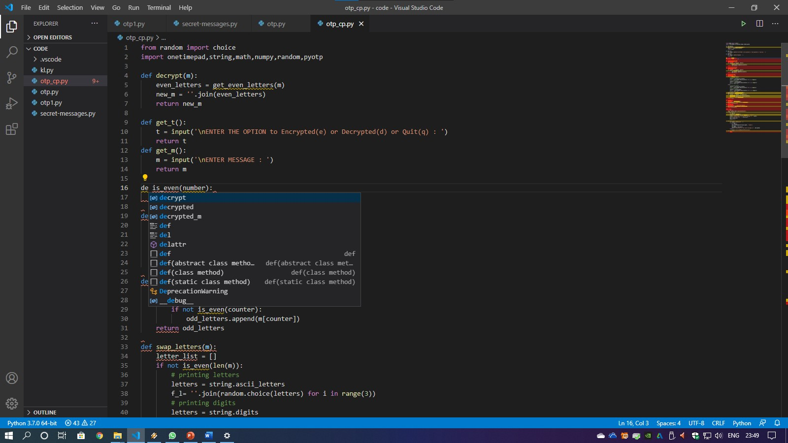

**Step – 3: *Fixing the errors (debugging)***

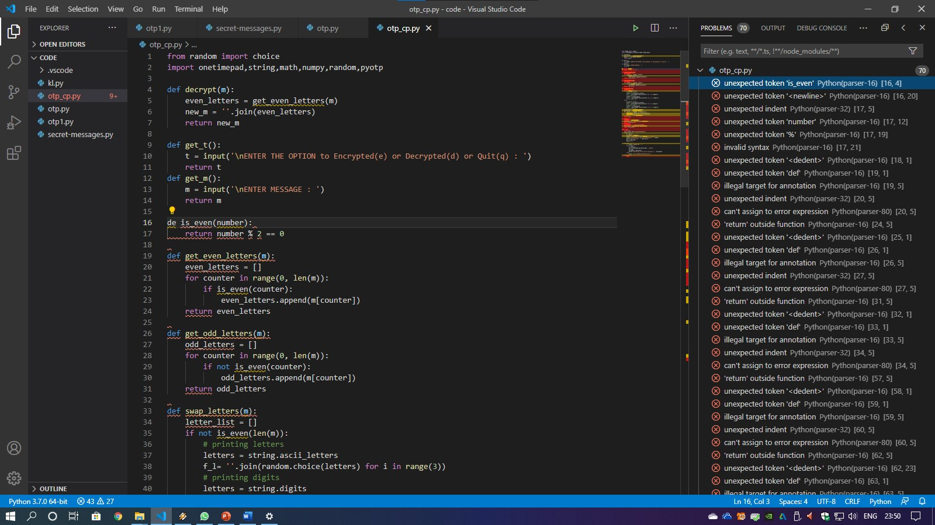

**Step – 4: *Execution of program in Python Shell or Terminal***

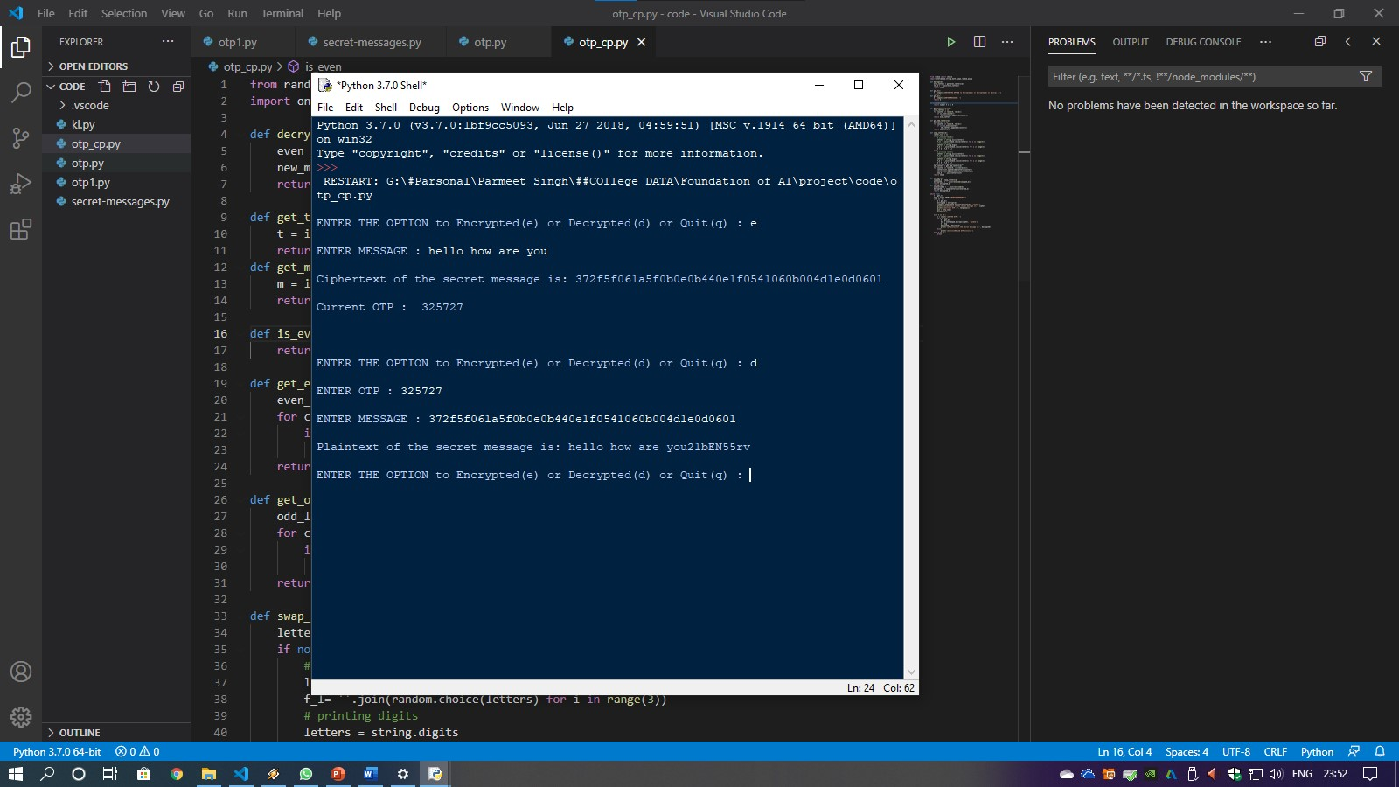

Now the entered message is ***encrypted*** *and* ***decrypted****.*

No one can read it unless he/she has the OTP which is generated by the program.

**********************************************************

**Contribution of group members are follows as ---**

* CODING OF PROGRAM AND PPT

1. PARMEET SINGH
2. AKASH

* BACKGROUNG AND USES OF CRYPTOGRAPHY

1. HARSH BABU
2. BHARTI MALIK

* PROJECT REPORT

1. ASHISH KUMAR

**********************************************************