📈 Binary Signal Prediction Project (1m, 3m, 5m)
🔍 Project Goal: Build a system that automatically trains the best machine learning model to predict binary signals (UP/DOWN) for 1-minute, 3-minute, and 5-minute timeframes using historical candle data (20 years).

📁 Project Structure
Folder Layout:
binary_signal_project/
│
├── data/ # Raw Parquet or CSV files
│ ├── eurusd.parquet
│
├── models/ # Saved best models
│ ├── eurusd_1m.pkl├── eurusd_3m.pkl├── eurusd_5m.pkl
│
├── utils/
│ ├── feature_engineering.py # Auto create features
│ ├── model_selector.py # Auto select best model
│ └── label_creator.py # Make labels for 1m, 3m, 5m
│
├── train_models.py # Train all models
├── predict_live.py # Predict from latest candle
├── signal_output.json # Output signal
└── requirements.txt

🔁 Workflow Steps
1. Data Preparation: Split and label candle data for 1m, 3m, and 5m future signals.
2. Feature Engineering: Calculate OHLC-based features, moving averages, technical indicators.
3. Model Training: Automatically try XGBoost, LightGBM, CatBoost, Random Forest, Logistic Regression.
4. Model Selection: Select best model using accuracy / ROC-AUC.
5. Save Best Model: Save each model with filename like `eurusd_1m.pkl`
6. Live Prediction: Predict signal based on most recent candle data.

🧾 Output Format
Example JSON Output:
{
"pair": "EUR/USD",
"timeframe": "3m",
"signal": "UP",
"confidence": 0.734
}

⚙️ How to Use (Commands)
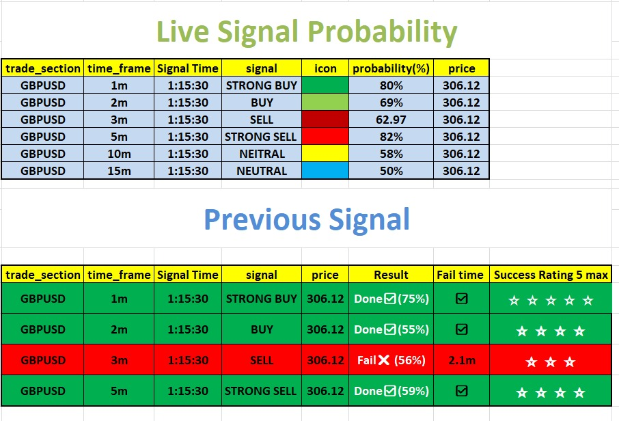
Characteristics of Data:

