# CHAROTAR UNIVERSITY OF SCIENCE & TECHNOLOGY CHANDUBHAI S. PATEL INSTITUTE OF TECHNOLOGY

U & P U. Patel Department of Computer Engineering

|  |  |  |  |  |  |
| --- | --- | --- | --- | --- | --- |
| **Subject Name** | : | Big Data Analytics | **Semester** | : | VII |
| **Subject Code** | : | CE441 | **Academic year** | : | 2021-22 |

**Practical 8**

**AIM:**

Configure Neo4j , Create node & relationship in it.

**KNOWLEDGE REQUIRED:**

Neo4j is a graph database management system where data is organized as nodes, relationships, and properties (data stored on the nodes or relationships). ***Nodes*** are the entities in the graph. They can hold any number of attributes (key-value pairs) called *properties*. Nodes can be tagged with *labels*, representing their different roles in your domain. Node labels may also serve to attach metadata (such as index or constraint information) to certain nodes.***Relationships*** provide directed, named, semantically-relevant connections between two node entities

**HARDWARE/SOFTWARE REQUIRED:**

Neo4j software

**IMPLEMENTATION:**

This is the default database screen when we open neo4j

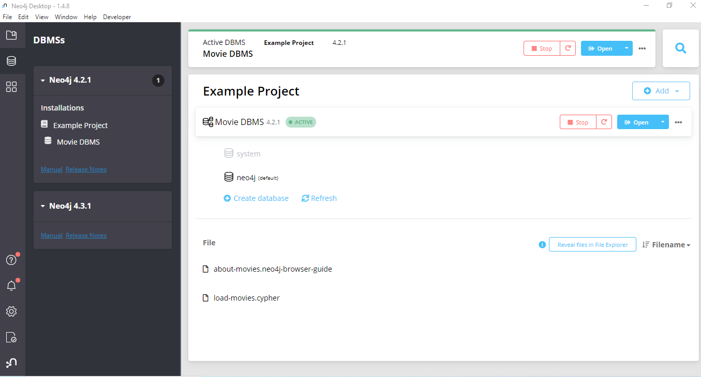

To create a new database click on the add button shown in below given figure

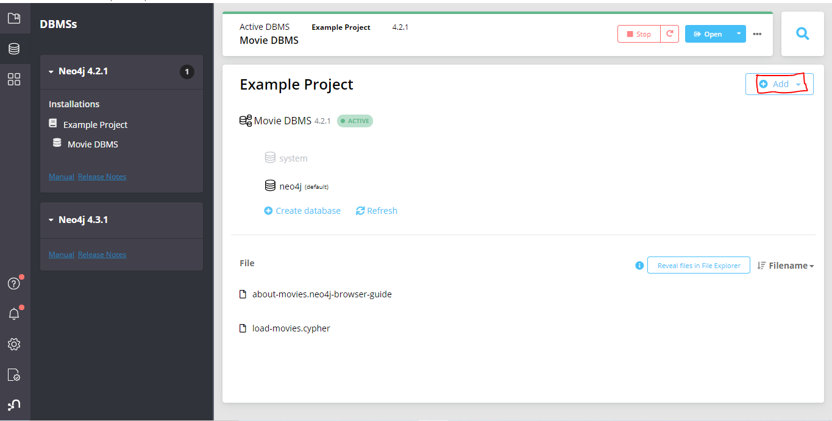

And select Local DBMS from the dropdown menu

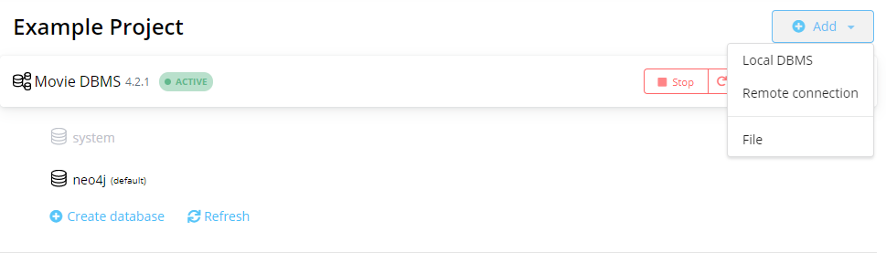

Now give the name and set any password and click on create

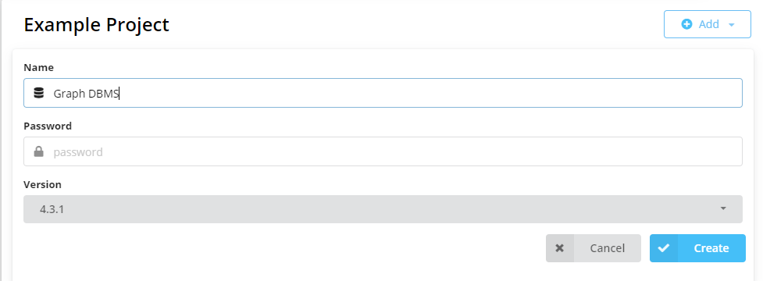

By creating database it will show a start button so click on the start button to start the database

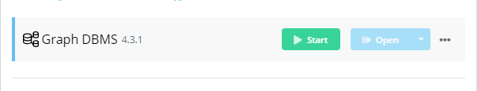

After clicking start it will set status as active

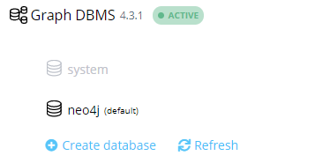

Now after starting we can open the database in neo4j browser click on the open and it will open a new window of neo4j browser

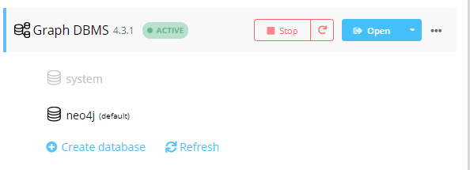

This is the initial screen of neo4j browser

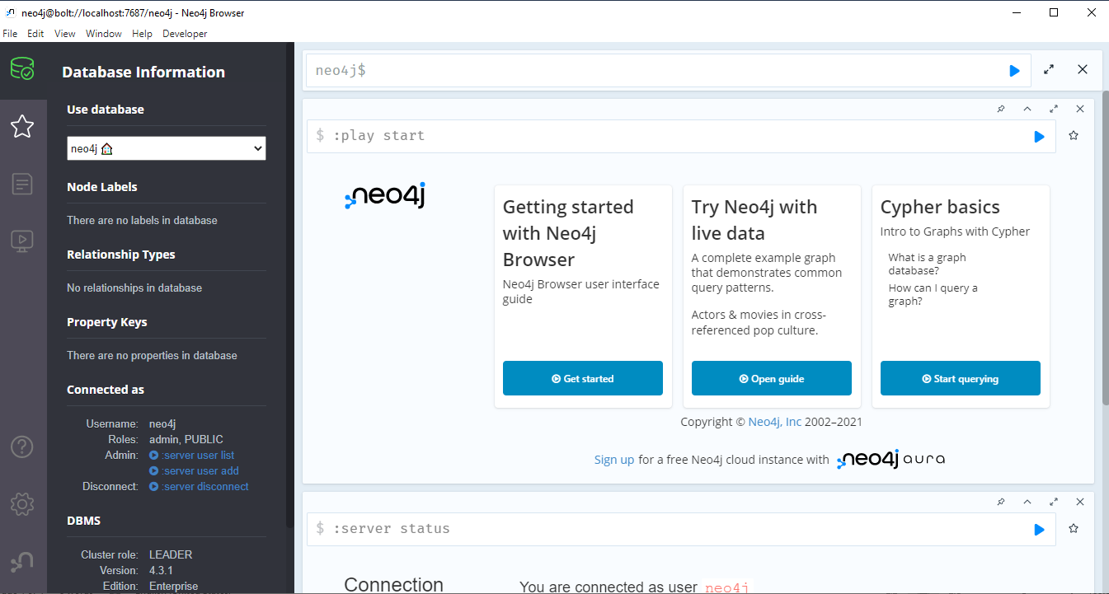

**Create nodes**

Now to create nodes we have to write command in textbox given

We can create node by:

Create(n:cities{name:”Ahmedabad”,id:”1”})

So it will create node n with label as cities and properties as name and id



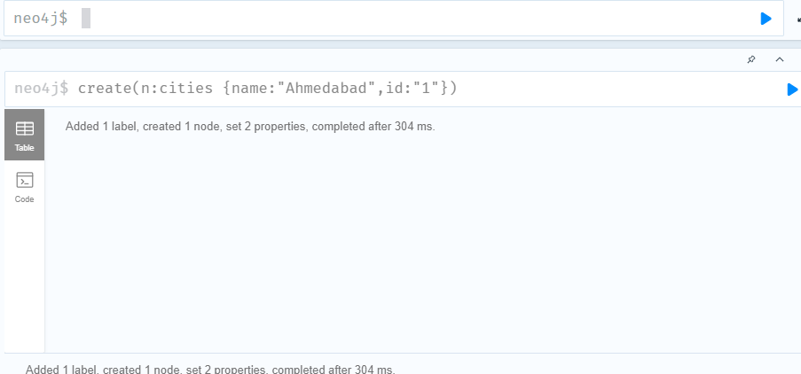

Now if we want to see what all nodes are added in label named cities:

Match(n:cities)return n



Currently we have added only 1 node so it will show only Ahmedabad

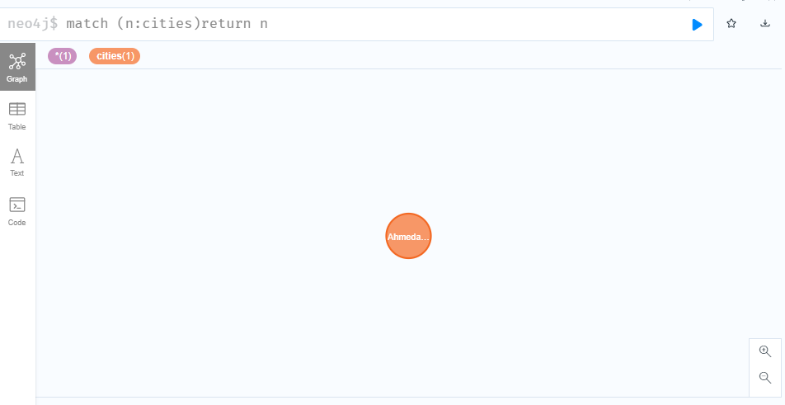

We can also change the colour of node as shown in below figure



This is the table form of node

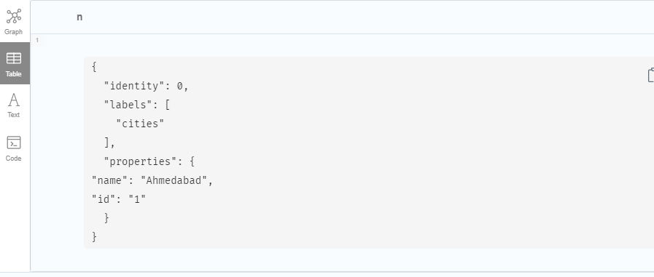

This is the text form of nodes

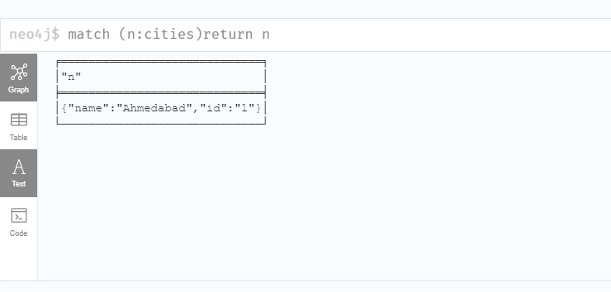

This is the code form of nodes

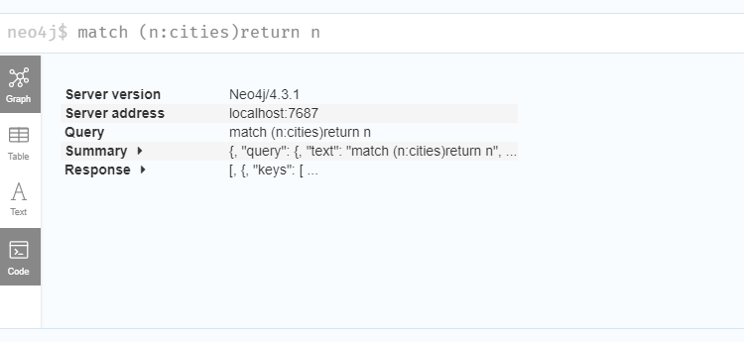

Now similarly I will add 15 more nodes

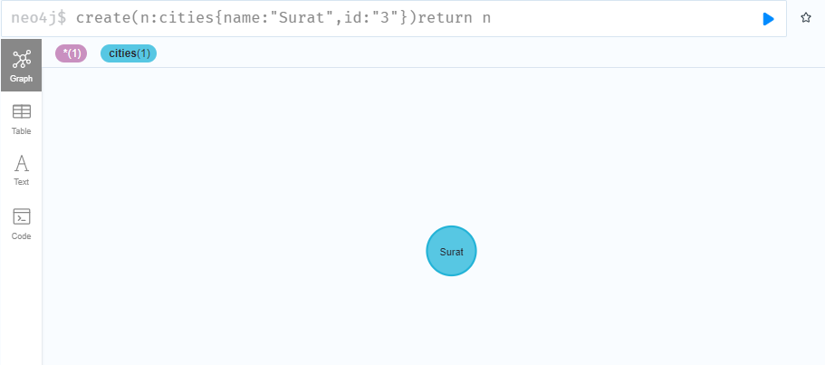

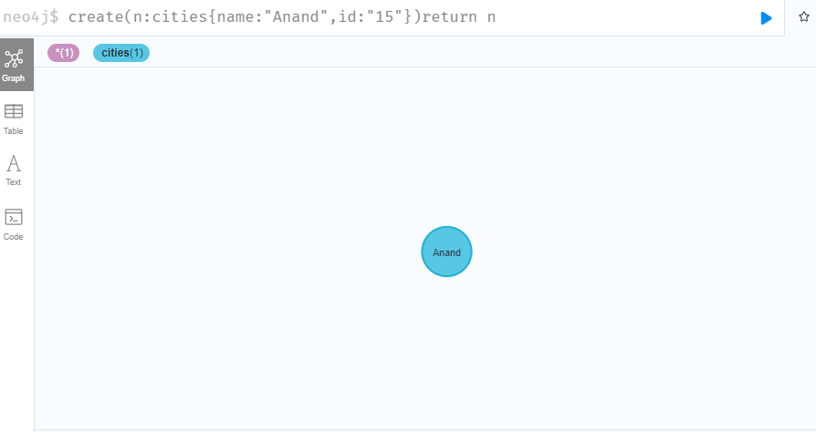

So I have added 15 nodes of cities as a label

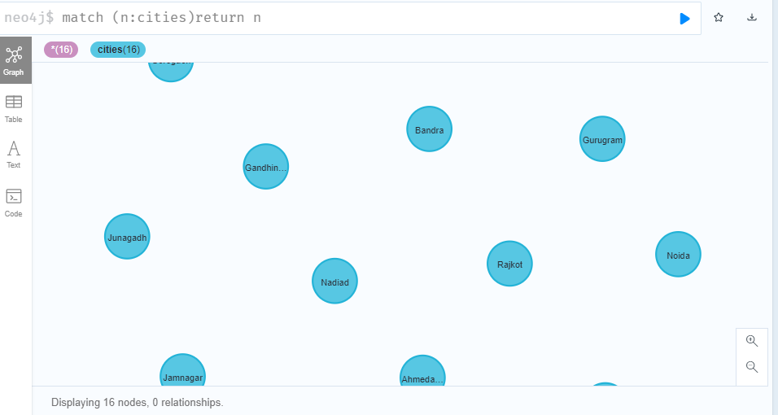

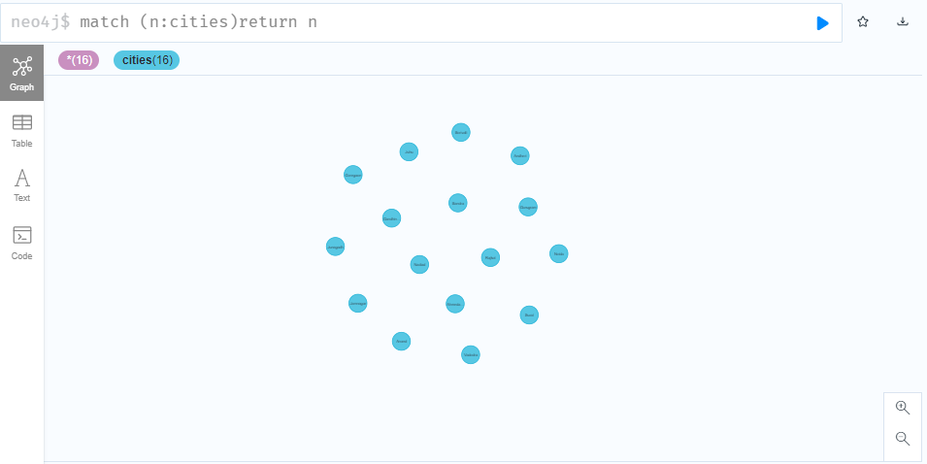

We can also add node in another label

Create(n:states{name:”Gujarat”)return n



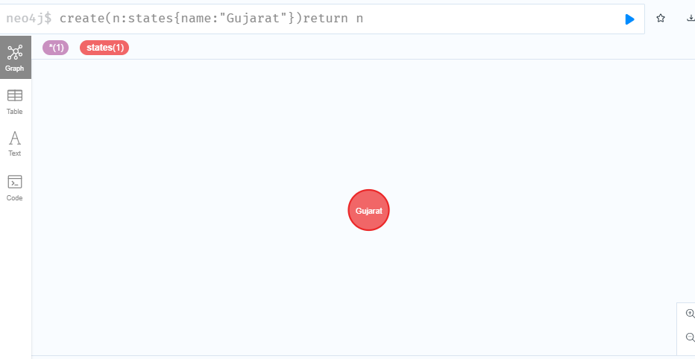

**Add property**

We can also add property for a particular node by below shown command

Here I have added state property Gujarat in Ahmedabad node

Create(n:cities{name:”Ahmedabad”})set n.state=”Gujarat” return n

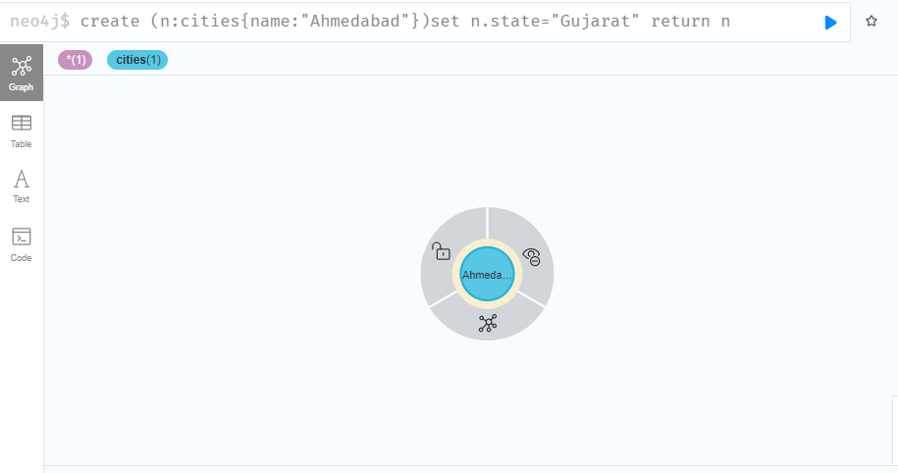

In table form

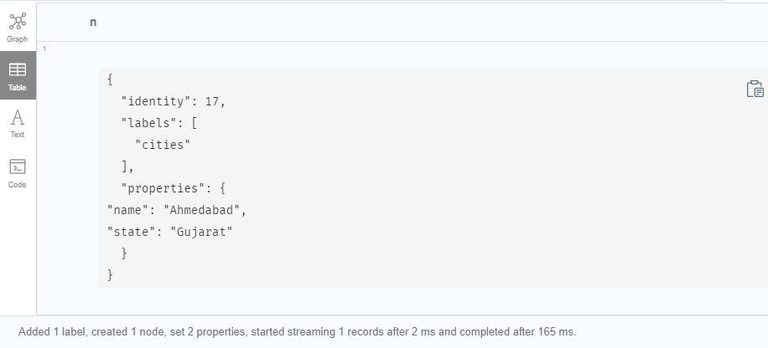

Here I have added state property Mumbai in Juhu node

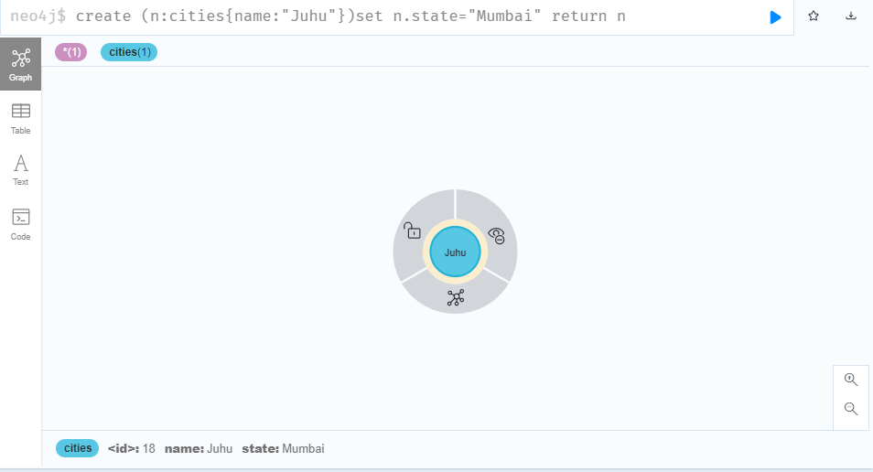

In table form

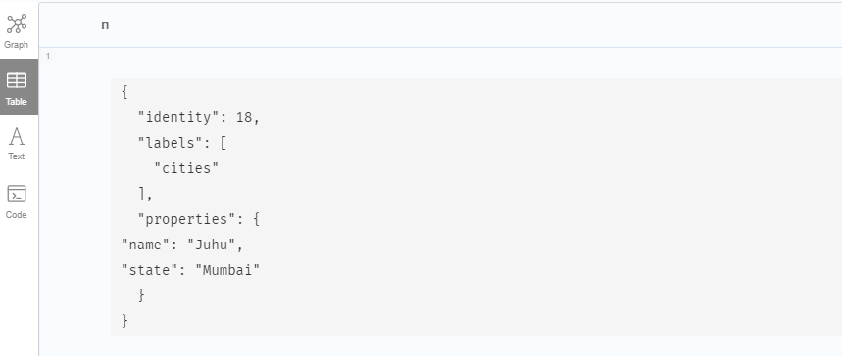

**Deleting the property**

Here I have deleted state property which was added in Juhu node

Match(n:cities{name:”Juhu”})remove n.state return n

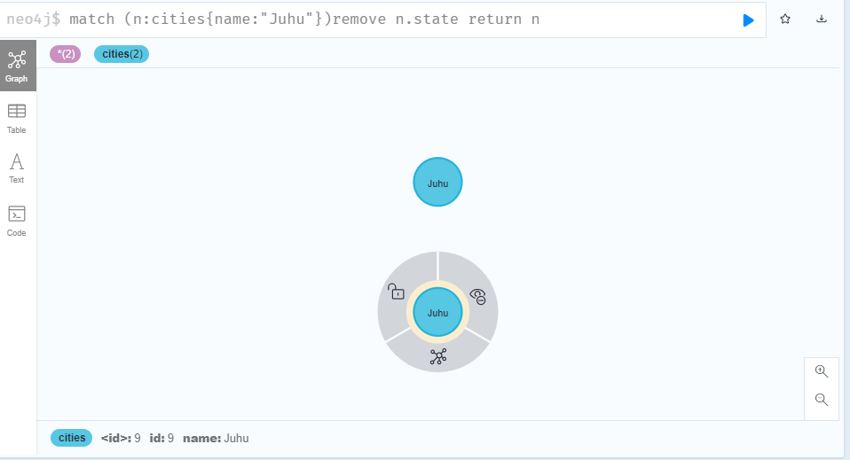

**Deleting nodes**

Here I have deleted Juhu node

It shows 2 node deleted because when state property was added a duplicate node has been created.

Match(n:cities{name:”Juhu”}) delete n

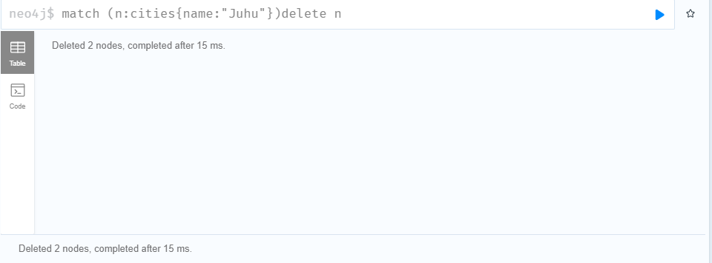

**Relationship**

We can also add relation between 2 nodes . Currently we can see there is no relationships in database

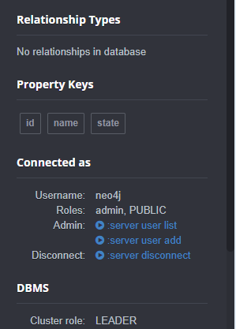

Here I have created relationship between Vadodra and Surat node as Gujarat

To create a relationship:

Match (n:cities{name:”Vadodra”}),(a:cities{name:”Surat”})merge(n)-[r:Gujarat

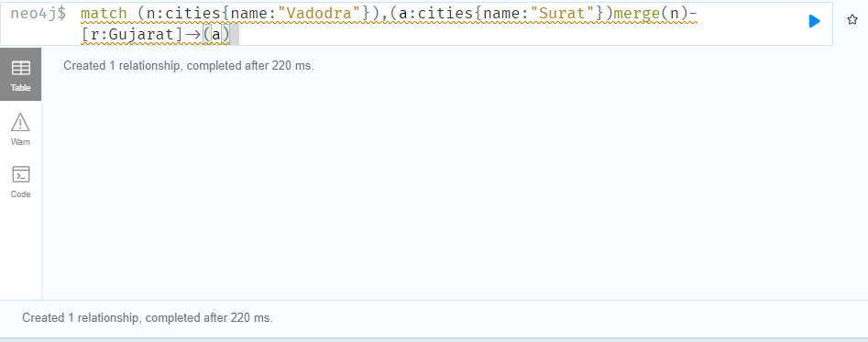

I have created another relationship between Bandra node and Andheri node as Mumbai

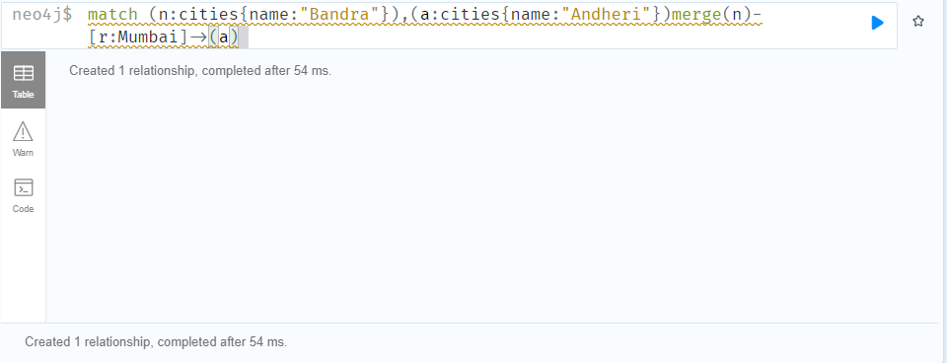

Now we can see added relationship

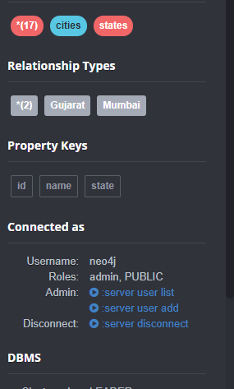

We can see both relationship as graph visual

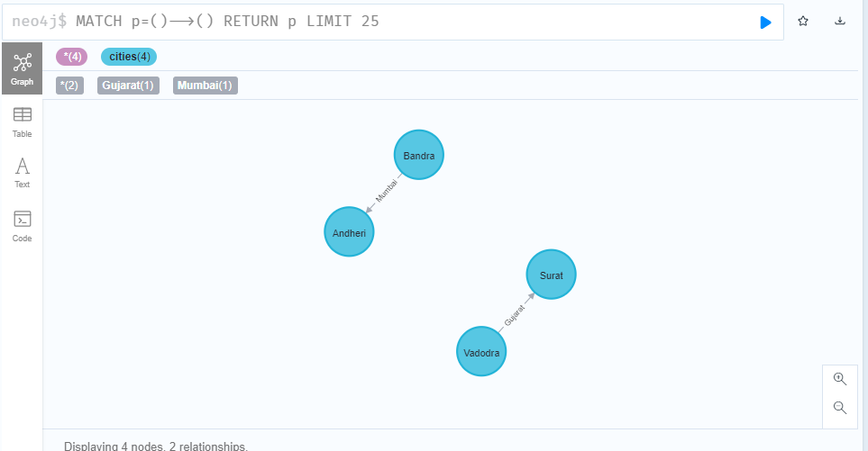

We can also add multiple relationship

Like vadodra is already related to surat as Gujarat so here new relationship is added as india between vadodra and rajkot

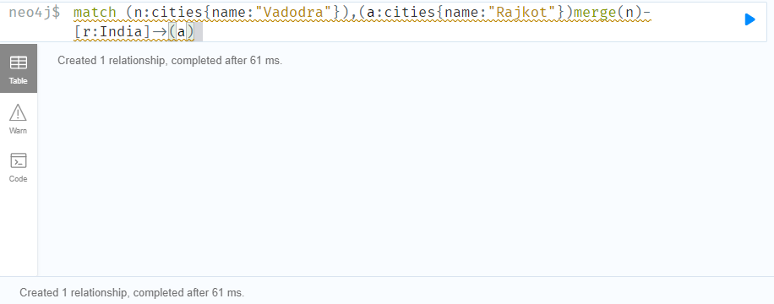

We can see the output in graph visual

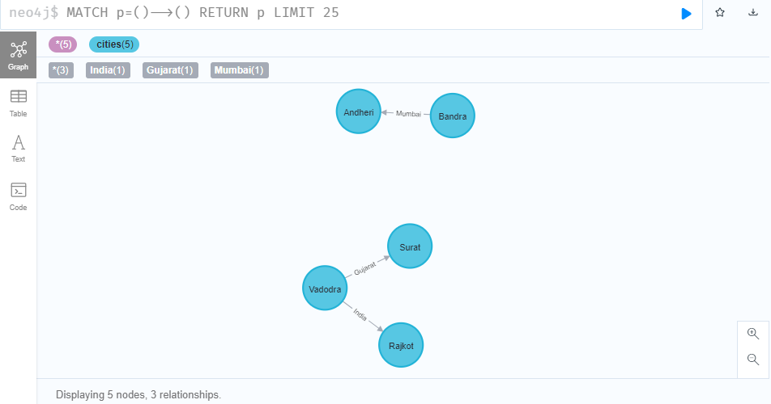

We can see all the nodes listed with its relationship

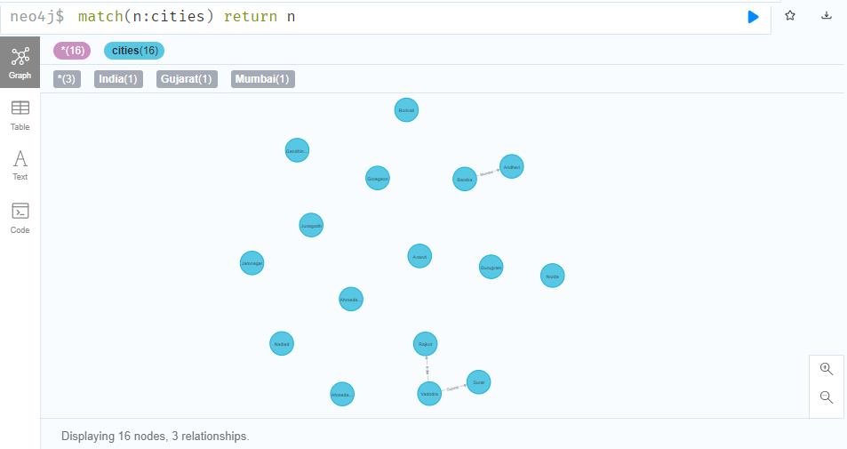

Adding property while adding relationship

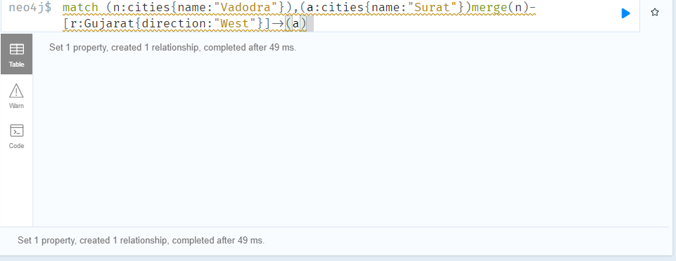

**Deleting the relationship:**

Match(n:cities{name:”Vadodra”})-[r]-(a) delete r

It will delete relationships of vadodra

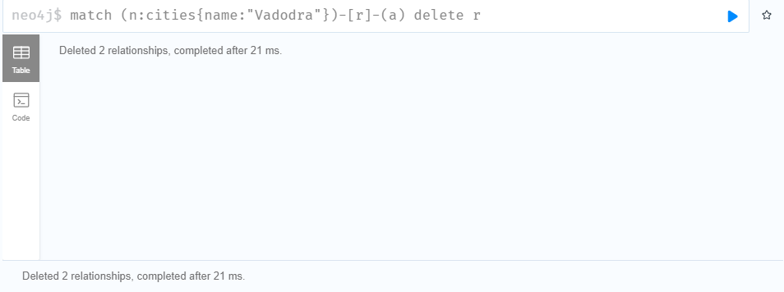

**Conclusion:**

Here I get to know about neo4j and how to create database and add and remove property and relationships.