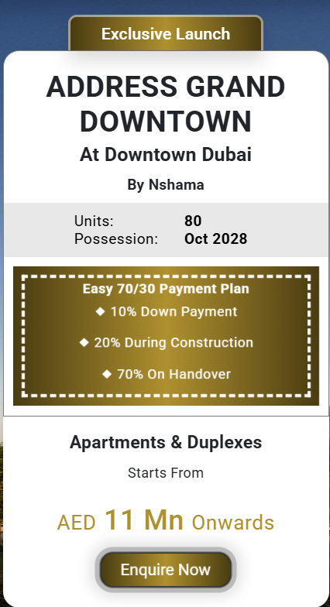  
  
Exclusive Launch   
  
Emaar The Grand Polo  
At Dubai Investment Park 2  
By Emaar **1) Dubai's Most Strategic Luxury Investment  
  
2) Location Advantages That Maximize ROI   
  
3) Payment Plan 80:20   
 4 Year Payment Plan  
 10% Down Payment  
  
4) 60M Sqft Development**

**Sharjah’s First Fully alkable Community.**  
**Polo Theme Villas Starts at**

**AED 5M Onwards**

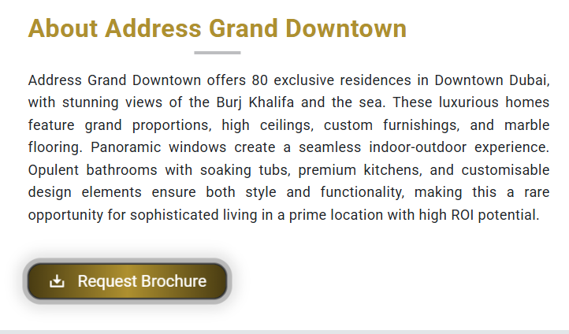

**About Emaar The Grand Polo**

**Emaar The Grand Polo Club & Resort, located in Dubai Investment Park 2, offers prestigious polo-inspired living with unmatched luxury and direct access to Dubai Mall, Burj Khalifa, and key business hubs. Spanning 60 million sq. ft., Emaar The Grand Polo exclusive development features world-class villas, townhouses, and polo fields. With rising demand, limited competition, and exceptional growth potential, Emaar Grand Polo stands out as a prime investment for those seeking high returns in Dubai’s luxury real estate market. Welcome to The Grand Polo by Emaar.**

**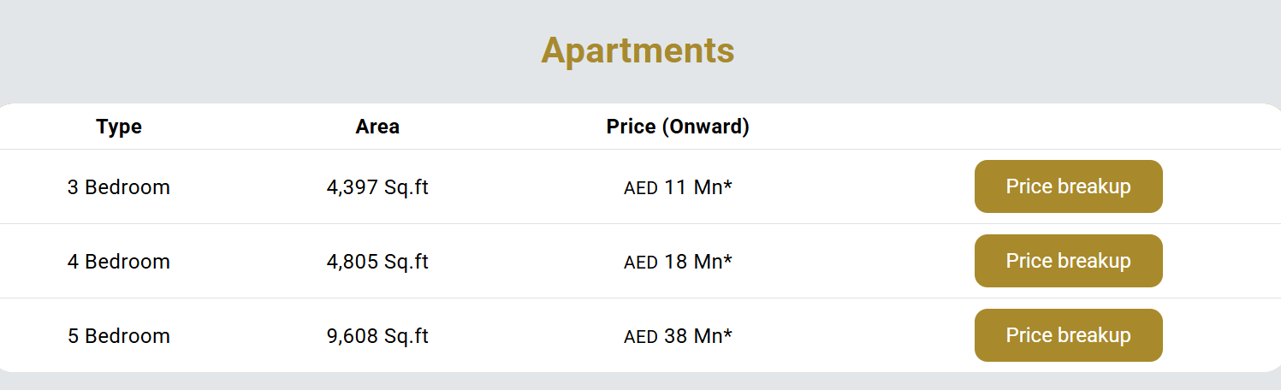  
  
Villas \*\*\*\*\*\*\*\*\*\*\*\*\*\*\*\*\*\*\*\*\*\*\*\***

| **Type** | **Carpet Area** | **Price** |  |
| --- | --- | --- | --- |
| **4 Bedroom** | **On Request** | **AED 5 Mn** | Request For Price Breakup |
| **5 Bedroom** | **On Request** | **AED On Request** | Request For Price Breakup |
| **6 Bedroom** | **On Request** | **AED On Request** |  |

**Location** [**https://maps.app.goo.gl/XfSY65MTDmyBkMLN7**](https://maps.app.goo.gl/XfSY65MTDmyBkMLN7) **Location map image also added  
  
  
  
  
  
  
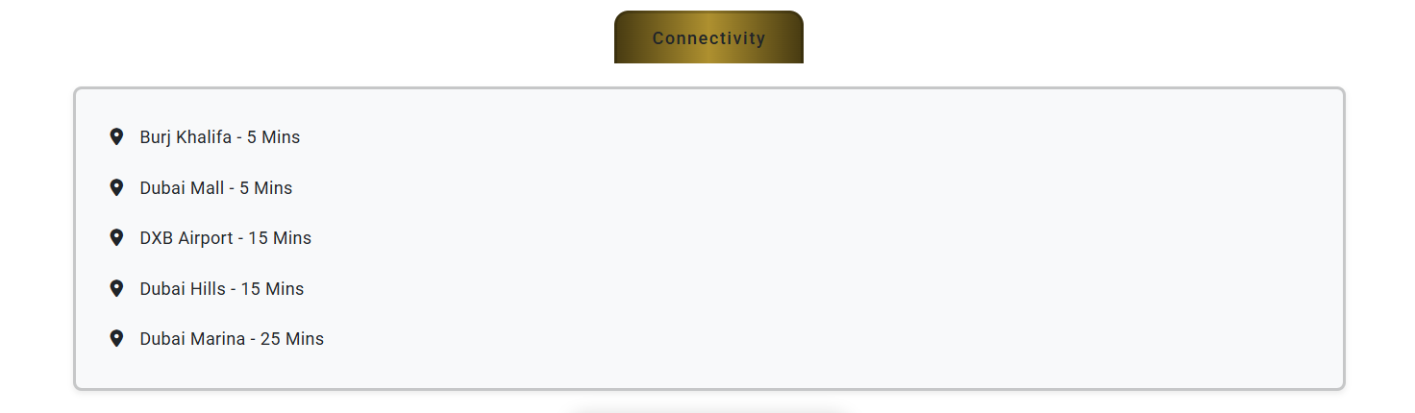  
  
  
Emaar The Oasis - 2 Mins**

**Dubai Mall - 10 Mins**

**Airport - 10 Mins  
Burj Khalifa - 15 Mins**