Understanding Bicycle Theft Risk:

Drawing Correlations Between Bicycle Cost and Risk of Theft Based on Location & Time Factors

CST8390 – 011
Group Project

Meet Ahalpara
Nataliya Burlakov
Krish Patel
Joseph Riel

March 30, 2025

Table of Contents
1.0 Introduction 2
2.0 Business Understanding 3
2.1 Determine Business Objectives 4
2.2 Assess Situation 4
2.3 Determine Data Mining Goals 4
2.4 Produce Project Plan 5
3.0 Data Understanding 6
3.1 Collect Initial Data 7
3.2 Describe Data 8
3.3 Explore Data 10
3.4 Verify Data Quality 14
4.0 Data Preparation 18
4.1 kNN Preparation (Krish Patel) 19
4.1.1 Select Data 19
4.1.2 Clean Data 20
4.1.3 Construct Data 20
4.1.4 Integrate Data 20
4.1.5 Format Data 21
4.2 Decision Tree Preparation (Joseph Riel) 21
4.2.1 Select Data 22
4.2.2 Clean Data 23
4.2.3 Construct Data 23
4.2.4 Integrate Data 25
4.2.5 Format Data 25
4.3 Clustering Preparation (Nataliya Burlakov) 26
4.3.1 Select Data 27
4.3.2 Clean Data 28
4.3.3 Construct Data 28
4.3.4 Integrate Data 28
4.3.5 Format Data 28
4.4 Outlier Detection Preparation (Meet Ahalpara) 29
4.4.1 Select Data 30
4.4.2 Clean Data 31
4.4.3 Construct Data 31
4.4.4 Integrate Data 31
4.4.5 Format Data 31
5.0 Modeling 31
5.1 KNN Modeling 32
5.1.1 Select modeling techniques 32
5.1.2 Generate test design 32
5.1.3 Build model 32
5.1.4 Assess model 33
5.2 Decision Tree Modeling 37
5.2.1 Select modeling techniques 38
5.2.2 Generate test design 38
5.2.3 Build model 38
5.2.4 Assess model 41
5.3 Clustering Modeling 42
5.3.1 Select modeling techniques 42
5.3.2 Generate test design 43
5.3.3 Build model 43
5.3.4 Assess model 44
5.4 Outlier detection Modeling 46
5.4.1 Select modeling techniques 46
5.4.2 Generate test design 47
5.4.3 Build model 47
5.4.4 Assess model 49
6.0 Evaluation 51
6.1 KNN Evaluation 52
6.1.2 Interpret results 55
6.1.3 Review of process 56
6.1.4 Determine next steps 56
6.2 Decision Tree Evaluation 56
6.2.1 Evaluation of Results 57
6.2.2 Interpret results 57
6.2.3 Review of process 58
6.2.4 Determine next steps 58
6.3 Clustering Evaluation 59
6.3.1 Evaluation results 60
6.3.2 Interpret results 64
6.3.3 Review of process 65
6.3.4 Determine next steps 66
6.4 Outlier detection Evaluation 66
6.4.1 Evaluation results 67
6.4.2 Interpret results 67
6.4.3 Review of process 70
6.4.4 Determine next steps 71
7.0 Conclusion 72

Introduction
Bicycle theft is a common issue in many urban areas and understanding where and when thefts occur can help prevent these crimes. This study analyzes bicycle theft data from the Toronto Police Service Open Data Portal to identify patterns and risk factors.
The dataset contains key details for each reported theft, such as date, time, location, and bicycle attributes (e.g., make, model, color, and cost). Some data points were adjusted for privacy. To better understand theft trends, we apply various data models: including K-Nearest Neighbors (KNN), Decision Trees, Clustering, and Outlier Detection. These models help uncover key factors influencing bicycle theft, such as high-risk locations, common theft times, frequently stolen bicycle types, and unusual theft patterns.

2.0 Business Understanding

2.1 Determine Business Objectives
The objective of this analysis is to examine bicycle thefts incidents reported by the Toronto Police Service from 2014 to 2024. By identifying thefts patterns related to locations, times, and bike attributes, the findings will help in crime prevention and bike recovery efforts.

2.2 Assess Situation
- Determine the Availability of Resorces
  - The Toronto Police Service provides publicly available data on bicycle thefts through the Open Data Portal.
  - The dataset covers 10 years (2014-2024), detailing theft locations, bike types, premises types, and case statuses.
  - The data can be used to classify theft risks and detect trends over time.
- Assess Risks
Key risks related to bicycle theft in Toronto include:
- High-Theft Locations - Outdoor spaces and apartments tend to experience higher theft rates.
- Bike Value and Targeting - Expensive bikes may be stolen more frequently. Data classification into Low, Medium, and High-cost categories can help analyze this trend.
- Seasonal Trends - Theft rates may increase during warmer months when bike usage is higher.
- Contingency Plans for Risks
To mitigate these risks, the following measures should be considered:
- Increase secure bike parking facilities in high-risk areas (e.g., commercial zones, apartments).
- Encourage more detailed reporting, including whether bikes were locked or registered.

2.3 Determine Data Mining Goals
- Build a model to analyze how bike theft risk varies across different cost classes (Low, Medium, High) based on location, time, and date factors.
- Identify key factors that influence bike theft, such as high-risk locations, peak theft hours, and seasonal trends.
- Use outlier detection to find unusual theft activity.
- Provide insights into how these patterns can help cyclists and policymakers improve theft prevention strategies.
Models to Apply:
- k-Nearest Neighbors (kNN): Classify theft risk based on location and bike attributes.
- Decision Trees: Identify rules (e.g., "IF bike cost > $1,000 AND location = transit station THEN high risk").
- Clustering: Group thefts with similar spatial/temporal patterns.
- Outlier Detection: Flag anomalies (e.g., high-cost bikes stolen in low-risk zones).

The analysis will answer critical questions about theft patterns using models like kNN and clustering. For example, decision trees will reveal actionable rules for high-risk scenarios, while outlier detection flags unusual cases needing further investigation.

2.4 Produce Project Plan
Phases:
- Data Preparation: Clean data, handle missing values, sample 10,000 records (seed=1992).
- Model Development: Build and validate kNN, Decision Trees, Clustering, and Outlier Detection models.
- Analysis: Extract trends (e.g., peak theft times, high-risk zones).
- Reporting: Deliver insights via visualizations (maps, heatmaps) and stakeholder recommendations.

Team Roles:
- Krish Patel: kNN model preparation – classifying theft risk based on bike attributes and location.
- Joseph Riel: Decision Tree model preparation – establishing rules for theft prediction.
- Nataliya Burlakov: Clustering analysis – grouping theft incidents with similar characteristics.
- Meet Ahalpara: Outlier detection – identifying unusual or anomalous theft incidents.
The project follows a structured timeline, aligning with CRISP-DM phases. Success is measured by model accuracy and actionable insights. Team roles are clearly defined to ensure efficient execution, with key deliverables including visualizations, risk assessments, and predictive models.

3.0 Data Understanding

3.1 Collect Initial Data
The dataset was obtained from the Toronto Police Service Open Data Portal (Bicycle Thefts - City of Toronto Open Data Portal).
It contains records of reported bicycle theft incidents across Toronto, including those where the exact location could not be verified. The dataset contains Bicycle Theft occurrences from 2014 to 2024.
Key considerations during data collection:
- The dataset does not include occurrences that have been deemed unfounded.
- The location of crime occurrences has been deliberately offset to the nearest road intersection node to protect the privacy of parties involved in the occurrence.
- Some records may not have been fully verified at the time of publication.
Data Formatting Issue and Resolution:
The dataset was initially provided as a CSV file, but an issue was identified where two columns were incorrectly merged. Upon investigation, the original .txt file was explored, revealing the presence of unnecessary escape characters (\), which caused incorrect parsing of column values.
To resolve this issue:
- The .txt file was reviewed, and the escape characters (\) were identified as the cause of the formatting error.
- The incorrect characters were removed, ensuring proper column separation.
- The cleaned dataset was then saved again as a properly formatted CSV, ensuring that each attribute was correctly assigned for further analysis.
Data Preprocessing in RapidMiner:
The dataset was uploaded into RapidMiner with the “Replace errors with unknown values” setting enabled. This option ensured that any errors in the dataset were replaced with missing values (“?”), preventing import failures due to formatting issues.
Sampling Strategy:
The original dataset contained 37,697 records. To improve processing efficiency while maintaining data representativeness, a random sample of 10,000 records was extracted using a seed value of 1992.

3.2 Describe Data
Meet
Attributes | Description | DataType
_id | Unique row identifier for Open Data database | Integer
EVENT_UNIQUE_ID | Offence Number | Polynominal
PRIMARY_OFFENCE | Primary Offence Type | Polynominal
OCC_DATE | Date of Offence | Date
OCC_YEAR | Year Offence Occurred | Integer
OCC_MONTH | Month Offence Occurred | Polynominal
OCC_DOW | Day of the Month Offence Occurred | Polynominal
OCC_DAY | Day of the Year Offence Occurred | Integer

Krish
Attributes | Description | DataType
OCC_DOY | Day of the year when offence occurred | Integer
OCC_HOUR | Hour of the day when offence occurred | Integer
REPORT_DATE | Date when offence was reported | Date
REPORT_YEAR | Year when offence was reported | Integer
REPORT_MONTH | Month when offence was reported | Polynominal
REPORT_DOW | Day of the week when offence was reported | Polynominal
REPORT_DAY | Day of the year when offence was reported | Integer

Nataliya
Attribute name | Description | Datatype
REPORT_DOY | Day of the Year Offence was Reported | Numerical
REPORT_HOUR | Hour when Offence was Reported | Numerical
DIVISION | Police Division where Offence Occurred | Nominal
LOCATION_TYPE | Location Type of Offence | Nominal
PREMISES_TYPE | Premises Type of Offence | Nominal
BIKE_MAKE | Make of Bicycle | Nominal
BIKE_MODEL | Model of Bicycle | Nominal
BIKE_TYPE | Type of Bicycle | Nominal
Joseph
Attribute Name | Description | Datatype
BIKE_SPEED | Speed of Bicycle | Numerical
BIKE_COLOUR | Colour of bicycle | Nominal
BIKE_COST | Cost of bicycle (assumed in CAD) | Numerical
STATUS | Status of bicycle (Stolen, Recovered, Unknown) | Nominal
LONG_WGS84 | Longitude coordinate | Numerical
LAT_WGS84 | Latitude coordinate | Numerical
geometry | Unknown JSON object | Nominal

3.3 Explore Data
Meet
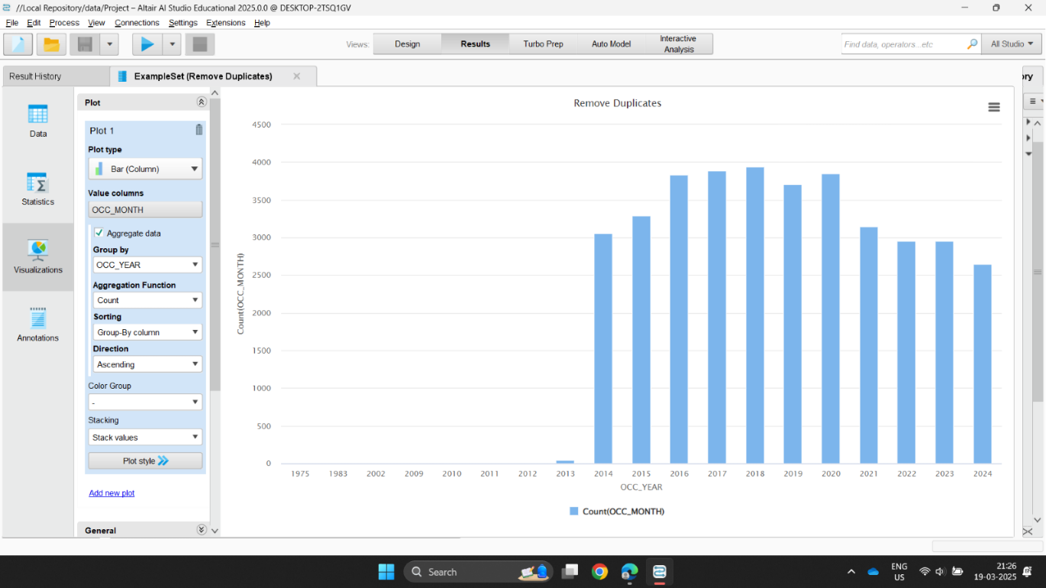
- Incidents peaked between 2016 and 2018, showing a higher number of reported cases during those years.
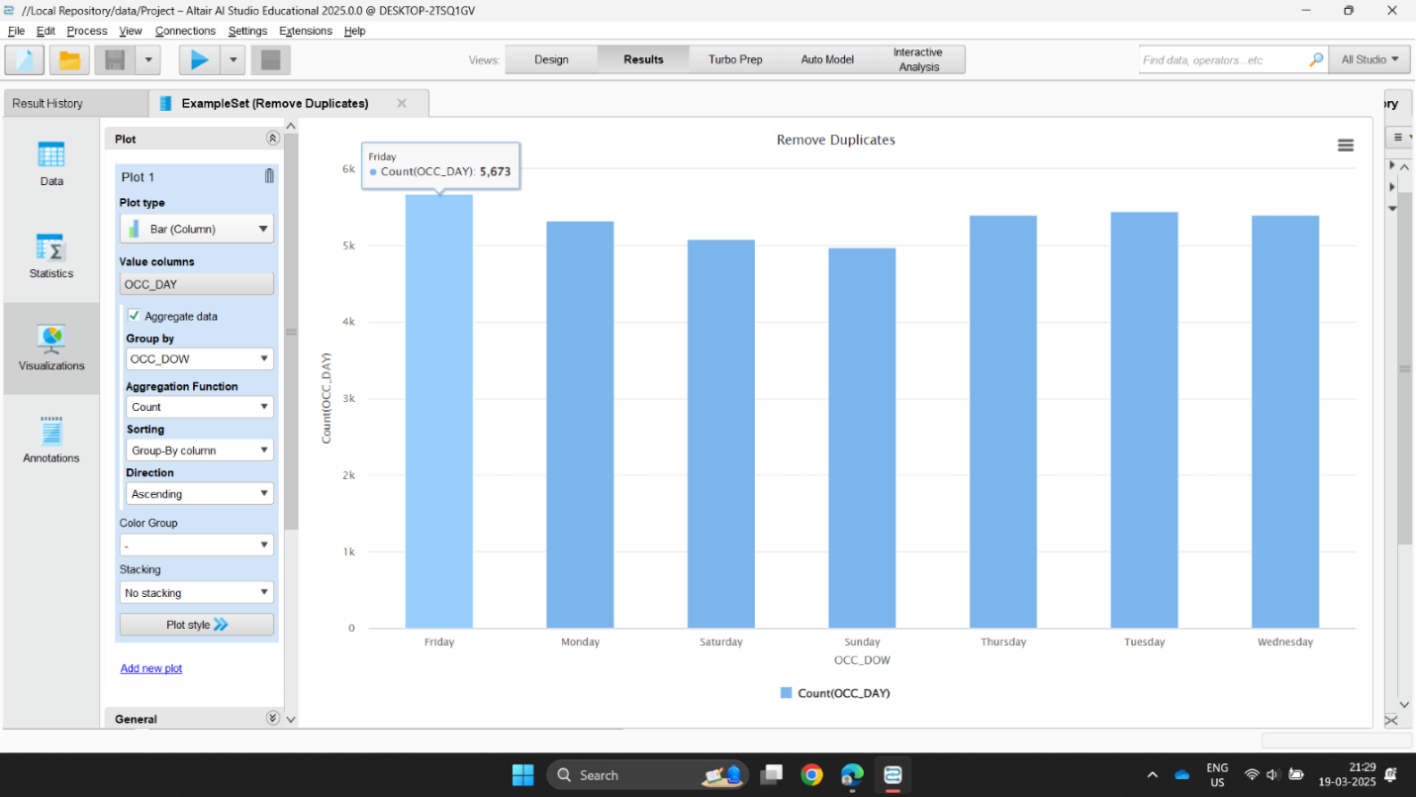
- Fridays recorded the most incidents, suggesting increased theft or accident activity closer to the weekend.
Krish
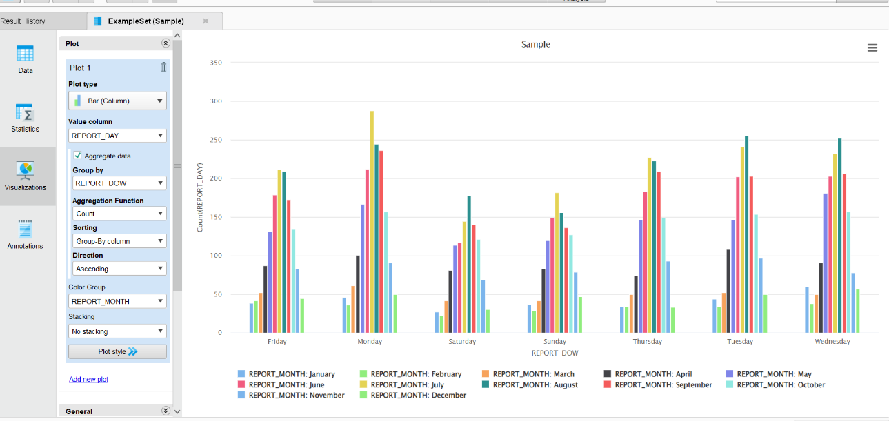
- Most theft reports happen on weekdays across all months, with July and August showing consistently higher counts than other months.
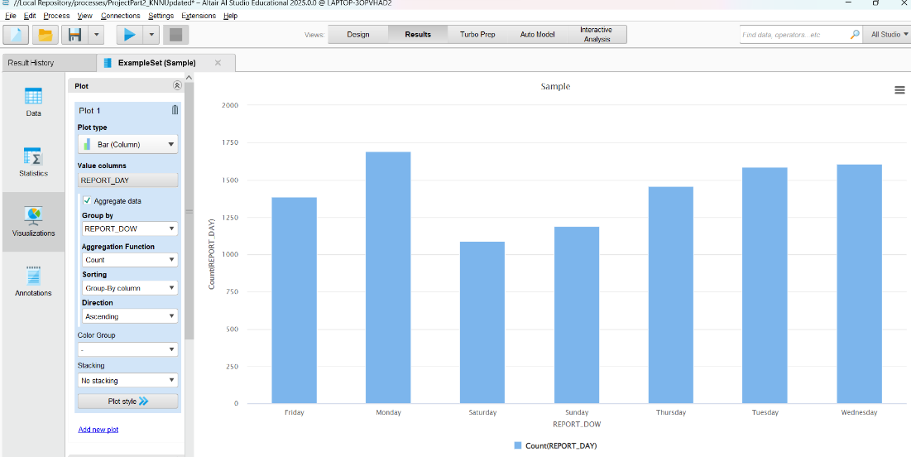
- More bicycle thefts are reported on weekdays, especially Monday to Wednesday, while weekends have fewer reports.

Nataliya
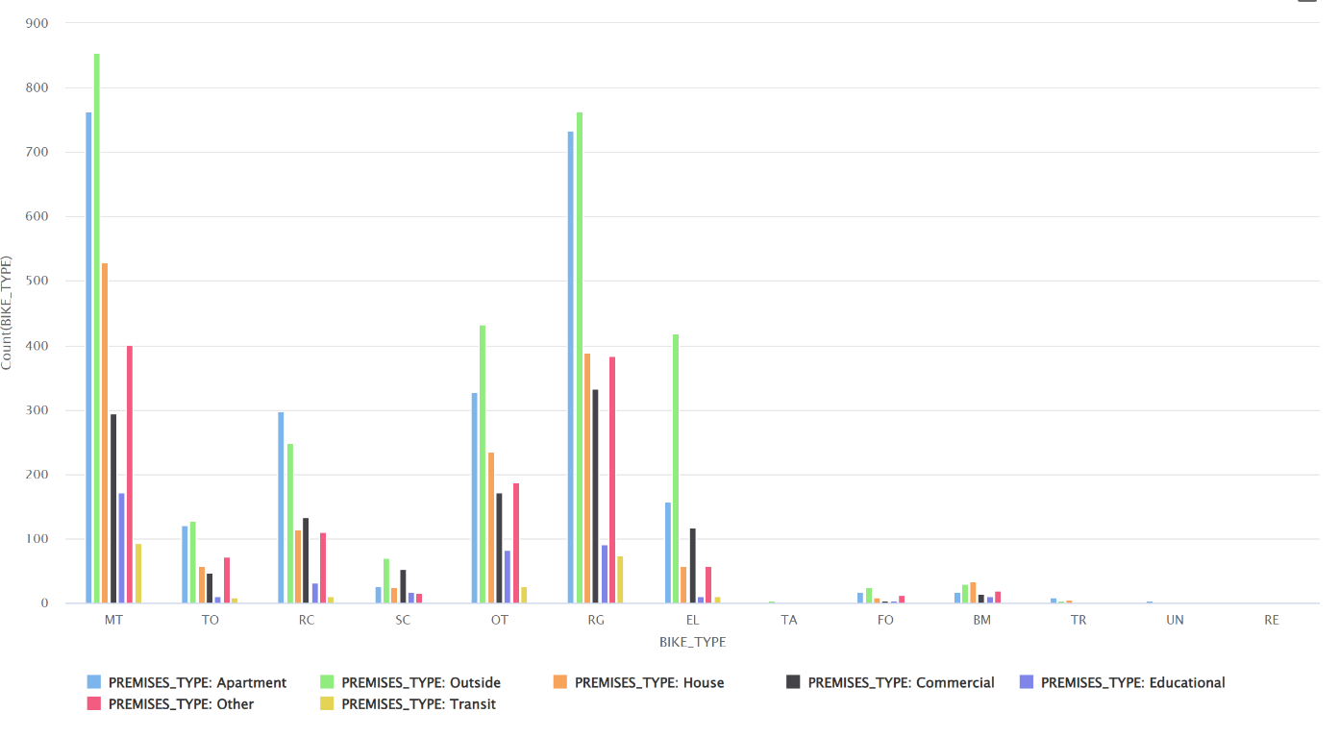
Key Observations:
- Some bike types (MT, RG) are stolen more often than others.
- Outside locations and apartments account for the highest theft counts.
- Educational and transit premises have lower theft rates.

Joseph
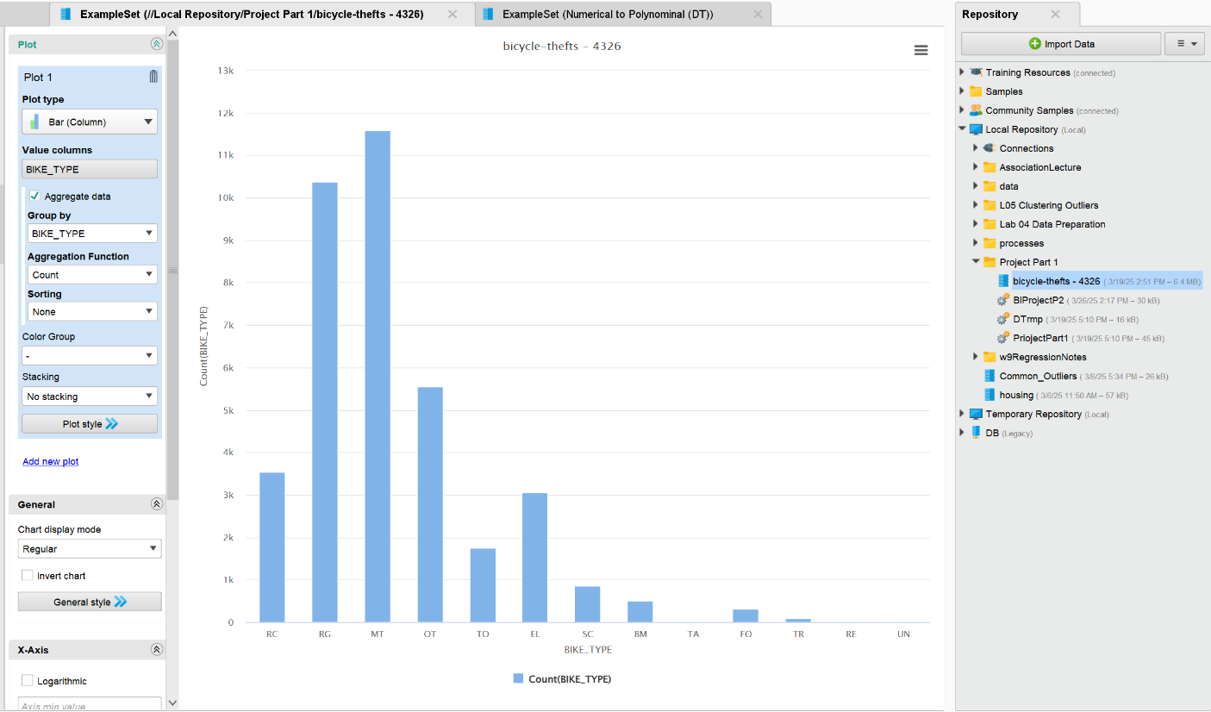
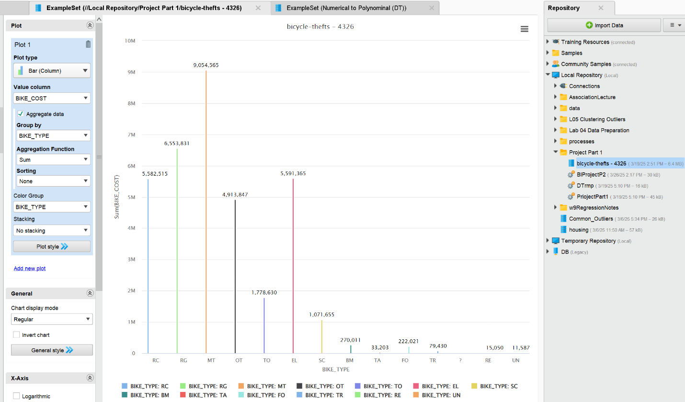
Key Observations:
- Mountain bikes (MT) and Road/Gravel (RG) bikes are by far the most stolen bikes, doubling the next closest BIKE_TYPE, which is OT (Other)
- Similarly, the combined cost of theft for mountain bikes (MT) and road/gravel bikes (RG) total $15,608,386, which accounts for nearly half of the value of all bike thefts

3.4 Verify Data Quality
To ensure data quality, the following steps were taken:
- Before proceeding with data sampling, the dataset was checked for duplicate records, excluding the _id attribute and EVENT_UNIQUE_ID attribute. Duplicates were removed, and the EVENT_UNIQUE_ID column was then restored to the dataset.
- After duplicate removal, a random sample of 10,000 records was extracted from the dataset.
- The BIKE_COST_CLASS column was created to categorize bicycles into three cost-based classes - “Low”, “Medium”, and “High” - based on their BIKE_COST value.
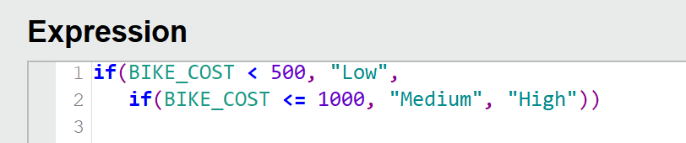

Meet
Attribute Name | Number of Missing Values/ Duplicates | Data Quality Issue | Data Preparation Step
_id | 399 Duplicates | Duplicate records | Removed duplicates by excluding _id
EVENT_UNIQUE_ID | 2 Duplicates (if _id excluded) | Minor duplicate records | Removed duplicates by excluding EVENT_UNIQUE_ID
PRIMARY_OFFENCE | 0 | No issues | No changes required
OCC_DATE | 0 | No issues | No changes required
OCC_YEAR | 0 | No issues | No changes required
OCC_MONTH | 0 | No issues | No changes required
OCC_DOW | 0 | No issues | No changes required
OCC_DAY | 0 | No issues | No changes required

Krish
Attribute Name | Number of Missing Values / Duplicates | Data Quality Issue | Data Preparation
OCC_DOY | 0 missing | No issues | No changes required
OCC_HOUR | 0 missing | No issues | No changes required
REPORT_DATE | 0 missing | No issues | No changes required
REPORT_YEAR | 0 missing | No issues | No changes required
REPORT_MONTH | 0 missing | No issues | No changes required
REPORT_DOW | 0 missing | No issues | No changes required
REPORT_DAY | 0 missing | No issues | No changes required

Nataliya
Attribute name | Number of Missing Values | Data Quality Issue | Data Preparation
REPORT_DOY | 0 | No issues
REPORT_HOUR | 0 | No issues
DIVISION | 0 | No issues
LOCATION_TYPE | 0 | No issues
PREMISES_TYPE | 0 | No issues
BIKE_MAKE | 0 | “?” | Replaced by “UNKNOWN”
BIKE_MODEL | 3 | “?”  “None” inconsistent representation | Replaced by “UNKNOWN”  Replaced by “NONE”  Missing data replaced by “UNKNOWN”
BIKE_TYPE | 4 | No issues | Missing data replaced by “UNKNOWN”

Joseph
Attribute Name | Missing Values | Data Quality Issue | Data Preparation
BIKE_SPEED | 1296 | “?” | Replaced with “UKNOWN”
BIKE_COLOUR | 15 | “?”  “NONE” | Replaced with “UNKNOWN” because there is already “UNKNOWN” value
BIKE_COST | 4365 | “?” | Replaced with Average
STATUS | 15 | “?” | Replaced with “UNKNOWN”
LONG_WGS84 | 348 | “?” | Replaced with Average
LAT_WGS84 | 348 | “?” | Replaced with Average
Geometry | 15 | Unusable | Removed geometry Attribute

Correlation Matrix
A Correlation Matrix was used to measure and analyze the relationships between numerical variables in dataset. In helps in understanding how one variable influence another.
Correlation matrix of dataset:
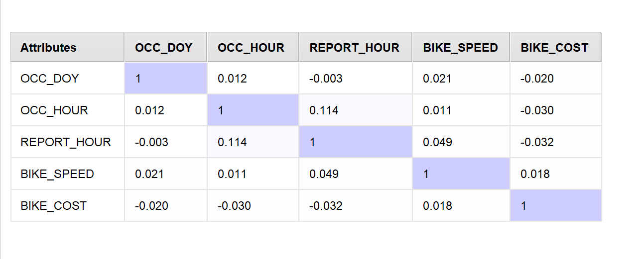
Correlation values range from –1 to 1:
- 1.0: Perfect positive correlation (both variables increase together).
- -1.0: Perfect negative correlation (one increases while the other decreases).
- 0: No correlation (the variables do not affect each other).
Results:
- Positive Correlations:
  - OCC_HOUR and REPORT_HOUR (0.114) - when a theft occurs at a certain hour, it is likely to be reported around same time.
  - BIKE_SPEED and REPORT_HOUR (0.0487) - higher-speed bikes show a slight tendency to be reported at later hours.
  - OCC_DOY and BIKE_SPEED (0.0209) - slight connection between theft day and bike speed, but almost negligible.
  - OCC_DOY and OCC_HOUR (0.0116) - weak relationship between when in the year a bike theft happens and the hour of the day.
  - BIKE_SPEED and BIKE_COST (0.0182) - higher-speed bikes may cost slightly more, but the correlation is very weak.
- Negative Correlation
  - BIKE_COST and OCC_HOUR (-0.0301) - cost might not strongly depend on when the theft occurs.
  - REPORT_HOUR and BIKE_COST (-0.0323) - expensive bikes might be reported slightly less at later hours.
  - OCC_DOY and BIKE_COST (0.0198) - no strong pattern between theft day and bike cost.
  - REPORT_HOUR and OCC_DAY (0.0031) - practically no relationship between theft day and the hour it was reported.
- Weak or No Correlation:
  - All values are close to 0, indicating no strong relationships between those variables.

Association Rules
Association rule mining was applied to the bicycle theft dataset from the Toronto Police Service to identify patterns and relationships between different attributes. The goal was to generate meaningful association rules that could help understand the circumstances surrounding bicycle theft incidents.

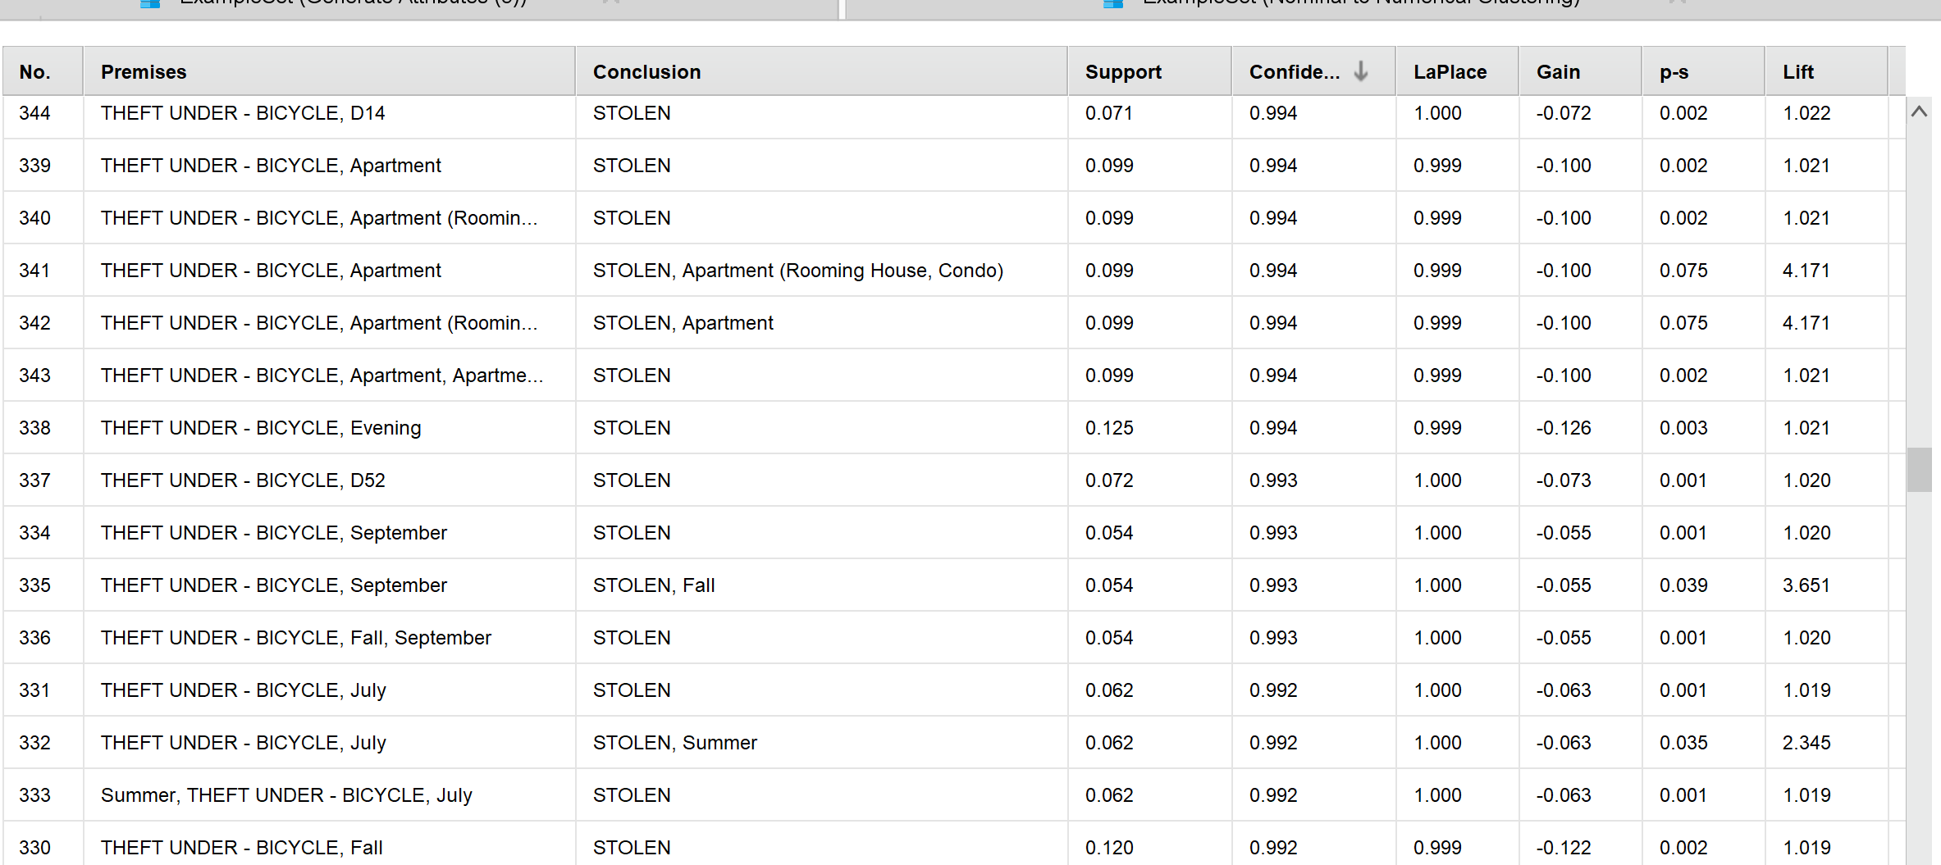
The analysis revealed strong associations between theft incidents and specific locations, such as “Apartments” and “Streets”.
Additionally, seasonal trends were observed, with thefts occurring more frequently in Summer and Fall, indicating that warmer months may present higher risks for bicycle thefts.
Furthermore, certain police divisions showed frequent patterns of bicycle theft, indicating that thefts are more common in specific areas.

4.0 Data Preparation

4.1 kNN Preparation (Krish Patel)
k-Nearest Neighbors (kNN) is a distance-based classification algorithm that predicts class labels by comparing a data point to its closest neighbors in the feature space. In this project, kNN is used to classify bike cost category (Low, Medium, High) using features related to bike characteristics, theft context, and time of occurrence. The aim is to detect meaningful theft patterns that help anticipate the likelihood of a bike belonging to a certain cost group thereby supporting crime prevention and investigation strategies.

4.1.1 Select Data
Attribute Name | Description | Relevancy
_id | Unique row ID; used only for record tracking, not helpful for prediction | Irrelevant
EVENT_UNIQUE_ID | Case-specific ID; no meaningful pattern for theft value | Irrelevant
PRIMARY_OFFENCE | All offences are related to bike theft; no variation | Irrelevant
OCC_DATE | Redundant; same info captured in year, month, hour, etc. | Irrelevant
OCC_YEAR | Helps detect long-term shifts in bike value over years | Relevant
OCC_MONTH | Can show seasonal trends in high- or low-cost bike theft | Relevant
OCC_DOW | Day of week doesn’t impact cost class prediction | Irrelevant
OCC_DAY | Exact day of month doesn’t add meaningful pattern | Irrelevant
OCC_DOY | Useful to spot yearly trends but decrease the performance | Irrelevant
OCC_HOUR | Important to know if cost varies by time (night/day) | Relevant
REPORT_DATE | Reporting date isn’t related to theft value | Irrelevant
REPORT_YEAR | Not useful since we care about when bike was stolen | Irrelevant
REPORT_MONTH | Doesn’t reflect when theft occurred | Irrelevant
REPORT_DOW | Report day of week doesn't help predict bike cost | Irrelevant
REPORT_DAY | Same reason — only shows reporting pattern, not theft value | Irrelevant
REPORT_HOUR | Reporting time isn’t useful for predicting value | Irrelevant
DIVISION | Tested and improve model | Relevant
LOCATION_TYPE | Overlaps with PREMISES_TYPE (more general) | Irrelevant
PREMISES_TYPE | Indicates theft context (e.g., private vs. public) | Relevant
BIKE_MAKE | Brand is strongly tied to value/cost of bike | Relevant
BIKE_MODEL | Too many unique models; hard for kNN | Irrelevant
BIKE_TYPE | Type (mountain, road) affects cost | Relevant
BIKE_SPEED | Higher-speed bikes often mean higher cost | Relevant
BIKE_COLOUR | Slight relevance; kept for visual value cues | Relevant
BIKE_COST | Replaced by BIKE_COST_CLASS — not needed | Irrelevant
BIKE_COST_CLASS | Target variable (Low, Medium, High) | Relevant
STATUS | May show if bike was recovered, included for testing | Relevant
LONG_WGS84 | Coordinates not needed; division/location already used | Irrelevant
LAT_WGS84 | Same as above — adds redundancy | Irrelevant

4.1.2 Clean Data
- Removed duplicate records based on _id and EVENT_UNIQUE_ID
- Replaced missing values in numerical columns (e.g., BIKE_SPEED) with the average value
- Replaced missing values in text columns (e.g., BIKE_MAKE, BIKE_COLOUR) with "UNKNOWN"
- Removed columns that were not useful for prediction
- Only the selected attributes were kept for the model

4.1.3 Construct Data
To improve model performance, two new columns were created:
- OCC_DAY_TIME: This was created by grouping OCC_HOUR into four categories: Morning, Afternoon, Evening, and Night. It helped capture time-of-day patterns in bike thefts.
- OCC_SEASON: This was created by grouping OCC_MONTH into four seasons: Winter, Spring, Summer, and Fall. It made it easier for the model to learn seasonal trends.
These constructed features replaced OCC_HOUR and OCC_MONTH and helped improve accuracy when tested with k = 9.

4.1.4 Integrate Data
No data integration was required

4.1.5 Format Data
The data was prepared to be compatible with the k-NN algorithm through the following steps:
- Numerical attributes (e.g., BIKE_SPEED, OCC_YEAR) were normalized to a common scale so that no single attribute had a stronger influence due to its range.
- Categorical attributes (e.g., BIKE_TYPE, PREMISES_TYPE, OCC_DAY_TIME, OCC_SEASON) were converted into numerical format using Nominal to Numerical encoding.
- The class label BIKE_COST_CLASS was set as the target attribute for classification.

4.2 Decision Tree Preparation (Joseph Riel)
A Decision Tree is a supervised machine learning algorithm used for both classification and regression tasks. It mimics a tree-like structure where each internal node represents a decision based on a feature, each branch represents an outcome, and each leaf node represents a final prediction. The model splits data into subsets based on feature values, making decisions step-by-step until it reaches a conclusion. Decision Trees are easy to interpret and visualize, making them popular for tasks like customer segmentation, medical diagnosis, and fraud detection.

4.2.1 Select Data
Attribute Name | Description | Relevancy
EVENT_UNIQUE_ID | Unique identifier; not used for analysis or modeling for DT models (too many records) | Irrelevant
BIKE_COST_CLASS | Class column, used in DT model to predict correlation between cost and theft | Relevant
PRIMARY_OFFENCE | Text label of offence; converted to number for modeling. | Irrelevant
DIVISION | The division are of the police where the theft occurred in. Too complex to assume and bin so discarded | Irrelevant
OCC_DATE | Original date column, replaced by granular parts (day, hour, etc.) | Irrelevant
OCC_YEAR | Year of occurrence; Not used directly in DT model. | Irrelevant
OCC_MONTH | Month-level seasonality; Used to determine whether was withing covid timeline | Relevant
OCC_DOW | Day of the week; Used to determine weekday/weekend | Relevant
OCC_DAY | Day of the month; used for binning in DT Model | Relevant
OCC_DOY | Day of the year (1–365); Unused in DT Model | Irrelevant
OCC_HOUR | Hour of the day; detects peak theft timing. | Relevant
REPORT_DATE | Full report date; redundant due to split columns. | Irrelevant
REPORT_YEAR | Reported year; included in DT model. | Irrelevant
REPORT_MONTH | Month reported; included in DT model | Irrelevant
REPORT_DOW | Day of week reporting; not useful for theft pattern detection. | Irrelevant
REPORT_DAY | Reported day of month; unused for DT model | Irrelevant
REPORT_DOY | Reported day of year; Unused in DT model | Irrelevant
REPORT_HOUR | Reported time; sometimes helps identify delayed reports. | Irrelevant
DIVISION | Used to indicate general location; not in model. | Relevant
LOCATION_TYPE | Where the theft happened, more specific than PREMISIS_TYPE. Removed because too specific and already grouped into PREMESIS_TYPE | Irrelevant
PREMISES_TYPE | Where the theft happened; Used because LOCATION_TYPE already grouped into PREMESIS_TYPE | Irrelevant
BIKE_MAKE | Brand of bike; no impact on location or cost. | Irrelevant
BIKE_MODEL | Specific bike model; not consistent or complete. | Irrelevant
BIKE_TYPE | Type of bike (MTB, road, etc.); useful for classification. | Relevant
BIKE_SPEED | Numeric speed indicator of stolen bike. | Irrelevant
BIKE_COLOUR | Not meaningful for pattern or numeric modeling. | Irrelevant
BIKE_COST | Original cost of the bike; included directly in model. | Irrelevant
STATUS | All values are “STOLEN”; no variance to learn from. | Relevant
LONG_WGS84 | Longitude coordinate; used in outlier model. | Irrelevant
LAT_WGS84 | Latitude coordinate; used in outlier model. | Irrelevant

- Removed irrelevant attributes: OCC_DATE, OCC_DOY, REPORT_DATE, REPORT_DOY, LONG_WGS84, LAT_WGS84, BIKE_SPEED, LOCATION_TYPE

4.2.2 Clean Data
- For BIKE_COLOUR, converted instances where the values = 18 and “None” to “UNKNOWN” as there were already “UNKNOWN” values present for this attribute
- Checked for missing numeric values and replaced with the average if they occurred
- Checked for missing nominal values and replaced with “UNKNOWN” for values that occurred

4.2.3 Construct Data
- BIKE_TARGET was constructed from the BIKE_TYPE (which was formatted to be more detailed). It groups bikes based on how popular a target for theft they were.
if(BIKE_TYPE == "MOUNTAIN BIKE"
|| BIKE_TYPE == "ROAD/GRAVEL BIKE"
|| BIKE_TYPE == "RACE BIKE"
|| BIKE_TYPE == "TOURING BIKE", "COMMON TARGETS",
if(BIKE_TYPE == "TANDEM BIKE"
|| BIKE_TYPE == "FOLDING BIKE"
|| BIKE_TYPE == "BMX BIKE"
|| BIKE_TYPE == "TREKKING/TRAIL BIKE"
|| BIKE_TYPE == "RECUMBENT BIKE", "UNCOMMON TARGETS",
if(BIKE_TYPE == "ELECTRIC BIKE"
|| BIKE_TYPE == "SCOOTER/SMALL COMMUTER BIKE", "ELECTRIC TARGETS",
if(BIKE_TYPE == "OTHER"
|| BIKE_TYPE == "UNKNOWN", "UNKNOWN/OTHER TARGETS",
"UNKNOWN/OTHER TARGETS"))))
- DAY_PART was created from OCC_HOUR, and breaks the day up into “Morning”, “Afternoon”, “Evening”, “Night”
if(OCC_HOUR >= 6 && OCC_HOUR < 12, "Morning",
if(OCC_HOUR >= 12 && OCC_HOUR < 18, "Afternoon",
if(OCC_HOUR >= 18 && OCC_HOUR < 21, "Evening",
if(OCC_HOUR >= 21 || OCC_HOUR < 6, "Night", "UNKNOWN"))))
- WEEK_PART was created from OCC_DOW and breaks the week into “Weekday” or “Weekend”
if(OCC_DOW == "MONDAY"
|| OCC_DOW == "TUESDAY"
|| OCC_DOW == "WEDNESDAY"
|| OCC_DOW == "THURSDAY"
|| OCC_DOW == "FRIDAY", "WEEKDAY",
if(OCC_DOW == "SATURDAY"
|| OCC_DOW == "SUNDAY", "WEEKEND", "UNKNOWN")
)
- MONTH_PART was created from OCC_DAY and breaks the month into “Early-Month”, “Mid-Month”, and ”Late-Month”
if(OCC_DAY > 20, "LATE-MONTH", if(OCC_DAY > 10, "MID-MONTH", "EARLY-MONTH"))
- Created the attribute DAY_PART that splits the occurrence hour (OCC_HOUR) into a specific time of the day (OCC_HOUR):
  - If OCC_HOUR is between 06:00-11:59 then “Morning”
  - If OCC_HOUR is between 12:00-17:59 then “Afternoon”
  - If OCC_HOUR is between 18:00-20:59 then “Evening”
  - If OCC_HOUR is between 21:00-05:59 then “Night”
- Created VIOLENT_CRIME attribute that determines from PRIMARY_OFFENCE whether the crime was violent or not when the theft occurred
- Created COVID_LOCKDOWN attribute that determines from OCC_MONTH and OCC_YEAR whether the theft happened inside or outside COVID times

4.2.4 Integrate Data
No data integration was required

4.2.5 Format Data
- BIKE_TYPE names were converted from two letter abbreviations to names that best represented those abbreviations using this formula (too large to screenshot):
if(BIKE_TYPE == "MT", "MOUNTAIN BIKE",
if(BIKE_TYPE == "RG", "ROAD/GRAVEL BIKE",
if(BIKE_TYPE == "OT", "OTHER",
if(BIKE_TYPE == "RC", "RACE BIKE",
if(BIKE_TYPE == "EL", "ELECTRIC BIKE",
if(BIKE_TYPE == "TO", "TOURING BIKE",
if(BIKE_TYPE == "SC", "SCOOTER/SMALL COMMUTER BIKE",
if(BIKE_TYPE == "BM", "BMX BIKE",
if(BIKE_TYPE == "FO", "FOLDING BIKE",
if(BIKE_TYPE == "TR", "TREKKING/TRAIL BIKE",
if(BIKE_TYPE == "TA", "TANDEM BIKE",
if(BIKE_TYPE == "RE", "RECUMBENT BIKE",
if(BIKE_TYPE == "UN", "UNKNOWN",
"UNKNOWN")))))))))))))

4.3 Clustering Preparation (Nataliya Burlakov)
Clustering is an unsupervised machine learning technique used to group similar data points based on shared characteristics. The goal is to identify patterns in the data without predefined labels. In the current dataset, clustering can be applied to group similar bicycle theft incidents based on factors such as theft location, time of occurrence, and types of stolen bicycles.

4.3.1 Select Data
The following attributes were selected to identify patterns in theft incidents:
Attribute name | Description | Relevancy
EVENT_UNIQUE_ID | A unique identifier that has no relationship to thefts. | irrelevant
BIKE_COST_CLASS | Class label changed to regular | relevant
PRIMARY_OFFENCE | Offence-category, not relevant to time and location pattern | irrelevant
OCC_DATE | Redundancy, | irrelevant
OCC_YEAR | Useful for detecting long-term trends | relevant
OCC_MONTH | Captures seasonal trends | relevant
OCC_DOW | Helps identify day of the week theft occurred | relevant
OCC_DAY | Helps identify daily trends | relevant
OCC_DOY | Helps track yearly theft patterns | relevant
OCC_HOUR | Critical for spotting peak theft times | relevant
REPORT_DATE | The reported date is not relevant for analysis | irrelevant
REPORT_YEAR | The reported year is not relevant for analysis | irrelevant
REPORT_MONTH | The reported month is not relevant for analysis | irrelevant
REPORT_DOW | The reported day of the week is not relevant for analysis | irrelevant
REPORT_DAY | The reported day is not relevant for analysis | irrelevant
REPORT_DOY | The reported day of the year is not relevant for analysis | irrelevant
REPORT_HOUR | The reported hour is not relevant for analysis | irrelevant
DIVISION | Helps identify the division where the theft occurred | relevant
LOCATION_TYPE | Type of location. Redundant since “PREMISES_TYPE” is available | irrelevant
PREMISES_TYPE | Helps understand the theft context | relevant
BIKE_MAKE | Not relevant to analysis | irrelevant
BIKE_MODEL | Not relevant to analysis | irrelevant
BIKE_TYPE | Helps identify the bike type | relevant
BIKE_SPEED | Helps to identify speed of the bicycle | relevant
BIKE_COLOUR | Not relevant for analysis | irrelevant
BIKE_COST | Redundant, as “BIKE_COST_CLASS” is selected | irrelevant
STATUS | Not relevant, all bikes were stolen | irrelevant
LONG_WGS84 | Redundant, as the division already provides location information | irrelevant
LAT_WGS84 | Redundant, as the division already provides location information | irrelevant

4.3.2 Clean Data
To ensure data consistency and quality, the following steps were performed:
- Checked for missing values in selected attributes.
Numerical missing values replaced with Average; Nominal values were replaced with “UNKNOWN”
- Checked for duplicate records in selected attributes.
- Checked for consistency through selected attributes.

4.3.3 Construct Data
No new attributes created.

4.3.4 Integrate Data
No integrating of data was done.

4.3.5 Format Data
- Set BIKE_COST_CLASS attribute as Regular.
- Select relevant attributes for analysis: OCC_YEAR, OCC_MONTH, OCC_DOW, OCC_DAY, OCC_DOY, OCC_HOUR, DIVISION, BIKE_TYPE, BIKE_SPEED, BIKE_COST_CLASS and PREMISES_TYPE.
- Numerical attributes were normalized to ensure equal weighting during clustering. Applied Z-transformation normalization to numerical attributes: BIKE_SPEED, OCC_DAY, OCC_DOY, OCC_HOUR, and OCC_YEAR.
- Categorical variables (DIVISION, LOCATION_TYPE, OCC_MONTH, PREMISES_TYPE, BIKE_TYPE, and OCC_DOW) were converted into numerical values to facilitate application of clustering algorithms.

4.4 Outlier Detection Preparation (Meet Ahalpara)
Outlier detection is a crucial step in the data analysis process to identify unusual bicycle theft patterns in Toronto. Detecting anomalies, I can identify thefts that happen at odd times, in unexpected locations, or involve unusually expensive bikes. Below is a structured approach to preparing data for Outlier Detection.

4.4.1 Select Data
Attribute Name | Description | Relevancy
EVENT_UNIQUE_ID | Unique identifier; not used for analysis or modeling. | Irrelevant
BIKE_COST_CLASS | Categorical cost class used earlier; converted to numeric. | Irrelevant
PRIMARY_OFFENCE | Text label of offence; converted to number for modeling. | Irrelevant
OCC_DATE | Original date column, replaced by granular parts (day, hour, etc.) | Irrelevant
OCC_YEAR | Year of occurrence; not used directly in outlier model. | Irrelevant
OCC_MONTH | Month-level seasonality; not selected in final model. | Relevant
OCC_DOW | Day of the week; useful but not used in final outlier model. | Irrelevant
OCC_DAY | Day of the month; used to find theft patterns. | Relevant
OCC_DOY | Day of the year (1–365); helpful for seasonal insight. | Irrelevant
OCC_HOUR | Hour of the day; detects peak theft timing. | Relevant
REPORT_DATE | Full report date; redundant due to split columns. | Irrelevant
REPORT_YEAR | Reported year; included in outlier model. | Irrelevant
REPORT_MONTH | Not used in model; too similar to OCC_MONTH. | Irrelevant
REPORT_DOW | Day of week reporting; not useful for theft pattern detection. | Irrelevant
REPORT_DAY | Reported day of month; used for timing comparison. | Irrelevant
REPORT_DOY | Reported day of year; included in final model. | Irrelevant
REPORT_HOUR | Reported time; sometimes helps identify delayed reports. | Irrelevant
DIVISION | Used to indicate general location; not in model. | Relevant
LOCATION_TYPE | Redundant due to presence of “PREMISES_TYPE”. | Relevant
PREMISES_TYPE | Where the theft happened, can help in analysis. | Relevant
BIKE_MAKE | Brand of bike; no impact on location or cost. | Irrelevant
BIKE_MODEL | Specific bike model; not consistent or complete. | Irrelevant
BIKE_TYPE | Type of bike (MTB, road, etc.); useful for classification. | Irrelevant
BIKE_SPEED | Numeric speed indicator of stolen bike. | Relevant
BIKE_COLOUR | Not meaningful for pattern or numeric modeling. | Irrelevant
BIKE_COST | Original cost of the bike; included directly in model. | Relevant
STATUS | All values are “STOLEN”; no variance to learn from. | Irrelevant
LONG_WGS84 | Longitude coordinate; used in outlier model. | Relevant
LAT_WGS84 | Latitude coordinate; used in outlier model. | Relevant

4.4.2 Clean Data
- Missing data in all attributes was handled by assigning "UNKNOWN” values.
- Duplicate records were removed from the dataset.
- A check was done for any value issues, ensuing data consistency.

4.4.3 Construct Data
- There was no requirement to derive any new attributes from the existing columns.

4.4.4 Integrate Data
No integration data.

4.4.5 Format Data
- Set BIKE_COST_CLASS attribute as Regular, and EVENT_UNIQUE_ID attribute was assigned accordingly.
- Select relevant attributes for analysis: BIKE_COST, BIKE_SPEED, DIVISION, LAT_WGS84, LOCATION_TYPE, LONG_WGS84, OCC_DAY, OCC_HOUR, OCC_MONTH, and PREMISES_TYPE.
- Normalization: Applied Z-transformation normalization to numerical attributes: BIKE_COST, BIKE_SPEED, LAT_WGS84, LONG_WGS84, OCC_DAY, and OCC_HOUR.
- Nominal to Numeric: Converted the Nominal attributes (DIVISION, LOCATION_TYPE, OCC_MONTH, PREMISES_TYPE) into Numeric values by assigning unique integers coding type.

5.0 Modeling

5.1 KNN Modeling

5.1.1 Select modeling techniques
For this project, the k-Nearest Neighbors (k-NN) algorithm was selected as the classification method. k-NN is a distance-based supervised machine learning algorithm that assigns a class to a data point based on the majority class of its k closest neighbors. In this case, the goal was to classify stolen bicycles into cost categories (Low, Medium, High) based on their features and theft context.
The distance metric used was Euclidean distance. This algorithm is suitable for datasets with mixed numerical and categorical features (after conversion), and works well when relationships are based on similarity.

5.1.2 Generate test design
To evaluate the best value for k, the Optimize Parameters (Grid) operator was used in combination with 10-fold Cross Validation. The performance metric used for evaluation was Accuracy.
Steps followed:
- Tested k values from 2 to 10
- Used Cross Validation to avoid overfitting
- Evaluated average performance for each value of k
- Selected the model with highest consistent performance

5.1.3 Build model
The k-Nearest Neighbors (k-NN) classification model was built in RapidMiner using the following process:
- Selected 10 most relevant attributes including bike features, time-based context, and theft environment. Constructed two new attributes:
  - OCC_DAY_TIME (from OCC_HOUR)
  - OCC_SEASON (from OCC_MONTH)
- Normalized all numerical attributes using Z-Transformation to ensure balanced impact in distance-based classification.
- Converted categorical attributes to numerical using the Nominal to Numerical operator for compatibility with k-NN.
- Applied Set Role to define BIKE_COST_CLASS as the target (label) attribute.
- Integrated the k-NN operator into a Cross Validation framework to allow proper evaluation of model performance.
- Wrapped the process in an Optimize Parameters (Grid) operator to automatically test different k values and identify the most accurate model.
- The best result was achieved with k = 9, producing an overall accuracy of 45.07%.

5.1.4 Assess model
The final k-NN model was assessed using a structured evaluation pipeline that included cross-validation and parameter optimization. The performance was measured using accuracy and class-level metrics. Below are the details of how the model was tested and the supporting screenshots.
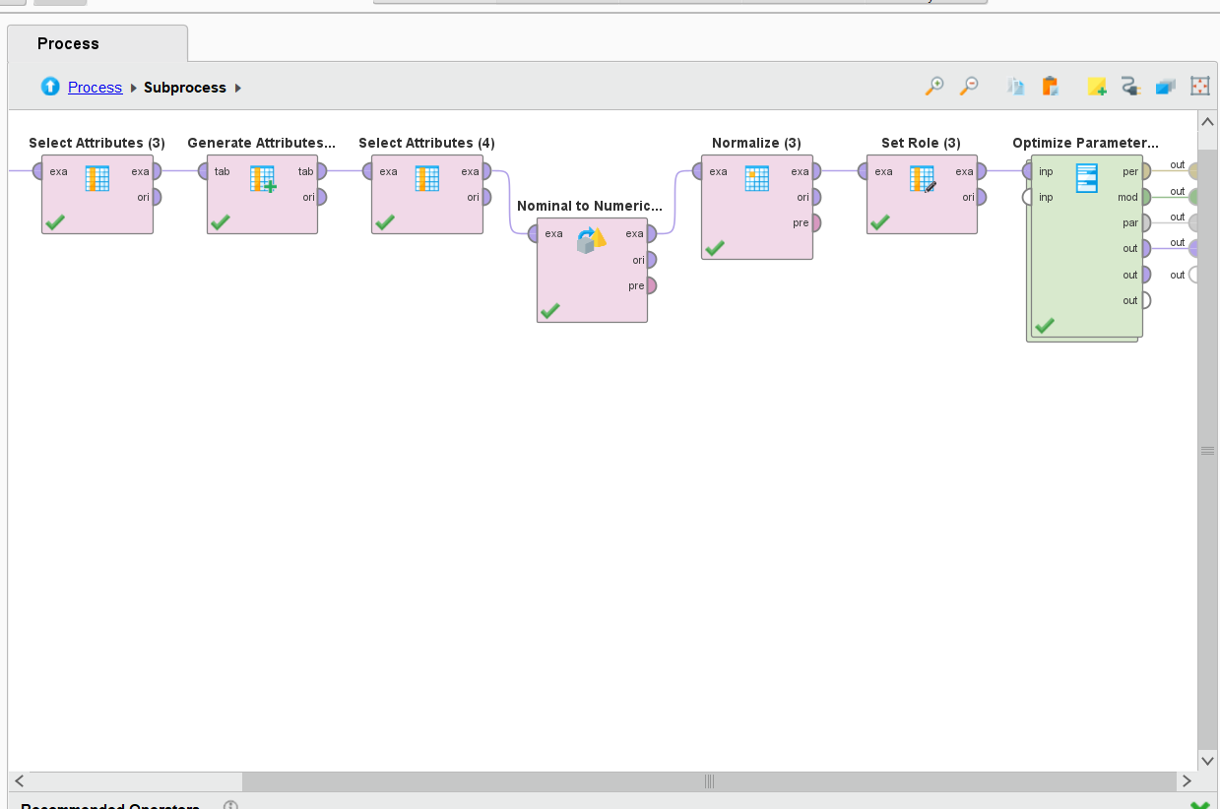

- This screenshot shows the full preprocessing and modeling pipeline used to build the k-NN model. It includes selecting and generating attributes, converting nominal data to numeric, applying normalization, setting the label role (BIKE_COST_CLASS), and finally connecting everything to the Optimize Parameters (Grid) operator. This setup ensures that data is clean, consistent, and ready for training.

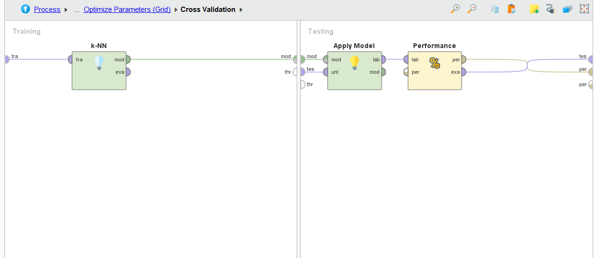

- Inside the Cross Validation process, this screenshot highlights the training and testing structure. The k-NN model is trained on one -fold of the data, then tested on another using Apply Model, and evaluated using the Performance operator. This method prevents overfitting and gives a reliable accuracy score.
- 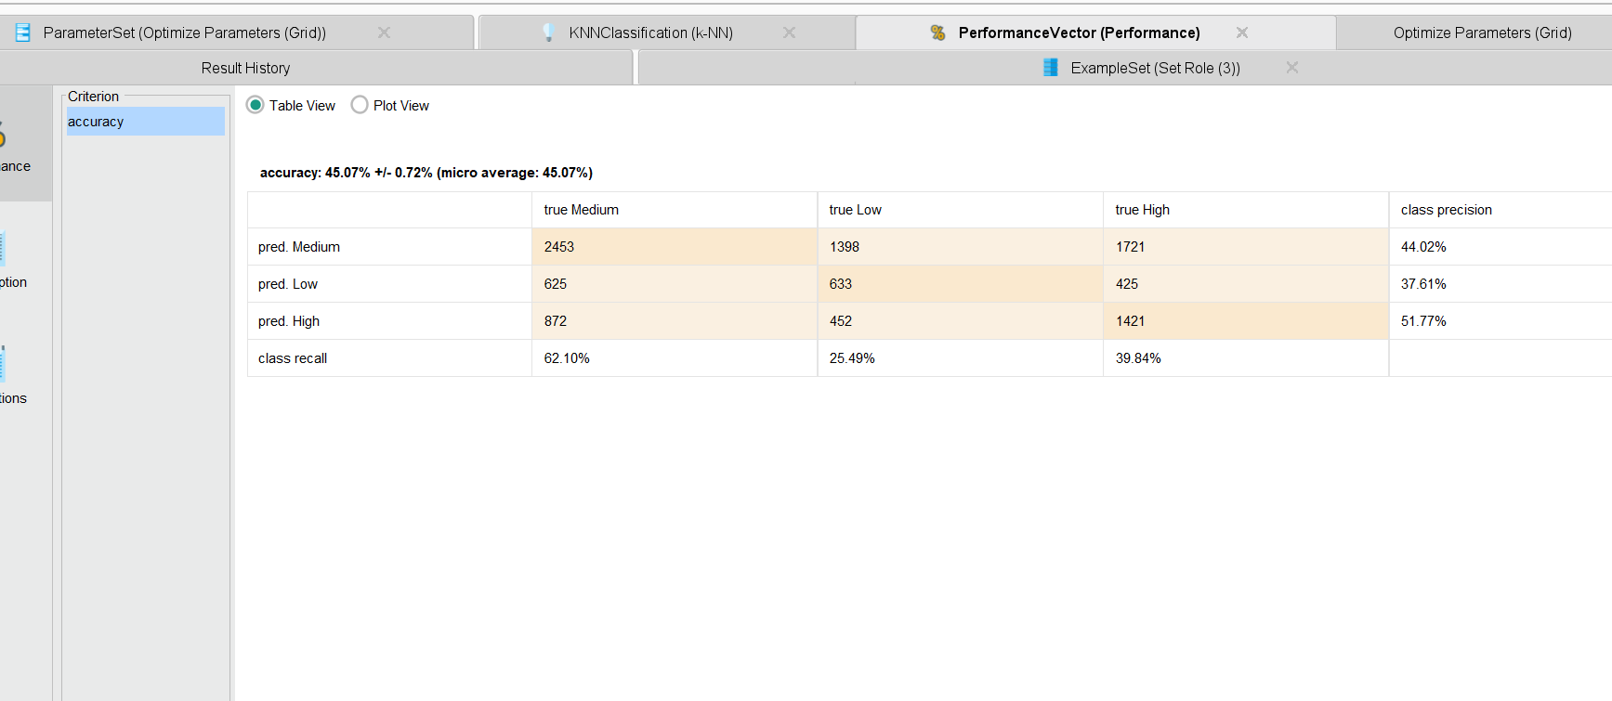

- The final k-NN model used k = 9 and achieved an improved accuracy of 45.07% ± 0.72%, indicating slightly better performance compared to the previous version.
- Among all classes, the model had the highest recall (62.10%) for the medium bike cost category. This means most medium-cost bikes were correctly identified.
- The High-cost category had the best precision (51.77%), showing that when the model predicted high-cost bikes, it was mostly correct.
- The Low class had the lowest precision (37.61%) and recall (25.49%), suggesting more misclassification in this group.

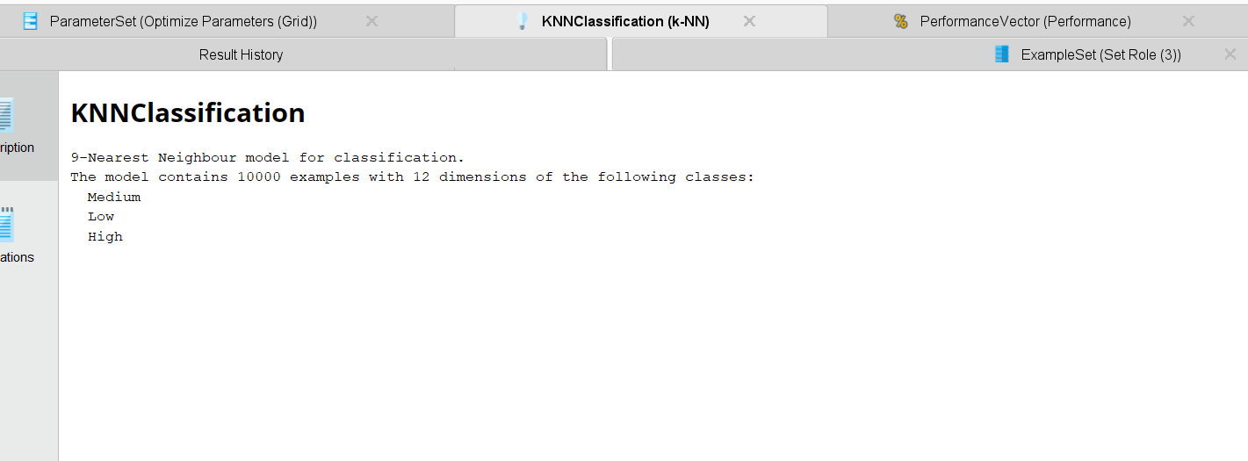

- This final model summary confirms that the selected model is a 9-Nearest Neighbors classifier, trained over 10,000 examples with 12 features. The output also lists the three prediction classes: Low, Medium, and High.
- The final k-NN model used k = 9 and reached an improved accuracy of 45.07%.
- This indicates moderate performance in predicting bike cost categories (Low, Medium, High).
- It had the highest recall (62.10%) for the medium class, meaning it correctly identified most medium-cost bikes.
- The High class had the best precision (51.77%), showing that high-cost bike predictions were the most accurate.
- The model handled class overlap reasonably, balancing between correct identification and misclassifications.
- Overall, the model was able to capture useful patterns when supported by good data prep and attribute selection.

5.2 Decision Tree Modeling

5.2.1 Select modeling techniques
For evaluating nominal/categorical data, both the decision tree and random forest machine learning algorithms were applied. They are both supervised learning algorithms that are trained using labelled/categorical data. These algorithms lean relationships between inputs and outputs to make predictions on a dataset.
The decision tree algorithm is great for being simple and interpretable and is great for understanding relationships between the class label and other attributes in a dataset. The tree is easy to visualize and interpret which makes it incredibly valuable in identifying new (potentially unseen) features and relationships
The random forest algorithm is simple an array of multiple decision trees, where each tree is trained on a random subset of the dataset. It averages the predictions across multiple decision trees, leading to better results, and improves accuracy.

5.2.2 Generate test design
There are two phases, the training phase and the test phase. During the training phase, the model is trained on most of the dataset. Next, during the testing phase, the trained model is applied against a small subset of the dataset to make predictions.
The nominal cross-validation operator used for both decision trees and random forests in RapidMiner splits the training and testing phases. During training, a model is built of the current training dataset and uses 90% of the data by default, 10 times (the model is built over 10 iterations using 90% of the dataset). During testing, the model created in the training phase is applied to 10% of the current test set.
In short, the data was split 90%/10% for training/testing.

5.2.3 Build model
Both decision tree and random forest models were built using Altair AI Studio 2025.0.0 and used nominal cross-validation and performance operators with the following properties:
- Nominal Cross-Validation:
  - Number of folds: 10
  - Sampling type: Stratified sampling
- Decision Tree:
  - Criterion: information gain
  - Maximal depth: 10
  - Applied Pruning:
    - Confidence: 0.1
  - Applied Prepruning:
    - Minimal gain: 0.01
    - Minimal leaf size: 1
    - Minimal size for split: 75
    - Number of prepruning alternatives: 3
- Random Forest
  - Number of trees: 50
  - Everything else identical to Decision Tree
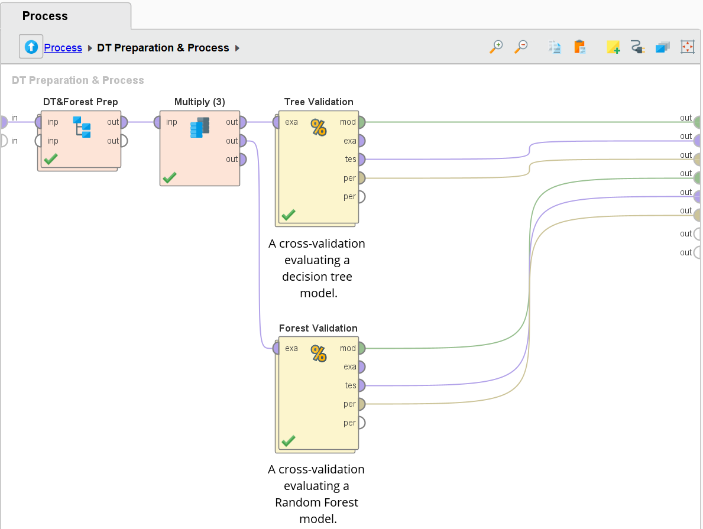
Decision Tree:
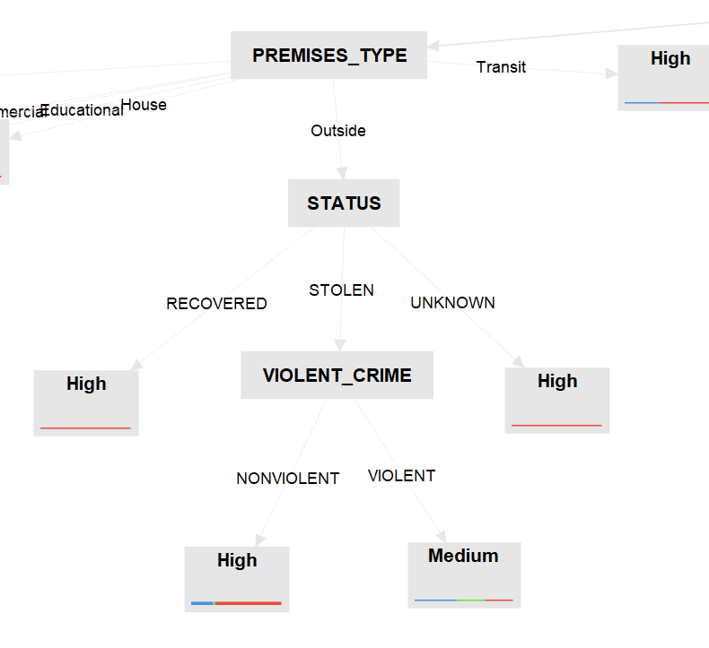
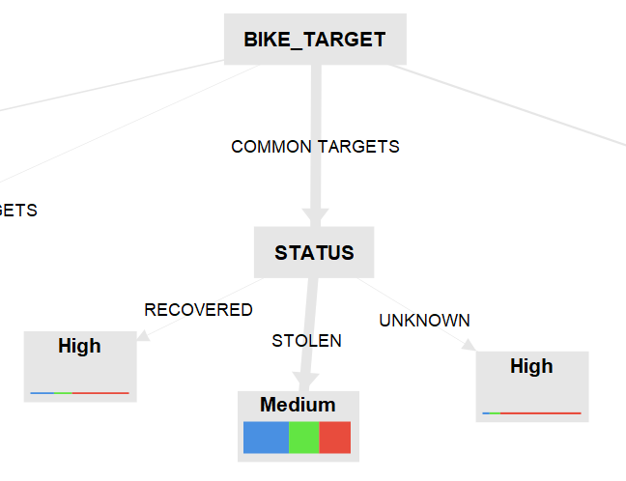
Random Forest:
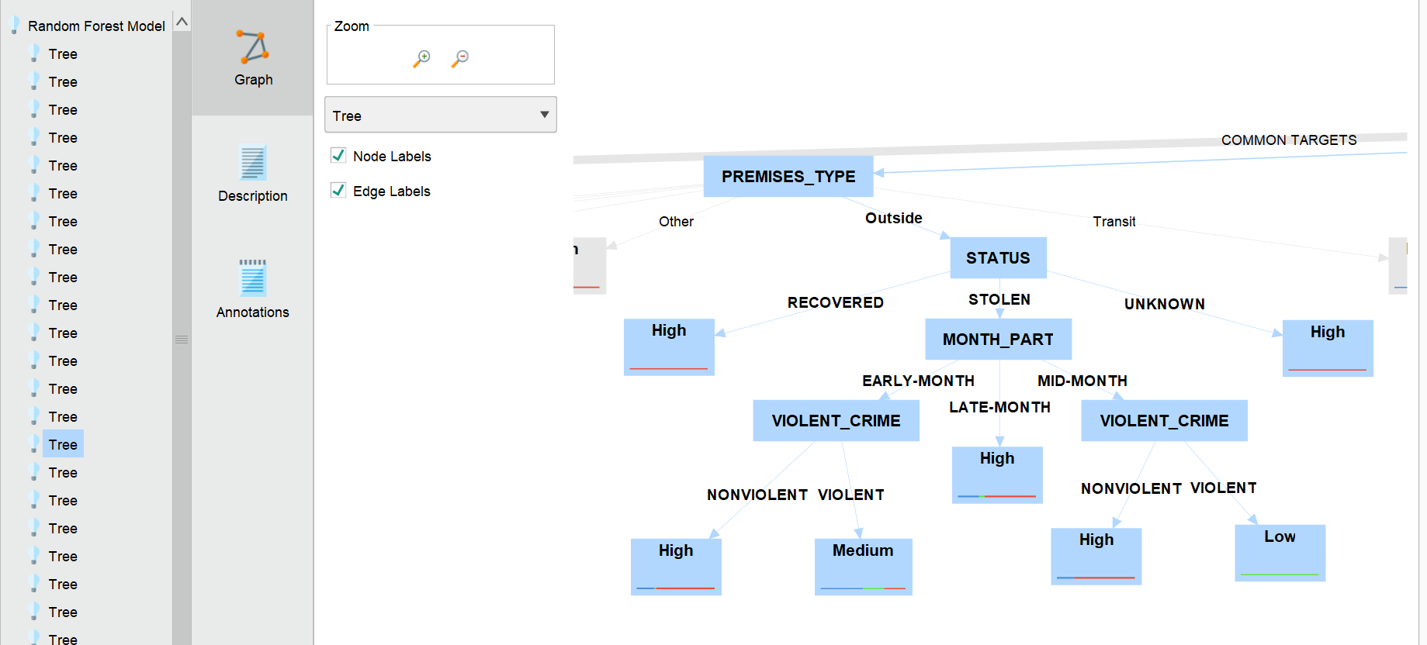

5.2.4 Assess model
The model generated both a decision tree and a random forest that consists of a 50-tree subset. Both the decision tree and random forest produced a similar accuracy reading of 46.37 and 46.37% respectively.
Decision Tree Performance:
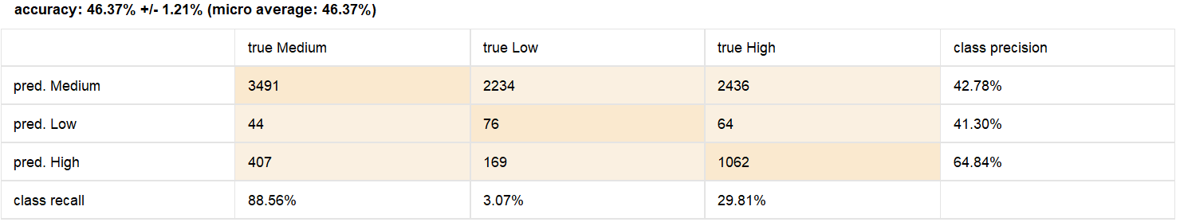Random Forest Performance:
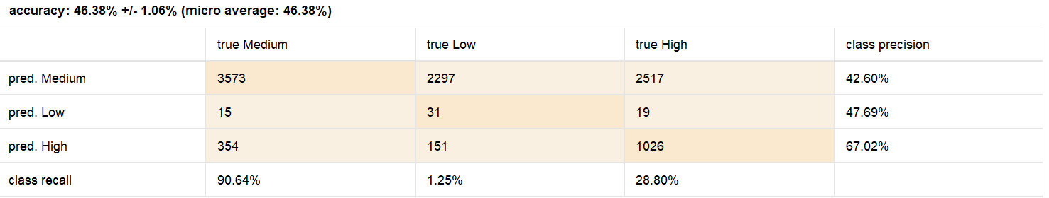
Additionally, this may have been due to poor test data used as the confidence levels output from the performance operators on the test data had very low average values, indicating that the model isn’t very certain about its classifications
Decision Tree Confidence:
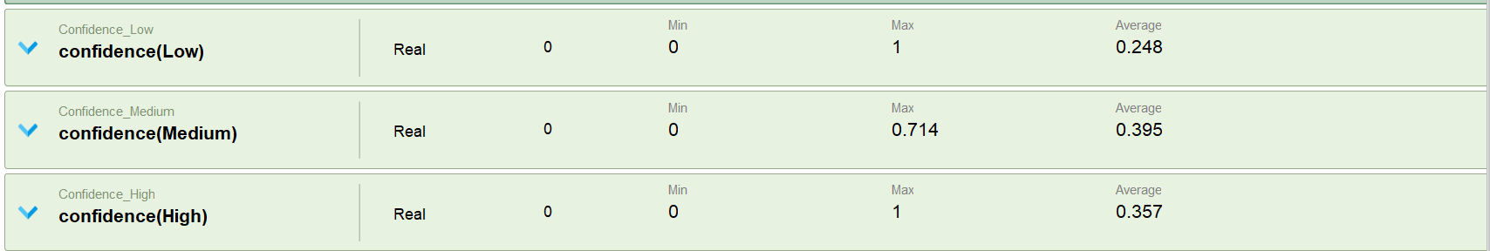
Random Forest Confidence:
Some Rules Derived from Decision Tree:
- For the most common targets for bicycle theft in Toronto, the vast majority of the bikes recovered were those that had a high value
- Violent crimes were more common for stolen electric bikes that had a medium cost when the PREMESIS_TYPE was outside
- For Unknown/Other bike targets, during covid, bike thefts that occurred in the morning & afternoon more often resulted in the theft of medium value bikes, where bike thefts that occurred in the evenings & nights more often resulted in the theft of high value bicycles.

5.3 Clustering Modeling

5.3.1 Select modeling techniques
For clustering the bicycle theft dataset was used K-Means Clustering. K-Means is an unsupervised machine learning algorithm that partitions data into k clusters based on feature similarity. This technique is useful for detecting theft trends, such as common theft locations, times, and high-risk bicycle types.
To determine the optimal number of clusters (k), the elbow method was applied. The elbow point, derived from plotting the sum of squared distances against different k values, indicates the most appropriate cluster number.

5.3.2 Generate test design
To evaluate different values of k, a loop-based clustering approach was implemented in RapidMiner. The experiment tested multiple k values while tracking clustering performance using within-cluster sum of squares. The process involved:
- Iterating k values from 2 to 10.
- Recording the average within-cluster distance for each k.
- Logging the results for visualization and elbow point determination.

5.3.3 Build model
The K-Means clustering model was built using RapidMiner following steps:
- Standardizing relevant numerical attributes to ensure unbiased clustering.
- Running the K-Means algorithm within a loop to determine clustering performance across different values of k.
- Using performance metrics such as average within-cluster distance.

Clustering Process
This picture represents the clustering workflow, where data is processed through multiple steps, including filtering specific clusters (cluster_5 for patterns and cluster_1 with cluster_7 for outliers) :
Performance Evaluation and Logging
This picture shows the performance evaluation and logging mechanism. The clustering results are assessed based on performance metrics, and relevant thresholds are logged for further analysis:

5.3.4 Assess model
The Elbow Point was identified by plotting k against the average within-cluster distance.
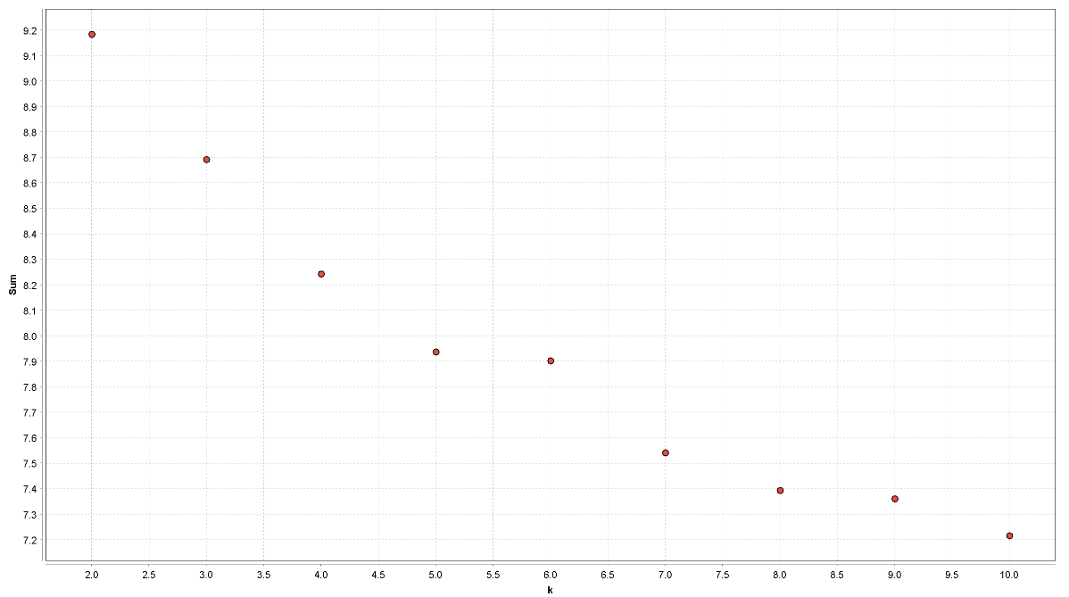
The optimal number of clusters (K) was determined to be 8 based on the evaluation.
The Clustering (best K) operator was applied to generate the most suitable number of clusters.
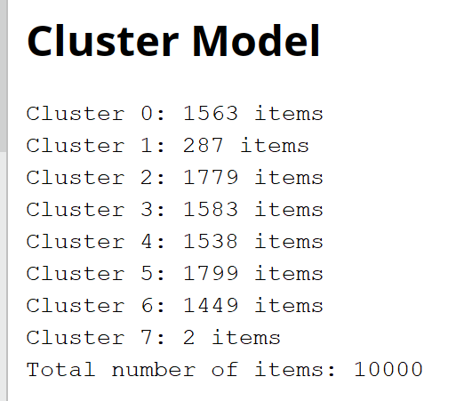
Detection of Outliers and Patterns:
From the clustering results, Cluster 7 (containing only 2 items) is identified as an outlier, while Cluster 5, having the largest number of items, represents a common pattern in the data.
Low-Density Cluster - Cluster 7:
- This cluster helps identify anomalies in bicycle theft cases that do not follow common trends.
- It includes rare theft locations, unusual time periods, or specific bicycle types that stand out from the majority.
- Since Cluster 7 contained only 2 items, clustering was also performed for k = 7 and k = 9.
- In both cases (k = 7 and k = 9), a cluster with only 2 items was found, confirming the presence of these outliers.
K = 7 K = 9
Second Least Populated Cluster – Cluster 1
- Given that Cluster 7 contained only 2 items, the next smallest cluster in best model (k=8), Cluster 1, was examined for further anomalies.

High-Density Cluster – Cluster 5 (Frequent Theft Pattern):
- Represents the most frequent theft occurrences, indicating common trends.
- Highlights locations with repeated thefts, high-risk time periods, or common theft methods.
These insights help in understanding theft patterns and improving preventive measures.

5.4 Outlier detection Modeling

5.4.1 Select modeling techniques
Unsupervised outlier detection algorithms:
- Local Outlier Factor: Detects local anomalies by comparing a point’s density to nearby points.
- Isolation Forest: Detects outliers by isolating data points using random trees—outliers are easier to isolate.
Use Case:
- Identifies theft trends such as Bike cost, Bike speed, and location.

5.4.2 Generate test design
- LOF:
  - Used Detect Outlier Local Outlier Operator with Mixed Euclidean Distance for identifying anomalies by comparing the Local Density of a data point to its neighbors. Points with significantly lower density than their surroundings are classified as Outliers.
  - Generate Outlier Flag used to generate new column outlier_flag, and next to it change the name to LOF_Outlier.
  - Filter LOF_Outlier to analysis only LOF_Outlier = Outlier.
- ISF
  - Used Detect Outlier Isolation Forest for identifying anomalies by randomly participating data points using decision trees; points that get isolated quickly are classified as Outliers.
  - From new columns Prediction set it as ISF_Outlier using formula: if (prediction >= 0.60, "Outlier", "Normal").
  - Filter only ISF_Outlier as Outlier for analysis.

5.4.3 Build model
The outlier detection models were built in RapidMiner using process:
- LOF:
  - LOF Operator: kMin: 10, kMax: 20,
Mesuare Type: MixedMesaure->MixedEuclideanDistance.
  - Generate Outlier Flag: Manual Method, score column: outlier, threshold: 1.5
  - Rename: outlier_flag->LOF_Outlier
  - Filter LOF_Oulier = Outlier

- ISF:
  - Detect Outlier Isolation Forest-> Number of Trees: 100, Max leaf size: 2, bootstrap ratio: 0.8, and socre_calculation: normalized_score, because the more common choice and normalize the score to a range from 0 to 1, which is easier to interpret and typically gives better results when identifying outliers.
  - Used formula: if (prediction >= 0.60, "Outlier", "Normal") & create new columns from prediction.
  - ISF_Outlier = Outlier filtered.

5.4.4 Assess model
Outlier Detection techniques helped identify theft incidents that significantly deviated from typical patterns. The combination of Local Outlier Factor + Isolation Factor allowed for a more robust analysis.
LOF:

ISF:

6.0 Evaluation

6.1 KNN Evaluation
The k-Nearest Neighbors (kNN) classification model was trained using theft incident data and grouped by different attributes to explore the effectiveness of the algorithm in predicting the BIKE_COST_CLASS (Low, Medium, High). The screenshots provide visual confirmation of how different variables influence theft patterns.

Division Analysis – High-Density Areas
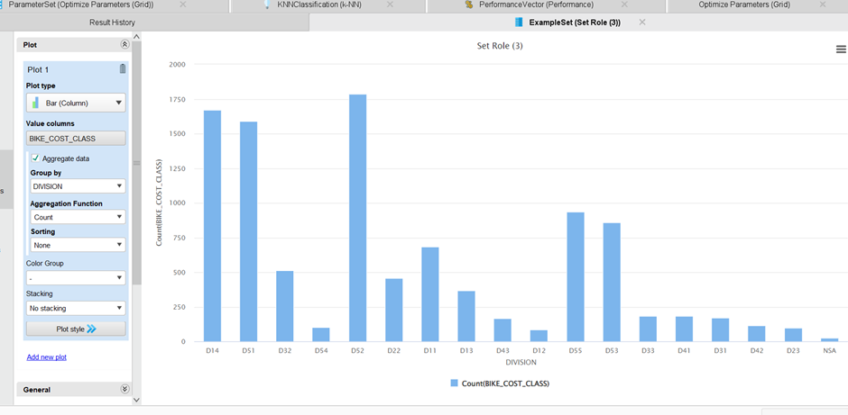
High-Risk Divisions (D51, D52, D14):
- These three police divisions recorded the highest number of bicycle thefts across all cost categories Low, Medium, and High.
- Located in downtown Toronto, they are high-traffic zones, making them hotspots for theft activity.
- The presence of valuable bikes in these regions may contribute to more targeted thefts.

Bike Type Trends:
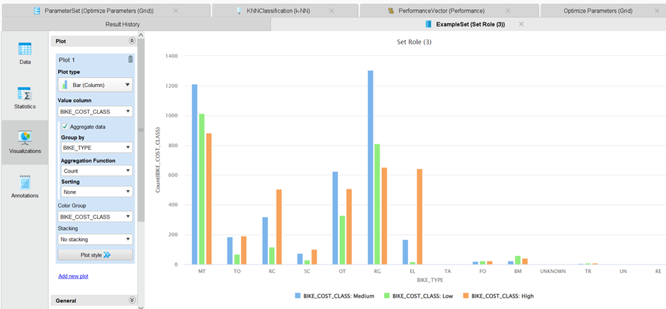
- Mountain Bikes (MT) and Road/Gravel Bikes (RG) are the most frequently stolen types, regardless of cost category.
- These types dominate thefts in the High and Medium-cost categories.
- Bike type appears to be a strong predictor of theft risk, especially during peak theft seasons.

Premises Type vs BIKE_COST_CLASS
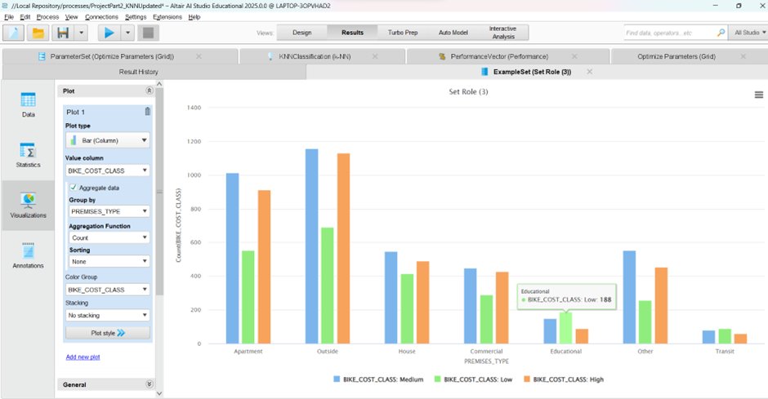
- According to the third chart, most thefts happen in Outside areas, followed by Apartments and Houses.
- Educational and Transit locations have the least thefts.
- The kNN model could leverage this to associate cost with likely theft location, as high-cost bikes were mostly stolen from more accessible, public premises.

Seasonal Patterns
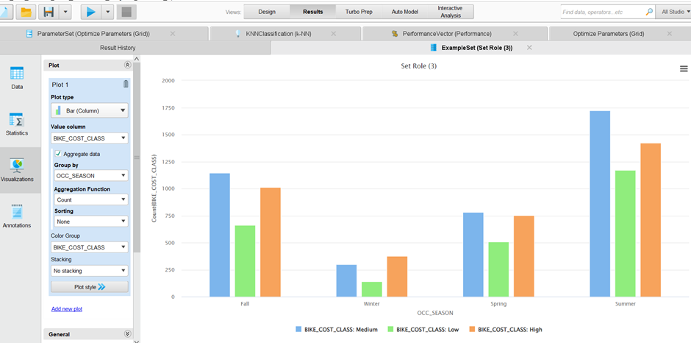
- The fourth screenshot shows that Summer is the peak season for bike theft, especially for High and Medium-cost categories.
- Theft frequency decreases significantly in Winter, reflecting reduced bike usage.
- This seasonal behavior added predictive strength to the OCC_SEASON feature used by kNN.
Time-of-Day Patterns
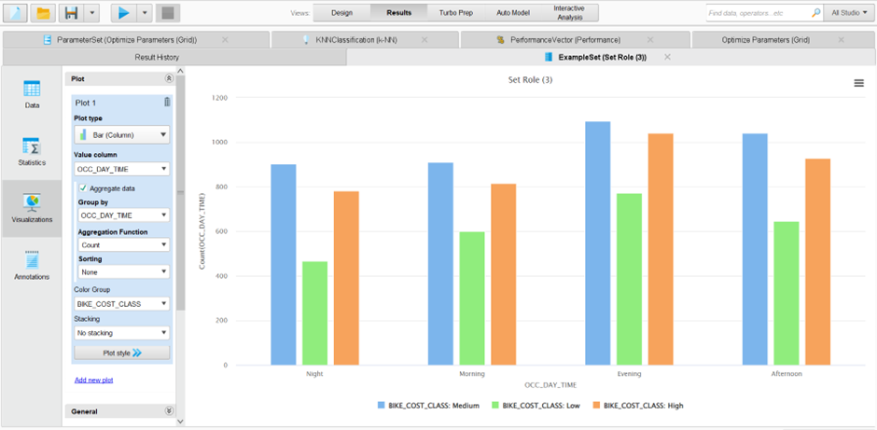
- The final screenshot presents theft distribution by OCC_DAY_TIME.
- Most thefts occurred during Morning, Afternoon, and Evening.
- The lowest theft activity was at Night, indicating that thefts are more likely when public activity is high.
- These patterns helped improve model accuracy by making time of day a key input feature.

6.1.2 Interpret results
- High-Cost Bikes:
  - Performed best in terms of precision (51.77%).
  - Most were stolen during Summer from Outside and Apartment areas.
  - Types included Electric, Road/Gravel, and Mountain bikes.
- Medium-Cost Bikes:
  - Had the highest recall (62.10%).
  - Commonly stolen across seasons and premises, especially Apartments.
  - Model identified them well due to strong data patterns.
- Low-Cost Bikes:
  - Weakest precision and recall.
  - Distributed across various types and locations.
  - Less distinguishable features led to misclassification with Medium-cost bikes.

6.1.3 Review of process
- Cleaned the dataset and replaced missing values with average values or "UNKNOWN".
- Created new features such as OCC_SEASON and OCC_DAY_TIME to improve model performance.
- Applied normalization to numerical attributes and converted nominal attributes to numeric format.
- Used grid optimization to test different values of k; the best result was found with k = 9.
- Performance metrics:
  - Accuracy: 45.07%
  - Low-Cost Class: Precision 37.61%, Recall 25.49%
  - Medium-Cost Class: Precision 46.57%, Recall 62.10%
  - High-Cost Class: Precision 51.77%, Recall 39.80%

6.1.4 Determine next steps
- Improve prediction for the Low-cost category using SMOTE oversampling techniques.
- Use additional attributes like weather, weekday/weekend, or events to enrich the dataset.
- Engineer combined features such as BIKE_TYPE + OCC_SEASON to capture interaction effects.
- Benchmark kNN against Decision Tree and Random Forest models to validate classification accuracy.

6.2 Decision Tree Evaluation

6.2.1 Evaluation of Results
The decision tree model's evaluation results indicate an overall accuracy of 46.37%, with class precision varying across theft risk categories. The high-risk category (pred. High) achieved a precision of 64.84%, meaning the model is relatively effective at identifying high-risk theft scenarios. This aligns with our business goal of pinpointing high-risk locations and peak theft times. However, the model's recall for low-risk cases is only 3.07%, suggesting difficulty in correctly identifying low-theft areas. This misclassification could stem from feature overlap or data imbalance, potentially impacting our ability to accurately differentiate between theft risk levels.
To further assess the model’s effectiveness, we compared its predictions against expected patterns derived from our correlation matrix. Key influencing factors such as location, time of theft, and bike value exhibited notable correlations, supporting the model’s focus on these variables. However, the high misclassification rate of medium-risk cases (pred. Medium = 42.78% precision) suggests room for improvement in feature selection or model complexity. Future enhancements could involve hyperparameter tuning, alternative algorithms (e.g., Random Forest), or incorporating external crime data for better contextual accuracy.

6.2.2 Interpret results
The decision tree model provides valuable insights into bicycle theft risk levels based on key factors such as location, time of theft, and bike value. The model effectively identifies high-risk cases with a precision of 64.84%, meaning that when the model predicts a theft as high-risk, it is correct in nearly two-thirds of cases. This supports our business goal of pinpointing theft hotspots and peak theft times. However, the lower precision for medium (42.78%) and low-risk (41.30%) categories suggests that the model struggles to distinguish between moderate and minimal theft risk locations.
From a business perspective, these results indicate that theft prevention strategies, such as targeted police patrols, increased bike parking security, or public awareness campaigns, should prioritize areas classified as high-risk. Additionally, the model’s low recall for low-risk areas (3.07%) implies that some low-risk locations may still experience theft incidents that the model underestimates, which could lead to missed opportunities for proactive intervention.
Further refinement of the model, possibly by adjusting feature selection, incorporating external crime data could enhance prediction accuracy and better align results with the broader goal of reducing bike theft rates in Toronto.

6.2.3 Review of process
The data mining process followed the CRISP-DM framework, beginning with business understanding, where we defined the goal of identifying high-risk bicycle theft locations and peak theft times. In the data understanding phase, we collected and analyzed theft-related data, using correlation analysis to identify key features such as location, time, and bike value.
During data preparation, we cleaned and transformed the dataset, ensuring categorical variables were properly encoded and missing values were handled appropriately. The modeling phase involved training a decision tree classifier to categorize theft risk levels, with evaluation metrics showing strengths in identifying high-risk cases but weaknesses in distinguishing medium and low-risk cases.
One of the main challenges encountered was the imbalance in theft risk categories, leading to lower recall for low-risk predictions. Additionally, some features showed overlapping characteristics, making classification more difficult. Despite these challenges, the model successfully highlighted high-risk theft patterns, supporting key business objectives.
For future iterations, improvements could include:
- Incorporating external datasets, such as police reports or weather conditions, to enhance predictive power.
- Refining feature engineering, possibly creating new variables that better capture theft patterns.
Overall, the CRISP-DM methodology provided a structured approach to analyzing bicycle theft risks, and the insights gained will contribute to improved security strategies and theft prevention efforts in Toronto.

6.2.4 Determine next steps
To enhance the model’s accuracy and better support theft prevention strategies, the next steps should focus on improving classification performance and expanding data sources. Future work includes incorporating external crime data for a broader context, and refining feature engineering to better capture theft patterns. Additionally, further evaluation with real-world data and stakeholder feedback (e.g., law enforcement or city planners) will ensure the model’s insights are actionable for improving bike security in Toronto.

6.3 Clustering Evaluation

6.3.1 Evaluation results
Cluster 7 – Low Density Cluster
Cluster 7 represents a low-density cluster, suggesting that these cases may be anomalies or outliers in the dataset. This cluster consists of theft incidents from the years 1983 and 1975, which fall outside the primary timeframe of the dataset (2014-2024). The inclusion of incidents from the 1970s and 1980s suggests that these data points are outliers and may not accurately represent the trends observed in more recent years. The low density of this cluster highlights the rare occurrence of these outlier data points, making them stand out from the more recent theft incidents.

Cluster 1 – Second Least-Populated Cluster
Cluster 1 represents thefts that occurred in January and February. The relatively low frequency of thefts during these months suggests that bike thefts are less common in the winter, likely due to colder weather and reduced bike usage. This pattern reflects a seasonal trend, where thefts are less frequent in colder months.

Cluster 5 – High Density Cluster
Cluster 5 represents a high-density cluster, indicating a concentration of thefts incidents.
Frequency of bicycle thefts based on Bike Type and Month:
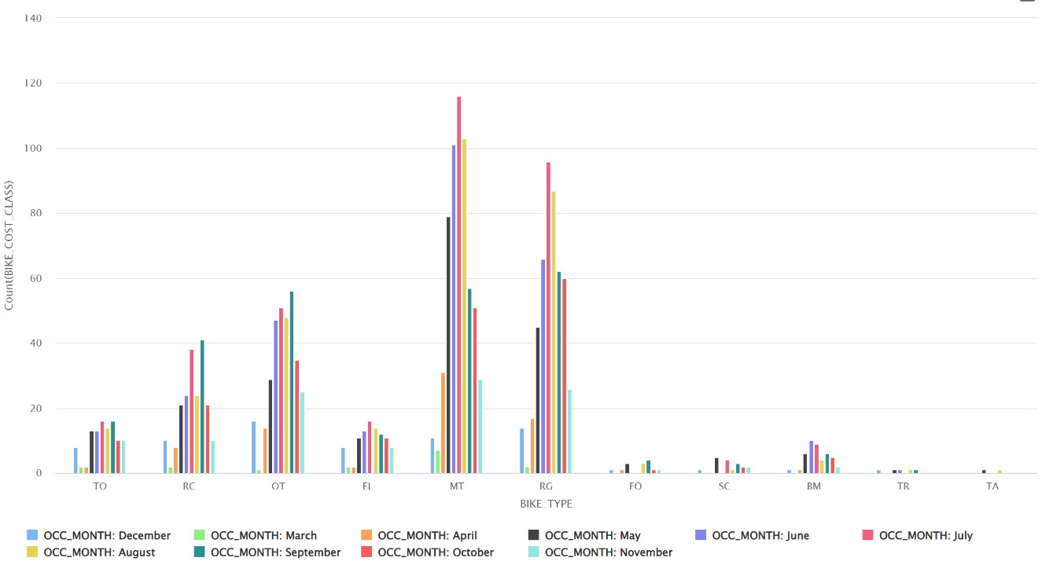
The bar chart visualizes the frequency of bicycle thefts based on BIKE_TYPE and OCC_MONTH. The key observations are as follows:
- Mountain Bikes (MT) and Road Bikes (RG) show the highest theft occurrences across multiple months. These two bike types are more frequently stolen.
- Theft rates peak in July and August, indicating a seasonal trend. Higher theft activity during these months is likely due to increased outdoor activity and bike usage during warmer months.
- Winter months (December, January, February) show lower theft activity, which aligns with the reduced bike usage during colder weather.

Frequency of bicycle thefts based on Premises Type and Bike Cost:
The bar chart also visualizes the frequency of bicycle thefts based on PREMISES_TYPE and BIKE_COST_CLASS (Low, Medium, High). Key findings include:
- For low, medium and high-cost bikes, most thefts occur from outside, followed by thefts from apartments and houses.
- Transit locations (like bus stations or train stations) and educational institutions (such as school or universities) have the fewest thefts across all cost categories.

Bicycle thefts based on Police Divisions and Bike Cost:
The bar chart visualizes bicycle theft occurrence based on BIKE_COST_CLASS (Low, Medium, High) across different Police Divisions. Key observations include:
- Divisions D51, D52, and D14 show the highest number of thefts across all cost categories, indicating these areas have a higher risk of bike thefts.
- Low-cost bikes have a theft frequency, with D51, D52, and D14 showing the most incidents.
- Medium-cost bikes also see a high theft rate, particularly in D51, D52, and D14.
- High-cost bikes follow a similar pattern, with thefts concentrated in D51, D52, and D14.

6.3.2 Interpret results
Outliers:
- Theft Trends by Year
The theft incidents from 1983 and 1975 are outliers in this dataset, as they fall outside the timeframe of 2014-2024. These data points do not follow the same trends as the more recent thefts, suggesting they are anomalies. The low density of this cluster highlights the rarity of these outlier incidents, which may be due outdated or incomplete records, potential data entry errors, or inconsistencies in historical data collection.
- Theft Trends by Season
The relatively low number of thefts in January and February reflects a clear seasonal trend. The winter months show reduced theft activity, likely because fewer people are cycling in colder weather. This suggests that bike thefts tend to occur more frequently during warmer months when bike usage is higher.
Common Patterns - Theft Trends by Bike Type, Location, Season, Division, and Cost
- Seasonal and Bike Type Trends
Bicycle thefts are influenced by both bike types and seasonal patterns. Mountain Bikes and Road Bikes are the most frequently stolen, with incidents peaking during the summer months (July and August). Higher theft rates during the summer when more bikes are in use.
- Premises and Theft Location:
The data shows that outside is the most common place for bicycle thefts, regardless of the cost of the bike. This suggests that bicycles, regardless of value, are often targeted when left outside, possibly due to lack of security measures in public areas.
- Least frequent theft locations:
Transit location (like bus station or train stations) and educational institutions (such as school or universities) have the fewest thefts across all cost categories. This suggests that these areas may have better security measures.
- Division trends:
The most frequent bicycle thefts occur in Divisions D14, D52, and D51. These divisions appear to be high-risk areas for bicycle theft, indicating that there may be a need for increased security measures in these regions to address the elevated theft activity.

6.3.3 Review of process
The clustering analysis was conducted using Clustering (Loop) and Clustering (Best K) operators, which allowed to determine the most suitable number of clusters.
To further enhance the accuracy of the analysis, filtering and joining operations were applied. These steps helped distinguish between meaningful patterns and anomalies, allowing for more structured understanding of bicycle theft occurrences. High-density clusters provided insight into common theft trends, while low-density clusters highlighted rare and potentially anomalous incidents.
Potential Limitations
Despite the effectiveness of the clustering approach, there are some limitations:
- Cluster Overlap – some theft incidents may share characteristics across multiple clusters, leading to potential overlap and reduced clarity in distinguishing unique patterns.
- External Factors not included – the clustering model did not incorporate external influences such as weather conditions, special events, or population density, which could significantly impact theft trends.
- Potential Bias in Data – the dataset may have missed or underreported incidents, affecting the overall distribution and validity of the detected clusters.

6.3.4 Determine next steps
To further improve the analysis and enhance theft prevention strategies, the following next steps are considered:
- Include weather conditions, public events, and population density to analyze their impact on bicycle theft trends.
- Recommend better bike security policies in high-risk areas, such as improved lighting, surveillance, and secure bike parking zones.
- Implement machine learning models to predict theft risk based on historical patterns.

6.4 Outlier detection Evaluation

6.4.1 Evaluation results
More is not always better. Sometimes too many = too sensitive (false positives), too few = missed anomalies.
Outlier Detection in LOF:
- Local Outlier Factor:
  - Trying with Default Values
- Generate Outlier Flag:
  - Threshold: 0.5 = 10000
  - Threshold: 1.0 = 8824
  - 1.1 = 2970 (Observation as Threshold high, low number of perfect outlier example.)
  - 1.2 = 1199, 1.3 = 586, 1.4 = 303, 1.5 = 140
Isolation Forest:
- I tried different versions for number of trees, max leaf size, and boostrap like 100, [200, 300], 1, [2,3], 0.6, [0.75, 0.8, 0.9, 1.0], best combination was 100, 2, 0.8, respectively.
- Set prediction above 0.6 as Outlier, as near to 0 normal and near to 1 Outlier.

Outlier Detection in LOF:
ISF:

LOF + ISF:

6.4.2 Interpret results
Theft Trends by Speed:
- Several outliers had very high bike speeds, such as 6.349 and 8.177, which stand out from the rest of the dataset. This may suggest unusual activity or potentially incorrect speed entries.
Theft Trends by Cost:
- Some thefts involved extremely high-value bikes, with costs reaching 7,237 and even 23,035. These bikes are far above the average and may have been targeted specifically due to their value.
Theft Trends by Time:
- Multiple outlier records had theft times occurring around early morning hours, represented by OCC_HOUR values like 7 in Morning and 3 in night, which is not common in typical theft patterns.
Theft Trends by Location:
- Outlier events occurred in uncommon or distant locations, as seen from LAT_WGS84 values like 2.913 and 3.255. These locations were far from the typical clusters of thefts and may indicate isolated or special cases.

6.4.3 Review of process
The review process involved evaluating the outlier detection results from two different unsupervised machine learning models — Local Outlier Factor (LOF) and Isolation Forest (ISF) — to ensure accuracy and consistency in identifying abnormal theft records.
- The process included the following steps:
- Independent Model Execution
- LOF and ISF were each applied to the dataset using separate subprocesses. Each model generated its own outlier labels based on their unique algorithmic logic.
- Filtering Based on Thresholds
- LOF outliers were filtered using a threshold of LOF score > 1.5
- ISF outliers were filtered using a threshold of Prediction score ≥ 0.60
- Joining the Results
- The outputs from both models were joined using the unique event ID, and a Filter Examples operator was used to extract only those rows that were marked as outliers by both models.
- Manual Review of Outlier Records
- The filtered outlier list was manually reviewed to observe patterns in: Bike cost, Speed, Theft time (OCC_HOUR), Location (LAT_WGS84).
- Interpretation Based on Patterns
- Patterns were then categorized by trends in speed, cost, time, and location to explain why each record was considered an outlier.

6.4.4 Determine next steps
Next Steps for Improving Analysis and Theft Prevention:
Incorporate Additional Data Sources:
Bring in external datasets such as:
- Weather conditions
- Holiday or event calendars
- Police incident reports
- to explore correlations with theft spikes or anomalies.
Improve Data Quality:
Address records with:
- Incomplete timestamps
- Negative or extreme speed values
- Missing or inaccurate locations
- This ensures outliers reflect real patterns and not just dirty data.
Map Risk Zones Using Outlier Locations:
- Use outlier latitude/longitude data to mark high-risk or uncommon theft areas and recommend preventive measures like:
- Increased surveillance
- Community alerts
- Bike locker installation
Develop Predictive Models:
- Use historical theft data (and confirmed outliers) to build models that:
- Predict future theft hotspots
- Alert authorities or users in advance

7.0 Conclusion
This study focused on understanding how bicycle theft risk varies across different cost classes (Low, Medium, High) by analyzing key factors such as location, time, and date. The goal was to build a model that could identify high-risk locations, peak theft hours, and seasonal trends, and use outlier detection to uncover unusual theft activity.
With K-Nearest Neighbors (KNN), Decision Trees, Clustering, and Outlier Detection models, we were able to uncover valuable insights into the patterns of bike theft in Toronto. The models identified areas with a higher risk of theft, times of day with the most incidents, and revealed seasonal trends that help explain fluctuations in theft rates.
The outlier detection model was particularly useful for identifying unusual theft patterns that could indicate emerging trends or areas needing extra attention. By analyzing the data in relation to cost classes, we also observed how theft risk correlates with the value of the bicycle, highlighting that higher-cost bikes may be targeted in specific areas or times.
These findings offer practical insights for both cyclists and policymakers. Cyclists can use this information to make safer decisions about where and when to park their bikes, while policymakers can use these insights to develop targeted theft prevention strategies, such as increasing patrols in high-risk areas or implementing awareness campaigns during peak theft periods.

