AI Based Intrusion Detection System
A PROJECT REPORT

Submitted by

Algotar Meet Girishkumar

220020148004

In partial fulfillment for the award of the degree of
BACHELOR OF ENGINEERING

in
Bachelor of Engineering
Computer Science and Engineering (Cyber Security)
Ahmedabad Institute of Technology, Ahmedabad



Gujarat Technological University, Ahmedabad

[2026]

[PMMS COMPLETION CERTIFICATE]



Ahmedabad Institute of Technology

Nr. Vasantnagar Township, Gota-Ognaj Road, Ahmedabad, Gujarat-380061

CERTIFICATE

This is to certify that the project report submitted along with the project entitled AI Based Intrusion Detection System has been carried out by Algotar Meet Girishkumar under my guidance in partial fulfillment for the degree of Bachelor of Engineering in Computer Engineering (Cyber Security), 8th Semester of Gujarat Technological University, Ahmadabad during the academic year 2026.

Prof. Prachi Parihar Dr. Harsha Padheriya
Internal Guide Head of the Department

[Company completion certificate]

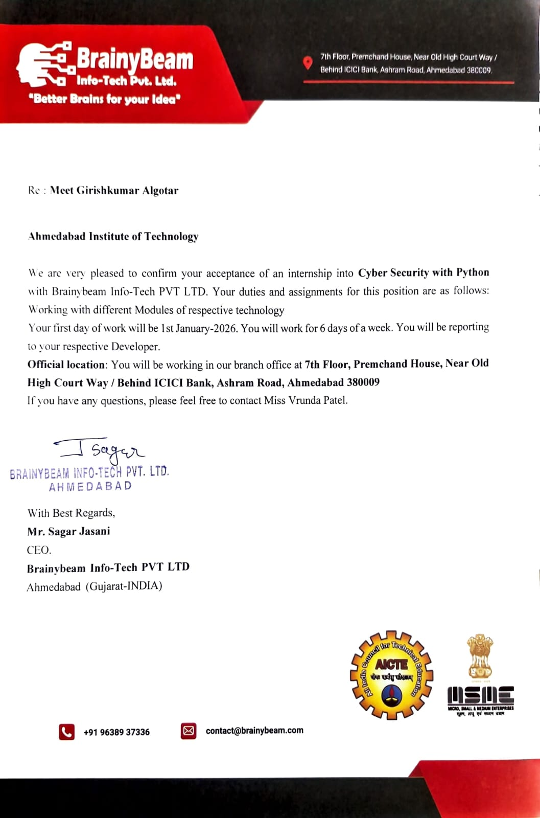



Ahmedabad Institute of Technology

Nr. Vasantnagar Township, Gota-Ognaj Road, Ahmedabad, Gujarat-380061

DECLARATION

We hereby declare that the Internship report submitted along with the Internship entitled AI Based Intrusion Detection System submitted in partial fulfillment for the degree of Bachelor of Engineering in Computer to Gujarat Technological University, Ahmedabad, is a Bonafide record of original project work carried out by me at BrainyBeam Technologies Pvt. Ltd. under the supervision of Mr. Sagar Jasani and that no part of this report has been directly copied from any students’ reports or taken from any other source, without providing due reference.

Meet Algotar

Abstract

With the rapid growth of digital systems and internet connectivity, cyber threats and unauthorized network access have become major concerns for organizations and individuals. Traditional security mechanisms are often not sufficient to detect advanced and evolving cyber attacks. Therefore, there is a need for intelligent systems that can automatically identify suspicious activities in a network. The AI Based Intrusion Detection System (IDS) is designed to enhance network security by using artificial intelligence techniques to monitor, analyze, and detect potential threats in real time.

This project focuses on developing a web-based intrusion detection platform that simulates network security monitoring and provides insights into possible cyber attacks. The system analyzes network-related data and classifies activities as normal or malicious using machine learning concepts. The interface provides a dashboard where users can perform network scans, view security alerts, and analyze detected threats through graphical visualizations such as charts and reports. The system also includes features such as automated scanning indicators, live output display, and report generation to help users understand security events more effectively.

The proposed solution is implemented using technologies such as Python, HTML, CSS, and JavaScript, which together create an interactive and user-friendly environment for security monitoring. The system demonstrates how artificial intelligence can be applied to cybersecurity to improve the detection of suspicious network behavior.

Overall, the project highlights the importance of intelligent intrusion detection systems in strengthening cybersecurity and protecting digital infrastructures from potential attacks.

Acknowledgement

I appreciate the investment of my time and energy in this project. It would not have been feasible to finish the project without the help of a huge number of people and organizations. To each and every one of them, I am profoundly grateful.
I wouldn't be where I am now without Miss. Prachi Parihar They have guided me, offered constant oversight, and briefed me on key aspects of the project. I'd like to use this opportunity to express my appreciation to everyone who helped get the ball rolling on this conversation and provided really helpful review input, as well as to those who provided consistent backing and assistance as we worked to complete our project.
The Ahmedabad Institute of Technology at which I am employed has been quite helpful in giving me with both the tools and atmosphere I need to do my job properly.
I'd like to thank the Head of Department, Dr. Harsha Padheriya, for his kind assistance and support during this project.

-Meet Algotar

List of Figures

Fig 1.1- Company Log
Fig 1.2- Services
Fig 2.2 Development Process
Fig 3.1 Gantt Chart
Fig 5.1: Flow Chart

Table of Contents
Abstract i

Acknowledgement ii
List of Figures iii
Table of Contents iv
- Overview of the Company 1
  - History 1
  - Different product / scope of work 1
  - Capacity of plant 4
- Overview of the process being carried out in company 40
  - It includes the details about the work being carried out in each department 5
  - List the technical specifications of major equipment used in each department 5
  - Prepare schematic layout which shows the sequence of operation for manufacturing of end product 7
- Introduction to Project 11
  - Project / Internship Summary – Key To a good summary is the FIRST sentence, which MUST contain the most essential information that you wish to convey 11
  - Purpose 11
  - Objective 12
  - Scope (what it can do and can’t do) 12
  - Technology and Literature Review 13
  - Project / Internship Planning 25
  - Project / Internship Scheduling (Gantt Chart/PERT/Network Chart) 27
- System Analysis 28
  - Study of Current System 28
  - Problem and Weaknesses of Current System 28
  - Requirements of New System 29
  - System Feasibility 29
  - Activity / Process in New System / Proposed System 30
  - Features of New System / Proposed System 31
  - List Main Modules / Components / Processes / Techniques of New System / Proposed System 32
  - Selection of Hardware / Software / Algorithms / Methodology / Techniques / Approaches and Justification 33
- System Design 36
  - System Design & Methodology 36
- Implementation 39
  - Implementation Platform / Environment 39
  - Process / Program / Technology / Modules Specification 41
  - Finding / Results / Outcomes 43
- Testing 50
  - Testing Plan / Strategy 50
  - Test Results and Analysis 52
- Conclusion and Discussion 54
  - Overall Analysis of Internship / Project Viabilities 54
  - Dates of Continuous Evaluation (CE-I and CE-II) 54
  - Problem Encountered and Possible Solutions 54
  - Summary of Internship / Project work 55
  - Limitation and Future Enhancement 56
References 57

  - OVERVIEW OF THE COMPANY

HISTORY
BrainyBeam Technologies Pvt. Ltd. is a software development company headquartered in Ahmedabad, Gujarat, India. The company focuses on providing innovative solutions in web development, mobile application development, and emerging technologies for businesses across different industries. It works with organizations from sectors such as healthcare, retail, travel, entertainment, education, and social networking to develop customized digital solutions according to client requirements.
BrainyBeam Technologies was established with the aim of delivering high-quality software solutions that improve business efficiency and user experience. Over the years, the company has built expertise in developing Android, iOS, and cross-platform mobile applications, web applications, and enterprise software systems. The company’s development team works with modern technologies including IoT development, web services, database management, and UI/UX design to build scalable and secure applications.
Since its inception, BrainyBeam Technologies has worked on multiple projects for clients in India and international markets. The organization focuses on delivering reliable solutions within the committed timeline while maintaining competitive pricing and high product quality. The company has successfully developed numerous web and mobile applications and continues to expand its technical capabilities in modern software technologies

1.1.1 Our Vision
The vision of BrainyBeam Technologies Pvt. Ltd. is to deliver innovative and reliable technology solutions that help businesses grow in the digital era. The company aims to develop high-quality web and mobile applications that improve productivity, enhance user experience, and support digital transformation for organizations across various industries. By continuously adopting new technologies and improving development practices, the organization strives to become a trusted technology partner for businesses worldwide.

1.1.2 Our Values
BrainyBeam Technologies Pvt. Ltd. operates with strong professional values that guide its work culture and project development process. The company emphasizes innovation, quality, transparency, and customer satisfaction in every project. It focuses on understanding client requirements and delivering efficient and scalable software solutions. The organization also values teamwork, continuous learning, and the adoption of modern technologies to create reliable products that meet industry standards and client expectations.

  - Different product / scope of work

BrainyBeam Technologies Pvt. Ltd. is a software development company that provides a wide range of digital solutions for businesses and organizations. The company mainly focuses on developing custom software, web applications, and mobile applications that help organizations improve their digital presence and operational efficiency. Instead of manufacturing physical products, the company delivers technology-based services and software solutions tailored to the needs of its clients.
The major scope of work at BrainyBeam Technologies includes web application development, mobile application development, custom software development, and enterprise solutions. The company designs and develops dynamic and scalable web platforms using modern programming frameworks and technologies. These web solutions are developed to support different business domains such as e-commerce platforms, business management systems, and service-based applications.

Fig.1.1: Company Logo

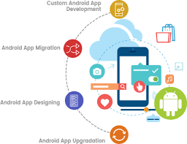
Fig.1.2: Services
In addition, the company works on emerging technologies and custom software solutions, including cloud-based systems, API integration, and enterprise software applications. BrainyBeam Technologies also provides maintenance, technical support, and system upgrades to ensure that developed applications continue to operate efficiently and securely.
Through its diverse technical services, BrainyBeam Technologies Pvt. Ltd. supports organizations in building reliable digital platforms, improving business processes, and adapting to modern technological requirements.

CAPACITY OF PLANT

BrainyBeam Technologies Pvt. Ltd. has the infrastructure and technical resources required to develop and deliver multiple software projects simultaneously. The company operates with a professional development environment equipped with modern computing systems, software tools, and internet connectivity to support software development, testing, and deployment activities. The organization primarily focuses on delivering web applications, mobile applications, and customized software solutions for clients from different industries.
The company maintains a structured working environment that allows multiple development teams to collaborate efficiently on different projects. The workspace includes dedicated systems for software development, UI/UX design, quality assurance, and project management to ensure smooth project execution.
Capacity Details:
- Development Team Capacity:
BrainyBeam Technologies has a team of software developers, designers, and testers who can work on multiple projects simultaneously. Different teams handle various modules such as frontend development, backend development, and testing.
- Software Development Infrastructure:
The company uses modern computer systems, development environments, and programming frameworks required for building scalable web and mobile applications.
- Project Handling Capacity:
The organization has the capability to manage multiple client projects at the same time by dividing work among specialized development teams and following structured development processes.
- Testing and Quality Assurance:
Dedicated testing procedures and tools are used to ensure that the developed applications are reliable, secure, and meet client requirements before deployment.
- Technical Support and Maintenance:
BrainyBeam Technologies also provides ongoing support, updates, and maintenance services for deployed applications to ensure continuous system performance and reliability.

- OVERVIEW OF PROCESS BEING CARRIED OUT IN COMPANY

IT INCLUDES THE DETAILS ABOUT THE WORK BEING CARRIED OUT IN EACH DEPARTMENT.
BrainyBeam Technologies Pvt. Ltd. follows a structured software development process to design, develop, test, and deliver high-quality digital solutions. The company works on various projects related to web development, mobile application development, and custom software solutions for clients from different industries. Each department in the company performs specific tasks that contribute to the successful completion of projects. The development process generally includes requirement analysis, system design, development, testing, deployment, and maintenance.

1. Project Management Department
This department is responsible for managing client requirements and planning project execution. The team communicates with clients to understand their business needs, prepares project plans, defines development timelines, and coordinates with different technical teams to ensure the project is completed successfully within the given schedule.

2. Web Development Department
The web development department focuses on designing and developing web applications and websites. Developers work on frontend and backend technologies to create dynamic, responsive, and scalable web solutions. The team also ensures proper database integration and system functionality.

3. Mobile Application Development Department
This department develops mobile applications for platforms such as Android and iOS. The development team designs user-friendly interfaces and implements application features according to the client’s requirements to provide smooth performance and usability.

4. UI/UX Design Department
The UI/UX design team is responsible for creating attractive and user-friendly interfaces for web and mobile applications. Designers focus on improving user experience by designing layouts, navigation structures, and visual elements that make applications easy to use.5. Accounts & Finance Department

5. Quality Assurance and Testing Department
This department ensures that the developed software is reliable and free from major errors. Testing teams perform different types of testing such as functionality testing, performance testing, and security testing to verify that the application works correctly before deployment.

LIST THE TECHNICAL SPECIFICATIONS OF MAJOR EQUIPMENT USED IN EACH DEPARTMENT.

The technical departments at BrainyBeam Technologies Pvt. Ltd. use modern computing systems and software development tools required for designing, developing, testing, and deploying web and mobile applications. Since the company mainly works in software development, the major equipment used consists of computer systems, development software, testing tools, and server platforms.

1. Development Workstations
- Desktop and laptop computers used by software developers and designers
- Installed with operating systems such as Windows, Linux, or macOS
- Used for coding, debugging, and application development
- Connected to high-speed internet and internal development environments

2. Web Development Tools
- Programming languages such as HTML, CSS, JavaScript, Python, and PHP
- Code editors and integrated development environments (IDEs) used for writing and managing code
- Version control platforms such as Git used for managing project source code

3. Mobile Application Development Tools
- Mobile development platforms used for creating Android and iOS applications
- Software development kits (SDKs) and emulators used for testing mobile applications
- Mobile devices used for real-time application testing

4. Database Management Systems
- Database technologies used for storing and managing application data
- Database administration tools used for database design, queries, and management
- Local and cloud-based database servers used in software projects

5. Testing and Deployment Tools
- Software testing tools used to verify application performance and functionality
- Web browsers used for compatibility testing of web applications
- Web servers and cloud platforms used for deploying developed applications

2.3 PREPARE SCHEMATIC LAYOUT WHICH SHOWS THE SEQUENCE OF OPERATION FOR MANUFACTURING OF PRODUCT

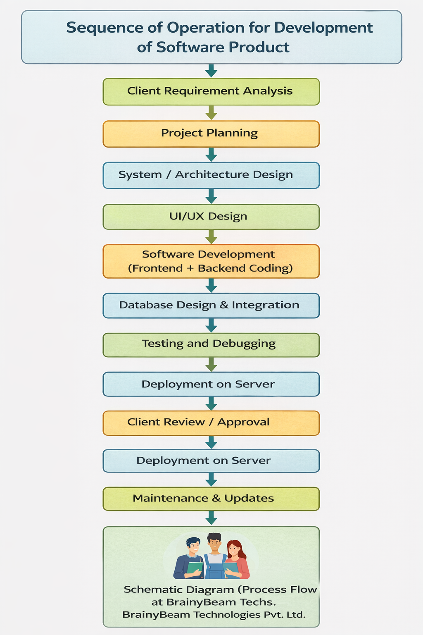
Fig 2.1: Development Process
  - Explain in details about each stage of production.
The software development process at BrainyBeam Technologies Pvt. Ltd. is designed to ensure that the final product meets client requirements and maintains high quality standards. The development process involves several stages including planning, design, development, testing, deployment, and maintenance.

- Requirement Analysis:
In this stage, the development team communicates with the client to understand the project requirements, objectives, and expected features. The team collects detailed information about the system that needs to be developed and prepares requirement documents to guide the development process.
- Project Planning:
After gathering requirements, the project team prepares a development plan. This includes defining project scope, allocating tasks to team members, estimating time schedules, and selecting appropriate technologies required for the project.
- System / Architecture Design:
In this stage, the overall structure of the software system is designed. Developers define system architecture, database structure, and module design to ensure that the application will function efficiently and meet performance requirements.
- UI/UX Design:
The design team creates the user interface and user experience layout of the application. This stage focuses on designing attractive and user-friendly screens that allow users to interact with the system easily.
- Software Development:
During this stage, developers write the actual program code based on the design specifications. Frontend developers build the user interface while backend developers implement the application logic and server-side functionalities.
- Database Design & Integration:
The database structure is created to store and manage application data efficiently. Developers integrate the database with the application so that information can be stored, retrieved, and updated properly.
- Testing and Debugging:
The testing team checks the software for errors, bugs, and performance issues. Different testing methods are used to ensure that the application works correctly and meets the required quality standards.
- Deployment on Server:
Once the application is tested successfully, it is deployed on a web server or cloud platform so that it can be accessed by users or clients.
- Client Review / Approval:
After deployment, the client reviews the application to verify whether it meets the expected requirements. Any suggested changes or improvements are implemented before final delivery.
- Maintenance & Updates:
After the project is delivered, the company provides maintenance and technical support services. This includes fixing bugs, improving performance, and adding new features when required.

INTRODUCTION TO PROJECT

PROJECT / INTERNSHIP SUMMARY – KEY TO A GOOD SUMMARY IS THE FIRST SENTENCE, WHICH MUST CONTAIN THE MOST ESSENTIAL INFORMATION THAT YOU WISH TO CONVEY.
The project titled “AI Based Intrusion Detection System” was carried out with the objective of developing a system that can identify and analyze suspicious activities in a network using artificial intelligence concepts. The main aim of this project is to improve cybersecurity by detecting potential threats and unauthorized access in computer networks.
In this project, a web-based application was developed to simulate the process of network monitoring and intrusion detection. The system analyzes network-related data and provides alerts about possible malicious activities. It includes features such as network scanning, threat analysis, visual representation of detected activities, and report generation. The application provides a user-friendly interface that allows users to monitor network behavior and understand potential security risks.
The system was developed using technologies such as Python for backend processing and HTML, CSS, and JavaScript for frontend interface design. The application demonstrates how machine learning and artificial intelligence concepts can be applied to detect unusual patterns in network activities.
Overall, the project provides a basic demonstration of an intelligent intrusion detection system that can assist organizations in monitoring network traffic and improving cybersecurity awareness. The project also helped in gaining practical knowledge of software development, cybersecurity concepts, and web application design during the internship period.

PURPOSE
The purpose of the “AI Based Intrusion Detection System” project is to develop a system that can detect and analyze suspicious activities in a computer network using artificial intelligence techniques. The system aims to enhance network security by identifying potential cyber threats and unauthorized access attempts in real time.
By monitoring network-related data and analyzing different patterns of system behavior, the intrusion detection system helps in distinguishing between normal and malicious activities. The system is designed to alert users about possible security threats so that appropriate actions can be taken to prevent data breaches and network attacks.
The project also demonstrates how artificial intelligence and machine learning concepts can be applied in the field of cybersecurity to improve threat detection and system monitoring. Overall, the project contributes to developing a basic intelligent security solution that helps organizations strengthen their network protection and increase awareness about potential cyber risks.

OBJECTIVE
• To design and develop an AI Based Intrusion Detection System that can monitor network activities and identify potential security threats.
• To analyze network traffic and detect unusual or suspicious behavior that may indicate unauthorized access or cyber-attacks.
• To apply artificial intelligence and machine learning techniques for classifying network activities as normal or malicious.
• To provide a system that can generate alerts and notifications when suspicious activities are detected in the network.
• To create a user-friendly web interface that allows users to view network analysis results, alerts, and security reports easily.
• To improve cybersecurity awareness by demonstrating how intelligent systems can be used to detect and prevent network intrusions.

Scope of the Project
The scope of the “AI Based Intrusion Detection System” project is to design and develop a system that can monitor network activities and detect potential cyber threats using artificial intelligence techniques. The system focuses on identifying suspicious patterns in network traffic and helping users understand possible security risks in a digital environment.
The project analyzes network-related data to detect abnormal behavior that may indicate unauthorized access or malicious activities. By using machine learning concepts and data analysis techniques, the system classifies network behavior into normal and suspicious categories, allowing users to quickly identify possible security issues.
The developed system provides features such as network monitoring, threat detection, and graphical representation of security data. These features help users observe network activity patterns and gain insights into potential vulnerabilities or attacks. The system also demonstrates how artificial intelligence can assist in improving cybersecurity practices.
The application can be used as a basic model for organizations, educational institutions, or individuals who want to understand the working of intelligent intrusion detection systems. It can also serve as a foundation for further development of advanced cybersecurity solutions that improve network monitoring and threat prevention.

TECHNOLOGY AND LITERATURE REVIEW
TThe “AI Based Intrusion Detection System” project was developed using web technologies and Python to create a simple web-based platform for demonstrating intrusion detection and network security analysis. The following tools and technologies were used for the development of the project:
- Programming Language: Python
- Frontend Technologies:
- HTML (for structuring web pages)
- CSS (for designing the user interface)
- JavaScript (for interactive features and dynamic content)
- Backend Framework:
- Flask (for building the web application and handling server-side logic)
- Libraries Used:
- Pandas (for data handling and processing)
- Matplotlib (for generating charts and graphical visualization)
- Development Environment:
- Visual Studio Code (for writing and managing source code)
- Artificial Intelligence Concepts:
- Data preprocessing and analysis
- Pattern recognition in network activity
- Classification of normal and suspicious behavior
These technologies were used to develop a working prototype of the intrusion detection system that demonstrates how network activity can be analyzed and visualized through a web application.

Project / Internship Planning
The “AI Based Intrusion Detection System” project was carried out in a systematic and planned manner to ensure successful completion during the internship period. The planning process involved defining the project objectives, selecting the required technologies, and organizing development tasks step by step.
Initially, the problem statement was clearly defined to develop a system capable of identifying suspicious activities in a network environment. After understanding the project requirements, the necessary tools and technologies such as Python, Flask framework, HTML, CSS, and JavaScript were selected for developing the web-based application.
The project was then divided into several phases including system design, development of the web interface, implementation of backend logic, and integration of data visualization components. Each phase was planned carefully to ensure smooth development and proper functionality of the system.
Testing and verification were performed during development to check whether the application worked correctly and displayed results properly. The system interface, scanning simulation, and graphical representation of results were tested to ensure that the application functioned as expected.
Through proper planning, regular testing, and organized development steps, the project was successfully completed within the internship duration while achieving the intended objectives of demonstrating an AI-based intrusion detection system.

3.7Project / Internship Scheduling (Gantt Chart/PERT/Network Chart)

The “AI Based Intrusion Detection System” project was completed following a structured schedule to ensure systematic progress and timely completion during the internship period. The project activities were divided into different phases, and each phase was planned according to a specific timeline.

Project Activity Schedule
Phase No. | Activity | Duration
1 | Problem Identification & Requirement Analysis | Week 1
2 | System Design & Project Planning | Week 2
3 | Frontend Development (HTML, CSS, JavaScript) | Week 3
4 | Backend Development using Python and Flask | Week 4
5 | Integration of System Modules | Week 5
6 | Testing and Debugging | Week 6
7 | Result Visualization and Output Generation | Week 7
8 | Documentation and Final Report Preparation | Week 8

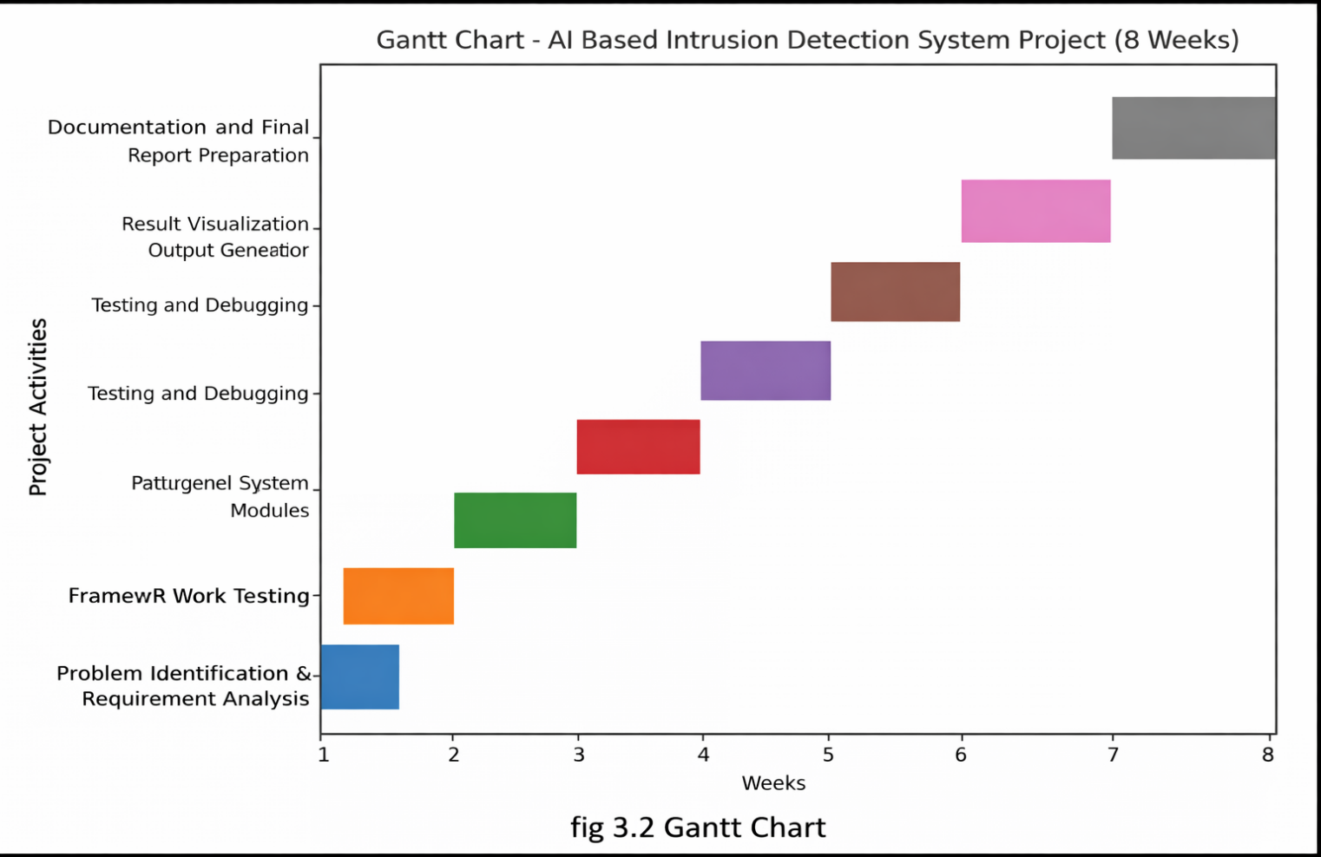

4.0SYSTEM ANALYSIS

4.1 STUDY OF CURRENT SYSTEM
The current network security systems in many organizations mainly rely on traditional security mechanisms such as firewalls, antivirus software, and manual monitoring of network activities. These systems help in protecting networks from basic threats, but they often depend on predefined rules and signatures to identify malicious activities. As a result, detecting new or unknown cyber attacks becomes difficult.
Most existing systems do not provide an intelligent mechanism to analyze large amounts of network data and identify unusual patterns automatically. Security administrators usually have to manually monitor system logs and network traffic to identify suspicious activities. This process can be time-consuming and may not always detect threats at an early stage.
In many cases, traditional intrusion detection systems are limited in their ability to analyze complex network behaviours. They may fail to identify advanced or previously unseen attacks because they depend mainly on known attack patterns. Without automated analysis and intelligent detection techniques, it becomes challenging to respond quickly to potential security threats.
Therefore, while the current systems provide basic protection against cyber threats, they lack advanced features such as intelligent analysis, automated threat detection, and real-time monitoring using artificial intelligence techniques. This creates the need for a more advanced system that can analyze network activities efficiently and detect suspicious behaviour more accurately.

4.2 PROBLEM AND WEAKNESSES OF CURRENT SYSTEM

The current network security systems used in many organizations have several limitations that reduce their effectiveness in detecting modern cyber threats.
- Dependence on Traditional Security Methods:
Many systems rely mainly on firewalls and antivirus software, which detect only known threats and may fail to identify new or unknown attacks.
- Lack of Intelligent Analysis:
Traditional systems do not use artificial intelligence or machine learning techniques to analyze network data and detect suspicious patterns automatically.
- Limited Detection Capability:
Existing intrusion detection systems often depend on predefined rules or signatures, which makes it difficult to detect advanced or previously unseen cyber attacks.
- Manual Monitoring of Network Activities:
Network administrators often have to manually review logs and network traffic to identify suspicious activities, which can be time-consuming and inefficient.
- Delayed Threat Identification:
Without automated analysis, security threats may be detected only after unusual behavior becomes noticeable, which can increase the risk of security breaches.
- Lack of Real-Time Threat Detection:
Many traditional systems are not capable of providing real-time analysis of network activity, which reduces the ability to respond quickly to potential cyber attacks.

REQUIREMENTS OF NEW SYSTEM
To overcome the limitations of the current system, the new AI Based Intrusion Detection system must meet the following requirements:
1. Functional Requirements
- The system should monitor and analyze network-related data to identify suspicious activities.
- It should perform network scanning and display the results through the web interface.
- The system must analyze network behavior and identify possible intrusion attempts or unusual patterns.
- It should generate alerts or notifications when suspicious activities are detected.
- The system should provide graphical visualization of analysis results using charts.
- It must allow users to view scanning results and security information through a dashboard interface.
2. Non-Functional Requirements
- The system should provide reliable detection of suspicious network activities.
- It must have a user-friendly interface that is easy to understand and operate.
- The system should process and display results efficiently without significant delay.
- It should maintain the security and integrity of the data being analyzed.
- The system should be scalable so that additional features or security modules can be added in the future.

SYSTEM FEASIBILITY
The proposed AI Based Intrusion Detection System is feasible in terms of technical, operational, economic, and schedule aspects.
1. Technical Feasibility
The system is technically feasible because it is developed using commonly available technologies such as Python, Flask, HTML, CSS, and JavaScript. These technologies are widely used for web application development and do not require expensive hardware or specialized infrastructure. The system can run on standard computer systems and development environments, making it technically practical to implement.
2. Operational Feasibility
The system is easy to use and operate. It provides a simple web-based interface where users can view network scanning results and analysis through a dashboard. The system helps users understand possible suspicious activities in the network without requiring advanced technical knowledge, making it operationally feasible.
3. Economic Feasibility
The project is cost-effective because it uses open-source programming languages and development tools. No additional expensive hardware or software licenses are required to develop or run the system. Therefore, the system can be implemented without significant financial investment.
4. Schedule Feasibility
The project was completed within the planned internship duration by following a structured development process. Proper planning and step-by-step execution helped ensure that all development stages were completed within the available timeframe, making the project feasible in terms of time management.

ACTIVITY / PROCESS IN NEW SYSTEM / PROPOSED SYSTEM
The proposed AI Based Intrusion Detection System follows a structured process to monitor network activities and identify potential security threats. The activities involved in the new system are as follows:
- Network Data Monitoring
The system monitors network-related data and activities to observe traffic patterns and identify possible unusual behaviour in the network environment.
- Data Processing
The collected network data is processed and organized so that it can be analyzed effectively. This step helps in preparing the data for further analysis and visualization.
- Intrusion Detection Analysis
The system analyses the monitored data to detect suspicious activities or patterns that may indicate unauthorized access or potential cyber attacks.
- Threat Identification
Based on the analysis results, the system identifies possible security threats and marks activities that appear abnormal or suspicious.
- Result Visualization
The system displays the analysis results through graphical representations such as charts and dashboards to help users understand network activity easily.
- Security Monitoring Support
Based on the detected results, users can review the information and take appropriate actions to improve network security and prevent potential threats.

FEATURES OF NEW SYSTEM / PROPOSED SYSTEM

The proposed AI Based Intrusion Detection System includes several useful features that help in monitoring network activities and identifying possible security threats:
- AI-Based Intrusion Detection
The system uses artificial intelligence concepts to analyze network activities and detect suspicious patterns.
- Network Activity Monitoring
It continuously monitors network-related data to observe unusual or abnormal behavior in the system.
- Threat Identification
The system identifies potential cyber threats or unauthorized access attempts by analyzing network behavior.
- Graphical Data Visualization
The system displays analysis results through graphical charts and visual representations to make the results easy to understand.
- Web-Based Interface
A user-friendly web interface allows users to view scanning results and network activity through a dashboard.
- Automated Analysis Process
The system automatically analyzes network data without requiring manual monitoring of logs.
- Improved Security Awareness
The system helps users understand possible network threats and security risks more clearly.
- Time-Efficient Monitoring
The system quickly processes network data and provides analysis results, helping users detect suspicious activities in a shorter time.

LIST MAIN MODULES / COMPONENTS / PROCESSES / TECHNIQUES OF NEW SYSTEM / PROPOSED SYSTEM

The proposed AI Based Intrusion Detection System consists of the following main modules and components:
- Network Monitoring Module
This module monitors network activities and collects network-related data to observe traffic patterns and system behavior.

- Data Processing Module
This module processes the collected network data and organizes it in a structured format so that it can be analyzed efficiently.

- Intrusion Detection Module
This module analyzes network activities to identify suspicious patterns or abnormal behavior that may indicate possible cyber attacks.

- Threat Identification Module
This module identifies potential security threats or unauthorized access attempts based on the analysis of network data.

- Visualization Module
This module generates graphical representations such as charts to display the analysis results in an easy-to-understand format.

- User Interface Module
This module provides a web-based dashboard where users can view network scanning results and analysis outputs.

- Security Monitoring Support Module
Based on the analysis results, this module assists users in understanding possible network threats and helps improve network security awareness.

SELECTION OF HARDWARE / SOFTWARE / ALGORITHMS / METHODOLOGY / TECHNIQUES / APPROACHES AND JUSTIFICATION

The development of the “AI Based Intrusion Detection System” required careful selection of hardware, software, and development methodology to ensure proper functionality and efficient execution of the system.
1. Hardware Selection
The project was developed and executed on a standard computer system with:
- Minimum 8GB RAM
- Intel i3 / i5 Processor
- 500GB Storage
Justification:
The selected hardware configuration is sufficient for developing and running a web-based application using Python and related technologies. It provides adequate processing capability for coding, testing, and running the application without requiring high-end hardware resources.

2. Software Selection
- Programming Language: Python
- Backend Framework: Flask
- Frontend Technologies: HTML, CSS, JavaScript
- Development Environment: Visual Studio Code
- Libraries Used: Pandas, Matplotlib
Justification:
Python was selected because it is easy to use, widely supported, and suitable for data analysis and application development. Flask allows simple development of web-based applications, while HTML, CSS, and JavaScript help in creating an interactive user interface. These technologies are open-source and suitable for building the project efficiently.

3. Algorithm Selection
The system uses data analysis and pattern identification techniques to observe network activities and detect suspicious behavior.
Justification:
These techniques help in analyzing network activity patterns and identifying unusual behavior that may indicate potential intrusion attempts.

4. Methodology
The project followed a structured development methodology consisting of the following steps:
- Problem Identification
- System Design
- Application Development
- Testing and Debugging
- Result Visualization
- Documentation
Justification:
Following a structured development process ensures systematic implementation, proper testing, and reliable functioning of the system.

5. Techniques and Approaches
- Network activity monitoring
- Data processing and analysis
- Graphical visualization of results
- Web-based dashboard interface
Justification:
These approaches help in efficiently monitoring network activities and presenting the analysis results in a clear and understandable format for users.

5.0 SYSTEM DESIGN

SYSTEM DESIGN & METHODOLOGY
The AI Based Intrusion Detection System is designed using a structured web-based framework to monitor network activities and identify suspicious behavior. The system follows a modular design where each component performs a specific function in the overall workflow.
System Design
The system consists of the following major components:
1. Input Layer
Network-related data and system activity information are provided as input to the system for monitoring and analysis.
2. Data Processing Layer
The collected data is processed and organized into a structured format so that it can be analyzed efficiently.
3. Analysis Layer
The system analyzes network activity patterns to identify unusual behavior that may indicate possible intrusion attempts or security threats.
4. Output Layer
The system generates results that indicate suspicious activities or potential threats in the network.
5. Visualization Layer
The results of the analysis are displayed through graphical charts and dashboard interfaces to help users easily understand the network activity.

Methodology
The methodology adopted for the project includes the following steps:
1. Problem Identification
The objective was defined as monitoring network activity and identifying possible intrusion attempts using analytical techniques.
2. Data Collection
Network activity data and system-related information were considered for analysis and monitoring.
3. Data Processing
The collected data was processed and organized to make it suitable for analysis and visualization.
4. System Development
A web-based application was developed using Python, Flask, HTML, CSS, and JavaScript.
5. System Testing
The developed system was tested to verify that the scanning simulation, analysis features, and graphical outputs worked correctly.
6. Result Analysis
The system outputs were analyzed through charts and dashboards to observe possible suspicious network activities.
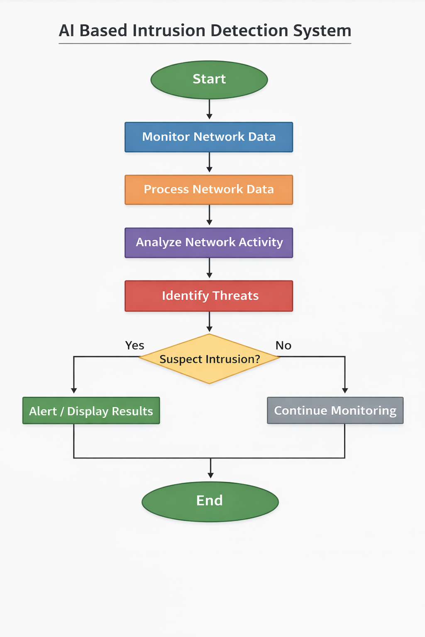

Fig 5.1: Flow Chart

6.0 IMPLEMENTATION

6.1 IMPLEMENTATION PLATFORM / ENVIRONMENT
The AI-Based Intrusion Detection and Network Scanner System is developed using modern web technologies and Python-based tools to ensure efficient monitoring, analysis, and visualization of network activities.
Software Platform
- Programming Language: Python
- Development Environment: VS Code / Python Environment
- Libraries Used:
  - Flask (for backend web framework and routing)
  - Chart.js / JavaScript libraries (for displaying graphical charts and dashboards)
  - Python Standard Libraries (for network scanning simulation and data processing)
- Frontend (Implemented):
HTML, CSS, JavaScript
- Backend Framework:
Flask (Python-based web framework used to connect backend logic with the frontend interface)
- Dataset / Data Storage:
JSON / CSV-based data storage used for storing scan results and analysis outputs.

6.2 PROCESS / PROGRAM / TECHNOLOGY / MODULES SPECIFICATION(S)

1. Process Specification

The system follows a step-by-step workflow for monitoring and analyzing network activities:

1. Network Data Monitoring

Network activity data such as incoming connections, traffic information, and scanning inputs are monitored through the system interface.

2. Data Processing Process

Organizing collected network activity data

Filtering relevant information

Preparing data for analysis

3. Analysis Process

The system analyzes network activity patterns

Suspicious or abnormal activities are identified

Potential intrusion behavior is detected

4. Threat Detection Process

System checks whether the activity is suspicious

Possible intrusion attempts are detected

5. Result Display Process

Security alerts or analysis results are displayed

Graphical charts and dashboards show system activity

Output is presented on the web interface

2. Program Specification

Developed using Python programming language

Backend implemented using Flask framework

Frontend designed using HTML, CSS, and JavaScript

Code structured into reusable functions and modules

System integrates backend logic with web interface for monitoring and visualization

3. Technology Specification

Programming Language: Python

Backend Framework: Flask

Frontend Technologies: HTML, CSS, JavaScript

Visualization Tools: Chart.js / JavaScript libraries

Development Environment: VS Code / Python environment

The system uses analytical techniques and monitoring methods to detect suspicious network activity and visualize results effectively.

4. Module Specification

The system is divided into the following main modules:

1. Network Monitoring Module

Monitors network activity and collects information related to system connections.

2. Data Processing Module

Processes and organizes collected data for analysis.

3. Threat Detection Module

Analyses network activity and identifies suspicious patterns or potential intrusion attempts.

4. User Interface Module

Provides the web interface for users to monitor network activity and interact with the system.

5. Result & Visualization Module

Displays analysis results using charts and dashboards to help users understand network security.

