**Name: Meet Brijwani**

**Batch: T11**

# Roll no:14 Experiment 3

**AIM:** To Perform various GIT operations on local and Remote repositories.

**THEORY:**

**1. Git Local Repository Operations**

A local Git repository exists on your computer and allows you to manage changes to a project independently of any remote server.

**a. Initialize a Local Repository**

git init

This creates a new Git repository in the current directory.

**b. Checking Repository Status**

git status

Shows the current state of the working directory and staging area.

**c. Adding Files to Staging Area**

git add <filename> # Adds a specific file

git add . # Adds all files in the directory

Prepares files for commit by moving them to the staging area.

**d. Committing Changes**

git commit -m "Commit message"

Saves a snapshot of the staged changes to the local repository.

**e. Viewing Commit History**

git log

Displays a list of all the commits made in the repository.

**f. Creating and Switching Branches**

git branch <branch-name> # Create a new branch

git checkout <branch-name> # Switch to the branch

git switch <branch-name> # Alternative to checkout for switching

**g. Merging Branches**

git checkout main

git merge <branch-name>

Combines changes from another branch into the current branch.

**2. Git Remote Repository Operations**

A remote Git repository is hosted on a server like GitHub, GitLab, or Bitbucket. It allows collaboration and backup of your code.

**a. Connecting to a Remote Repository**

git remote add origin https://github.com/user/repo.git

Links the local repository to a remote one.

**b. Pushing Changes to Remote**

git push origin main # Push changes from local main to remote main

git push -u origin main # Sets upstream to track remote branch

**c. Pulling Changes from Remote**

git pull origin main

Fetches and merges changes from the remote repository into your local branch.

**d. Cloning a Remote Repository**

git clone https://github.com/user/repo.git

Creates a local copy of the remote repository.

**e. Fetching Updates Without Merging**

git fetch origin

Downloads commits, files, and refs from a remote repository without merging them automatically.

**SCREENSHOTS:**





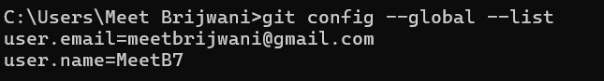



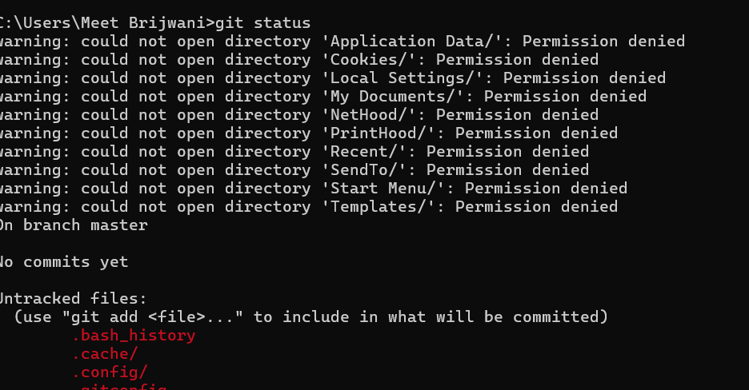





**CONCLUSION:** Hence, we have performed various GIT operations on local and Remote repositories.