**Name: Meet Brijwani**

**Batch: T11**

**Roll no:14 Experiment 4**

**AIM:**  To understand Continuous Integration, install and configure Jenkins with Maven/Ant/Gradle to setup a build Job.

**THEORY:**

Jenkins is an open-source automation tool written in Java with plugins built for Continuous Integration purpose. Jenkins is used to build and test your software projects continuously making it easier for developers to integrate changes to the project and making it easier for users to obtain a fresh build. It also allows you to continuously deliver your software by integrating with many testing and deployment technologies.

Jenkins simplifies and accelerates the software development lifecycle. By automating repetitive tasks, it reduces the chance of errors, provides faster feedback to developers, and enables more frequent software releases. This automation helps teams to deliver software more quickly and with higher quality. It is a valuable tool for any team looking to improve their software development workflow.

The Steps to install Jenkins and implement the jobs are given below as:

Step 1:

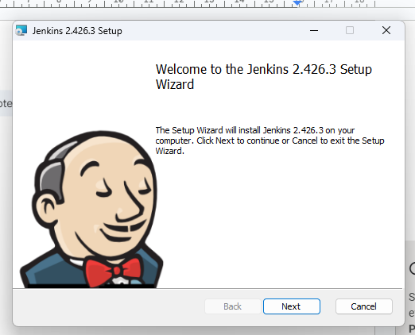

Step 2:

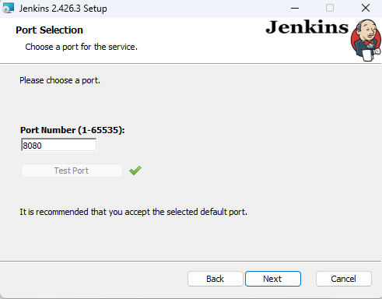

Step 3:

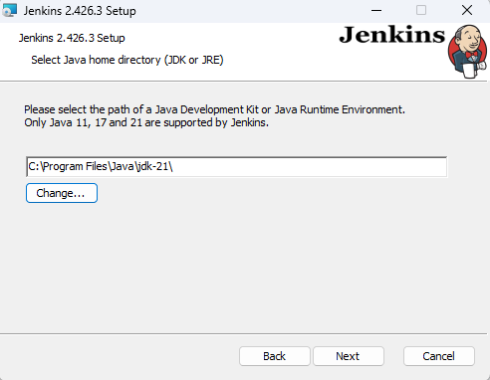

Step 4:

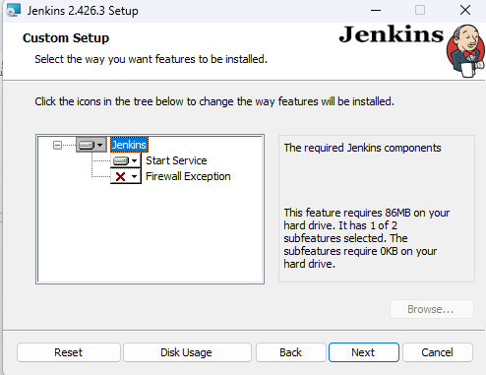

Step 5:

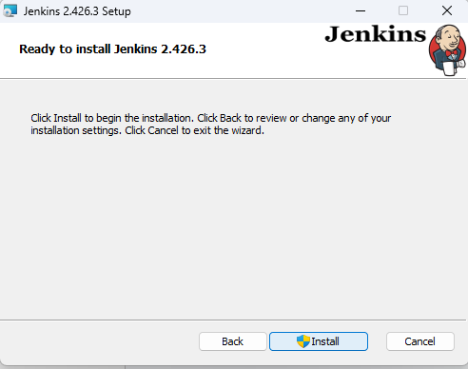

Step 6:

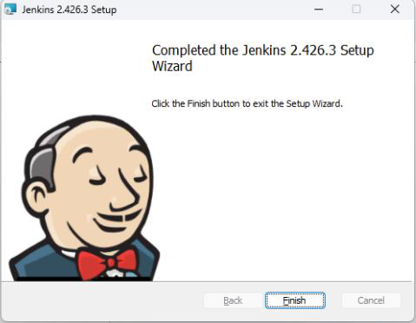

Step 7:

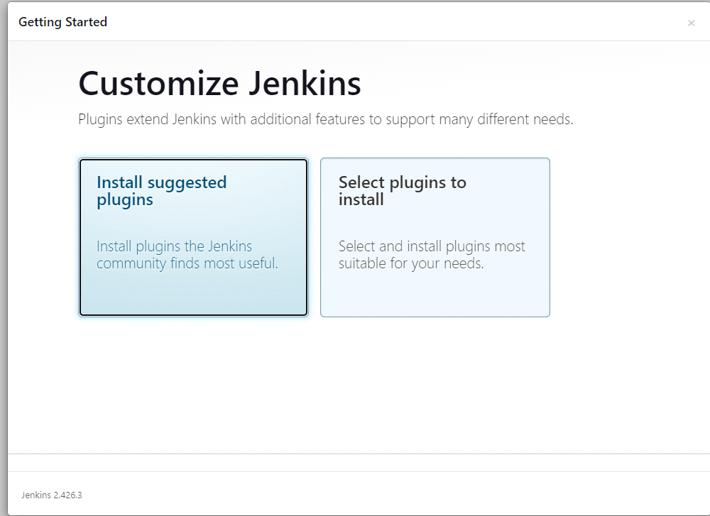

Step 8:

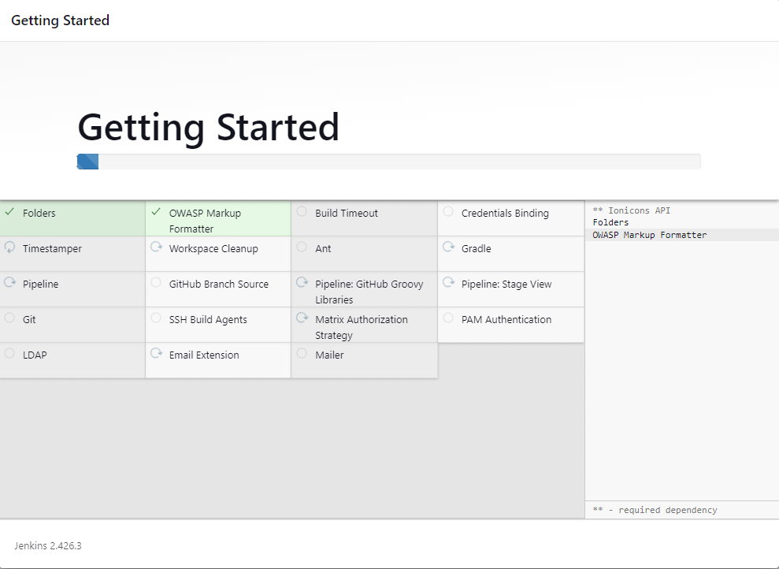

Step 9:

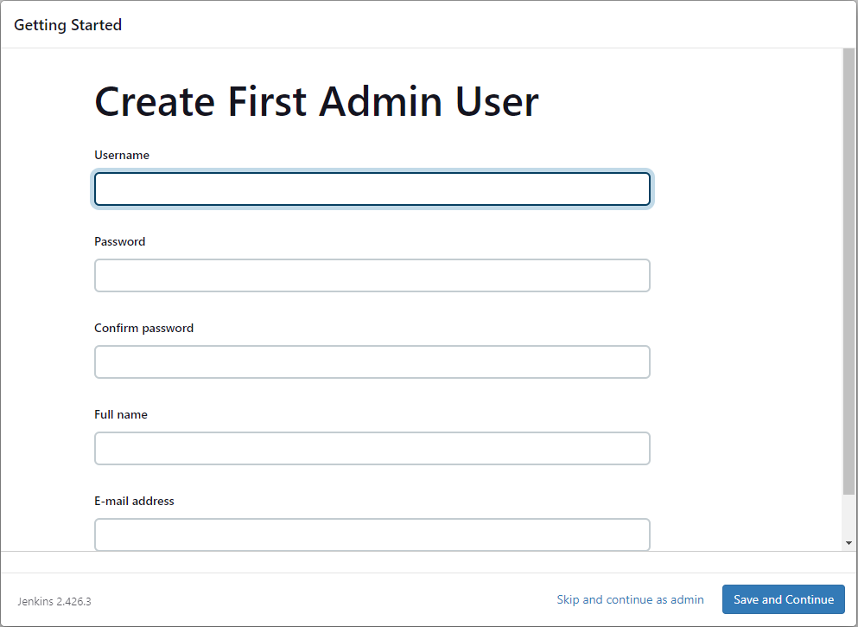

Step 10:

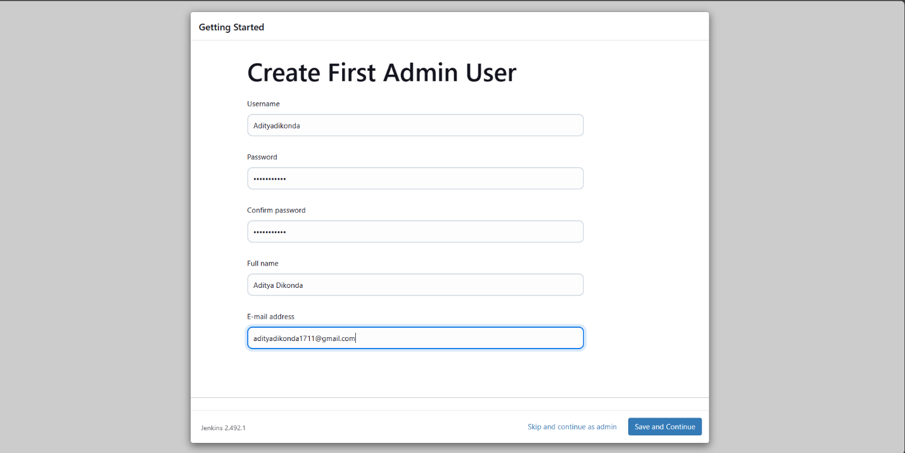

Step 11:

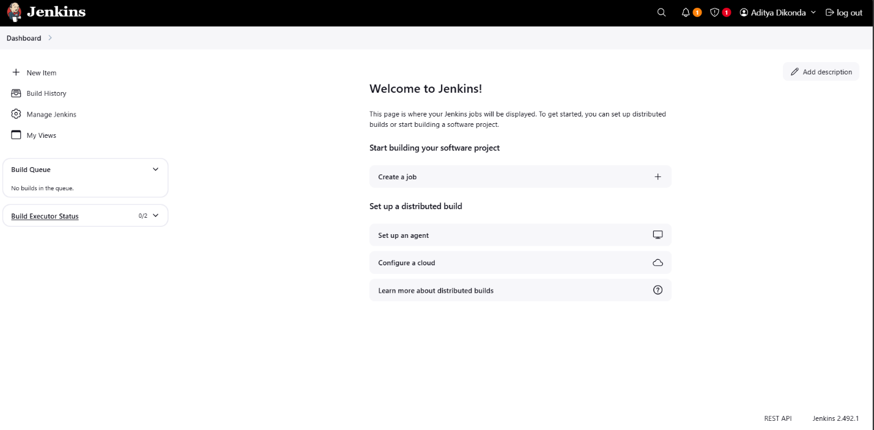

**CONCLUSION:** Jenkins with Maven simplifies Continuous Integration, automating builds and improving project efficiency for faster development cycles and higher software quality.