**Name: Meet Brijwani**

**Batch: T11**

**Roll no: 14**

**Experiment 6**

**AIM:** To study agile methodology and test case management using the JIRA tool. To create a scrum board for scrum master using the JIRA tool.

**THEORY:**

Jira is a software development tool that helps teams plan, track, and release software projects. It's a popular tool among software development teams.

JIRA is a widely used issue tracking and project management software developed by Atlassian. The theory behind JIRA revolves around several key principles and concepts:

**Issue Tracking:**

At its core, JIRA is designed to help teams track tasks, bugs, features, and other issues within a project. It provides a centralized platform for capturing, organizing, and prioritizing these items.

**Agile Methodologies:**

JIRA supports agile methodologies such as Scrum and Kanban, enabling teams to plan, track, and deliver work in iterative cycles. Agile principles emphasize collaboration, adaptability, and delivering value to customers.

**Workflow Management:**

JIRA allows teams to define custom workflows that represent the lifecycle of an issue from creation to completion. Workflows can include various statuses, transitions, and conditions to reflect the

specific processes followed by the team.

**Customization:**

One of the key strengths of JIRA is its flexibility and customization options. Teams can tailor JIRA to their specific needs by creating custom issue types, fields, workflows, and project configurations.

**Collaboration and Communication:** JIRA facilitates collaboration among team members by providing features such as commenting, mentioning, and attaching files to issues. It also integrates with other Atlassian products like Confluence and Bitbucket for seamless communication and knowledge sharing. Reporting and **Analytics:** JIRA offers robust reporting and analytics capabilities, allowing teams to gain insights into their project progress, team performance, and other key metrics. Users can create custom dashboards, charts, and reports to monitor and analyze project data.

**OUTPUT:**



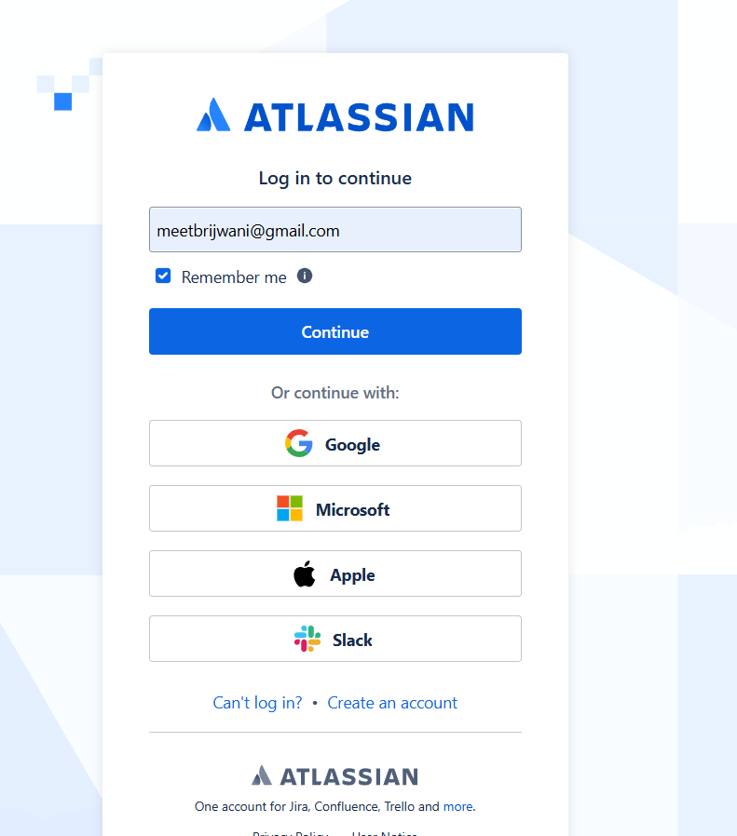

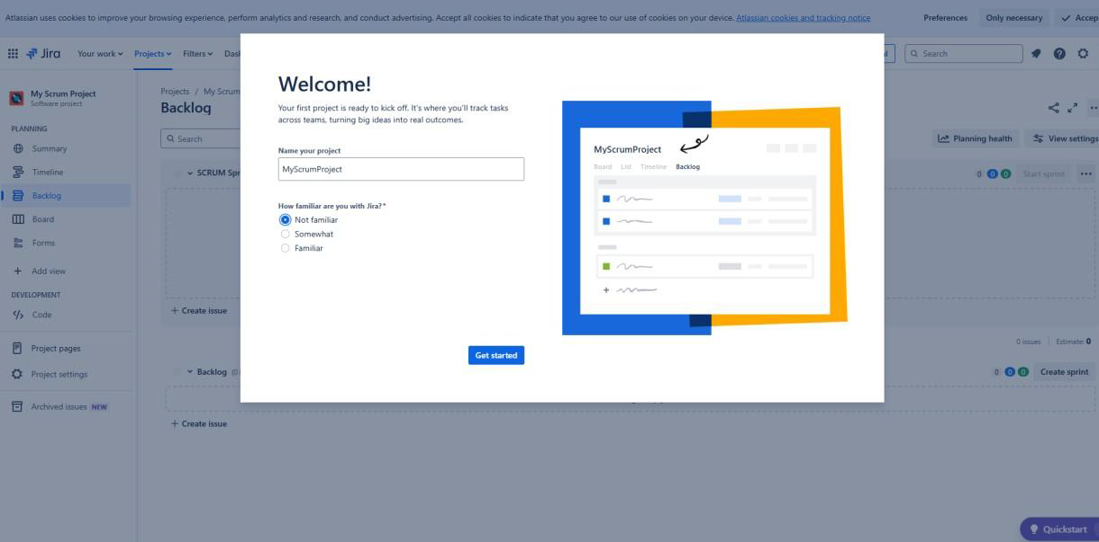

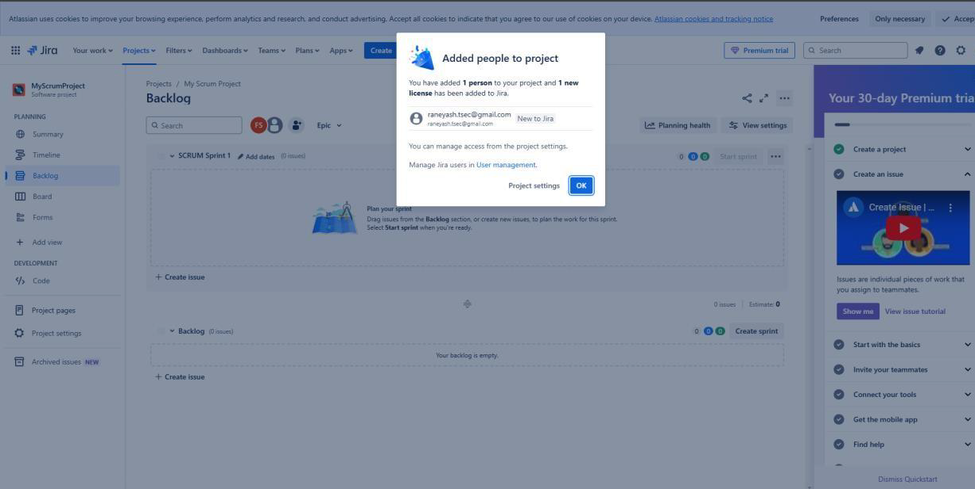

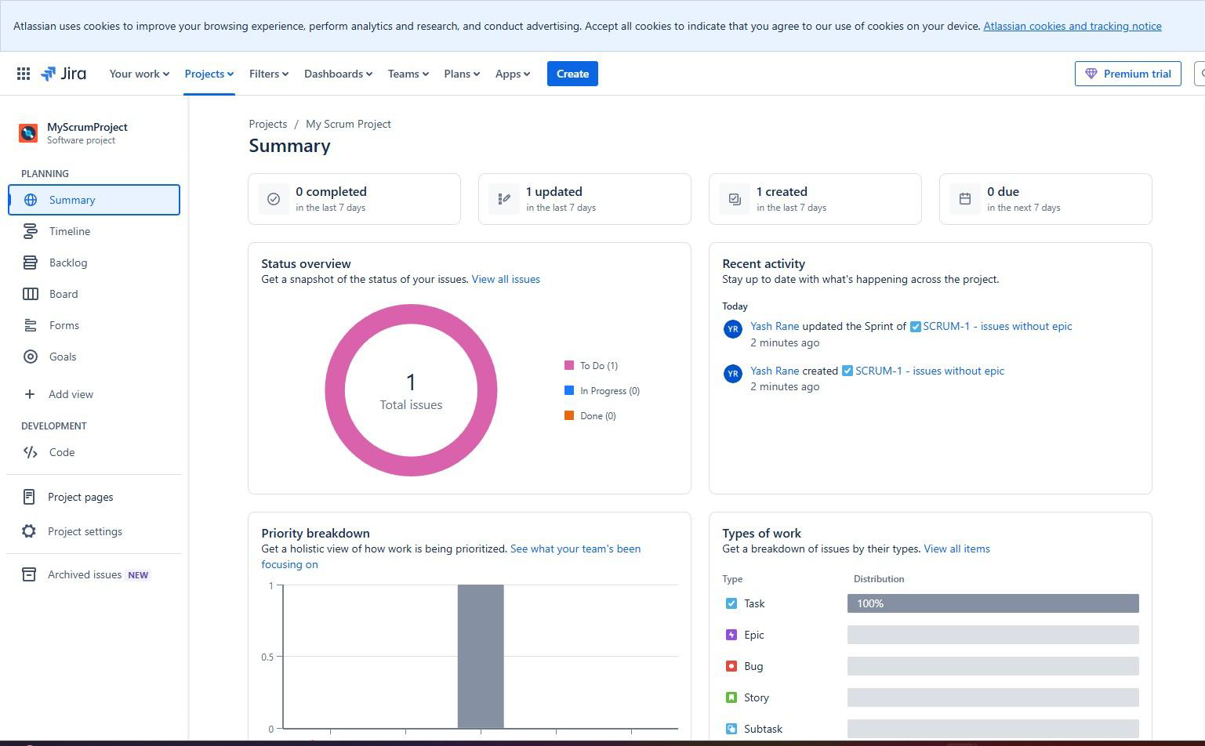

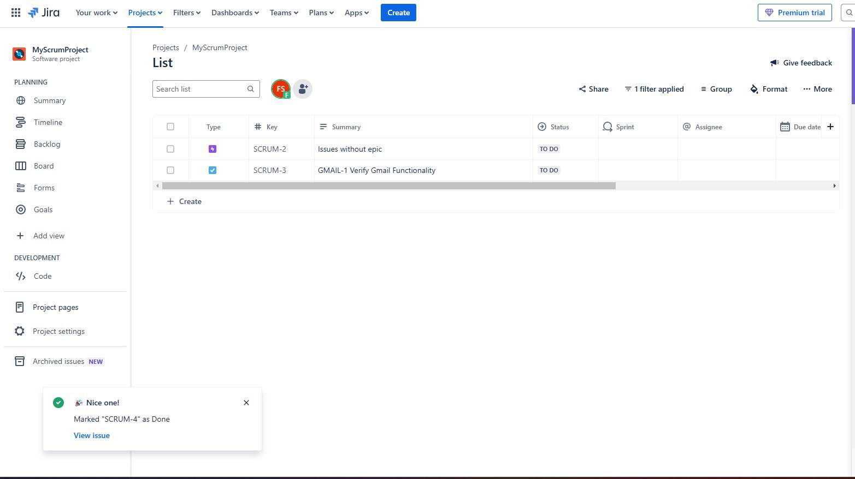

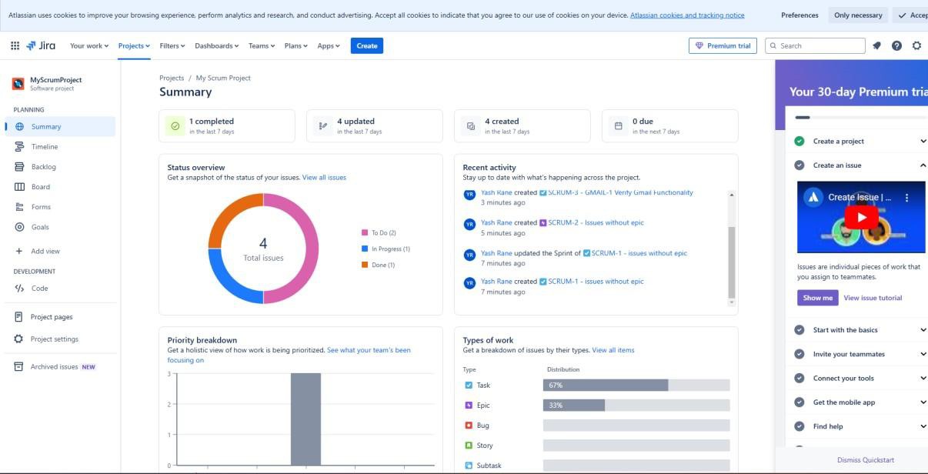

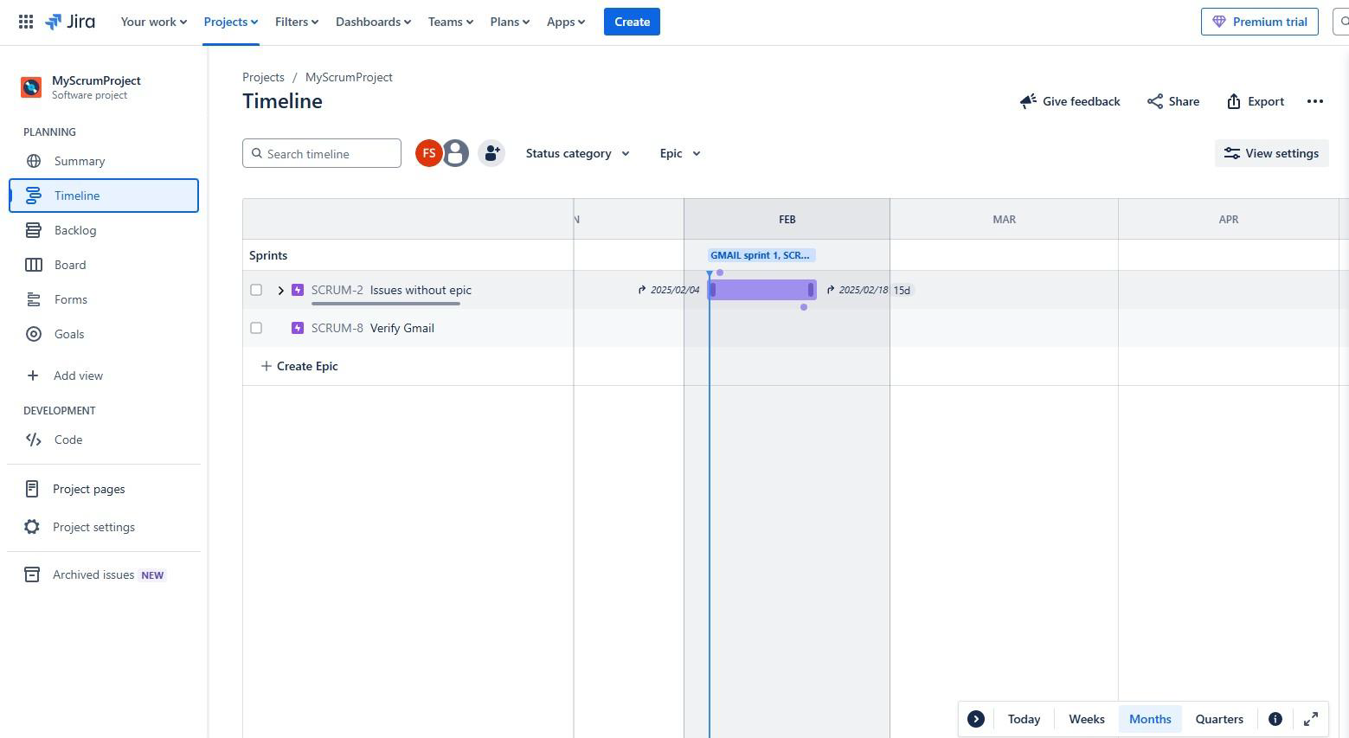

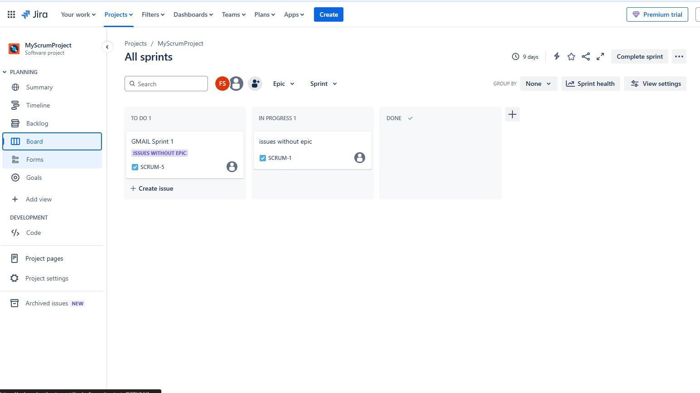

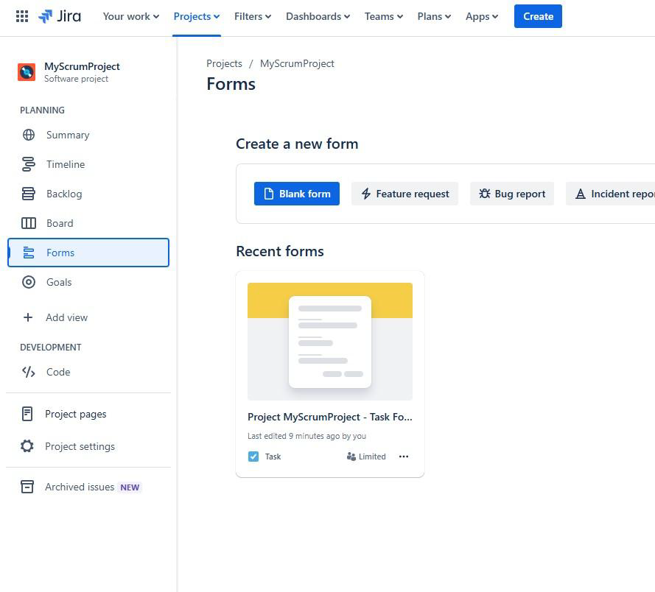

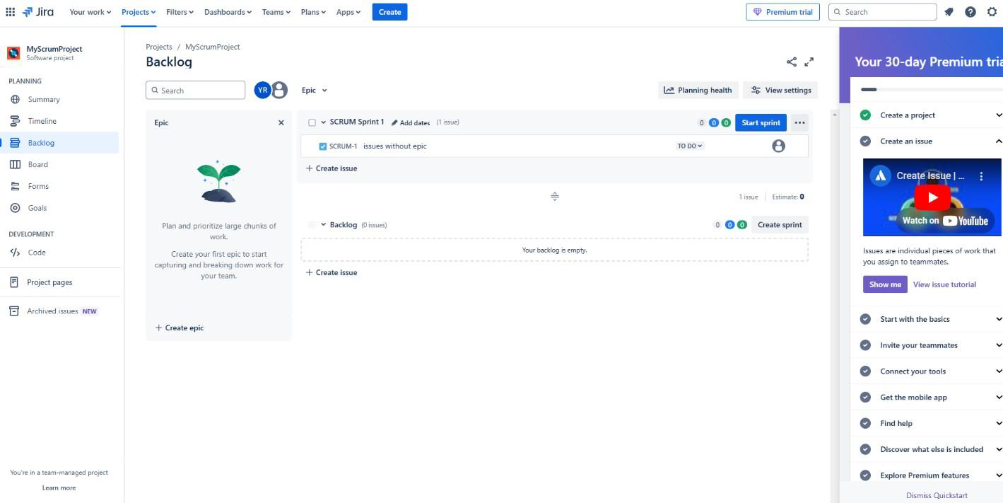

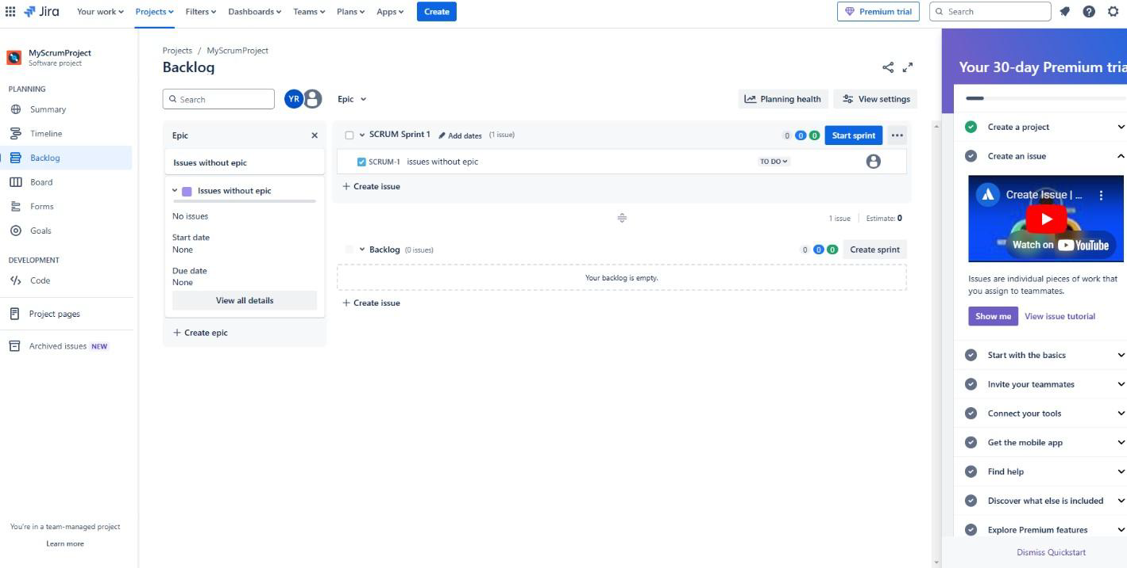

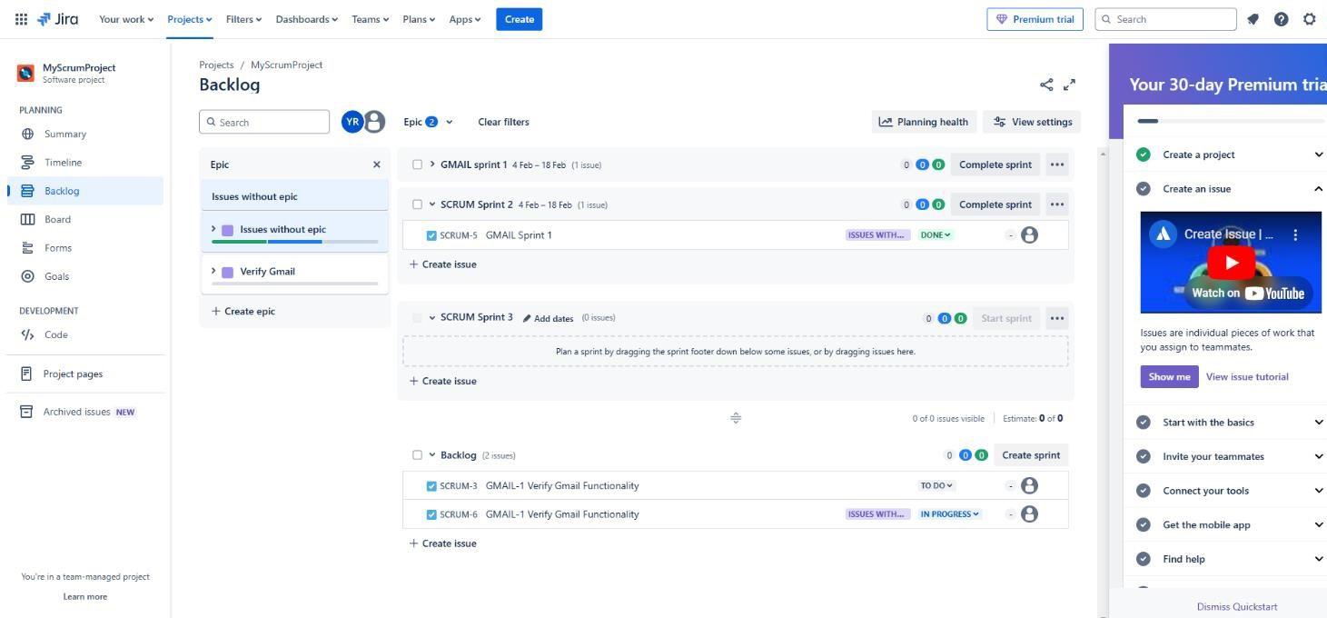

**CONCLUSION:** Thus, we have successfully studied agile methodology and test case management using JIRA tool and create scrum board for scrum master using JIRA tool.