**Name: Meet Brijwani**

**Batch: T11**

**Roll no: 14**

**Experiment 8**

**AIM:**  To Study Project Scheduling Using Gantt chart in ClickUp.

**THEORY:**

## Project Scheduling-

A project schedule is a timeline that outlines the tasks, milestones, deadlines, and resources required for completing a project. It helps project managers organise and plan the sequence of activities, allocate resources efficiently, set realistic timelines, and monitor progress. Having a clear project schedule is crucial for a project manager as it ensures tasks are completed on time, helps in managing resources effectively, allows for better coordination among team members, and assists in identifying potential issues or delays, enabling timely adjustments to keep the project on track.

## Gantt chart-

A Gantt chart, commonly used in project management, is one of the most popular and useful ways of showing activities (tasks or events) displayed against time. On the left of the chart is a list of the activities and along the top is a suitable time scale. Each activity is represented by a bar; the position and length of the bar reflects the start date, duration and end date of the activity.

**OUTPUT:**

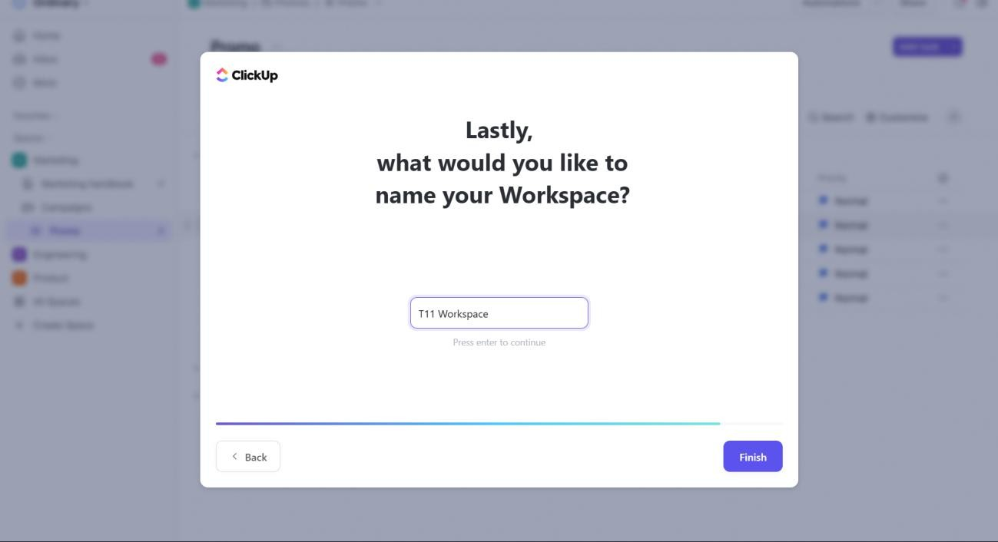

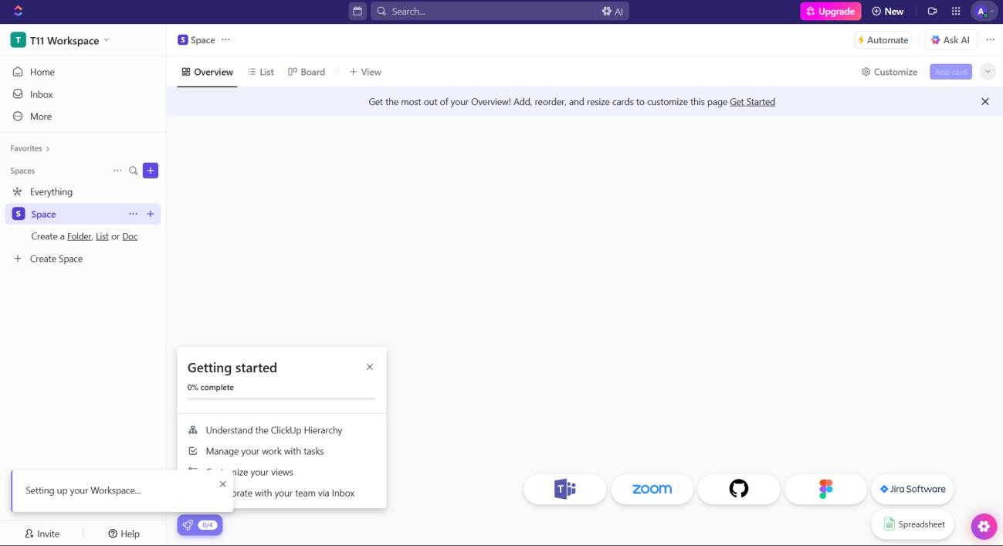

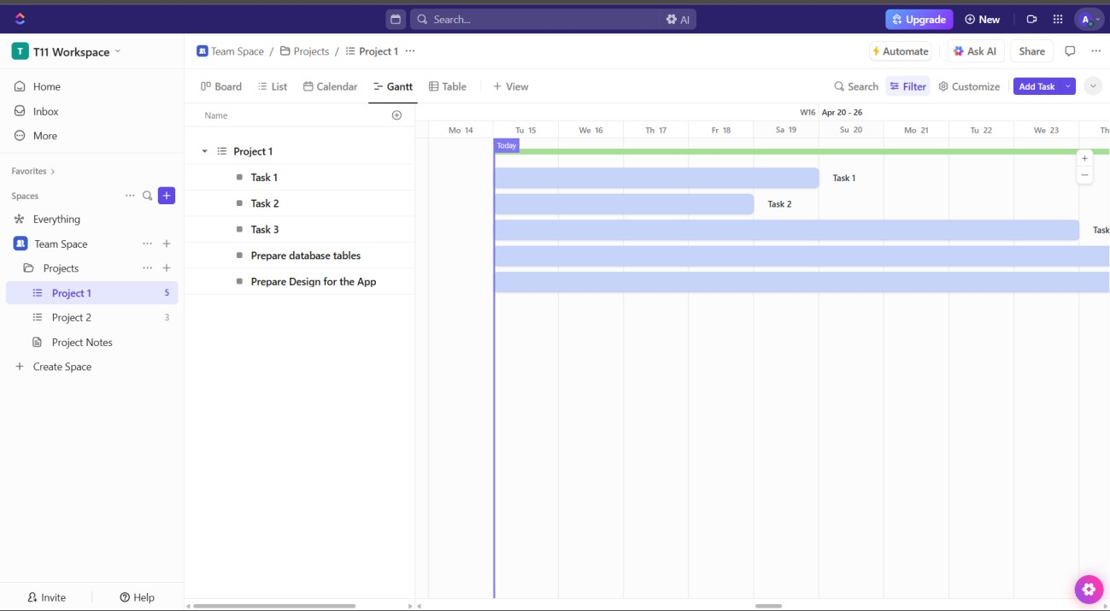

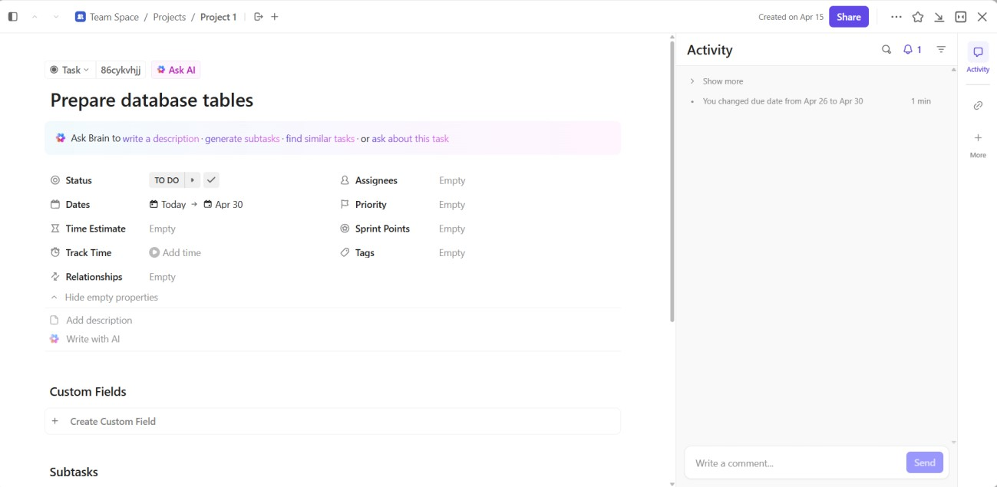

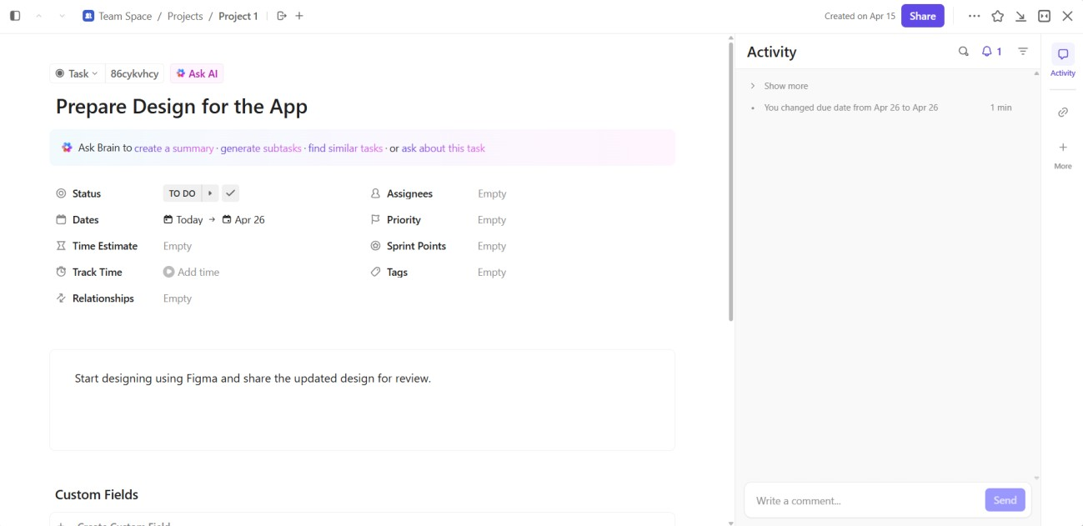

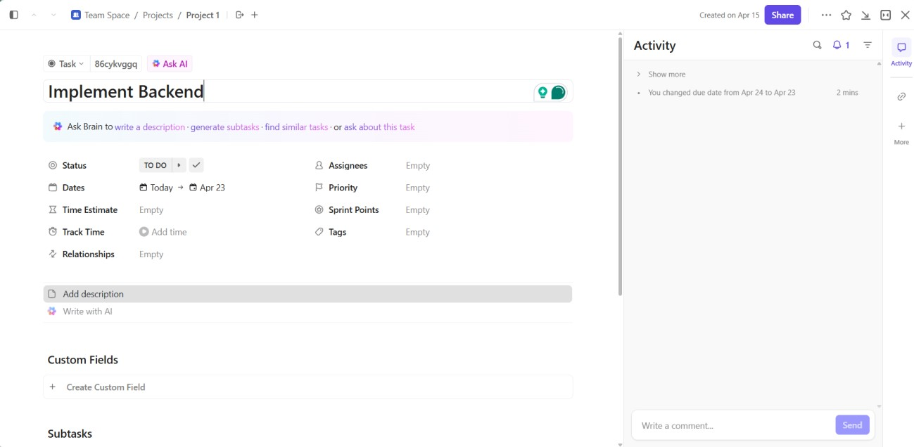

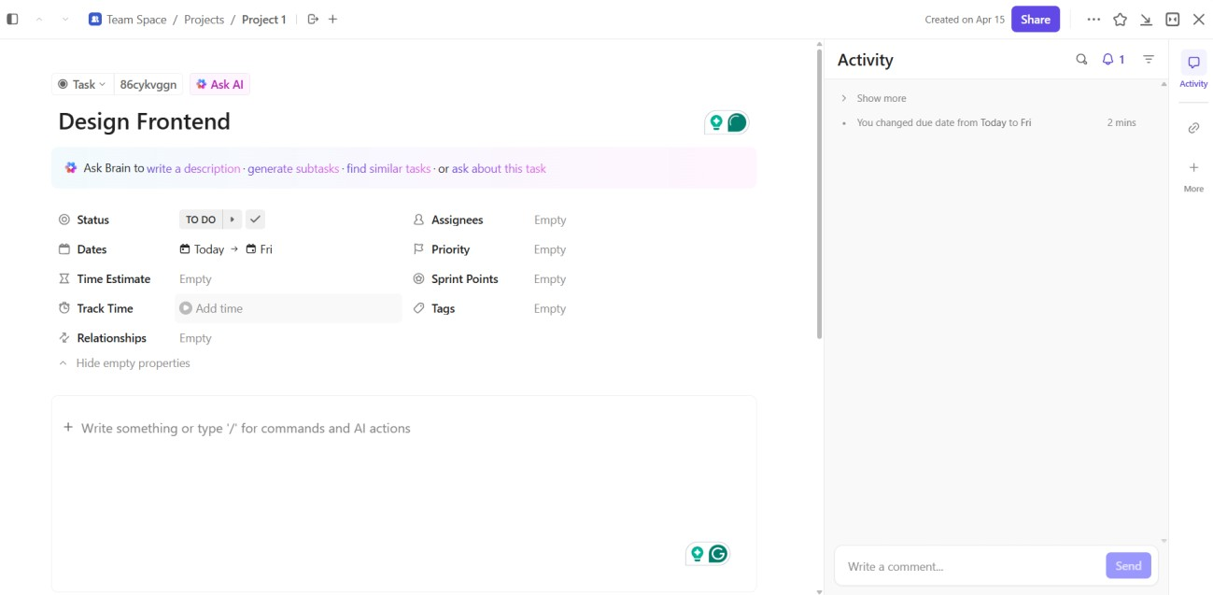

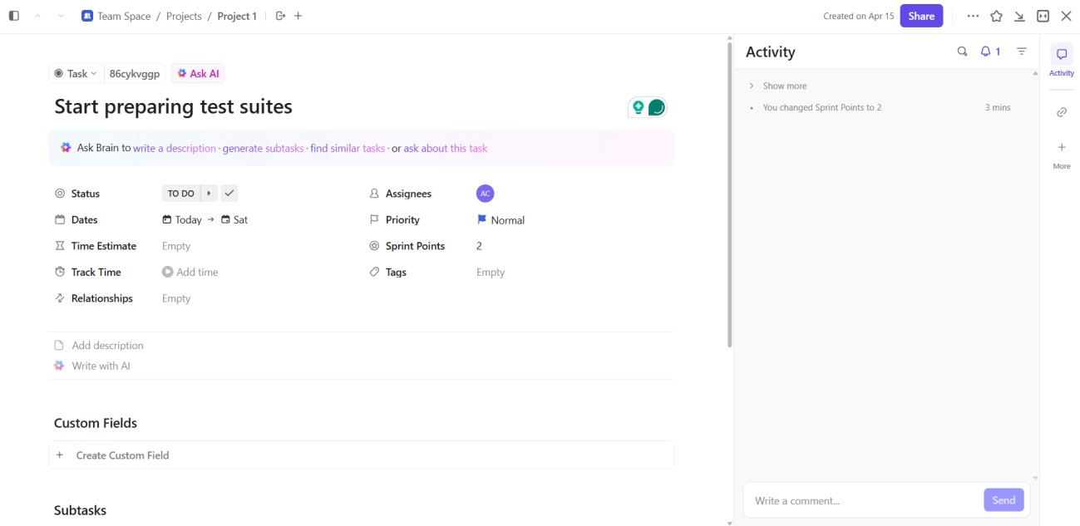

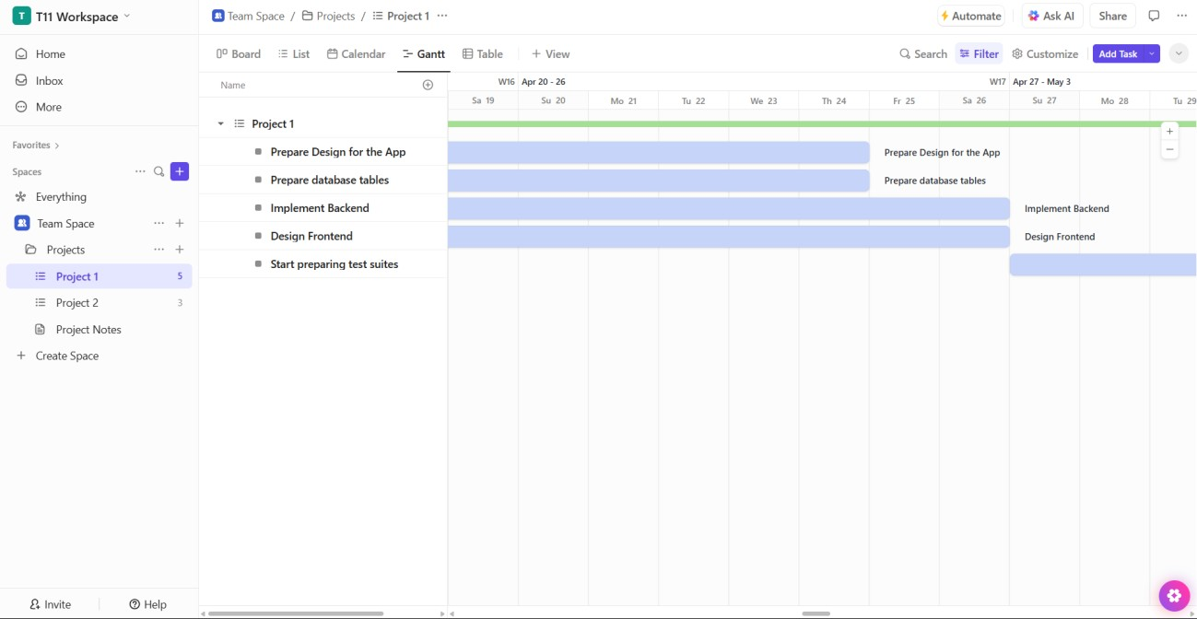

**CONCLUSION:** Thus, we have successfully implemented Project Scheduling using Gantt Chart in ClickUp.