1. Custom Hook
Code :-
File :- App.jsx
- import useToggle from './useToggle'

- function App() {
- const [isOn, toggle] = useToggle();

- return (
- <>
- <h1>Custom Hook</h1>
- <h1>Status: {isOn ? "ON" : "OFF"}</h1>
- <button onClick={toggle}>{isOn ? "Turn Off" : "Turn On"}</button>
- </>
- )
- }

- export default App

File :- useToggle.jsx
import { useState } from "react";
function useToggle()
{
const [isOn, setIsOn] = useState(false);
const toggle = () => setIsOn(!isOn);
return [isOn, toggle];
}
export default useToggle;

Output :-
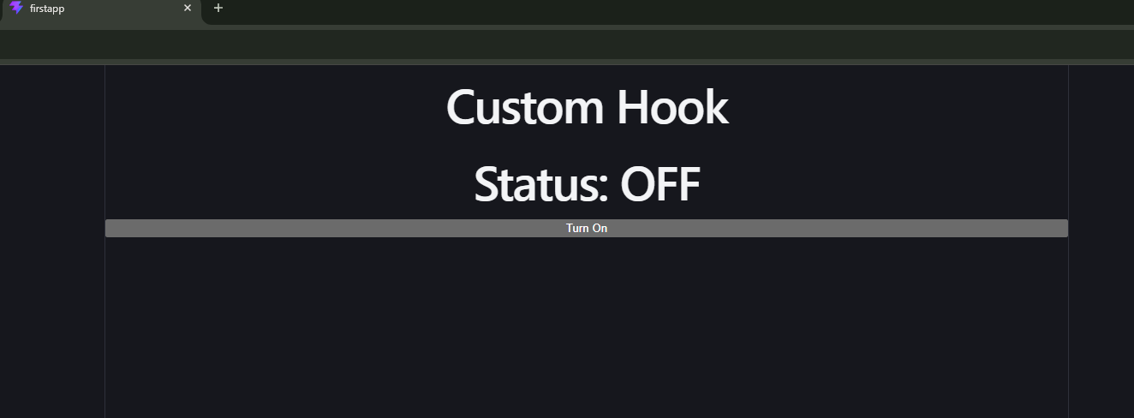

1. UseMemo
Code :-

import { useState, useMemo } from "react";

function Memo() {
const [number, setNumber] = useState([10, 20, 30, 40]);
const [count, setCount] = useState(0);

const maxNumber = useMemo(() => {
console.log("Finding highest number...");
return Math.max(...number);
}, [number]);

return (
<div style={{ padding: "20px" }}>
<h2>React Performance Optimization</h2>

<p>Number: {number.join(", ")}</p>
<p>Highest Number: {maxNumber}</p>

<button onClick={() => setNumber([...number, 50])}>
Add 50
</button>

<p>Count: {count}</p>

<button onClick={() => setCount(count + 1)}>
Increment Count
</button>
</div>
);
}

export default Memo;
Output :-


