




Summer Training Report
Academic Year 2026-27

Student’s Full Name | Meet Bhingradiya
Enrollment No. | 25SE09CS039
Branch: | Computer Science & Engineeering

Name of the Company | : | Valora Infotech
Location | : | 402, akshar square, katargam ,surat



Student Declaration
I hereby declare that this internship report is my original work carried out during my Summer Internship. The information presented in this report is true to the best of my knowledge.
Student Signature
Date:

INDEX

Sr. No. | Component | Page. No.
 | Chapter 1: Organization Profile | 3
 | Chapter 2: Internship Details | 4
 | Chapter 3: Work Performed | 5
 | Chapter 4: Learning Outcomes | 13

CHAPTER 1
ORGANIZATION PROFILE
- Company Name: Valora Infotech
- About the Organization:
Valora Infotech is a forward-thinking technology company specializing in innovative software solutions and product development. They focus on delivering high-quality, robust, and scalable software products.
- Vision and Mission:
To deliver high-quality, robust, and scalable software products while empowering developers to build cutting-edge solutions.
- Products/Services:
Web Application Development, Full Stack Solutions, Game Development.

Department Assigned
- Role : Full Stack Web Development

CHAPTER 2
Internship Details
Internship Objectives
- To gain practical experience in Full Stack Web Development using modern frameworks like Next.js, React, and Bun.
- To understand the software development lifecycle, from project planning to deployment.
- To develop a fully functional Resume Builder web application featuring admin dashboards, authentication, and dynamic pages.

Roles and Responsibilities
As an Intern in the Development department, my primary responsibility was to design, develop, and test web application components. I collaborated with the team to implement the Resume Builder Application, focusing on creating dynamic React components, managing MongoDB databases, and building RESTful APIs using Next.js (Turbopack). I also handled user authentication and the integration of various pages such as the Landing Page, Experience Page, and Admin Panel Dashboard.

CHAPTER 3
Work Performed
During the internship, I developed a comprehensive My Portfolio & Resume Builder Web Application. Below are the key features and applications of this project:

Include:
Tasks Assigned & Project Features:
- Landing Page: Designed a modern, responsive landing page to introduce the application.
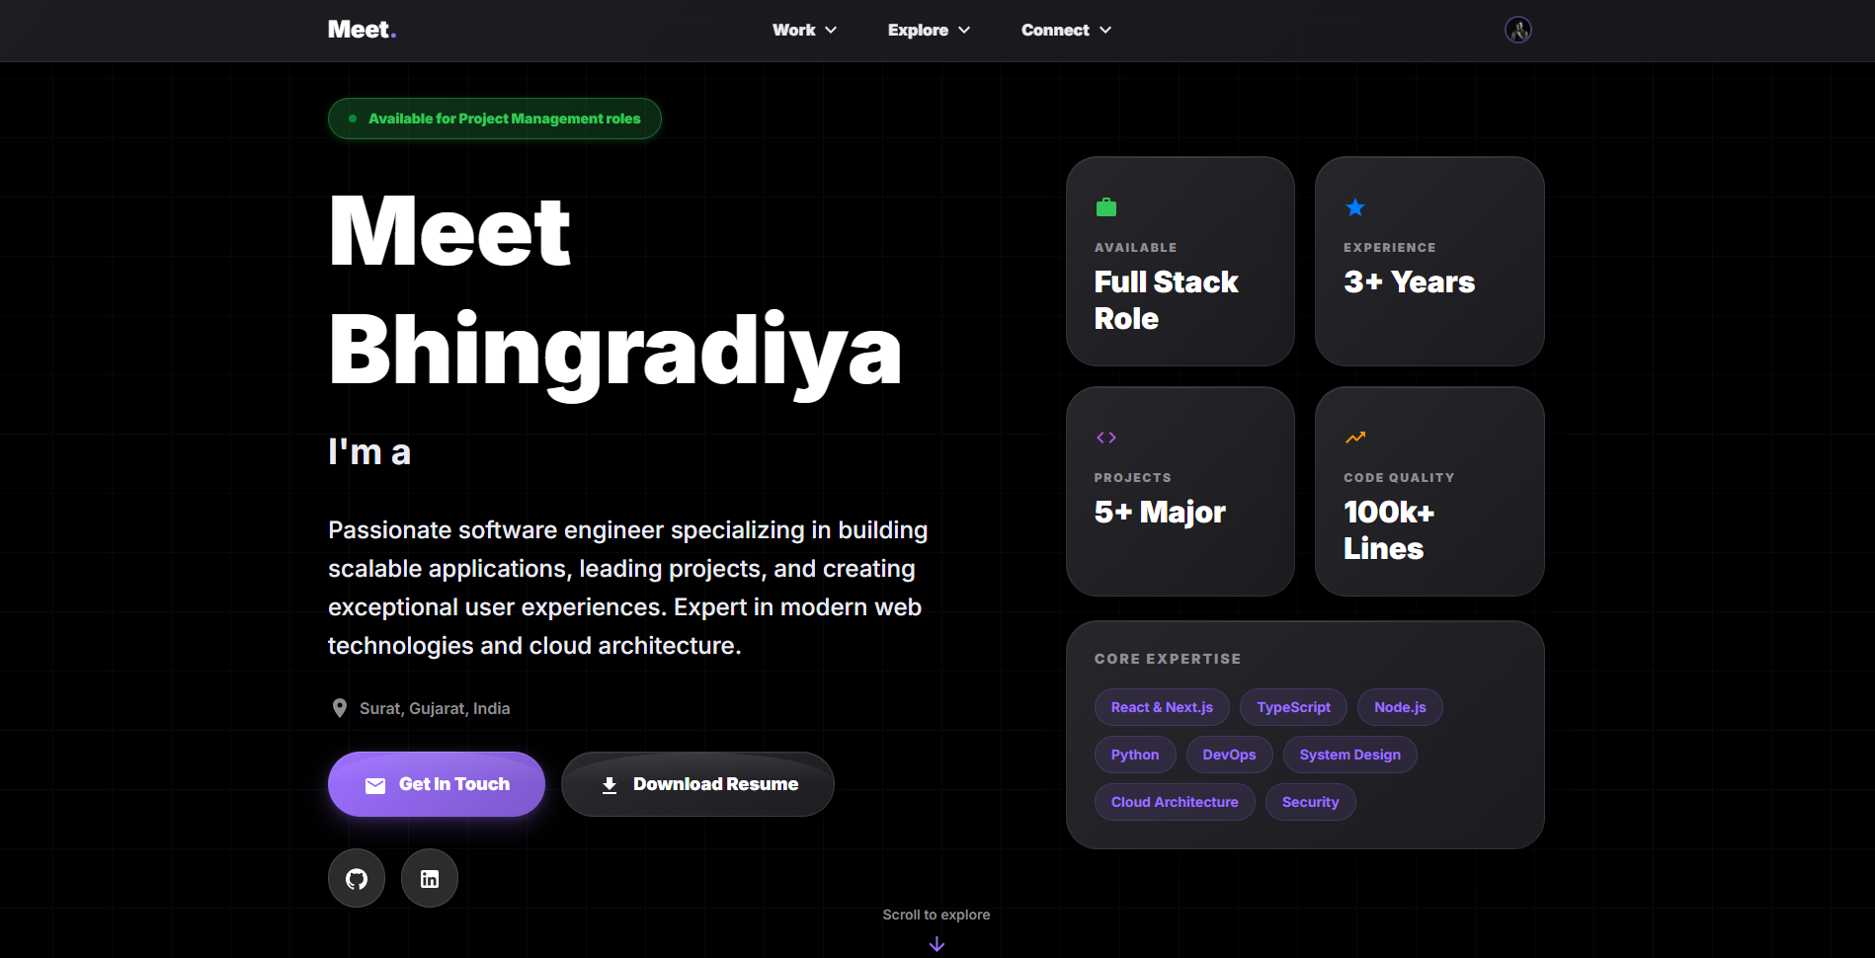
- Experience Page & Projects Page: Created dynamic pages to showcase work experience and portfolio projects.
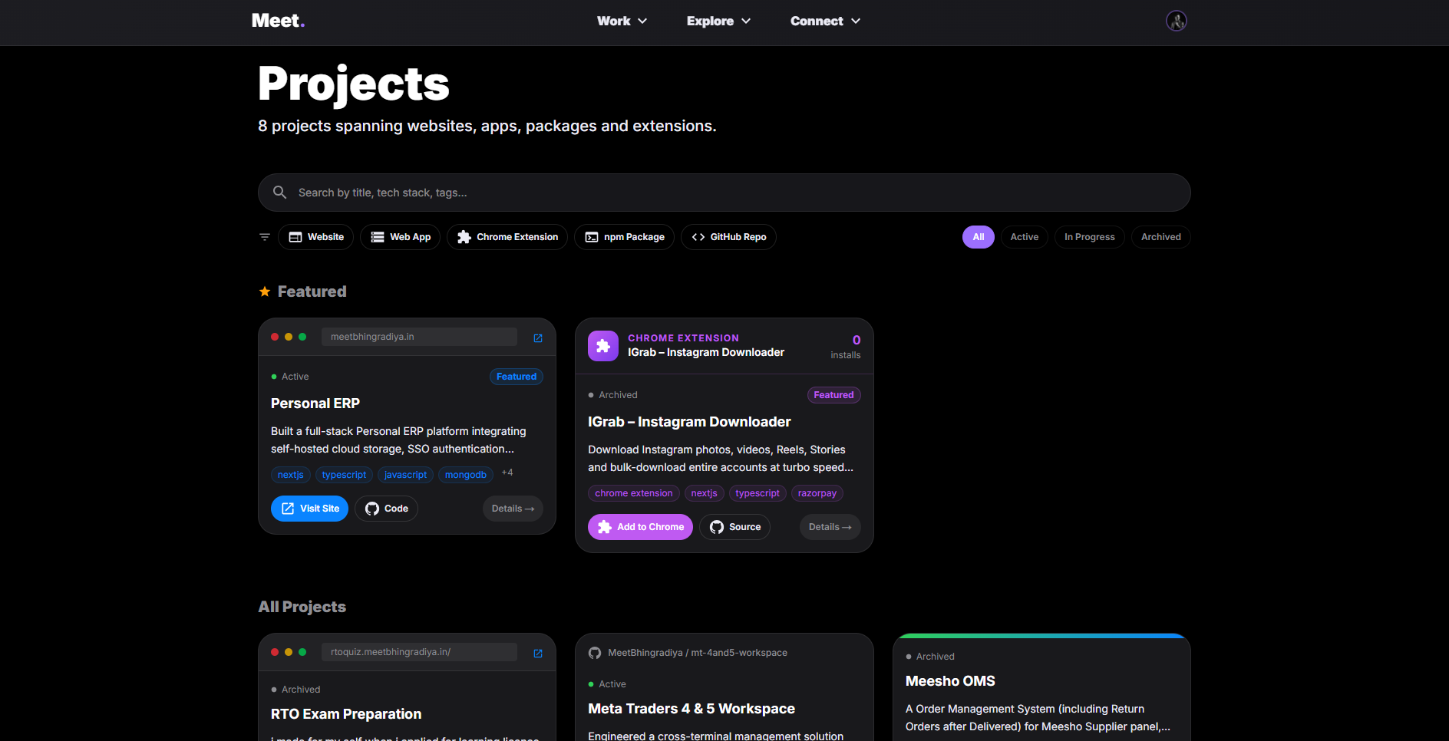
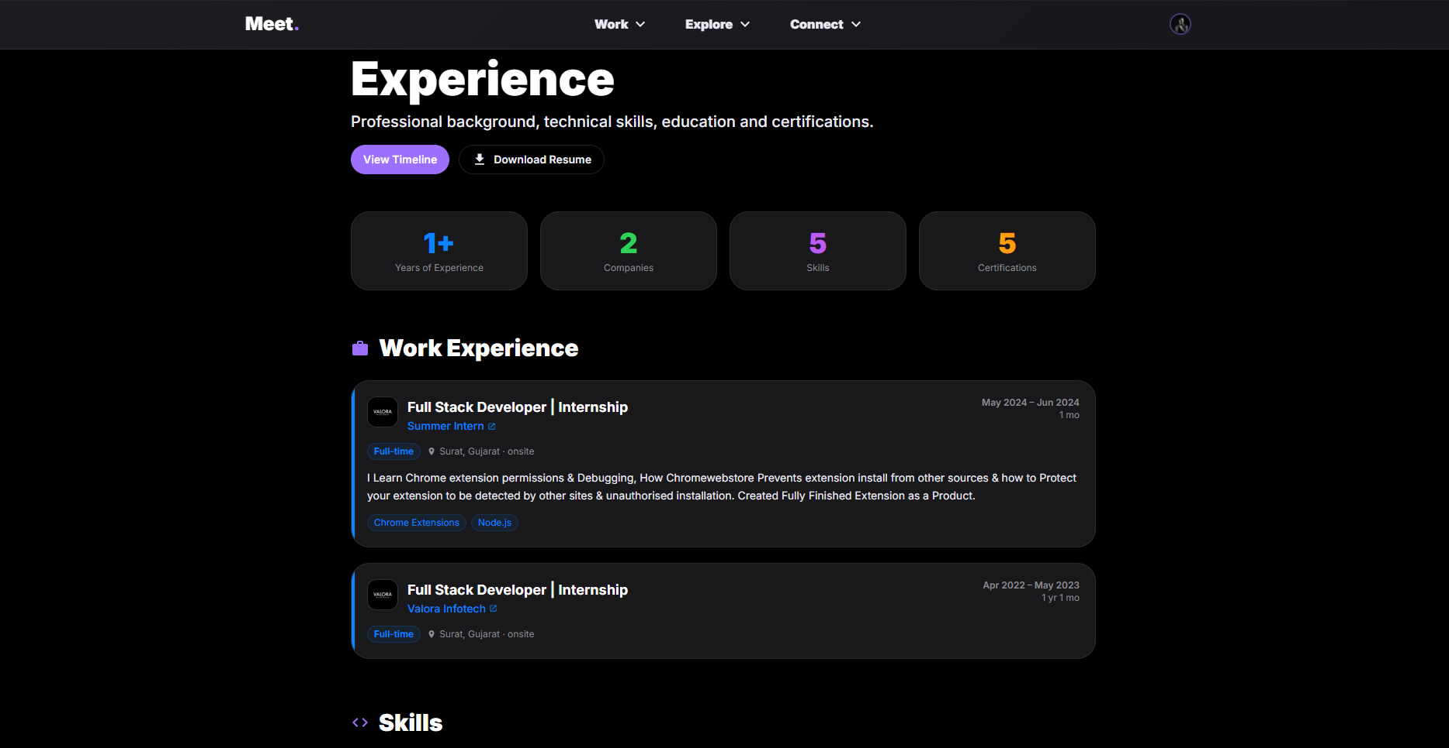
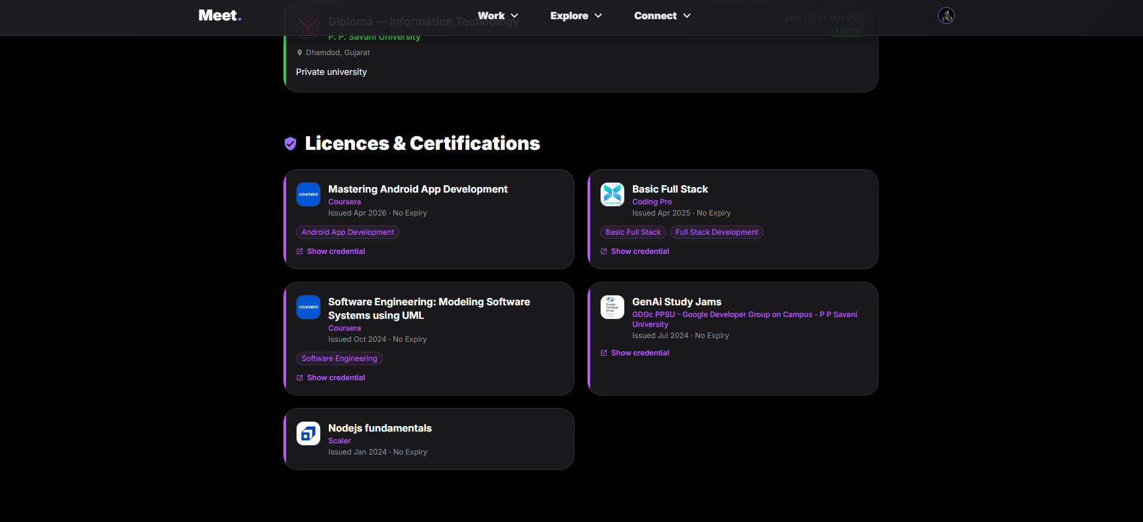

- Projects Items Page & Timeline Page: Implemented detailed views and a timeline component for tracking project histories.
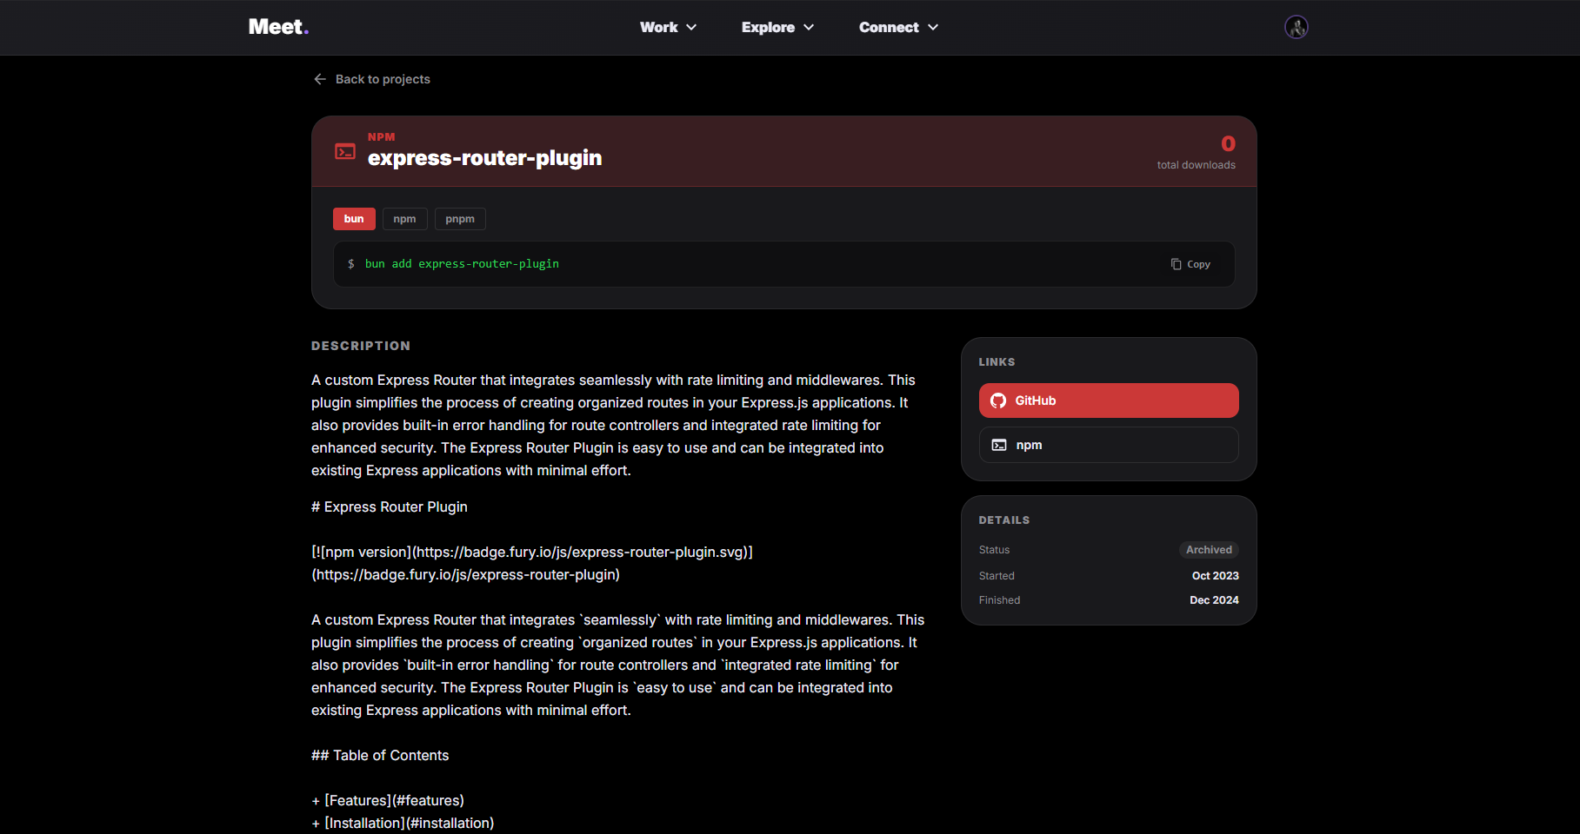
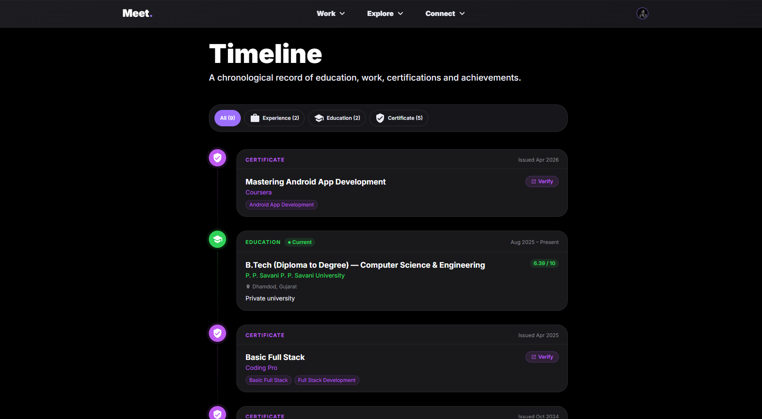

- Admin Panel Dashboard: Developed a secure dashboard for content management and administrative controls.
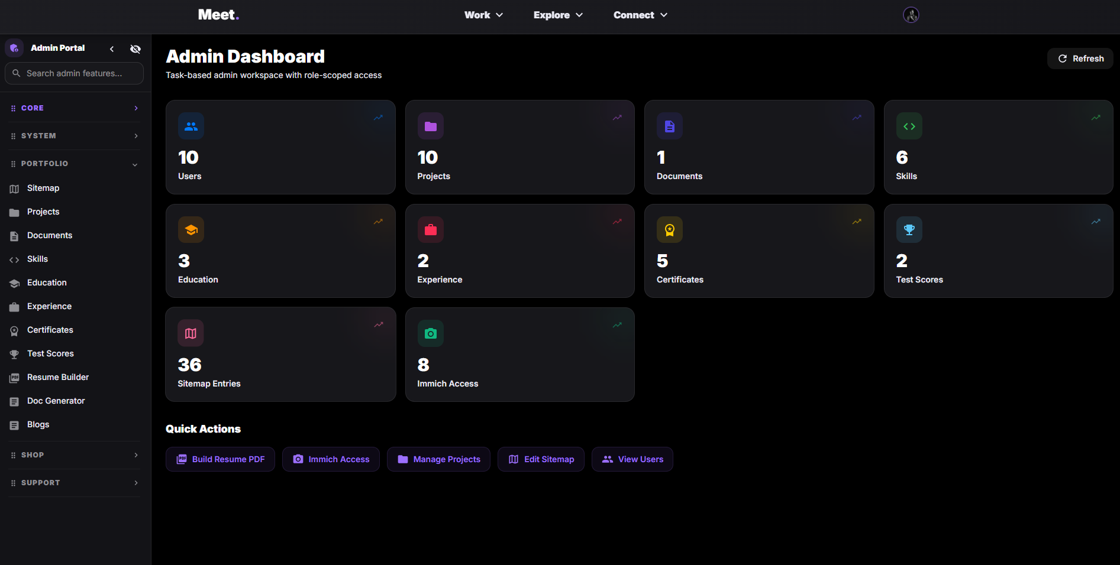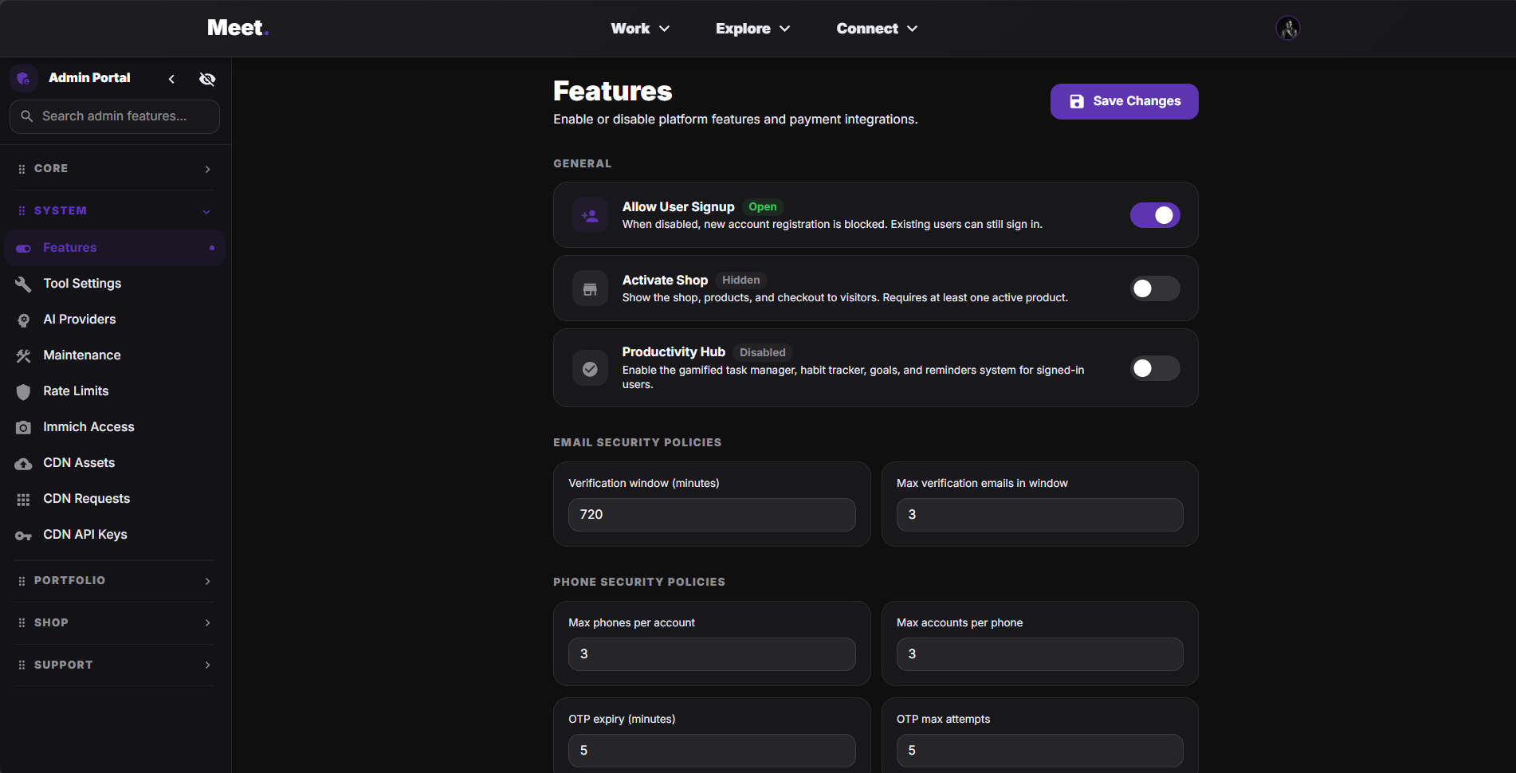

- Project Edit & Create Model: Built functional models for users to seamlessly add and modify their project details.
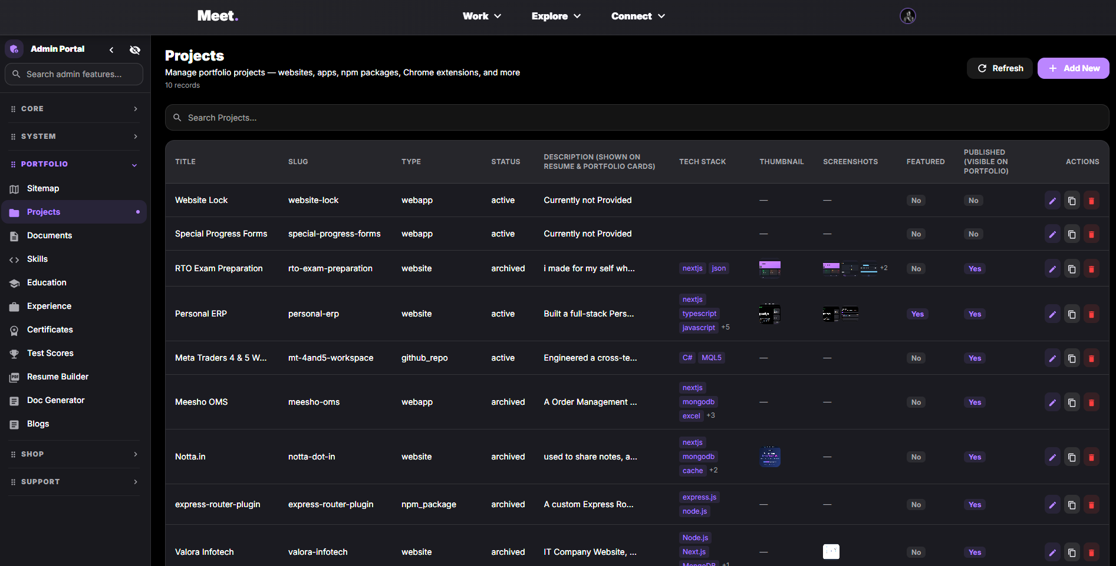
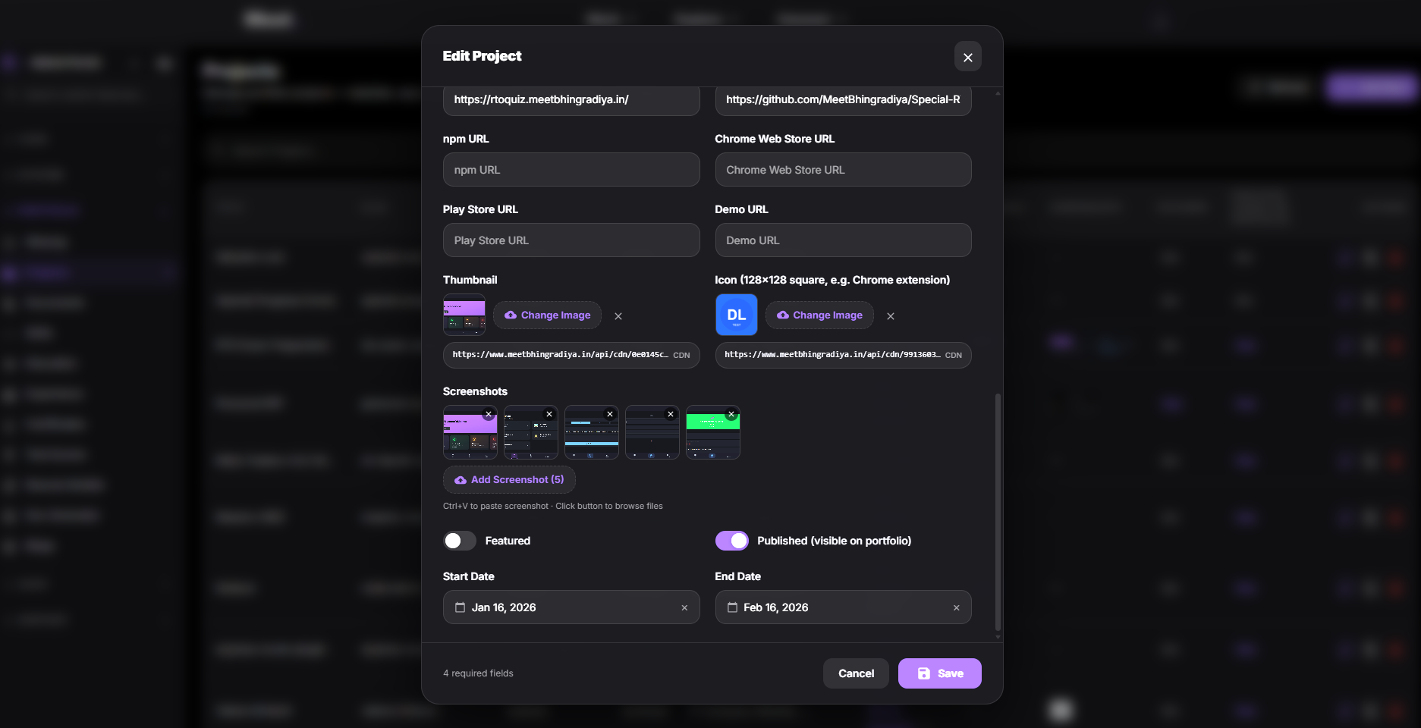

- Resume Builder Page: Engineered the core resume builder tool with real-time preview and editing capabilities with Auto AI Tailor for Targated & posted job descriptions on Any plateform like Linkedin & Freelancers.
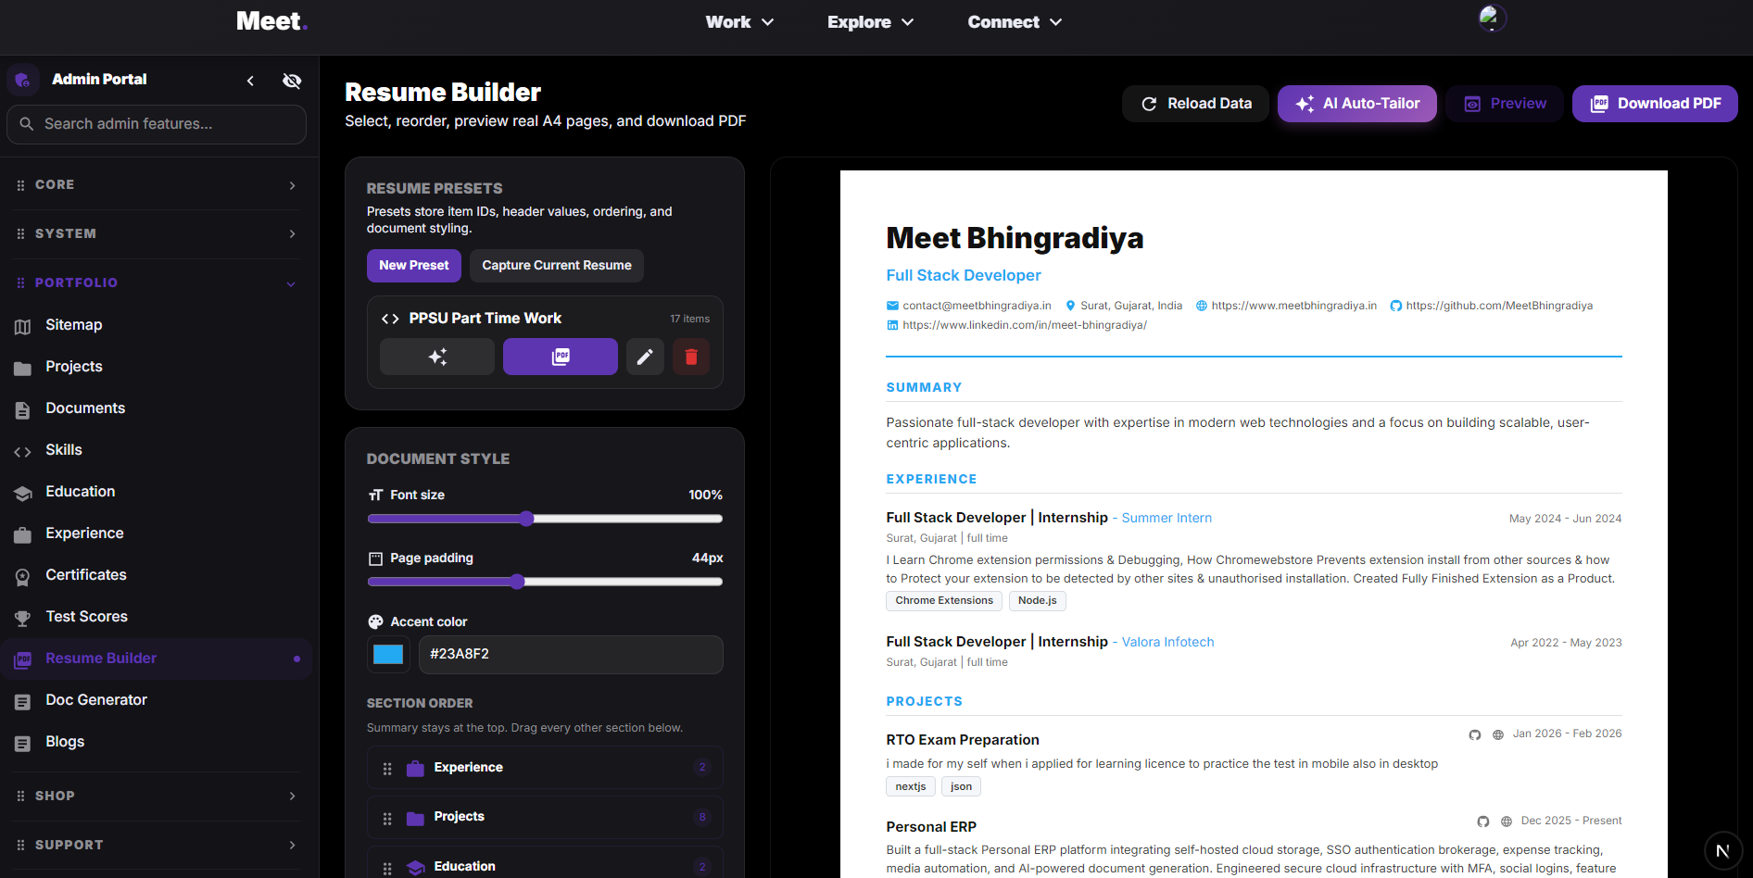
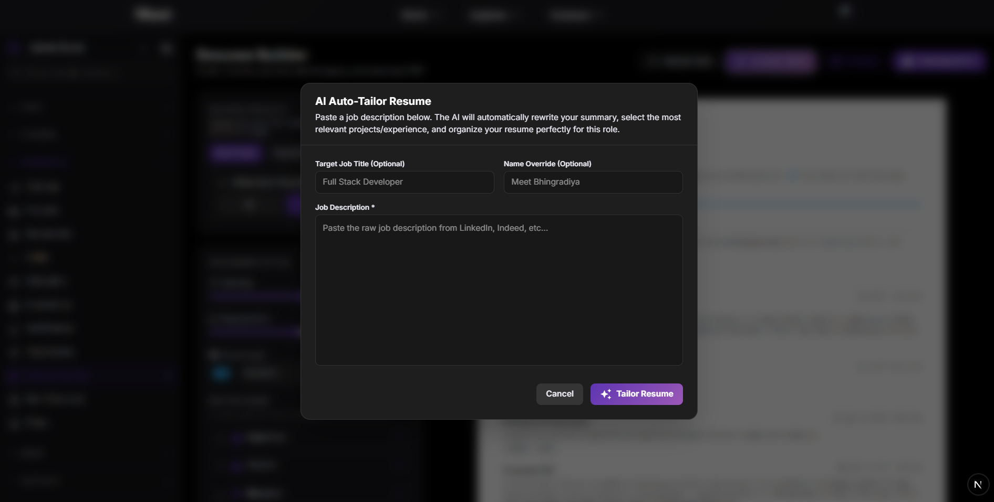

- Login & Signup Page: Integrated secure user authentication and session management.
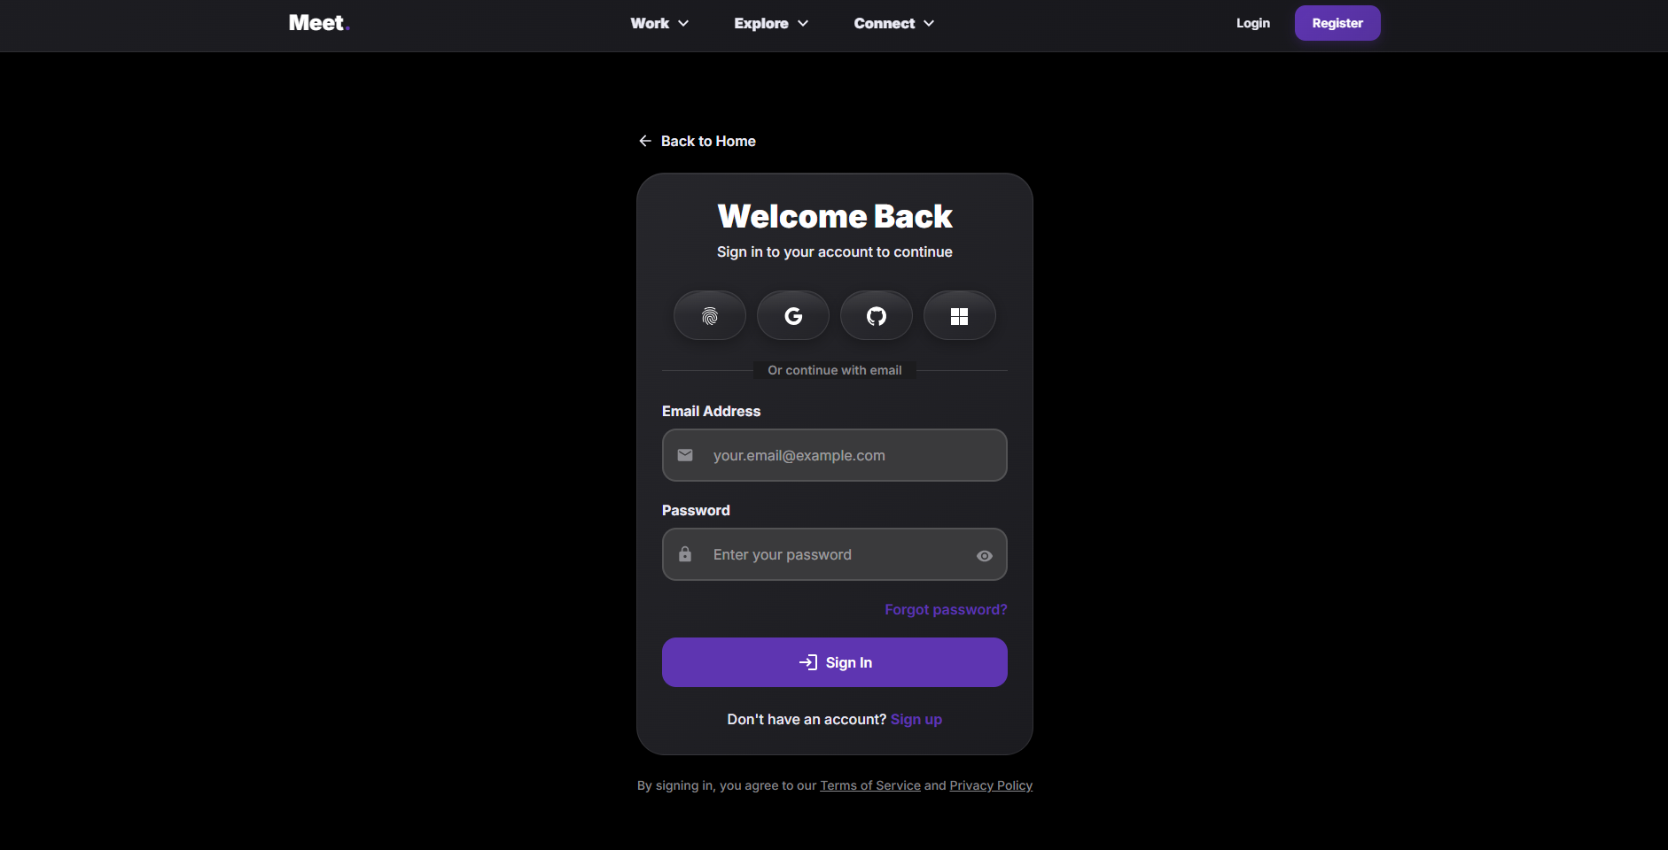
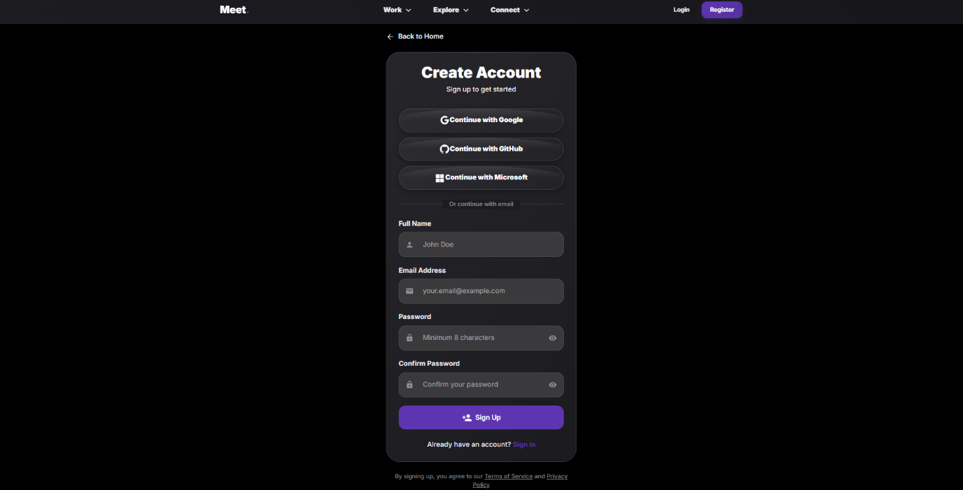

- Sitemap: Generated a sitemap for better navigation and SEO structure.
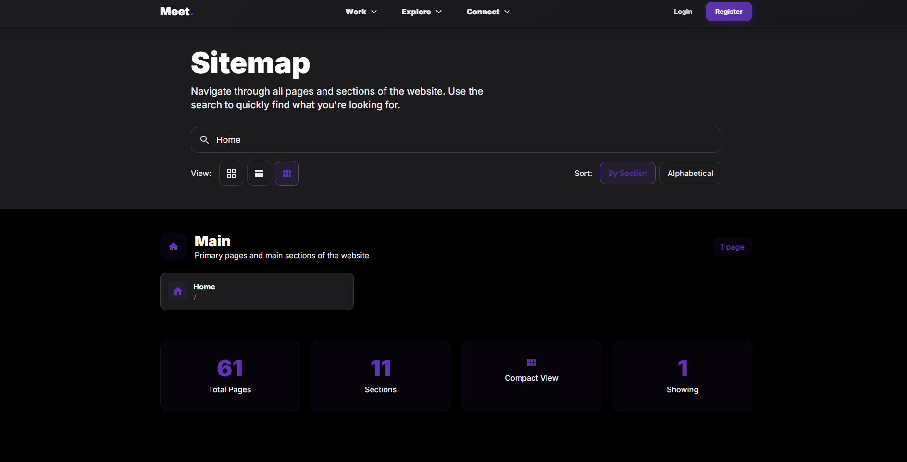
- Daily/Weekly Activities:
- Week 1: Project setup, requirement analysis, and UI/UX design for the Resume Builder.
- Week 2: Implementation of authentication (Login/Signup) and MongoDB schema design.
- Week 3: Development of the Admin Panel Dashboard and Project management models.
- Week 4: Building user-facing pages including the core Resume Builder, Experience Page, and Timeline.
- Week 5: Bug fixing, performance optimization, and testing the overall application using Next.js Turbopack.
- Technologies Used:
Next.js (16.1.6), React, Node.js, Bun.
- Software/Tools Used:
Visual Studio Code, Git, MongoDB.
- Programming Languages:
TypeScript, JavaScript, HTML, CSS.
- Challenges Faced:
- Adapting to the Turbopack bundler in Next.js.
- Managing complex state across the Resume Builder components.
- Ensuring responsive design across various device screen sizes.
- Solutions Implemented:
- Utilized Next.js documentation to resolve Turbopack compatibility issues.
- Implemented robust state management using React Context/Hooks to manage resume data.
- Used CSS Flexbox/Grid for cross-device compatibility.
CHAPTER 4
Learning Outcomes
Mention the knowledge and skills gained during the internship.
- Technical Skills:
Proficiency in Next.js and React, experience with MongoDB and NoSQL database design, server-side rendering, and API route development.
- Communication Skills:
Improved ability to articulate technical challenges and solutions during team meetings.
- Teamwork:
Learned the importance of version control (Git) and collaborative development.
- Time Management:
Successfully balanced multiple feature requests and met project deadlines.
- Problem Solving:
Enhanced debugging skills and logical thinking when resolving application errors.
- Professional Ethics:
Gained an understanding of workplace professionalism, meeting etiquette, and code quality standards.
Conclusion
This summer internship at Valora Infotech has been an invaluable experience. It provided me with a deep understanding of full-stack web development and the intricacies of building a production-ready application. Working on the Resume Builder Application allowed me to apply theoretical knowledge to a practical, real-world project, greatly enhancing my technical and professional skill set.
Mention:
- - Overall learning: Gained hands-on experience in building a complete Next.js web application.
- - Industrial exposure: Understood the agile development lifecycle and team collaboration.
- - Future scope: The application can be extended with AI-powered resume suggestions.
- - Career benefits: Laid a strong foundation for my future career as a Full Stack Web Developer.

References
Mention books, websites, documentation, research papers, or manuals referred to during the internship.
- - Next.js Official Documentation (https://nextjs.org/docs)
- React Documentation (https://react.dev/)
- - Valora Infotech Company Website
- - this website is hosted on Vercel at (https://meetbhingradiyain) for Verification of Screenshots, Signup is Turned off due to External Users
- - MongoDB Official Documentation (https://www.mongodb.com/docs/)

Student Declaration
I certify that the work presented in this report is carried out by me during my Summer Internship and has not been copied from any other source. I understand that any form of plagiarism or false information may lead to disciplinary action.
Student Signature: _______________________
Date: _______________________

Sr. No. | Evaluation Criteria | Out of Marks | Marks Obtained
1 | Internship Report Organization (Cover Page, Certificate, Formatting, TOC, Overall Presentation) | 10
2 | Organization Profile and Internship Details | 10
3 | Quality of Work Performed (Tasks, Technologies, Technical Understanding) | 20
4 | Project Description / Technical Contribution | 15
5 | Learning Outcomes and Skill Development | 10
6 | Report Quality (Clarity, Grammar, Figures, References, Originality) | 10
7 | Viva-Voce (Understanding of Internship and Technical Concepts) | 20
8 | Overall Performance and Professionalism | 5
Total |  | 100
Evaluator Remarks

Faculty Evaluator Details
Evaluator Name: ________________________________________
Signature: ____________________________________________
Date: _________________________________________________

