DePauw University

FIN 365A- Portfolio Management
Submitted: Prof. Bin Qiu

12-2025

GE Vernova (NYSE: GEV) Investment Research Report
Manmeet Singh Hayer

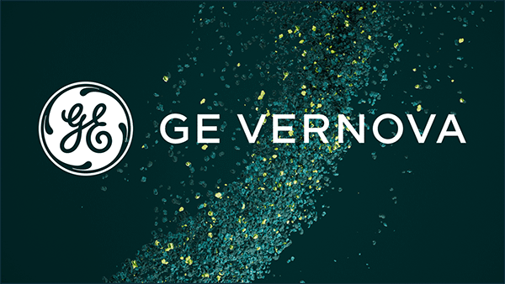

*Disclaimer: All financial data, projections, valuation outputs, and scenario analyses in this report are forward-looking estimates based solely on publicly available company disclosures, Bloomberg analyst consensus, and reputable industry sources; they are illustrative in nature and not guarantees of future performance. *

Current Price: $600 Target Price: $636 Upside: 6.11%
DATE: 12/03/2025
recommendation: Buy
Position size: 100 shares
Current Price: $600
Cost basis: $60,000 USD

Investment Rationale
We issue a BUY recommendation on GE Vernova (NYSE: GEV) with a 12-month target price of $636.66, implying ~6.1% upside from current levels. This recommendation is grounded in three pillars: backlog-driven revenue visibility, multi-segment margin expansion and rapidly multiplying structural demand.
• GEV enters 2026 with unusually high forward visibility, anchored by $130B+ in RPO across gas turbines, grid equipment, and wind services. This revenue base is materially larger than peers and supports multi-year growth irrespective of macro cyclicality.
• Margin expansion is accelerating faster than the market is pricing in. FY2025 adjusted EBITDA has already tripled YoY, Power margins are tracking toward mid-teens, Electrification is scaling profitably, and Wind losses are narrowing sharply after the offshore exit. Management guidance points to multi-year incremental margin gains across all three segments through 2028.
• GEV is levered to the strongest capital-expenditure cycles in global energy: firm-power demand from AI/data centers (160–200 GW needed by 2030), HVDC grid expansion, transformer scarcity, and accelerating electrification. Each of these TAMs is expanding at high-single- to double-digit rates, structurally lifting the company’s multi-year revenue trajectory.
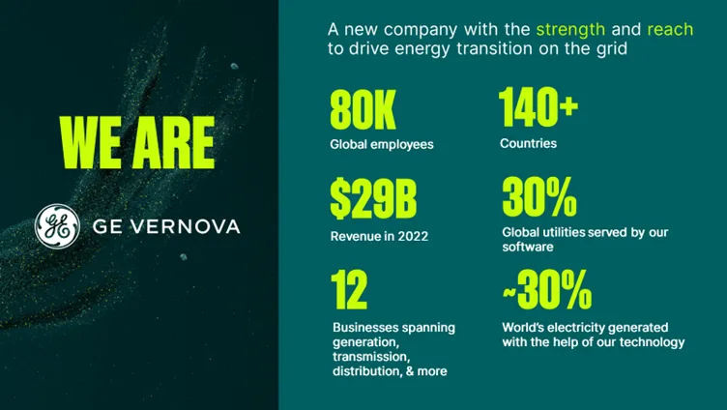
• GEV’s valuation remains attractive relative to its growth profile. Despite elevated near-term multiples from spin-related distortions, DCF analysis (60% weight) and peer/self-comps both converge toward a bullish implied value. Scenario modeling shows that even under conservative assumptions, intrinsic value remains anchored near current trading levels, limiting downside risk.
• Finally, the stock is positioned ahead of multiple near-term catalysts — including Prolec earnings consolidation beginning 2026, large gas-turbine deliveries tied to AI/hyperscale buildouts, HVDC megaproject awards in 2026–2027, and inflows from repower-cycle wind contracts — each offering discrete valuation unlock points.
Together, these dynamics position GEV as a rare combination of infrastructure-grade stability and high-growth secular exposure, warranting inclusion in DIG’s diversified portfolio and supporting our BUY rating.

Company Overview
“GE Vernova, a purpose-built company to electrify and decarbonize the world.”

Spin-off & Corporate Identity
- On April 2, 2024, General Electric (GE) completed the spin-off of its energy businesses, creating GE Vernova as an independent publicly traded firm listed on the NYSE under ticker “GEV.”
- Under the spin-off, GE shareholders received 1 share of GEV for every 4 shares of GE held on the record date.
- Before the spin-off, GEV’s businesses were held under GE — spanning its power generation, renewables (wind / hydro), grid & electrification, and energy-services arms. As of 2024, these legacy assets were consolidated under GEV.
- GEV is headquartered in Cambridge, Massachusetts
- The company’s stated mission is to “electrify to thrive and decarbonize” — framing itself as a full-spectrum energy infrastructure and services firm built for the global transition to sustainable energy.
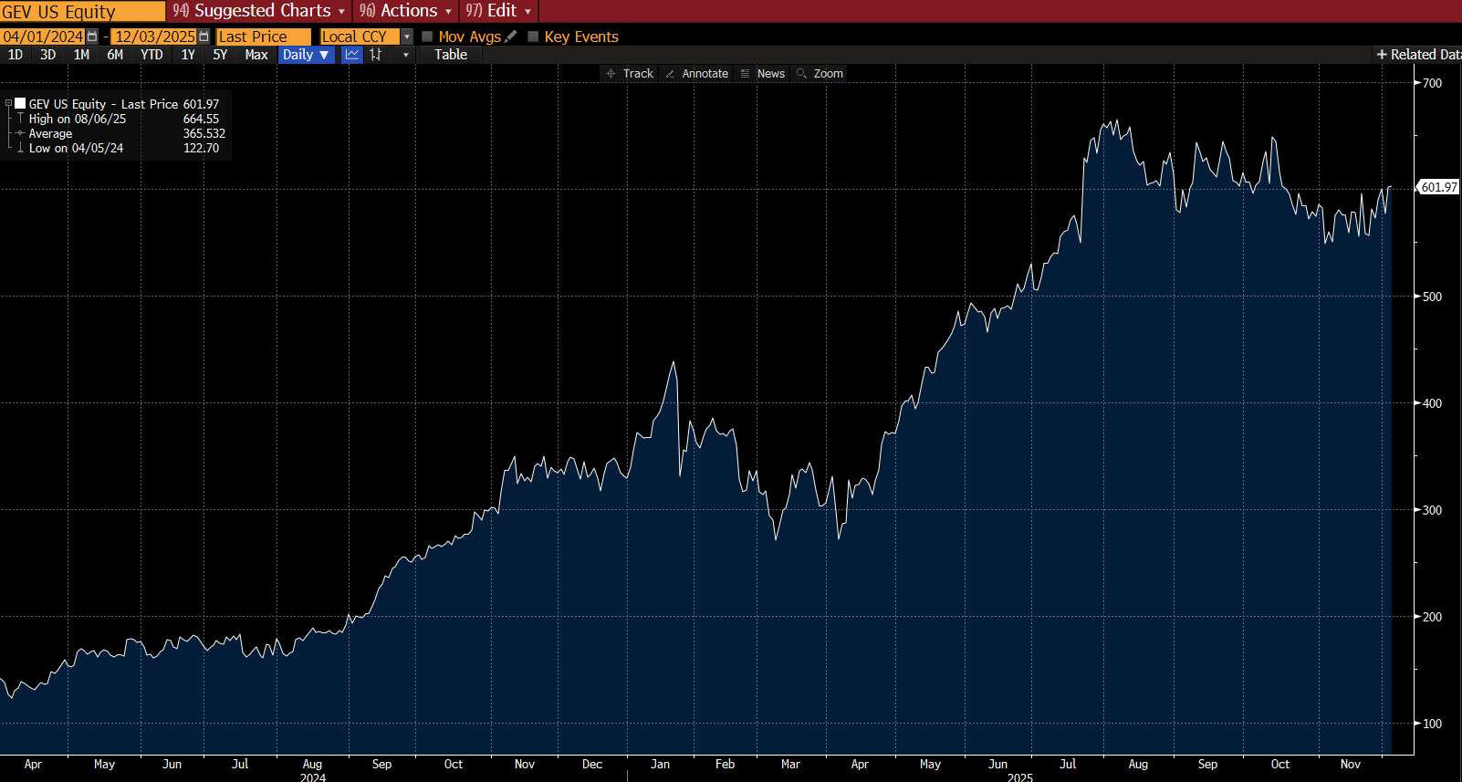
The spin-off marks not just a corporate restructuring, but a strategic repositioning: GEV emerges as a pure-play energy infrastructure & services company, with a broad portfolio across generation, renewables, grid/electrification, and services — aiming to capture secular growth from global electrification, decarbonization, and rising power demand.
GEV Share Price from 04/01/24 to 12/03/25

Business Segments
GE Vernova operates as a global energy-technology company with a broad and diversified revenue footprint. In 2024 the company generated roughly 34.9 billion dollars in revenue, distributed across major regions as follows:
- United States: ~ 42% of total revenue (≈ 14.7B dollars)
- Europe: ~ 24% (≈ 8.3B)
- Asia: ~ 13–14% (≈ 4.7B)
- Middle East & Africa: ~ 12% (≈ 4.2B)
- Americas ex-U.S.: ~ 9% (≈ 3.0B)
This geographic spread shows a balanced mix between mature power markets (U.S., Western Europe) and fast-growing demand centers (Middle East, India, Southeast Asia), supporting both stable service revenue and multi-year growth in new equipment orders.
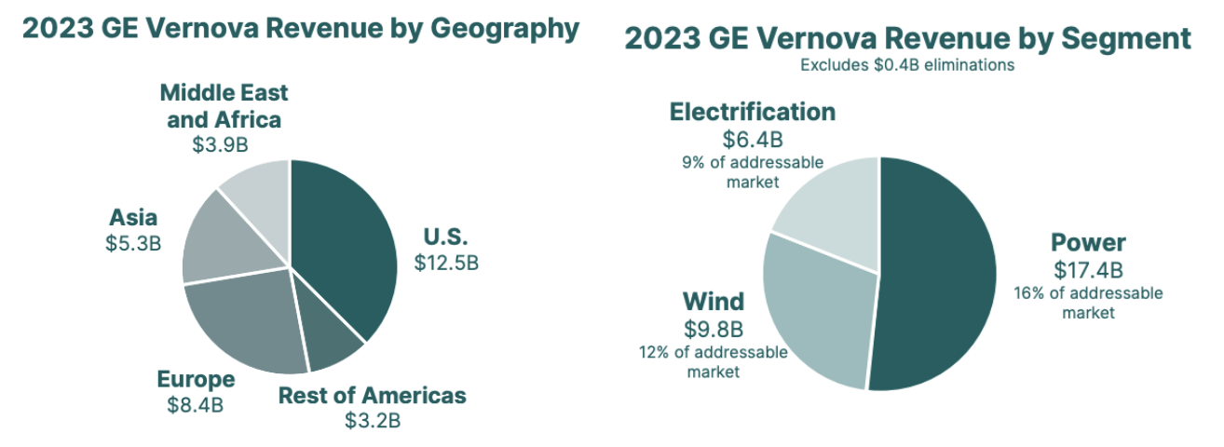
GE Vernova organizes this global footprint into three operating segments — Power, Wind, and Electrification. Together, the three segments span nearly the entire electricity value chain — from firm gas and nuclear generation to onshore/offshore wind and the grid systems that deliver and convert power. Power is the cash-generating backbone supported by a large installed turbine base; Wind provides global renewable scale as profitability improves; and Electrification is the high-growth engine driven by grid expansion, renewable integration, industrial electrification and surging data-center demand.
- Power (≈52% of total revenue):
Provides heavy-duty and aeroderivative gas turbines, steam and nuclear equipment, hydro technologies, and long-term service agreements that anchor Vernova’s cash flow. With a global installed base of ~7,000 turbines, Power remains the company’s most profitable and scale-backed segment. In fact, GEV holds 38% market share of gas turbines for all in-construction plants in Asia. Through Q3-2025, Power continued to track mid-teens revenue growth and steady margin improvement, supported by strong equipment demand and high-quality service volume.
- Wind (≈28% of total revenue):
Designs and services onshore and offshore wind turbines and blades, backed by a global fleet of ~57,000 units. While still recovering profitability, Wind provides Vernova with meaningful renewable scale. By Q3-2025, the segment showed consistent year-over-year margin improvement and a continued reduction in EBITDA losses as pricing, services mix and cost discipline improved.
- Electrification (≈20% of total revenue):
Supplies grid solutions, high-voltage equipment, power-conversion systems, storage technologies, and advanced grid software needed for renewable integration and electrification. This is GEV’s fastest-growing segment, strategically positioned for grid modernization and data-center power demand. As of Q3-2025, Electrification remained on a strong double-digit organic growth trajectory with notable margin expansion tied to scale, pricing and productivity.

Recent Performance
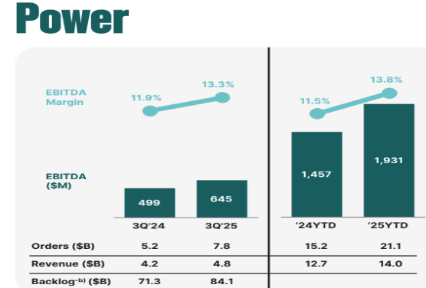
GE Vernova’s 2025 YTD and Q3 results reflect accelerating momentum post–spin-off: the company delivered double-digit revenue growth, significant margin expansion, sharply higher order intake, and a record backlog driven by strong execution in Power and Electrification. Wind remains a profitability drag, but losses are narrowing consistently, positioning the portfolio for balanced growth and expanding cash flow through 2026–2027.

Power
- Revenue up mid-teens YoY in Q3 and +10 percent YTD (~14.0B dollars).
- Orders up ~50 percent YoY, with heavy-duty turbine bookings more than doubling.
- Backlog expanded to ~84B dollars (+10 percent YoY), providing multi-year visibility.
- Performance driven by strong equipment demand, pricing discipline, higher-margin service mix and productivity.

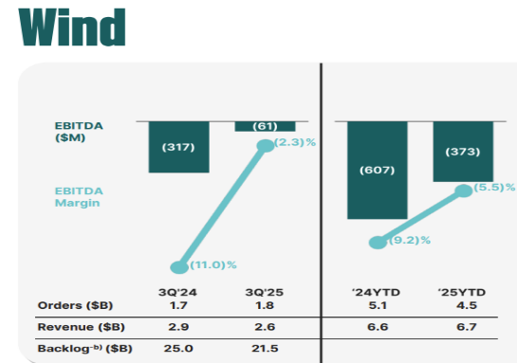
Wind
- Q3 revenue slightly lower YoY (lapping a large 2024 offshore settlement).
- YTD losses nearly halved as services and onshore pricing strengthen.
- Backlog declined from ~25B → ~21.5B dollars as GEV prioritizes higher-quality orders and reduces offshore exposure.
- The segment is still a drag but trending clearly upward with consistent quarterly margin improvement.

Electrification
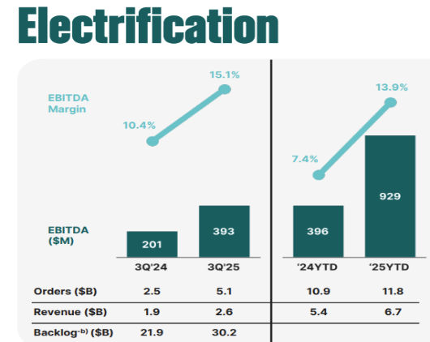
- Q3 organic revenue up ~32 percent YoY, broad-based across HVDC (High-Voltage Direct Current transmission, switchgear and conversion systems.
- Backlog increased from ~21.9B → ~30.2B dollars YoY (orders ~2x revenue).
- Demand driven by global grid upgrades, renewable integration and rapidly rising digital/data-center load.

Overall Company Metrics — Q3 & YTD 2025
- Q3 revenue: ~10.0B dollars (+10 percent YoY).
- Q3 adjusted EBITDA: ~0.8B dollars (vs. 0.2B in 2024).
- Q3 Total orders: ~14.6B dollars (+55 percent YoY).
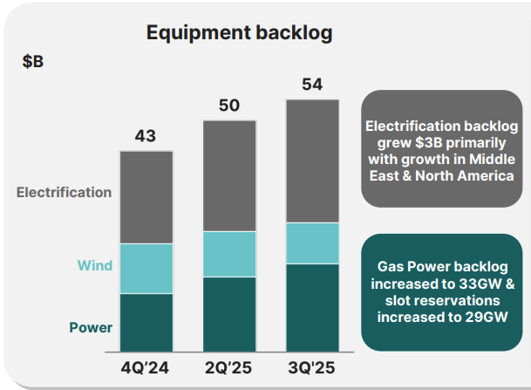
- Total backlog: ~135B dollars (+17.5B YoY).
- Margin expansion: projected 8-9% EBITDA for 2025, driven by Power + Electrification outperformance.
- Forward visibility: secured through turbine slot reservations, grid megaproject awards, and Electrification order momentum.

Strategic Position

GE Vernova is positioned to benefit from structurally higher electricity demand, driven by data-center growth, electrification and global grid modernization. Its mix of gas generation, renewables and grid technology gives it strategic relevance across both reliability and decarbonization. Strong order momentum across Power and Electrification, combined with a disciplined wind turnaround, positions the company to lead the next decade of energy-infrastructure investment.

Strengths
- Integrated portfolio: Unique ability to deliver turbines, HVDC/FACTS systems, transformers (Prolec GE) and renewables, giving Vernova scope competitors lack.
- Backlog depth: ~$135B total, with $80B+ in service contracts, providing multi-year revenue & cash-flow visibility.
- Turbine and service leadership: HA-class and modern aeroderivatives backed by one of the largest installed fleets and high-margin service contracts.
- Grid bottleneck positioning: Expanded transformer and HV capacity at a time of 24–36 month industry lead times gives Vernova a procurement advantage.

Weaknesses
- Wind profitability lag: Margins improving but still negative; offshore exposure and legacy warranties remain a drag.
- Operational complexity: Three very different industrial businesses increase execution and supply-chain risk
- Long-cycle sensitivity: Major HVDC and CCGT projects rely on permitting, financing and stable material costs.

Opportunities
- AI/data-center load: Rapid growth toward ~35 GW U.S. demand by 2030 boosts need for fast-start turbines, substations and power-conversion systems.
- Grid expansion cycle: Multi-GW HVDC corridors, transformer shortages and FACTS deployments favor Vernova’s Electrification footprint.
- Wind reset: Higher-priced onshore backlog, reduced offshore exposure and upgraded turbine optimization support a path back to breakeven
- Hydrogen transition: GE turbines already certified for higher hydrogen blends, extending relevance of gas assets.

Threats
- Competitor pressure: Siemens Energy in HVDC, Mitsubishi Power in thermal, ABB/Eaton in grid equipment, Vestas in onshore wind.
- Policy/permitting delays: Grid approvals, gas plant permits and offshore siting can stall revenue conversion.
- Cost volatility: Transformer steel, copper and turbine components remain exposed to global supply-chain constraints.
- Mega-project execution risk: HVDC and CCGT delays carry financial penalties and can compress margins.

GEV: SWOT Analysis

Industry Analysis
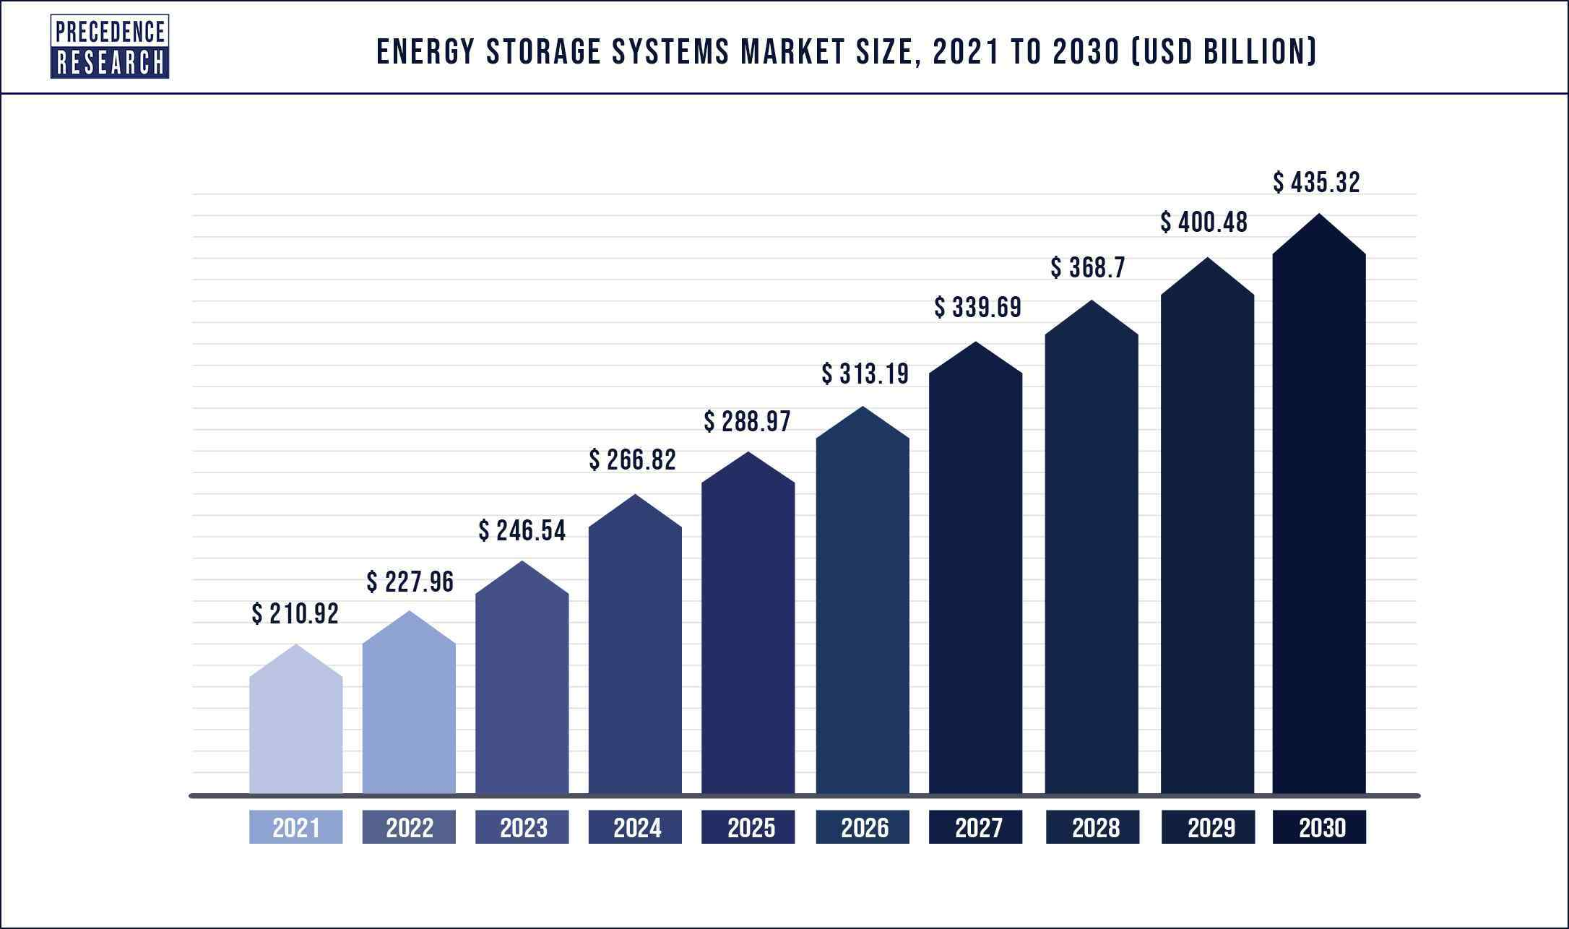
GE Vernova operates across three major segments of the global energy technology and electrical equipment industry: thermal power generation, renewable generation, and grid and power-electrification equipment. The company serves markets experiencing their strongest demand cycle in decades, driven by AI-driven data-center load growth, industrial electrification, transmission bottlenecks, and large-scale renewable integration. Across gas turbines, aeroderivative units, onshore/offshore wind platforms, transformers, HVDC converter stations, substations, and power-conversion systems, GE Vernova participates in electrical equipment and power-infrastructure markets with a combined annual addressable opportunity exceeding $200 billion and expected CAGR of 6–12% across core sub-sectors through 2030.
Thermal Power Generation (Gas + Aeroderivatives)
The global gas turbine market is roughly $20–25B annually, with expected CAGR of 6–7% through 2030 as utilities add fast-ramping thermal plants to support renewables and AI-driven load growth. U.S. data center electricity consumption is projected to rise from ~19–20 GW today to ~35–38 GW by 2030, creating incremental multi-gigawatt demand for flexible generation. GE Vernova currently holds one of the largest installed turbine fleets worldwide (7,000+ units), giving it >30% share of the heavy-duty turbine market and a strong position to capture new growth. Its HA-class turbines and modern LM2500/LM6000 aeroderivatives are positioned for markets needing rapid ramping and hydrogen-readiness, and the global shift toward capacity markets is increasing attach rates for long-term service contracts.
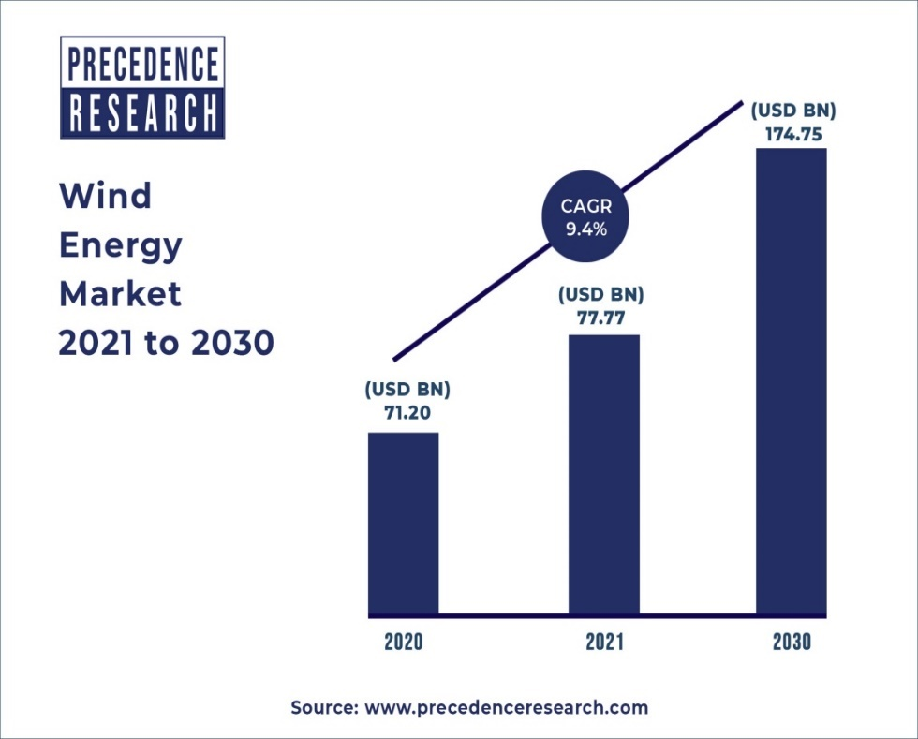
Renewable Generation (Onshore + Offshore Wind)
The global wind equipment market exceeds $60B annually, expected to reach ~$100B by 2030 as onshore repowering and offshore expansion accelerate. Onshore installations alone are projected to average 110–130 GW per year globally from 2026 onward, driven by repowering cycles in the U.S. and EU. GE Vernova’s installed base of ~57,000 turbines gives it meaningful aftermarket scale, but its current ‘new-build’ share is in the mid-single digits compared to leaders like Vestas with market share access in mid-20s. However, Vernova’s strategy of prioritizing higher-priced onshore backlog and reducing offshore exposure aligns with industry conditions and is strategically placed to expand EBITDA margins through controlled costs & clearing backlog. With repowering expected to account for 25–30% of U.S. wind additions by 2027, Vernova is well positioned to monetize its existing fleet.
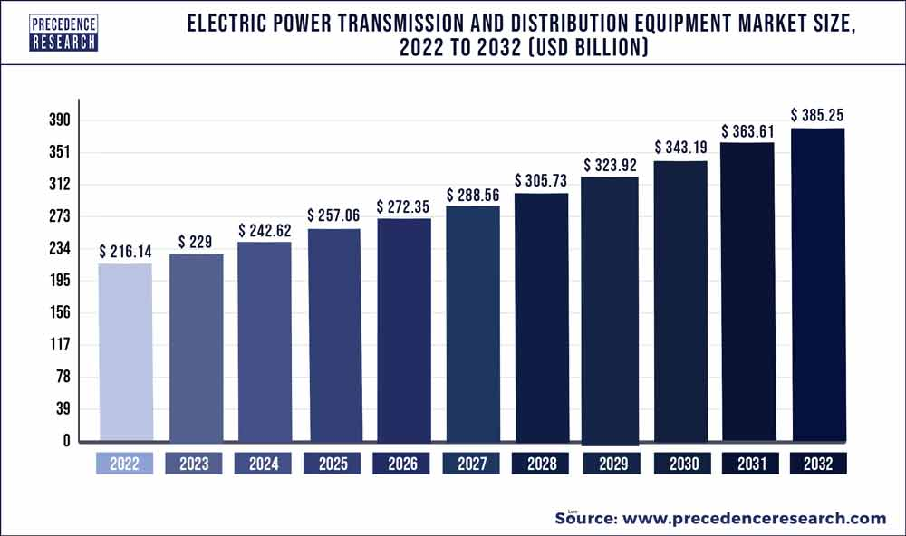
Grid Infrastructure (HVDC, Transformers, Substations)
Transmission and distribution represent the fastest-growing segment of the entire power value chain. Global T&D capex is projected to exceed $3 trillion between 2024 and 2030, with HVDC capacity expected to triple. Utilities in the U.S. and EU must expand transmission capacity by ~2× by 2035 to meet electrification and renewable targets. Transformer shortages remain critical, with 24–36 month order lead times and global transformer demand rising 8–10% annually. GE Vernova’s Electrification segment, now supported by Prolec GE transformer capacity, is positioned directly in this bottleneck. Its ~$30B+ backlog reflects multi-GW HVDC and substation projects tied to renewable integration and data-center clusters. The HVDC converter station market alone is projected to grow from ~$12B today to ~$25B by 2030, where Vernova competes with Siemens Energy and Hitachi across large multi-terminal projects.
Power Conversion & Industrial Electrification
Industrial electrification (steel, mining, EV metals, semiconductors) represents a $40–50B TAM growing at 10–12% annually as high-temperature processes electrify and digital infrastructure expands. Semiconductor fabs and AI campuses demand extremely stable, low-harmonic power quality — a market where Vernova’s converters, drives, and microgrid systems compete directly with ABB and Schneider. Growing federal and state incentives for U.S. manufacturing add additional tailwinds, particularly in marine, EV metals, and clean hydrogen applications.
Services & Lifecycle Revenue
Aftermarket services across turbines, wind fleets, and grid equipment represent a stable $70–90B global industry, with OEM service growth outpacing equipment growth due to aging infrastructure and rising reliability requirements. GE Vernova’s massive installed base provides recurring high-margin service revenue, with upgrade cycles, digital monitoring, and reliability programs forming a key profit engine. Services attach rates in heavy-duty turbines can exceed 80%, and turbine upgrades can add 2–4 points of incremental margin versus new equipment.

Competitor Analysis
GE Vernova competes across a spectrum of players in power generation, grid equipment and electrical infrastructure. The five closest “macro comps” by BICS fit and scale (>$50B market cap) are Vertiv, Eaton, Siemens Energy, Schneider Electric and Mitsubishi Heavy Industries (MHI). Together they frame the competitive landscape around data-center infrastructure, power-management equipment, grid technologies and thermal generation.
Vertiv (VRT) – data-center infrastructure pure-play
Vertiv is effectively the AI data-center infrastructure pure-play: it provides power-management systems, liquid and air cooling, racks, and integrated infrastructure for hyperscale and colocation customers. FY24 revenue was about $8.0B (+16.8% YoY), with strong free cash flow of roughly $1.1B and a rapidly expanding AI-driven backlog. Recent commentary puts backlog at ~$9.5B (nearly a full year of revenue), with book-to-bill >1.0x Rev as AI and cloud spending accelerate.
Vertiv does not compete with GE Vernova in turbines or wind, but it is a highly relevant comp for understanding how the market values data-center-linked electrical infrastructure. GEV operates upstream (generation, grid interconnection, HV equipment), while Vertiv owns a large share of the downstream, inside-the-data-center power and cooling stack.
Eaton (ETN) – broad electrical equipment & grid-adjacent leader
Eaton is a global power-management and electrical equipment leader with $24.9B of 2024 revenue (up ~7% YoY), driven largely by its North America and Global Electrical segments, which deliver high-teen margins and ended 2024 with a record backlog up nearly 30% organically. Eaton competes directly with GE Vernova’s Electrification segment in switchgear, breakers, and low/medium-voltage distribution, as well as portions of utility equipment, but it has no exposure to gas turbines or wind OEM manufacturing. Compared with Eaton, GEV is more capital-intensive and cyclical due to its generation and wind businesses, whereas Eaton benefits from diversification into building and industrial end-markets and maintains structurally higher margins, while GEV’s differentiation lies in large high-voltage and transmission-scale infrastructure where Eaton has a more limited presence.
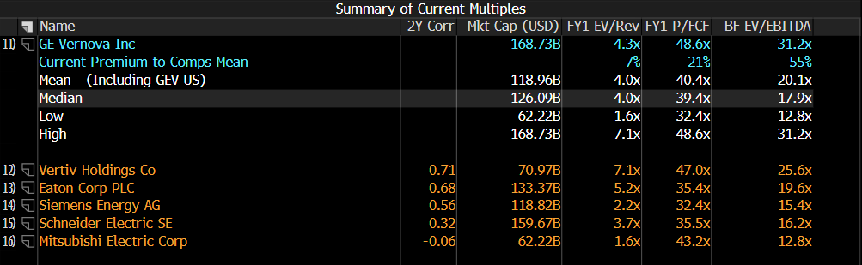
Siemens Energy (ENR) – closest full-stack energy OEM peer
Siemens Energy is the closest true “like-for-like” peer to GE Vernova, combining Gas Services, Grid Technologies, and Siemens Gamesa within a single integrated energy-infrastructure group. The company generated roughly €39.1B (~$42B) of revenue in FY25, supported by record order intake and a massive €136B (~$146B) backlog, driven heavily by grid equipment and large gas-turbine demand tied to electrification and data-center expansion. In FY24, Siemens Energy reported €34.5B (~$37B) of revenue and €50.2B (~$54B) of orders, with Grid Technologies growing over 30% YoY and Gas Services margins near 9.5%, highlighting strong momentum in the non-wind parts of the portfolio. Strategically, Siemens Energy and GE Vernova overlap in heavy-duty gas turbines, HVDC and high-voltage grid systems, and wind, with Siemens’ offshore wind issues weighing heavily on profitability in a way that mirrors, but exceeds, GEV’s wind challenges. Relative to Siemens Energy, GEV is smaller overall, more U.S.-centric, and arguably cleaner positioned in wind due to its emphasis on higher-margin onshore, service, and repower opportunities rather than the deeply troubled offshore segment that continues to drag on Siemens Energy’s results.
Schneider Electric (SU) – energy management & electrification heavyweight
Schneider Electric is a global leader in energy management, low/medium-voltage electrical equipment, and industrial automation, generating €38.15B (~$41B) of revenue in 2024, with ~8% organic growth. Its Energy Management division produced €31.1B (~$33B) and grew 11.5% organically, supported by sustained electrification trends and accelerating AI data-center demand. The company delivered ~€7.1B (~$7.6B) of adjusted EBITA, translating into low-20% margins for Energy Management, reflecting its strong mix of software-enabled products, services, and building/industrial automation solutions. Schneider competes with GE Vernova primarily in grid digitalization, power quality, and industrial electrification, but has no exposure to utility-scale gas turbines or wind OEM equipment. Compared with Schneider, GE Vernova offers greater leverage to transmission upgrades, HVDC deployments, and broader generation cycles, whereas Schneider benefits from a much larger installed base in building-level and industrial electrical systems, giving it structurally higher recurring revenue through software, controls, and lifecycle services.
Mitsubishi Electric Corp (6503 JP) – diversified industrial & GTCC competitor
Mitsubishi Electric Corporation, backed by the broader Mitsubishi Group keiretsu (Japan’s most powerful corporate alliance), is a major competitor to GE Vernova in grid and power-electronics markets, combining strong financial resilience with deep industrial partnerships similar to how GEV benefits from GE’s legacy technology and installed base. In FY2024, MELCO generated ¥5.6 trillion (~$37–38B) in revenue, including roughly ¥1.5 trillion (~$10B) from its Energy & Electric Systems division, which spans HV/MV switchgear, transformers, protection relays, power semiconductors, and emerging HVDC/FACTS solutions. Mitsubishi Electric maintains leading share across Japan and Southeast Asia in substation equipment and power-conversion systems, though its overall portfolio is much more diversified — factory automation, semiconductors, elevators, HVAC — which stabilizes earnings but dilutes pure exposure to the global grid-modernization, transmission-expansion, and HVDC cycles driving GE Vernova’s Electrification growth. While MELCO’s power-systems margins typically run in the high-single to low-teens range, its growth outlook is constrained by Japan’s slower grid expansion and limited access to North America’s accelerating HVDC and transformer markets, where GEV (especially post-Prolec) is positioned for faster share gains. Overall, Mitsubishi Electric is a credible regional competitor with strong corporate backing, but it lacks GE Vernova’s backlog depth, North American manufacturing footprint, and long-cycle utility-scale project visibility.

GE Vernova screens optically expensive relative to peers because FY24 EBITDA is temporarily depressed by $1B+ in Wind losses, legacy EPC/Grid adjustments, and spin-related restructuring, which artificially inflate EV/EBITDA and P/E multiples. Competitors such as Siemens Energy, Vestas, Eaton, and Schneider report more normalized margin profiles- Siemens’ Grid Technologies operates in the mid-teens, Vestas’ service segment exceeds 20% EBIT, and Eaton/Schneider generate high-teens to low-20s margins- making their multiples look lower despite comparable or slower growth. The key difference is earnings timing, not demand quality: GE Vernova holds an exceptional $120B+ backlog, similar to Siemens Energy and well above Vestas, with multi-year gas turbine, HVDC, and onshore wind service contracts that convert over 24–48 months. As Wind and Grid margins improve and restructuring costs roll off, EBITDA should normalize toward peer levels, reducing the valuation gap. Thus, the direction these multiples and share price move in ultimately depends on management’s execution on the $120B+ RPO of existing equipment/service contracts.

Porter’s Five Forces- Electrical Equipment
Threats of New Entrants- Very Low
Entering utility-scale power equipment, HVDC, transformers, or wind turbines requires decades of reliability data, multi-billion-dollar manufacturing bases, service networks, and regulatory certification. GE Vernova, Siemens Energy, Mitsubishi Heavy Industries etc. operate with installed bases in the tens of thousands of units; Vernova alone has 7,000+ gas turbines and ~57,000 wind turbines in operation — a barrier no newcomer can replicate. HVDC projects (>1 GW) require 5–7 year qualification cycles and grid-code compliance in each region. New entrants in wind and grid equipment (especially China-based OEMs) face export constraints, IP challenges, and lack of service credibility.

Result: GEV benefits from structural insulation; competition comes only from established OEMs.
Bargaining Power of Suppliers- Moderate and Rising
GE Vernova’s cost structure relies heavily on advanced alloys, copper, electrical steel and semiconductor-based control systems. Transformer steel shortages and 24–36 month global transformer lead times raise supplier bargaining power, particularly for Electrification. Aeroderivative turbines and HA-class turbines require precision components sourced from a small number of aerospace-grade suppliers. For wind, blade resins, rare earth magnets, and carbon fiber remain volatile.
• Power Segment: Moderate power because GEV has scale and long-term supplier contracts.
• Electrification Segment: Higher power due to transformer steel bottlenecks and HVDC converter components.
• Wind Segment: Moderate–high due to commodity volatility impacting blade and generator components.
Overall, suppliers have enough leverage to affect margins, especially in long-cycle projects, but GE Vernova’s scale offsets the worst of the pressure.
Bargaining Power of Customers- Moderate-High
Utilities, independent power producers (IPPs), transmission operators, and hyperscale data-center developers represent sophisticated, consolidated buyers with substantial procurement leverage. Most utility-scale contracts involve multi-billion-dollar capital commitments, competitive tendering, and strict performance guarantees, giving customers meaningful influence over pricing and delivery terms. Hyperscale cloud providers — Amazon, Microsoft, Google — also exert high buyer power due to scale, standardization, and tight delivery windows for substation, grid-interconnection, and firm-capacity equipment.
However, customer leverage is partially constrained by structural supply limitations in the industry. HVDC systems, large power transformers, and multi-hundred-megawatt gas turbines can be supplied by only a few global OEMs, and current manufacturing backlogs mean delivery slots are scarce. Lead times for transformers often exceed 24–36 months, and only GE Vernova, Siemens Energy, and Mitsubishi Heavy Industries can deliver large combined-cycle turbines at global scale. Similarly, HVDC converter stations are supplied by only three major players worldwide.
• Generation customers: High bargaining power due to project scale, but limited OEM availability and long turbine delivery queues reduce switching ability.
• Grid customers: High bargaining power in normal conditions, but today’s transformer shortages and HVDC capacity constraints shift some leverage toward suppliers.
• Wind customers: Historically high buyer power due to competitive auctions, but recent industrywide cost inflation has forced OEMs (including GE, Vestas, Siemens Gamesa) to adopt stricter pricing discipline.
Overall, customer power is objectively high, but the presence of only a small number of credible global suppliers, combined with long equipment lead times, lessens the practical impact on pricing and contract margins.
Threat of Substitutes- Moderate
The most credible substitutes for GE Vernova’s core generation offerings are small modular reactors (SMRs) and utility-scale solar + storage combinations, with SMRs representing the closest long-term alternative to gas-fired firm capacity. Global SMR deployment remains early, but the addressable market is significant: the IEA estimates $1T+ in cumulative SMR investment potential by 2050, and several North American and European utilities have active SMR feasibility studies with earliest commercial units expected in the early-to-mid 2030s. If SMRs reach targeted cost ranges, they could begin displacing new combined-cycle builds in certain baseload markets, though not within current planning horizons.
Solar-plus-storage hybrids also compete for developer capex and can substitute for onshore wind in high-solar regions; with global solar TAM exceeding $250B annually, substitution pressure is meaningful for the wind business but uneven geographically. Grid infrastructure, including HVDC and transformers, faces almost no direct substitutes — transmission cannot be replaced by distributed resources, only deferred through reconductoring or efficiency measures.
• Gas turbines: SMRs are a viable substitute but only post-2032–2035; near-term displacement is minimal.
• Wind: Solar + storage competes for new-build budgets; substitution varies by region.
• Grid: Virtually no substitutes; HV transmission remains essential for renewable integration.
Overall substitution pressure is moderate today, moving steadily over the long-term depending on how SMRs and solar hybrids scale.
Industry Rivalry- High and Intensifying
Rivalry is intense because only a few global OEMs can deliver utility-scale turbines, wind platforms, transformers, or HVDC systems — and they frequently compete for the same multi-billion-dollar utility tenders and grid-upgrade programs. Backlogs are at record highs across the industry, but manufacturing constraints and long delivery cycles force competitors to differentiate on technology, reliability, and execution rather than price alone.

• Siemens Energy: Closest full-portfolio peer with €34–39B revenue and ~€136B backlog; strong in HVDC/grid technologies and competitive in heavy-duty turbines. Offshore wind losses weaken its pricing flexibility, but rivalry in HVDC and gas turbines is direct and high.
• Mitsubishi Heavy Industries: Major GTCC competitor with ¥1.8T+ (~$12B) energy revenue and strong presence in Asia/Middle East. Hydrogen-capable J-Series turbines overlap with GE’s HA-class in growth markets.
• Vestas: Controls ~25–30% of global onshore wind new-builds vs GE’s ~7–8%. Dominant services business (20%+ margins) allows aggressive bidding; rivalry concentrated in U.S. and Europe.
• Eaton & Schneider Electric: Not turbine competitors but shape pricing and expectations in electrical equipment. Eaton $25B and Schneider €38B revenue with structurally higher margins pressure GE’s Electrification segment in LV/MV equipment and power management.
• Vertiv: Indirect competitor tied to data-center power systems; its $8B+ revenue and hyperscale backlog illustrate strong adjacent demand that influences GE’s grid and substation opportunities.

Overall: Rivalry is structurally high across wind and grid markets, moderate in gas turbines (limited OEMs), and shaped by execution capability and backlog-expansion capacity rather than price cutting.

Financial Analysis
GE Vernova represents a unique analytical case because, as a recent spin-off (announced in 2021 and completed in April 2024, with stand-alone segment reporting beginning in 2022), its profitability metrics are distorted by non-recurring separation expenses, elevated Wind losses, legacy EPC/Grid clean-ups, and front-loaded capital expenditures. High restructuring, M&A integration (including the Prolec GE expansion), and capacity-build investments—many of which will peak in 2025–2026—directly suppress earnings and inflate ratios such as EV/EBITDA, ROE, and ROIC. This distortion is visible in the comps table: GE Vernova’s 148.55% YoY growth in operating profit margin and 437.14% YoY growth in profit margin are not signs of extraordinary efficiency, but the mechanical rebound from abnormally low margins during spin-related clean-up years. Even though some FY2024 and TTM metrics appear comparable to peers, they are not reflective of steady-state operations. As a result, GE Vernova effectively has only one near-accurate year—FY2024—for evaluating its intrinsic profitability, and even that year remains influenced by transition costs and segment restructuring.
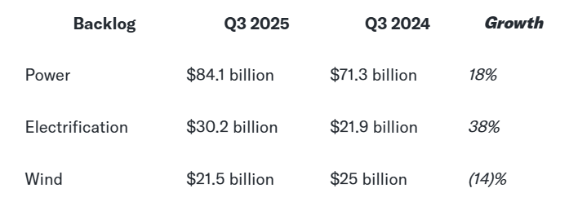
Given these distortions, the most reliable way to assess financial health is by analyzing the company segment by segment, focusing on footprint, revenue trajectory, and margin outlook. First, GE Vernova operates in a capital- and time-intensive industry in which turbine manufacturing, grid equipment production, HVDC buildouts, and wind platform development require multi-year CapEx cycles and substantial upfront investment; the pace at which each segment converts backlog into revenue determines how quickly these investments generate shareholder value. For example, the Prolec GE acquisition materially expands transformer capacity, but the benefit appears only as 2025–2027 projects convert. Second, the company’s $130B+ backlog/RPO provides exceptional revenue visibility across gas turbines, grid infrastructure, and wind services, enabling more accurate forward modeling than a single year of profitability ratios would allow. Management’s multi-year guidance, combined with contracted revenue already in the pipeline, makes segment-level analysis far more predictive of GEV’s financial trajectory across different market scenarios than high-level profitability ratios distorted by the spin.

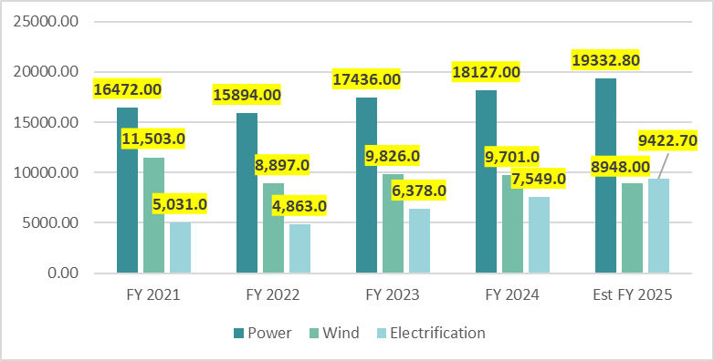
Revenue Growth & Projections
GE Vernova’s revenue trajectory reflects a business entering a sustained multi-year expansion cycle supported by an exceptionally large and visible order book. After delivering solid top-line growth in FY2024 and guiding to another step up in FY2025 in Q3 Earnings, management outlined a long-term framework targeting approximately $45B in annual revenue by 2028. This destination guidance, rather than year-by-year growth percentages, reflects the inherent variability of multi-year HVDC, transmission, and wind programs while still signaling a clear upward path for the top line. Across this 2024–2028 horizon, revenue growth is expected to be driven primarily by accelerating Grid/HVDC demand, stable and recurring Gas Power services, and a gradual recovery in Wind as losses normalize and service intensity increases.
Power: The global environment for dispatchable generation is entering a structurally stronger decade. AI and hyperscale data centers alone are expected to require 160–200 GW of incremental firm capacity by 2030, compared with today’s ~1,800 GW global gas-turbine fleet. This need expands the addressable market for combined-cycle equipment and long-term services by $120–150 billion, assuming $600–750 million of revenue per GW across OEM equipment, upgrades, and lifecycle services. Rising turbine utilization rates, tightening grid reliability requirements, and delayed renewable transmission projects are collectively extending the demand window for high-efficiency gas turbines. Against this backdrop, OEMs like GE Vernova are experiencing multi-year visibility in turbine slot scheduling, with strong tender activity across North America, the Middle East, and Asia.

Structural Drivers of GE Vernova’s Power Rev Growth (2025–2032)
- Deep Multi-Year Backlog Support:
Power enters FY2025 with an $84B+ backlog—mostly long-term service agreements and multi-year turbine commitments—providing stable, non-cyclical revenue through at least 2029.
- Installed Base Scale & Recurring Services:
A global fleet of 7,000+ gas turbines anchors high-margin services revenue. Aging fleets and rising utilization are accelerating repowers, upgrades, and reliability programs.
- Demand Upside from AI & Reliability Markets:
The structural increase in firm-power demand from data centers, grid-firming, and thermal reliability markets raises the baseline for gas-turbine orders beyond historical CCGT cycles.
Over the next 5–7 years, GE Vernova’s Power segment is positioned to benefit from one of the strongest firm-power cycles in recent history. The global surge in hyperscale data-center construction is driving sustained demand for reliable, fast-ramping gas turbines, and GE’s credibility with major players — including AWS, Chevron, JERA, and leading Middle Eastern utilities — along with one of the largest installed turbine fleets in Asia, gives it a defensible advantage. With an $84B+ backlog and a services engine tied to more than 7,000 operating turbines, the segment enters the second half of the decade with unusually high revenue visibility. In a neutral scenario, Power is positioned for ~6–7% revenue CAGR, supported by steady turbine orders, a rising replacement cycle, and expanding service penetration. In a bull scenario, stronger-than-expected AI/data-center power demand and accelerated buildouts could lift growth high single digits. In a bear scenario, growth may slow toward the low-single digits, but is unlikely to dip below that given the long-term service contracts, locked-in backlog, and the structural requirement for dispatchable power capacity given the unfavorable present outlook on renewables & climate change.
Wind: The global wind industry is entering a multi-speed recovery after several years of inflation, permitting delays, offshore project setbacks, and order cancellations. While the long-term demand backdrop remains strong — with onshore additions expected to rise from ~70–75 GW annually toward 110–140 GW by 2030, and offshore capacity projected to triple from ~75 GW today to 250–300 GW — GE Vernova’s recent history reflects the sector’s volatility. The Vineyard Wind blade failure in 2024, which led to a 10.5M settlement, highlighted quality and execution risks and triggered a strategic reset of the offshore business. Several offshore markets, including Taiwan, have canceled or restructured procurement rounds, while Brazil’s demand slowdown prompted GE to close its LM Wind Power blade plant. Against this backdrop, GE Vernova has narrowed its offshore exposure, cut up to 900 roles, and shifted Wind toward more selective bidding, higher-margin services, and repowering programs.

Structural Drivers of GE Vernova’s Wind Rev Growth (2025–2032)
- Backlog Quality & Loss Reduction:
FY2025 guidance calls for a high-single-digit revenue decline, but losses are narrowing: Q3 2025 posted a 61M core loss versus 317M a year prior. The backlog is smaller but healthier, with improved pricing and lower exposure to unprofitable offshore contracts.
- Installed Base Scale & Repowering:
GE Vernova has repowered more than 6,000 turbines in the U.S., anchoring a growing services and upgrade platform. The Taiwan Power repower award (25 turbines, install through 2027) marks the start of international expansion of this model.
- Offshore Footprint Rationalization:
Following Vineyard Wind issues, management has reduced offshore capacity and adopted a narrower, margin-focused strategy. This reduces upside leverage but materially lowers downside project risk.
- Lean Manufacturing & Quality Reset:
Production lines across GE Vernova’s wind hubs are undergoing lean certification to raise safety, blade reliability, and cost efficiency. Early results include shorter cycle times, fewer rework hours, and more consistent blade-quality metrics. These improvements are essential for restoring cost competitiveness against Vestas, Siemens Gamesa, and fast-scaling Chinese OEMs.
Over the next 5–7 years, GE Vernova’s Wind segment is positioned as a controlled-recovery story rather than a pure growth engine. The global buildout of wind remains intact, but execution, permitting, and financing risks require wider scenario bands. In a neutral scenario, Wind is positioned for ~2-4% revenue CAGR, supported by onshore stability, repowering growth, and a rising mix of long-term service agreements. In a bull scenario, faster permitting, improved offshore economics, and stronger procurement cycles could lift growth into high-single digits. In a bear scenario, growth may flatten toward low single digits or near zero, but a deeper contraction is unlikely given the multi-decade installed base as well as $20B+ backlog, expanding repower economics, and binding renewable-energy mandates that sustain baseline demand even under weaker macro conditions.
Electrification: Electrification is GE Vernova’s strongest growth engine and the segment most directly aligned with the structural needs of the global energy transition. For much of the last decade, grid investment lagged renewable and load growth, creating a large backlog of required transmission upgrades, transformer additions, and interconnection infrastructure. Over the past two years that has flipped into a full grid-build cycle: organic revenue growth accelerated from roughly 20% in 2024 to about 25% in FY2025 guidance, backlog expanded from around $21.9B to more than $30B, and orders more than doubled year over year across transformers, HV/MV equipment, HVDC systems, and power-conversion platforms. Electrification now sits at the center of the world’s key bottlenecks – transformer scarcity, HVDC buildout, substation modernization, and AI/data-center grid connections – which makes it the most visible and structurally supported growth contributor in GEV’s portfolio.

Structural Drivers of GE Vernova’s Wind Rev Growth (2025–2032)
- Multi-Year Grid Expansion Cycle:
Utilities in the US, EU, India, and the Middle East are committing to long-duration transmission and substation upgrades to connect renewables and improve reliability. That underpins sustained demand for transformers, HVDC lines, switchgear, FACTS, and digital substations well into the next decade.
- Transformer Shortages and Prolec GE Integration:
Global transformer lead times often run 18–30 months, and capacity is tight. The Prolec GE acquisition adds meaningful manufacturing footprint just as demand exceeds supply, supporting both volume and pricing power for much of the decade.
- AI and Data-Center Interconnection:
Hyperscale campuses require large HV/MV substations, reactive-power equipment, and power-conversion systems. As AI-driven electricity demand ramps, Electrification participates in every new large data-center interconnect, from transformers to control and protection systems.
- HVDC (High Voltage Direct Current) and Grid Modernization Momentum:
Countries are announcing multi-GW HVDC corridors and reinforcement projects to move power from renewable resource hubs to load centers. HVDC, FACTS, and protection systems are expected to grow faster than overall power-sector capex, creating a long-cycle revenue stream.
- Rising Software and Services Mix:
Grid orchestration, advanced controls, and power-conversion software add recurring, higher-margin revenue on top of hardware sales, improving segment economics and smoothing the cycle over time.
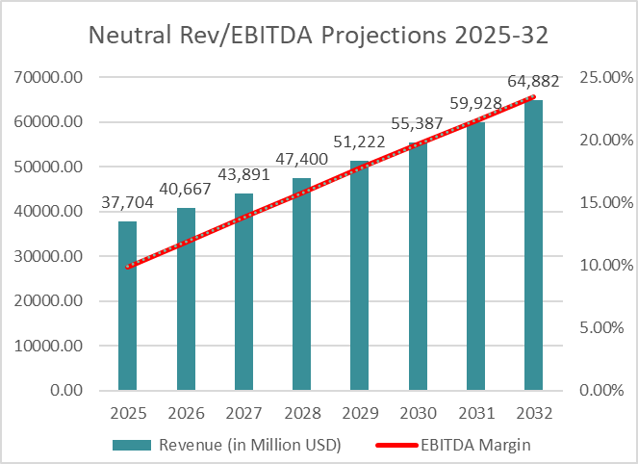
Electrification is the clearest structural growth story within GE Vernova. Its drivers – grid congestion, data-center load growth, transformer scarcity, and renewable integration – are secular rather than cyclical. In a neutral scenario, the segment is positioned for roughly 8–10% annual revenue growth over the next 5–7 years, driven by backlog conversion, transformer capacity expansion, and steady HVDC and substation demand. In a bull scenario, faster AI load growth and accelerated national grid-expansion programs could push growth into the low- to mid-teens, especially if permitting improves. In a bear scenario, revenue growth may slow toward 5–6%, constrained by permitting or supply-chain delays, but is unlikely to fall below that level given multi-year transformer shortages, regulatory reliability requirements, and already-committed transmission and interconnection projects.
Margins & Costs
GE Vernova’s consolidated EBITDA profile is expanding materially as pricing, mix, and productivity improvements flow through the P&L. In Q3-2025, adjusted EBITDA more than tripled YoY to $811M, with margins widening 600 bps, driven by stronger equipment pricing, higher-margin service growth, and manufacturing productivity across gas turbines, transformers, and HVDC systems. Management reaffirmed 8–9% FY2025 EBITDA margin guidance, supported by improved backlog quality and disciplined underwriting across all operating segments, while still projecting $3–3.5B in positive free cash flow despite heavier CapEx and R&D investment. Company-wide margin expansion is being propelled by favorable pricing in Power and Electrification, a rising mix of recurring services, and cost efficiencies across the supply chain, though these gains are partly offset by $300–400M of tariff headwinds, inflation, and ongoing investment in AI, automation, and capacity expansion. Looking beyond 2025, management expects multi-year structural EBITDA uplift as higher-priced turbine and grid orders convert to revenue beginning in late 2026, Electrification scales through transformer and HVDC backlog conversion, and Wind narrows its losses through portfolio pruning and repowering growth — collectively positioning GE Vernova for a steady upward EBITDA margin trajectory through 2028 and beyond, with each segment contributing to consolidated improvement at different speeds.
Power: GE Vernova’s Power segment continues to deliver strong margin expansion, with Q3-2025 EBITDA margin rising to 13.3% (+120 bps YoY) on better pricing, higher-margin HA/aeroderivative service work, and productivity gains. Management reaffirmed 14–15% FY2025 EBITDA margin guidance, supported by sharply improved commercial quality — including a +68% YoY increase in equipment RPO, signaling materially higher future equipment margins once these orders convert beginning in late 2026. With 7,000+ turbines in the installed base and rising utilization driven by data-center load growth and grid-firming demand, management believes Power can ultimately approach its prior ~25% peak. Over the next 5–7 years, margins appear set for steady expansion: a neutral case of ~50–100 bps uplift annually, a bull case of +150–200 bps per year as mix and volumes strengthen, and a bear case still delivering ~0–50 bps of annual improvement due to the inherent stability of service contracts and upgrade cycles.
Costs continue to trend favorably as lean initiatives reduce rework and cycle times, supply chains stabilize, and higher service penetration adds operating leverage. Near-term pressures — including GEV-wide tariffs of $300–400M in FY2025, inflation, and elevated R&D/capacity spending — partially offset these gains, but improved pricing and backlog mix continue to absorb most of the impact, supporting a durable upward margin trajectory through the rest of the decade.
Wind: Wind remains GE Vernova’s most challenging segment, but margin recovery is progressing faster than expected. Q3-2025 EBITDA losses improved by ~$250M YoY, driven by lower offshore contract losses, a reset backlog priced under the new commercial discipline, and continued productivity gains in onshore. Excluding last year’s $500M offshore cancellation settlement, underlying revenue actually grew low double digits, reflecting improving execution on Dogger Bank A/B/C and Vineyard, alongside rising onshore services and repower activity. Management continues to guide to FY2025 Wind EBITDA losses of ~$(400)M, revised weaker due to ongoing softness in onshore equipment orders, tariff headwinds, and permitting delays. But operational trends are improving: onshore margins expanded in Q3, supported by pricing, mix, and tangible factory-level productivity gains.
Structurally, Wind margins should continue recovering over the next 5–7 years as the segment works through its legacy offshore backlog and shifts to higher-margin repowering and services. Management expects material uplift beginning in 2026 as new onshore platforms, post-tariff pricing, and improved offshore contracting discipline begin flowing into revenue. In a neutral scenario, EBITDA margins move steadily toward breakeven by 2027 and into the low–mid single digits afterward. In a bull case, faster U.S. repower cycles, stable tariff policy, and normalized permitting could lift margins meaningfully faster by almost a year. In a bear case, onshore softness and tariff drag could slow progress, but losses should not worsen materially from today’s levels due to a shrinking offshore loss pool, improving service mix, and no new legacy-style fixed-price contracts entering the portfolio.
Electrification: Electrification remains GE Vernova’s strongest margin engine and the clearest structural growth contributor. Segment EBITDA margins expanded meaningfully through 2024 and into 2025, supported by 25% organic revenue growth, a $30B+ backlog (up from ~$22B YoY), and sharply higher pricing across transformers, HVDC systems, FACTS, and power-conversion equipment. Q3-2025 results highlighted a segment operating with far better commercial discipline: order growth exceeded 100% YoY, pricing held firm in a capacity-constrained market, and early productivity benefits from the Prolec GE integration and transformer capacity expansions supported steady margin improvement. Management reiterated that Electrification is positioned for multi-year margin expansion, benefiting from extreme global transformer scarcity (18–30 month lead times), HVDC project acceleration in Europe and the U.S., and hyperscale data-center interconnection demand rising faster than expected.
Cost dynamics are also trending favorably. Electrification is realizing margin uplift from scale efficiencies in transformer manufacturing, localized supply-chain expansion, and lean execution in HVDC and substation builds. While inflation and tariffs continue to pressure near-term equipment costs, pricing discipline and backlog mix have more than offset these headwinds. Over the next 5–7 years, margins should climb steadily as new capacity ramps, Prolec GE integration matures, software and services expand as a share of revenue, and HVDC projects transition from development to delivery. In a neutral scenario, Electrification achieves consistent 50–75 bps of annual EBITDA margin expansion; in a bull case, accelerated data-center interconnect demand and transformer bottlenecks could push gains toward 100–150 bps per year. Even in a bear case, permitting delays or slower investment cycles would likely only moderate — not reverse — margin progress, given multi-year backlog visibility and structural supply shortages across the global grid equipment market.

Valuation Analysis
Valuing GE Vernova requires a careful and flexible approach, because the company’s short standalone history creates unusually high volatility in reported earnings, margins, and cash flows. As a newly listed entity with large restructuring charges, segment resets, and front-loaded CapEx, backward-looking ratios do not yet reflect its normalized earnings power. At the same time, GEV’s forward visibility is unusually strong for a recent spin-off: the company enters FY2025 with a service-heavy installed base, multi-year turbine and grid-equipment commitments, and a backlog spanning several years’ worth revenue, which allows for structured scenario modeling despite limited historical data. Given these characteristics, three complementary valuation methods that collectively capture both the long-cycle nature of the business and the market’s near-term expectations have been employed.
The first method is a Discounted Cash Flow (DCF) model based on Free Cash Flow to the Firm (FCFF). This approach is well suited for GE Vernova because of its established asset base, durable long-term service agreements, visibility within Power and Electrification backlog, and the multi-year uplift expected as higher-priced turbine and transformer orders convert beginning in 2026. DCF allows us to explicitly model margin normalization, CapEx, and the forward economics of the company’s largest segments — dynamics that current accounting earnings do not fully capture. The second valuation framework uses relative valuation, incorporating both peer multiples and self-derived trading ranges. GE Vernova has traded at a premium to the mean of several key industrial and grid-equipment multiples since inception, largely due to its backlog depth, margin expansion trajectory, and exposure to secular growth drivers such as grid modernization and data-center load. Using both peer EV/EBITDA and P/E multiples, as well as GEV’s own early trading patterns, helps anchor valuation to realistic market benchmarks while acknowledging its transition-phase distortions.

Weights & Rationale
For this valuation, 60% weight was assigned to the DCF, because with fewer than two years of standalone financials, GE Vernova’s intrinsic value is much better captured by forward-looking projections than by backward-looking ratios, which is why DCF contributes more than half to final Valuation. The company’s unusually strong revenue visibility, long-term service agreements, and multi-year turbine and grid-equipment commitments make the DCF the most reliable framework for reflecting margin normalization and long-cycle growth.
Peer and self-comparables each receive 20% weight. Peer multiples allow us to incorporate how the market currently values companies in similar power equipment, grid technology, and renewables segments, ensuring the model reflects industry pricing rather than purely intrinsic estimates. Meanwhile, self-comps help anchor the 1-year target price to the reality that GE Vernova is still early in its trading life; as a high-growth spin-off with rapidly improving fundamentals, it may continue to trade near the upper end of its historical multiples as earnings recover. Because this report aims to produce a 12-month target price, retaining some emphasis on market-based trading behavior is appropriate, but should not dominate the model given the company’s limited historical base.

Key Assumptions
The assumptions underlying this valuation model are based primarily on Bloomberg analyst mean consensus forecasts for FY2025–FY2032, supplemented by management guidance and segment-level outlooks discussed throughout this report. Using consensus averages provides a more stable foundation for long-term projections, especially given GE Vernova’s limited standalone financial history and the volatility associated with its first two fiscal years as an independent company.
CapEx and Depreciation & Amortization (D&A) expectations reflect the industry’s capital-intensive nature and GE Vernova’s ongoing investment cycle, which is concentrated in transformer capacity expansion, HVDC manufacturing, turbine readiness, and lean factory upgrades. D&A assumptions are aligned with the expansion of the asset base in Electrification and Power, and gradually converge toward normalized reinvestment ratios later in the decade as major facilities come online.
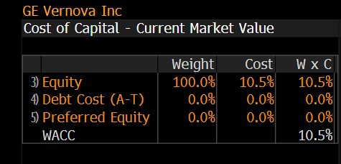
Changes in non-cash working capital also follow consensus estimates and account for the timing of project-based revenue recognition, long-term service agreements, and multi-year cash conversion cycles typical of large equipment and grid-infrastructure businesses. These assumptions incorporate the effects of GE Vernova’s growing RPO (remaining performance obligations), higher equipment down payments, and the shift toward more service-heavy, faster-converting revenue streams.
For the discount rate, I use WACC = 10.5%, which is effectively equal to the cost of equity because GE Vernova operates with near-zero net debt. As of the latest quarter, Bloomberg’s capital structure screen shows the company financed 100% by equity, with only ~$725M total debt versus a $166B+ market capitalization, making the after-tax cost of debt immaterial to the weighted average. Using the cost of equity as WACC therefore best reflects the firm’s risk profile and current capital structure.
Market/Industry Outlook: BULLISH (Assumed)
To capture the full valuation range for a young but highly visible company like GE Vernova, this model considers five distinct market sentiments — Bear, Bearish, Neutral, Bullish, and Bull — rather than relying solely on a traditional bear/neutral/bull framework. Because GEV has limited standalone history yet unusually strong forward visibility through its backlog, service contracts, and multi-year project pipeline, a simple three-scenario model risked understating the asymmetry between downside protection and upside optionality. Therefore, Bearish and Bullish scenarios were added as midpoints (averaging Neutral with Bear and Bull, respectively), offering more realistic gradients of sentiment consistent with the company’s position as a high-capital, high-growth business operating in a rapidly expanding yet inherently volatile segment of the global energy infrastructure market.For the purposes of establishing a 1-year target price, this model adopts BULLISH as the most appropriate base case, supported by: (I) exceptional backlog expansion across Power and Electrification, (II) rapid margin uplift in both segments, especially Electrification, (III) expected EBITDA expansion beginning in 2026 from Prolec transformer sales and synergy capture, and (IV) improving medium-term economics in Wind as repower demand grows and legacy offshore losses roll off, higher pricing contracts begin mid-2026. These dynamics collectively argue for sentiment above Neutral but short of fully Bull, making Bullish the justified and balanced projection for the Valuation Model(s) that follow.
GEV: 1-Yr Valuation Model (Excel-Macro Object)- *Double-click to interact! *

Absolute Valuation- DCF (FCFF)
This model applies two terminal valuation methods — perpetual growth and EV/EBITDA exit multiple — to anchor long-run value for a business with limited standalone history but unusually strong multi-year revenue visibility. Using both methods stabilizes long-term valuation for a company that is (1) essentially debt-free, and (2) operates in permanent, infrastructure-critical markets (firm power, grid equipment, electrification).
DCF Intrinsic Value: In the bullish projection, the model uses a 2.5% perpetual growth rate, above the industry’s typical 1.5–2.0% range, because GE Vernova is a new high-growth spin-off entering a multi-decade cycle of data-center-driven firm-power demand, transformer shortages, and global HVDC expansion. With GE Management’s year of expertise & network, the firm is bound to see impressive CAGR growth for a period of multiple decades.
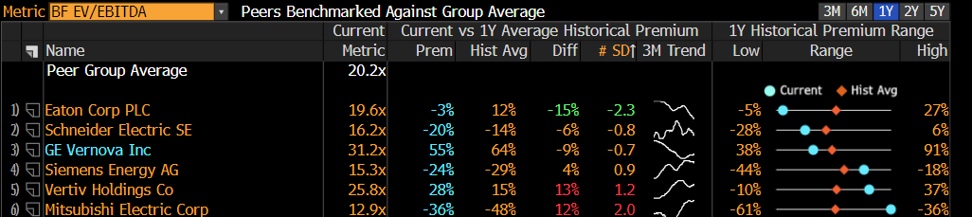
For the EV/EBITDA terminal multiple, a rate of 18x is employed, a justified premium relative to long-run sector norms given:
• accelerating Power & Electrification margin expansion,
• the AI/data-center build cycle,
• structurally tight grid-equipment supply, creating demand & backlog for a decade at least.

Together, management’s bullish guidance & Data Center boom reflect a scenario where GE Vernova exits the forecast period as a high-growth, higher-margin pure-play electrification leader with sector-leading backlog visibility.
FCFF Projection (2025-32): Bullish growth

Relative Valuation- EV/Revenue and EV/EBITDA
To complement the DCF, the model applies relative valuation framework anchored on enterprise value (EV) rather than equity value, since GE Vernova’s high market capitalization and minimal net debt make EV the most accurate and comparable measure of financial health and operating scale. On the denominator side, both Revenue and EBITDA are used because, for GEV, these two metrics together reflect the company’s entire value-creation profile — Revenue captures long-cycle backlog conversion and secular grid/gas demand, while EBITDA incorporates margin expansion from mix shift, cost discipline, and the tapering of wind losses. Each tells a different but reinforcing part of the story; using both yields a complete operational picture. After obtaining valuation outputs from EV/Revenue and EV/EBITDA, I take the average implied enterprise value as the final relative valuation anchor, ensuring that the model balances both top-line scale and margin recovery. From there, the methodology splits into Self-Comps and Peer-Comps, each serving a different role in assessing GEV’s 1-year forward fair value.
Self-Comps: For self-comparables, FY2026 Bloomberg consensus estimates are used for Revenue and EBITDA. This approach reflects how the market has historically priced GEV since the spin — notably, at a persistent premium to peer multiples due to backlog visibility & expansion, leading gas-turbine franchise, and high-value grid positioning. By applying GEV’s own forward multiples to its FY2026 estimates, this method captures the company’s idiosyncratic momentum, its margin recovery trajectory, and market expectations that are specific to GEV rather than the broader industry. In essence, the self-comp valuation reflects the price level the market would assign assuming GEV continues performing in line with its historical post-spin profile.
Peer-Comps: For peer comparables, the model uses the median FY2026 EV/Revenue and EV/EBITDA multiples of the closest industrial and electrification peers. To make this relevant for GEV’s 2026 target price, the model adjusts these medians upward by GEV’s 1-year historical daily premium to the peer-mean multiple. This adjustment is justified because GEV’s EBITDA is expected to nearly double by 2026, with significant incremental revenue recognition from new higher-priced grid and gas contracts, placing the company on a different growth and margin trajectory compared to diversified peers. Applying the historical premium preserves this structural differentiation and recognizes that GEV has consistently traded above industry averages. The result is a peer-derived relative price that reflects both sector fundamentals and GE Vernova’s superior forward operating leverage.

Conclusion
Across all valuation approaches, GE Vernova’s bullish scenario indicates modest but meaningful upside over the next 12 months. The DCF — weighted most heavily at 60% due to GEV’s long-cycle backlog visibility and rapidly improving margin trajectory — yields an intrinsic value of $636.10 per share, contributing $381.66 to the blended target. The two relative valuation frameworks reinforce this view: the Self Comps method, based on FY2026 consensus estimates and GEV’s historic post-spin trading premium, arrives at $654.26, while the Peer Comps method — adjusted to reflect GEV’s consistent one-year premium over sector medians — produces $620.76. Together, these results generate a blended 1-year price target of $636.66, modestly above the current ~$600 share price and implying ~6.1% upside.
Importantly, the scenario analysis shows that the valuation is well supported even under more conservative assumptions, with mid-case outcomes clustering near the blended target and high-case scenarios extending into the $670–$740 range. This suggests the market has already priced in part of GEV’s operational turnaround, but not the full earnings power implied by backlog conversion, Electrification scale-up, and upcoming abnormal margin expansion in 2026. Realizing or exceeding the target will depend on GEV executing against these drivers — delivering sustained backlog burn, continued margin expansion in Gas and Grid, and further stabilization in Wind. These execution milestones, combined with structural industry tailwinds, form the basis of the Catalysts section that follows.

Catalysts
GE Vernova’s business model creates unusually event-driven catalysts because turbine orders, HVDC awards, SMR milestones, and wind-backlog conversions all have identifiable timelines and revenue-recognition profiles. Since the April 2, 2024 spin-off, GEV has already benefited from several catalysts — including record Electrification orders, multi-unit AI/data-center turbine deals, and the start of construction for the world’s first grid-scale SMR. Over the next 18–36 months, the company has a clear pipeline of catalysts that can unlock incremental revenue, margin expansion, and re-rating potential.
Below are the specific, time-anchored catalysts most likely to drive upside between 2025–2027:
AI/Data-Center Gas Turbine Conversions (2025–2027)
Crusoe’s 29-unit aeroderivative order (Sept 2024) and the Chevron–Engine No. 1 partnership (Nov 2024) begin revenue recognition in 2025, with service revenue compounding through 2027+. Any additional hyperscale multi-unit award materially revises Street expectations upward.
HVDC & Grid Equipment Tightness Driving Multi-Year Pricing Power (2025–2030)
Electrification orders have doubled YoY (>$12B LTM), while industry transformer/HVDC capacity remains constrained until 2030. Three HVDC projects awarded in 2024 convert to revenue starting late 2025, with Prolec-linked transformer capacity adding incremental output (at estimated 20-25% EBITDA) starting mid-2026.
Offshore Wind Backlog Burn-Off Completed by 2026
Management reaffirmed that the remaining ~$4B offshore backlog will be fully delivered by end of 2026, eliminating a major EBITDA drag. This transition materially reduces loss volatility and allows Wind margins to normalize into 2026–2027, which could very well be a catalyst depending upon onshore order growth.
Prolec Transaction Margin Uplift Beginning 2026
The 2024 Prolec divestiture + long-term supply agreement expands GE Vernova’s access to higher-value transformer categories. Management guides to EBITDA uplift starting in 2026, driven by mix improvement and lower working-capital intensity.
SMR Construction Milestones (2024–2027)
The BWRX-300 project broke ground in Dec 2024, the first grid-connected SMR globally. Licensing progress in the U.S. (2026–2027) and early-stage commitments from Poland, Czech Republic, and Estonia create multi-year optionality in GE Vernova’s future nuclear revenue base.

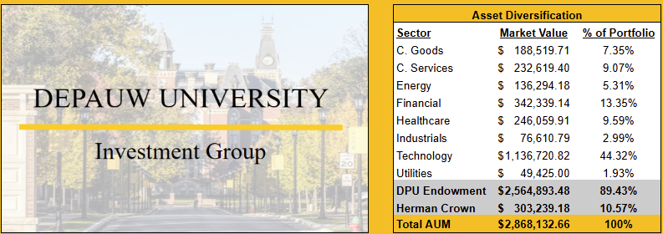
Portofolio Fit
A small ~2% position of roughly $60,000 in GE Vernova (100 shares @ 600 USD)— funded entirely from the portfolio’s 5.45% cash — adds high-quality exposure to the Industrials → Electrical Equipment & Grid Infrastructure space, which is meaningfully underweighted in DIG’s current allocation. GEV brings long-duration, contract-backed cash flows into a portfolio dominated by short-duration Technology (44% weight), improving balance and reducing concentration risk.
Since its April 2024 spin, GE Vernova has returned roughly 55–65% YTD (depending on measurement date), which places it well above DIG’s Energy (+62%) and Utilities (+46%) returns, and in line with the portfolio’s mid-tier outperformers like Healthcare (+41%) and Industrials (+57%). While not matching the extreme gains of DIG’s Technology sleeve (+224%) or Financials (+164%), GEV’s performance trajectory reflects a high-growth industrial profile rather than a mature utilities-like one. This return pattern demonstrates two advantages for DIG: (1) GEV behaves like a growth industrial with materially higher upside potential than our traditional Energy and Utilities holdings; and (2) unlike Tech — where concentrated positions already dominate portfolio risk — GEV’s volatility is supported by hard assets, long-cycle contracts, and visibility from $130B+ RPO, making it a comparatively lower-risk contributor to incremental return. Adding GEV therefore strengthens the portfolio’s underweight exposure to next-decade infrastructure winners while still maintaining a return profile competitive with DIG’s strongest non-tech sectors.
The primary portfolio risk introduced is industrial cyclicality and project-execution sensitivity, but these are moderated by GEV’s backlog profile and multi-year visibility. A small reduction in Technology (0.5–1.0%) would offset this addition, easing sector concentration while keeping overall beta in line with historical ranges.
Overall, GEV strengthens the portfolio by converting idle cash into a contract-driven, policy-supported, AI-adjacent infrastructure asset, improving diversification as well as increasing exposure to cash generating industries.

Bibliography

Bloomberg L.P. Financial Data Terminal: GE Vernova (GEV US), Peer Multiples, Analyst Consensus, WACC, and Historical Trading Data. New York: Bloomberg Finance L.P., 2025.
(https://www.bloomberg.com)
GE Vernova Inc. Company Filings, Investor Presentations, Earnings Materials, and Press Releases (2024–2025).
Includes: Q3 2025 Earnings Call Transcript; Q3 2025 Company Presentation; Q3 2025 Form 10-Q; 2024 Investor Day Presentation; AWS partnership release; Chevron partnership release; Crusoe aeroderivative turbine agreement.
(All provided as attachments in this report.)
International Energy Agency. Electricity 2024: Nuclear Expansion Outlook. Paris: IEA, 2024.
Market Research Future. Electric Power Transmission and Distribution Equipment Market Forecast 2024–2034. Market Research Future, 2024.
Reuters. “Grid Equipment Makers Invest in U.S. to Ease Supply Shortage.” Reuters News Service, 2024.
(https://www.reuters.com)
The Motley Fool. “2 Things Every GE Vernova Investor Needs to Know.” The Motley Fool, 2024.
World Nuclear Association. World Nuclear Fuel Report: Global Uranium Supply and Demand Projections 2024–2040. London: WNA, 2024.

