1.静态分析工具：
Bug Detector: FindBugs
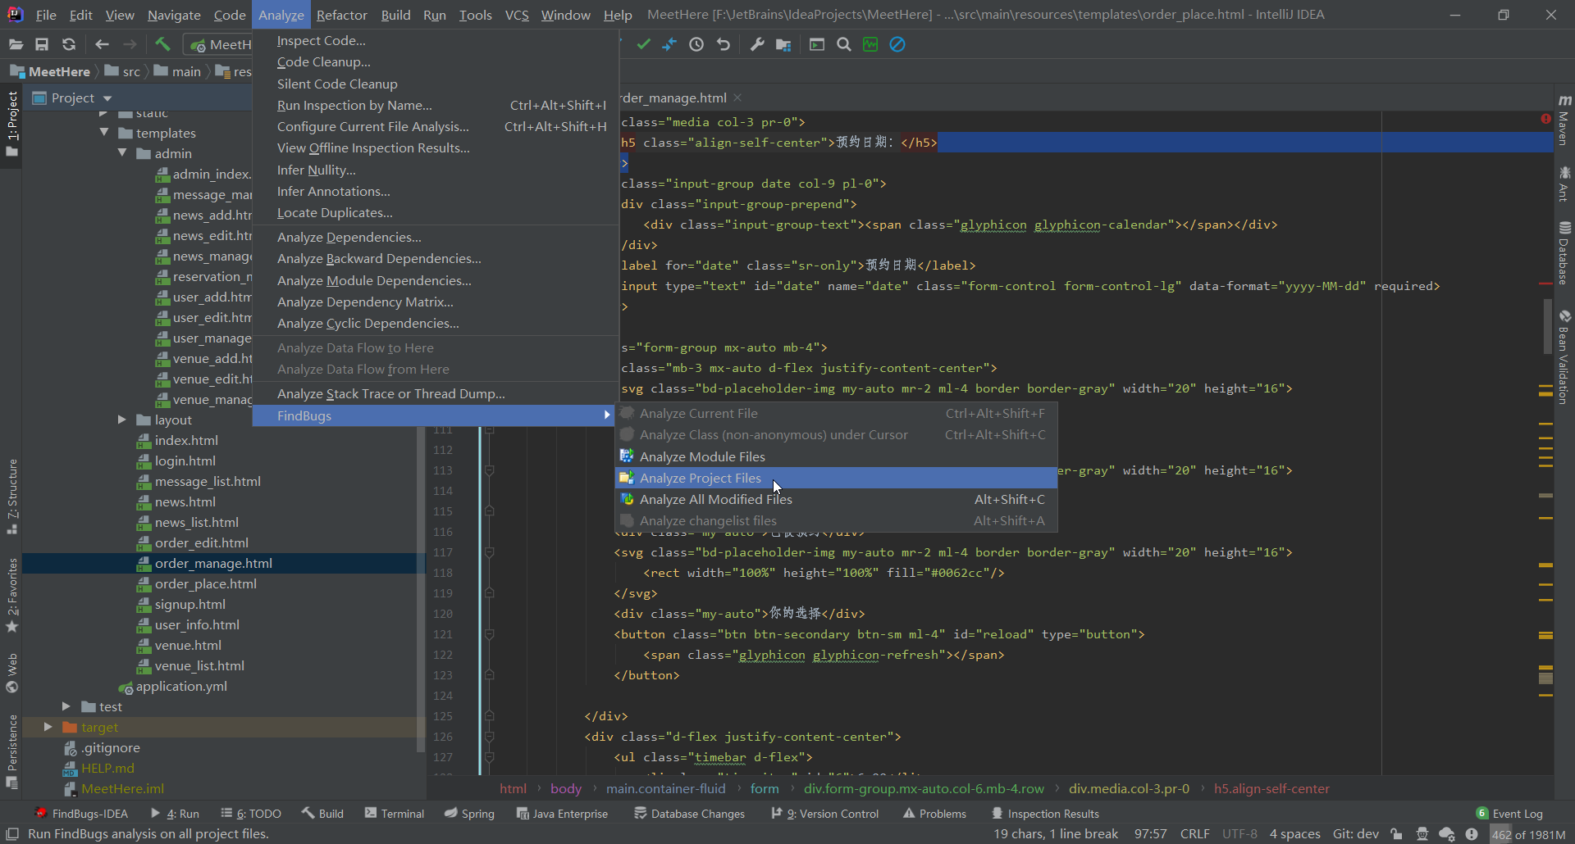
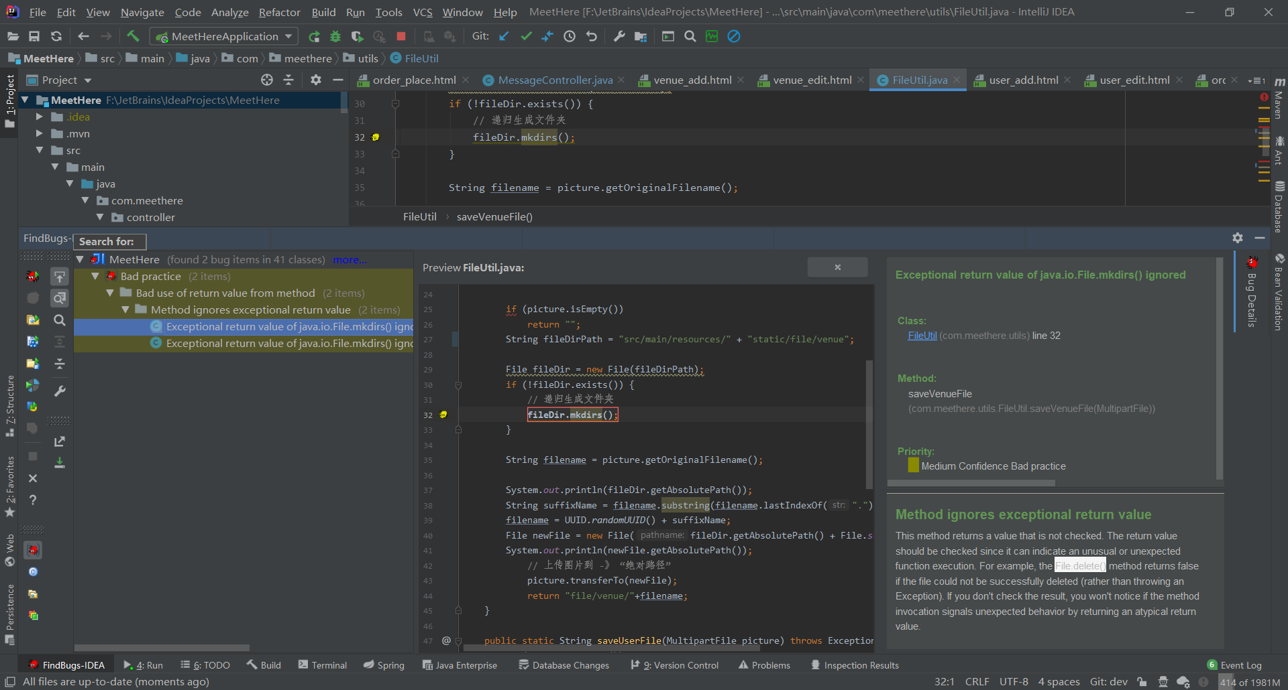
Code Style Checker: P3C
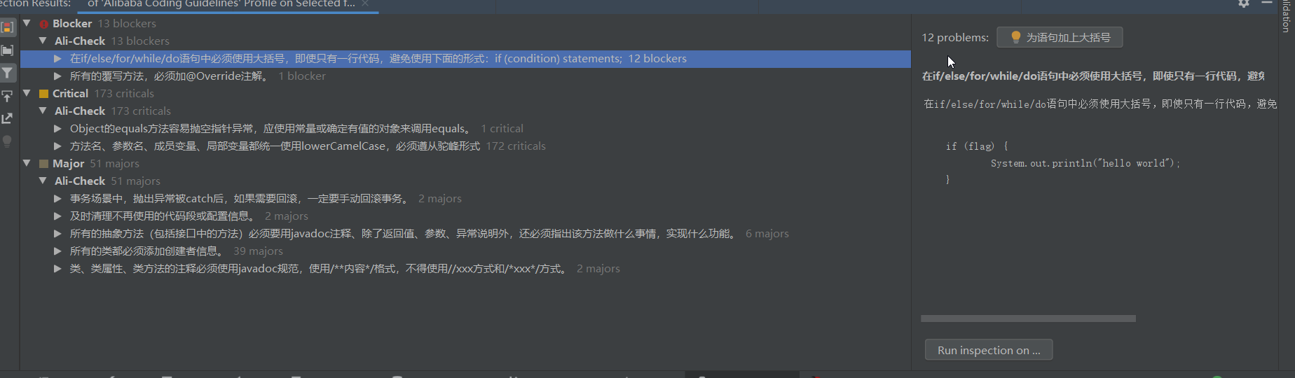

2.缺陷统计
FindBugs发现缺陷: 2个
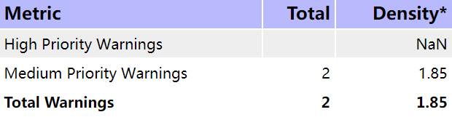
缺陷编号 | No.1
缺陷内容 | Exceptional return value of java.io.File.mkdirs() ignored
缺陷提示 | This method returns a value that is not checked. The return value should be checked since it can indicate an unusual or unexpected function execution. For example, the File.delete() method returns false if the file could not be successfully deleted (rather than throwing an Exception). If you don't check the result, you won't notice if the method invocation signals unexpected behavior by returning an atypical return value.
Priority | Medium Confidence Bad practice
模式 | Method ignores exceptional return value
类别 | Bad practice Warnings
缺陷位置 | src/main/java/com/meethere/controller/user/MessageController.java
Method | saveVenueFile(com.meethere.utils.FileUtil.saveVenueFile(MultipartFile))

缺陷编号 | No.2
缺陷内容 | Exceptional return value of java.io.File.mkdirs() ignored
缺陷提示 | This method returns a value that is not checked. The return value should be checked since it can indicate an unusual or unexpected function execution. For example, the File.delete() method returns false if the file could not be successfully deleted (rather than throwing an Exception). If you don't check the result, you won't notice if the method invocation signals unexpected behavior by returning an atypical return value.
Priority | Medium Confidence Bad practice
模式 | Method ignores exceptional return value
类别 | Bad practice Warnings
缺陷位置 | src/main/java/com/meethere/utils/FileUtil.java
Method | saveUserFile (com.meethere.utils.FileUtil.saveUserFile(MultipartFile))

P3C检测后发现7种缺陷，按严重等级分为3类
Blocker:
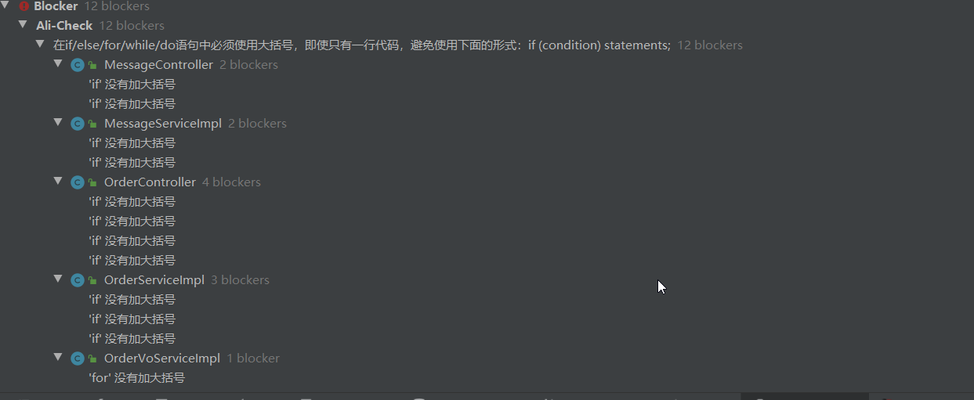
Critical
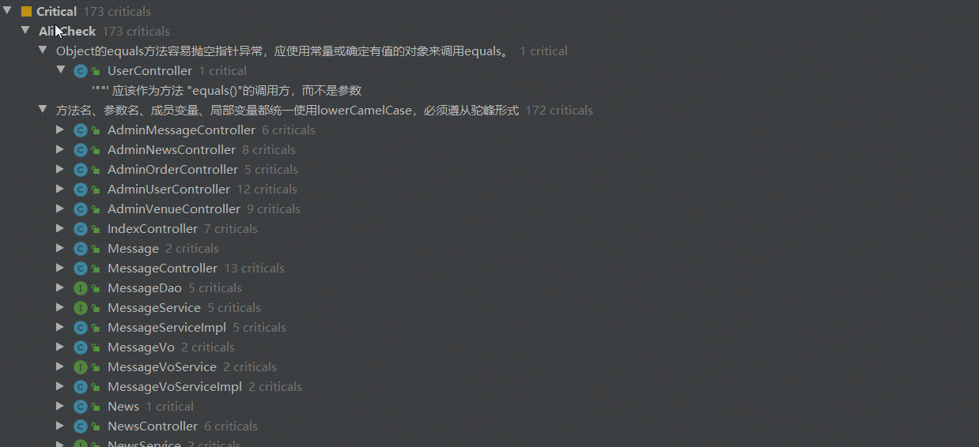
Major:
