 | Course Name: Design Patterns/Thinking LAB | EXPERIMENT NO. 3
 | Course Code: 20CP210P  Faculty: Dr. Payal Chaudhari | Branch: CSE | Semester: IV
(To be filled by Student)
Submitted by: Meet Jain
Roll no: 23BCP093

Objective: To familiarize students with standard Creational design patterns.
Experiment: Explain the builder design pattern and write a program using any object-oriented programming language to demonstrate the working of builder design pattern.

Code:
public class BuilderPatternDemo {
public static class CafeOrder {
private String coffeeType;
private String milkType;
private String sugar;
private String size;
public CafeOrder(String coffeeType, String milkType, String sugar, String size) {
this.coffeeType = coffeeType;
this.milkType = milkType;
this.sugar = sugar;
this.size = size;
}
@Override
public String toString() {
return "CafeOrder [Coffee Type: " + coffeeType + ", Milk Type: " + milkType +
", Sugar: " + sugar + ", Size: " + size + "]";
}
}
public static class CafeOrderBuilder {
private String coffeeType;
private String milkType;
private String sugar;
private String size;
public CafeOrderBuilder setCoffeeType(String coffeeType) {
this.coffeeType = coffeeType;
return this;
}
public CafeOrderBuilder setMilkType(String milkType) {
this.milkType = milkType;
return this;
}
public CafeOrderBuilder setSugar(String sugar) {
this.sugar = sugar;
return this;
}
public CafeOrderBuilder setSize(String size) {
this.size = size;
return this;
}

public CafeOrder build() {
return new CafeOrder(coffeeType, milkType, sugar, size);
}
}
public static void main(String[] args) {
CafeOrderBuilder orderBuilder = new CafeOrderBuilder();
CafeOrder order1 = orderBuilder
.setCoffeeType("Latte")
.setMilkType("Almond Milk")
.setSugar("2 cubes")
.setSize("Large")
.build();
System.out.println(order1);
CafeOrder order2 = orderBuilder
.setCoffeeType("Espresso")
.setMilkType("Whole Milk")
.setSugar("No sugar")
.setSize("Medium")
.build();
System.out.println(order2);
}
}
Output:
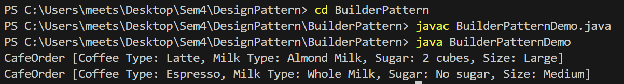
Class Diagram:
