 | Course Name: Design Patterns/Thinking LAB | EXPERIMENT NO. 6
 | Course Code: 20CP210P  Faculty: Dr. Payal Chaudhari | Branch: CSE | Semester: IV
(To be filled by Student)
Submitted by: Meet Jain
Roll no: 23BCP093

Objective: To familiarize students with standard Structural design patterns.
Experiment: Explain the Adapter design pattern and write a program using any object-oriented programming language to demonstrate the working of Adapter design pattern.

Code:
interface CafeOrder {
void placeOrder();
}

class CoffeeOrder implements CafeOrder {
private String coffeeType;

public CoffeeOrder(String coffeeType) {
this.coffeeType = coffeeType;
}

@Override
public void placeOrder() {
System.out.println("Order placed for: " + coffeeType + " Coffee.");
}
}

class TeaOrder {
private String teaType;

public TeaOrder(String teaType) {
this.teaType = teaType;
}

public void orderTea() {
System.out.println("Order placed for: " + teaType + " Tea.");
}
}

class TeaOrderAdapter implements CafeOrder {
private TeaOrder teaOrder;

public TeaOrderAdapter(String teaType) {
this.teaOrder = new TeaOrder(teaType);
}

@Override
public void placeOrder() {
teaOrder.orderTea();
}
}

public class Cafe {
public static void main(String[] args) {
CafeOrder coffee = new CoffeeOrder("Espresso");
coffee.placeOrder();

CafeOrder tea = new TeaOrderAdapter("Masala");
tea.placeOrder();
}
}

Output:
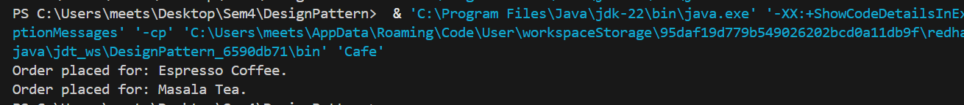

Class Diagram:

