 | Course Name: Design Patterns/Thinking LAB | EXPERIMENT NO. 6
 | Course Code: 20CP210P  Faculty: Dr. Payal Chaudhari | Branch: CSE | Semester: IV
(To be filled by Student)
Submitted by: Meet Jain
Roll no: 23BCP093

Objective: To familiarize students with standard Structural design patterns.
Experiment: Explain the Composite design pattern and write a program using any object-oriented programming language to demonstrate the composite design pattern.

Code:
package composite;

import java.util.*;

interface MenuComponent {
void display();
}

class MenuItem implements MenuComponent {
private String name;
private double price;

public MenuItem(String name, double price) {
this.name = name;
this.price = price;
}

@Override
public void display() {
System.out.println(" - " + name + " ($" + price + ")");
}
}

class MenuSection implements MenuComponent {
private String name;
private List<MenuComponent> components = new ArrayList<>();

public MenuSection(String name) {
this.name = name;
}

public void add(MenuComponent component) {
components.add(component);
}

@Override
public void display() {
System.out.println("\n" + name + ":");
components.forEach(MenuComponent::display);
}
}

public class CafeMenu {
public static void main(String[] args) {
MenuSection menu = new MenuSection("Café Menu");
MenuSection hotDrinks = new MenuSection("Hot Beverages");
MenuSection coldDrinks = new MenuSection("Cold Beverages");

hotDrinks.add(new MenuItem("Espresso", 2.5));
hotDrinks.add(new MenuItem("Cappuccino", 3.5));

coldDrinks.add(new MenuItem("Iced Coffee", 3.0));
coldDrinks.add(new MenuItem("Berry Smoothie", 4.5));

menu.add(hotDrinks);
menu.add(coldDrinks);
menu.display();
}
}

Output:
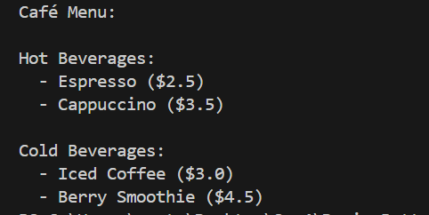
Class Diagram:
