 | Course Name: Design Patterns/Thinking LAB | EXPERIMENT NO. 4
 | Course Code: 20CP210P  Faculty: Dr. Payal Chaudhari | Branch: CSE | Semester: IV
(To be filled by Student)
Submitted by: Meet Jain
Roll no: 23BCP093

Objective: To familiarize students with standard Creational design patterns.
Experiment: Explain the prototype design pattern and write a program using any object-oriented programming language to demonstrate the working of prototype design pattern.

Code:
interface CafeOrder extends Cloneable {
CafeOrder clone();
void displayOrder();
}

class CoffeeOrder implements CafeOrder {
private String coffeeType;
private String milkType;
private String sugar;
private String size;

public CoffeeOrder(String coffeeType, String milkType, String sugar, String size) {
this.coffeeType = coffeeType;
this.milkType = milkType;
this.sugar = sugar;
this.size = size;
}

@Override
public CafeOrder clone() {
try {
return (CafeOrder) super.clone();
} catch (CloneNotSupportedException e) {
return null;
}
}

@Override
public void displayOrder() {
System.out.println("Coffee Type: " + coffeeType);
System.out.println("Milk Type: " + milkType);
System.out.println("Sugar: " + sugar);
System.out.println("Size: " + size);
}

public String getCoffeeType() { return coffeeType; }
public void setCoffeeType(String coffeeType) { this.coffeeType = coffeeType; }

public String getMilkType() { return milkType; }
public void setMilkType(String milkType) { this.milkType = milkType; }

public String getSugar() { return sugar; }
public void setSugar(String sugar) { this.sugar = sugar; }

public String getSize() { return size; }
public void setSize(String size) { this.size = size; }
}

public class PrototypePatternDemo {
public static void main(String[] args) {
CoffeeOrder originalOrder = new CoffeeOrder("Espresso", "Almond Milk", "2 cubes", "Medium");

CoffeeOrder clonedOrder1 = (CoffeeOrder) originalOrder.clone();
clonedOrder1.setSize("Large");
clonedOrder1.setSugar("No sugar");

CoffeeOrder clonedOrder2 = (CoffeeOrder) originalOrder.clone();
clonedOrder2.setCoffeeType("Cappuccino");
clonedOrder2.setMilkType("Whole Milk");

System.out.println("Original Order:");
originalOrder.displayOrder();

System.out.println("\nCloned Order 1:");
clonedOrder1.displayOrder();

System.out.println("\nCloned Order 2:");
clonedOrder2.displayOrder();
}
}

Output:
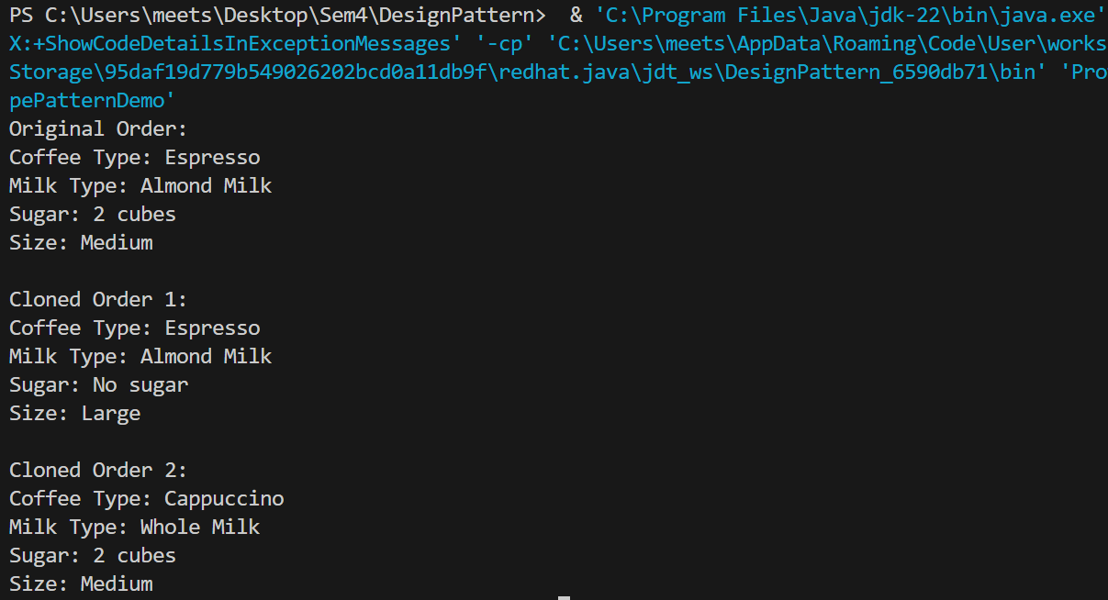
Class Diagram:
