24IT053 | CHAROTAR UNIVERSITY OF SCIENCE AND TECHNOLOGY  FACULTY OF TECHNOLOGY AND ENGINEERING  B. TECH (IT) | 
__________________________________________________________________
Subject: Advanced Web Development Frameworks (ITUE301) | Semester: 5th
Practical Statement: Practical 1: Introduction to React and Component Architecture
Student Name: Meet Nakarani
Student ID: 24IT053
GitHub Repository: https://github.com/MeetKumar6789/student-portfolio

Problem Statement
- Create a React application using Vite for a student portfolio page.
- The application must include at least 4 reusable components: Header, About, Skills, and Footer.
- Each component must be independently structured and composed into a single-page layout.
- No logic or JSX should be duplicated across components.
- Props must be used to pass at least one piece of data into a minimum of 2 components.

Screenshots & Terminal Execution
1. Verify Node.js and npm are installed:
Open PowerShell terminal to display Node and npm runtime versions:
PS C:\Users\HP> node -v
v24.11.1
PS C:\Users\HP> npm -v
10.9.3
2. Scaffold the React app using Vite:
Scaffolding Vite template environment:
PS C:\Users\HP> npm create vite@latest student-portfolio --template react
Scaffolding project in C:\Users\HP\student-portfolio...
Done. Now run:
cd student-portfolio
npm install
npm run dev
* Header.jsx component code:
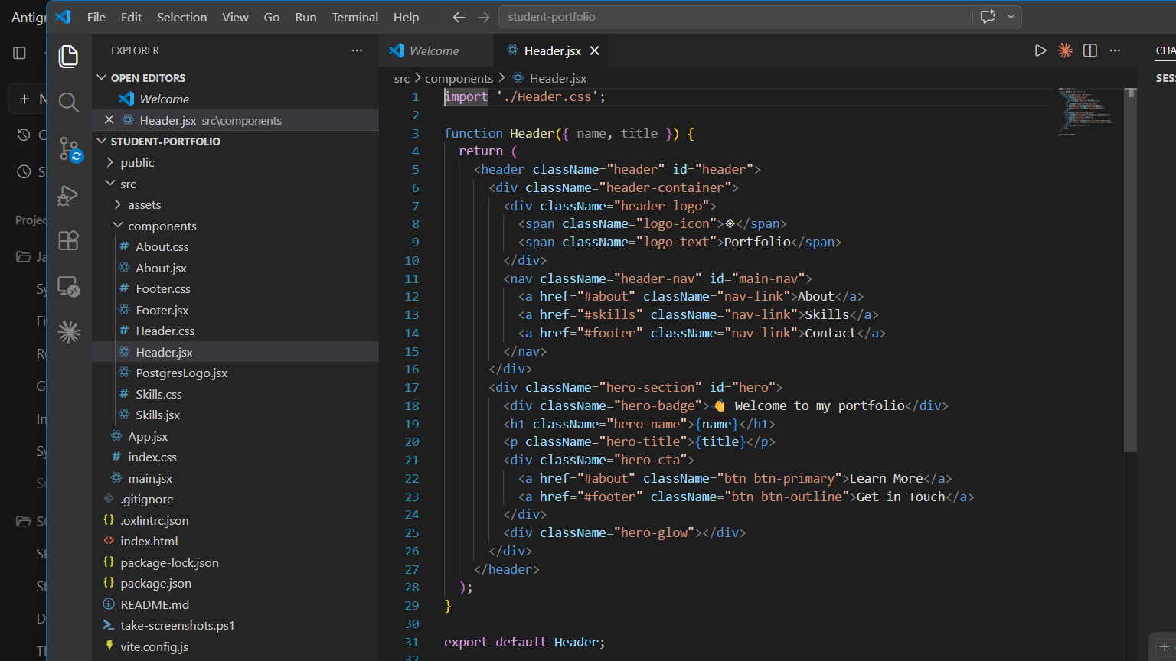
* Skills.jsx component code (handling props mapping):
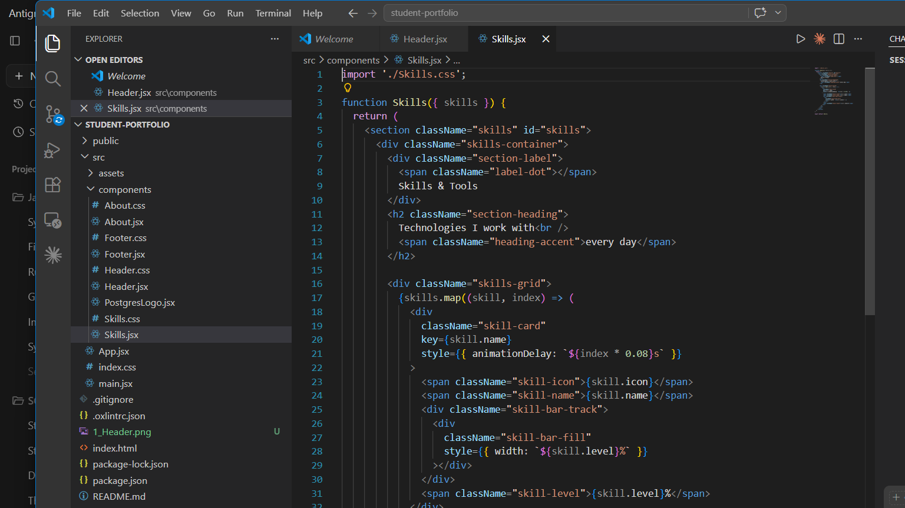
* About.jsx component code:
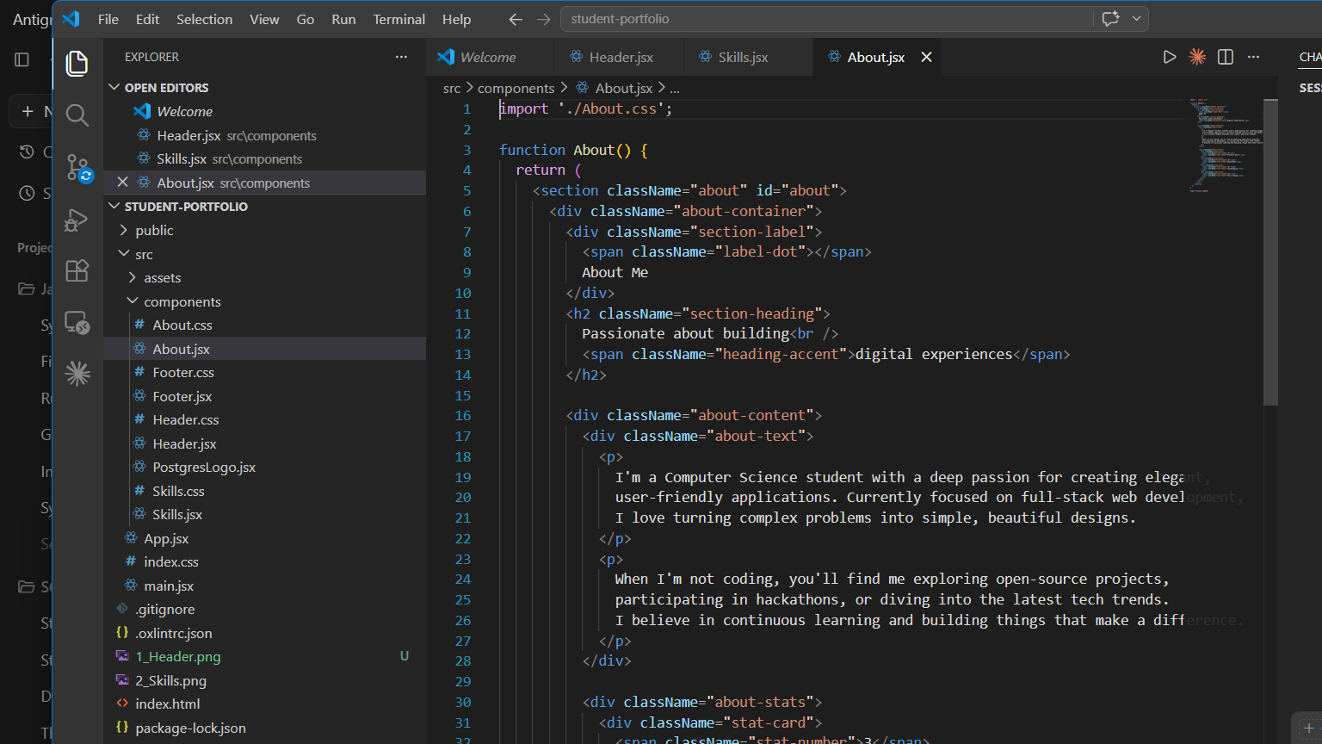
* Footer.jsx component code:
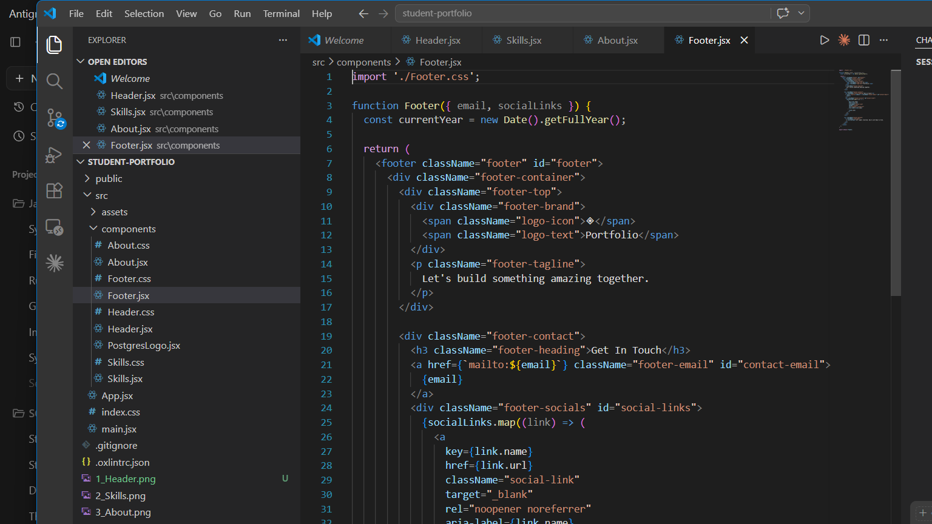
* index.css stylesheet:
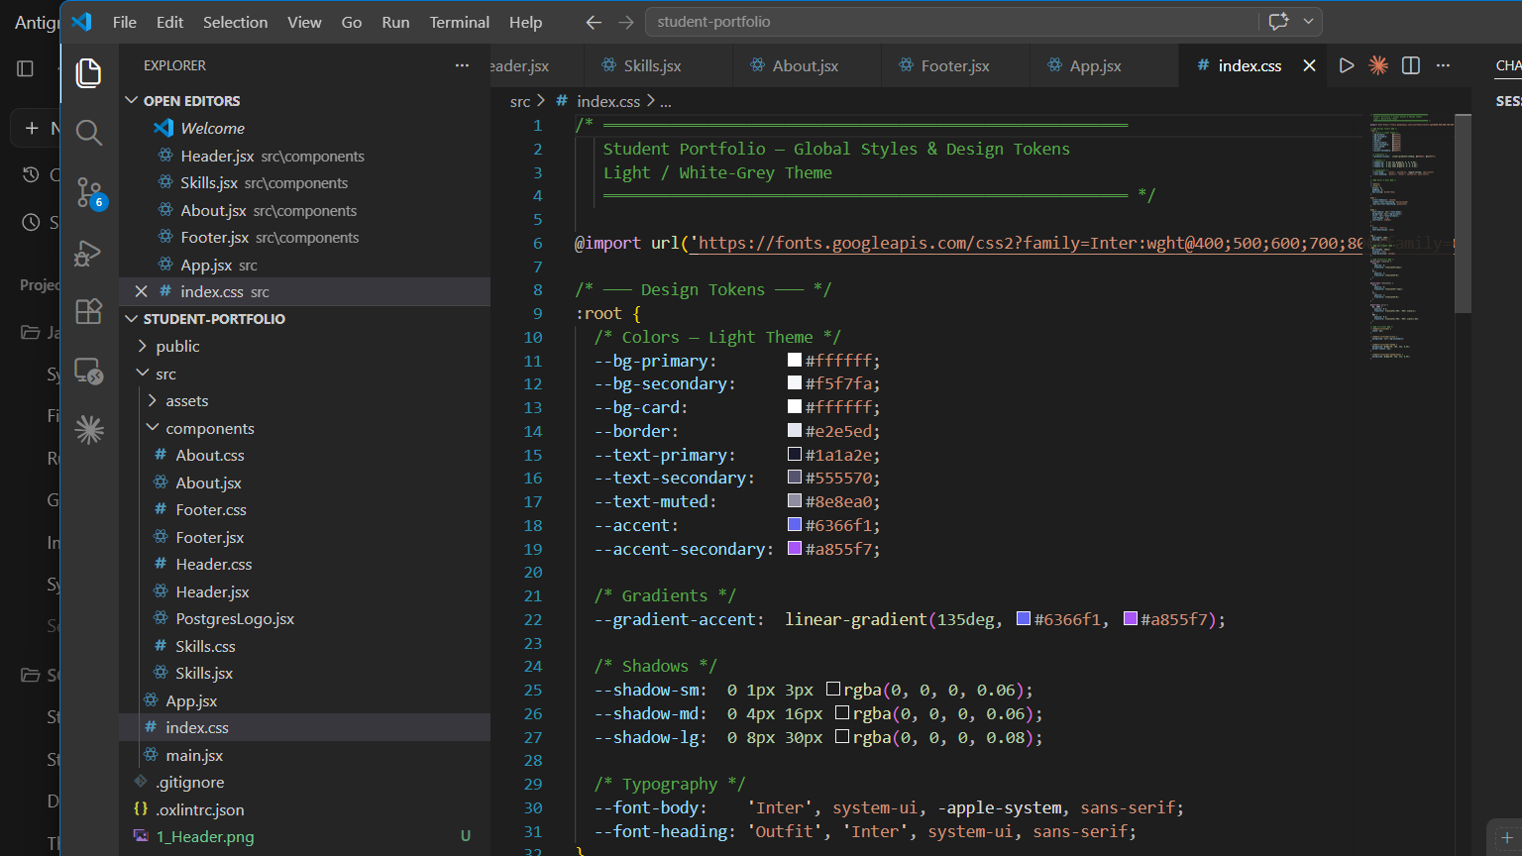
* App.jsx Root layout orchestrator:
