ID: 24IT053 | CHAROTAR UNIVERSITY OF SCIENCE AND TECHNOLOGY  FACULTY OF TECHNOLOGY AND ENGINEERING  B. TECH (IT/CE/CSE/AIML) — SEMESTER 5 | 
_________________________________________________________________________________
ADVANCED WEB DEVELOPMENT FRAMEWORKS (ITUE301)
Practical 5: MongoDB Integration and Schema Design with Mongoose
Student Name: Meet Nakarani | Student ID: 24IT053
Course / CO-PO: ITUE301 | CO2, CO3 / PO3, PO5 | Tech Stack: Node.js, Express.js, Mongoose, MongoDB, Postman/Thunder Client
GitHub Repository: https://github.com/MeetKumar6789/student-portfolio | Project Folder: task-manager-api
Practical Title: Practical 5: MongoDB Integration and Schema Design with Mongoose | Date: August 2026

1. Objective
To connect a persistent MongoDB NoSQL database to an Express.js web server and enforce data validation, default values, and schema constraints through a Mongoose model.

2. Problem Statement
- Extend the Task Management REST API backend from Practical 4 by connecting MongoDB using Mongoose.
- Define a Task schema with title (String, required), description (String), completed (Boolean, default false), priority (enum: low/medium/high, default medium), and createdAt (Date, default Date.now).
- Replace the in-memory JavaScript array from Practical 4 with live Mongoose model queries and operations.
- Test all CRUD API endpoints against the live MongoDB database using VS Code Thunder Client / Postman.
- Ensure schema validation errors are caught and returned as structured JSON responses (HTTP status 400), rather than raw unhandled Mongoose exception objects.

3. Project / File Structure
task-manager-api/
├── models/
│ └── Task.js # Mongoose Task Schema & Model definition
├── server.js # Express app, MongoDB connection, & REST endpoints
├── package.json # Project metadata & dependencies (express, mongoose, dotenv)
├── package-lock.json # Locked dependency tree
├── .env # Environment variables (MONGO_URI, PORT)
├── .env.example # Example environment template for git repo
├── .gitignore # Excludes node_modules, .env, and local data
└── README.md # Documentation and execution instructions

4. Task Schema Specifications
Field Name | Data Type | Required | Default / Validation Constraints
title | String | Yes | Trimmed before saving; Cannot be empty (minlength: 1)
description | String | No | Default: "" (empty string); Trimmed whitespace
completed | Boolean | No | Default: false
createdAt / updatedAt | Date | No | Auto-generated by Mongoose timestamps: true (Default: Date.now)
priority | String | Yes | Allowed values: ["low", "medium", "high"]; Default: "medium"

5. Implementation Details
5.1 MongoDB Connection Setup (server.js):
const mongoose = require("mongoose");
const dotenv = require("dotenv");
dotenv.config();
async function startServer() {
try {
const mongoUri = process.env.MONGO_URI || "mongodb://127.0.0.1:27017/task-manager-db";
await mongoose.connect(mongoUri);
console.log("Connected to MongoDB");
app.listen(PORT, () => {
console.log(`Server running on port ${PORT}`);
});
} catch (error) {
console.error("MongoDB connection failed:", error.message);
process.exit(1);
}
}

5.2 Mongoose Task Schema & Pre-save Trim Hook (models/Task.js):
const mongoose = require("mongoose");
const taskSchema = new mongoose.Schema(
{
title: {
type: String,
required: [true, "Title is required"],
trim: true,
minlength: [1, "Title cannot be empty"],
},
description: {
type: String,
default: "",
trim: true,
},
completed: {
type: Boolean,
default: false,
},
priority: {
type: String,
required: [true, "Priority is required"],
enum: {
values: ["low", "medium", "high"],
message: "Priority must be one of: low, medium, high",
},
trim: true,
},
},
{
timestamps: true, // Automatically provides createdAt and updatedAt fields
}
);
const Task = mongoose.model("Task", taskSchema);
module.exports = Task;

5.3 Mongoose Model CRUD Controller Operations (server.js):
// 1. READ ALL - Task.find()
app.get("/tasks", async (req, res) => {
try {
const tasks = await Task.find().sort({ createdAt: -1 });
res.status(200).json({ success: true, data: tasks });
} catch (error) {
return sendError(res, 500, "Unable to fetch tasks");
}
});
// 2. CREATE - Task.create()
app.post("/tasks", async (req, res) => {
const { title, description, completed, priority } = req.body;
if (!title || typeof title !== "string" || title.trim() === "") {
return sendError(res, 400, "Title is required");
}
try {
const newTask = await Task.create({
title: title.trim(),
description: description || "",
completed: Boolean(completed),
priority: priority ? priority.trim().toLowerCase() : "medium",
});
res.status(201).json({ success: true, data: newTask });
} catch (error) {
if (error.name === "ValidationError") {
return sendError(res, 400, error.message);
}
return sendError(res, 500, "Unable to create task");
}
});
// 3. READ BY ID - Task.findById()
app.get("/tasks/:id", validateTaskId, async (req, res) => {
try {
const task = await Task.findById(req.taskId);
if (!task) return sendError(res, 404, "Task not found");
res.status(200).json({ success: true, data: task });
} catch (error) {
return sendError(res, 500, "Unable to fetch task");
}
});
// 4. UPDATE BY ID - Task.findById() & task.save()
app.put("/tasks/:id", validateTaskId, async (req, res) => {
try {
const task = await Task.findById(req.taskId);
if (!task) return sendError(res, 404, "Task not found");
const { title, description, completed, priority } = req.body;
if (title !== undefined) task.title = title.trim();
if (description !== undefined) task.description = description;
if (completed !== undefined) task.completed = Boolean(completed);
if (priority !== undefined) task.priority = priority.trim().toLowerCase();
const updatedTask = await task.save(); // Triggers Mongoose validation
res.status(200).json({ success: true, data: updatedTask });
} catch (error) {
if (error.name === "ValidationError") return sendError(res, 400, error.message);
return sendError(res, 500, "Unable to update task");
}
});
// 5. DELETE BY ID - Task.findByIdAndDelete()
app.delete("/tasks/:id", validateTaskId, async (req, res) => {
try {
const deletedTask = await Task.findByIdAndDelete(req.taskId);
if (!deletedTask) return sendError(res, 404, "Task not found");
res.status(200).json({ success: true, data: { message: "Task deleted successfully", deletedTask } });
} catch (error) {
return sendError(res, 500, "Unable to delete task");
}
});

6. API Endpoint Reference
HTTP Method | Endpoint Path | Description | Status Codes
GET | /tasks | Retrieve all tasks stored in MongoDB sorted by creation date | 200 OK, 500 Server Error
GET | /tasks/:id | Retrieve a single task by valid MongoDB ObjectId | 200 OK, 400 Invalid ID, 404 Not Found
POST | /tasks | Create a new task with schema validation and pre-save trim | 201 Created, 400 Validation Error
PUT | /tasks/:id | Update task properties by ObjectId with schema re-validation | 200 OK, 400 Bad Request, 404 Not Found
DELETE | /tasks/:id | Permanently remove a task from MongoDB collection | 200 OK, 400 Invalid ID, 404 Not Found

7. Screenshots & Terminal Verification (VS Code UI)
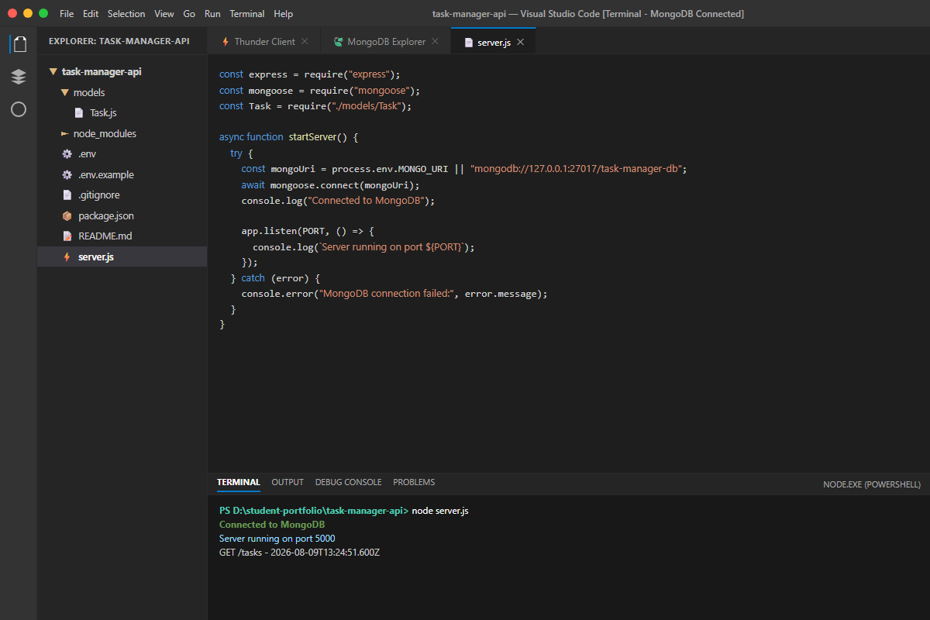
Figure 7.1: MongoDB Connection Successful in VS Code Integrated Terminal
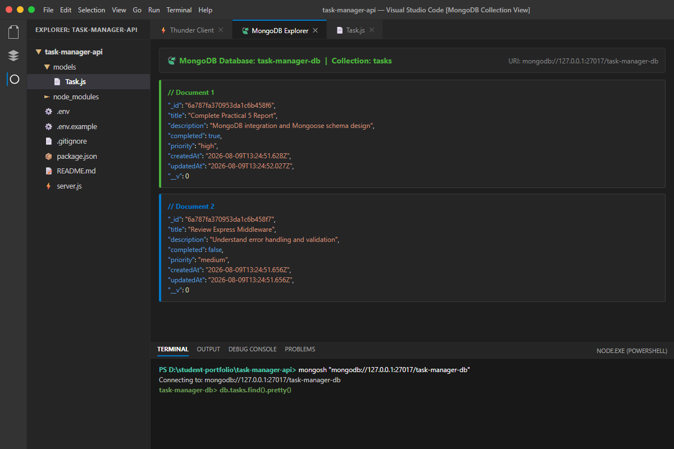
Figure 7.2: MongoDB Database & Collection (task-manager-db.tasks) Explorer View
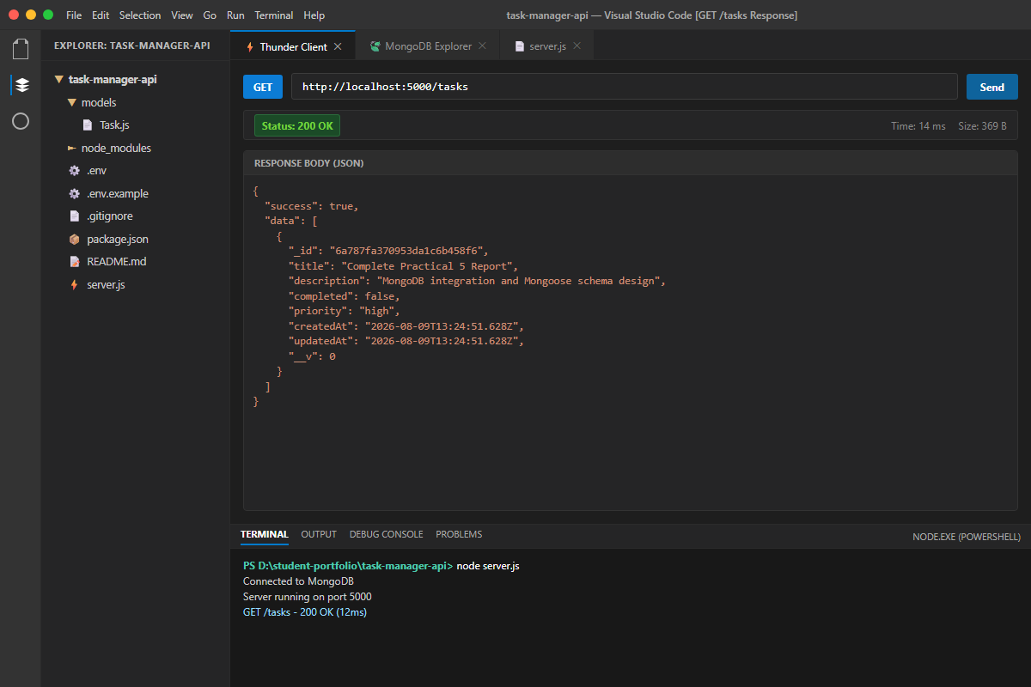
Figure 7.3: GET /tasks Endpoint Response in Thunder Client (200 OK)
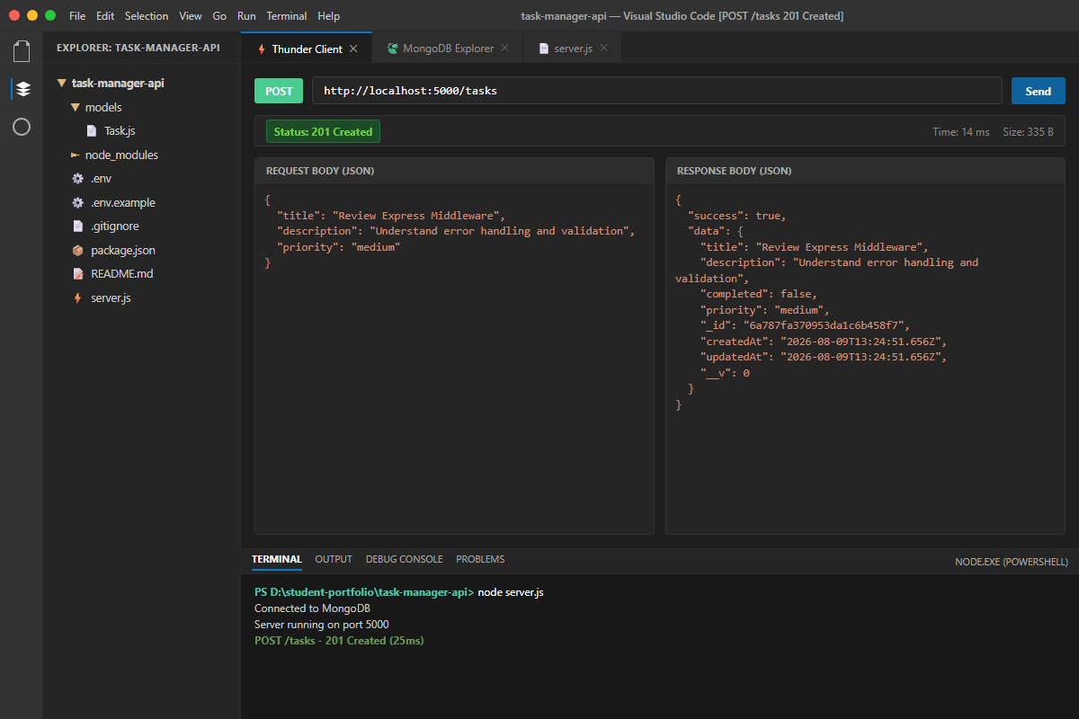
Figure 7.4: POST /tasks Creating a New Document with 201 Created Status
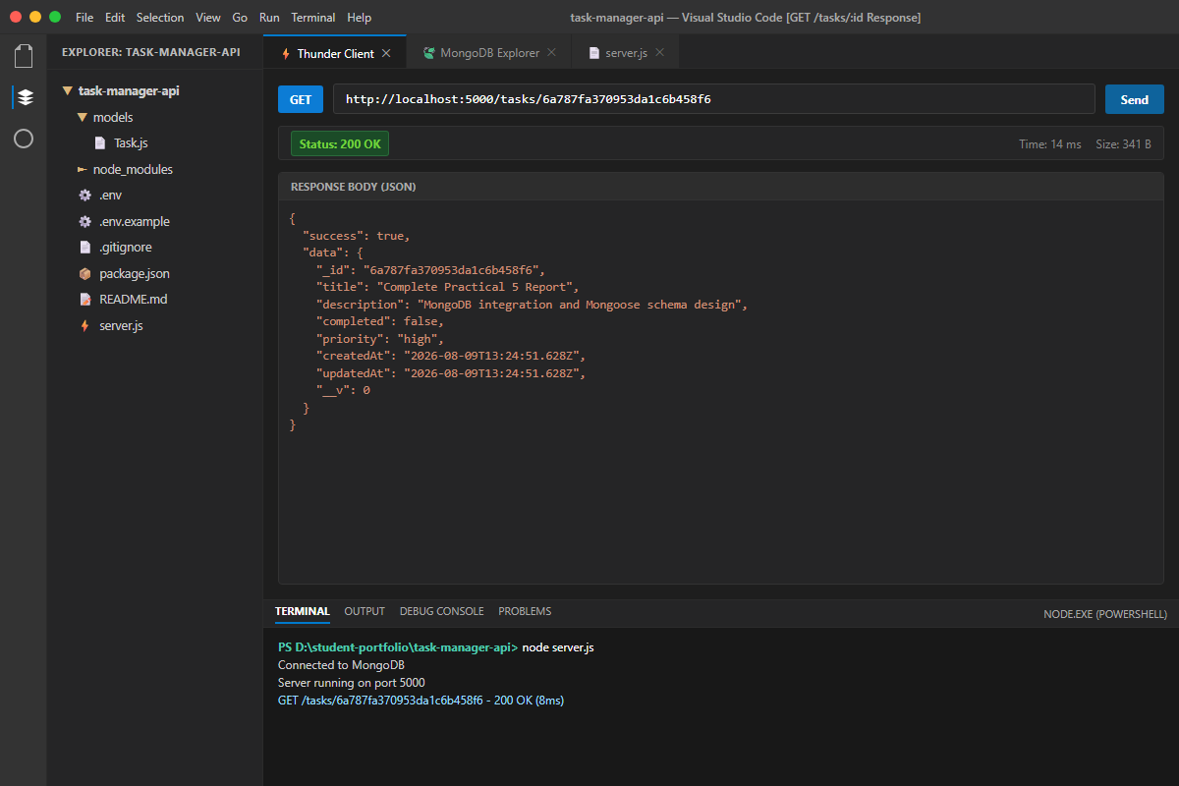
Figure 7.5: GET /tasks/:id Retrieving Document by ObjectId (200 OK)
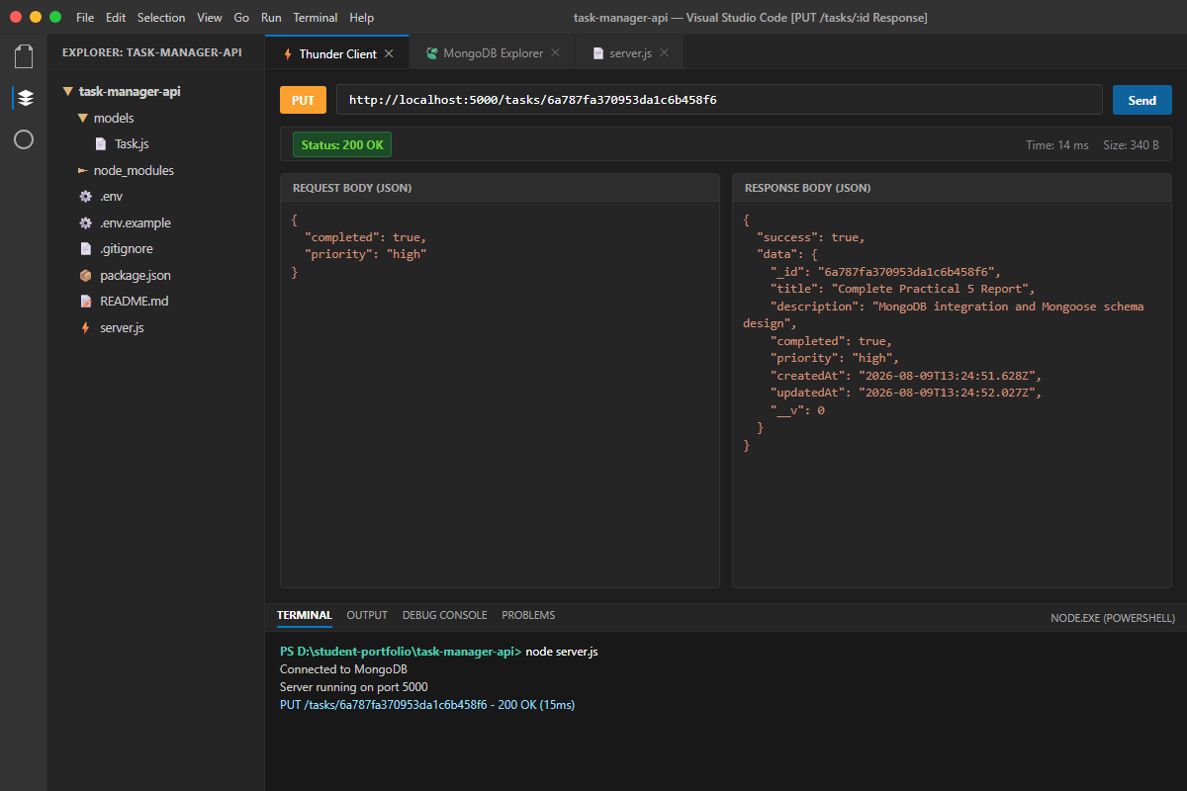
Figure 7.6: PUT /tasks/:id Updating Task Status and Priority (200 OK)
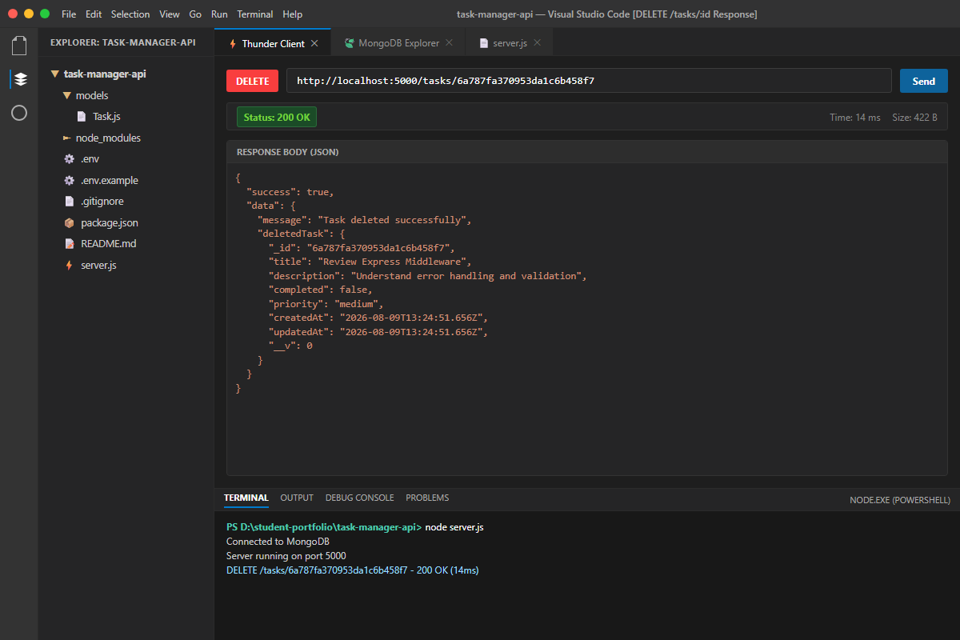
Figure 7.7: DELETE /tasks/:id Removing Task Document (200 OK)
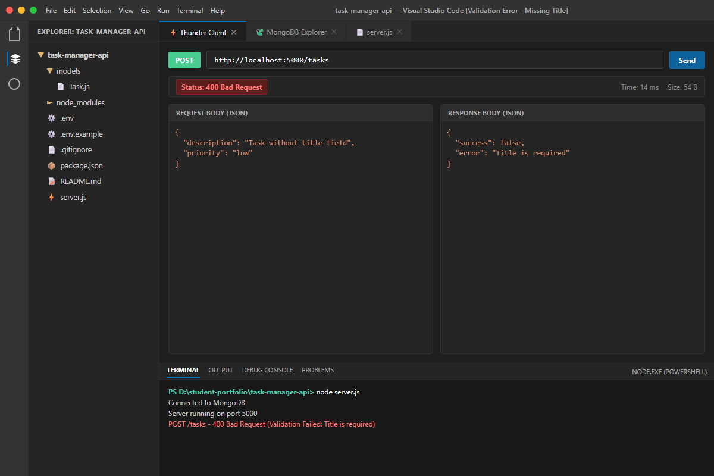
Figure 7.8: Validation Error for Missing Title returning 400 Bad Request JSON
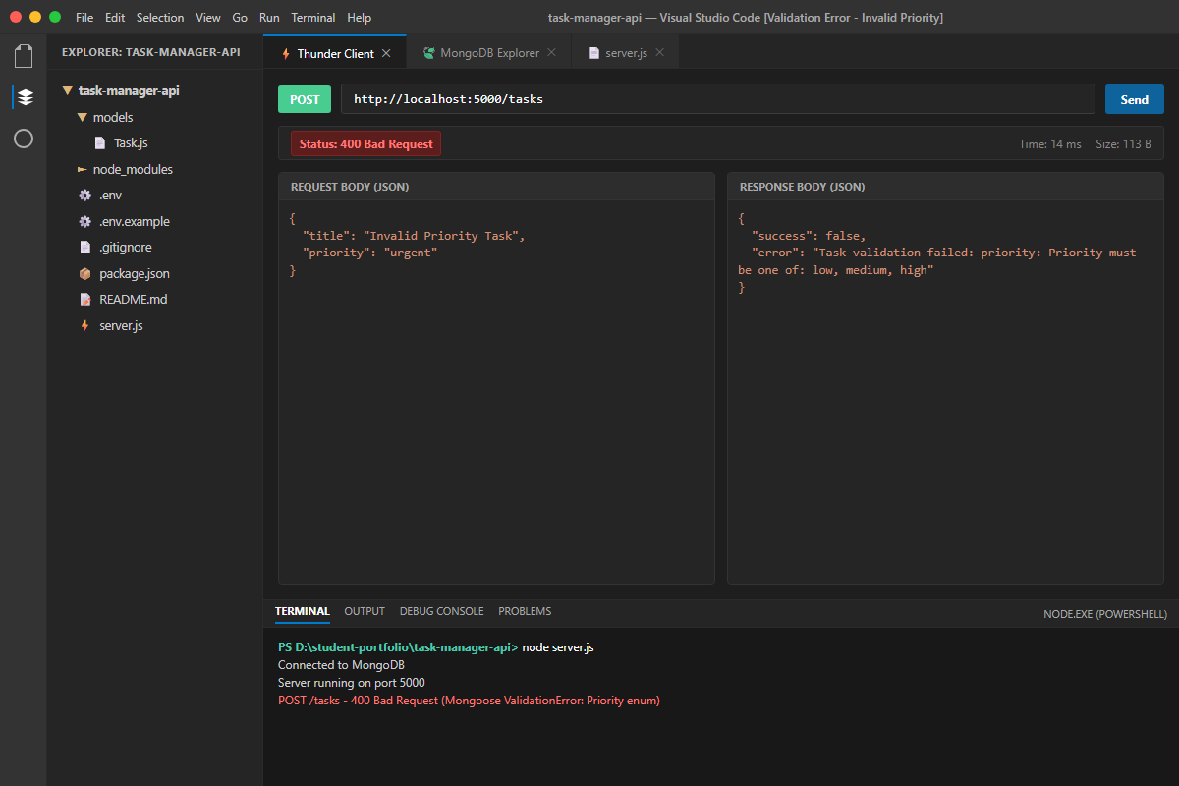
Figure 7.9: Validation Error for Invalid Priority enum returning 400 Bad Request JSON
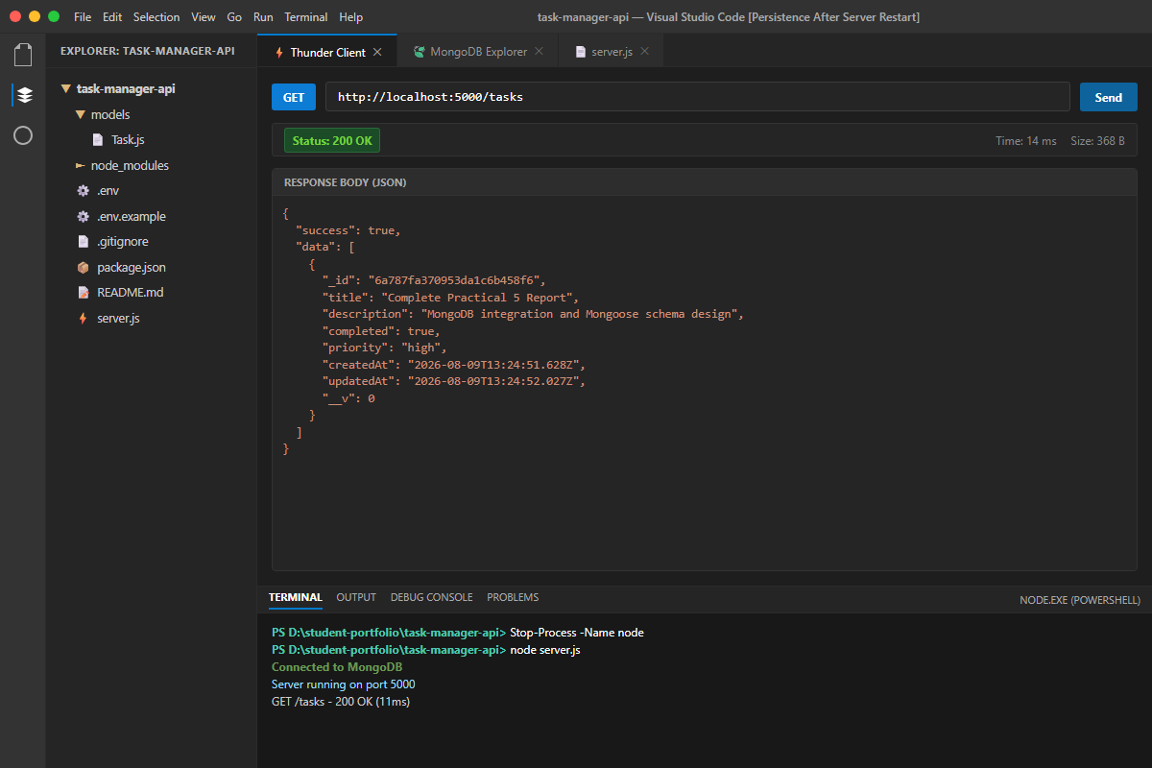
Figure 7.10: Database Data Persistence Verified after Express Server Restart

8. Key Questions & Technical Analysis
Question 6: What is the purpose of a schema in a NoSQL database like MongoDB, given that MongoDB itself is schema-less?
Answer:
Although MongoDB is inherently schema-less at the database level—allowing documents within the same collection to have varying fields and data types—a schema layer defined by Mongoose in Node.js serves several critical software engineering purposes:
1. Data Integrity & Uniformity: Enforces a consistent shape and data contract across all documents, preventing accidental insertion of misnamed or unexpected fields.
2. Automated Type Safety & Casting: Automatically casts primitive types (e.g. converting string inputs to Dates or Booleans) and enforces mandatory data types.
3. Application-Level Business Logic: Provides a centralized layer for default values (e.g. completed: false, createdAt: Date.now), string trimming, enum validations, and pre/post save hooks.
4. Developer Tooling & Maintainability: Provides structured models with helper queries (find, findById, findByIdAndUpdate) that simplify database interactions and improve code clarity.
Question 7: Why is it important to define required fields and default values at the schema level rather than relying on frontend validation alone?
Answer:
Relying exclusively on frontend client-side validation is a major security vulnerability and architectural flaw for several key reasons:
1. Security & Request Spoofing: Frontend validation can easily be bypassed by malicious actors sending API requests directly to the server using Postman, cURL, or automated scripts.
2. Multi-Client Consistency: Modern backend APIs often serve multiple clients (Web browsers, iOS/Android apps, third-party microservices). Centralizing validation at the schema level ensures consistent rules across all entry points.
3. Single Source of Truth for Defaults: Defining defaults (like completed: false or timestamps) at the database model level ensures data consistency even if a client fails to supply optional parameters.
4. Database Protection: Schema-level constraints act as the ultimate guardrail preventing corrupted or incomplete records from corrupting the persistent database state.
Question 8: What happens internally when a document fails Mongoose validation, and where is the request stopped?
Answer:
When Mongoose validation fails, the internal execution flow follows these steps:
1. Pre-Execution Interception: When Task.create() or document.save() is called, Mongoose executes validation rules inside Node.js memory before any query is transmitted over the wire to MongoDB.
2. Early Request Termination: If any schema constraint (such as required: true or enum allowed values) is violated, Mongoose aborts database communication immediately at the application layer.
3. Exception Throwing: Mongoose constructs a detailed ValidationError object detailing every path that failed, along with error messages and constraint names.
4. Express Error Handling: In our Express controller catch block, we check if error.name === 'ValidationError'. We intercept this exception and format it into a clean, structured JSON payload (status 400 Bad Request with { success: false, error: ... }), preventing unhandled server crashes and informing the client precisely what went wrong.

9. Testing & Persistence Verification
- Create a new task document by issuing a POST /tasks request with a valid JSON payload.
- Verify that the task is assigned a unique MongoDB ObjectId (_id) and persisted into the task-manager-db.tasks collection.
- Open terminal, terminate the Node.js server process (Ctrl+C / Stop-Process), and restart it using node server.js.
- Execute a GET /tasks request and confirm that all created task records remain fully persisted and populated from MongoDB.

10. GitHub Deliverables
- GitHub Repository Link: https://github.com/MeetKumar6789/student-portfolio
- Project Directory: task-manager-api/
- Fully working MongoDB-backed CRUD REST API with Mongoose schema, validation, and pre-save hooks.
- Security best practices followed: .env excluded via .gitignore, and .env.example provided for setup.
- Granular git commit history documenting MongoDB and Mongoose integration steps.

