RoomNavigate System

Introduction to Project

- This website is designed to assist you in discovering the perfect room for your need, Whether you are planning avacation, a Business trip or a short term stay.

- You can explore a diverse range of rooms, from budget friendly option to luxury gateways. The User friendly Inter face and powerful search filter make it easy to narrow down your choices and find the perfect match.

- Whether you are a solo traveler or a family in search of the perfect retreat. This plate form simplify the process by presenting intuiting interface that allows you to quickly browse through available rooms, View detailed description , and access real time availability.

Advantages of System
- Wide selection of room
- Time and efforts savings
- Real time availability
- Save energy
- Search engine

Sardar Patel University
C.P. Patel & F.H. Shah Commerce College,
Anand

BCA, BBA (ITM) & PGDCL Department
BCA semester V || US05CBCA27 Project – 1

Project Profile

Full Name: | Meet Pankajbhai Modasiya
Uni. Exam Seat no: | 414
Roll no: | 48
Project Title: | RoomNavigate System
Front-End tool: | HTML, CSS, JAVASCRIPT
Back-End Tool: | PHP, MySQL
Project Guide: | Yogesh Solanki

Scope of work

- Scope of work divided into two categories:

- Admin
- User

- Admin
    - Manage rooms
    - User Management
    - Booking Management
    - Website Content Management
    - User Search Option

- User
    - User Registration and Login
    - View room details
    - Book rooms
    - User Profile Management
    - Real Time Search Engine

An Existing System

- In the conventional room finding process However with the introduction of our innovative room finding website these challenges are now a thing of the past. Say hello to RoomNavigate your ultimate solution for a seamless and user-friendly room search experience.

- Through RoomNavigate, User can now effortlessly explore a wide array clicks, eliminating the need for physically Visiting multiple locations. Detailed description, Images and Real time availability makes it easier than ever to find the perfect room that meets all your preferences.

- With all our secure and efficient electronic payment system. The hassle is manual calculations and recordkeeping is a thing of the past. Experience the convenience of swift and secure transaction. Ensuring a smooth booking process from start to finish.
Need of Proposed System

- Enhanced Convenience:
RoomNavigate is all about making room searching easier making confortable for user. With a user-friendly interface and advanced search filters. Finding the perfect room becomes a breeze.

- Online registration and payment:
Users can registration from the comfort from their home. They can complete transaction securely online. This can eliminate the purpose of in-person visits and ensures the smooth and efficient booking process.

- Instant Report Generation:
RoomNavigate Empowers users and property owners to generate reports within seconds, eliminating paperwork. This time-saving feature benefits both customers and owners alike.

- Enhanced Performance:
The new RoomNavigate System surpasses the limitations of the existing process, offering improved performance, reliability and user satisfaction.

- Nationwide Access:
Users from all parts of the country can take advantage of the RoomNavigate System, providing equal opportunities for individuals in different regions to find their ideal accommodation.

Feasibility Study

Types of feasibility study
1. Economic Feasibility
2. Technical Feasibility
3.OperationalFeasibility
1. Economic Feasibility
Development cost
- The initial development cost of creating RoomNavigate website encompass expenses related to software development, web design, databases setup, infrastructure. These costs are one time investment and not recur after completion of the project.

Maintenance cost
- After the website’s launch, there will be ongoing maintenance cost, including server hosting, software updates, security measure and customers supports.

- Benefits:
- Revenue Generation: The RoomNavigate website will generate revenue through commissions or fees from room booking. As the user base and transaction grow, the potential of significant revenue increases.

- Cost saving for users, property owners: RoomNavigate streamlines the room finding process, savings user’s time and efforts.

- Technical Feasibility

User-Friendly Interface
- The graphical user interface of RoomNavigate is designed with a focus on ease of use. Novice users can navigate the platform effortlessly.

Secure data handling
- The platform prioritizes data security, implementing encryption protocols and secure data handling practices payment transection.

- Operational Feasibility
Real-Time Functionality
- RoomNavigate is design to operate seamlessly in a real-time environment. User can access up to-date information on room availability. Price, and booking status, ensuring accuracy and reliability in the room finding process.

Technical expertise
- The platform is designed to be user-friendly, making it accessible to both novice users and those with technical expertise. RoomNavigate require minimal technical knowledge, allowing a broad audience to utilize the system effectively.

System Feature

- User feature

- User profiles
- Booking history
- Room details
- Booking process
- Search Hotels

- Admin feature

- Admin dashboard
- Room management
- User management
- Booking management
- Reporting
- Customer’s support
- Content management
Hardware And Software Specification

- Hardware requirement of system :
- This phase of the software development process deals with a brief study of different hardware used in the computerized system.

- There is a list of hardware materials used during the making and also during the use of the proposed system.

- As the new system to be made into a computerized function system, Requirement of a computer is must.

- All the hardware needed here are generally the basic configuration of a typical office computer.

- A list of the hardware requirement used in the system given below :

- Minimum configuration :
Intel dual core processor
1 GB ram
10 GB HDD
Mouse
Keyboard
Monitor

- SOFTWARE REQUIREMENTS :

- Along with the hardware used in the system. It requires software to make a system as well as to run a system with the computer hardware collection of different type of hardware into a specific type can from a computer but it cannot execute different process on its own for efficient and proper working of any system software must be in the form of operating system application software.

- To make the system one also needs to use-software.

Front and tool | VS Code, NotePade
Back end tool | Xampp, MYSQL
Operating system | Window 10

DATA FLOW DIAGRAM (DFD)
CONTEXT LEVEL DIAGRAM:

Request for Login Room Navigate Request for Register
User
Admin
Response Management Response
System

Zero Level Admin Side:
Request for login

Request
Response
Response
Response
Request for Payment
View Payment
Bill
5.0
Payment
Insert Data
Room

Response
Add Room

Response

Responser login

Request for login
Manage Room
Response
Response
Response
Admin
3.0
Customer
Booking

Room
2.0
Manage
Room
Tbl_Admin
1.0
Login
Process (2.0):

Request
Request for login
2.2
Book
Room

2.1
Check Availability
Admin
Room
2.0
Login

Response
Response

Request for Checking Room

Request
Response

Response

View Booked Room
Request for Booking

Response
Response

Process (3.0):

Request
Request for login
3.2
Delete
Booking

3.1
Update
Booking
Admin
Room
3.0
Login
Request for login
Request for login

Request for Update Booking

Request

Response
Response

Request To view Delete Booking
Request for Delete Booking

Response
Response

Process (4.0):
Request
Request for login
4.2
Update
Profile

4.1
View
Profile
Admin
Room
4.0
Login

Response
Response

Request for View Profile
Request
Response

Response

Request for Updating Profile
Request To View

Response
Response

Zero Level User Side:
Tbl_Customer
Request
Request for Registering
2.0
Login
User
1.0
Registration
Response
Response

Request For Login
Request
Response
Response

3.0
Profile

Request for Manage Profile
View Profile

Response
Response

Request for Search Room
4.0
Search
Room
Room
Response
Response

Request For Booking ROom
View Room
5.0
Book
Room

Response
Response

Response
Request For Payment
Bill
6.0
Payment
Process (2.0):

Request for Login
Request
3.2
User
Information

3.1
View
Profile
User
Tbl_Customer
3.0
Login

Response
Response

Request for Show Profile

Response
Response

Request For user Information

Response
Response

Process (3.0):
Request for Login
Request
4.2
Check
Availability

4.1
View
Room
Admin
Room
4.0
Login
Response
Response

View Rooms

Response
Response

Request for Check availability

1
Response
4.3
Confirm
Or cancel Room

Confirm Or Cancel Booking

Response

- Tbl_admin:
Id | Number(5) | Primary key
Username | Varchar(20)
Password | varchar (5)

- Tbl_booking:
ID | Number(5) | Primary key
Username | Varchar(20)
Room_type | Varchar(20)
Check_in | Date
Check_out | Date
price | Integer

- Tbl_room:
ID | Number(5) | Primary key
Himg | text(5)
Hname | Varchar(20)
Hlocation | Location (5)
Hprice | varchar (5)

- Tbl_user:

Id | Number(10) | Primary Key
Username | varchar (10)
Passwowrd | Varchar(20)
Email | Varchar(20)

            - Home Page

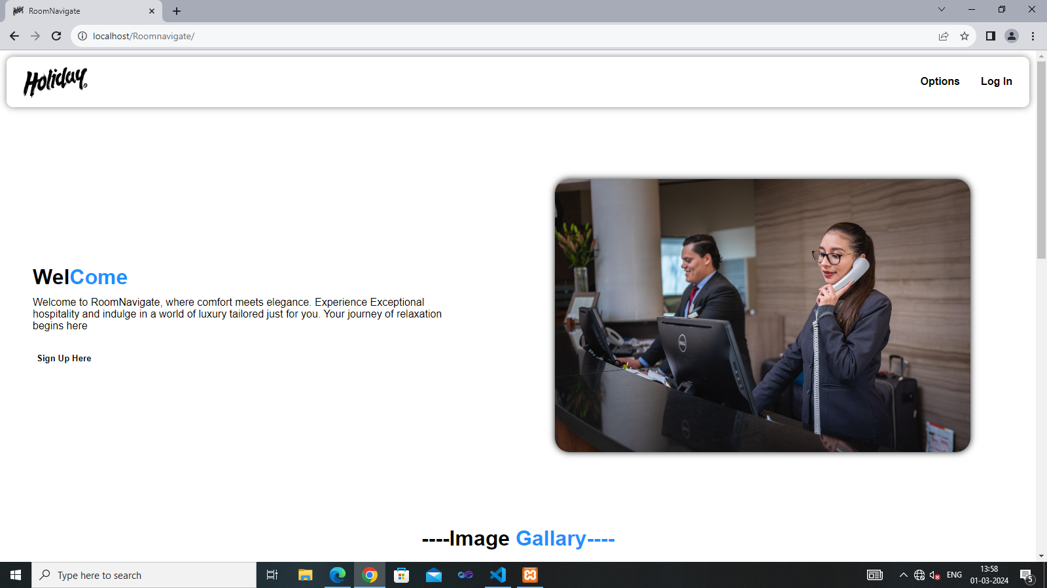

This Is the Home Page Of the website.
This
            - Services Page

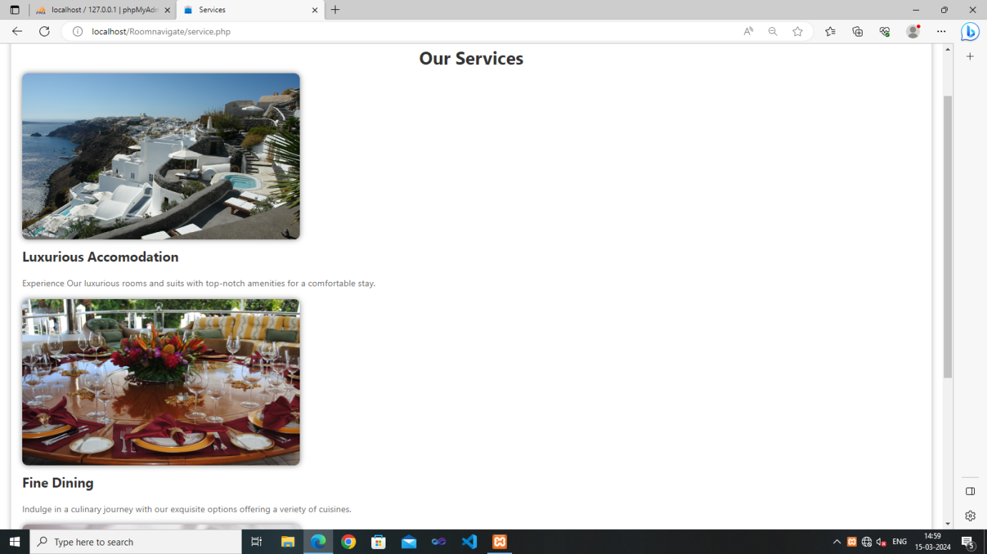

This Is the Service Page Of the website Where services of the company show.
            - Contact Us Page

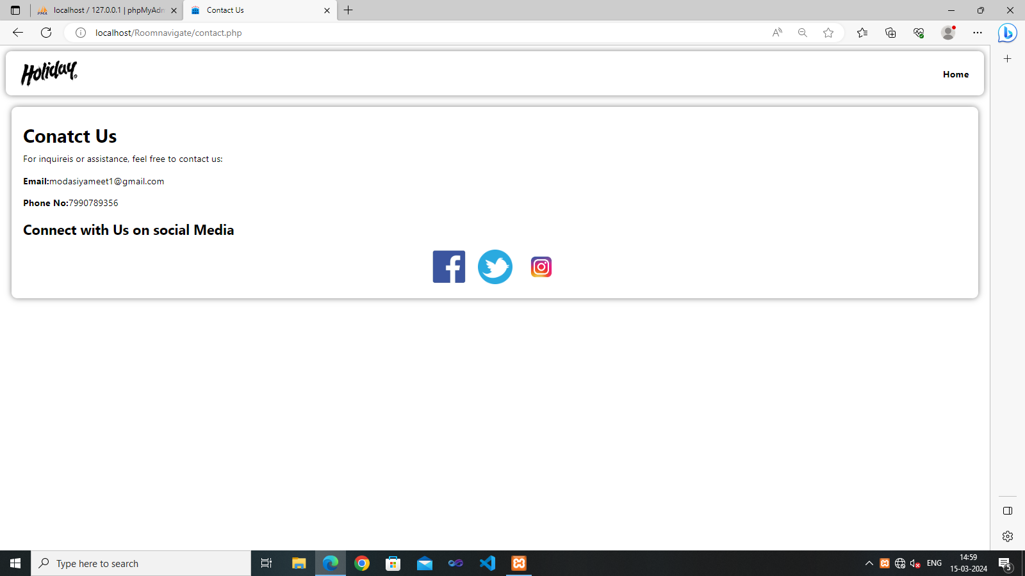

This Is the contact Us Page Of the website Where You can Contact with the company.

            - About Us Page

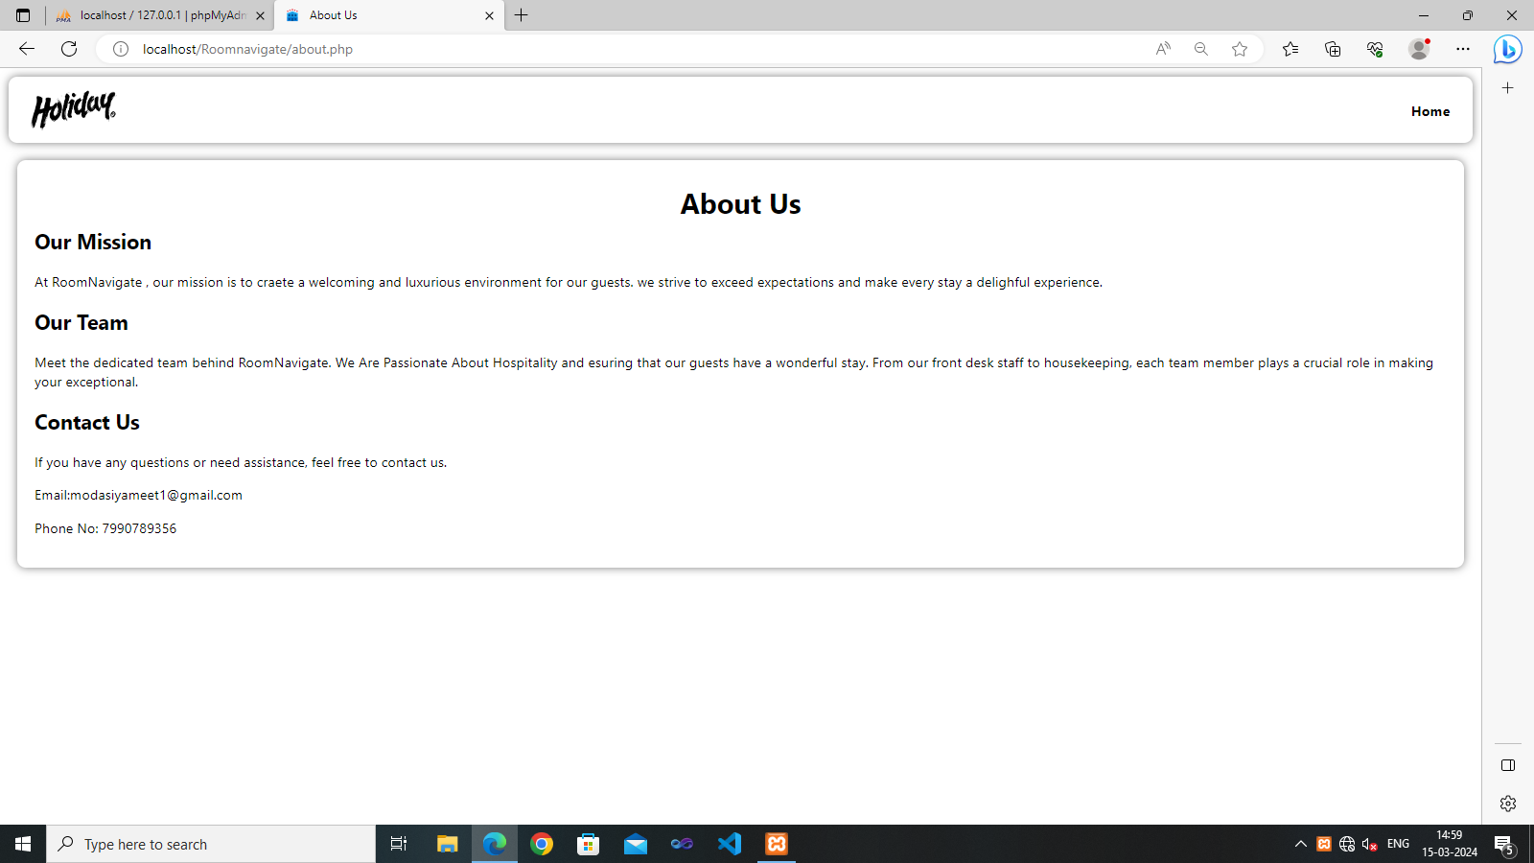

This Is the About Us Page Of the website

            - Registration Page

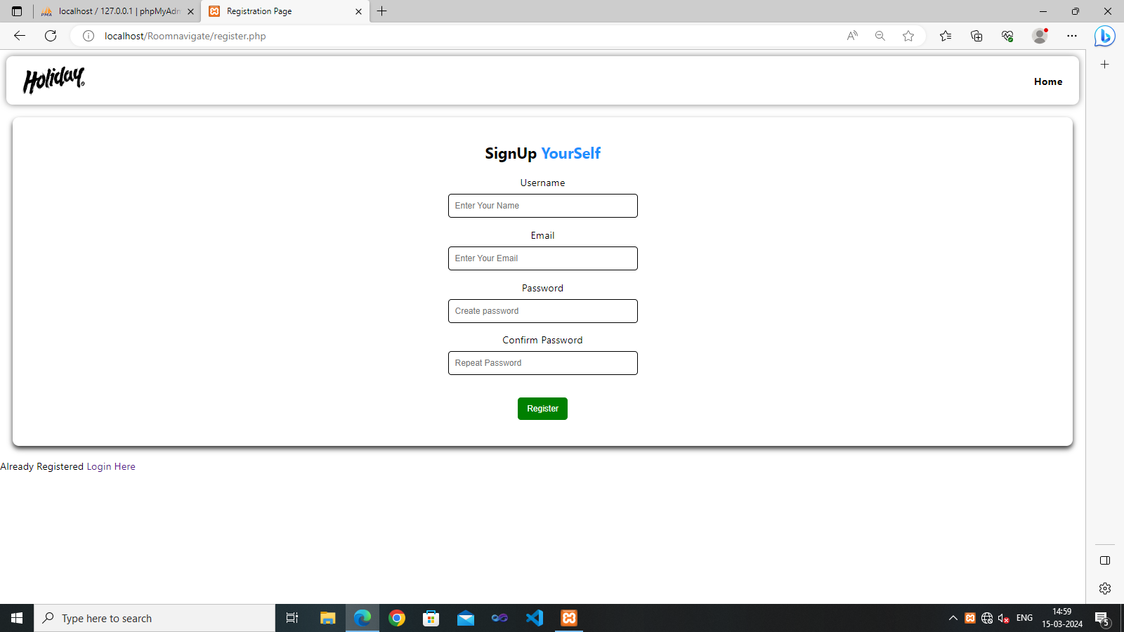

This is registration Page where user can register themselves.

            - Admin Login Page

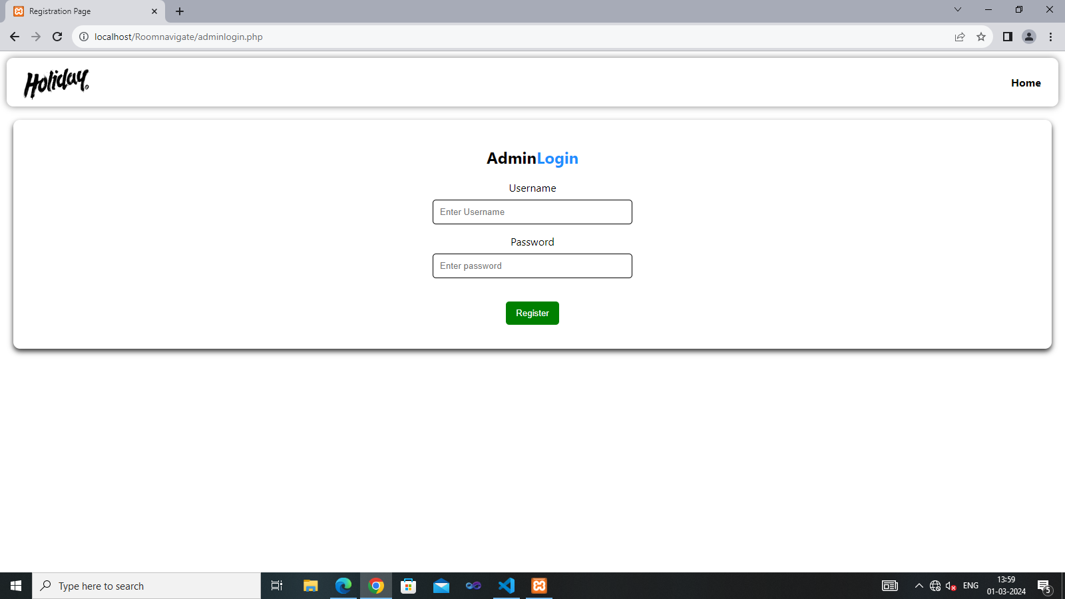

This is admin Login Page for Admin.

            - Booking Page

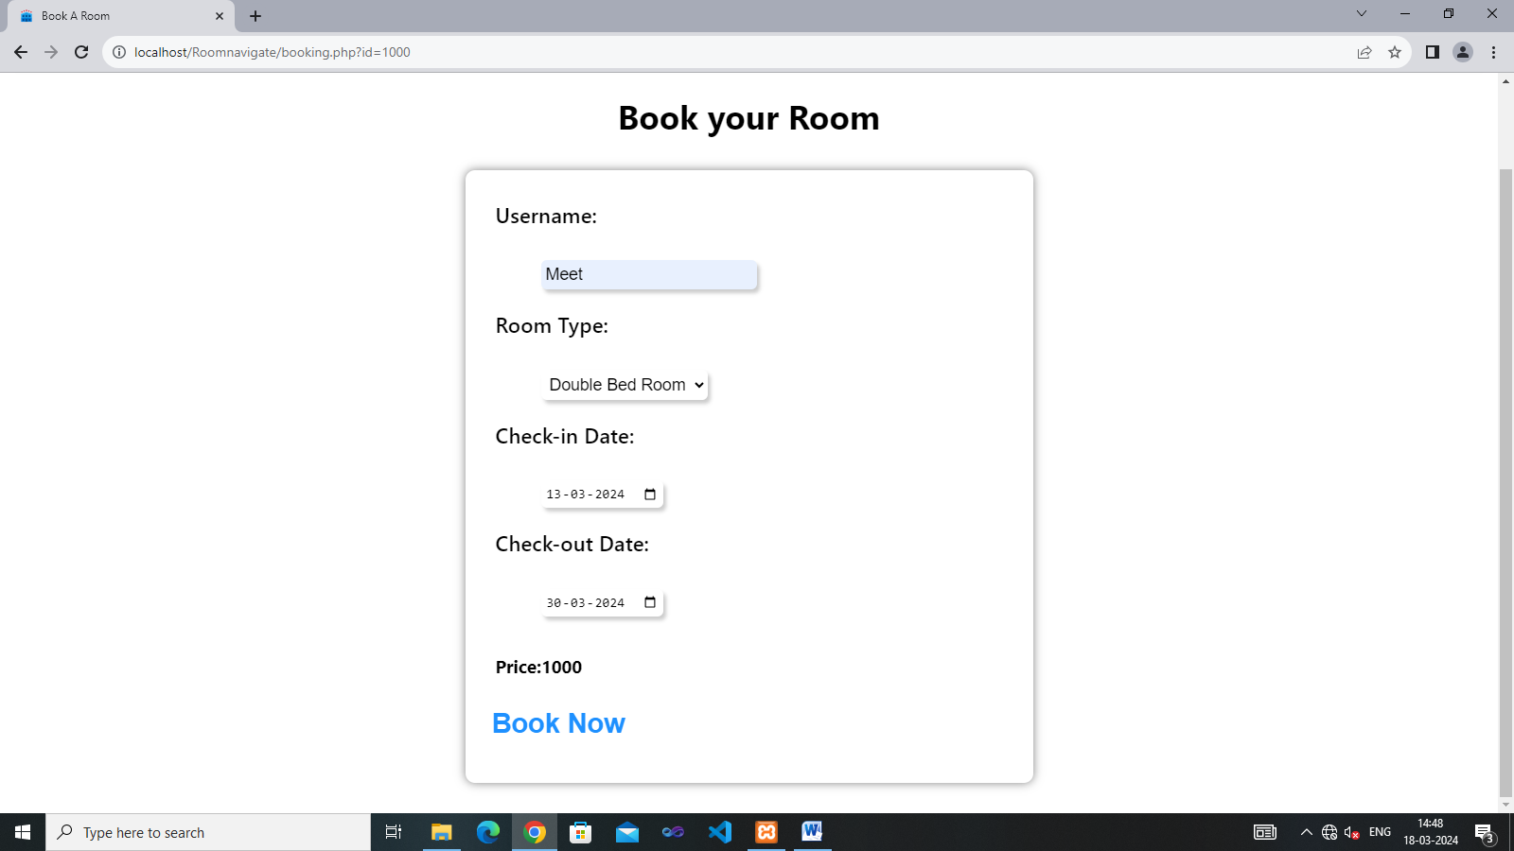

This is Booking Page for the users.
            - Select Hotel Here

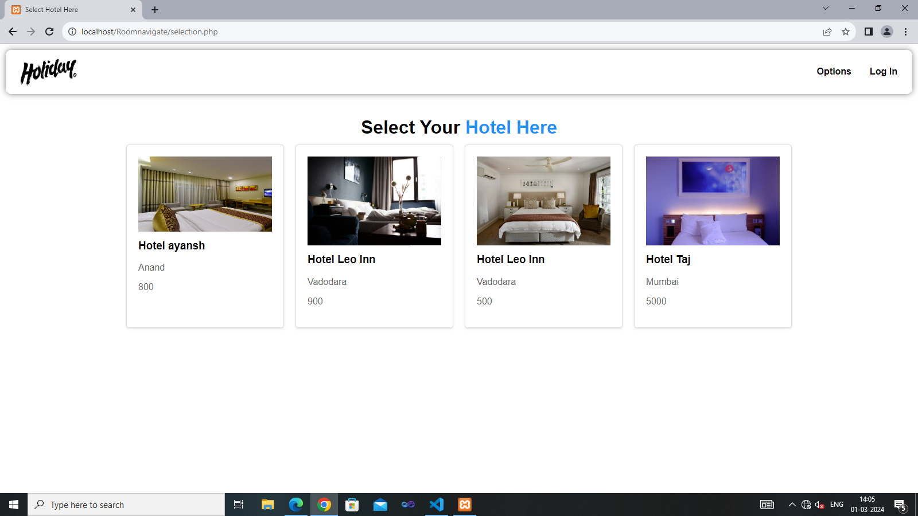

This is option to select the specific hotels.
            - Admin Dashboard Options

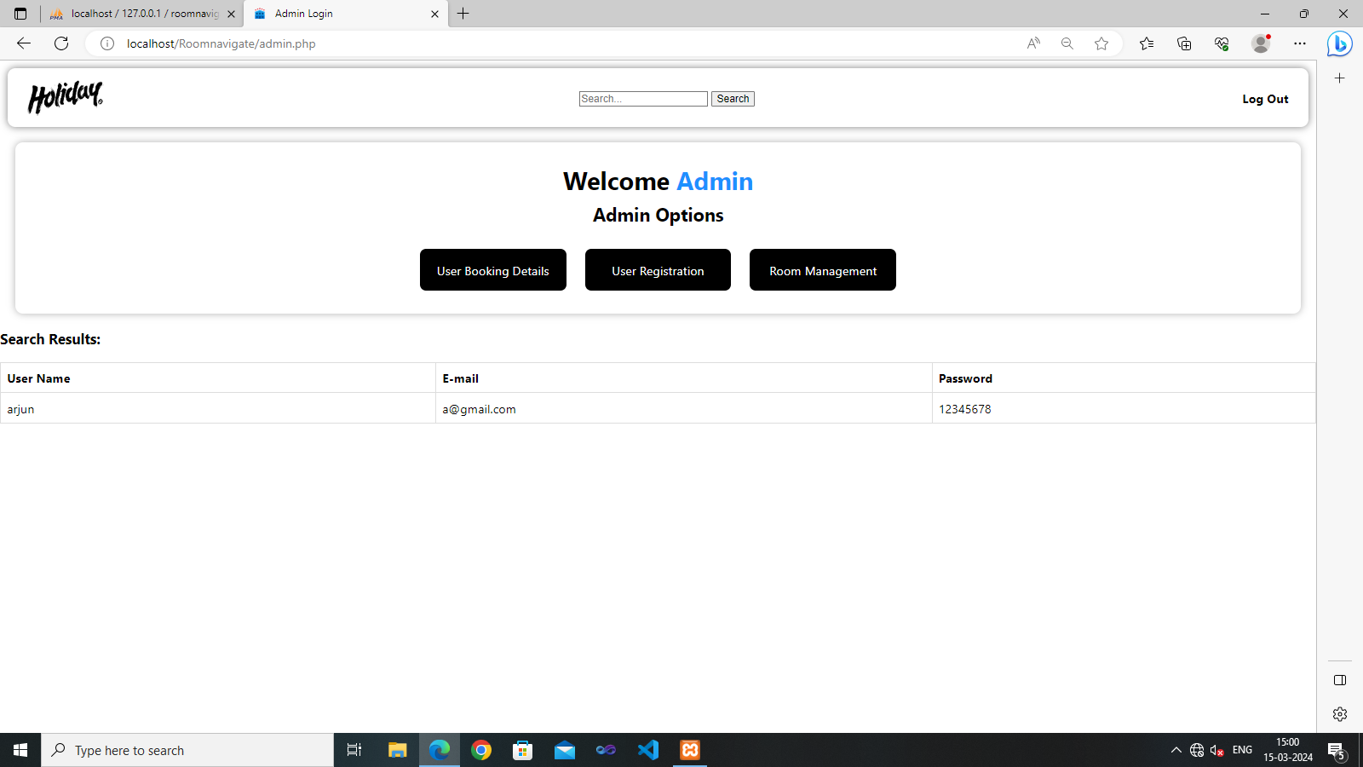

This is admi n dashboard where admin can perform different operations.

9.Insert Hotels Here

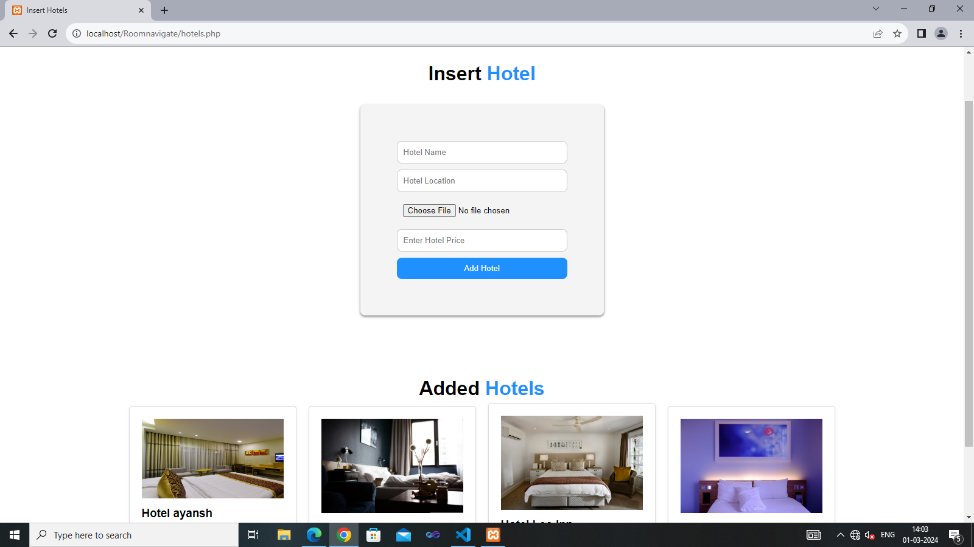

Admin Can Insert Hotels in the website for users.

- View Bookings Here

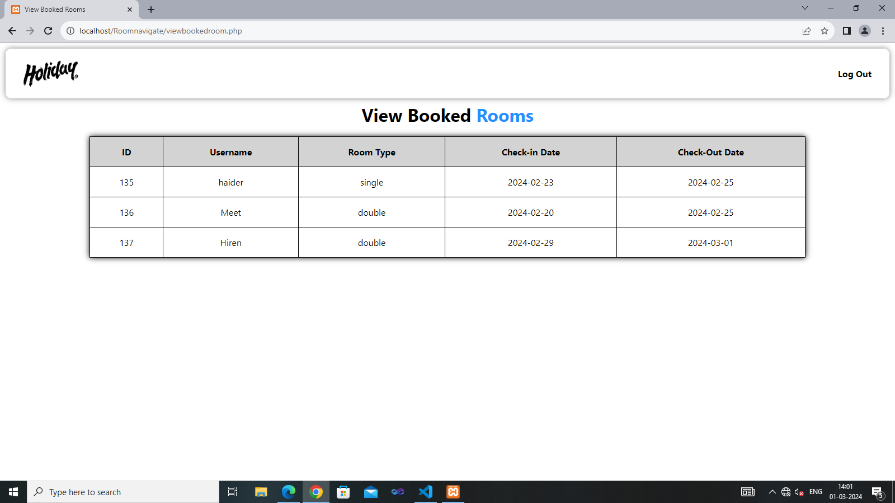

Here admin can view rooms and user which are using the website.
Limitations of the Website:

- Advertisement Management
- Discount And Offer Management
- Improve Responsive ness
- Refund Policy
- Customer Feedback Option

Proposed Enhancement:

- Introduction of online Payment
- Improvised Responsiveness
- Enhance Hotel Description
- Improve Bill Generation

API Integration:

- Implementing Games API for information.

- Easily Connect with player with the help of API.

Security and privacy:

- Implementing robust security measures to protect user data.

- Encryption of sensitive information.

- Compliance with privacy registration and data protection policies.

Conclusion:

Building this website has allowed me to strengthen my proficiency in various programming languages and technologies including HTML, CSS, JavaScript, PHP and MySQL. I’ve’ learned how to design and develop dynamic web applications handle use authentication, interest with database and implement require design principles.

