**RoomNavigate System**

**Introduction to Project**

* This website is designed to assist you in discovering the perfect room for your need, Whether you are planning avacation, a Business trip or a short term stay.
* You can explore a diverse range of rooms, from budget friendly option to luxury gateways. The User friendly Inter face and powerful search filter make it easy to narrow down your choices and find the perfect match.
* Whether you are a solo traveler or a family in search of the perfect retreat. This plate form simplify the process by presenting intuiting interface that allows you to quickly browse through available rooms, View detailed description , and access real time availability.

**Advantages of System**

* Wide selection of room
* Time and efforts savings
* Real time availability
* Save energy
* Search engine

**Sardar Patel University**

C.P. Patel & F.H. Shah Commerce College,

Anand

BCA, BBA (ITM) & PGDCL Department

BCA semester V || US05CBCA27 Project – 1

**Project Profile**

|  |  |
| --- | --- |
| Full Name: | Meet Pankajbhai Modasiya |
| Uni. Exam Seat no: | 414 |
| Roll no: | 48 |
| Project Title: | RoomNavigate System |
| Front-End tool: | HTML, CSS, JAVASCRIPT |
| Back-End Tool: | PHP, MySQL |
| Project Guide: | Yogesh Solanki |

**Scope of work**

* Scope of work divided into two categories:
* Admin
* User

1. **Admin**
   * 1. Manage rooms
     2. User Management
     3. Booking Management
     4. Website Content Management
     5. User Search Option

1. **User**
   * 1. User Registration and Login
     2. View room details
     3. Book rooms
     4. User Profile Management
     5. Real Time Search Engine

**An Existing System**

* In the conventional room finding process However with the introduction of our innovative room finding website these challenges are now a thing of the past. Say hello to RoomNavigate your ultimate solution for a seamless and user-friendly room search experience.
* Through RoomNavigate, User can now effortlessly explore a wide array clicks, eliminating the need for physically Visiting multiple locations. Detailed description, Images and Real time availability makes it easier than ever to find the perfect room that meets all your preferences.
* With all our secure and efficient electronic payment system. The hassle is manual calculations and recordkeeping is a thing of the past. Experience the convenience of swift and secure transaction. Ensuring a smooth booking process from start to finish.

**Need of Proposed System**

* **Enhanced Convenience:**

RoomNavigate is all about making room searching easier making confortable for user. With a user-friendly interface and advanced search filters. Finding the perfect room becomes a breeze.

* **Online registration and payment:**

Users can registration from the comfort from their home. They can complete transaction securely online. This can eliminate the purpose of in-person visits and ensures the smooth and efficient booking process.

* **Instant Report Generation:**

RoomNavigate Empowers users and property owners to generate reports within seconds, eliminating paperwork. This time-saving feature benefits both customers and owners alike.

* **Enhanced Performance:**

The new RoomNavigate System surpasses the limitations of the existing process, offering improved performance, reliability and user satisfaction.

* **Nationwide Access:**

Users from all parts of the country can take advantage of the RoomNavigate System, providing equal opportunities for individuals in different regions to find their ideal accommodation.

**Feasibility Study**

Types of feasibility study

1. Economic Feasibility

2. Technical Feasibility

3.OperationalFeasibility

1. Economic Feasibility

Development cost

* The initial development cost of creating RoomNavigate website encompass expenses related to software development, web design, databases setup, infrastructure. These costs are one time investment and not recur after completion of the project.

Maintenance cost

* After the website’s launch, there will be ongoing maintenance cost, including server hosting, software updates, security measure and customers supports.
* Benefits:
* Revenue Generation: The RoomNavigate website will generate revenue through commissions or fees from room booking. As the user base and transaction grow, the potential of significant revenue increases.
* Cost saving for users, property owners: RoomNavigate streamlines the room finding process, savings user’s time and efforts.

1. Technical Feasibility

User-Friendly Interface

* The graphical user interface of RoomNavigate is designed with a focus on ease of use. Novice users can navigate the platform effortlessly.

Secure data handling

* The platform prioritizes data security, implementing encryption protocols and secure data handling practices payment transection.

1. Operational Feasibility

Real-Time Functionality

* RoomNavigate is design to operate seamlessly in a real-time environment. User can access up to-date information on room availability. Price, and booking status, ensuring accuracy and reliability in the room finding process.

Technical expertise

* The platform is designed to be user-friendly, making it accessible to both novice users and those with technical expertise. RoomNavigate require minimal technical knowledge, allowing a broad audience to utilize the system effectively.

**System Feature**

* User feature

1. User profiles
2. Booking history
3. Room details
4. Booking process
5. Search Hotels

* Admin feature

1. Admin dashboard
2. Room management
3. User management
4. Booking management
5. Reporting
6. Customer’s support
7. Content management

**Hardware And Software Specification**

1. Hardware requirement of system :

* This phase of the software development process deals with a brief study of different hardware used in the computerized system.
* There is a list of hardware materials used during the making and also during the use of the proposed system.
* As the new system to be made into a computerized function system, Requirement of a computer is must.
* All the hardware needed here are generally the basic configuration of a typical office computer.
* A list of the hardware requirement used in the system given below :
* **Minimum configuration :**

Intel dual core processor

1 GB ram

10 GB HDD

Mouse

Keyboard

Monitor

1. **SOFTWARE REQUIREMENTS :**

* Along with the hardware used in the system. It requires software to make a system as well as to run a system with the computer hardware collection of different type of hardware into a specific type can from a computer but it cannot execute different process on its own for efficient and proper working of any system software must be in the form of operating system application software.
* To make the system one also needs to use-software.

|  |  |
| --- | --- |
| **Front and tool** | VS Code, NotePade |
| **Back end tool** | Xampp, MYSQL |
| **Operating system** | Window 10 |

**DATA FLOW DIAGRAM (DFD)**

**CONTEXT LEVEL DIAGRAM:**

Request for Login Room Navigate Request for Register

User

Admin

Response Management Response

System

**Zero Level Admin Side**:

Request for login

Request

Response

Response

Response

Request for Payment

View Payment

Bill

Insert Data

Room

Response

Add Room

Response

Responser login

Request for login

Manage Room

Response

Response

Response

Admin

Room

Tbl_Admin

**Process (2.0):**

Request

Request for login

Admin

Room

Response

Response

Request for Checking Room

Request

Response

Response

View Booked Room

Request for Booking

Response

Response

**Process (3.0):**

Request

Request for login

Admin

Room

Request for login

Request for login

Request for Update Booking

Request

Response

Response

Request To view Delete Booking

Request for Delete Booking

Response

Response

**Process (4.0):**

Request

Request for login

Admin

Room

Response

Response

Request for View Profile

Request

Response

Response

Request for Updating Profile

Request To View

Response

Response

**Zero Level User Side:**

Tbl_Customer

Request

Request for Registering

User

Response

Response

Request For Login

Request

Response

Response

Request for Manage Profile

View Profile

Response

Response

Request for Search Room

Room

Response

Response

Request For Booking ROom

View Room

Response

Response

Response

Request For Payment

Bill

**Process (2.0):**

Request for Login

Request

User

Tbl_Customer

Response

Response

Request for Show Profile

Response

Response

Request For user Information

Response

Response

**Process (3.0):**

Request for Login

Request

Admin

Room

Response

Response

View Rooms

Response

Response

Request for Check availability

1

Response

Confirm Or Cancel Booking

Response

* Tbl_admin:

|  |  |  |
| --- | --- | --- |
| Id | Number(5) | Primary key |
| Username | Varchar(20) |  |
| Password | varchar (5) |  |

* Tbl_booking:

|  |  |  |
| --- | --- | --- |
| ID | Number(5) | Primary key |
| Username | Varchar(20) |  |
| Room_type | Varchar(20) |  |
| Check_in | Date |  |
| Check_out | Date |  |
| price | Integer |  |
|  |  |  |

* Tbl_room:

|  |  |  |
| --- | --- | --- |
| ID | Number(5) | Primary key |
| Himg | text(5) |  |
| Hname | Varchar(20) |  |
| Hlocation | Location (5) |  |
| Hprice | varchar (5) |  |

* Tbl_user:

|  |  |  |
| --- | --- | --- |
| Id | Number(10) | Primary Key |
| Username | varchar (10) |  |
| Passwowrd | Varchar(20) |  |
| Email | Varchar(20) |  |

Home Page

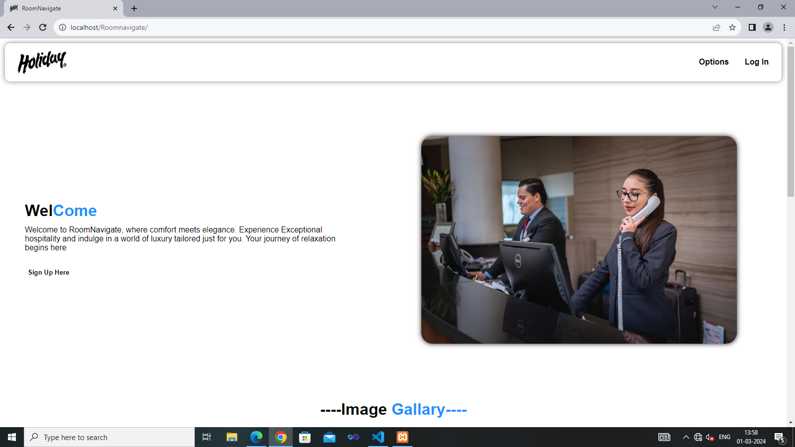

This Is the Home Page Of the website.This

Services Page

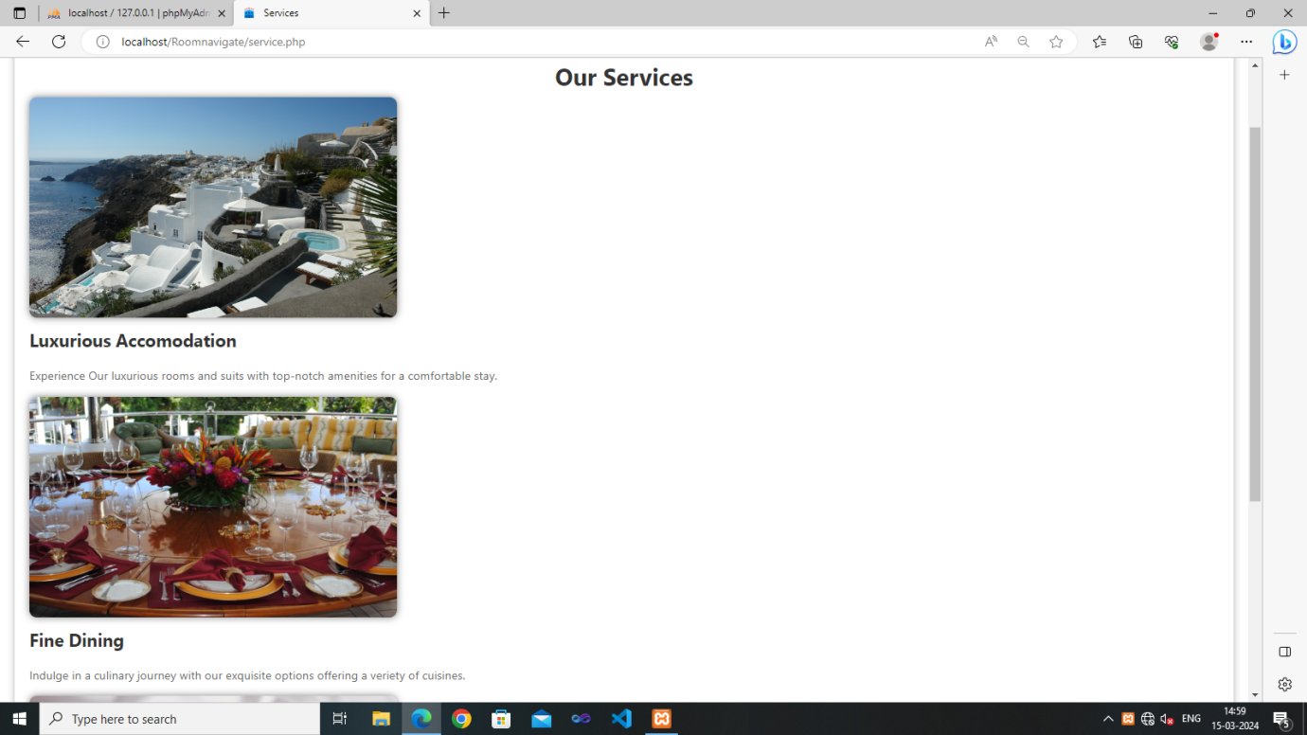

This Is the Service Page Of the website Where services of the company show.

Contact Us Page

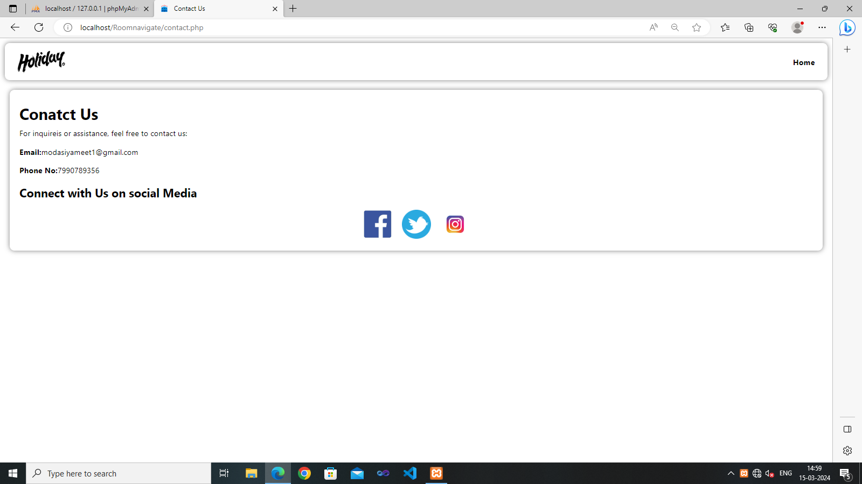

This Is the contact Us Page Of the website Where You can Contact with the company.

About Us Page

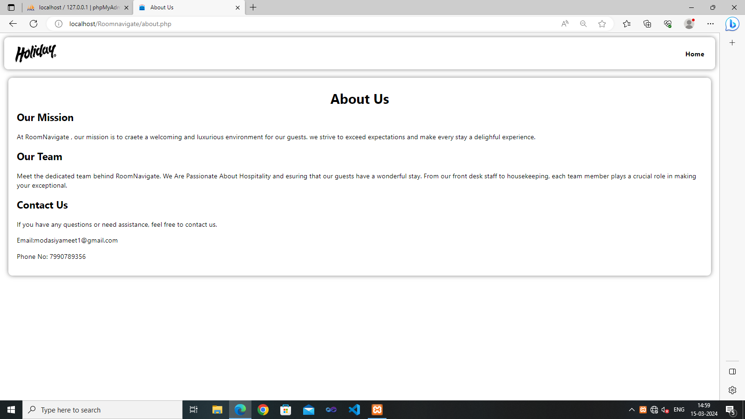

This Is the About Us Page Of the website

Registration Page

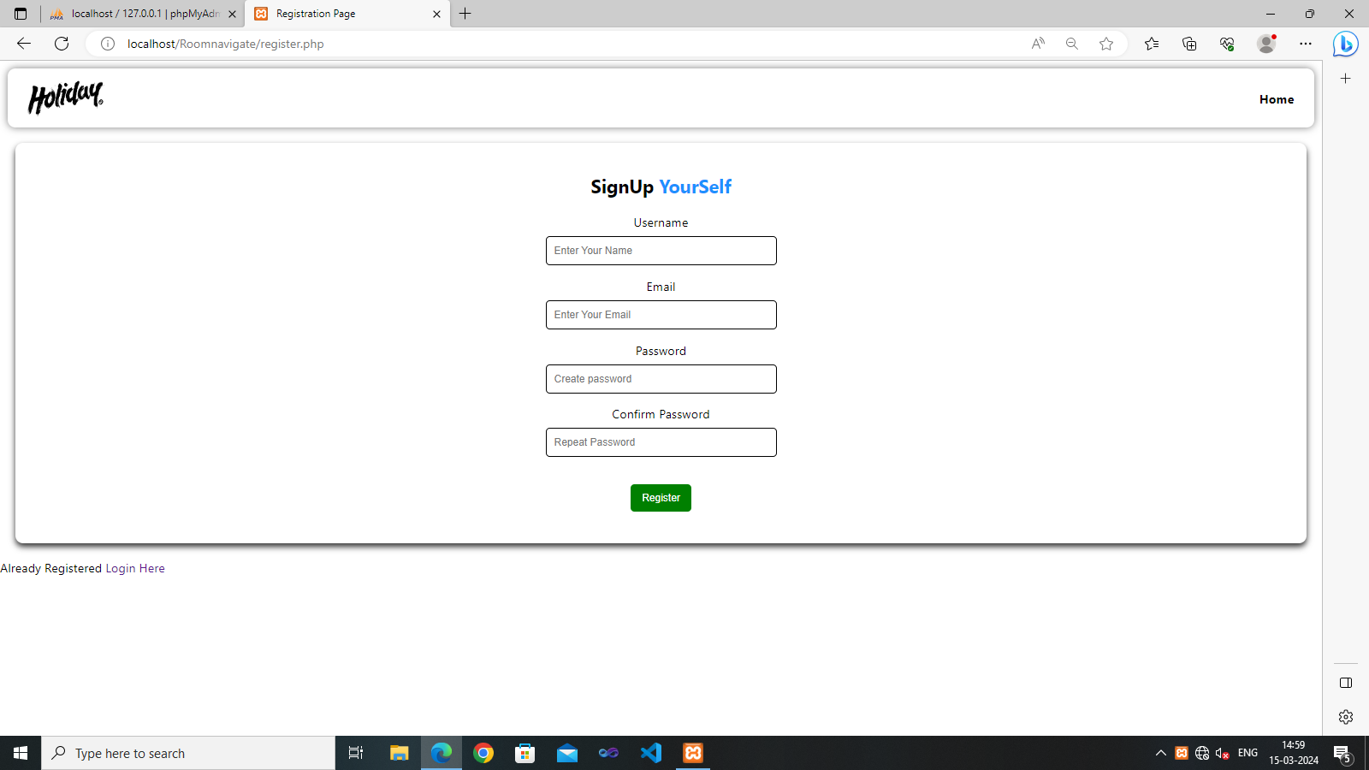

This is registration Page where user can register themselves.

Admin Login Page

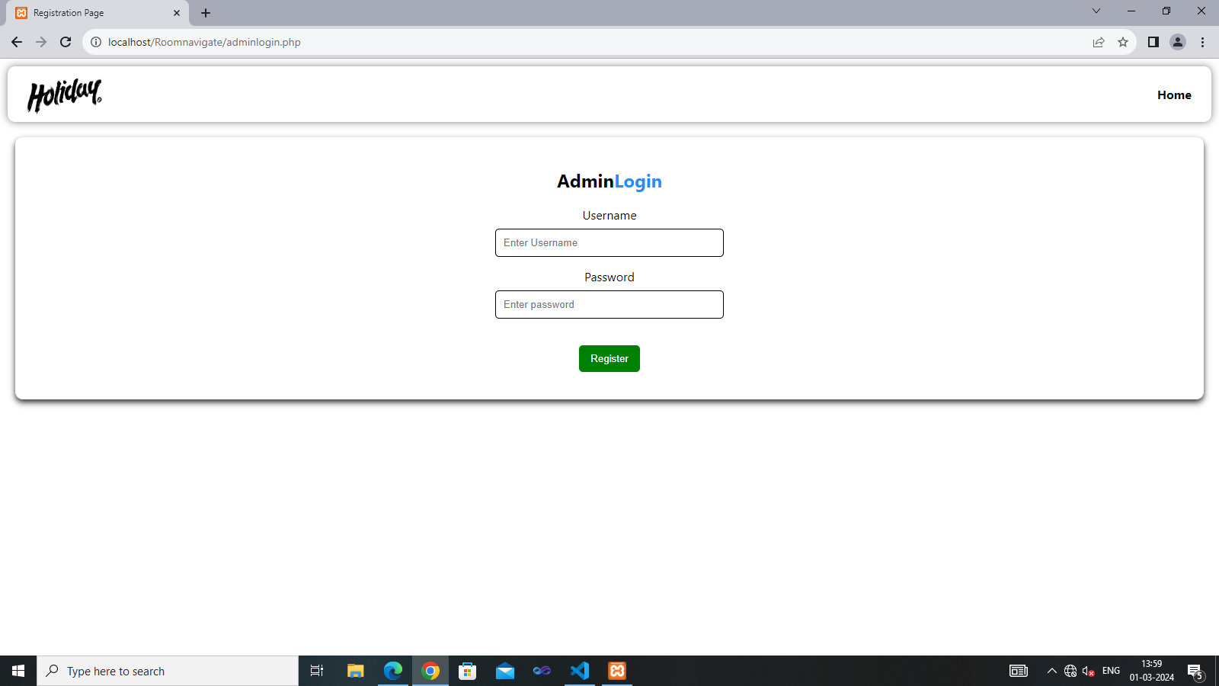

This is admin Login Page for Admin.

Booking Page

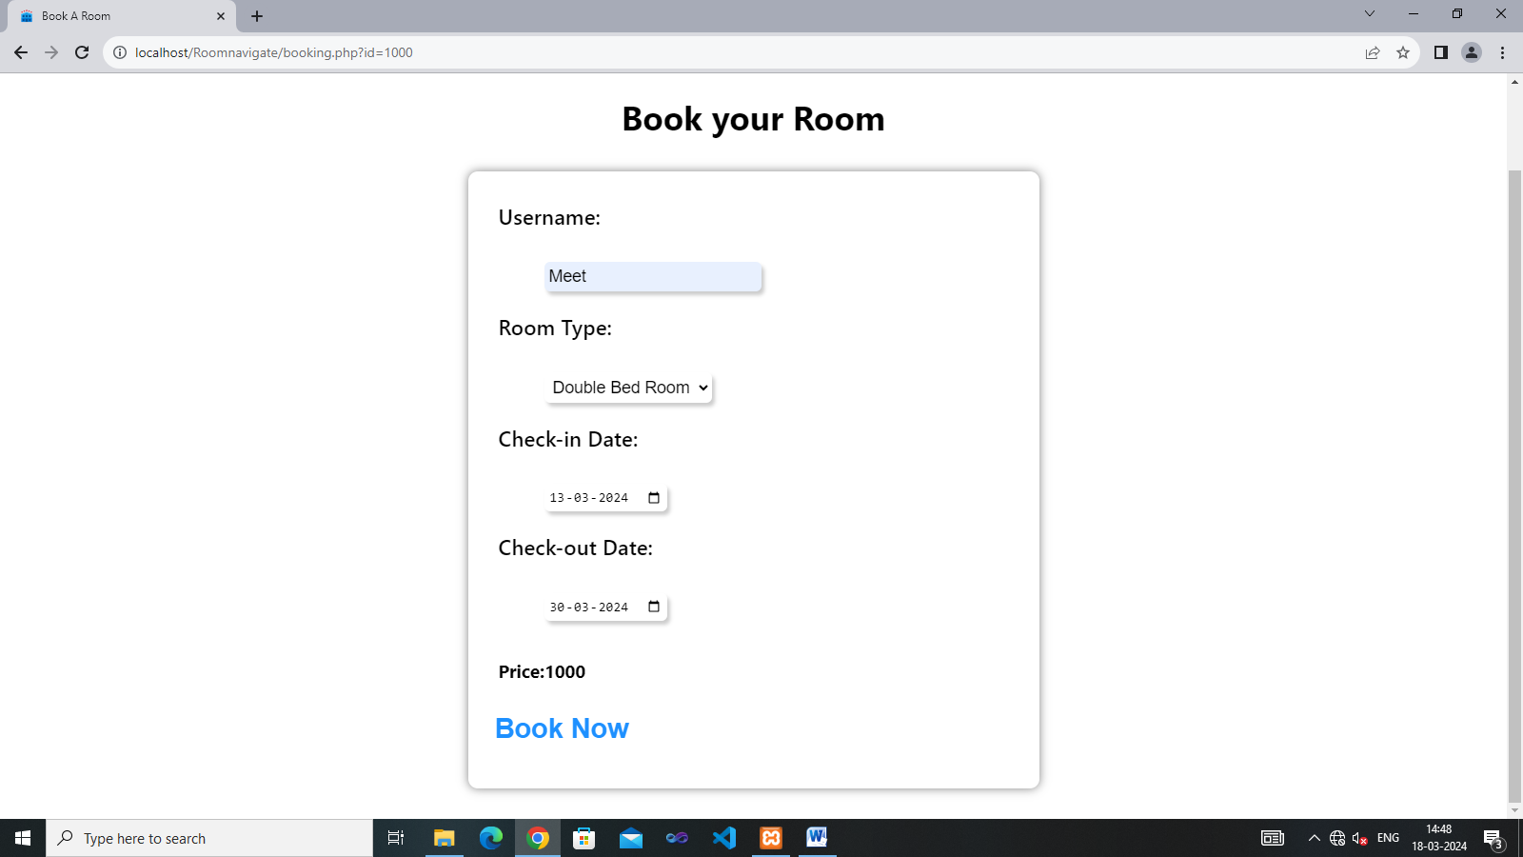

This is Booking Page for the users.

Select Hotel Here

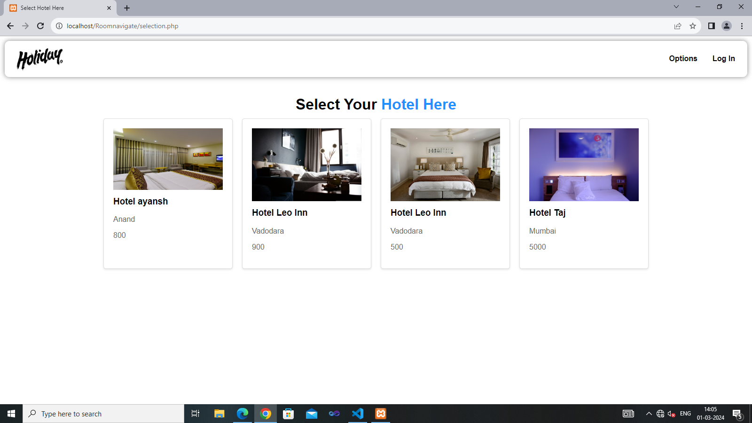

This is option to select the specific hotels.

Admin Dashboard Options

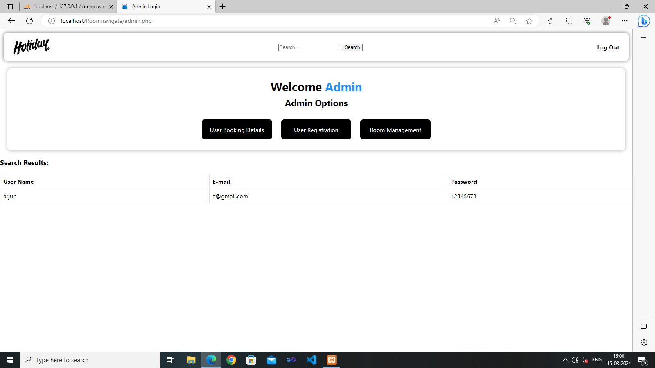

This is admi n dashboard where admin can perform different operations.

9.Insert Hotels Here

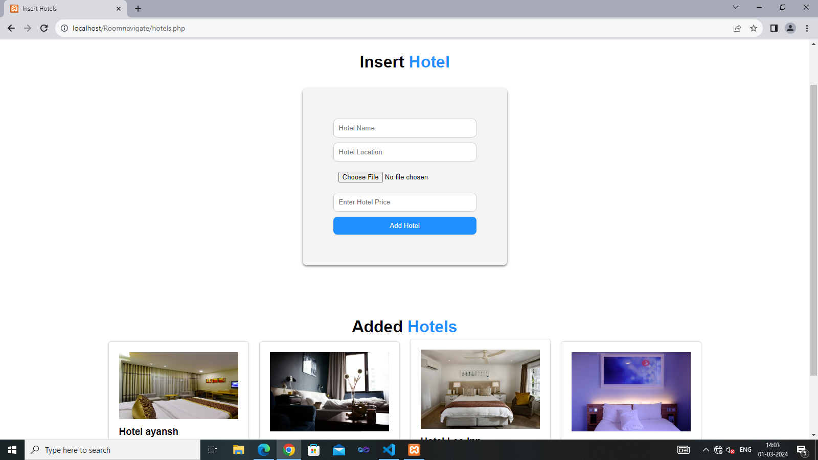

Admin Can Insert Hotels in the website for users.

1. View Bookings Here

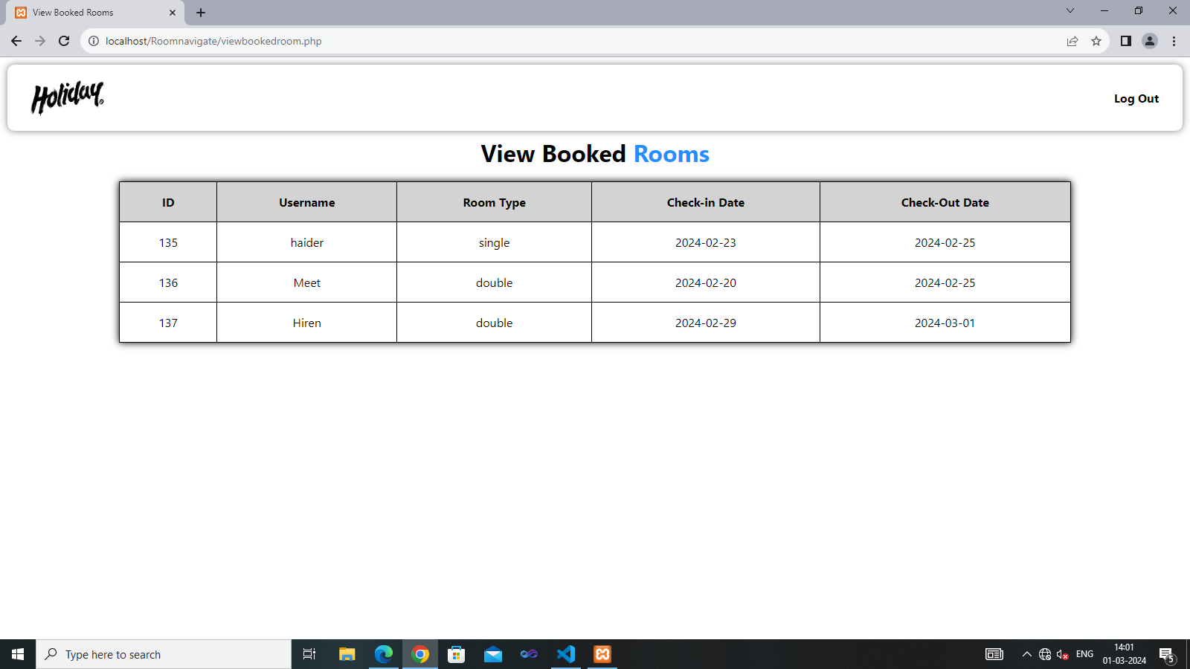

Here admin can view rooms and user which are using the website. Limitations of the Website:

* Advertisement Management
* Discount And Offer Management
* Improve Responsive ness
* Refund Policy
* Customer Feedback Option

Proposed Enhancement:

1. Introduction of online Payment
2. Improvised Responsiveness
3. Enhance Hotel Description
4. Improve Bill Generation

**API Integration:**

* Implementing Games API for information.
* Easily Connect with player with the help of API.

**Security and privacy:**

* Implementing robust security measures to protect user data.
* Encryption of sensitive information.
* Compliance with privacy registration and data protection policies.

Conclusion:

Building this website has allowed me to strengthen my proficiency in various programming languages and technologies including HTML, CSS, JavaScript, PHP and MySQL. I’ve’ learned how to design and develop dynamic web applications handle use authentication, interest with database and implement require design principles.