Visualizations

Meet Patel

2024-02-23

library(readxl)  
library(ggplot2)  
library(scales)  
library(fpp3)

## ── Attaching packages ────────────────────────────────────────────── fpp3 0.5 ──

## ✔ tibble 3.2.1 ✔ tsibbledata 0.4.1  
## ✔ dplyr 1.1.2 ✔ feasts 0.3.1  
## ✔ tidyr 1.3.0 ✔ fable 0.3.3  
## ✔ lubridate 1.9.2 ✔ fabletools 0.3.4  
## ✔ tsibble 1.1.3

## ── Conflicts ───────────────────────────────────────────────── fpp3_conflicts ──  
## ✖ lubridate::date() masks base::date()  
## ✖ dplyr::filter() masks stats::filter()  
## ✖ tsibble::intersect() masks base::intersect()  
## ✖ tsibble::interval() masks lubridate::interval()  
## ✖ dplyr::lag() masks stats::lag()  
## ✖ tsibble::setdiff() masks base::setdiff()  
## ✖ tsibble::union() masks base::union()

# NATIONAL SPORTING GOODS MARKET  
national_sporting <- read_excel("/Users/meetpatel/Desktop/Pitt Business Analytics Case Competition/Visualizations with R/sporting_goods.xlsx")  
national_sporting

## # A tibble: 6 × 7  
## Total `Athletic Footwear` `Athletic Apparel` `Outdoor Footwear`  
## <dbl> <dbl> <dbl> <dbl>  
## 1 2018 17010906192 15163835459 4943788089  
## 2 2019 18354160249 15542931345 5040908113  
## 3 2020 18285328655 14233617624 5316910284  
## 4 2021 19909243906 15054032004 5592867958  
## 5 2022 22062250020 16348904952 5437305614  
## 6 2023 24088439146 16627654284 4695502579  
## # ℹ 3 more variables: `Outdoor Apparel` <dbl>, Fitness <dbl>, Hydration <dbl>

# Reshape the data for plotting  
data_long <- tidyr::pivot_longer(national_sporting, -Total, names_to = "Category", values_to = "Value")  
  
  
# Create the line chart with y-axis in scientific notation format  
ggplot(data_long, aes(x = Total, y = Value, color = Category)) +  
 geom_line() +  
 labs(title = " National Sporting Goods Sales Over Years",  
 x = "Year",  
 y = "Sales",  
 color = "Category") +  
 scale_y_continuous(labels = label_number_si(scale = 1e-9, suffix = " Bil")) + # Format y-axis labels in scientific notation with 'Bil' suffix  
 theme_minimal()+  
 theme(plot.title = element_text(hjust = 0.5))

## Warning: `label_number_si()` was deprecated in scales 1.2.0.  
## ℹ Please use the `scale_cut` argument of `label_number()` instead.  
## This warning is displayed once every 8 hours.  
## Call `lifecycle::last_lifecycle_warnings()` to see where this warning was  
## generated.

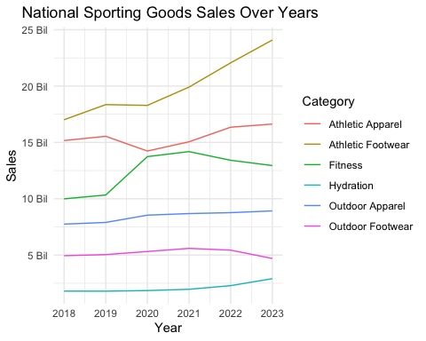

# bar chart- total sales: 2018 to 2023  
total_sales <- aggregate(Value ~ Category, data = data_long, sum)  
  
ggplot(data_long, aes(x = Category, y = Value, fill = Category)) +  
 geom_bar(stat = "identity", width = 0.3) + # Adjust thickness of bars  
 geom_text(data = total_sales, aes(label = sprintf("%.2f Bil", Value/1e9)), vjust = -0.5, size = 4) + # Display total values at the top of bars with two decimal places  
 labs(title = "Total National Sporting Goods Sales by Category",  
 x = "Category",  
 y = "Total Sales") +  
 scale_y_continuous(labels = label_number_si(scale = 1e-9, suffix = " Bil")) +  
 theme_minimal() +  
 theme(plot.title = element_text(hjust = 0.5), # Center the title  
 axis.text.x = element_text(angle = 45, hjust = 1, size = 10))

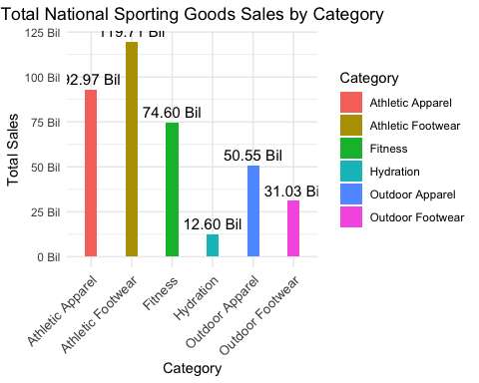

# 2018 Pie Chart  
total_sales_2018 <- data_long %>%  
 filter(Total == 2018)   
  
# Plot pie chart with labels formatted in billions  
formatted_labels <- label_number_si(scale = 1e-9, suffix = " Bil")(total_sales_2018$Value)  
  
# Combine category names and formatted values  
label_billion_2018 <- paste0(total_sales_2018$Category, "\n", formatted_labels)  
  
# Plot pie chart with formatted labels  
pie(total_sales_2018$Value,   
 labels = label_billion_2018,   
 main = "Total Sales in 2018",  
 col=terrain.colors(length(total_sales_2018$Value)))

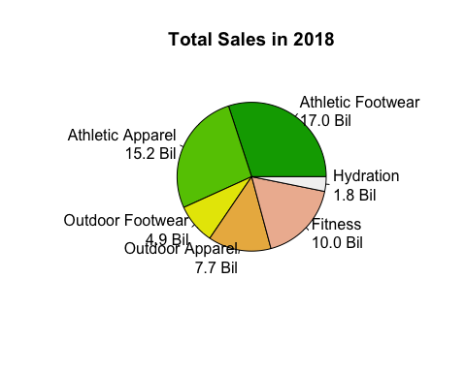

# 2023 Pie Chart  
total_sales_2023 <- data_long %>%  
 filter(Total == 2023 )   
  
# Plot pie chart with labels formatted in billions  
formatted_labels <- label_number_si(scale = 1e-9, suffix = " Bil")(total_sales_2023$Value)  
  
# Combine category names and formatted values  
label_billion_2023 <- paste0(total_sales_2023$Category, "\n", formatted_labels)  
  
# Plot pie chart with formatted labels  
pie(total_sales_2023$Value,   
 labels = label_billion_2023,   
 main = "Total Sales in 2023",  
 col=terrain.colors(length(total_sales_2023$Value)))

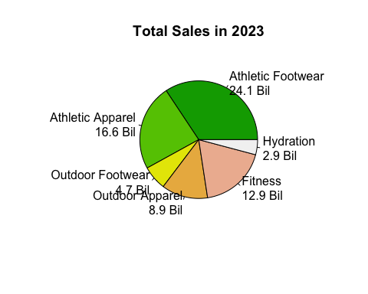

# Side by Side bar charts  
ggplot(data_long, aes(x = as.factor(Total), y = Value, fill = Category)) +  
 geom_bar(stat = "identity", position = position_dodge(), width = 0.8, colour = "black") +  
 labs(title = "Sales by Category for Each Year",  
 x = "Year",  
 y = "Sales",  
 fill = "Category") +  
 scale_y_continuous(labels = label_number_si(scale = 1e-9, suffix = " Bil")) +  
 theme_minimal() +  
 theme(axis.text.x = element_text(size=10),   
 plot.title = element_text(hjust = 0.5))

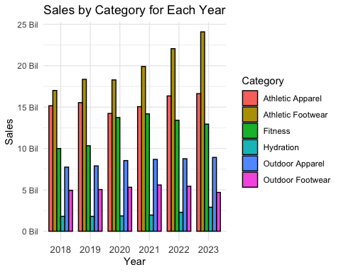

# NATIONAL ATHLETIC FOOTWEAR MARKET  
  
athletic <- read_excel("/Users/meetpatel/Desktop/Pitt Business Analytics Case Competition/Visualizations with R/athletic_footwear.xlsx")  
athletic

## # A tibble: 6 × 5  
## Total Nike Hoka `On Running` Adidas  
## <dbl> <dbl> <dbl> <dbl> <dbl>  
## 1 2018 6864811947 401730776 247189731 1833897194  
## 2 2019 7411782447 473273787 299487635 1881217282  
## 3 2020 7269842383 470897234 326151283 1917246020  
## 4 2021 7731653426 809489322 344649858 1952717572  
## 5 2022 8728949610 1045587578 529575679 1877068387  
## 6 2023 9508066849 1301430912 961049743 1817615842

athletic_long <- tidyr::pivot_longer(athletic, -Total, names_to = "Category", values_to = "Value")  
  
# Create the line chart with y-axis in scientific notation format  
ggplot(athletic_long, aes(x = Total, y = Value, color = Category)) +  
 geom_line() +  
 labs(title = " National Athletic Footwear Sales Over Years",  
 x = "Year",  
 y = "Sales",  
 color = "Category") +  
 scale_y_continuous(labels = label_number_si(scale = 1e-9, suffix = " Bil")) + # Format y-axis labels in scientific notation with 'Bil' suffix  
 theme_minimal()+  
 theme(plot.title = element_text(hjust = 0.5))

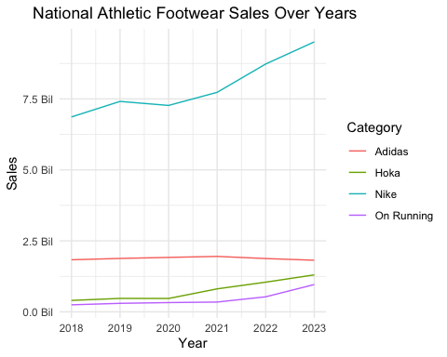

# bar chart- total sales: 2018 to 2023  
total_sales <- aggregate(Value ~ Category, data = athletic_long, sum)  
  
ggplot(athletic_long, aes(x = Category, y = Value, fill = Category)) +  
 geom_bar(stat = "identity", width = 0.2) + # Adjust thickness of bars  
 geom_text(data = total_sales, aes(label = sprintf("%.2f Bil", Value/1e9)), vjust = -0.5, size = 4) + # Display total values at the top of bars with two decimal places  
 labs(title = "Total National Athletic Footwear Sales by Category",  
 x = "Category",  
 y = "Total Sales") +  
 scale_y_continuous(labels = label_number_si(scale = 1e-9, suffix = " Bil")) +  
 theme_minimal() +  
 theme(plot.title = element_text(hjust = 0.5), # Center the title  
 axis.text.x = element_text(angle = 45, hjust = 1, size = 10)) # Rotate x-axis labels

