Exploratory Data Analysis of the Dataset

Meet Patel
Dept. Artificial Intelligence and Machine learning
Toronto, Canada
ID: C0871240

Abstract—This report presents an exploratory data analysis of the dataset. The dataset includes 12000 observations and 16 variables. The goal of this analysis was to gain a better understanding of the relationships between the variables and any underlying patterns or trends that might be present. Our analysis involved descriptive statistics, visualizations, and correlation analysis.

Introduction
This report presents an exploratory data analysis of a dataset containing information on cars, with 12000 observations and 16 attributes. The goal of our analysis was to gain insights into the different features of cars and to test the dataset using regression models. We used various visualization techniques such as pie charts, bar charts, histograms, radar charts, and scatter plots to gain insights from the data. We also applied linear regression and random forest regressor models to test the dataset and utilized cross-validation techniques such as K-fold and GridSearchCV to improve the results.

methodology

Data Exploration
The dataset has 12000 rows and 16 columns which have three different datatypes int64, float64 and object. The dataset also has missing values in some of the columns.

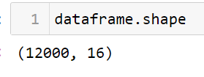

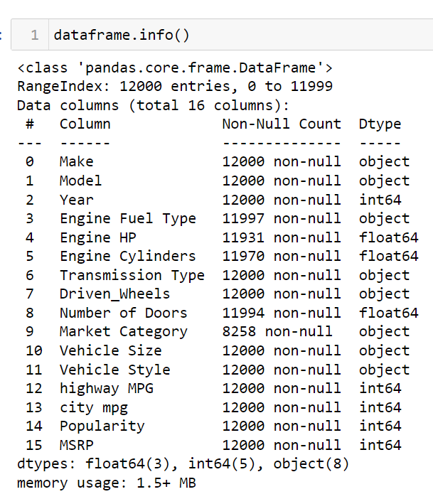
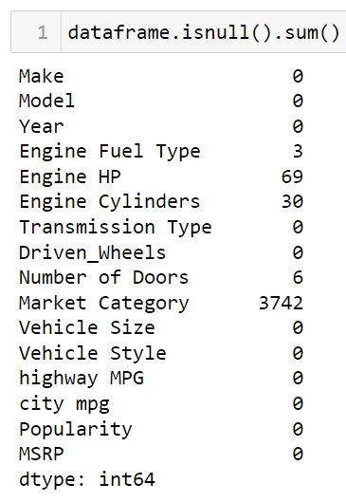

Data Visualization
We first identified how each feature correlated with each other. Hence, we used Heatmap to portray the correlation.

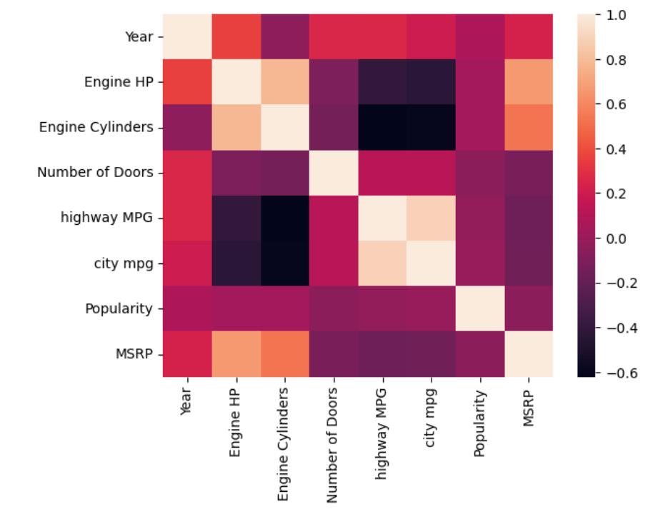
After that we used histogram to find out which company use most number of cylinders in their cars. And we found out that Bugatti uses most number of cylinders which is 16, while Tesla uses zero number of cylinders because they produce electric cars only.
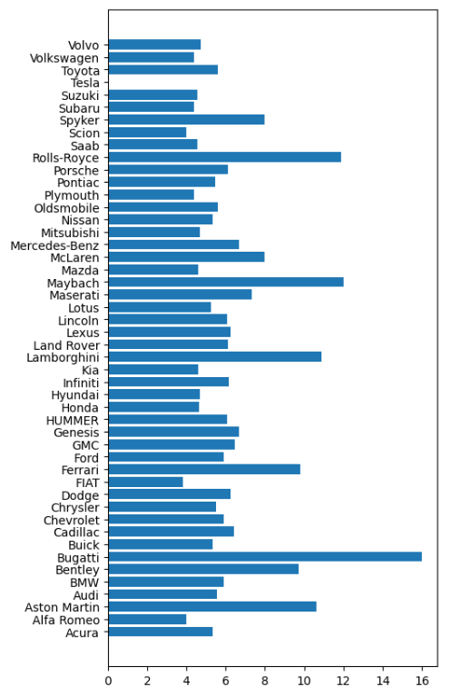
Similar observation can also be seen with Engine Horsepower. Bugatti uses highest HP of engine, and it was zero for Tesla.
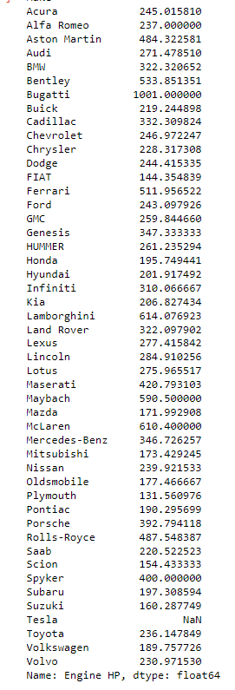
After that, we used pie chart to show howmany cylinders most car use.
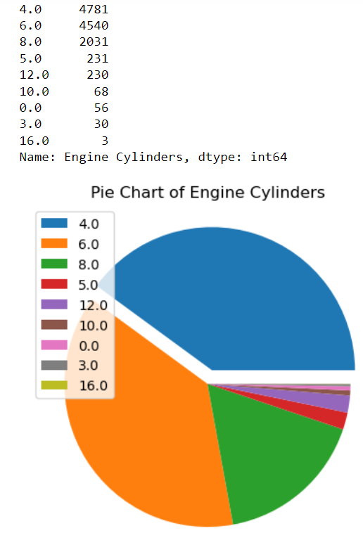
We also noticed that Tesla is not the only company that produce electric cars and found out which company is more famous for making EVs.
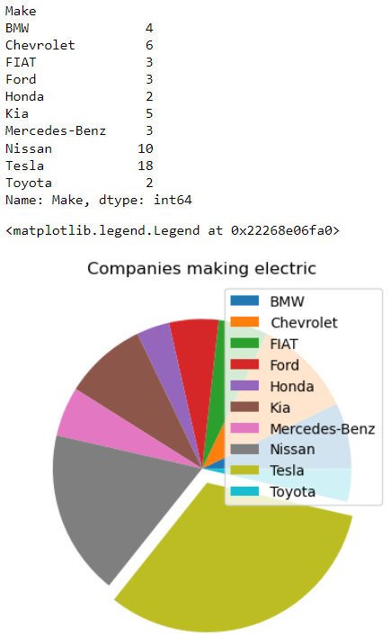
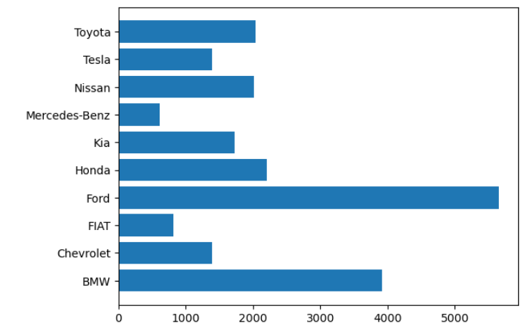
Above bar graph shows the popularity of the company in making EVs. Which shows Ford is most and Mercedes-Benz is least famous.
Now let’s find out why Ford is most popular. For that most critical feature is Milage. Below code shows the milage on Highway and intercity roads.
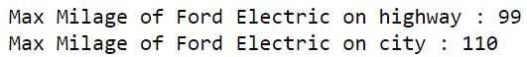
We saw above that Tesla produces most number of models in EVs. But it is less popular than Ford which has only 3 models of EV cars. We used bar chart to compare the max milage that Tesla and Ford give on Highway and Intercity.
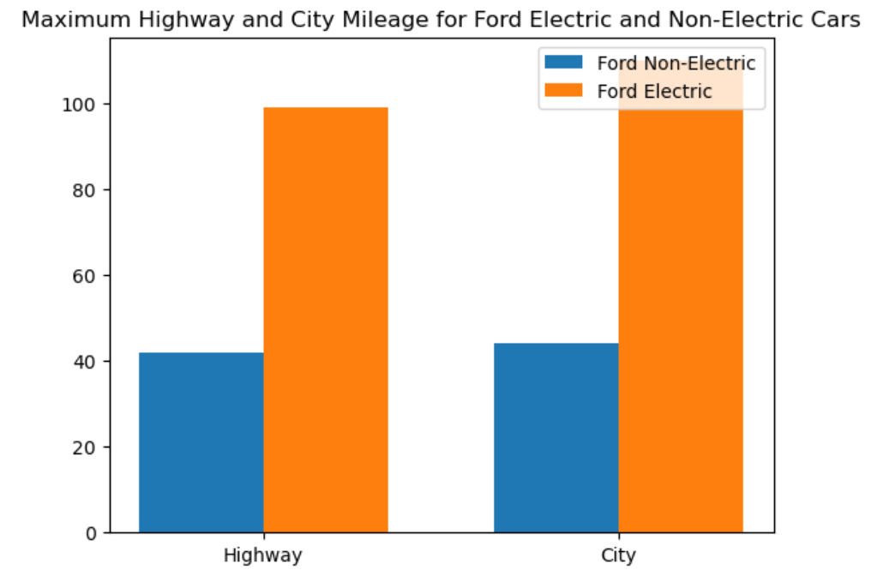
Now let’s see max and min price Ford electric cars compared to electric cars.
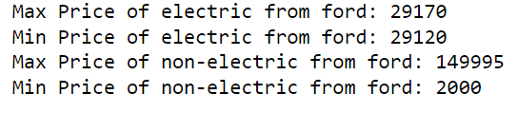
Now, let’s see which company is more popular for non- electric cars.
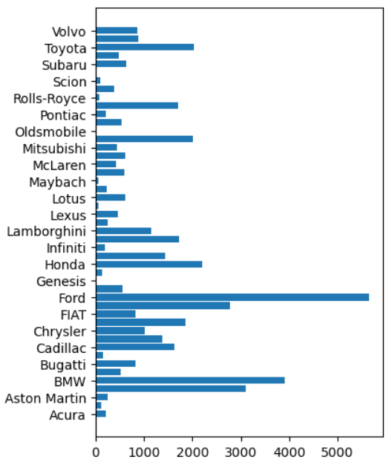
The graph shows that Ford also holds the highest popularity in non EVs as well. Now let's observe using bar graph why Chrysler, which has more models, is less popular than Ford, which has fewer models.
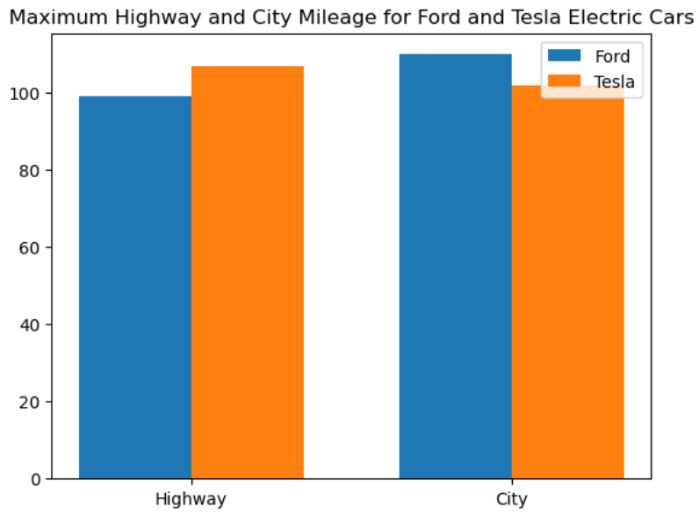
Now, Let’s find out which three companies have higher HP of engine and what is the popularity of each company. We plot the radar chart to depict the same.
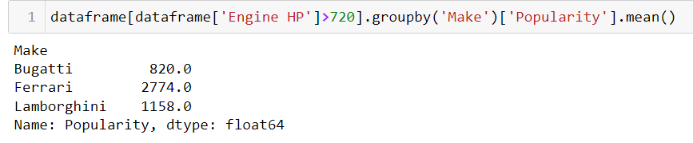
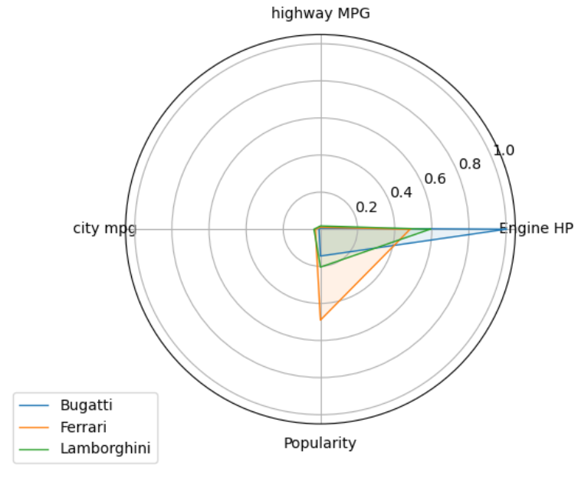
After that we found out that Chevrolet, Ford and Honda use least HP of engine. Below radar chart will shows the popularity of each company as well.
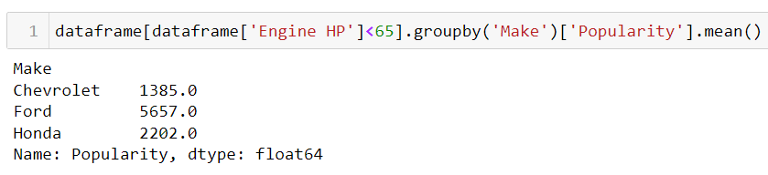
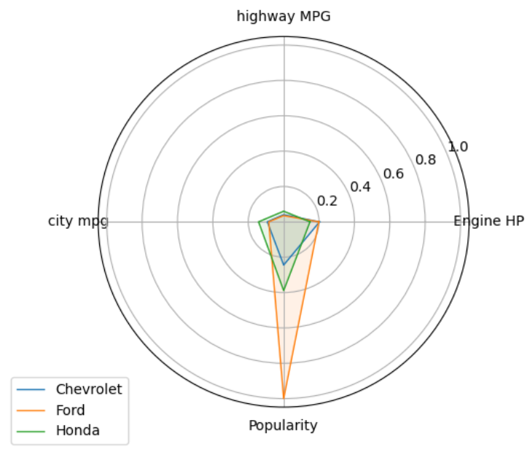
After that, we wanted to discover skewness of “Engine HP”, “Engine Cylinders”, “Number of Doors”, “highway MPG” and “city mpg”. So, we plotted the histogram to shows the dispersion.
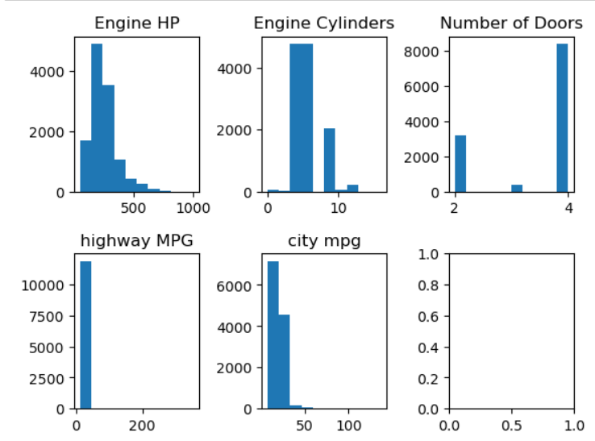
Now, let’s see if there are any outliers present in “Engine HP”, “Engine Cylinders”, “Number of Doors” and “highway MPG”. For that, we used box plot for each of the column.
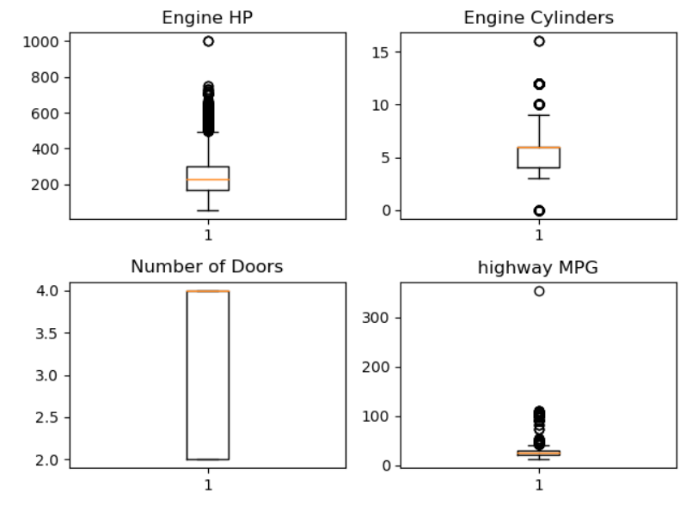
It’s clear from the graph that all these columns have outliers.
Further, we analysed the popularity of top three most famous companies for producing non-electric cars.
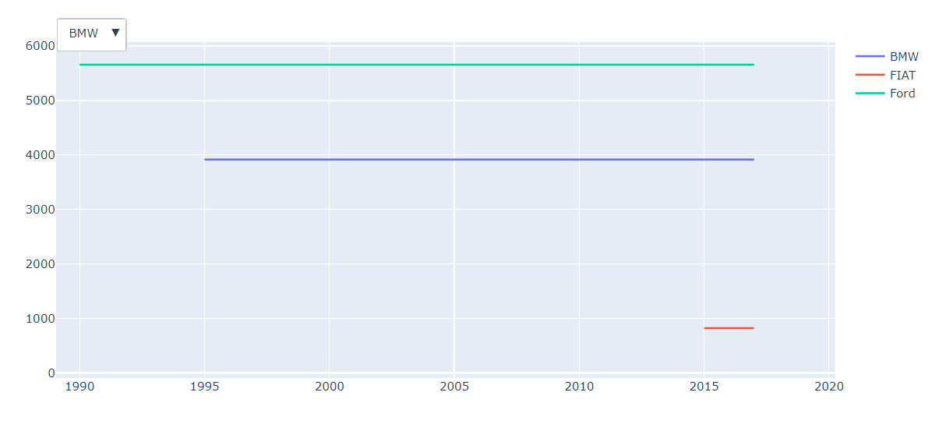
It is clear from the graph that popularity for the each company remained same throughout the years. Hence, this dataset is not good for determining how popular of these companies changed.
For further information, we plotted scatter plots to see how “Engine HP”, ”city MPG” and “highway MPG” affects the popularity of the car company.
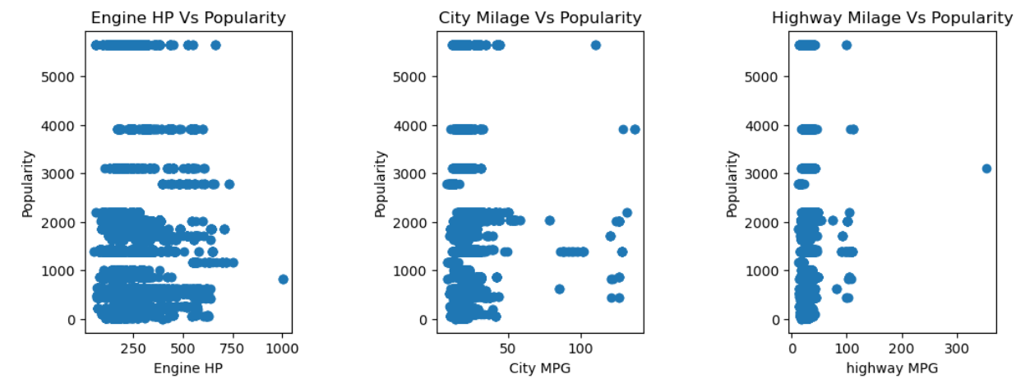
Now, instead of plotting each feature one by one let’s see plt all the data together in 3D space and see how it looks like. We used line space 3D diagram to show the result.
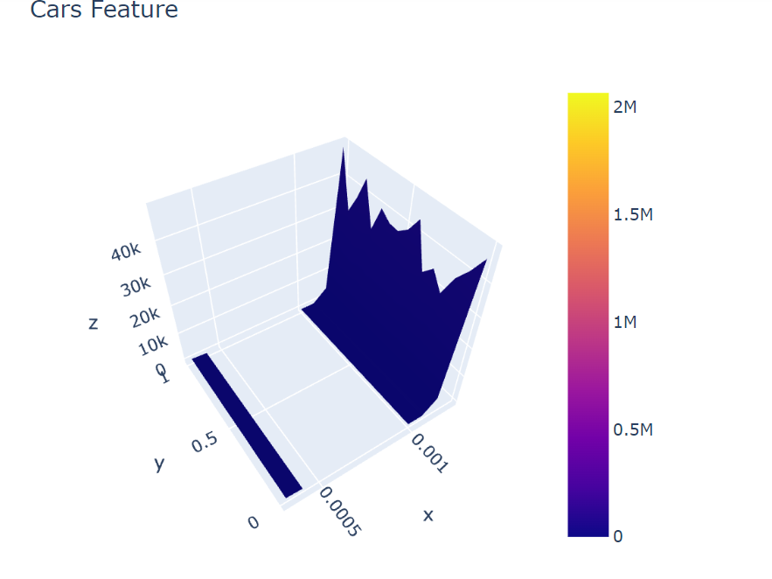
- Detecting and handling null values
In the dataset we observed that there are 4 columns with null values.
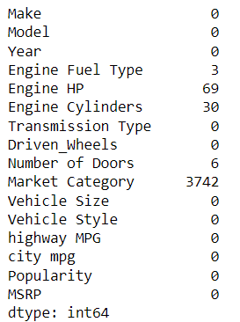
We noticed that “Engine Hp” and “Engine Cylinders” columns are linearly corelated.
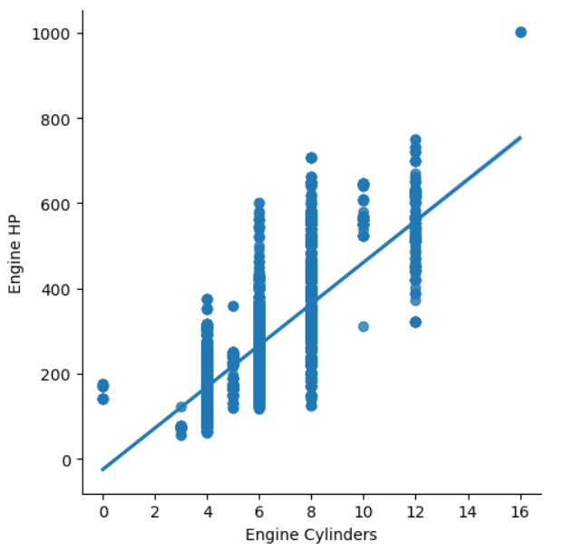 Hence, for both columns we imputed using linear method.
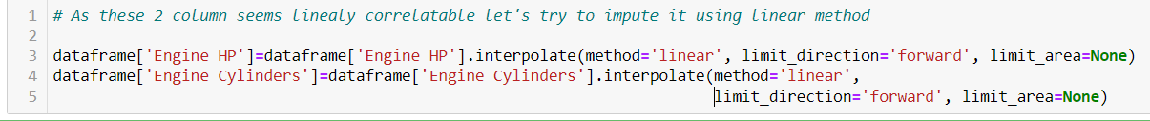
Now, for the market category, we dropped column because we noticed that the dataset has cars from simple cars to sports car. And there are ample of unique values in marketing category. So, it may become a different ML classification task for imputing values in “marketing category” column.
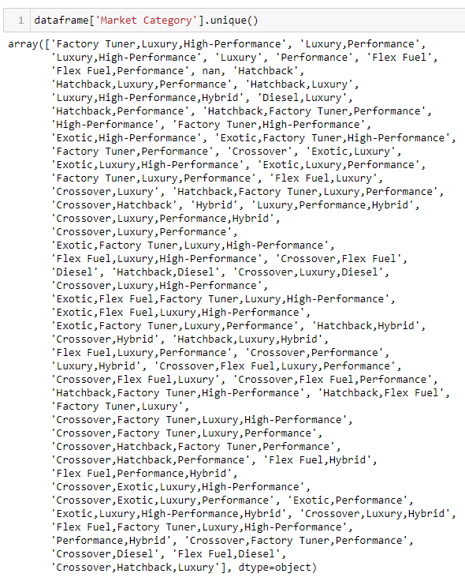
Moreover, for the “Engine fuel type” there were only 3 null values. So, plotted the bar chart to see which fuel is used in most of the cars and we imputed with that one.
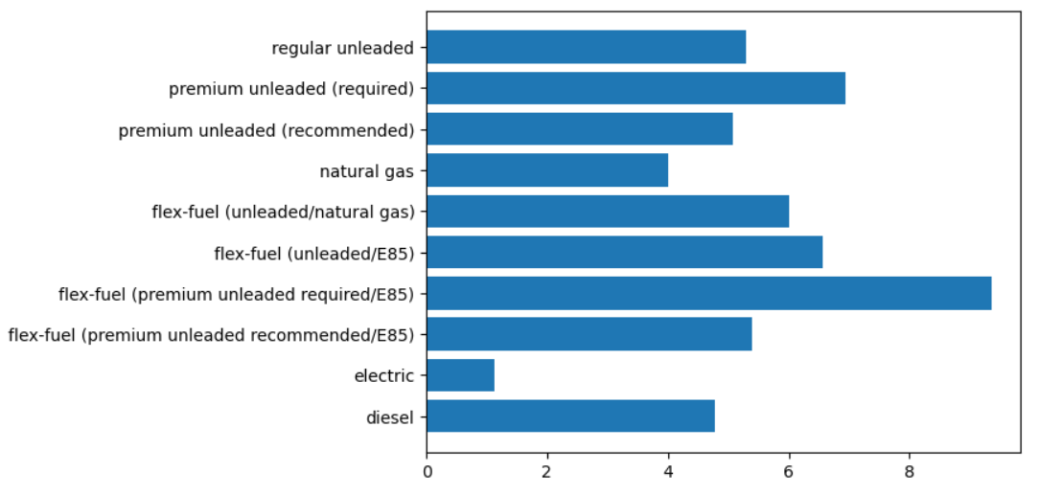

Model Selecton and Model Training

Coclusion
To conclude, this dataset works well on KNN Algorithm because the accuracy I got, which is 78.68%, is pretty good. And for the clustering, I used K-Means algorithm which can give good performance for the k value 3. Although, we can use non numerical feature as well and may be performance of the algorithms could improve.

References

https://www.kaggle.com/datasets/uciml/adult-census-income

https://scikitlearn.org/stable/modules/generated/sklearn.cluster.KMeans.html

https://www.dominodatalab.com/blog/getting-started-with-k-means-clustering-in-python

https://www.w3schools.com/python/python_ml_k-means.asp

