CloudPulse
Cloud Service Health Monitoring and Alert Dashboard
CSYE 6300 · Summer 2026 · Group 3 · Final Project — Milestone 1 Proposal
1. Project Group Number / Name
Group number: 3
Group name: CloudPulse Team
Team members:
- Katha Patel
- Ashwin Thankachan
- Meet Patel
- Pavithra Prasad
2. Project Topic / Name
CloudPulse — Cloud Service Health Monitoring and Alert Dashboard
CloudPulse is a full-stack Java application that monitors the availability and response time of application services. It is intentionally a student-scale observability project rather than a replacement for commercial platforms such as Datadog or New Relic.
3. Problem Statement
Modern applications are often divided into several services, making it difficult for developers to notice immediately when one service becomes slow or unavailable. Small teams and student developers may not have access to expensive observability platforms, so failures are often discovered only after users report them. CloudPulse will periodically perform real HTTP health checks against registered services and measure their response time and availability. It will classify every service as Unknown, Healthy, Degraded, Down, or Recovered and display the current condition through a React dashboard. When a service changes to an unhealthy state, the application will create an alert and maintain a chronological event history that users can review and acknowledge. The project provides a controlled and demonstrable introduction to monitoring, alerting, state management, and extensible software architecture through meaningful object-oriented design patterns.
4. UML Diagram / ER Diagram
UML Class Diagram
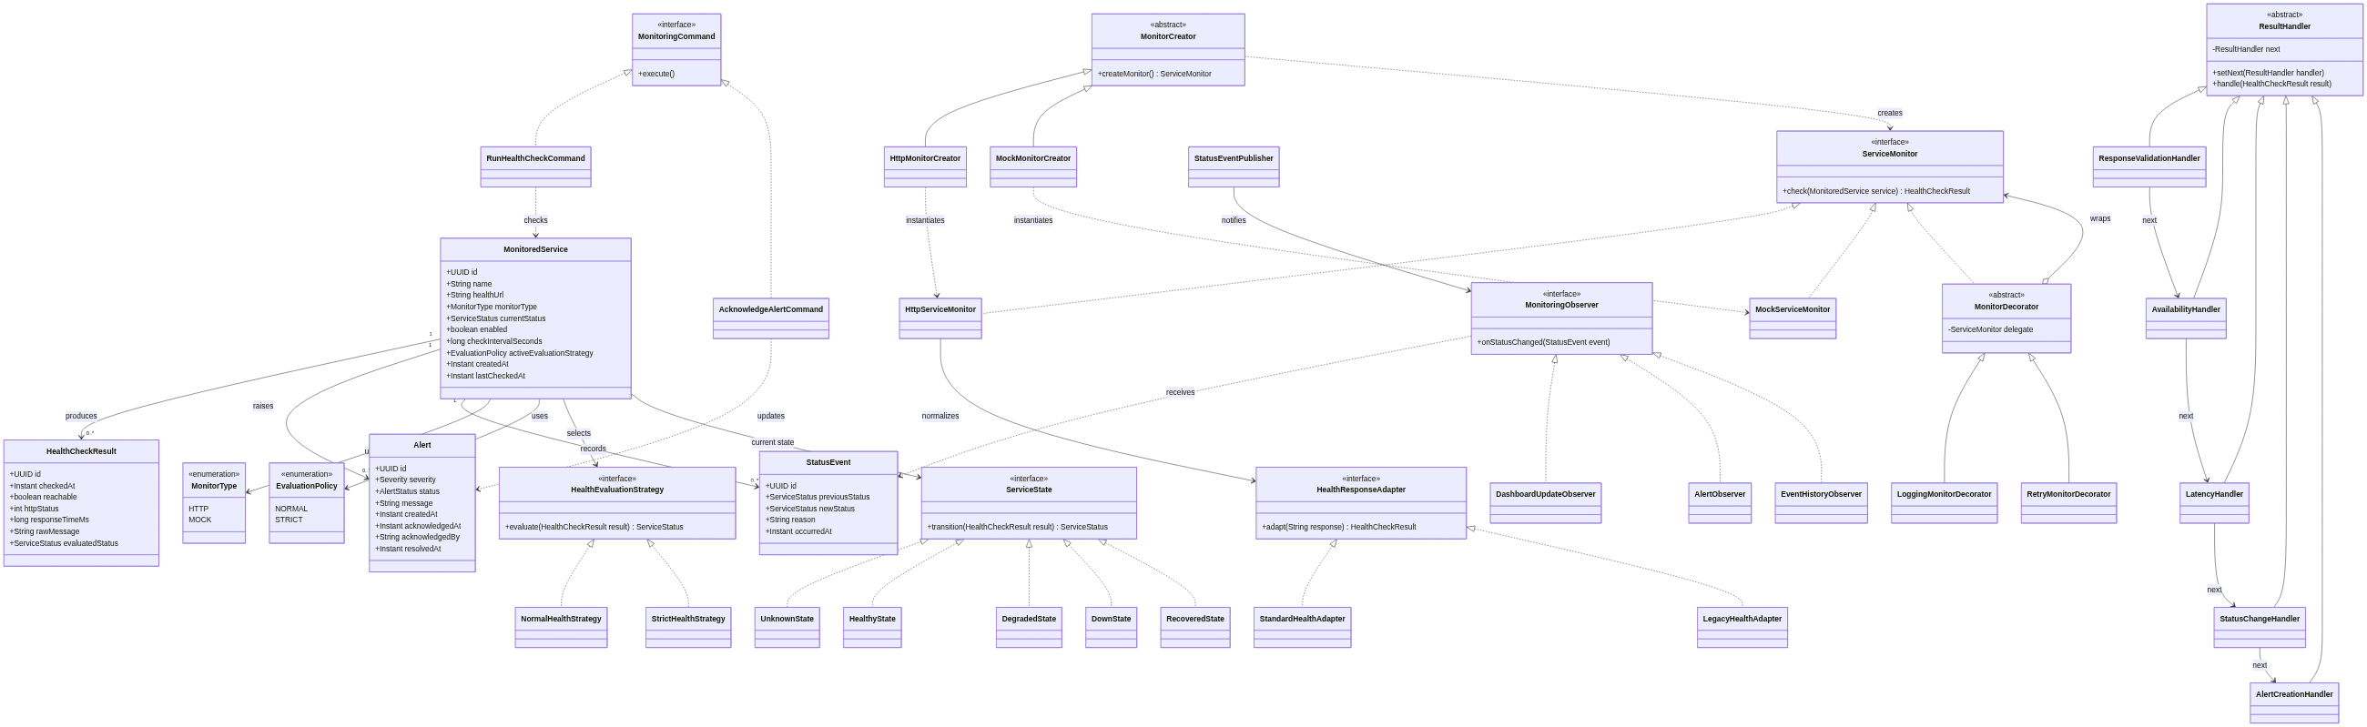
Figure 1. CloudPulse domain model and design-pattern class relationships.
ER Diagram
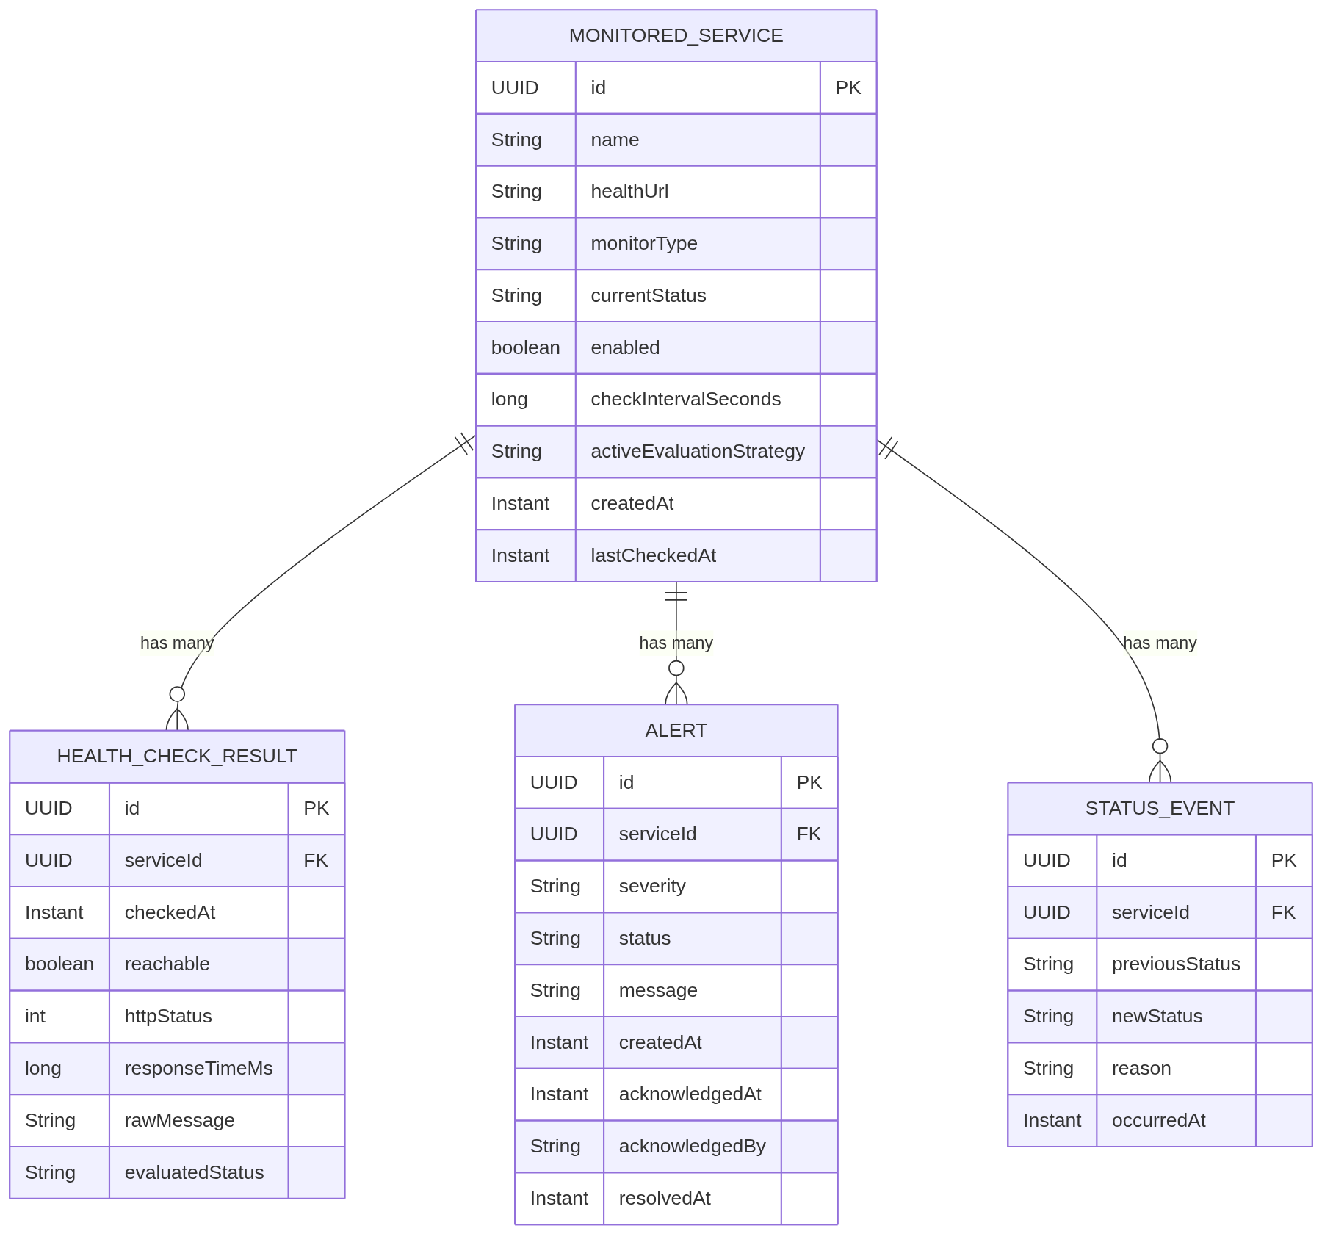
Figure 2. Relational schema for persisted entities.
5. Design Patterns to be Implemented
Observer Pattern
Problem solved: Several components must react when service health changes without tightly coupling them to the monitoring engine.
Implementation: A status event publisher will notify observers such as DashboardUpdateObserver, AlertObserver, and EventHistoryObserver whenever a service transitions between health states.
Visible demonstration: When Payment Service changes from Healthy to Degraded, the dashboard, alert list, and event timeline all update from the same event.
Strategy Pattern
Problem solved: Different environments require different definitions of acceptable response time.
Implementation: NormalHealthStrategy and StrictHealthStrategy will implement a common HealthEvaluationStrategy interface. Each MonitoredService carries its own activeEvaluationStrategy, so different services can be evaluated with different thresholds at the same time.
Visible demonstration: The presenter switches Payment Service from Normal to Strict while Notification Service stays on Normal, and the two services classify differently from the same response times.
State Pattern
Problem solved: A service behaves differently depending on its current health condition, and status transitions must be controlled and recorded.
Implementation: UnknownState, HealthyState, DegradedState, DownState, and RecoveredState will implement a common ServiceState interface.
Visible demonstration: Notification Service transitions from Healthy to Down, then to Recovered and Healthy after restoration.
Factory Method Pattern
Problem solved: The monitoring scheduler should not directly construct every concrete monitor.
Implementation: An abstract MonitorCreator will declare the createMonitor() factory method. HttpMonitorCreator and MockMonitorCreator override it to create the concrete monitors without coupling the scheduler to concrete classes.
Visible demonstration: A real HTTP service and a simulated service can be registered through the same UI and processed through the same monitoring workflow.
Chain of Responsibility Pattern
Problem solved: Health-check processing contains several independent stages that should remain modular and testable.
Implementation: Results pass through ResponseValidationHandler, AvailabilityHandler, LatencyHandler, StatusChangeHandler, and AlertCreationHandler.
Visible demonstration: The event details can display which pipeline stages processed a failing health check.
Command Pattern
Problem solved: User operations should have consistent execution, validation, and audit history.
Implementation: RunHealthCheckCommand, AcknowledgeAlertCommand, ResolveAlertCommand, and EnableMonitoringCommand implement a common command interface.
Visible demonstration: A user acknowledges an alert, and the command is recorded in the alert history with the user and timestamp.
Adapter Pattern
Problem solved: Services may return different health-response formats.
Implementation: StandardHealthAdapter and LegacyHealthAdapter convert different JSON payloads into the common HealthCheckResult model.
Visible demonstration: Two demo services return differently structured health responses, but both appear consistently in CloudPulse.
Decorator Pattern
Problem solved: Monitoring concerns such as logging, retry behavior, and timing metrics should be added without modifying every concrete monitor.
Implementation: LoggingMonitorDecorator, RetryMonitorDecorator, and MetricsMonitorDecorator wrap a ServiceMonitor and add behavior while preserving the same interface.
Visible demonstration: The team enables retry and logging around an HTTP monitor and shows that a failed check is retried and recorded without changing HttpServiceMonitor.
MVC Architecture
Problem solved: The UI, request handling, business logic, and domain data should remain separated.
Implementation: React provides the View, Spring REST controllers provide the Controller layer, and Java entities/services provide the Model and business layers.
Note: MVC is the application's architectural pattern. It is not one of the original Gang of Four patterns.
6. Tech Stack
Backend
- Java SE JDK 22, matching the course syllabus
- Spring Boot
- Spring Web / REST controllers
- Spring Scheduler
- Spring Data JPA
- Maven
Frontend
- React
- TypeScript
- Vite
- CSS or a lightweight component library selected by the team
Data & Infrastructure
- PostgreSQL
- Docker Compose for local database and optional final packaging
- Three minimal Spring Boot demo services
Testing & Documentation
- JUnit 5
- Mockito
- Spring Boot integration tests
- Optional Testcontainers for PostgreSQL integration tests
- OpenAPI/Swagger for REST API documentation
- GitHub for version control and pull requests
7. Functionalities to be Implemented by the End of Milestone 2
- Add, view, edit, enable, and disable monitored services
- Run scheduled HTTP health checks against registered endpoints
- Run an immediate manual health check
- Record reachability, HTTP status, response time, and timestamp
- Classify services as Unknown, Healthy, Degraded, Down, or Recovered
- Switch between Normal and Strict evaluation strategies
- Generate alerts when a service becomes Degraded or Down
- Acknowledge and resolve alerts
- Display current service health through React status cards
- Display active alerts and chronological status events
- Persist services, checks, alerts, and events in PostgreSQL
- Run three controllable Java demo services
- Implement and demonstrate Observer, Strategy, State, Factory Method, Chain of Responsibility, Command, Adapter, Decorator, and MVC through working code, UML relationships, automated tests, and the final demonstration
- Add unit tests for health evaluation, state transitions, alert generation, and command behavior
- Provide setup instructions and stable demonstration data
8. Contributions
Person Name | Contribution
Katha Patel | Monitoring engine and demo services — HTTP monitors, monitor creators, response adapters, monitor decorators, demo endpoints, and unit tests (Factory Method, Adapter, Decorator)
Ashwin S Thankachan | Health evaluation and lifecycle — threshold strategies, controlled state transitions, recovery logic, and unit tests (Strategy, State)
Meet Patel | Processing and alert workflow — processing handlers, alert acknowledgement and resolution commands, persistence, and tests (Chain of Responsibility, Command)
Pavithra Prasad | React dashboard and service registration — dashboard, service and alert views, event updates, API integration, and UI tests (Observer, MVC)

9. GitHub Repository
Repository URL: https://github.com/KathaPatel29/csye6300-summer26-group3-final-project
Repository access: All four team members and TA vaibhavsingh97 are added as collaborators.

